Enhancing copper toxicity against Saprolegnia parasitica, a devastating oomycete pathogen in aquaculture
Tomisin Happy Ogunwa, Madison Grace Thornhill, Daniel Ledezma and Ryan Loren Peterson†
Department of Chemistry, Texas State University, 601 University Drive, San Marcos, Texas, United States, 78666.
† Corresponding author

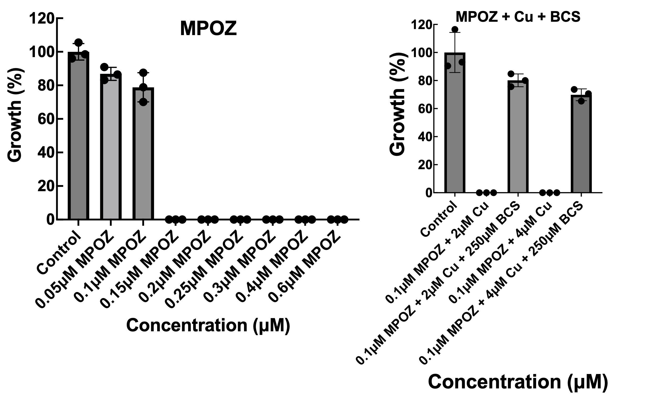
Fig. S1. (A) Dose-dependent assay of MPOZ against S. parasitica. Lethal dose for MPOZ was 0.15 μM as determined in vitro. (B) Treatment of S. parasitica with copper - MPOZ and copper - MPOZ – BCS in vitro. Total suppression of growth in S. parasitica was observed in the presence of 0.1 μM MPOZ combined with 2 μM or 4 μM copper. This effect was reversed by the addition of BCS (250 μM).

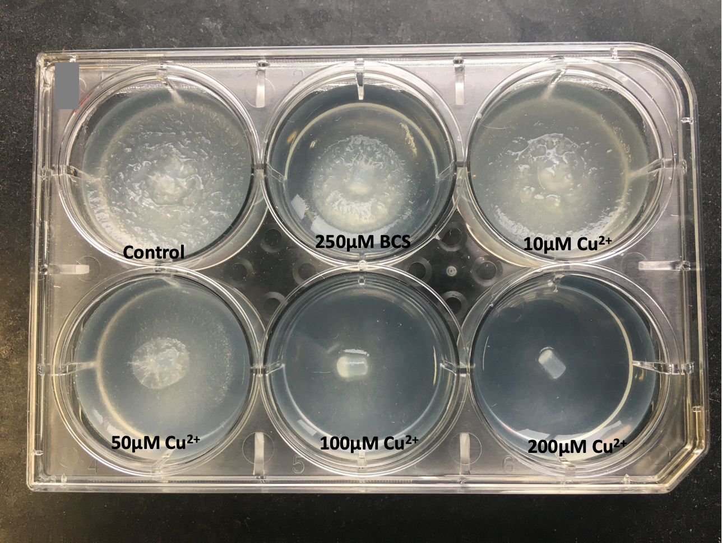
Fig. S2. Effect of varying copper concentration on the growth of S. parasitica on solid media in a six-well plate. Copper curved S. parasitica growth in a dose-dependent manner.

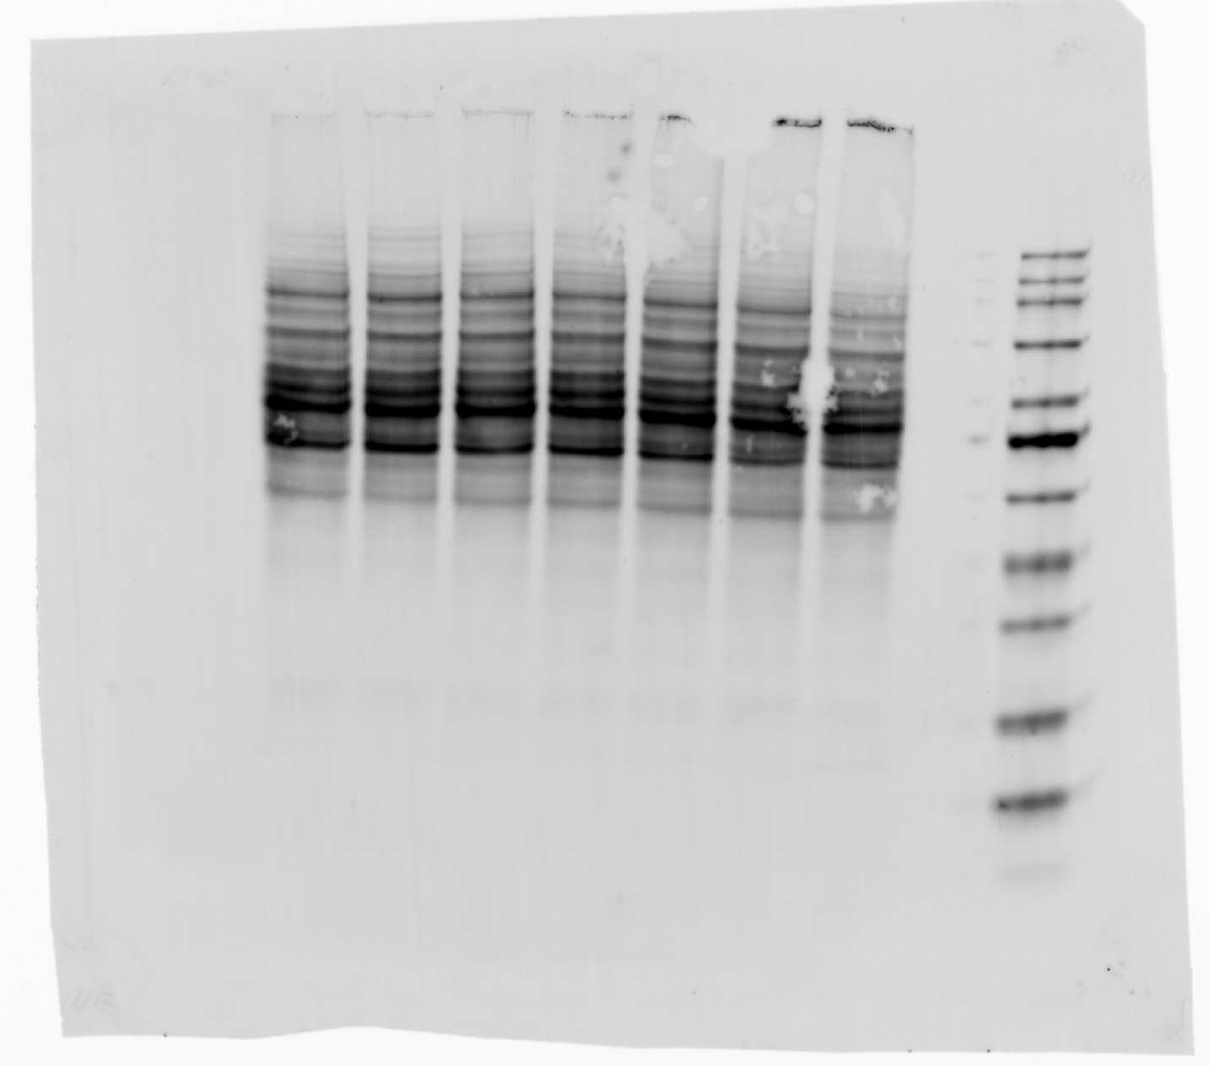

Fig. S3. Original image of the oxyblot western image displayed in Figure 9A of the main text.

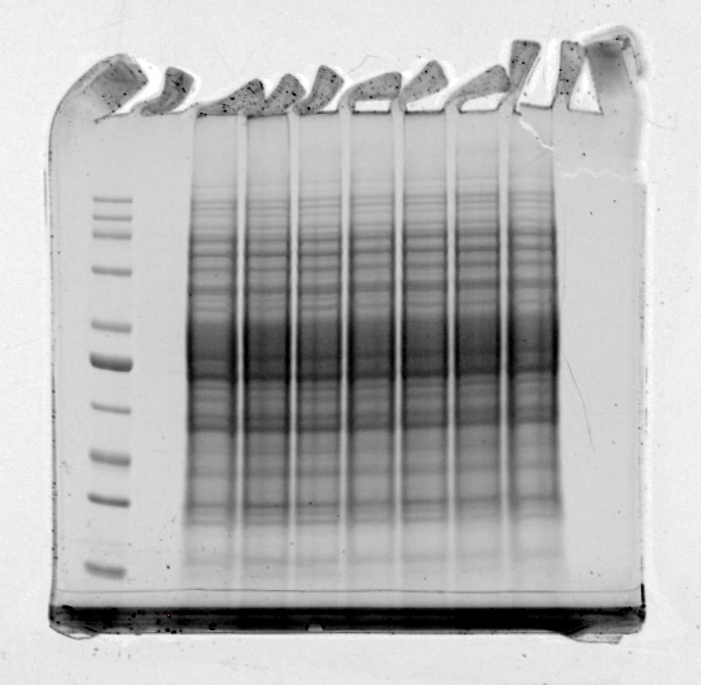
Fig. S4. Original image of the Coomassie-stained SDS-Page gel displayed in Figure 9B of the main text.

