Appendix
Dataset description and attribute analysis
The house prices dataset has 81 attributes including the response variable sales price and 1461 elements. In the figure below, we present the statistical analysis of the training data. We also present basic information about the dataset in the Table below. In data analysis, the study separated numerical and non-numerical attributes from the dataset. The numerical attributes were considered for further analysis.
Table 1: Dataset used for this study
sn | Attribute name | Non-Null Count | Dtype | Description
1 | Id | 1460 non-null | int64 | Item Id number
2 | MSSubClass | 1460 non-null | int64 | The building class
3 | MSZoning | 1460 non-null | object | The general zoning classification
4 | LotFrontage | 1201 non-null | float64 | Linear feet of street connected to property
5 | LotArea | 1460 non-null | int64 | Lot size in square feet
6 | Street | 1460 non-null | object | Type of road access
7 | Alley | 1460 non-null | object | Type of alley access
8 | LotShape | 1460 non-null | object | General shape of property
9 | LandContour | 1460 non-null | object | Flatness of the property
10 | Utilities | 1460 non-null | object | Type of utilities available
11 | LotConfig | 1460 non-null | object | Lot configuration
12 | LandSlope | 1460 non-null | object | Slope of property
13 | Neighborhood | 1460 non-null | object | Physical locations within Ames city limits
14 | Condition1 | 1460 non-null | object | - Proximity to main road or railroad
15 | Condition2 | 1460 non-null | object | Proximity to main road or railroad (if a second is present)
16 | BldgType | 1460 non-null | object | Type of dwelling
17 | HouseStyle | 1460 non-null | object | Style of dwelling
18 | OverallQual | 1460 non-null | int64 | - Overall material and finish quality
19 | OverallCond | 1460 non-null | int64 | Overall condition rating
20 | YearBuilt | 1460 non-null | int64 | Original construction date
21 | YearRemodAdd | 1460 non-null | int64 | Remodel date
22 | RoofStyle | 1460 non-null | object | Type of roof
23 | RoofMatl | 1460 non-null | object | Roof material
24 | Exterior1st | 1460 non-null | object | - Exterior covering on house
25 | Exterior2nd | 1460 non-null | object | Exterior covering on house (if more than one material)
26 | MasVnrType | 1460 non-null | object | Masonry veneer type
27 | MasVnrArea | 1452 non-null | float64 | Masonry veneer area in square feet
28 | ExterQual | 1460 non-null | object | Exterior material quality
29 | ExterCond | 1460 non-null | object | - Present condition of the material on the exterior
30 | Foundation | 1460 non-null | object | Type of foundation
31 | BsmtQual | 1460 non-null | object | Height of the basement
32 | BsmtCond | 1460 non-null | object | - General condition of the basement
33 | BsmtExposure | 1460 non-null | object | Walkout or garden level basement walls
34 | BsmtFinType1 | 1460 non-null | object | - Quality of basement finished area
35 | BsmtFinSF1 | 1460 non-null | int64 | - Type 1 finished square feet
36 | BsmtFinType2 | 1460 non-null | object | Quality of second finished area (if present)
37 | BsmtFinSF2 | 1460 non-null | int64 | Type 2 finished square feet
38 | BsmtUnfSF | 1460 non-null | int64 | Unfinished square feet of basement area
39 | TotalBsmtSF | 1460 non-null | int64 | Total square feet of basement area
40 | Heating | 1460 non-null | object | Type of heating
41 | HeatingQC | 1460 non-null | object | Heating quality and condition
42 | CentralAir | 1460 non-null | object | Central air conditioning
43 | Electrical | 1460 non-null | object | Electrical system
44 | 1stFlrSF | 1460 non-null | int64 | First Floor square feet
45 | 2ndFlrSF | 1460 non-null | int64 | Second floor square feet
46 | LowQualFinSF | 1460 non-null | int64 | Low quality finished square feet (all floors)
47 | GrLivArea | 1460 non-null | int64 | Above grade (ground) living area square feet
48 | BsmtFullBath | 1460 non-null | int64 | Basement full bathrooms
49 | BsmtHalfBath | 1460 non-null | int64 | Basement half bathrooms
50 | FullBath | 1460 non-null | int64 | Full bathrooms above grade
51 | HalfBath | 1460 non-null | int64 | Half baths above grade
52 | BedroomAbvGr | 1460 non-null | int64 | Bedrooms above grade (does NOT include basement bedrooms)
53 | KitchenAbvGr | 1460 non-null | int64 | Kitchens above grade
54 | KitchenQual | 1460 non-null | object | Kitchen quality
55 | TotRmsAbvGrd | 1460 non-null | int64 | Total rooms above grade
56 | Functional | 1460 non-null | object | Home functionality rating
57 | Fireplaces | 1460 non-null | int64 | Number of fireplaces
58 | FireplaceQu | 1460 non-null | object | Fireplace quality
59 | GarageType | 1460 non-null | object | Garage location
60 | GarageYrBlt | 1379 non-null | float64 | Year garage was built
61 | GarageFinish | 1460 non-null | object | Interior finish of the garage
62 | GarageCars | 1460 non-null | int64 | Size of garage in car capacity
63 | GarageArea | 1460 non-null | int64 | Size of garage in square feet
64 | GarageQual | 1460 non-null | object | Garage quality
65 | GarageCond | 1460 non-null | object | Garage condition
66 | PavedDrive | 1460 non-null | object | Paved driveway
67 | WoodDeckSF | 1460 non-null | int64 | Wood deck area in square feet
68 | OpenPorchSF | 1460 non-null | int64 | Open porch area in square feet
69 | EnclosedPorch | 1460 non-null | int64 | Enclosed porch area in square feet
70 | 3SsnPorch | 1460 non-null | int64 | Three season porch area in square feet
71 | ScreenPorch | 1460 non-null | int64 | Screen porch area in square feet
72 | PoolArea | 1460 non-null | int64 | Pool area in square feet
73 | PoolQC | 1460 non-null | object | Pool quality
74 | Fence | 1460 non-null | object | Fence quality
75 | MiscFeature | 1460 non-null | object | Miscellaneous feature not covered in other categories
76 | MiscVal | 1460 non-null | int64 | Value of miscellaneous feature
77 | MoSold | 1460 non-null | int64 | Month Sold
78 | YrSold | 1460 non-null | int64 | Year Sold
79 | SaleType | 1460 non-null | object | Year Sold
80 | SaleCondition | 1460 non-null | object | Condition of sale
81 | SalePrice | 1460 non-null | int64 | The property's sale price in dollars. This is the target variable that you're trying to predict.

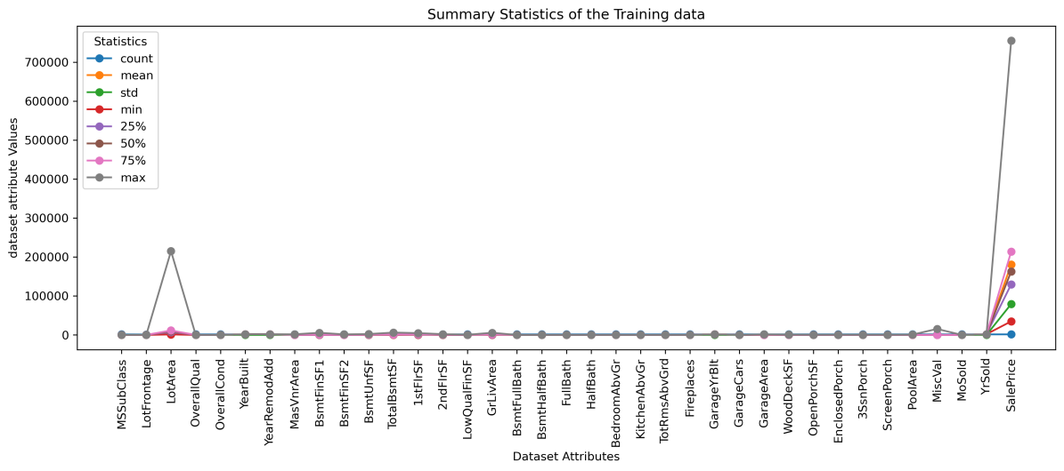
Figure 1: Summary statistical measure of the training data
In this study, we considered the numerical attributes using numeric_data <- data[, sapply(data, is.numeric)]. The data preprocessing identified 348 null values using sum(is.na(dat2)) and was removed from the dataset using processed_data <- na.omit(data)

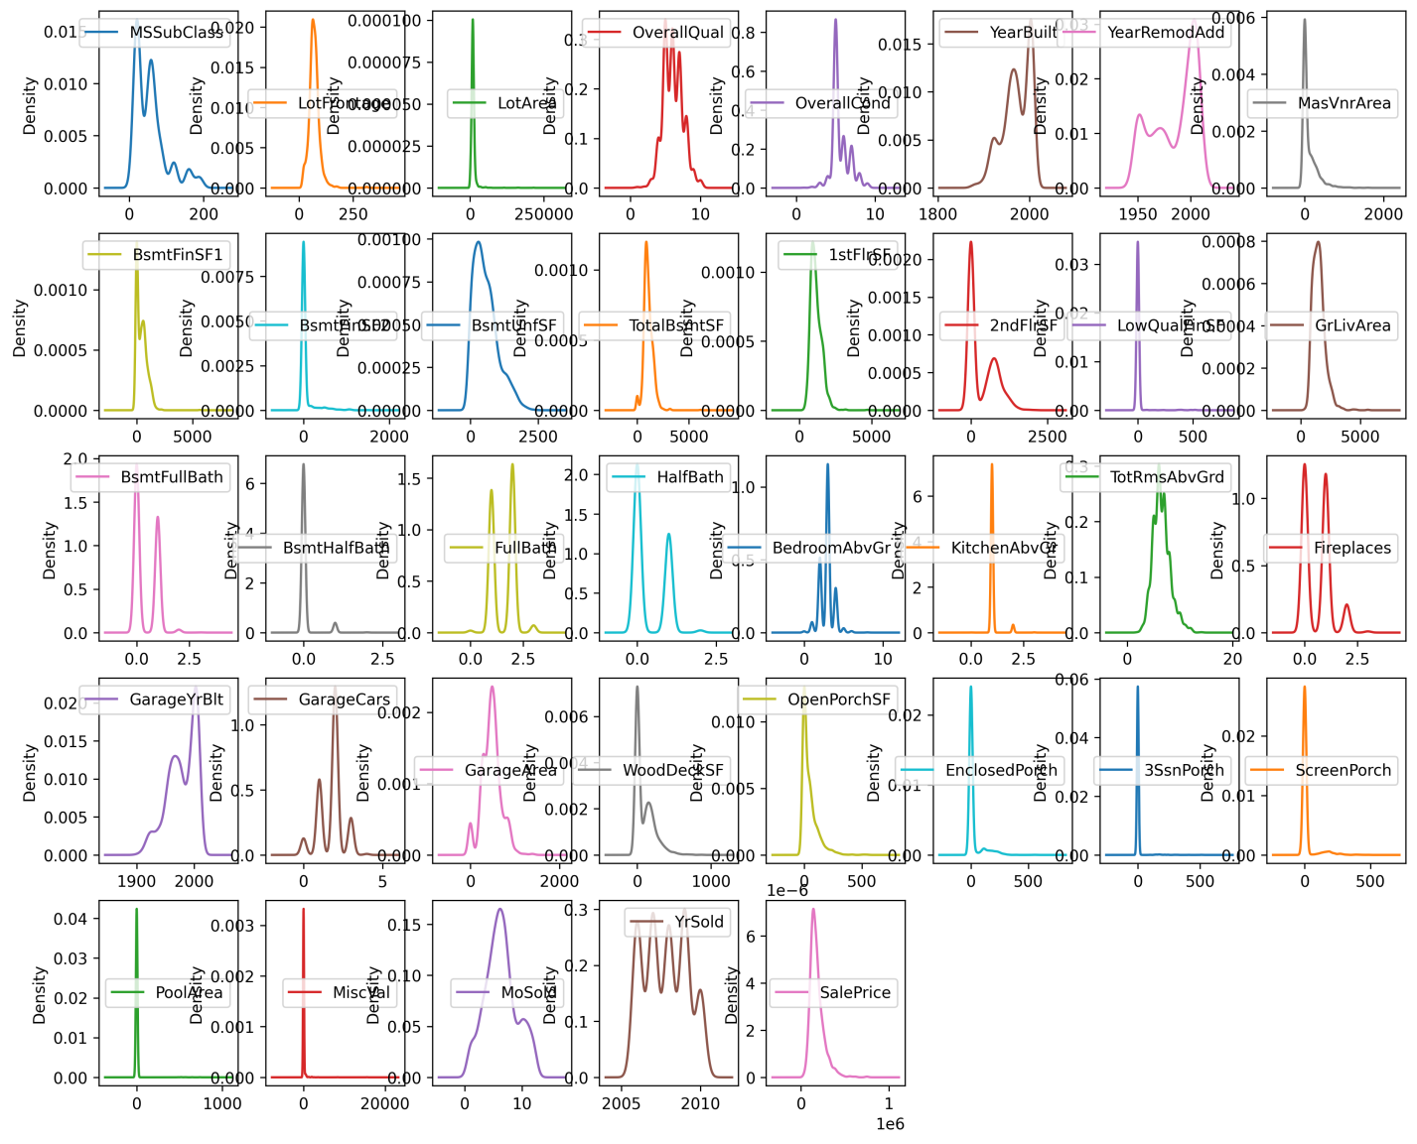
Figure 2: Density plot showing the distribution of the dataset
The study analyzed the distribution of target (response) variable and found that it’s skewed as in figure 3. This indicated that there are a small number whose prices are high while the big number of houses is relatively at low price. Therefore, we normalized the distribution using the log transform on target variable to make the distribution stable so that the model performance can be improve as in Figure 4
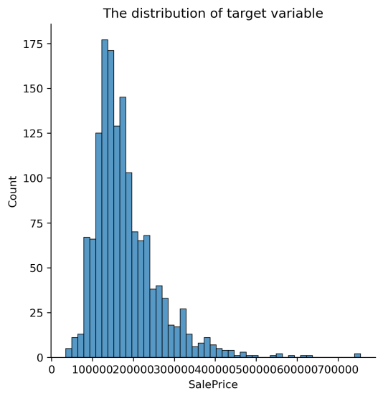
Figure 3: The distribution of target variable before being transformed

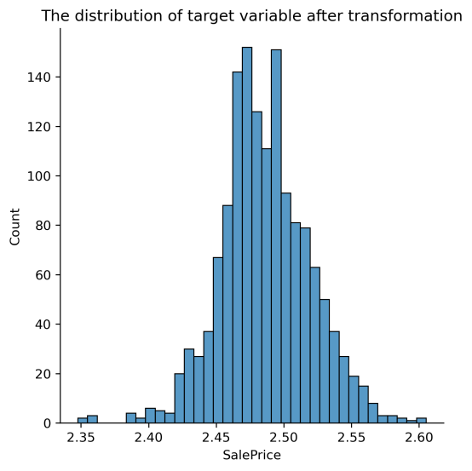
Figure 4: The distribution of target variable after transformation
Data preparation and preprocessing
In data preprocessing, we identified the numerical attributes using is.numeric in R. The 37 numeric attributes were identified and prepared for training the model. The future importance was performed to identify the features which are contributing to the prediction of response variable using Random Forest Regressor as shown in Figure 5. On the other hand, MARS have the ability to automatically perform feature importance during training. Therefore, it also performed feature importance showing the variables which have been used to predict the response variable or during the construction on basis functions. The variables which have been used during the model training are shown on the feature importance plot on Figure 6.
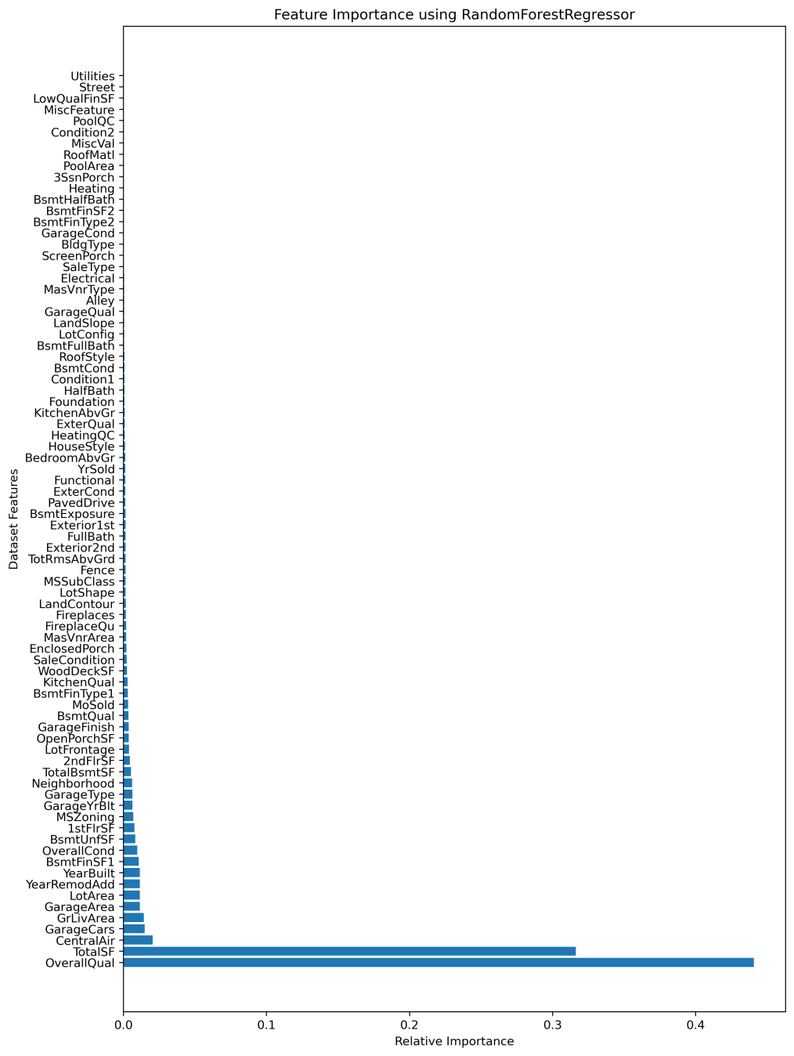
Figure 5: Feature Importance performed using random forest regressor
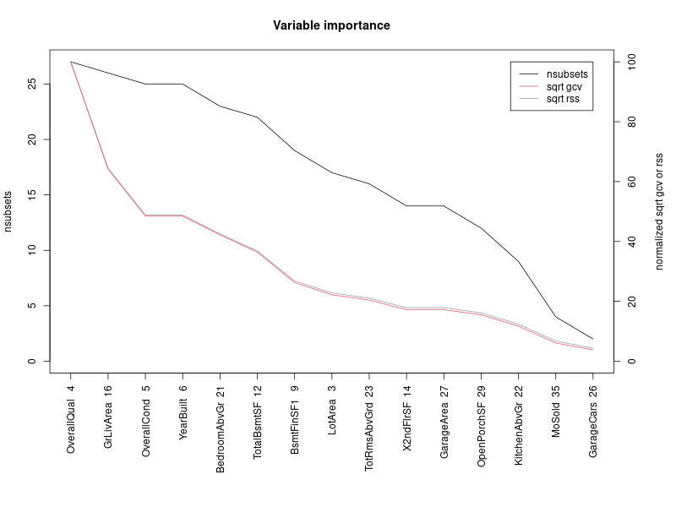
Figure 6: Important features identified during MARS Training
Table 2: The Description of MARS identified important features
OverallQual | Rates the overall material and finish of the house
GrLivArea | Above grade (ground) living area square feet
OverallCond | Overall condition rating
YearBuilt | Original construction date
BedroomabvGr | Bedrooms above grade (does NOT include basement bedrooms)
TotalBsmtSF | Total square feet of basement area
BsmFinSF1 | Type 1 finished square feet
LotArea | Lot size in square feet
TotRmsAbvGrd | Total rooms above grade (does not include bathrooms)
X2ndFlrSF | Second floor square feet
GarageArea | Size of garage in square feet
OpenPorchSF | Open porch area in square feet
KitchenAbvGr | Kitchens above grade
Mosold | Month sold
GarageCars | Size of garage in car capacity

Figure 6 shows the key factors on different levels that can influence the sale Sale Price of a house and Table provides the description of each factor identified to be influencing the price of the house
Experiments on MARS
Resampling results across tuning parameters:

Degree | nprune |  |  | RMSE |  | Rsquared |  |  | MAE
1 | 10 |  |  | 34293.40 |  | 0.9041211 |  |  | 21808.24
1 | 11 |  |  | 33454.88 |  | 0.9030742 |  |  | 21022.95
1 | 12 |  |  | 33386.26 |  | 0.90832453 |  |  | 20765.53
1 | 13 |  |  | 33038.05 |  | 0.9070385 |  |  | 20362.40
1 | 14 |  |  | 32886.73 |  | 0.9084994 |  |  | 20014.20
1 | 15 |  |  | 33004.31 |  | 0.9078057 |  |  | 19885.26
1 | 16 |  |  | 32557.76 |  | 0. 9022143 |  |  | 19594.52
1 | 17 |  |  | 32168.84 |  | 0.9054595 |  |  | 19515.73
1 | 18 |  |  | 32612.80 |  | 0.9014233 |  |  | 19477.32
1 | 19 |  |  | 32500.30 |  | 0.9024608 |  |  | 19411.78
1 | 20 |  |  | 32604.38 |  | 0.9010727 |  |  | 19473.81
1 | 21 |  |  | 32429.55 |  | 0.9019309 |  |  | 19452.11
1 | 22 |  |  | 32389.42 |  | 0.9022120 |  |  | 19329.76
1 | 23 |  |  | 32449.37 |  | 0.8919478 |  |  | 19397.72
1 | 24 |  |  | 32450.22 |  | 0.8919371 |  |  | 19415.67
1 | 25 |  |  | 32459.59 |  | 0.8919131 |  |  | 19377.12
1 | 26 |  |  | 32398.27 |  | 0.8931196 |  |  | 19314.30
1 | 27 |  |  | 32367.78 |  | 0.9034310 |  |  | 19304.21
1 | 28 |  |  | 32500.40 |  | 0.8919618 |  |  | 19364.37
1 | 29 |  |  | 32496.56 |  | 0.8921807 |  |  | 19362.67
1 | 30 |  |  | 32460.50 |  | 0.9025881 |  |  | 19336.73
1 | 31 |  |  | 32437.69 |  | 0.8927447 |  |  | 19322.86
1 | 32 |  |  | 32466.20 |  | 0.8924333 |  |  | 19328.81
1 | 33 |  |  | 32468.42 |  | 0.8923756 |  |  | 19331.03
1 | 34 |  |  | 32468.42 |  | 0.8923756 |  |  | 19331.03
1 |  |  | 35 |  | 32468.42 |  | 0.8923756 | 19331.03
1 |  |  | 36 |  | 32468.42 |  | 0.8923756 | 19331.03
1 |  |  | 37 |  | 32468.42 |  | 0.8923756 | 19331.03
1 |  |  | 38 |  | 32468.42 |  | 0.8923756 | 19331.03
1 |  |  | 39 |  | 32468.42 |  | 0.8523756 | 19331.03
1 |  |  | 40 |  | 32468.42 |  | 0.8923756 | 19331.03
1 |  |  | 41 |  | 32468.42 |  | 0.8923756 | 19331.03
1 |  |  | 42 |  | 32468.42 |  | 0.8823756 | 19331.03
1 |  |  | 43 |  | 32468.42 |  | 0.8923756 | 19331.03
1 |  |  | 44 |  | 32468.42 |  | 0.8923756 | 19331.03
1 |  |  | 45 |  | 32468.42 |  | 0.8923756 | 19331.03
1 |  |  | 46 |  | 32468.42 |  | 0.8823756 | 19331.03
1 |  |  | 47 |  | 32468.42 |  | 0.8823756 | 19331.03
1 |  |  | 48 |  | 32468.42 |  | 0.8723756 | 19331.03
1 |  |  | 49 |  | 32468.42 |  | 0.8823756 | 19331.03
1 |  |  | 50 |  | 32468.42 |  | 0.8523756 | 19331.03
2 |  |  | 10 |  | 47151.89 |  | 0.8516222 | 23397.57
2 |  |  | 11 |  | 46136.92 |  | 0.8573079 | 22605.49
2 |  |  | 12 |  | 45932.74 |  | 0.8669924 | 22151.81
2 |  |  | 13 |  | 43893.49 |  | 0.8721450 | 21579.29
2 |  |  | 14 |  | 43155.41 |  | 0.8745059 | 21194.22
2 |  |  | 15 |  | 42174.04 |  | 0.8802095 | 20796.19
2 |  |  | 16 |  | 42090.99 |  | 0.8816532 | 20765.64
2 |  |  | 17 |  | 42288.24 |  | 0.8806418 | 20597.94
2 |  |  | 18 |  | 41951.92 |  | 0.8822426 | 20401.49
2 |  |  | 19 |  | 42618.16 |  | 0.8827628 | 20182.01
2 |  |  | 20 |  | 42252.17 |  | 0.8857051 | 19995.87
2 |  |  | 21 |  | 42384.62 |  | 0.8861660 | 19958.37
2 |  | 22 |  |  | 42316.57 |  | 0.8871086 | 19833.12
2 |  | 23 |  |  | 37113.43 |  | 0.8661942 | 19043.22
2 |  | 24 |  |  | 35454.30 |  | 0.8790521 | 18903.00
2 |  | 25 |  |  | 34156.92 |  | 0.8513890 | 18536.35
2 |  | 26 |  |  | 36294.06 |  | 0.8515251 | 19096.36
2 |  | 27 |  |  | 35707.19 |  | 0.8770378 | 18884.81
2 |  | 28 |  |  | 35151.43 |  | 0.8520449 | 18724.58
2 |  | 29 |  |  | 35525.89 |  | 0.8590108 | 18788.63
2 |  | 30 |  |  | 36018.71 |  | 0.8447379 | 18941.50
2 |  | 31 |  |  | 35847.63 |  | 0.8666529 | 18880.09
2 |  | 32 |  |  | 38033.50 |  | 0.8583366 | 19170.60
2 |  | 33 |  |  | 38313.18 |  | 0.8666597 | 19229.20
2 |  | 34 |  |  | 37871.56 |  | 0.8503248 | 19102.16
2 |  | 35 |  |  | 37925.16 |  | 0.8599100 | 19106.68
2 |  | 36 |  |  | 37925.16 |  | 0.8599100 | 19106.68
2 |  | 37 |  |  | 37925.16 |  | 0.8599100 | 19106.68
2 |  | 38 |  |  | 37925.16 |  | 0.8599100 | 19106.68
2 |  | 39 |  |  | 37925.16 |  | 0.8599100 | 19106.68
2 |  | 40 |  |  | 37925.16 |  | 0.8599100 | 19106.68
2 |  | 41 |  |  | 37925.16 |  | 0.8599100 | 19106.68
2 |  | 42 |  |  | 37925.16 |  | 0.8599100 | 19106.68
2 |  | 43 |  |  | 37925.16 |  | 0.8599100 | 19106.68
2 |  | 44 |  |  | 37925.16 |  | 0.8599100 | 19106.68
2 |  | 45 |  |  | 37925.16 |  | 0.8599100 | 19106.68
2 |  | 46 |  |  | 37925.16 |  | 0.8599100 | 19106.68
2 |  | 47 |  |  | 37925.16 |  | 0.8599100 | 19106.68
2 |  | 49 |  |  | 37925.16 |  | 0.8599100 | 19106.68
2 |  | 50 |  |  | 37925.16 |  | 0.8599100 | 19106.68
3 |  | 10 |  |  | 41553.87 |  | 0.8790554 | 22683.83
3 |  | 11 |  |  | 38675.50 |  | 0.8990180 | 21666.80
3 |  | 12 |  |  | 38493.89 |  | 0.8704677 | 21145.99
3 |  | 13 |  |  | 41370.37 |  | 0.8862993 | 21010.03
3 |  | 14 |  |  | 41552.05 |  | 0.8842114 | 20992.04
3 |  | 15 |  |  | 38354.58 |  | 0.8345301 | 20811.99
3 |  | 16 |  |  | 37743.65 |  | 0.8497761 | 20292.56
3 |  | 17 |  |  | 37587.74 |  | 0.8213465 | 19978.63
3 |  | 18 |  |  | 36299.77 |  | 0.8607405 | 19636.59
3 |  | 19 |  |  | 35863.73 |  | 0.8248480 | 19398.62
3 |  | 20 |  |  | 35104.94 |  | 0.8303142 | 19141.62
3 |  | 21 |  |  | 35369.99 |  | 0.8292528 | 18938.62
3 |  | 22 |  |  | 34649.63 |  | 0.8341742 | 18698.13
3 |  | 23 |  |  | 34486.88 |  | 0.8364184 | 18740.45
3 |  | 24 |  |  | 34508.25 |  | 0.8385464 | 18733.27
3 |  | 25 |  |  | 35559.59 |  | 0.8311868 | 18766.13
3 |  | 26 |  |  | 35273.72 |  | 0.8336731 | 18601.44
3 |  | 27 |  |  | 35606.41 |  | 0.8289741 | 18748.05
3 |  | 28 |  |  | 35556.17 |  | 0.8296903 | 18655.81
3 |  | 29 |  |  | 32679.79 |  | 0.8504015 | 18203.37
3 |  | 30 |  |  | 32767.11 |  | 0.8498822 | 18175.85
3 |  | 31 |  |  | 32576.49 |  | 0.8511001 | 18051.54
3 |  | 32 |  |  | 32841.95 |  | 0.8488201 | 18024.35
3 |  | 33 |  |  | 33125.94 |  | 0.8471004 | 17993.41
3 |  | 34 |  |  | 33096.80 |  | 0.8481514 | 17998.77
3 |  | 35 |  |  | 32958.42 |  | 0.8489974 | 17899.55
3 |  | 36 |  |  | 32961.77 |  | 0.8489813 | 17873.56
3 |  | 37 |  |  | 32754.30 |  | 0.8508229 | 17836.44
3 |  | 38 |  |  | 32735.63 |  | 0.8510781 | 17844.03
3 |  | 39 |  |  | 32751.96 |  | 0.8510294 | 17844.63
3 |  | 40 |  |  | 32751.96 |  | 0.8510294 | 17844.63
3 |  | 41 |  |  | 32751.96 |  | 0.8510294 | 17844.63
3 |  | 42 |  |  | 32751.96 |  | 0.8510294 | 17844.63
3 |  | 43 |  |  | 32751.96 |  | 0.8510294 | 17844.63
3 |  | 44 |  |  | 32751.96 |  | 0.8510294 | 17844.63
3 |  | 45 |  |  | 32751.96 |  | 0.8510294 | 17844.63
3 |  | 46 |  |  | 32751.96 |  | 0.8510294 | 17844.63
3 |  | 47 |  |  | 32751.96 |  | 0.8510294 | 17844.63
3 |  | 48 |  |  | 32751.96 |  | 0.8510294 | 17844.63
3 |  | 49 |  |  | 32751.96 |  | 0.8510294 | 17844.63
3 |  | 50 |  |  | 32751.96 |  | 0.8510294 | 17844.63

RMSE was used to select the optimal model using the smallest value.
The final values used for the model were nprune = 15 and degree = 1.

[1] "Metrics for each fold of cross-validation:"

Iteration | RMSE |  |  | MSE |  | Rsquared
1 | 34293.40 |  |  | 1176037551 |  | 0.8919371
2 | 47151.89 |  |  | 2223300943 |  | 0.8919131
3 | 41553.87 |  |  | 1726724526 |  | 0.8931196
4 | 33454.88 |  |  | 1119228713 |  | 0.9034310
5 | 46136.92 |  |  | 2128615044 |  | 0.8919618
6 | 38675.50 |  |  | 1495794527 |  | 0.8990180
7 | 33386.26 |  |  | 1114642102 |  | 0.8432453
8 | 45932.74 |  |  | 2109816372 |  | 0.8669924
9 | 38493.89 |  |  | 1481779764 |  | 0.9004677
10 | 33038.05 |  |  | 1091512473 |  | 0.8470385
11 | 43893.49 |  |  | 1926638324 |  | 0.8721450
12 | 41370.37 |  |  | 1711507605 |  | 0.8862993
13 | 32886.73 |  |  | 1081537327 |  | 0.8484994
14 | 43155.41 |  |  | 1862389653 |  | 0.8745059
15 | 41552.05 |  |  | 1726573045 |  | 0.8842114
16 | 33004.31 |  |  | 1089284674 |  | 0.8478057
17 | 42174.04 |  |  | 1778649417 |  | 0.7802095
18 | 38354.58 |  |  | 1471073526 |  | 0.8045301
19 | 32557.76 |  |  | 1060007793 |  | 0.8522143
20 | 42090.99 |  |  | 1771651740 |  | 0.7816532
21 | 37743.65 |  |  | 1424583416 |  | 0.8097761
22 | 32168.84 |  |  | 1034834253 |  | 0.8554595
23 | 42288.24 |  |  | 1788295406 |  | 0.7806418
24 | 37587.74 |  |  | 1412838059 |  | 0.8113465
25 | 32612.80 |  |  | 1063594993 |  | 0.8514233
26 | 41951.92 |  |  | 1759963428 |  | 0.7822426
27 | 36299.77 |  |  | 1317673299 |  | 0.8207405
28 | 32500.30 |  |  | 1056269603 |  | 0.8524608
29 | 42618.16 |  |  | 1816307143 |  | 0.7827628
30 | 35863.73 |  |  | 1286207140 |  | 0.8248480
31 | 32604.38 |  |  | 1063045645 |  | 0.8510727
32 | 42252.17 |  |  | 1785245904 |  | 0.7857051
33 | 35104.94 |  |  | 1232356606 |  | 0.8303142
34 | 32429.55 |  |  | 1051676027 |  | 0.8519309
35 | 42384.62 |  |  | 1796455800 |  | 0.7861660
36 | 35369.99 |  |  | 1251036019 |  | 0.8292528
37 | 32389.42 |  |  | 1049074558 |  | 0.8522120
38 | 42316.57 |  |  | 1790691925 |  | 0.7871086
39 | 34649.63 |  |  | 1200596663 |  | 0.8341742
40 | 32449.37 |  |  | 1052961617 |  | 0.8519478
41 | 37113.43 |  |  | 1377406749 |  | 0.8161942
42 | 34486.88 |  |  | 1189344996 |  | 0.8364184
43 | 32450.22 |  |  | 1053016684 |  | 0.8519371
44 | 35454.30 |  |  | 1257007266 |  | 0.8290521
45 | 34508.25 |  |  | 1190819330 |  | 0.8385464
46 | 32459.59 |  |  | 1053625301 |  | 0.8519131
47 | 34156.92 |  |  | 1166695026 |  | 0.8413890
48 | 35559.59 |  |  | 1264484464 |  | 0.8311868
49 | 32398.27 |  |  | 1049647666 |  | 0.8531196
50 | 36294.06 |  |  | 1317258567 |  | 0.8215251
51 | 35273.72 |  |  | 1244235348 |  | 0.8336731
52 | 32367.78 |  |  |  | 1047673383 |  | 0.8534310
53 | 35707.19 |  |  |  | 1275003389 |  | 0.8270378
54 | 35606.41 |  |  |  | 1267816395 |  | 0.8289741
55 | 32500.40 |  |  |  | 1056275780 |  | 0.8519618
56 | 35151.43 |  |  |  | 1235623323 |  | 0.8320449
57 | 35556.17 |  |  |  | 1264241324 |  | 0.8296903
58 | 32496.56 |  |  |  | 1056026467 |  | 0.8521807
59 | 35525.89 |  |  |  | 1262088731 |  | 0.8290108
60 | 32679.79 |  |  |  | 1067968658 |  | 0.8504015
61 | 32460.50 |  |  |  | 1053684320 |  | 0.8525881
62 | 36018.71 |  |  |  | 1297347114 |  | 0.8247379
63 | 32767.11 |  |  |  | 1073683700 |  | 0.8498822
64 | 32437.69 |  |  |  | 1052203909 |  | 0.8527447
65 | 35847.63 |  |  |  | 1285052382 |  | 0.8266529
66 | 32576.49 |  |  |  | 1061227626 |  | 0.8511001
67 | 32466.20 |  |  |  | 1054054014 |  | 0.8524333
68 | 38033.50 |  |  |  | 1446547025 |  | 0.8083366
69 | 32841.95 |  |  |  | 1078593494 |  | 0.8488201
70 | 32468.42 |  |  |  | 1054198346 |  | 0.8523756
71 | 38313.18 |  |  |  | 1467899995 |  | 0.8066597
72 | 33125.94 |  |  |  | 1097327986 |  | 0.8471004
73 | 32468.42 |  |  |  | 1054198346 |  | 0.8523756
74 | 37871.56 |  |  |  | 1434255258 |  | 0.8103248
75 | 33096.80 |  |  |  | 1095397891 |  | 0.8481514
76 | 32468.42 |  |  |  | 1054198346 |  | 0.8523756
77 | 37925.16 |  |  |  | 1438317523 |  | 0.8099100
78 | 32958.42 |  |  |  | 1086257279 |  | 0.8489974
79 | 32468.42 |  |  |  | 1054198346 |  | 0.8523756
80 | 37925.16 |  |  |  | 1438317523 |  | 0.8099100
81 | 32961.77 |  |  |  | 1086478339 |  | 0.8489813
82 | 32468.42 |  |  |  | 1054198346 |  | 0.8523756
83 | 37925.16 |  |  |  | 1438317523 |  | 0.8099100
84 | 32754.30 |  |  |  | 1072844439 |  | 0.8508229
85 | 32468.42 |  |  |  | 1054198346 |  | 0.8523756
86 | 37925.16 |  |  |  | 1438317523 |  | 0.8099100
87 | 32735.63 |  |  |  | 1071621723 |  | 0.8510781
88 | 32468.42 |  |  |  | 1054198346 |  | 0.8523756
89 | 37925.16 |  |  |  | 1438317523 |  | 0.8099100
90 | 32751.96 |  |  |  | 1072690796 |  | 0.8510294
91 | 32468.42 |  |  |  | 1054198346 |  | 0.8523756
92 | 37925.16 |  |  |  | 1438317523 |  | 0.8099100
93 | 32751.96 |  |  |  | 1072690796 |  | 0.8510294
94 | 32468.42 |  |  |  | 1054198346 |  | 0.8523756
95 | 37925.16 |  |  |  | 1438317523 |  | 0.8099100
96 | 32751.96 |  |  |  | 1072690796 |  | 0.8510294
97 | 32468.42 |  |  |  | 1054198346 |  | 0.8523756
98 | 37925.16 |  |  |  | 1438317523 |  | 0.8099100
99 | 32751.96 |  |  |  | 1072690796 |  | 0.8510294
100 | 32468.42 |  |  |  | 1054198346 |  | 0.8523756
101 | 37925.16 |  |  |  | 1438317523 |  | 0.8099100
102 | 32751.96 |  |  |  | 1072690796 |  | 0.8510294
103 | 32468.42 |  |  |  | 1054198346 |  | 0.8523756
104 | 37925.16 |  |  |  | 1438317523 |  | 0.8099100
105 |  | 32751.96 | 1072690796 |  |  |  |  | 0.8510294
106 |  | 32468.42 | 1054198346 |  |  |  |  | 0.8523756
107 |  | 37925.16 | 1438317523 |  |  |  |  | 0.8099100
108 |  | 32751.96 | 1072690796 |  |  |  |  | 0.8510294
109 |  | 32468.42 | 1054198346 |  |  |  |  | 0.8523756
110 |  | 37925.16 | 1438317523 |  |  |  |  | 0.8099100
111 |  | 32751.96 | 1072690796 |  |  |  |  | 0.8510294
112 |  | 32468.42 | 1054198346 |  |  |  |  | 0.8523756
113 |  | 37925.16 | 1438317523 |  |  |  |  | 0.8099100
114 |  | 32751.96 | 1072690796 |  |  |  |  | 0.8510294
115 |  | 32468.42 | 1054198346 |  |  |  |  | 0.8523756
116 |  | 37925.16 | 1438317523 |  |  |  |  | 0.8099100
117 |  | 32751.96 | 1072690796 |  |  |  |  | 0.8510294
118 |  | 32468.42 | 1054198346 |  |  |  |  | 0.8523756
119 |  | 37925.16 | 1438317523 |  |  |  |  | 0.8099100
120 |  | 32751.96 | 1072690796 |  |  |  |  | 0.8510294
121 |  | 32468.42 | 1054198346 |  |  |  |  | 0.8523756
122 |  | 37925.16 | 1438317523 |  |  |  |  | 0.8099100
123 |  | 32751.96 | 1072690796 |  |  |  |  | 0.8510294

Memory used before execution: 193521571
Memory used after execution: 193521069
Memory used during execution: -502

Average RMSE: 33716.52
Average MSE: 1274407708
Average R²: 0.8955803
Time difference of 43.35262 sec

