1.1 Appendix 1
Table 7. Area of flow classes
Serial No. | Flow (m³/s) | Area (km²) | Area (%)
1 | ≤ 220 | 7812.91 | 43.18
2 | 221 to 300 | 4906.32 | 27.12
3 | 301 to 350 | 1403 | 7.75
4 | 351 to 400 | 1165.36 | 6.44
5 | 401 to 450 | 381.02 | 2.11
6 | 451 to 500 | 625.86 | 3.46
7 | > 500 | 1799.59 | 9.95

Table 8. Area of depth classes
Serial No. | Depth (m) | Area (km²) | Area (%)
1 | ≤ 4 | 1706.9 | 9.43
2 | 5 to 7 | 6452.67 | 35.66
3 | 8 to 10 | 3577.89 | 19.77
4 | 11 to 14 | 3815.43 | 21.09
5 | 15 to 17 | 1234.45 | 6.82
6 | 18 to 20 | 838.4 | 4.63
7 | > 20 | 468.33 | 2.59

Table 9. Area of width classes
Serial No. | Width (m) | Area (km²) | Area (%)
1 | ≤ 200 | 1453.29 | 8.03
2 | 201 to 250 | 2706.77 | 14.96
3 | 251 to 300 | 4715.16 | 26.06
4 | 301 to 350 | 4330.66 | 23.93
5 | 351 to 400 | 2424.20 | 13.40
6 | > 400 | 2463.98 | 13.62

Table 10. Area of precipitation classes
Serial No. | Precipitation (mm) | Area (km²) | Area (%)
1 | < 950 | 3736.97 | 20.65
2 | 951 to 1000 | 3378.50 | 18.67
3 | 1001 to 1200 | 8129.28 | 44.93
4 | 1201 to 1500 | 2094.11 | 11.57
5 | > 1500 | 755.20 | 4.17
Table 11. Area of Land Use Land Cover (LULC) classes
Serial No. | LULC Class | Area (km²) | Area (%)
1 | River | 688.61 | 3.81
2 | Sandbar | 486.22 | 2.69
3 | Island | 192.13 | 1.06
4 | Barrenland | 793.20 | 4.38
5 | Waterbody | 749.36 | 4.14
6 | Forest | 1161.92 | 6.42
7 | Agriculture | 12856.47 | 71.05
8 | Builtup | 1103.00 | 6.10
9 | Grassland | 63.15 | 0.35

Table 12. Area of geomorphology classes
Serial No. | Geomorphology | Area (km²) | Area (%)
1 | Flood Plain | 8407.69 | 46.47
2 | Waterbody | 212.16 | 1.17
3 | Alluvial Plain | 8756.19 | 48.39
4 | River | 350.38 | 1.94
5 | Pediment Pediplain Complex | 197.47 | 1.09
6 | Dam and Reservoir | 46.10 | 0.25
7 | Moderately Dissected Plateau | 47.01 | 0.26
8 | Highly Dissected Hills and Valleys | 76.90 | 0.42
9 | Moderately Dissected Hills and Valleys | 0.15 | 0.0008

Table 13. Area of soil texture classes
Serial No. | Soil texture | Area (km²) | Area (%)
1 | Loamy Skeletal | 48.71 | 0.27
2 | Loamy | 9231.88 | 51.02
3 | Sandy | 8082.38 | 44.67
4 | Clayey | 731.09 | 4.04

Table 14. Area of parent material classes
Serial No. | Parent material | Area (km²) | Area (%)
1 | Colluvium | 193.61 | 1.07
2 | Alluvium | 17260.65 | 95.39
3 | Sandstone | 639.8 | 3.54

Table 15. Area of mineral classes
Serial No. | Mineral | Area (km²) | Area (%)
1 | Smectite mixed mineral | 17524.99 | 96.85
2 | Illite mineral | 548.30 | 3.03
3 | Montmorillonite | 20.77 | 0.11

Table 16. Area of drainage density classes
Serial No. | Drainage Density | Area (km²) | Area (%)
1 | < 0.8 | 303.07 | 1.67
2 | 0.9 to 1.0 | 2737.54 | 15.13
3 | 1.1 to 1.2 | 6027.96 | 33.31
4 | 1.3 to 1.5 | 6959.56 | 38.46
5 | > 1.5 | 2065.94 | 11.42

Table 17. Area of elevation classes
Serial No. | Elevation (m) | Area (km²) | Area (%)
1 | ≤ 50 | 0.17 | 0.0009
2 | 51 to 100 | 3636.48 | 20.1
3 | 101 to 150 | 8606.18 | 47.56
4 | 151 to 200 | 3372.99 | 18.64
5 | 201 to 250 | 2020.61 | 11.17
6 | 251 to 300 | 345.84 | 1.91
7 | 301 to 400 | 63.75 | 0.35
8 | > 400 | 48.04 | 0.27

Table 18. Area of slope classes
Serial No. | Slope (degree) | Area (km²) | Area (%)
1 | ≤ 0.5 | 3707.91 | 20.49
2 | 0.6 to 1 | 4028.68 | 22.27
3 | 1.1 to 2 | 7256.58 | 40.1
4 | 2.1 to 3 | 1885.22 | 10.42
5 | 3.1 to 4 | 637.43 | 3.52
6 | 4.1 to 5 | 229.82 | 1.27
7 | > 5 | 348.43 | 1.93

Table 19. Area of Proximity to barrage classes
Serial No. | Proximity to barrage (km) | Area (km²) | Area (%)
1 | ≤ 20 | 2457.56 | 13.58
2 | 21 to 50 | 3557.05 | 19.66
3 | 51 to 100 | 4572.05 | 25.27
4 | 101 to 200 | 4171.57 | 23.05
5 | > 200 | 3335.83 | 18.44

Table 20. Area of human footprint classes
Serial No. | Human footprint | Area (km²) | Area (%)
1 | ≤ 30 | 2048.29 | 11.32
2 | 31 to 40 | 7859.55 | 43.44
3 | 41 to 60 | 5824.21 | 32.19
4 | 61 to 80 | 1625.58 | 8.98
5 | > 80 | 736.43 | 4.07

Table 21. Area of temperature classes
Serial No. | Temperature (°C) | Area (km²) | Area (%)
1 | ≤ 24 | 29.52 | 0.16
2 | 24.1 to 25 | 772.74 | 4.27
3 | 25.1 to 26 | 4857.23 | 26.84
4 | > 26 | 12434.57 | 68.72

1.2 Appendix 2
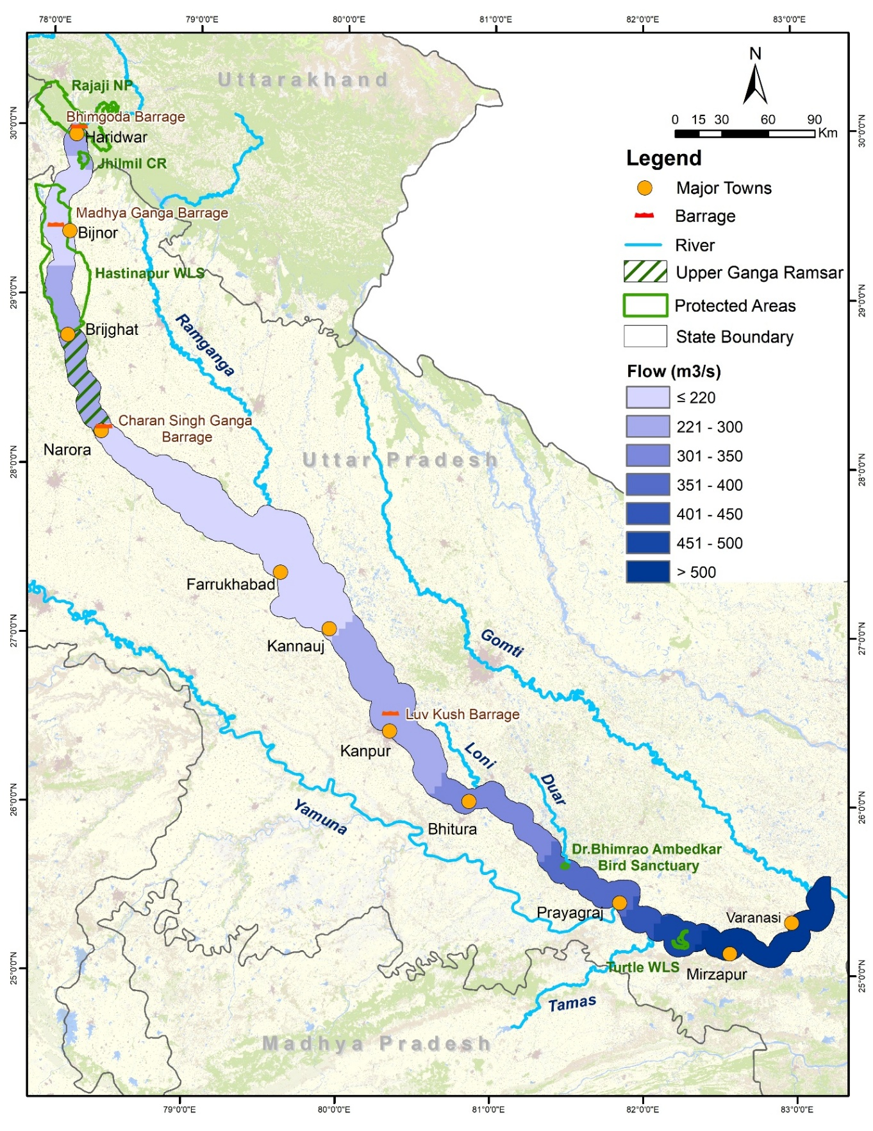Figure 3. Map showing flow classes
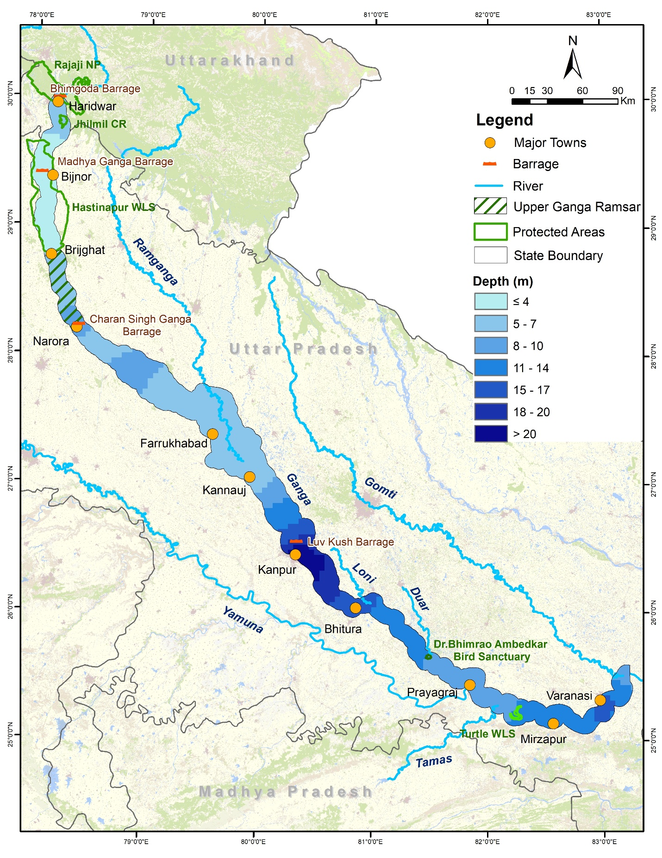
Figure 4. Map showing depth classes
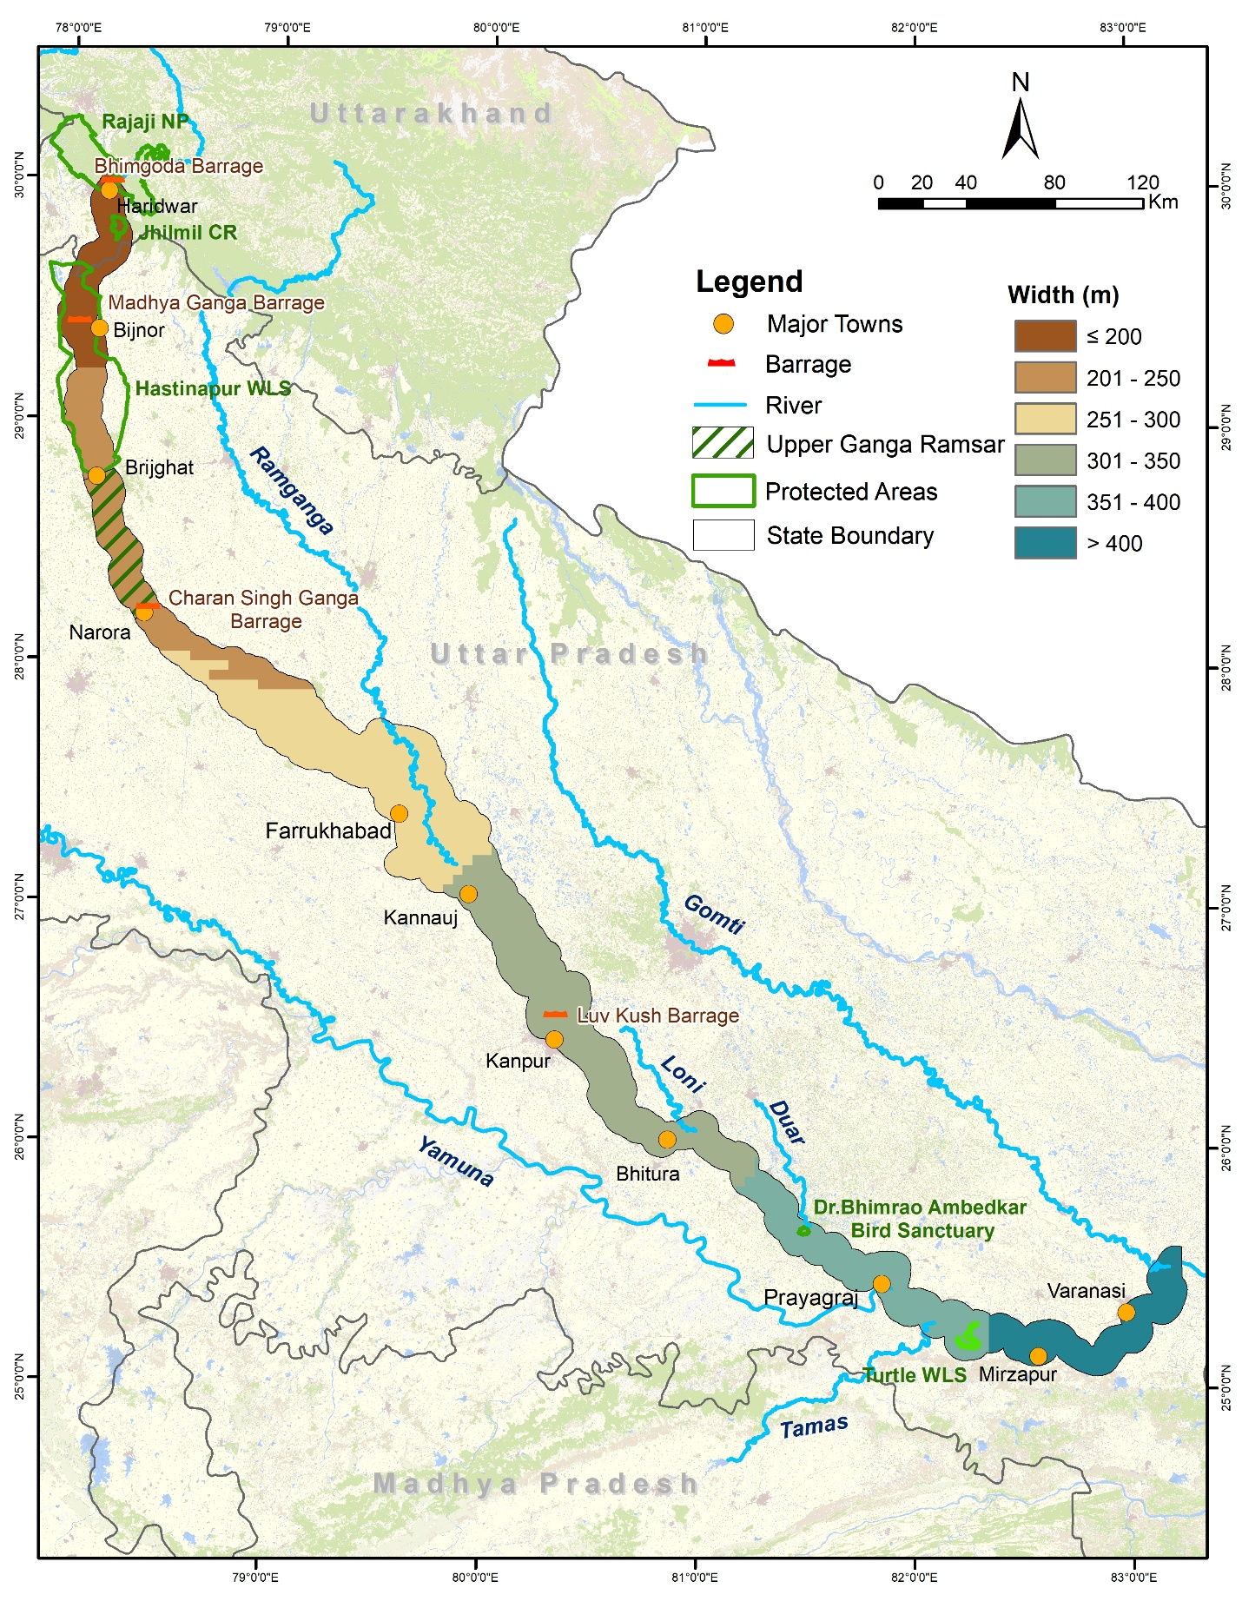
Figure 5. Map showing width classes
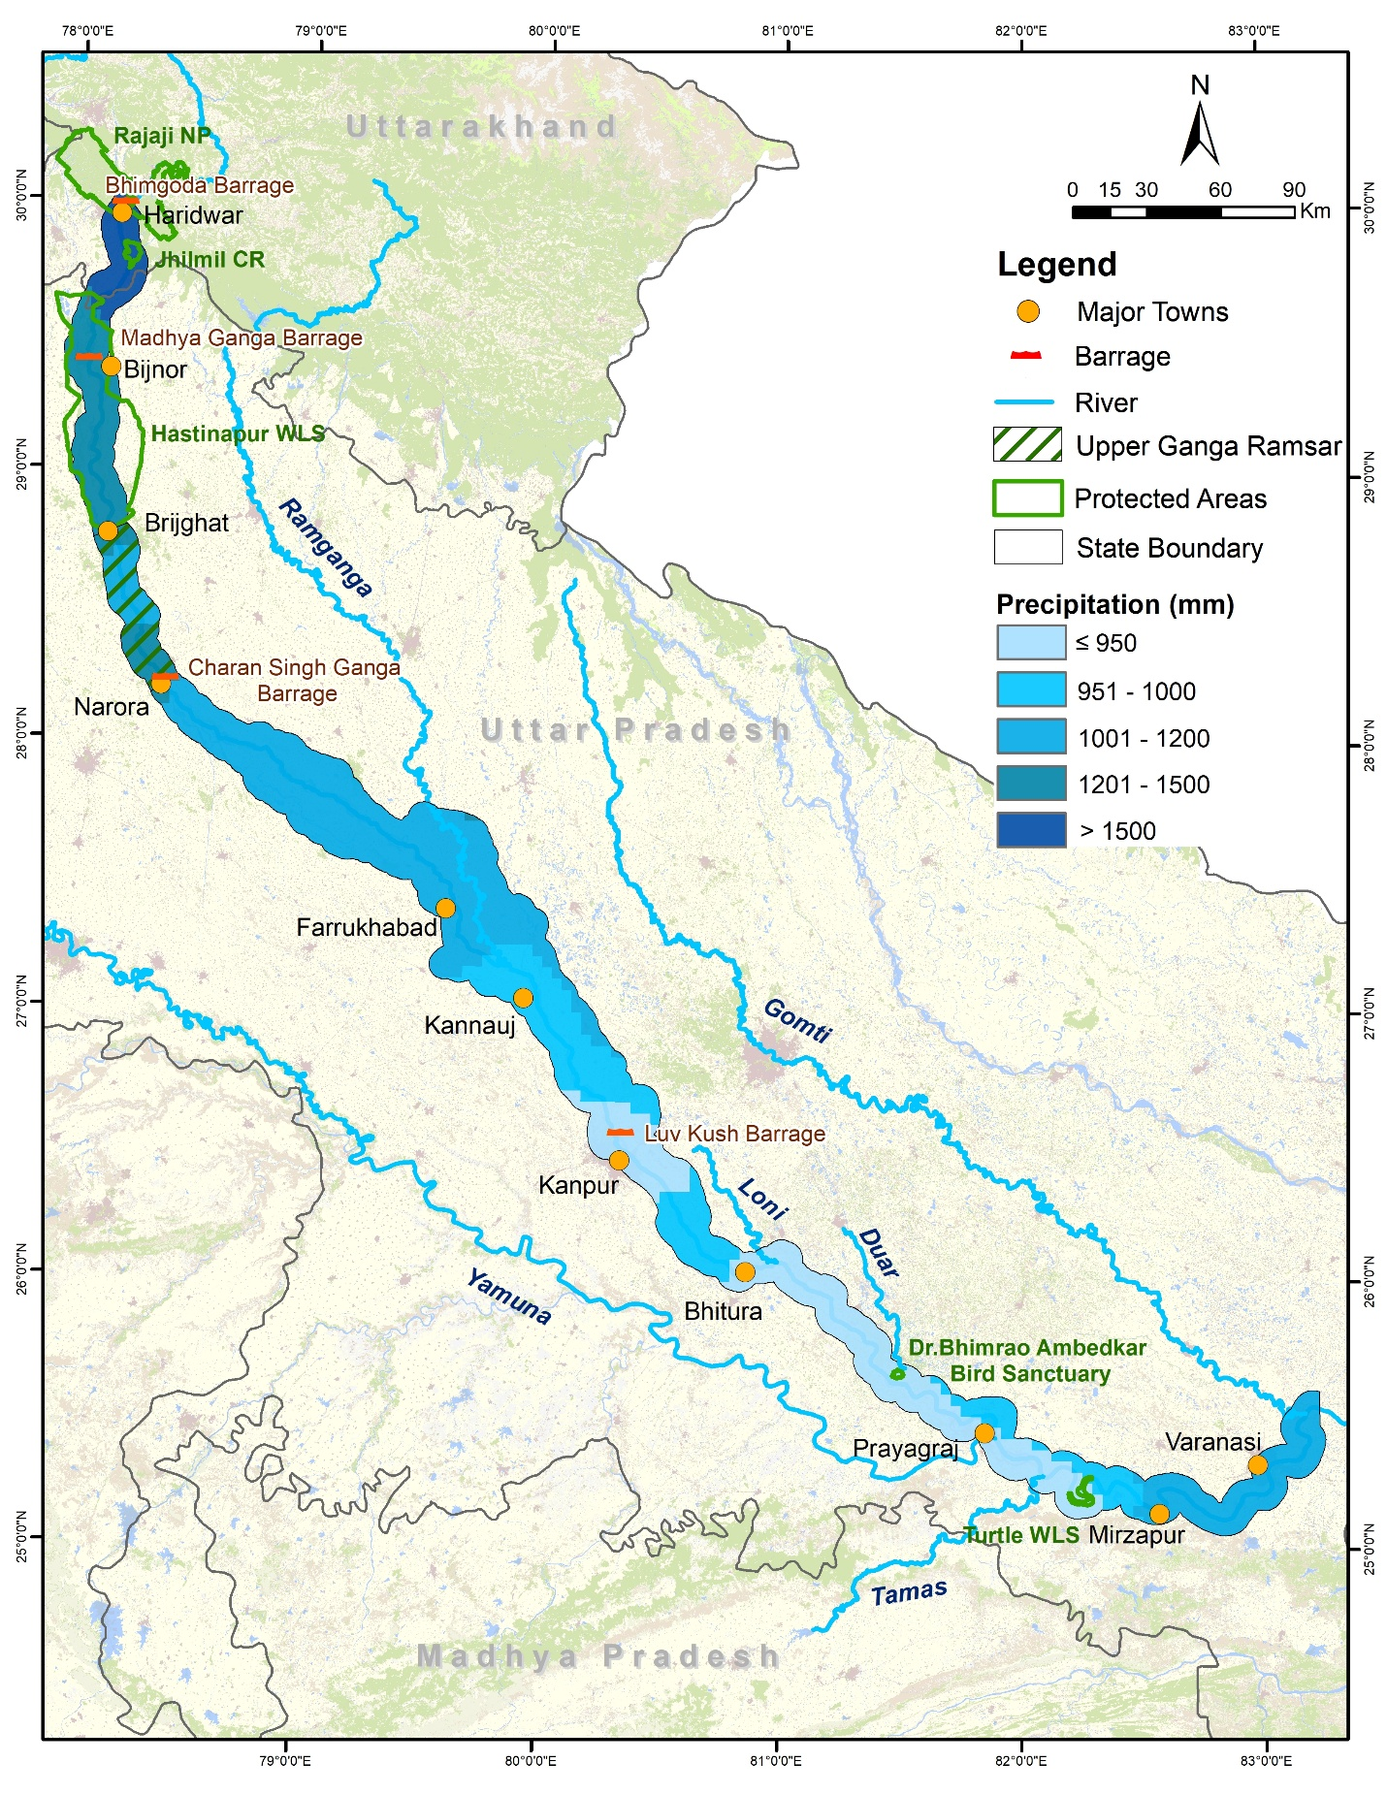Figure 6. Map showing precipitation classes
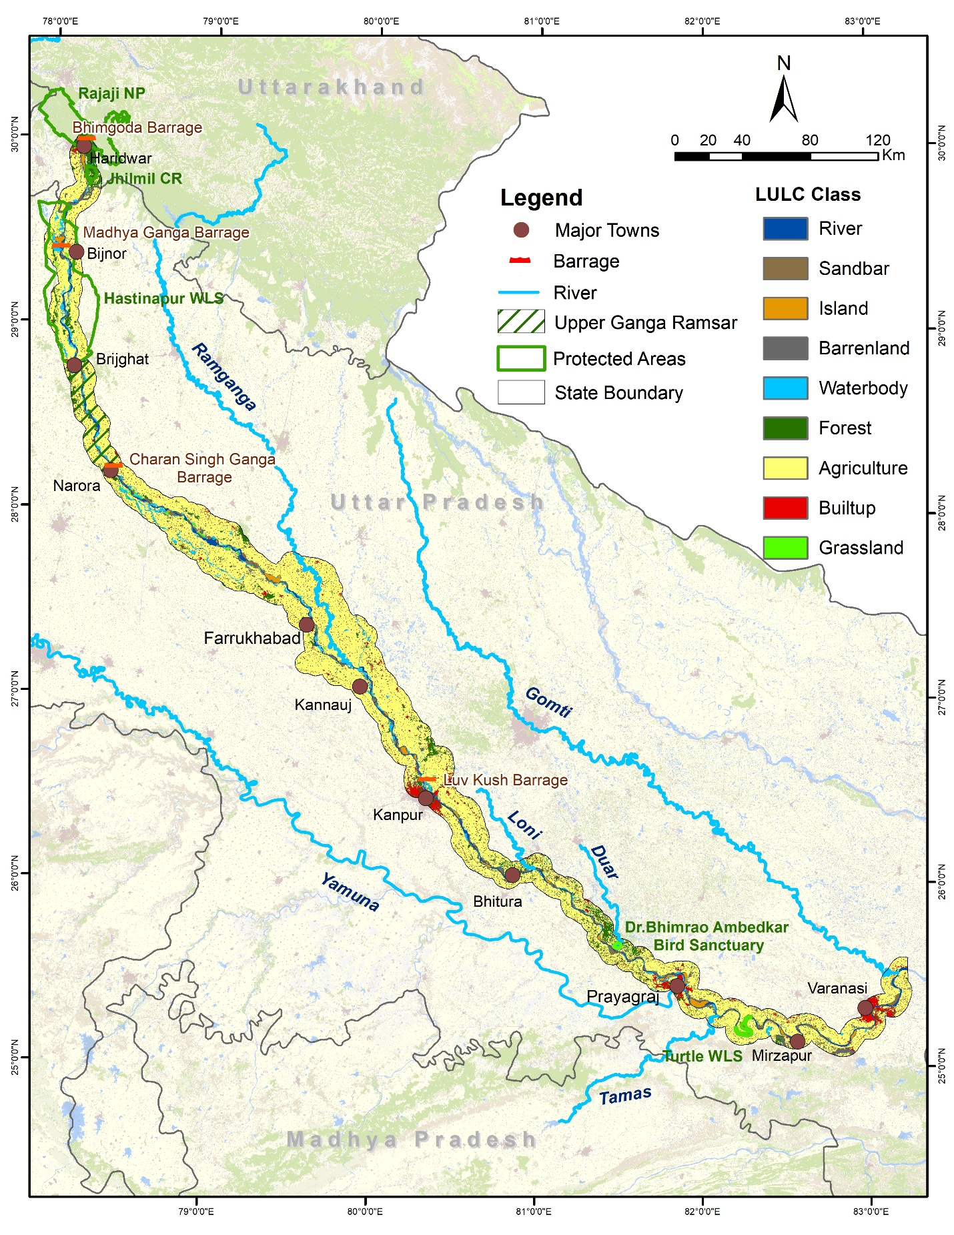Figure 7. Map showing Land Use Land Cover (LULC) classes
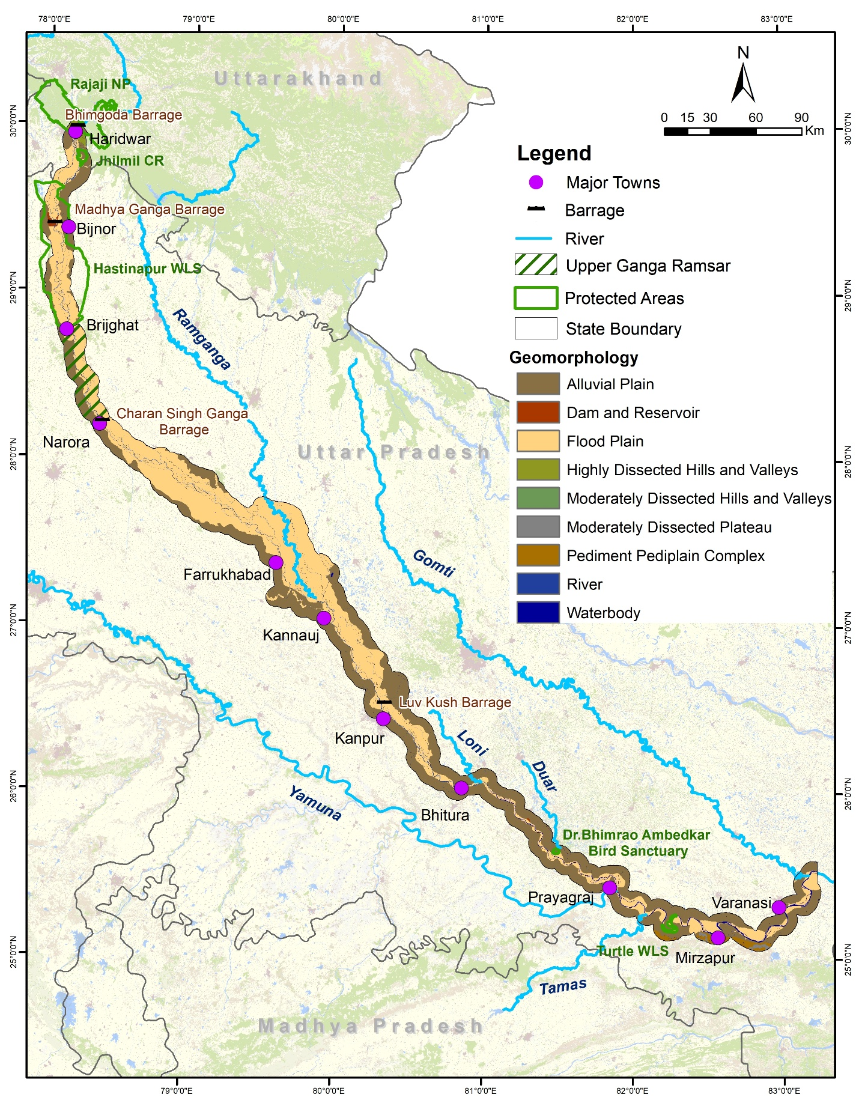Figure 8. Map showing geomorphology classes
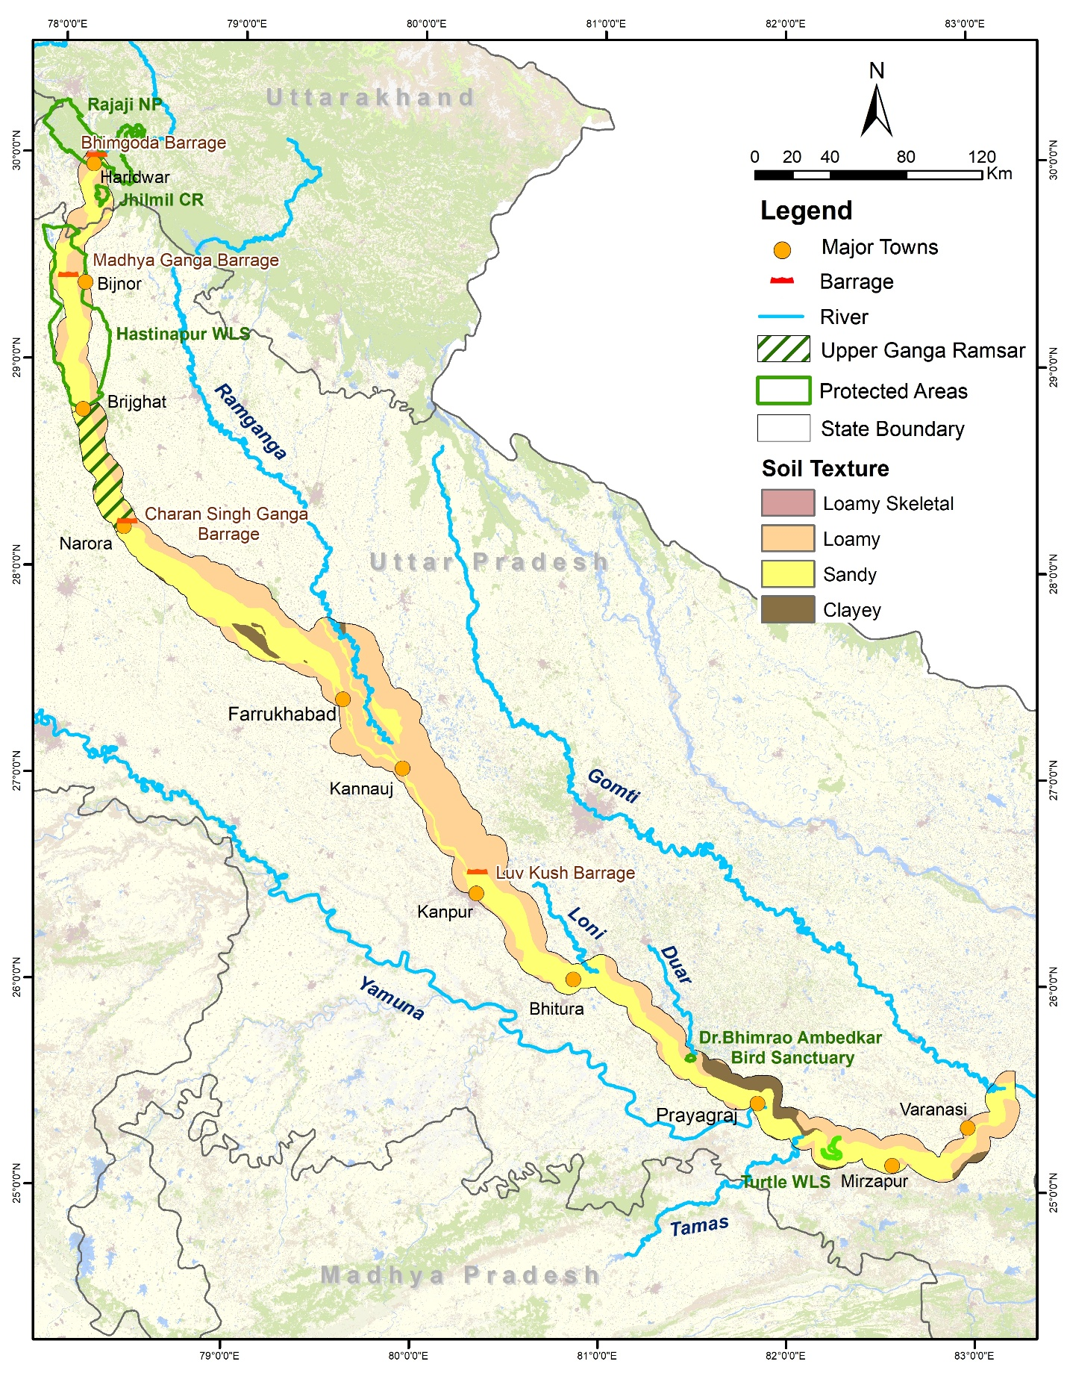Figure 9. Map showing soil texture classes
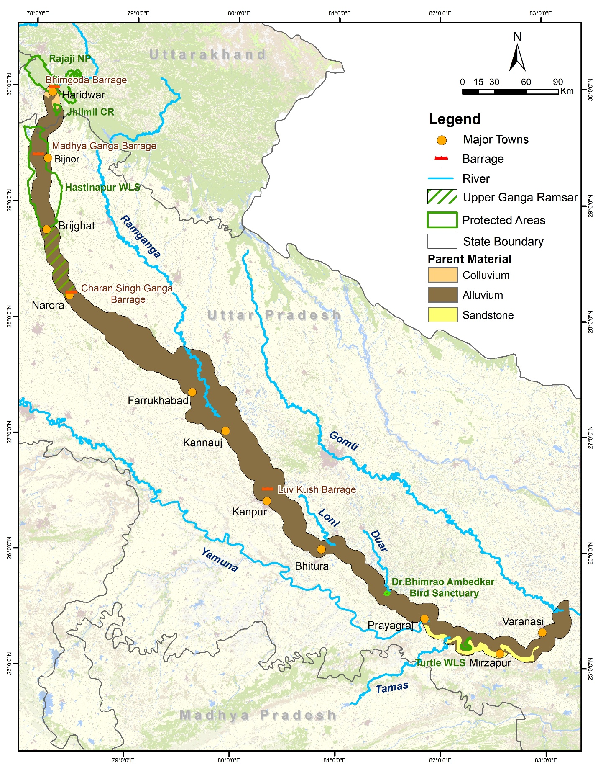Figure 10. Map showing parent material classes
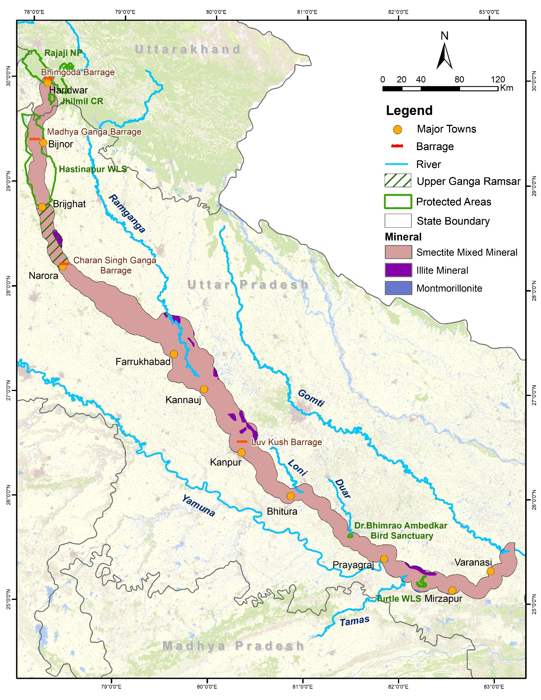Figure 11. Map showing mineral classes
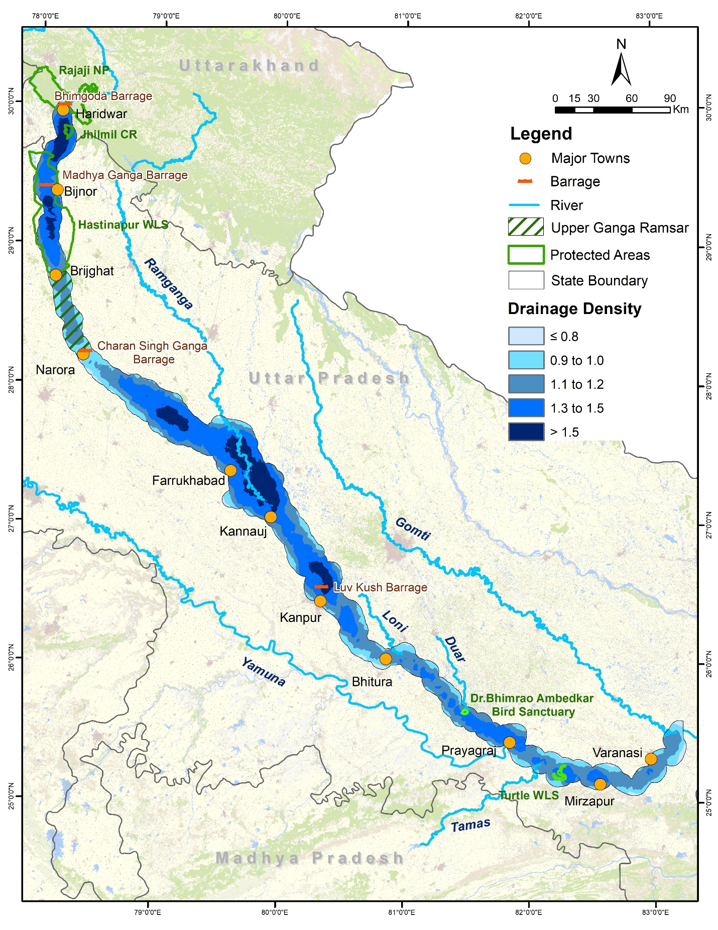Figure 12. Map showing drainage density classes
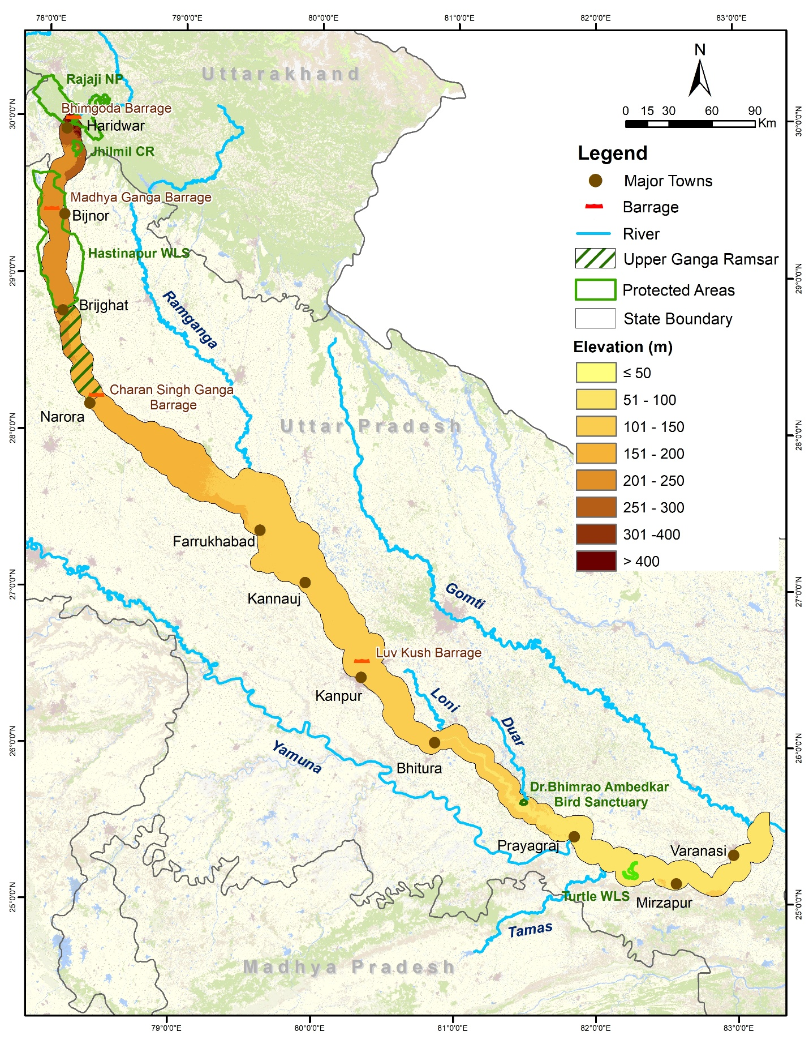Figure 13. Map showing elevation classes
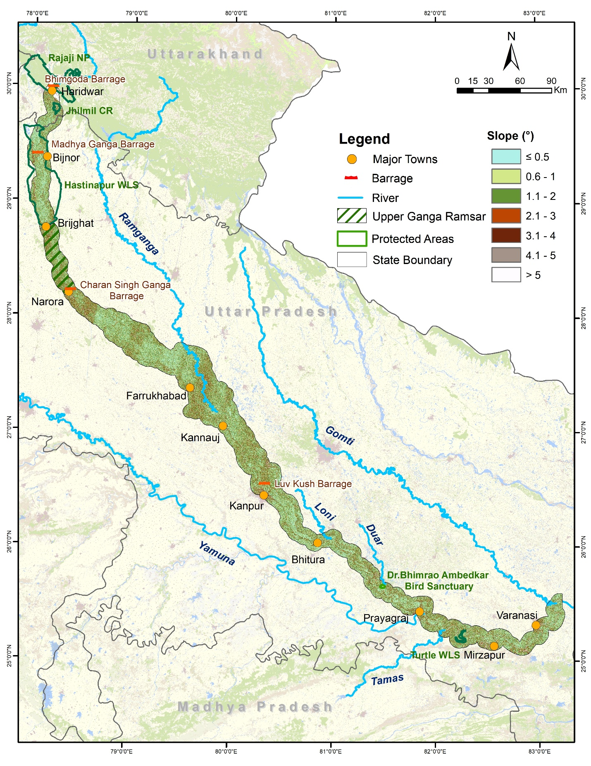Figure 14. Map showing slope classes
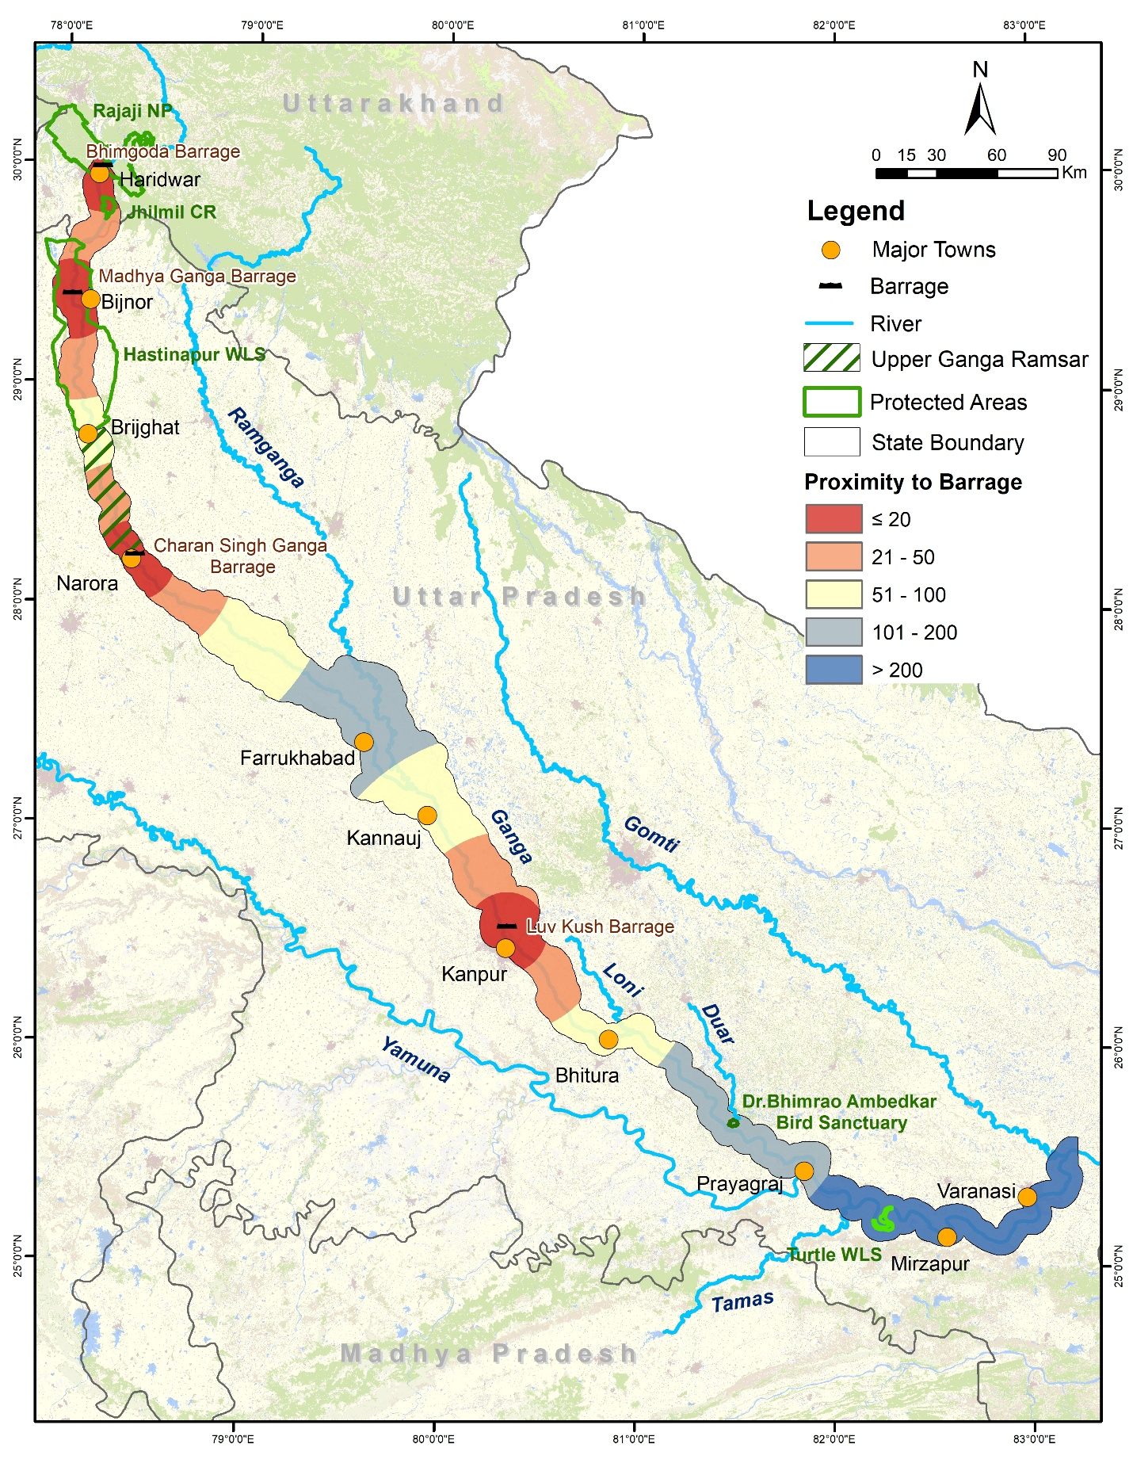Figure 15. Map showing proximity to barrage classes
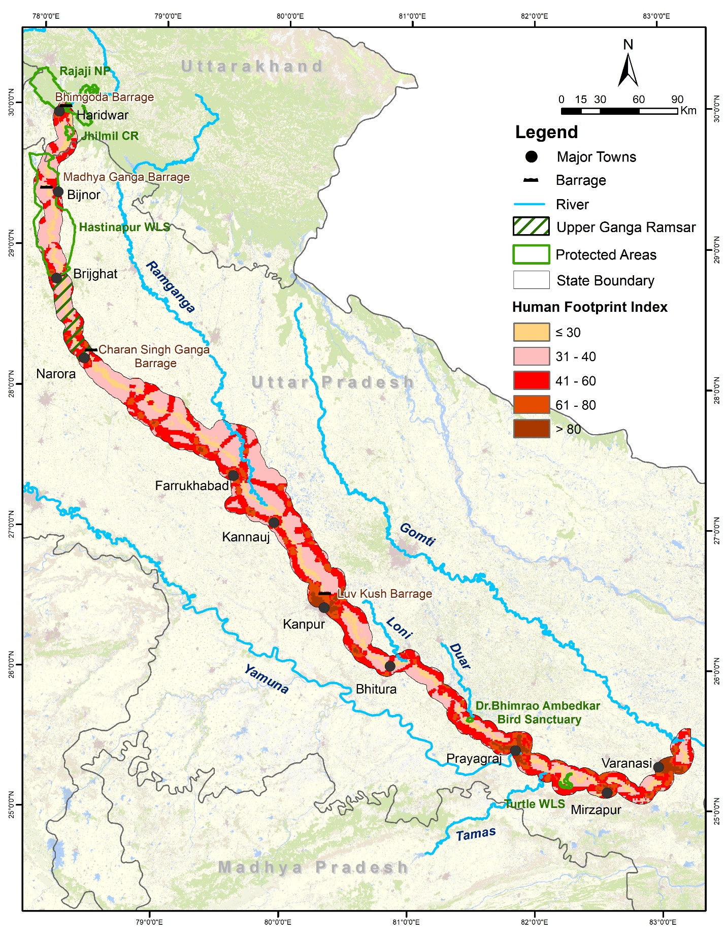Figure 16. Map showing Human Footprint classes
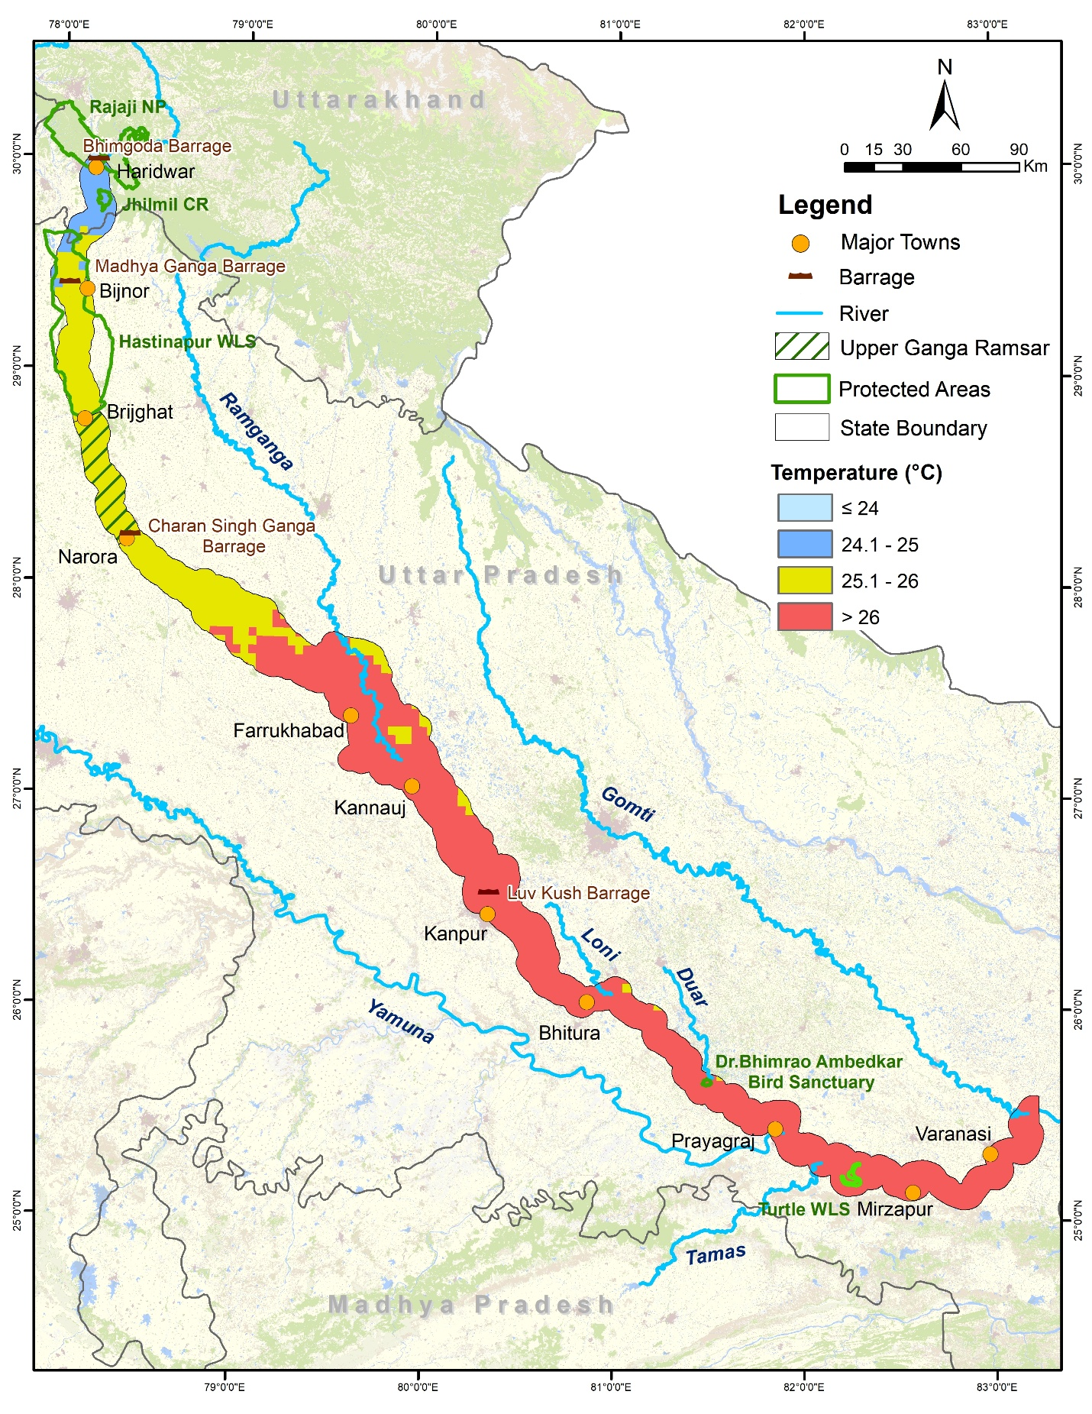Figure 17. Map showing temperature classes

