Table S1: List of target species presence points
2018 |  |  | 2019
Mauremys caspica | latitude | longitude | Mauremys caspica | latitude | longitude
S1 | 33.73139 | 48.07861 | S1 | 33.73139 | 47.80111
S2 | 33.77639 | 47.91722 | S2 | 33.86389 | 47.79861
S3 | 33.80472 | 47.87528 | S3 | 33.80472 | 47.79778
S4 | 33.72611 | 47.79972 | S4 | 33.72611 | 47.79639
S5 | 33.79611 | 47.81111 | S5 | 33.45566 | 47.54349
S6 | 33.40913 | 47.49899 | S6 | 33.47261 | 47.54297
S7 | 33.73139 | 47.80111 | S7 | 33.47274 | 47.48347
S8 | 33.86389 | 47.79861 | S8 | 33.45452 | 47.44274
S9 | 33.80472 | 47.79778 | S9 | 33.43760 | 47.48234
S10 | 33.72611 | 47.79639 | S10 | 33.41327 | 47.49138
S11 | 33.41196 | 47.53557 | - | - | -
S12 | 33.40211 | 47.49274 | - | - | -
S13 | 33.42203 | 47.48968 | - | - | -
S14 | 33.45179 | 47.45896 | - | - | -
S15 | 33.47337 | 47.47504 | - | - | -
S16 | 33.47517 | 47.49714 | - | - | -
S17 | 33.45338 | 47.58546 | - | - | -
S18 | 33.44105 | 48.43710 | - | - | -
S19 | 33.38545 | 48.12269 | - | - | -
S20 | 33.37375 | 48.12503 | - | - | -
S21 | 33.33290 | 48.17445 | - | - | -
S22 | 33.34214 | 48.17158 | - | - | -
2018 |  |  | 2019
Capra aegagrus | longitude | latitude | Capra aegagrus | longitude | latitude
S1 | 48.05426 | 33.64942 | S1 | 48.20892 | 33.51896
S2 | 48.08131 | 33.63461 | S2 | 48.21904 | 33.52539
S3 | 48.09155 | 33.63167 | S3 | 48.27797 | 33.51741
S4 | 48.09906 | 33.62442 | S4 | 48.26006 | 33.53195
S5 | 48.11071 | 33.61124 | S5 | 48.23796 | 33.55872
S6 | 48.14007 | 33.60068 | S6 | 48.20154 | 33.57958
S7 | 48.16297 | 33.6043 | S7 | 48.19060 | 33.59222
S8 | 48.18387 | 33.59299 | S8 | 48.17865 | 33.61305
S9 | 48.19692 | 33.56784 | S9 | 48.17335 | 33.60472
S10 | 48.21638 | 33.57897 | S10 | 48.16123 | 33.61225
S11 | 48.21317 | 33.58057 | S11 | 48.13502 | 33.62286
S12 | 48.21272 | 33.51752 | S12 | 48.12266 | 33.62777
S13 | 48.26246 | 33.53956 | S13 | 48.09470 | 33.62834
S14 | 48.27633 | 33.53042 | S14 | 48.08848 | 33.64553
S15 | 48.22172 | 33.57783 | S15 | 48.07123 | 33.65003
S16 | 48.26415 | 33.53326 | S16 | 48.05259 | 33.65668
S17 | 48.20391 | 33.53437 | S17 | 48.04592 | 33.65997
S18 | 48.22112 | 33.51637 | S18 | 48.03116 | 33.65898
S19 | 48.20892 | 33.51896 | S19 | 48.11763 | 33.61404
S20 | 48.21904 | 33.52539 | S20 | 48.14385 | 33.60794
S21 | 48.27797 | 33.51741 | S21 | 48.31437 | 33.39201
S22 | 48.26006 | 33.53195 | S22 | 33.37431 | 48.63810
S23 | 48.23796 | 33.55872 | S23 | 48.20892 | 33.51896
S24 | 48.20154 | 33.57958 | - | - | -
S25 | 48.19060 | 33.59222 | - | - | -
S26 | 48.17865 | 33.61305 | - | - | -
S27 | 48.17335 | 33.60472 | - | - | -
S28 | 48.16123 | 33.61225 | - | - | -
S29 | 48.13502 | 33.62286 | - | - | -
S30 | 48.12266 | 33.62777 | - | - | -
S31 | 48.09470 | 33.62834 | - | - | -
S32 | 48.08848 | 33.64553 | - | - | -
S33 | 48.07123 | 33.65003 | - | - | -
S34 | 48.05259 | 33.65668 | - | - | -
S35 | 48.04592 | 33.65997 | - | - | -
S36 | 48.03116 | 33.65898 | - | - | -
S37 | 48.11763 | 33.61404 | - | - | -
S38 | 48.14385 | 33.60794 | - | - | -
S39 | 48.16011 | 33.31211 | - | - | -
S40 | 48.19470 | 33.56729 | - | - | -
S41 | 48.06770 | 33.64201 | - | - | -
2018 |  |  | 2019
Sciurus anamalus | longitude | latitude | Sciurus anamalus | longitude | latitude
S1 | 47.92467 | 33.75254 | S1 | 47.57612 | 33.45534
S2 | 47.92236 | 33.74969 | S2 | 47.56254 | 33.45366
S3 | 47.93302 | 33.74546 | S3 | 47.55526 | 33.45279
S4 | 47.94035 | 33.75346 | S4 | 47.54317 | 33.46010
S5 | 47.96045 | 33.75815 | S5 | 47.50761 | 33.47589
S6 | 47.95272 | 33.76035 | S6 | 47.47249 | 33.47213
S7 | 47.95961 | 33.74421 | S7 | 47.47287 | 33.45481
S8 | 47.99845 | 33.74743 | S8 | 47.48196 | 33.45146
S9 | 48.00532 | 33.75163 | S9 | 47.50461 | 33.44607
S10 | 48.00623 | 33.73924 | S10 | 47.50591 | 33.42220
S11 | 48.01904 | 33.73727 | S11 | 47.53195 | 33.41194
S12 | 47.91966 | 33.76343 | S12 | 47.57391 | 33.41576
S13 | 47.99673 | 33.65304 | S13 | 47.57247 | 33.39147
S14 | 47.98825 | 33.67023 | S14 | 48.41117 | 33.37121
S15 | 47.55470 | 33.40120 | S15 | 48.10500 | 33.34463
S16 | 47.92725 | 33.69316 | S16 | 48.14111 | 33.32131
S17 | 47.85215 | 33.74276 | - | - | -
S18 | 47.88750 | 33.70976 | - | - | -
S19 | 47.97156 | 33.65476 | - | - | -
S20 | 47.92467 | 33.75254 | - | - | -
2018 |  |  | 2019
Sus scrofa | longitude | latitude | Sus scrofa | longitude | latitude
S1 | 48.02028 | 33.72634 | S1 | 47.90982 | 33.77377
S2 | 48.18075 | 33.57385 | S2 | 48.51803 | 33.35182
S3 | 48.19241 | 33.56035 | S3 | 47.58130 | 33.38179
S4 | 48.23460 | 33.54143 | S4 | 48.95000 | 33.31577
S5 | 48.20119 | 33.57281 | S5 | 48.18679 | 33.64328
S6 | 48.22173 | 33.57489 | S6 | 48.26022 | 33.56460
S7 | 48.24252 | 33.56706 | S7 | 48.12890 | 33.35274
S8 | 48.27832 | 33.53561 | S8 | 47.90982 | 33.77377
S9 | 48.04366 | 33.72869 | - | - | -
S10 | 48.05473 | 33.73819 | - | - | -
S11 | 48.06949 | 33.72248 | - | - | -
S12 | 48.10023 | 33.71664 | - | - | -
S13 | 48.16674 | 33.66575 | - | - | -
S14 | 48.19505 | 33.62272 | - | - | -
S15 | 47.94817 | 33.75026 | - | - | -
S16 | 47.98101 | 33.74682 | - | - | -
S17 | 47.87230 | 33.74254 | - | - | -
S18 | 47.90982 | 33.77377 | - | - | -
S19 | 47.80426 | 33.75719 | - | - | -
S20 | 48.02028 | 33.72634 | - | - | -
2018 |  |  | 2019
Testudo graeca | Latitude | Longitude | Testudo graeca | latitude | longitude
S1 | 33.76044 | 47.98148 | S1 | 33.79917 | 47.86833
S2 | 33.78227 | 47.91451 | S2 | 33.47462 | 47.46100
S3 | 33.80233 | 47.86845 | S3 | 33.48258 | 47.50252
S4 | 33.33162 | 48.18197 | S4 | 33.46166 | 47.56223
S5 | 33.80285 | 47.83216 | S5 | 33.44162 | 48.33760
S6 | 33.79409 | 47.78392 | S6 | 33.44516 | 48.11927
S7 | 33.39594 | 47.49914 | S7 | 33.38400 | 48.12335
S8 | 33.44785 | 48.45665 | S8 | 33.33328 | 48.17411
S9 | 33.47558 | 47.46841 | - | - | -
S10 | 33.47359 | 47.48217 | - | - | -
S11 | 33.48354 | 47.51254 | - | - | -
S12 | 33.46151 | 47.56141 | - | - | -
S13 | 33.45166 | 48.01373 | - | - | -
S14 | 33.44140 | 48.43244 | - | - | -
2018 |  |  | 2019
Ursus arctos | longitude | latitude | Ursus arctos | latitude | longitude
S1 | 48.12129 | 33.66121 | S1 | 33.80472 | 47.87250
S2 | 47.89552 | 33.70616 | S2 | 33.69079 | 47.99127
S3 | 47.85776 | 33.73309 | S3 | 33.40327 | 48.61067
S4 | 47.93905 | 33.67806 | S4 | 33.41363 | 48.15640
S5 | 48.04919 | 33.63744 | S5 | 33.63592 | 48.11523
S6 | 48.06748 | 33.63998 | S6 | 33.70815 | 48.02965
S7 | 48.16798 | 33.6478 | S7 | 33.72643 | 47.92199
S8 | 47.93938 | 33.72707 | S8 | 33.68239 | 48.06069
S9 | 48.11878 | 33.68870 | - | - | -
S10 | 47.95989 | 33.74784 | - | - | -
S11 | 48.08283 | 33.66903 | - | - | -
S12 | 47.84530 | 33.75747 | - | - | -
S13 | 47.76986 | 33.77511 | - | - | -
S14 | 48.12129 | 33.66121 | - | - | -

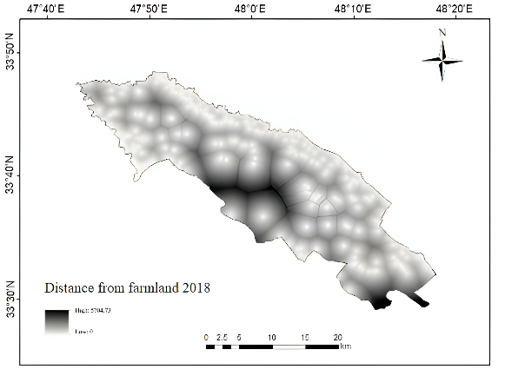 | 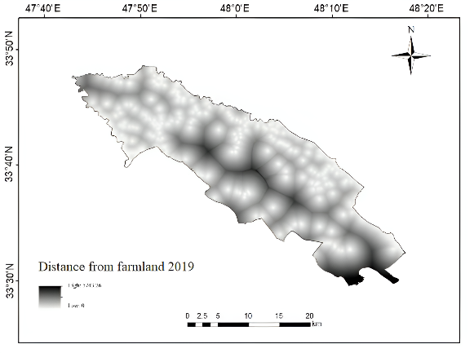
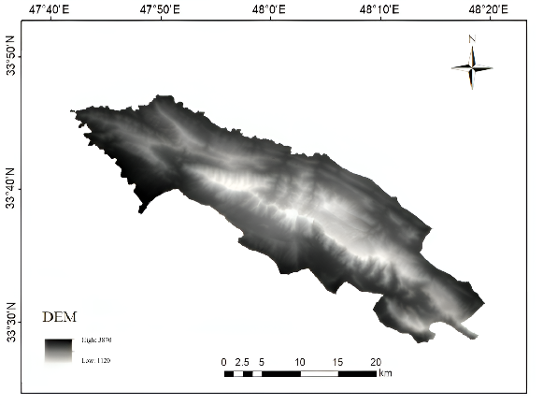 | 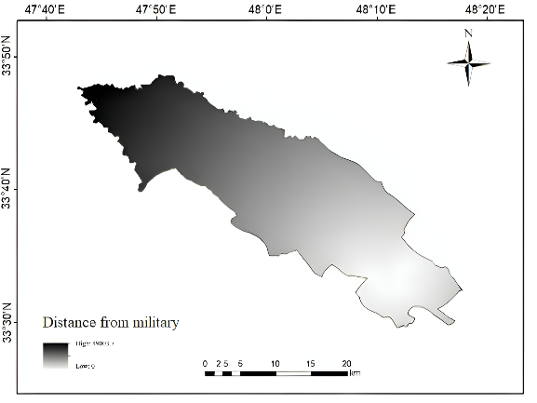
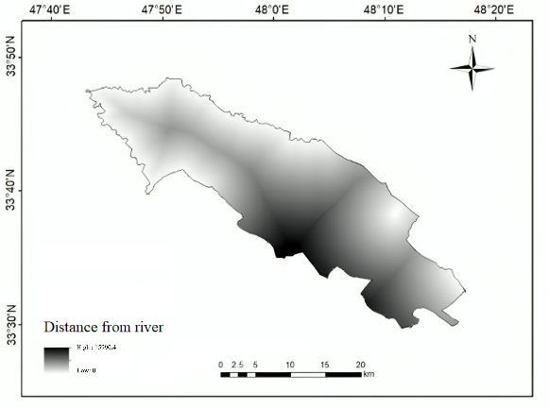 | 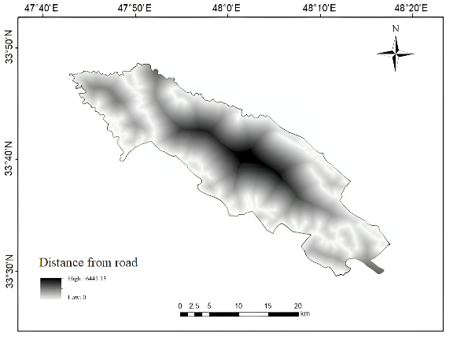
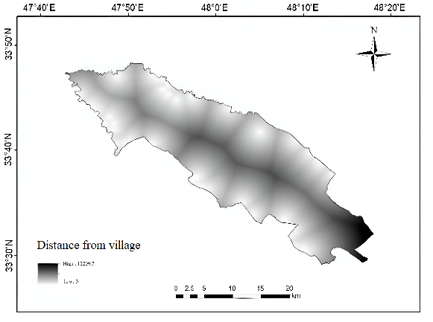 | 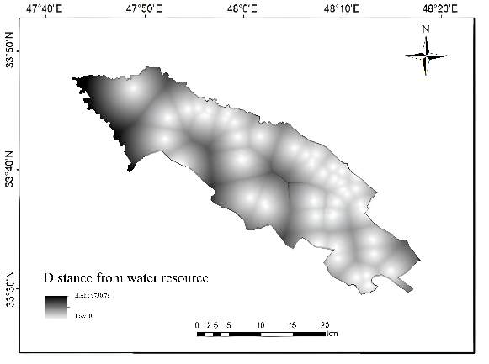
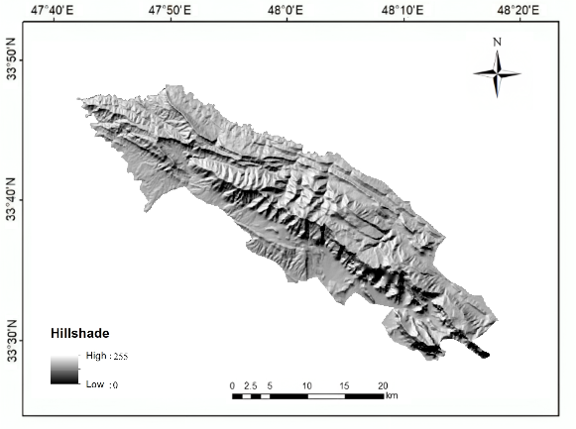 | 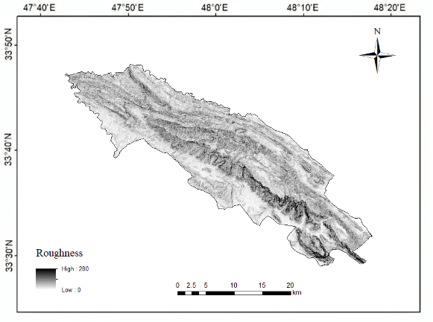
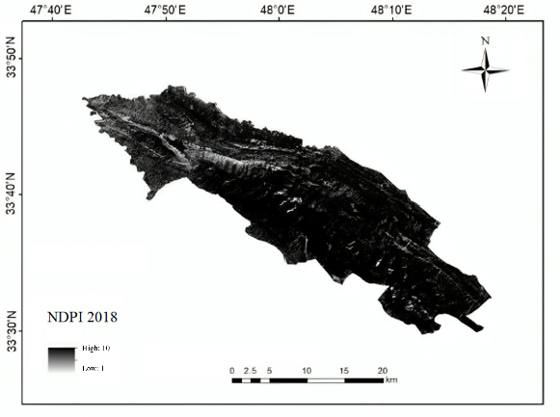 | 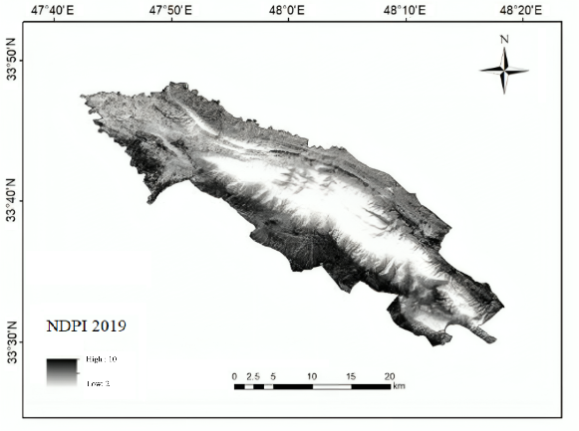
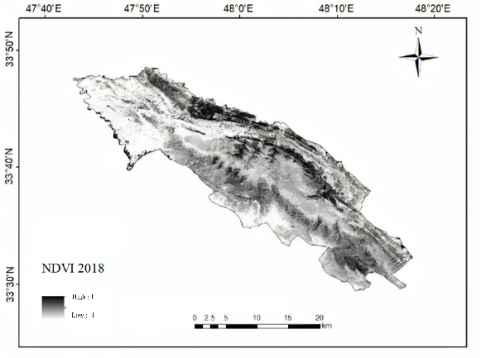 | 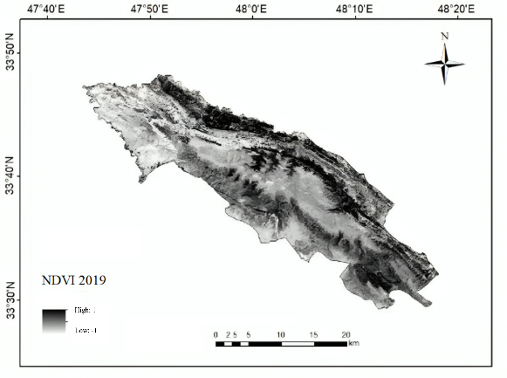
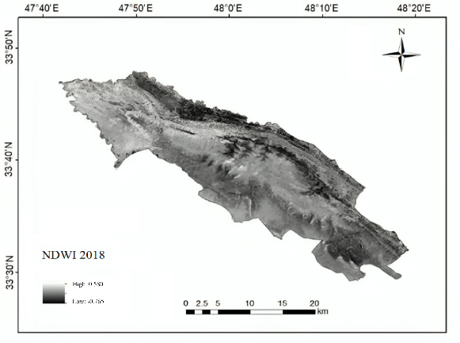 | 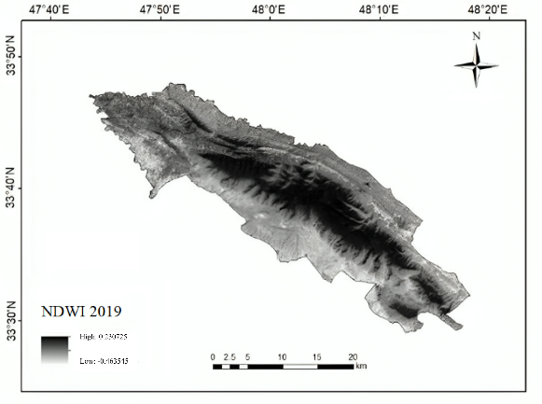
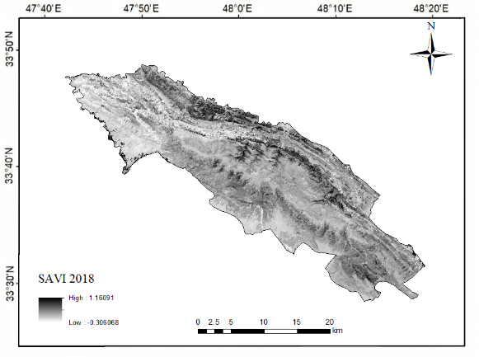 | 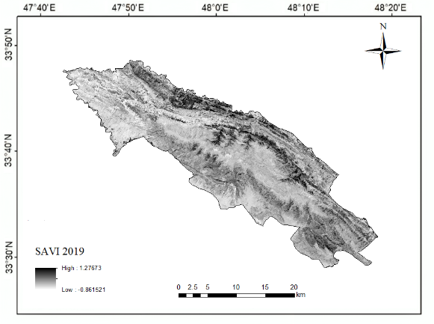
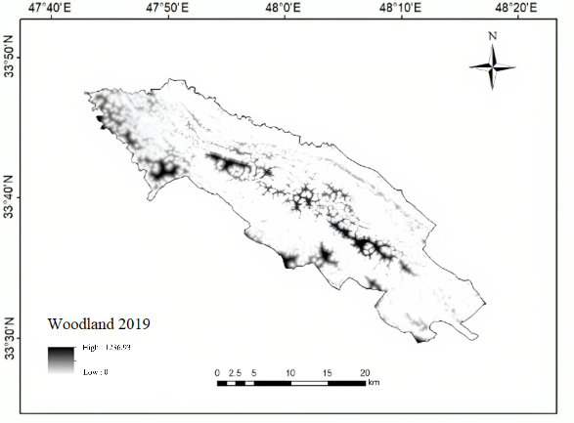 | 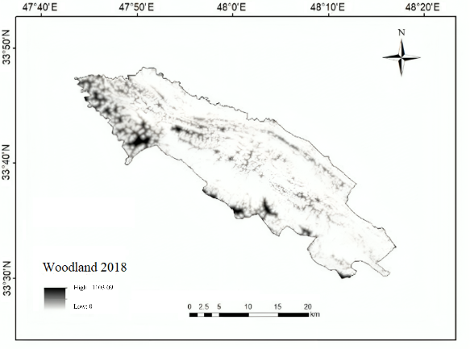
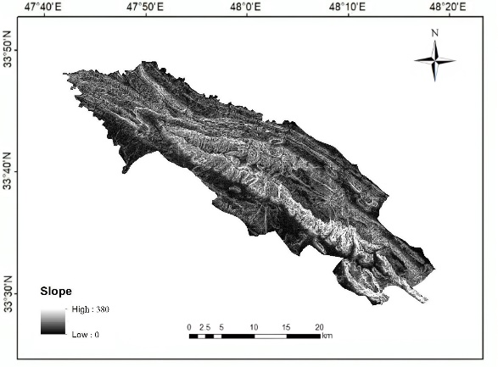
Figure S1. Environmental variables used for habitat modeling during 2018 and 2019.

