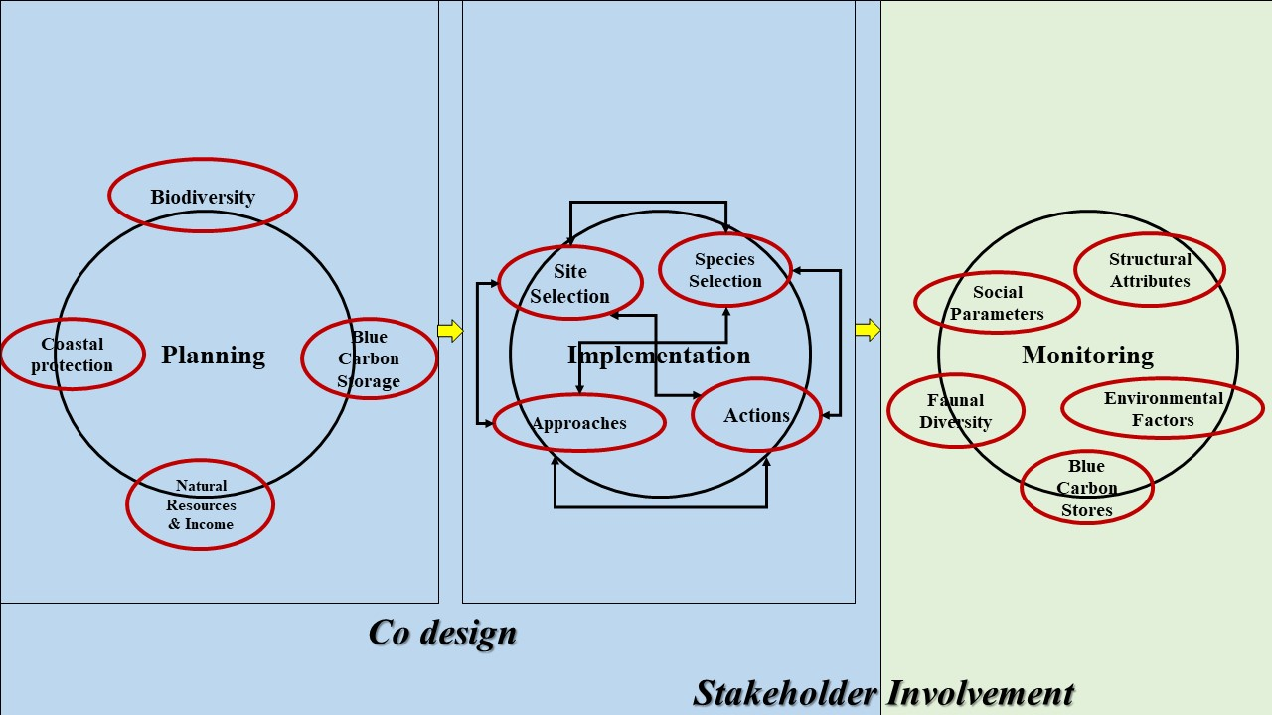
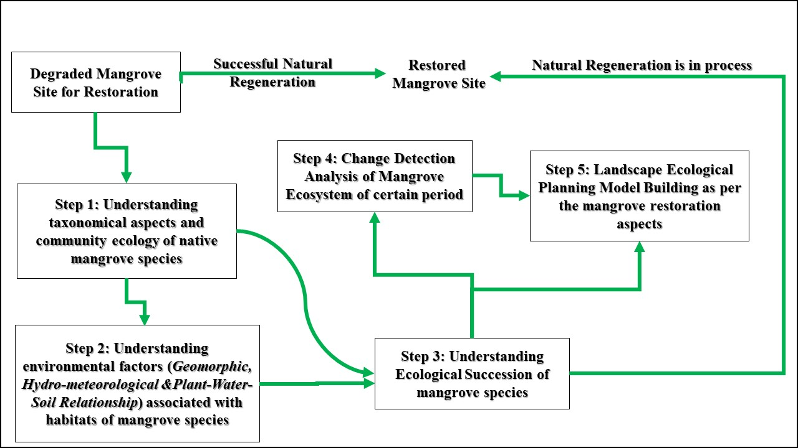
SFigure 1: Conceptual Framework on Mangrove Restoration (Source: Modified after Bosire et al., 2008; Nguyen et al., 2008; Stevenson et al., 1999)
SFigure 2: Conceptual Framework on Planning, Implementation and Monitoring to succeed the re-establishment of mangroves where, Yellow arrows show the continuation and Black arrows show the dependencies on actions (Source: Modified after Zimmer et al., 2022)
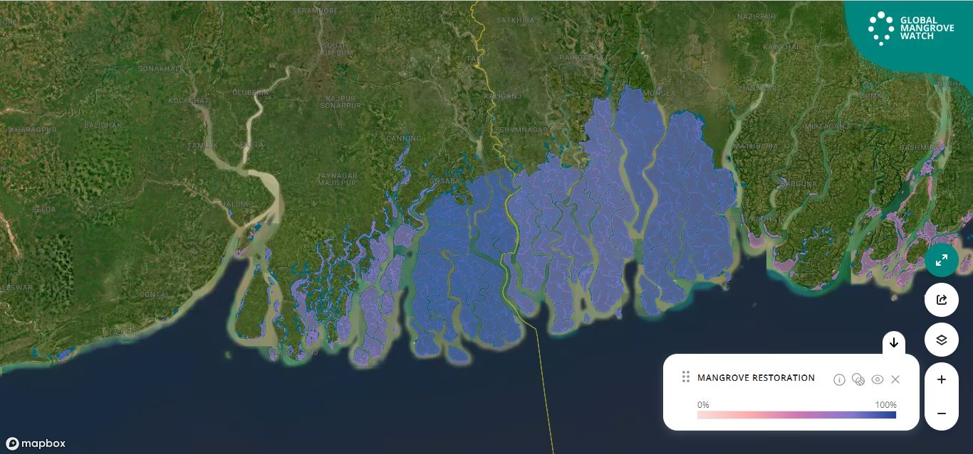
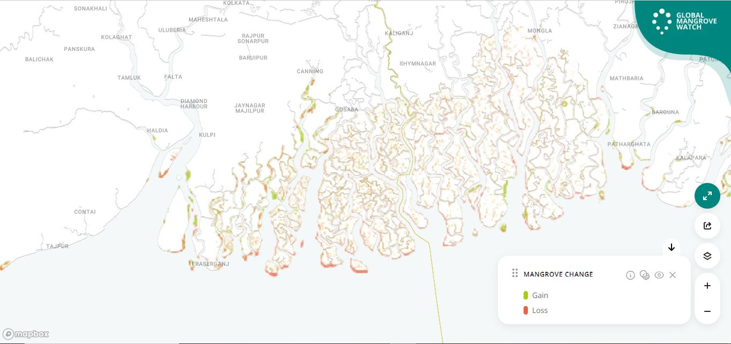
SFigure 3: Mangrove Net Change from 1996 to 2020 in Sundarbans (Source: Modified after Global Mangrove Watch, Bunting et al., 2018)
SFigure 4: Identified Mangrove Restoration Potential Zones of Sundarbans with respect to maximum extent of mangroves over time (1996-2020)

Bottlenecks | Solutions | Observations from Indian Sundarbans
Wrong Species Selection for Selected Site | Trait analysis on hydro-geomorphological aspects to correlate with the species requirement as well as selected site for plantation | Prior hydrodynamic monitoring was not done at the best level for the mangrove plantation program at the selected sites
Improper Site Selection | Involvement of Academic Experts for the fundamental aspects of site selection | Academic experts were informed at later stage for the sharing of progress but it should have been informed at the prior level the plantation program
Artificial Restoration often leads to reduction of species diversity | Promotion of Intrinsic species diversity based afforestation instead of mono specific afforestation | One new genus got introduced at 47% of sites, two new genera at 22% & three new at 30%
Survival of planted seedlings | Plantation of seedlings and saplings directly on mudflats of sites instead of transplantation at nurseries | 30 nurseries of 1974 ha were operational, where seedlings were compacted using plastic bags before planting in the selected sites
Plantation targets with achievements | Minimum of 10 years of survival of mangrove saplings is required for successful restoration outcome | Survival rate (77%) was higher than the global average but the report was produced only after 4-7 months of program; quite a short time
Lack of Local Communities Involvement | Sureness of an equitable approach among the local communities | Especially women were involved but there remains the traits of top down approaches
Failure of projects due to lack of political will | A strong political intent is needed to execute the administrative authorizations | Chief Minister urged the Department of Forest for planting of 50 million mangroves
Lack of Funding | Resource management should encompass the plantation period and a 10 year period for long term success | Funds covered by National Govt. Scheme for the daily wages for people involved but, a lack of agreement between national and state govt. has led to non-payment of wages
STable 1: Observations from Indian Sundarbans Plantation Program (Modified after Banerjee et al., 2023)
Orange color indicates Significant gaps; Yellow color indicates Partial achievements with some gaps & Green color indicates Achievements

STable 2: Site wise Species Distribution for Plantation Program
Spot | Species | Frequency | Height (cm) | Remarks
Spot 1 | Avicennia alba (new); Avicennia marina (new) | 81; 8 | 20-30 cm | New plants planted through direct seed sowing (no nursery plants)
Spot 2 | Avicennia alba (old/new); Avicennia marina (old/new) | (4;8), (3;3) | (120cms; 100 cm) ,(30 cm; 20 cm) | New plants planted through direct seed sowing (no nursery plants)
Spot 3 | Avicennia alba (new); Avicennia marina (old/new); Aegialitis rotundifolia (new) | 36; (3,20) ;2 | (20-40cm), (100cm; 40-60cm), (10 cm) | New plants planted through direct seed sowing (no nursery plants)
Spot 4 | Avicennia alba (old/new); Avicennia marina ( (old/new); Aegialitis rotundifolia (natural); Sonneratia alba. (natural) | (3,2); (10,25); 30;5 | (100-120cm; 20-35cm), (100-180cm; 30-50cm), (20-40cm), 160 cm | New plants planted through direct seed sowing (no nursery plants); naturally occurred plants
Spot 5 | Avicennia alba (old/new); Avicennia marina (old/new); Aegialitis rotundifolia (natural); Sonneratia apetala (natural) | (4,1); (30,6); 1; 2 | (130-150cm; 30 cm), (120-150 cm; 30-60 cm), (20cm), (10-20cm) | New plants planted through direct seed sowing (no nursery plants)
Spot 6 | Avicennia alba (old/new); Avicennia marina (old/new); Aegialitis rotundifolia (natural) | (2, 3); (28, 9); 1 | (110-130 cm; 20-30 cm), (130-160 cm; 30-60 cm); (10 cm) | New plants planted through direct seed sowing (no nursery plants)
Spot 7 | Avicennia alba (old/new); Avicennia marina (old/new); Avicennia officinalis (natural); Sonneratia apetala (natural) | (3, 15); (29,5); 1; 30; 1 | (90-110cm; 20-30 cm), (70-110 cm; 50-60 cm), (40 cm), (10-30 cm), (80 cm) | New plants planted through direct seed sowing (no nursery plants); naturally occurred plants
Spot 8 | Avicennia marina (old/new); Aegialitis rotundifolia (natural); Aegiceras corniculatum (natural) | (2, 5 nursery plants & 10 directly from seeds; total new 15); (3); (1) | (70-110 cm; 30-50 cm), (10-20 cm), (10 cm) | New plants planted through direct seed sowing & nursery plants; naturally occurred plants
Spot 9 | Avicennia alba (natural); Avicennia marina (old/new); Avicennia officinalis (natural); Aegiceras corniculatum (natural) | (5); (3, 6 nursery plants & 29 directly from seeds; total 35); (1); (1) | (20 cm); (110-130 cm, 30-50 cm); (40 cm); (10 cm) | New plants planted through direct seed sowing & nursery plants; naturally occurred plants
Spot 10 | Avicennia marina (old/new/natural) | (1; 9;7) | (100 cm; 40-48 cm; 20 cm) | New plants planted through nursery plants & naturally occurred plants
Spot 11 | Avicennia marina (old/new/natural) | (1; 7 as nursery plants;18 as directly from seeds; 7) | (70 cm; 20-30 cm; 20-30 cm; 20-30 cm) | New plants planted through nursery plants & naturally occurred plants
Spot A (Permanent Spot) | Avicennia alba (old/new); Avicennia marina (old/new) | (2; 3 as directly from seeds); (29; 5 as nursery plants) | (110-130 cm; 25-30 cm), (120-140 cm, 30-45 cm) | New plants planted through nursery plants & directly from seeds
Spot B (Permanent Spot) | Avicennia alba (old/natural); Avicennia marina (old/natural) | (1; 1), (6; 3) | (90-110 cm; 15 cm); (70-110 cm; 20-30 cm) | Naturally occurred with existing species

STable 3: Tabulation on Comparative Study on Planted Mangrove Species
Spot | Species | Survey Time |  | Survival Rate
Spot A | Avicennia alba | March, 2018 | January, 2019 | 42.8 %
No. of plants | Avicennia alba | 7 | 3 | 42.8 %
Spot B | Avicennia alba | March, 2018 | January, 2019 | 50 %
No. of plants | Avicennia alba | 2 | 1 | 50 %

STable 4: Division wise Planted Seedlings Distribution
Division | Area | Seedlings/ha | Total No. of Seedlings planted
South 24 Parganas | 2000 ha | 20000 | 4,00,00,000
Sundarban Tiger Reserve (STR) | 500 ha | 20000 | 1,00,00,000
Total Seedlings | 2500 ha | 20000 | 5,00,00,000

SFigure 5: Area Coverage under Mangrove Plantation Program Over Indian Part of Sundarbans

SFigure 6: Rate of Planted Species at selected site Indian Sundarbans by Botanical Survey of India (2017-2020)
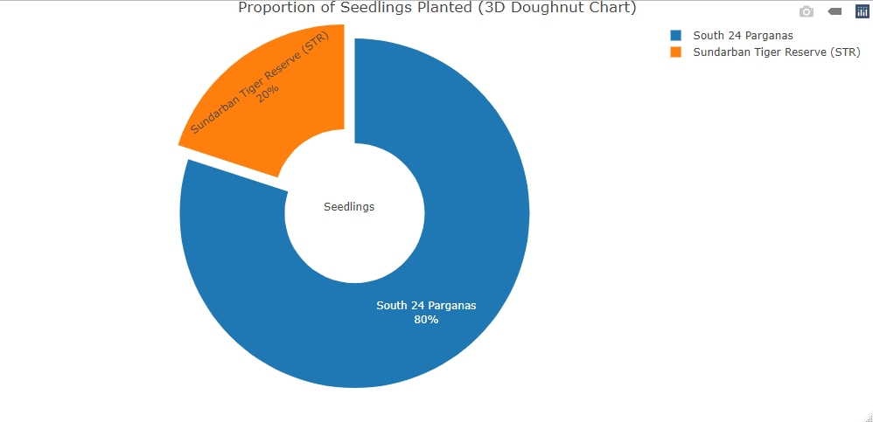
SFigure 7: 3D Doughnut Chart showing the Total Number of Seedlings Planted across South 24 Parganas District and Sundarbans Tiger Reserve
Plantation Site | Quantity and Time Frame of Plantation | Height of Planted Saplings (In Meter) | Mortality Rate (%) | Siltation Rate (%)
Chargheri Village, Gosaba | 3,00,000 (August, 2009) | 0.50-0.62 | 30 | 0.10-0.15 (December)
Chargheri Village, Gosaba | 1,00,000 (2017) | 10.97-12.19; 0.52-0.62 | 35 | 0.70-0.80  (December)
Chargheri Village, Kakmari Village, Gosaba | 1,00,000 (2019) | 6.09-7.62; 0.48-0.60 | 30 | 0.30-0.45 (December)
Kakmari Village, Kumirmari Village, Sonagaon | 60,000 (2021) | 3.05-3.66; 0.55-0.60 | 38 | 0.40-0.42 (December)
STable 5: Details on Mangrove Plantation Sites (2009-2021)

STable 6: Mangrove Species that have been planted by Purbasha Team (2009-2024)
Sl. No. | Mangrove Species (Local Names) | Scientific Name | Roots | Carbon Absorption Captivity | Soil Texture
1 | Goran | Ceriops decandra ( | Respiratory roots | High | Hard textured Alluvial Soil
2 | Bain | Avicennia alba, Avicennia marina, Avicennia officinalis. | Respiratory roots | Very High | Loose Structured Alluvial Soil
3 | Gorjan | Rhizophora mucronata | Aerial Roots | High | Hard textured Alluvial Soil
4 | Kankra | Bruguiera gymnorrhiza | Respiratory roots | High | Hard textured Alluvial Soil
5 | Dhudhul | Xylocarpus granatum | Respiratory roots | High | Hard textured Alluvial Soil
6 | Passur | Xylocarpus mekongensis | Respiratory roots | High | Hard textured Alluvial Soil
7 | Keora | Sonneratia apetala | Respiratory roots | Very High | Loose Structured Alluvial Soil
8 | Geoa | Excoecaria agallocha |  | High | Hard textured Alluvial Soil
9 | Sundari | Heritiera fomes | Respiratory roots | High | Hard textured Alluvial Soil
10 | Dhani Gash | Porteresia coarctata | - | Very High | Loose Structured Alluvial Soil
11 | Horgoj Kanta | Acanthus ilicifolius | - | High | Hard Textured Alluvial Soil
12 | Tora | Aegialitis rotundifolia | - | High | Hard Textured Alluvial Soil
13 | Khalishi | Aegiceras corniculatum | - | High | Hard Textured Alluvial Soil

Plantation Site | Year | Status of Mangrove Seedlings | Mangrove Army Numbers | Quantity of Seedlings | Remarks on Estimated Cost
Chargheri Village, Gosaba | 2009 | 3,00,000 | 200 | 4,30,000 | 1 tin estimated cost is 20-30 rupees (total  1200-1300 tins utilized)
Chargheri Village, Gosaba | 2010 | Protection Period | 220 | 50,000
Chargheri Village, Gosaba | 2011 | Protection Period | 50 | 30,000
Chargheri Village, Gosaba | 2012 | Protection Period | 50 | 30,000
Chargheri Village, Gosaba | 2013 | Protection Period | 50 | 20,000
Chargheri Village, Gosaba | 2014 | Protection Period | 50 | 20,000
Chargheri Village, Gosaba | 2015 | Protection Period | 50 | 10,000
Chargheri Village, Gosaba | 2016 | Protection Period | 50 | 10,000
Chargheri Village, Gosaba | 2017 | 1,00,000 | 50 | 1,75,000
Chargheri Village, Gosaba | 2018 | 1,00,000 | 50 | 1,80,000
Chargheri Village, Gosaba | 2019 | 1,00,000 | 50 | 1,60,000
Chargheri Village, Kakmari Village, Kumirmari Village, Sonagaon | 2020 | 42,000 | 250 | 70,000 | Gorjan-15 Rs. Bain- 10 Rs. Kankra- 15 Rs. Sundari- 15 Rs. Keora- 15 Rs.
 | 2021 | 60,000 | 280 | 90,000
 | 2022 | 1,70,000 | 350 | 2,30,000
 | 2023 | 50,000 | 380 | 1,40,000 | Gorjan-20 Rs. Bain- 15 Rs. Kankra- 20 Rs. Sundari- 20 Rs. Keora- 20 Rs
 | 2024 |  | 500 | 1,45,000
STable 7: Cost Estimate along with Plantation Details on Mangrove Species (2009-2024)
STable 8: Status on Mangrove Artificial Restoration Programme at Selected Sites over Indian Part of Sundarbans
Nature of Site | Chargheri, Bidhan Colony  (2019-2023) | Kakmari  (2020-2023) | Sonaga  (2020-2023) | Kumirmari  (2020-2023)
Bank Erosive Site 1 | Saplings: 4,20,000; Forest Length: 5 km; Forest Width: 200-350 ft. | Saplings: 70,000; Forest length: 1 km; Forest Width: 50-80 ft. | - | -
Bank Erosive Site 2 | Saplings: 2,00,000; Forest length: 2 Km; Forest Width: 200-350 ft. | - | Saplings: 30,000; Forest length: ½ Km; Forest width: 40-60 ft. | Saplings: 60,000; Forest length: 1 Km; Forest width: 15-20 ft.

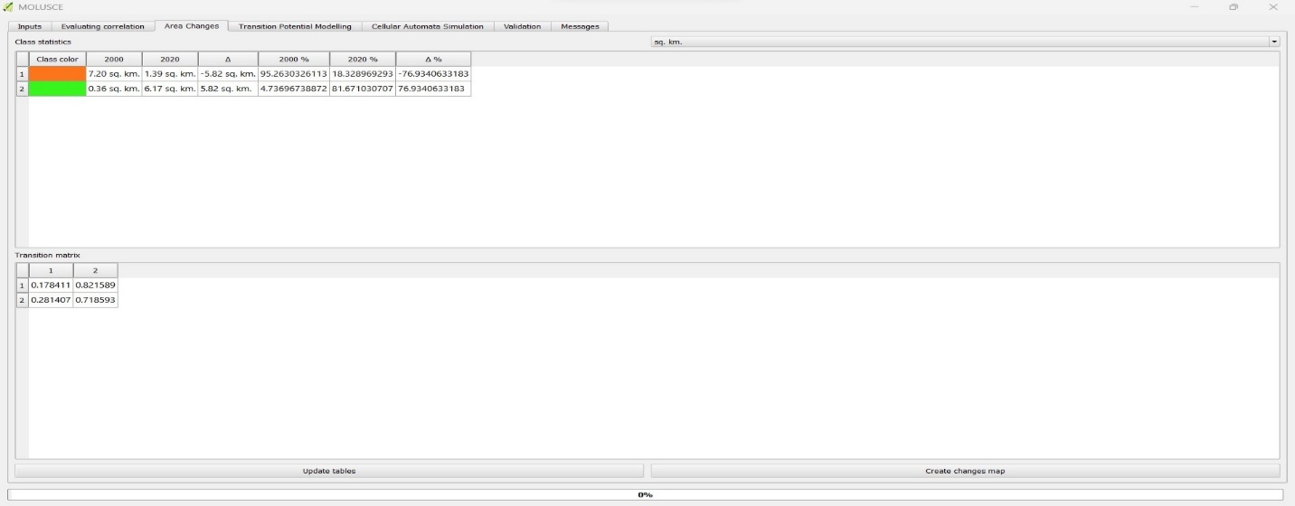

SFigure 8: Output on change in Areal Coverage of Land covers of Classified images (2000-2020), generated from Markov Chain Model
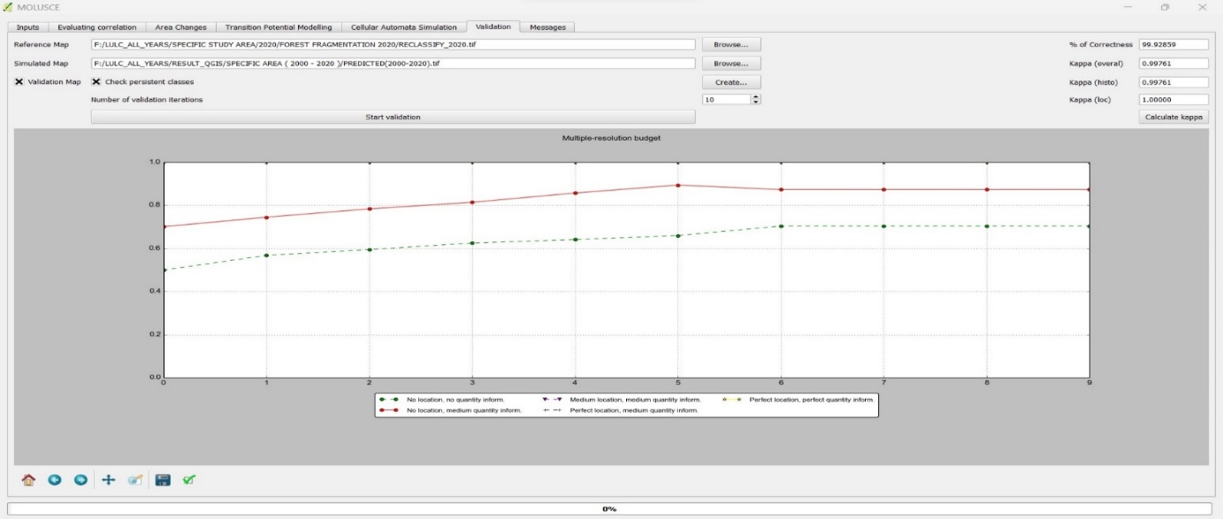

SFigure 9: Validation utilizing Kappa Statistic to show the percentage of correctness of classified images through Markov Chain Model (2000-2020)

