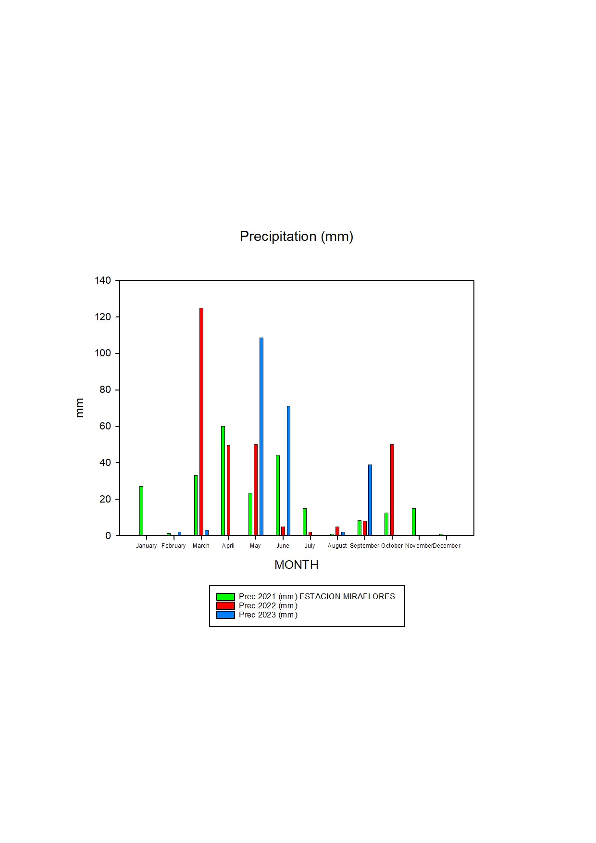
Figure S2. Precipitation recorded during the three years of study (2021-2023).
2021
2022
2023

