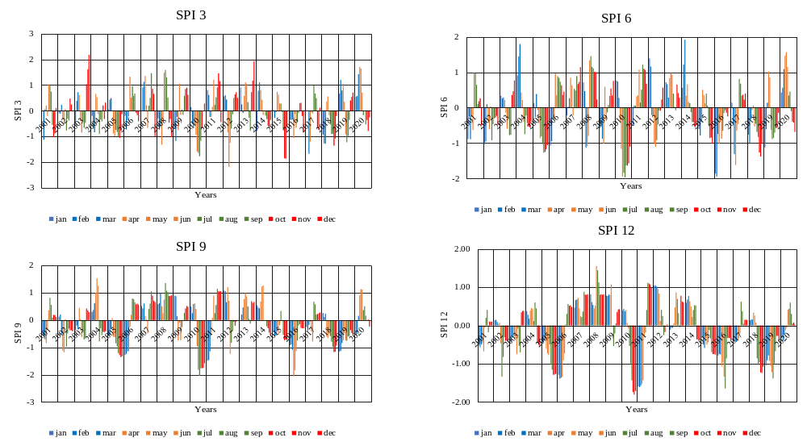
Figure 3. (a) Graph Showing Temporal Variation of SPI 3-month timescale from 2001 to 2020 of Ranchi, Jharkhand
Figure 3. (b) Graph Showing Temporal Variation of SPI 6-month timescale from 2001 to 2020 of Ranchi, Jharkhand
Figure 3. (c) Graph Showing Temporal Variation of SPI 9-month timescale) from 2001 to 2020 of Ranchi, Jharkhand
Figure 3. (d) Graph Showing Temporal Variation of SPI 12-month timescale from 2001 to 2020 of Ranchi, Jharkhand

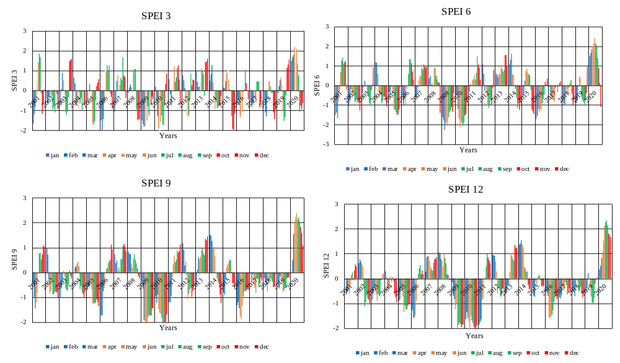
Figure 5.(a) Graph Showing Temporal Variation of SPEI 3-month timescale from 2001 to 2020 of Ranchi, Jharkhand

Figure 5.(b) Graph Showing Temporal Variation of SPEI 6-month timescale from 2001 to 2020 of Ranchi, Jharkhand

Figure 5.(c) Graph Showing Temporal Variation of SPEI 9-month timescale from 2001 to 2020 of Ranchi, Jharkhand

Figure 5. (d) Graph Showing Temporal Variation of SPEI 12-month timescale from 2001 to 2020 of Ranchi, Jharkhand

