Supplementary Information
Thermal and mesomorphic behavior of Hydrogen Bonded Liquid Crystals of new pyridine derivatives
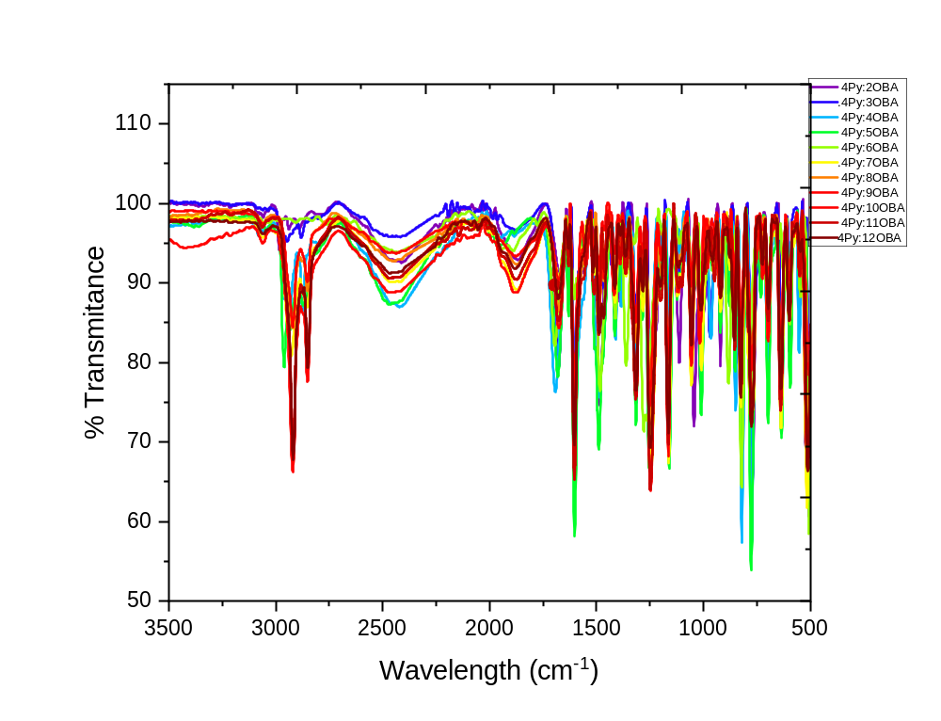
Fig S1 : FTIR spectra of 4Py:nOBA complexes

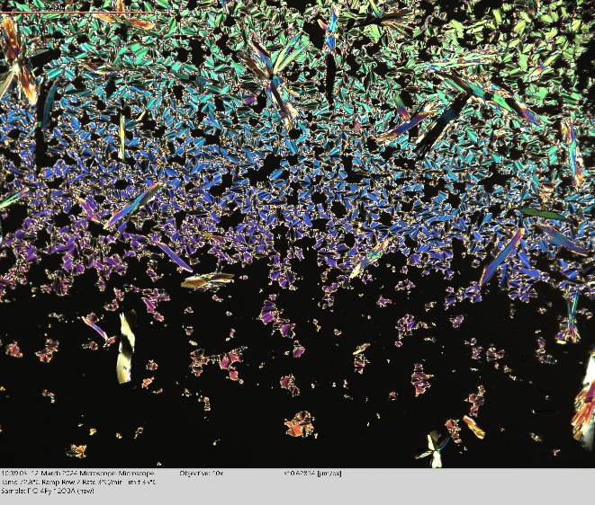  - Smectic Phase of 4Py:12OBA | 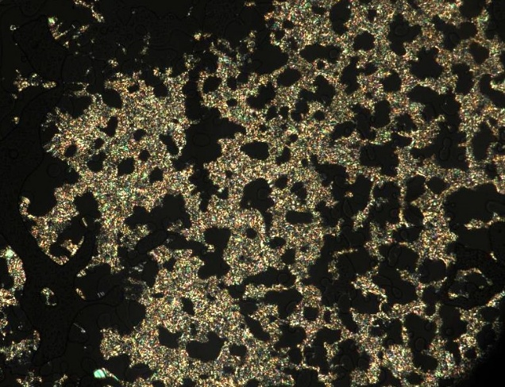  - Smectic Phase of 4Py:11OBA
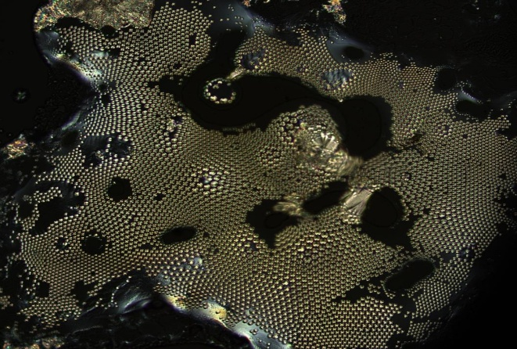  - Smectic Phase of 4Py:10OBA | 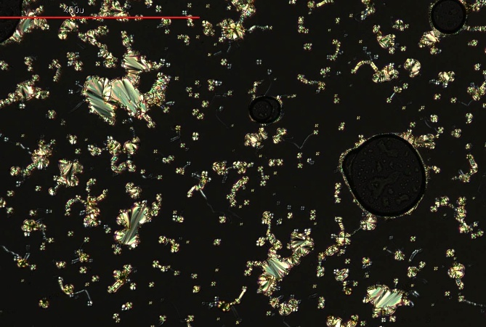  - Smectic Phase of 4Py:9OBA
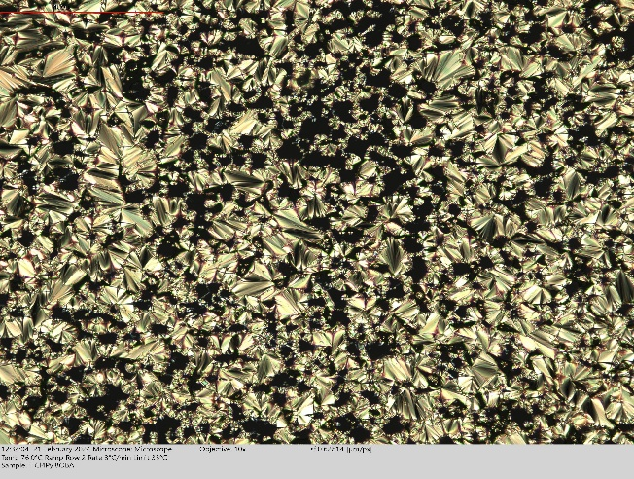  - Smectic Phase of 4Py:8OBA | 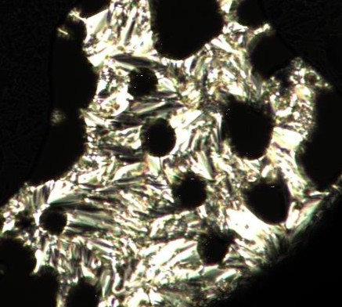  - Smectic Phase of 4Py:7OBA
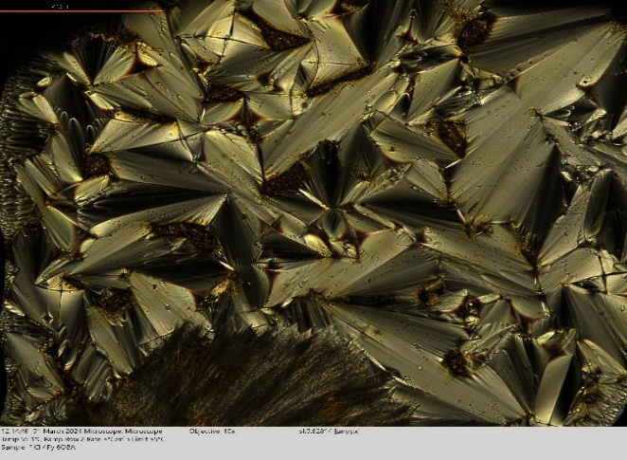  - Smectic Phase of 4Py:6OBA | 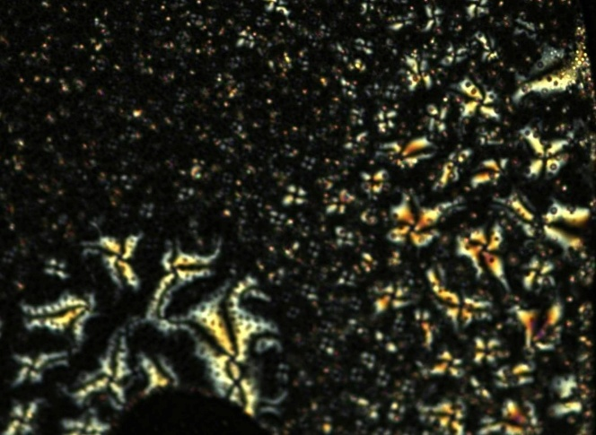  - Nematic Phase of 4Py:5OBA
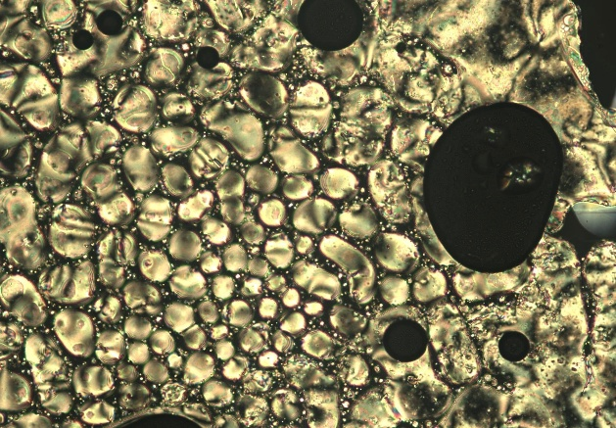  - Nematic Phase of 4Py:3OBA | 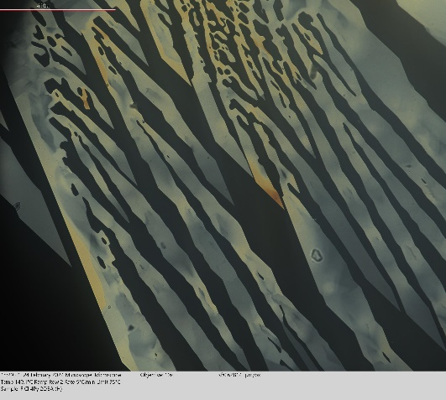  - Crystalline phase of 4Py:2OBA
Fig. S2 (a-j) : Liquid crystalline phases of different HB complexes viz., 4Py:nOBA as observed in POM under crossed polarisers

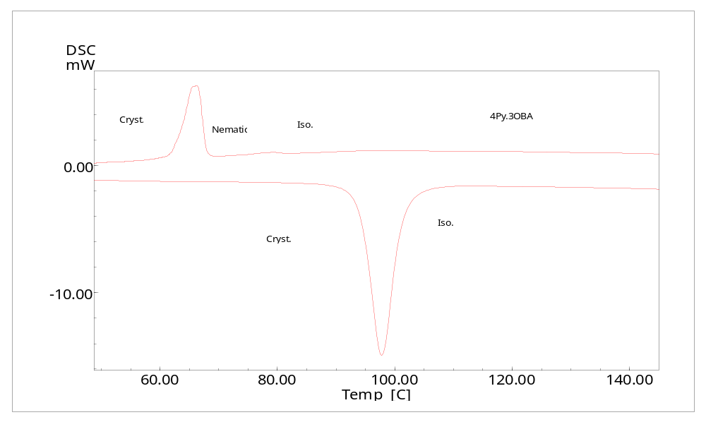
Fig. S4: DSC Thermograms of 4Py:3OBA

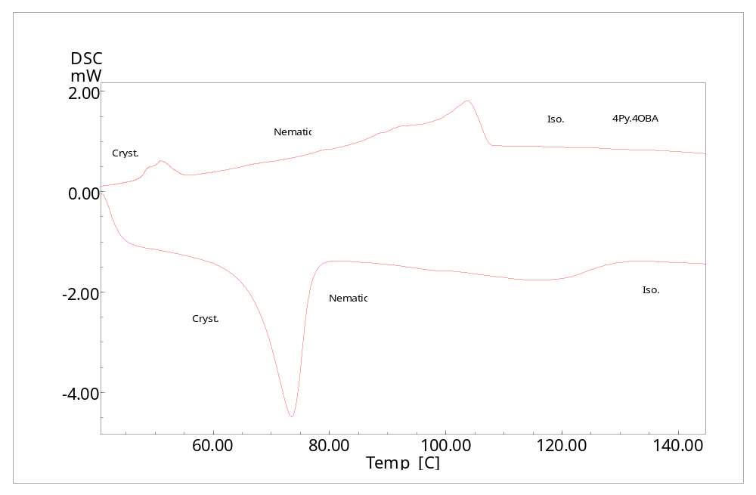
Fig. S5: DSC Thermograms of 4Py:4OBA

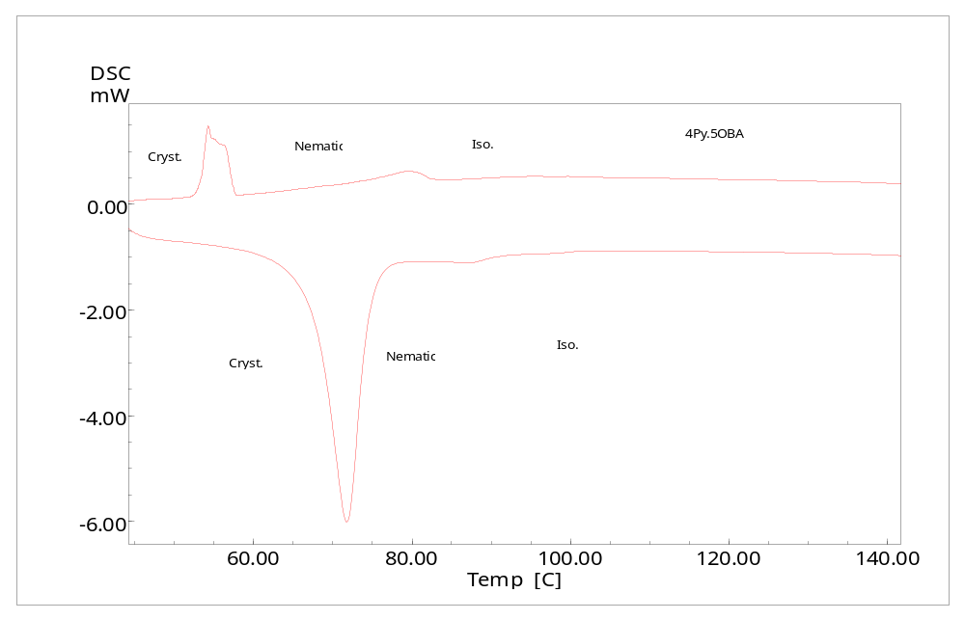
Fig. S6: DSC Thermograms of 4Py:5OBA

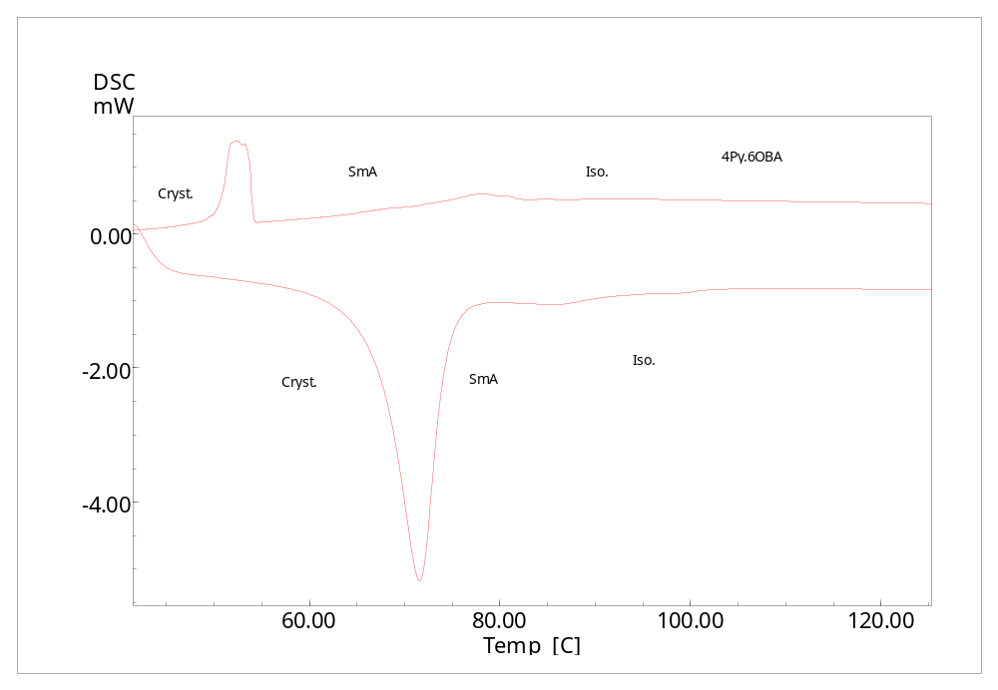
Fig. S7: DSC Thermograms of 4Py:6OBA

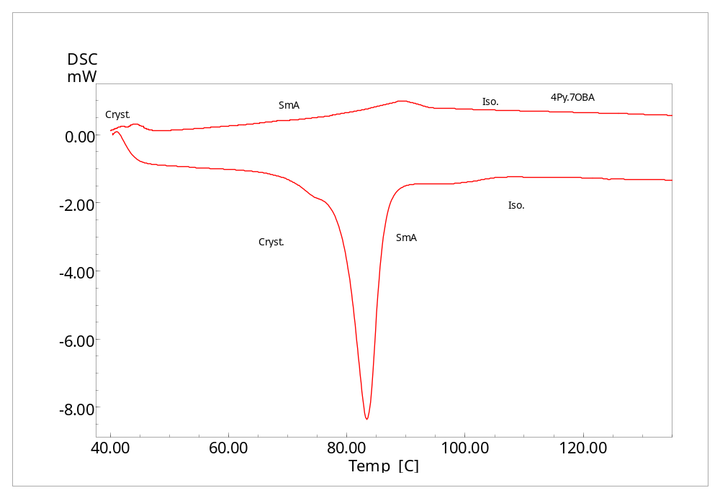
Fig. S8: DSC Thermograms of 4Py:7OBA

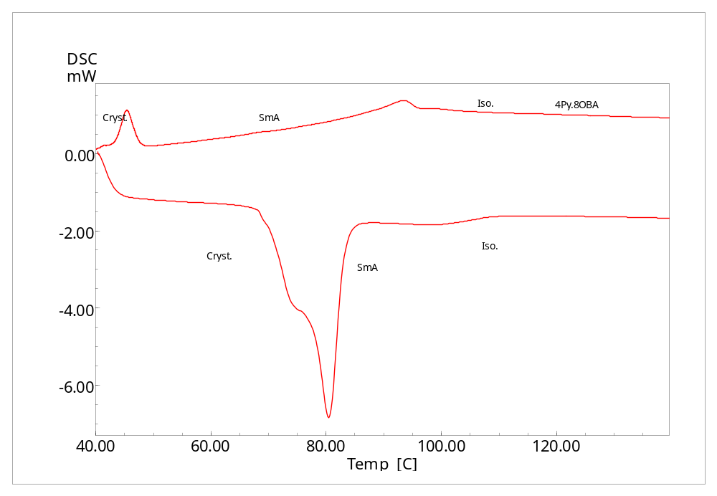
Fig. S9: DSC Thermograms of 4Py:8OBA

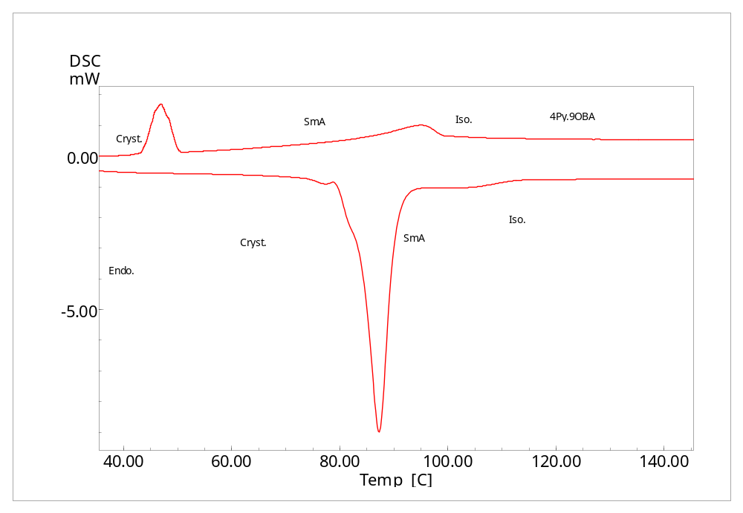
Fig. S10: DSC Thermograms of 4Py:9OBA

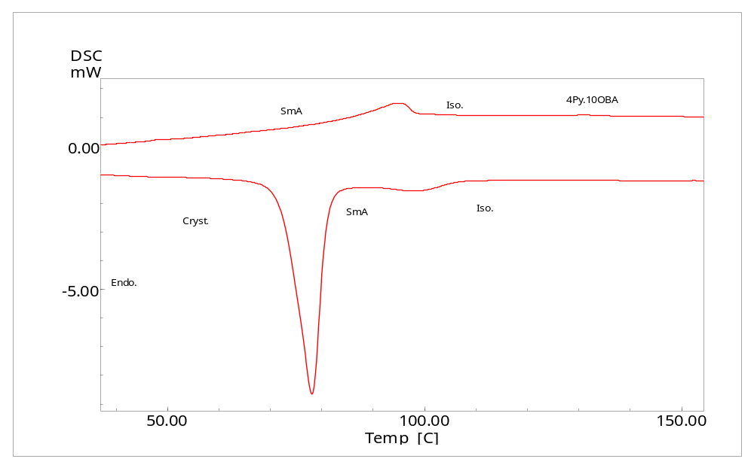
Fig. S11: DSC Thermograms of 4Py:10OBA

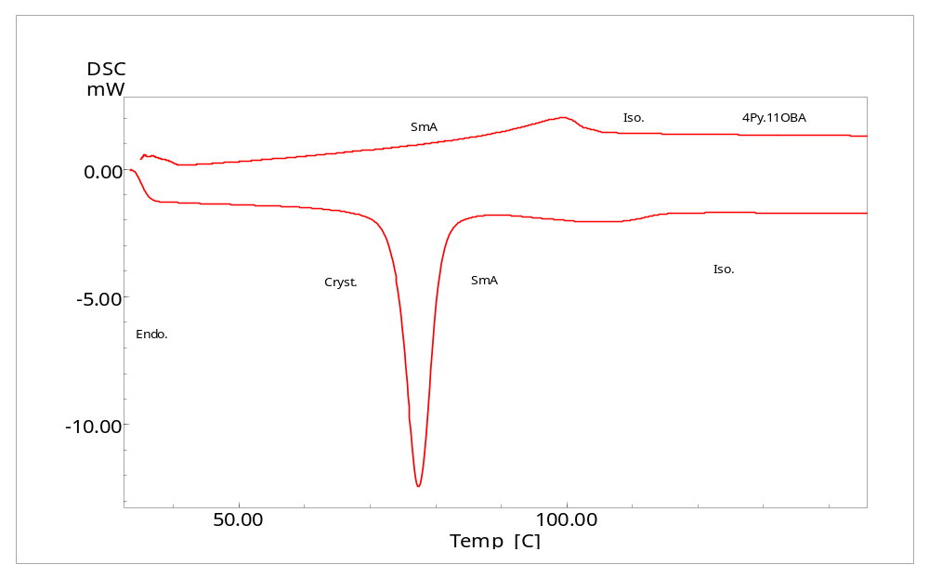
Fig. S12: DSC Thermograms of 4Py:11OBA

*****

