APPENDIX A
Development of model concrete mix designs for PET sustainable structural lightweight concrete
Empirical models, typically polynomial models (linear or quadratic), were developed using the data obtained from performance tests of concrete specimens. The model derivation followed the steps outlined below:
- Calculate effects: The effect of the individual independent factors and interactions of the independent factors on performance responses was calculated using the equation below:
$$Effect=\frac{\sum{P_{+}}}{n_{+}}-\frac{\sum{P_{-}}}{n_{-}} (1)$$
Where,
P is the performance response
n is the number of data points
- Determine the mean of the absolute values of the effects.
- Consider the effects which are greater than the mean value as likely significant (model) effects. The remaining effects lower than the mean value are considered as insignificant effects (residual).
- Calculate each effect’s sums of squares (SS) using the formula
$$SS=\frac{N}{4}{\left(Effect\right)}^{2} (2)$$
Where,
N is the number of runs.
- Compute SSModel: The addition of the Sum of squares for the likely significant effects.
- Compute SSResiduals: The addition of the Sum of squares for the insignificant effects.
- Construct an ANOVA table to finally isolate the truly significant effects and eliminate the insignificant effects.
- Derive predictive equations for all responses with statistically significant factors using standard statistical regression as follows:
$$\hat{y}=β_{0}+β_{1}X_{1}+β_{2}X_{2}+β_{3}X_{3}+β_{12}X_{1}X_{2}+β_{13}X_{1}X_{3}+β_{23}X_{2}X_{3}+β_{123}X_{1}X_{2}X_{3} \left(3\right)$$
The predictive model is presented in both actual and coded formats. The coded (or pseudo) equation is particularly beneficial for assessing the comparative importance by comparing the coefficients of factors.
By producing summary statistics, the model's suitability will be quantitatively confirmed. The derived model must satisfy the following criteria:
- Model significance is confirmed by the model F-value and related p-value (p < 0.05).
- The predicted R-squared and adjusted R-squared accord reasonably well ($≤$0.2).
- Adequate precision is high enough (> 4).
- The significance of each term is confirmed by tests (p < 0.05).
The summary statistics are described below:
- Pred. R-squared: An assessment of the degree to which the model accounts for variability in the new data.
$$Predicted R^{2}=1-\frac{\sum{{\left(y_{i}-\hat{y}\right)}^{2}}}{\sum{{\left(y_{i}-\overline{y}\right)}^{2}}} (4)$$
Where,
$\hat{y}$ is the predicted value of y
$\overline{y}$ is the mean value of y
- Adj. R-squared: This metric quantifies the extent of variation around the mean that is accounted for by the model, with adjustments made for the number of terms included in the model. The adjusted R-squared will decline with an increase in the number of terms in the model, provided that the additional terms do not contribute value to the model.
$$Adjusted R^{2}=1-\frac{\left(1-R^{2}\right)\left(N-1\right)}{N-p-1} \left(5\right)$$
Where,
R² is the predicted R²
N is the total sample size
P is the number of independent variables
The variance of the predicted R-squared and the adjusted R-squared should be below 0.20. If not, there might be an issue with the model or the data. Consider transformations, look for outliers, or explore a polynomial of a different order.
- Predicted Residual Error Sum of Squares: An evaluation of how well the model fits each design point. The PRESS is computed by first forecasting each point's location using a model that includes every other point, but not the one in question. The difference between the actual and expected values is represented by the squared residuals, which are then added together.
$$Prediction error sum of squares \left(PRESS\right)=\sum_{i=1}^{n}{{\left({\overline{y}}_{i}-\hat{y}\right)}^{2}} (6)$$
Where,
$\hat{y}$ is the predicted value of y
$\overline{y}$ is the mean value of y
- Adequate Precision: This represents a signal-to-noise ratio. The comparison involves assessing the extent of expected values at the designated points against the average prediction error. Ratios exceeding 4 demonstrate sufficient model judgement.
$$Adequate precision=\frac{\max\left(\hat{y}\right)-\min\left(\hat{y}\right)}{\sqrt{{\overline{V}}_{\hat{y}}}}>4 (7)$$

APPENDIX B
Optimization of model concrete mix design using desirability function
Optimization of model concrete mix designs will be achieved using the Desirability function approach (Derringer & Suich, 1980). The above approach seeks to identify the ideal conditions that will optimise each response individually or maintain them at predetermined levels. The first step is to transform each response y₁ into a unique desirability function d₁, with d₁ varying between 0 and 1. A response with d₁ = 0 is wholly undesired, whereas d₁ = 1 represents the most desired response. For this investigation, the two-sided desirability function will be used in order to reach the optimisation target T, which is located as outlined between the lowest (L) and higher (U) limits of each response.
Below is the two-sided desirability function:
$$d=\left\{\begin{aligned}0 y<L \\ {\left(\frac{y-L}{T-L}\right)}^{r_{1}} L≤y≤T \\ {\left(\frac{U-y}{U-T}\right)}^{r_{2}} T≤y≤U \\ 0 y>U\end{aligned}\right. (8)$$
Where
r₁ and r₂ denote the weights of the function.
All individual desirabilities will be combined into an overall desirability as follows:
$$D={\left(d_{1}.d_{2}………..d_{m}\right)}^{1/m} (9)$$
Where,
m stands for the number of responses.
Thus, the overall desirability will be a function of the independent variables.

APPENDIX C
Perturbation curves for a closer understanding of the effects of the model variables on the responses.
Factors
$${A=X}_{1}=0.425$$
$${B=X}_{2}=359$$
$${C=X}_{3}=532$$

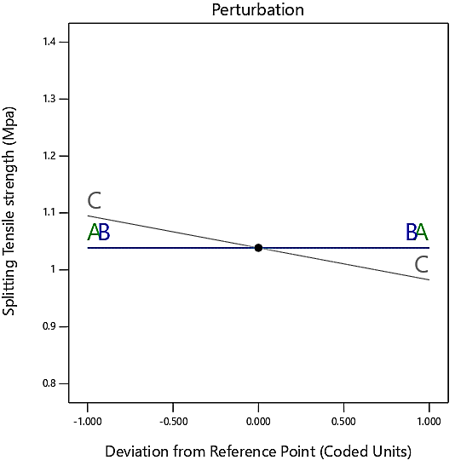 | 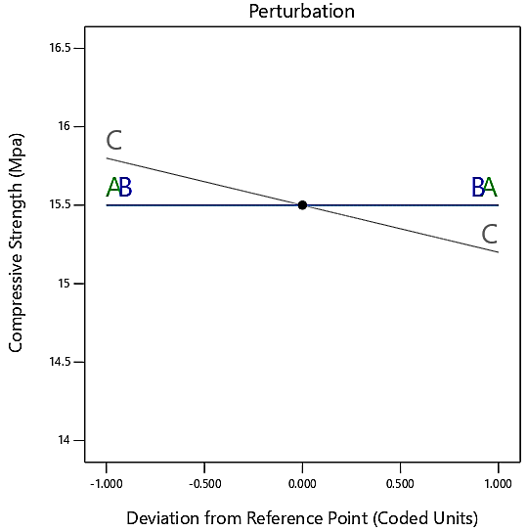
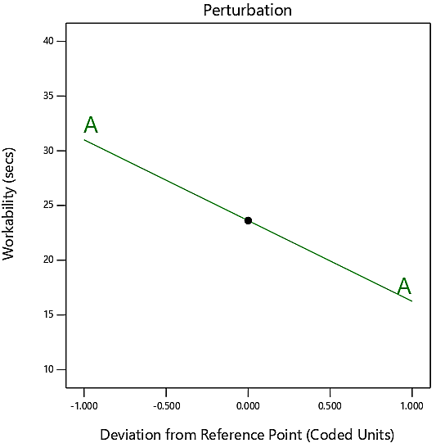 | 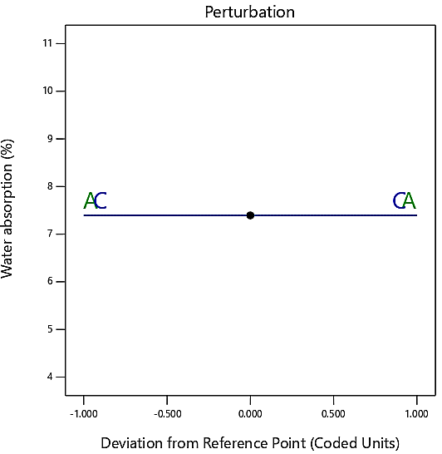
Perturbation curves of the developed models

APPENDIX D
Three-dimensional (3D) effect graphs to visualize the results of the models.
Workability
(a) 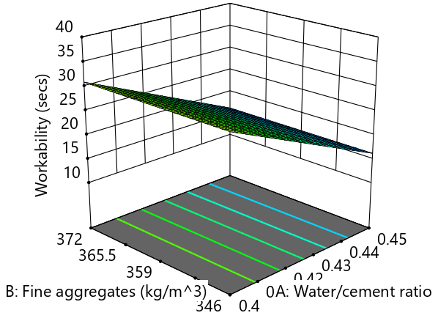
Compressive strength
(b) 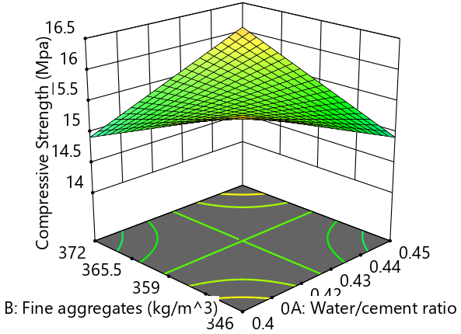 | (c)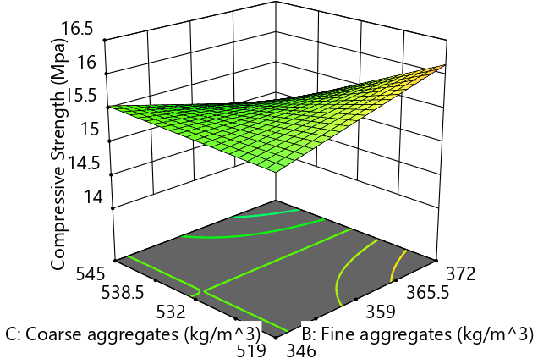
Splitting tensile strength
(d)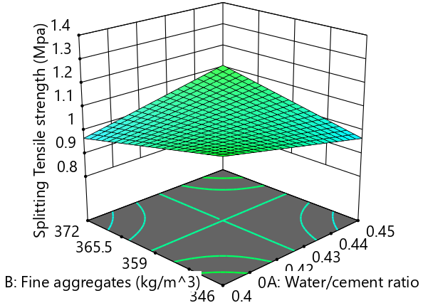 | (e) 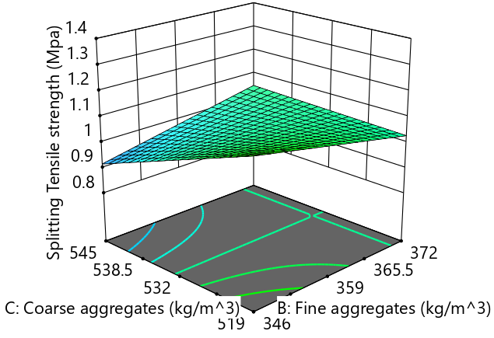
Water absorption
(f) 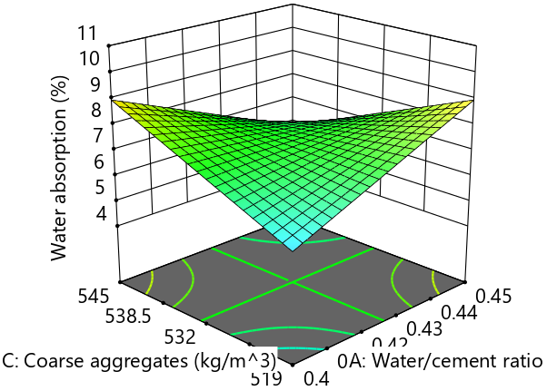
3-dimensional effect graphs

APPENDIX E
Desirability
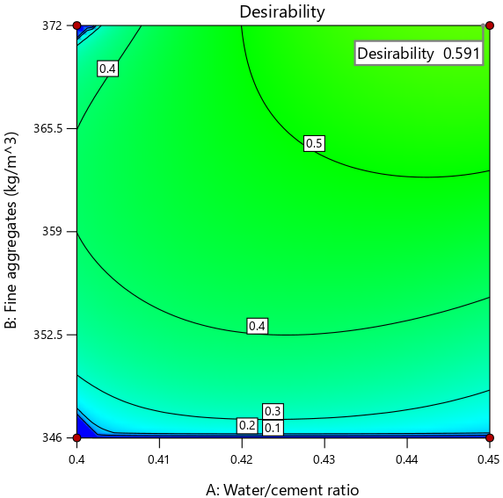 | 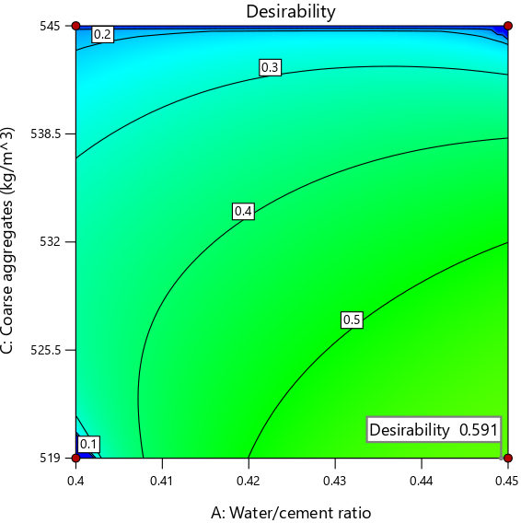
- Fine aggregates vs Water/cement ratio | - Coarse aggregates vs Water/cement ratio
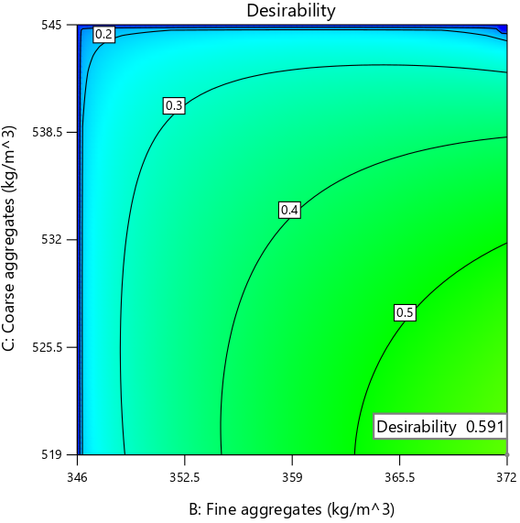
(c) Coarse aggregates vs Fine aggregates
Dry density
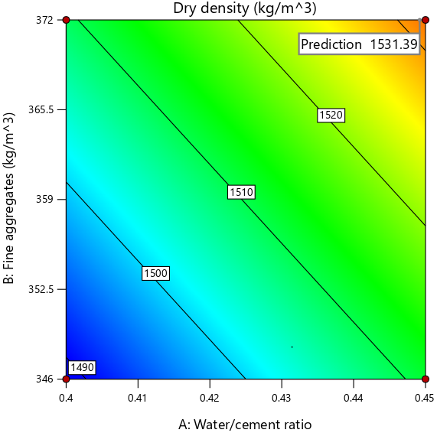 |  | 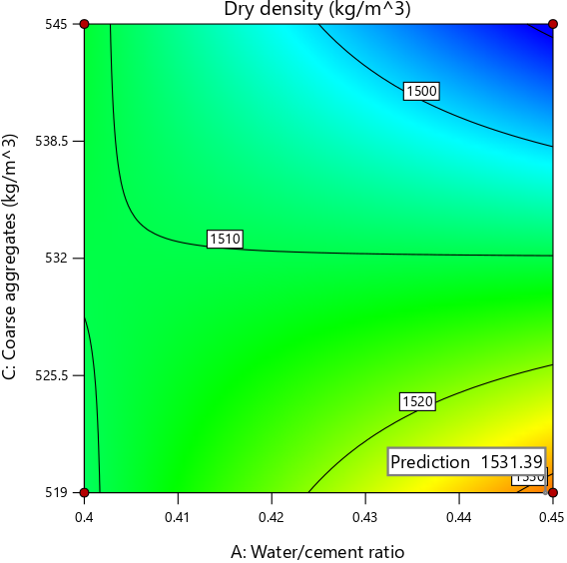
- Fine aggregates vs Water/cement ratio |  | - Coarse aggregates vs Water/cement ratio
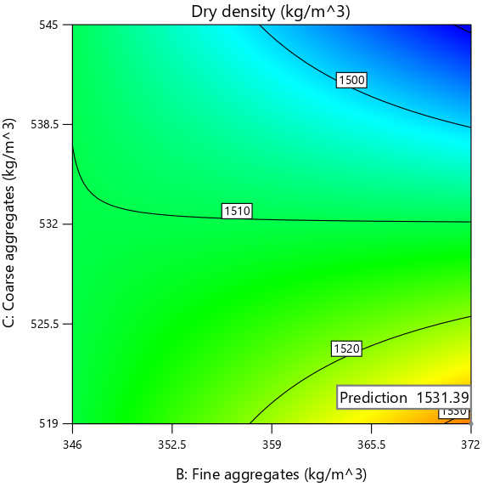
- Coarse aggregates vs Fine aggregates
Workability
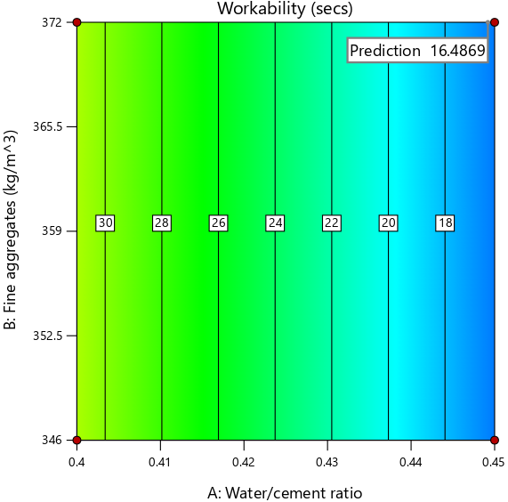 | 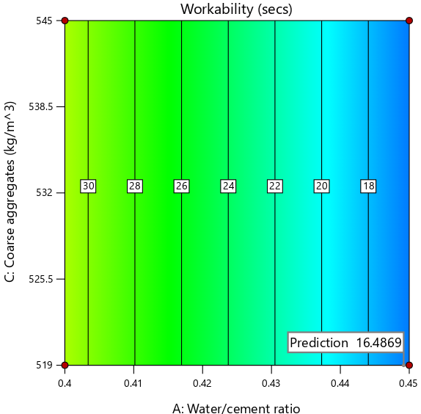
- Fine aggregates vs Water/cement ratio | - Coarse aggregates vs Water/cement ratio
Compressive Strength
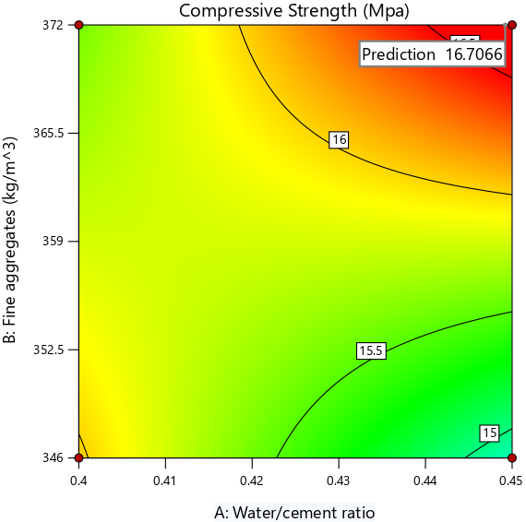 | 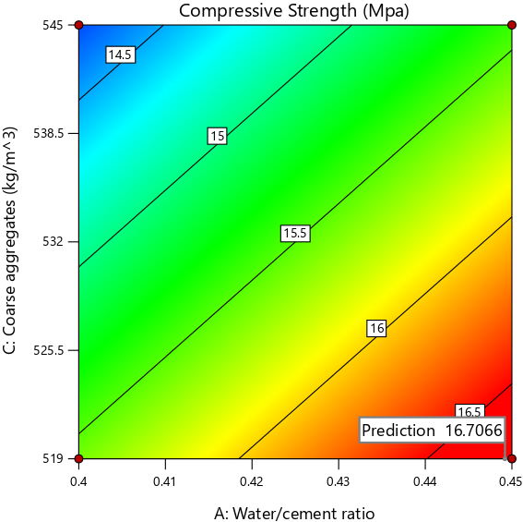
- Fine aggregates vs Water/cement ratio | - Coarse aggregates vs Water/cement ratio
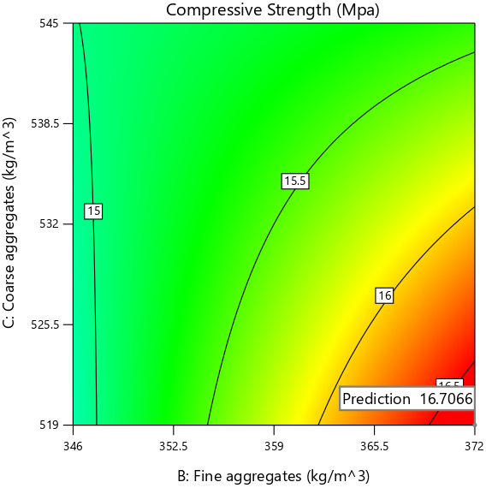
- Coarse aggregates vs Fine aggregates
Splitting Tensile Strength
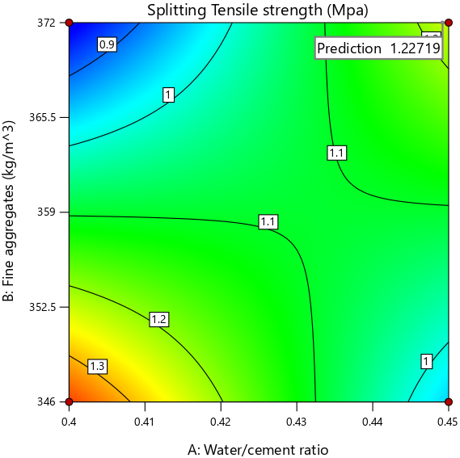 | 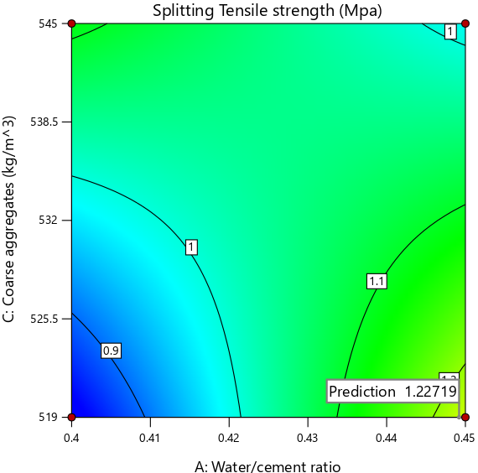
- Fine aggregates vs Water/cement ratio | - Coarse aggregates vs Water/cement ratio
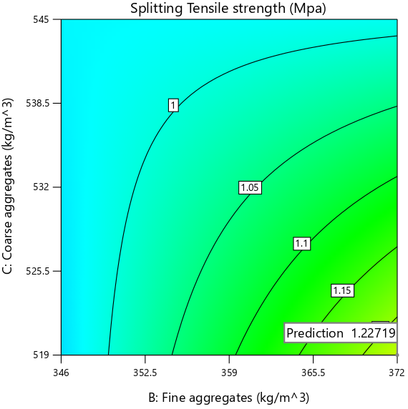
- Coarse aggregates vs Fine aggregates
Water absorption
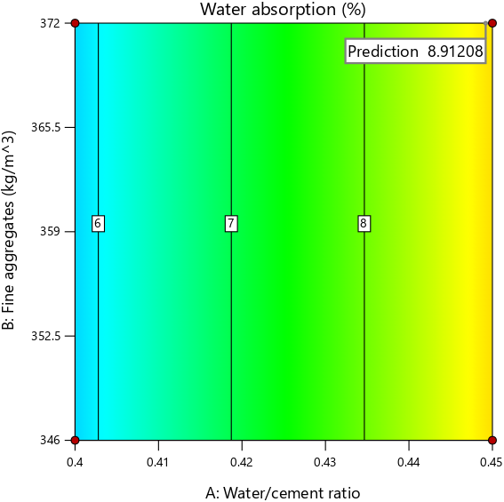 | 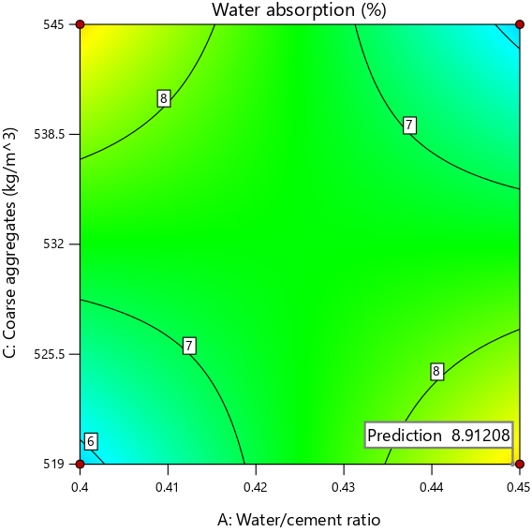
- Fine aggregates vs Water/cement ratio | - Coarse aggregates vs Water/cement ratio
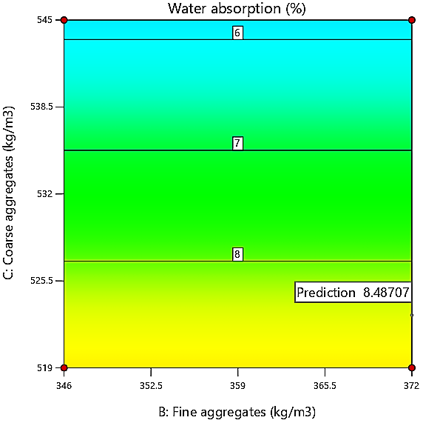
- Coarse aggregates vs Fine aggregates
2-dimensional Contour plots

APPENDIX F

