Supplementary Information for

Detachable Hyaluronic Acid Tattoo Microneedles of Various Colorants
Kornkamol Obthong,ª Supanan Ampawa ^{b} and Supason Wanichwecharungruang ^{a,}*

ª Center of Excellence in Materials and Bio-Interfaces, Department of Chemistry, Faculty of Science, Chulalongkorn University, Bangkok, 10330, Thailand.
^{b} Mineed Technology, 928 Block 28, Building D, Chulalongkorn 7 Alley, Bangkok, 10330, Thailand.
* Corresponding Author, E-mail: supason.p@chula.ac.th

Contents | Pages
Fig. S1 Photographic images of the colorants used in this study. | 2
Fig. S2 Microneedle mold design and microneedle dimensions. | 3
Fig. S3 Flowchart illustrating the preparation, fabrication, and analysis processes of tattoo microneedle patches. | 4
Fig. S4 Morphology of tattoo microneedle patches before and after compression and their mechanical properties. | 5
Fig. S5 Mechanism of microneedle transfer into the skin. | 6
Fig. S6 Penetration depths of selected tattoo microneedle patches. | 7
Fig. S7 Top-view stereomicroscopic images and corresponding cross-sectional images of ex vivo porcine skin after application of microneedles containing black colorants. | 8
Fig. S8 Top-view stereomicroscopic images and corresponding cross-sectional images of ex vivo porcine skin after application of microneedles containing blue colorants. | 9
Fig. S9 Top-view stereomicroscopic images and corresponding cross-sectional images of ex vivo porcine skin after application of microneedles containing yellow colorants. | 10
Fig. S10 Top-view stereomicroscopic images and corresponding cross-sectional images of ex vivo porcine skin after application of microneedles containing red colorants. | 11
Table S1 Penetration depths of tattoo microneedle patches measured in ex vivo porcine skin experiments. | 12
Table S2 Pairwise comparisons of penetration depth among colorants within each color category. | 12
Table S3 CIELAB color parameter (L* values) for black colorants. | 13
Table S4 CIELAB color parameter (b* values) for blue colorants. | 14
Table S5 CIELAB color parameter (b* values) for yellow colorants. | 15
Table S6 CIELAB color parameter (a* values) for red colorants. | 16

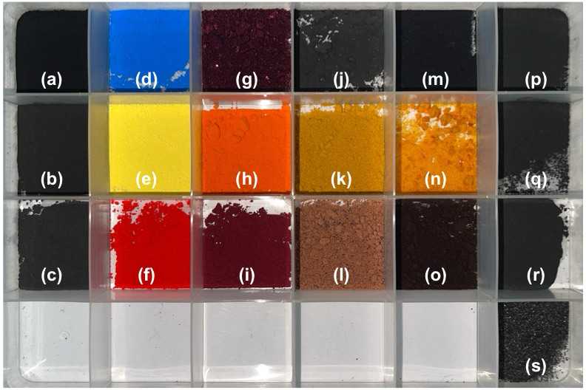
Fig. S1 Photographic images of the colorants used in this study. The colorants include carbon black (a), bamboo charcoal (b), melanin black (c), blue tattoo pigment (d), yellow tattoo pigment (e), red tattoo pigment (f), FD&C Blue No. 1 (g), FD&C Yellow No. 5 (h), FD&C Red No. 40 (i), butterfly pea (j), curcumin (k), beetroot (l), gardenia blue (m), beta-carotene (n), red yeast rice (o), and bamboo charcoal with different particle sizes:1–2 µm (p), 3–5 µm (q), 4–9 µm (r), and 0.3–0.7 mm (s).
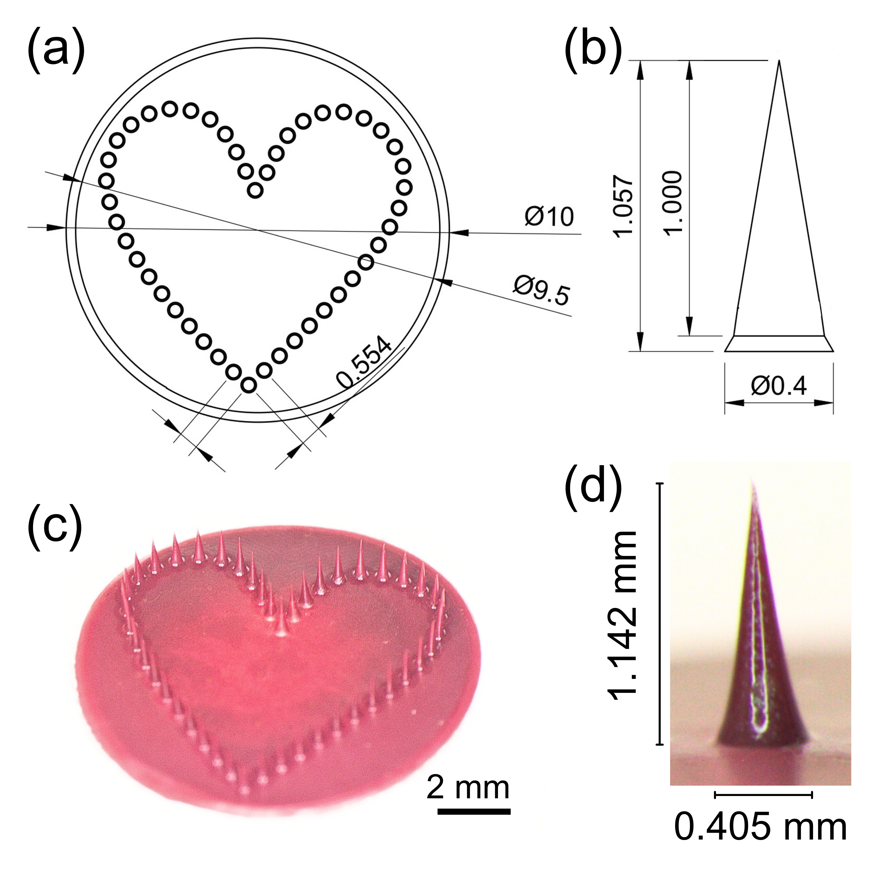
Fig. S2 Microneedle mold design and microneedle dimensions. (a) Schematic illustration of the heart-shaped microneedle arrangement containing 46 needles within a 10 mm patch, with a center-to-center needle spacing of 0.554 mm. (b) Dimensions of an individual conical microneedle (height: 1000 µm; base diameter: 400 µm). (c) Stereomicroscopic image of a fabricated tattoo microneedle patch showing 46 needles arranged in a heart-shaped pattern. (d) Stereomicroscopic image of a single fabricated microneedle with a measured height of 1.142 mm and a base diameter of 0.405 mm.
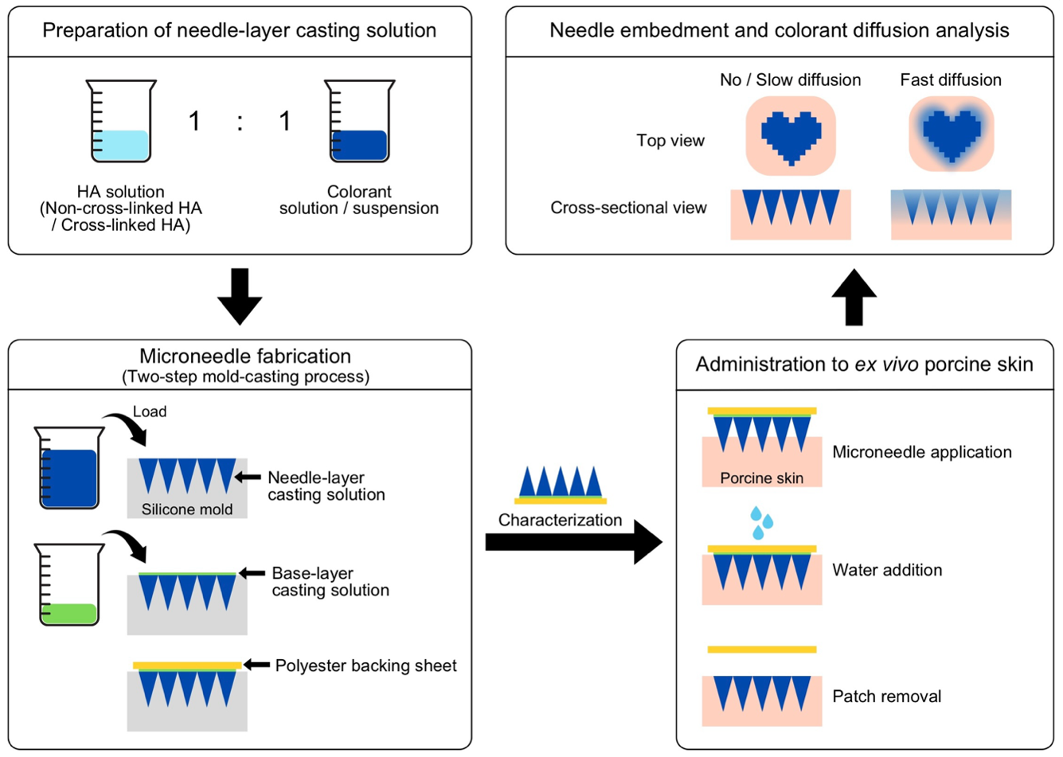
Fig. S3 Flowchart illustrating the preparation, fabrication, and analysis processes of tattoo microneedle patches.
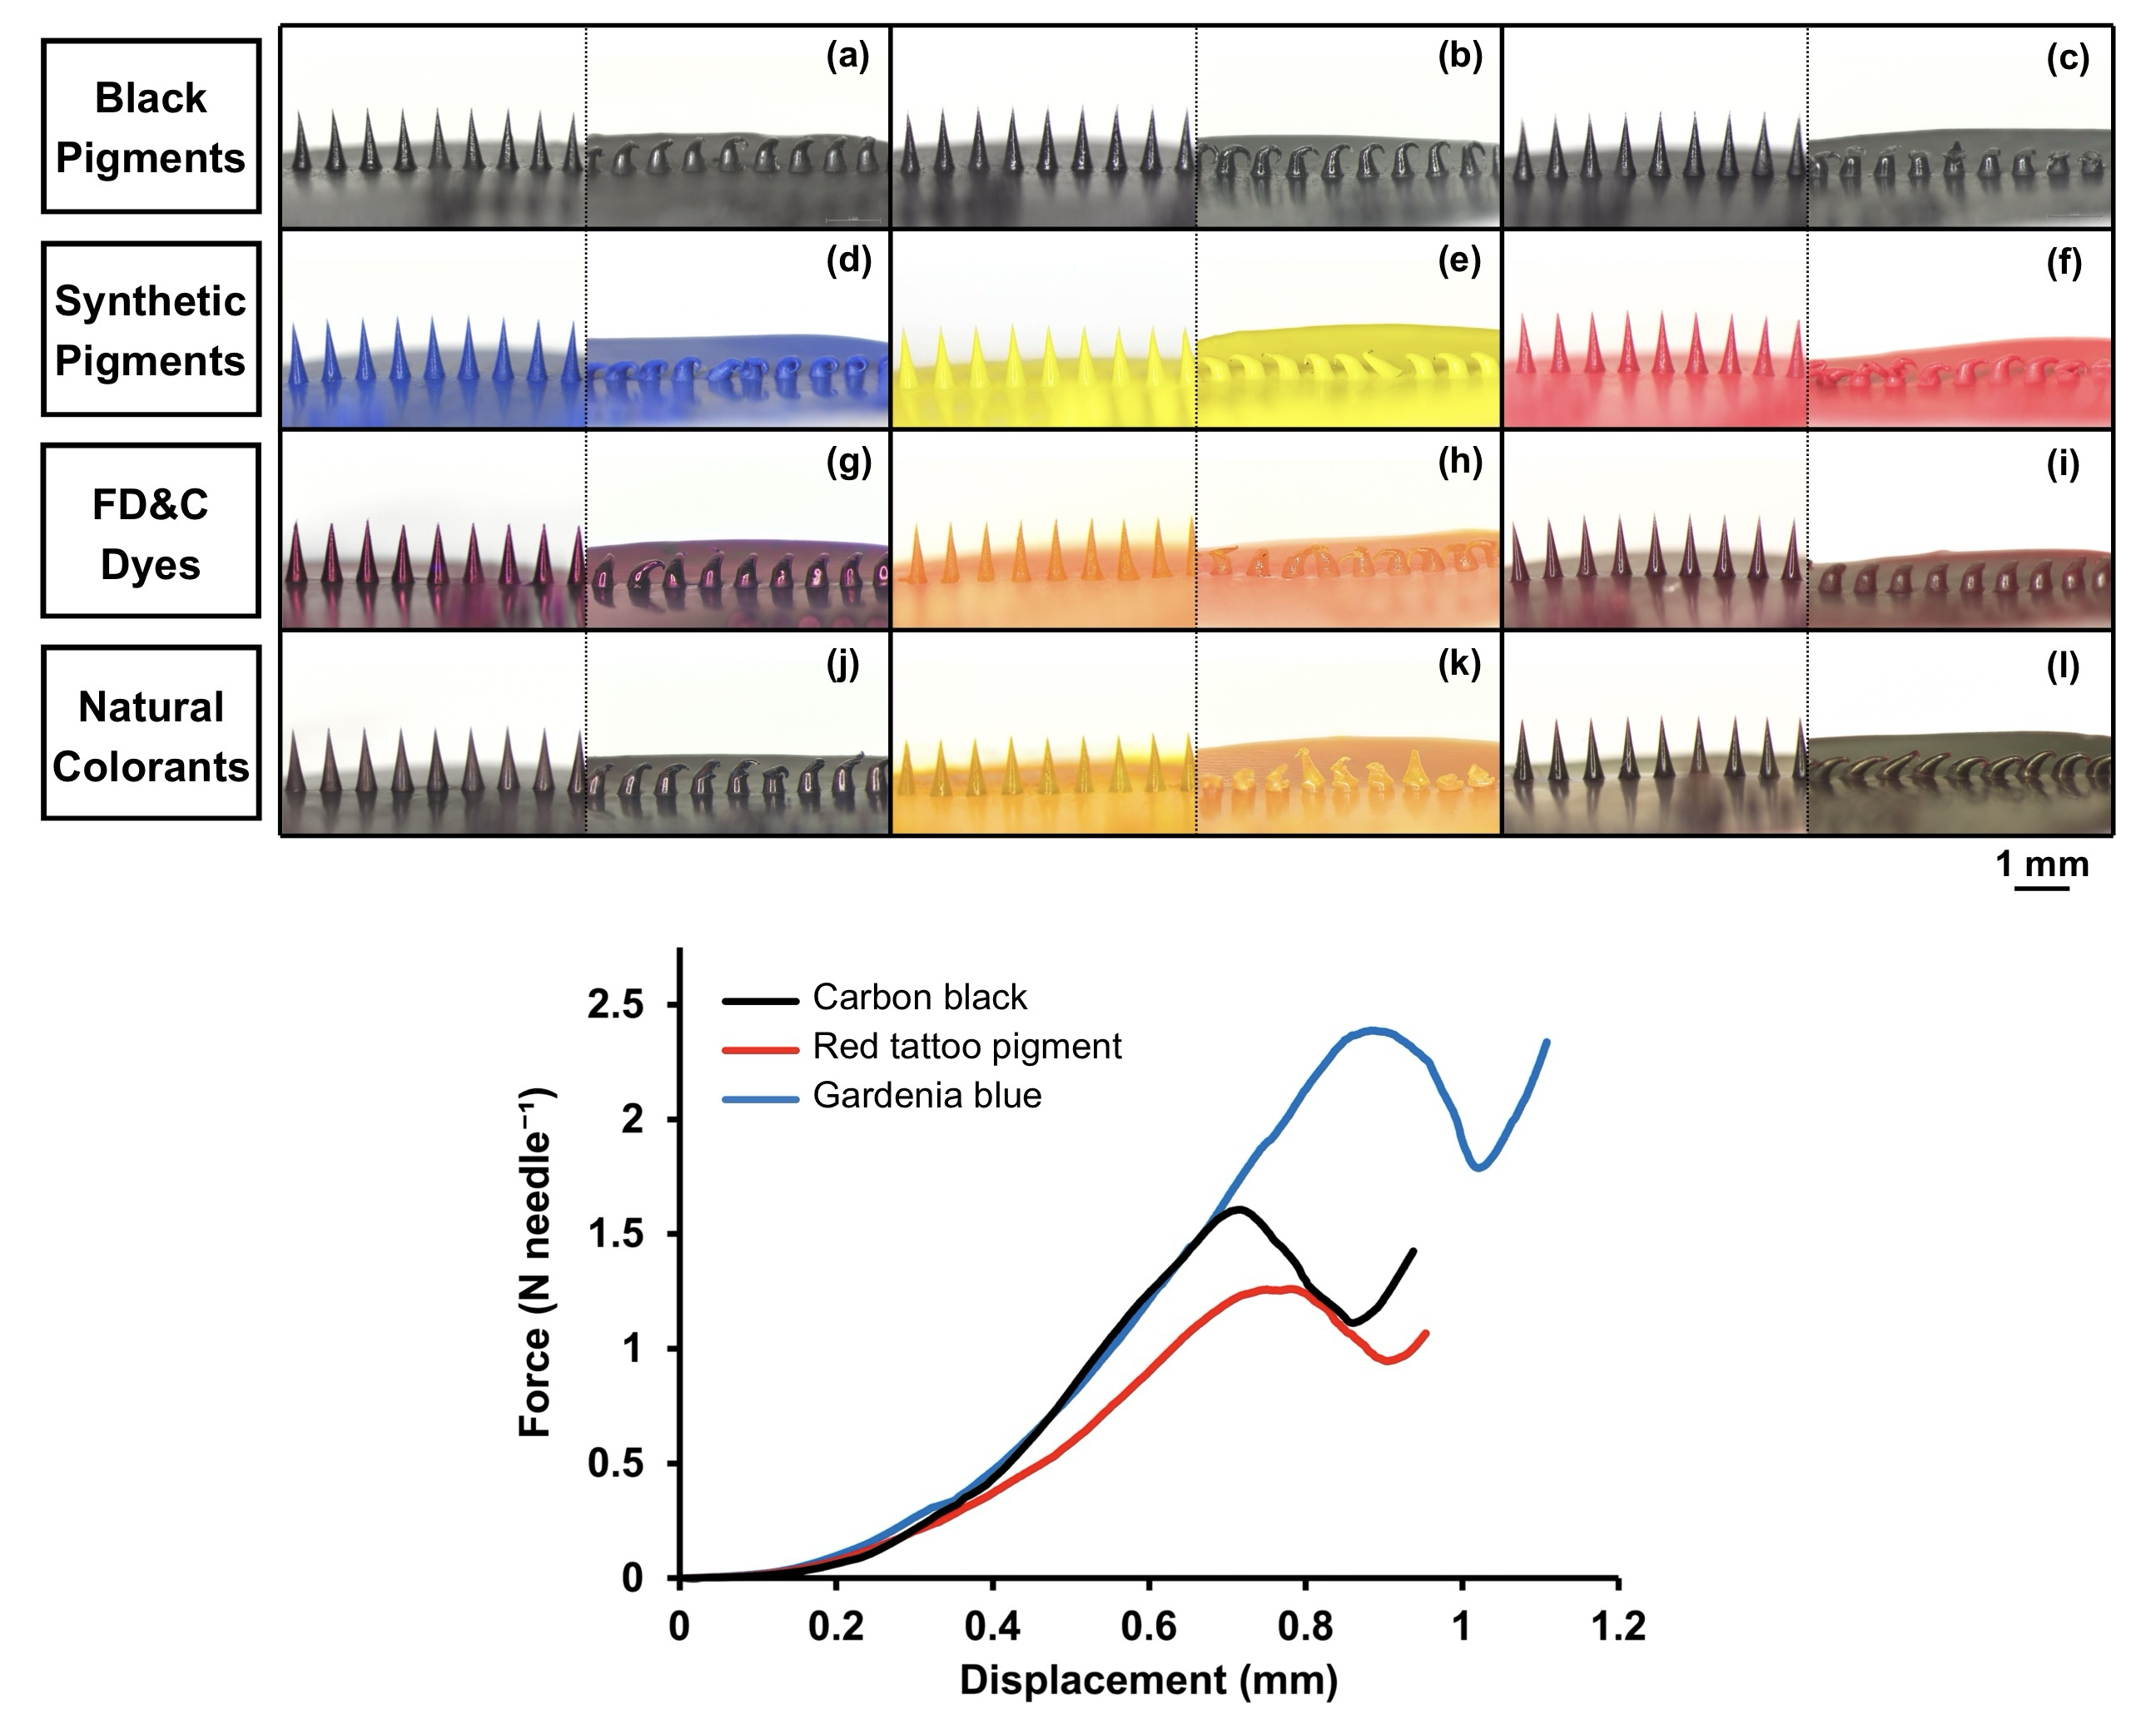
Fig. S4 Morphology of tattoo microneedle patches before and after compression and their mechanical properties. Each rectangular panel shows side-view stereomicroscopic images of each tattoo microneedle patch before (left) and after (right) compression for patches loaded with carbon black (a), bamboo charcoal (b), melanin black (c), blue tattoo pigment (d), yellow tattoo pigment (e), red tattoo pigment (f), FD&C Blue No. 1 (g), FD&C Yellow No. 5 (h), FD&C Red No. 40 (i), gardenia blue (j), curcumin (k), and red yeast rice (l). Representative force–displacement curves of tattoo microneedle patches loaded with carbon black, red tattoo pigment, and gardenia blue are shown at the bottom.
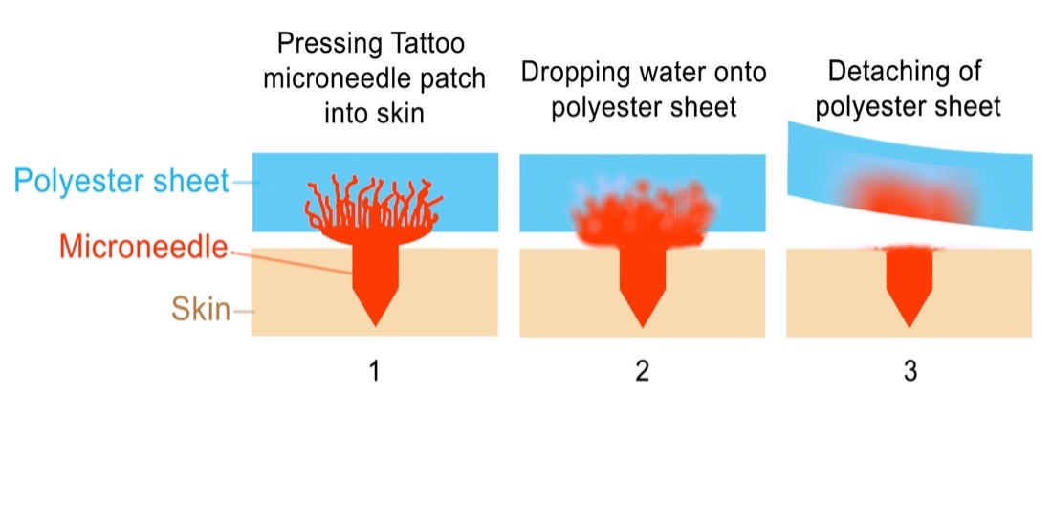
Fig. S5 Mechanism of microneedle transfer into the skin. (1) A microneedle (red), supported by a water-permeable polyester sheet (blue), is inserted into the skin (beige). Note that the microneedle base (root) is embedded within the polyester sheet. (2) Upon application of water to the polyester sheet, the root begins to dissolve. (3) After 1–2 min of sustained pressure, the root is fully dissolved, allowing removal of the polyester sheet while the microneedle remains embedded in the skin [22].
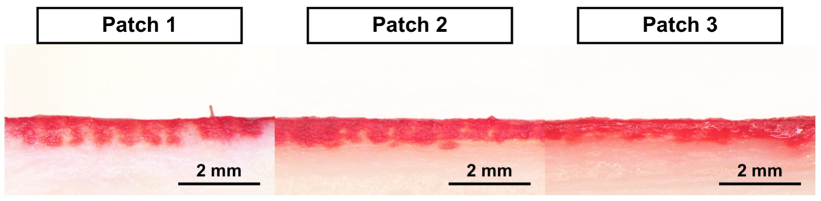
Fig. S6 Penetration depths of selected tattoo microneedle patches. Stereomicroscopic images showing cross-sectional views of ex vivo porcine skin after application of tattoo microneedles. Sectioning was performed immediately after the 2 min microneedle application using finger pressing, and images were captured immediately after sectioning. Images from three different FD&C Red No. 40-loaded microneedle patches are shown above.
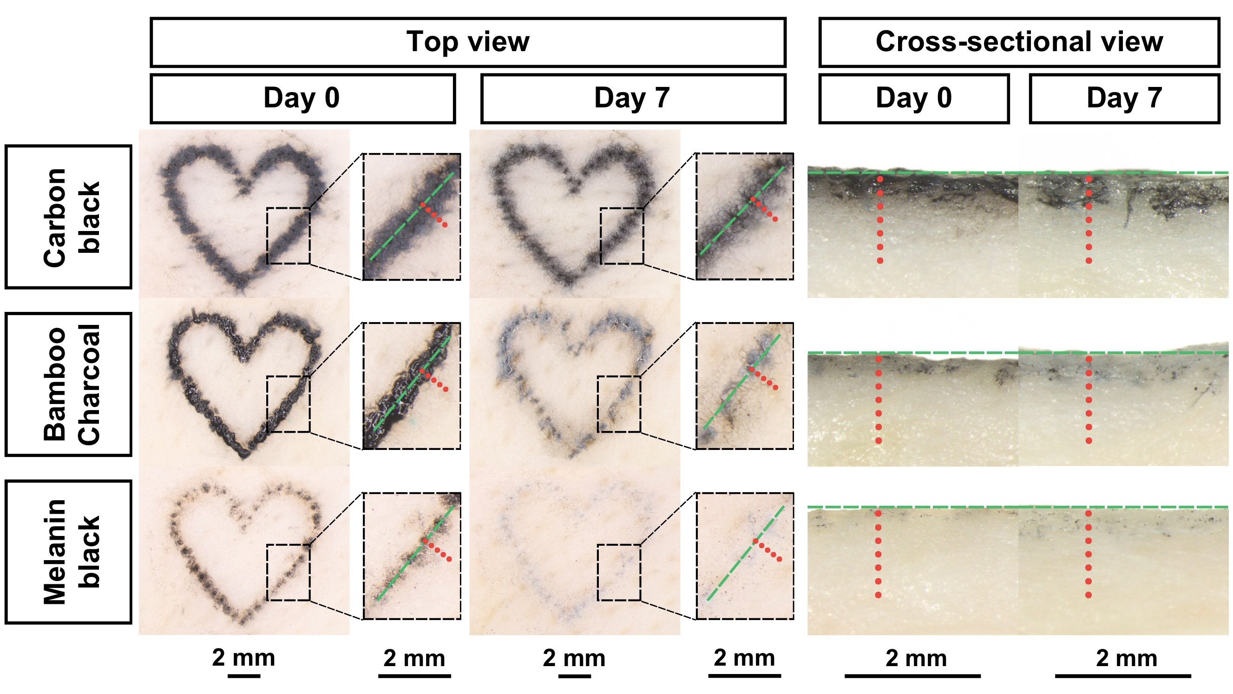
Fig. S7 Top-view stereomicroscopic images and corresponding cross-sectional images of ex vivo porcine skin after application of microneedles containing black colorants. The tested colorants include carbon black (top row), bamboo charcoal (middle row), and melanin black (bottom row). Images were taken on Day 0 and Day 7 after microneedle application. The reference line (green dashed line) and colored dots (red) indicate the measurement points used for color analysis. In the top-view images, color intensity was measured at distances of 0, 0.2, 0.4, 0.6, and 0.8 mm from the reference line. In the cross-sectional images, measurements were taken at distances of 0.1, 0.3, 0.5, 0.7, 0.9, 1.1, and 1.3 mm from the reference line.
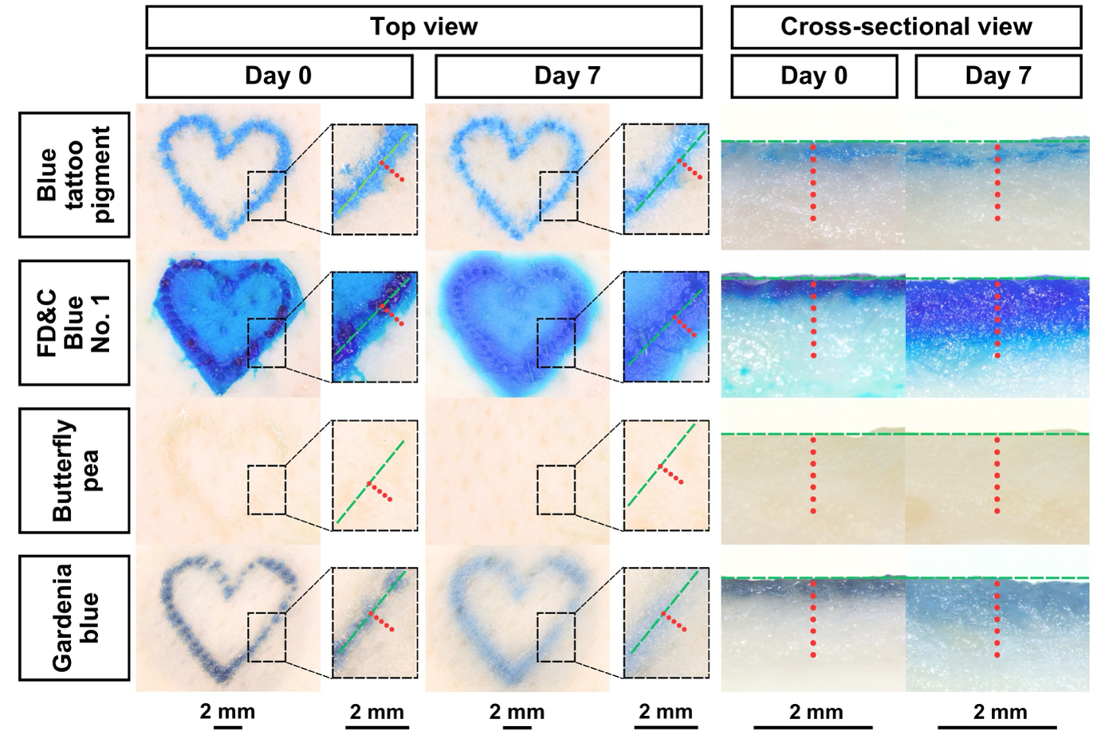
Fig. S8 Top-view stereomicroscopic images and corresponding cross-sectional images of ex vivo porcine skin after application of microneedles containing blue colorants. The tested colorants include blue tattoo pigment (top row), FD&C Blue No. 1 (second row), butterfly pea (third row), and gardenia blue (bottom row). Images were taken on Day 0 and Day 7 after microneedle application. The reference line (green dashed line) and colored dots (red) indicate the measurement points used for color analysis. In the top-view images, color intensity was measured at distances of 0, 0.2, 0.4, 0.6, and 0.8 mm from the reference line. In the cross-sectional images, measurements were taken at distances of 0.1, 0.3, 0.5, 0.7, 0.9, 1.1, and 1.3 mm from the reference line.
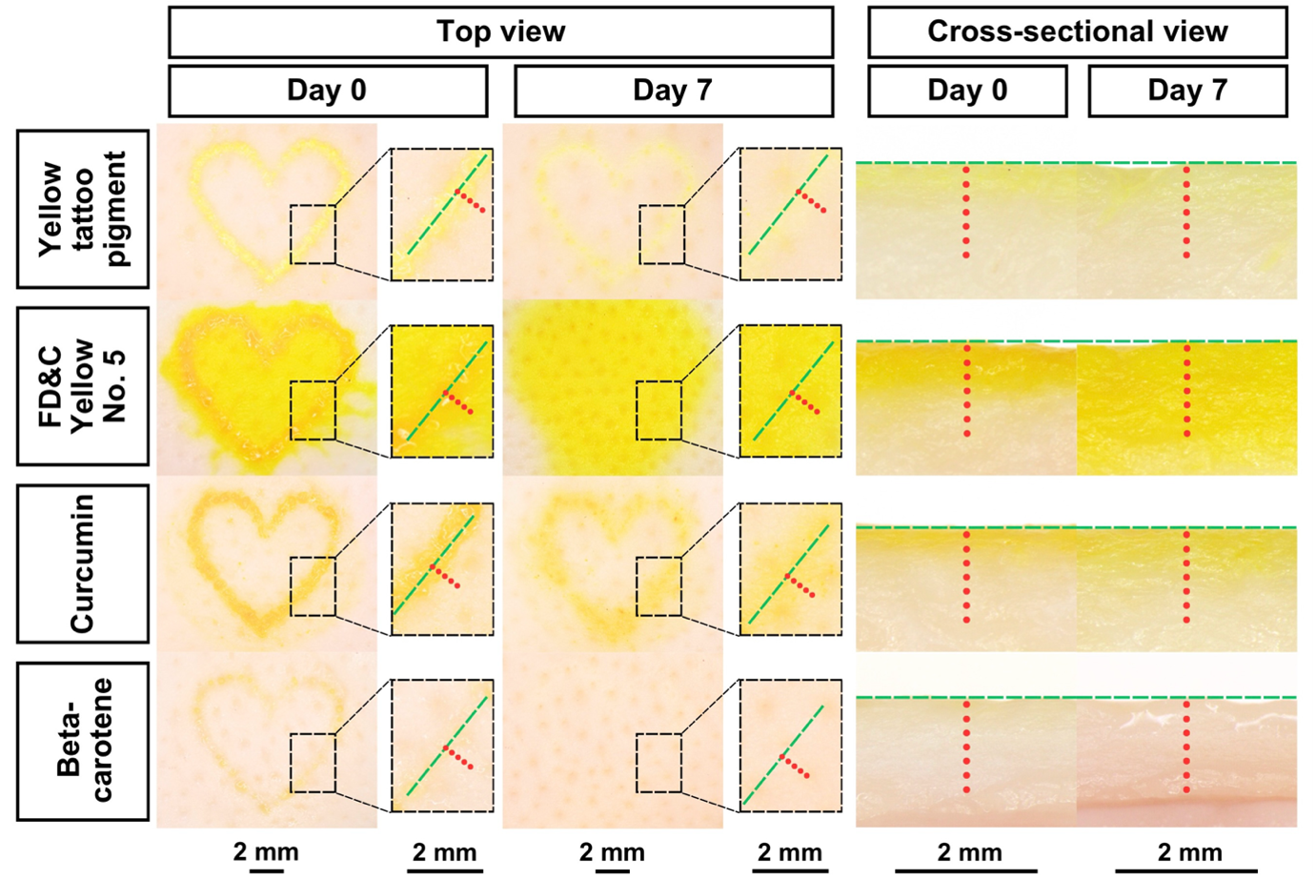
Fig. S9 Top-view stereomicroscopic images and corresponding cross-sectional images of ex vivo porcine skin after application of microneedles containing yellow colorants. The tested colorants include yellow tattoo pigment (top row), FD&C Yellow No. 5 (second row), curcumin (third row), and beta-carotene (bottom row). Images were taken on Day 0 and Day 7 after microneedle application. The reference line (green dashed line) and colored dots (red) indicate the measurement points used for color analysis. In the top-view images, color intensity was measured at distances of 0, 0.2, 0.4, 0.6, and 0.8 mm from the reference line. In the cross-sectional images, measurements were taken at distances of 0.1, 0.3, 0.5, 0.7, 0.9, 1.1, and 1.3 mm from the reference line.
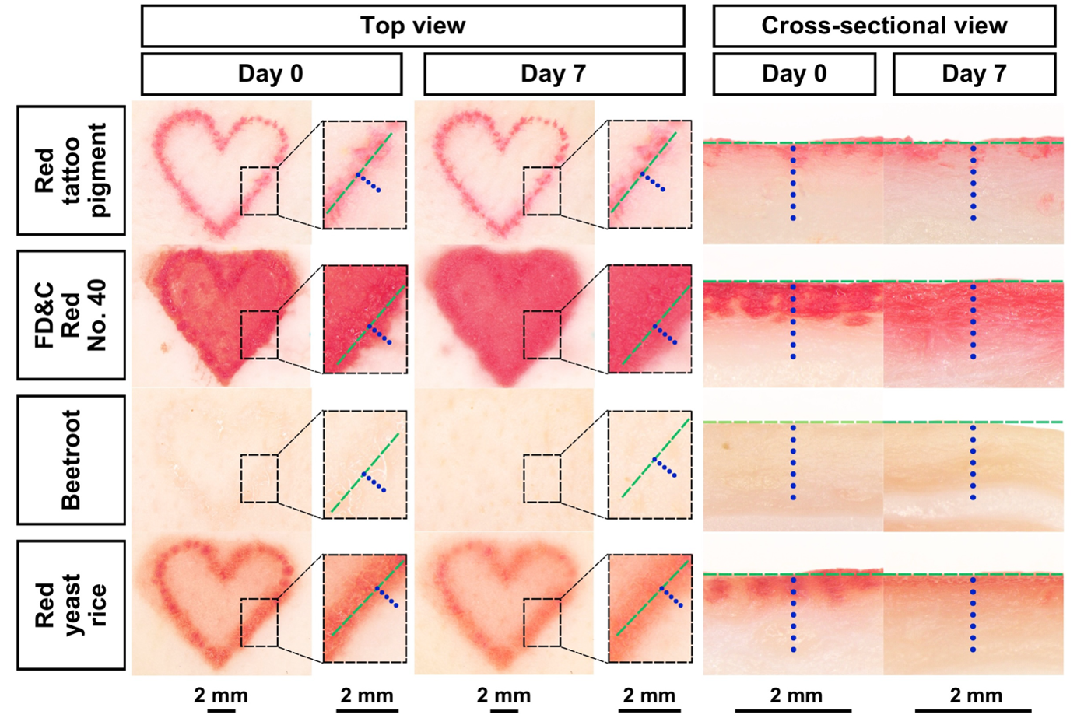
Fig. S10 Top-view stereomicroscopic images and corresponding cross-sectional images of ex vivo porcine skin after application of microneedles containing red colorants. The tested colorants include red tattoo pigment (top row), FD&C Red No. 40 (second row), beetroot (third row), and red yeast rice (bottom row). Images were taken on Day 0 and Day 7 after microneedle application. The reference line (green dashed line) and colored dots (blue) indicate the measurement points used for color analysis. In the top-view images, color intensity was measured at distances of 0, 0.2, 0.4, 0.6, and 0.8 mm from the reference line. In the cross-sectional images, measurements were taken at distances of 0.1, 0.3, 0.5, 0.7, 0.9, 1.1, and 1.3 mm from the reference line.
Table S1 Penetration depths of tattoo microneedle patches measured in ex vivo porcine skin experiments. Values for each patch represent the mean of five measurements taken at different locations. The mean penetration depth and standard error of the mean (SEM) were calculated from three patches per colorant.
Color | Colorant | Penetration depth (µm)
Color | Colorant | Patch 1ª | Patch 2ª | Patch 3ª | Mean^{b} | SEM
Black | Carbon black | 550.12 | 594.27 | 607.04 | 583.81 | 29.87
 | Bamboo charcoal | 510.32 | 577.57 | 550.24 | 546.04 | 33.82
 | Melanin black | 500.26 | 481.68 | 533.30 | 505.08 | 26.15
Blue | Blue tattoo pigment | 583.08 | 631.68 | 614.72 | 609.83 | 24.67
 | FD&C Blue No. 1 | 613.68 | 622.99 | 701.37 | 646.01 | 48.16
 | Gardenia blue | 597.74 | 572.00 | 592.68 | 587.48 | 13.64
Yellow | Yellow tattoo pigment | 627.85 | 571.52 | 568.15 | 589.17 | 33.53
 | FD&C Yellow No. 5 | 685.38 | 722.02 | 714.44 | 707.28 | 19.34
 | Curcumin | 594.38 | 598.67 | 549.61 | 580.89 | 27.17
Red | Red tattoo pigment | 561.48 | 550.25 | 555.88 | 555.87 | 5.61
 | FD&C Red No. 40 | 738.72 | 703.56 | 709.11 | 717.13 | 18.90
 | Red yeast rice | 584.63 | 563.08 | 576.42 | 574.71 | 10.88
ª Mean of each patch was obtained from five measurements taken at different locations.
^{b} Mean of each colorant was obtained from three patches.

Table S2 Pairwise comparisons of penetration depth among colorants within each color category (black, blue, yellow, and red) were performed using one-way ANOVA followed by Tukey’s post-hoc test. Differences were considered statistically significant at p < 0.05. Exact p values are reported.
Color | Group | p value | Difference
Black | Carbon black and bamboo charcoal | 0.3406 | No significant
 | Carbon black and melanin black | 0.0422 | Significant at p < 0.05
 | Bamboo charcoal and melanin black | 0.2915 | No significant
Blue | Blue tattoo pigment and FD&C Blue No. 1 | 0.4106 | No significant
 | Blue tattoo pigment and gardenia blue | 0.6806 | No significant
 | FD&C Blue No. 1 and gardenia blue | 0.1445 | No significant
Yellow | Yellow tattoo pigment and FD&C Yellow No. 5 | 0.0043 | Significant at p < 0.01
 | Yellow tattoo pigment and curcumin | 0.9000 | No significant
 | FD&C Yellow No. 5 and curcumin | 0.0031 | Significant at p < 0.01
Red | Red tattoo pigment and FD&C Red No. 40 | 0.0010 | Significant at p < 0.01
 | Red tattoo pigment and red yeast rice | 0.2552 | No significant
 | FD&C Red No. 40 and red yeast rice | 0.0010 | Significant at p < 0.01

Table S3 CIELAB color parameter (L* values) measured from top-view stereomicroscopic images and corresponding cross-sectional images of ex vivo porcine skin at different distances from the reference line on Day 0 and Day 7 after microneedle application for carbon black, bamboo charcoal, and melanin black. Mean L* values ± standard deviation (SD) were calculated from nine data points (three areas from each image of a sample and three samples per each colorant).
 |  | Distance from the reference line (mm) | Day 0ª |  | Day 7ª
Colorant | Image | Distance from the reference line (mm) | L* |  | L*
Carbon black | Top view | 0 | 22.67 ± 1.58 |  | 22.56 ± 2.30
 |  | 0.2 | 34.44 ± 2.30 |  | 34.89 ± 3.41
 |  | 0.4 | 39.33 ± 4.82 |  | 42.56 ± 3.50
 |  | 0.6 | 57.78 ± 4.74 |  | 60.22 ± 3.77
 |  | 0.8 | 79.67 ± 3.71 |  | 79.00 ± 1.73
 | Cross-sectional view | 0.1 | 23.22 ± 2.54 |  | 25.56 ± 1.81
 |  | 0.3 | 29.11 ± 2.76 |  | 31.67 ± 2.92
 |  | 0.5 | 56.89 ± 3.22 |  | 56.44 ± 3.54
 |  | 0.7 | 72.11 ± 1.69 |  | 72.78 ± 3.07
 |  | 0.9 | 79.33 ± 3.35 |  | 78.56 ± 2.79
 |  | 1.1 | 83.11 ± 1.90 |  | 83.22 ± 1.92
 |  | 1.3 | 86.44 ± 1.01 |  | 85.67 ± 1.41
Bamboo charcoal | Top view | 0 | 22.56 ± 2.74 |  | 44.44 ± 5.43
 |  | 0.2 | 22.88 ± 2.20 |  | 65.56 ± 5.00
 |  | 0.4 | 48.33 ± 8.87 |  | 73.00 ± 2.79
 |  | 0.6 | 85.00 ± 2.29 |  | 77.11 ± 4.48
 |  | 0.8 | 87.33 ± 2.29 |  | 85.44 ± 2.13
 | Cross-sectional view | 0.1 | 35.11 ± 5.01 |  | 38.67 ± 4.09
 |  | 0.3 | 55.67 ± 4.18 |  | 55.33 ± 5.83
 |  | 0.5 | 75.00 ± 1.41 |  | 74.11 ± 2.98
 |  | 0.7 | 81.11 ± 1.45 |  | 81.44 ± 3.69
 |  | 0.9 | 84.56 ± 1.13 |  | 85.89 ± 1.27
 |  | 1.1 | 85.33 ± 1.66 |  | 86.89 ± 1.36
 |  | 1.3 | 85.11 ± 1.36 |  | 87.44 ± 1.33
Melanin black | Top view | 0 | 27.78 ± 1.86 |  | 72.44 ± 5.13
 |  | 0.2 | 49.89 ± 4.86 |  | 85.67 ± 3.57
 |  | 0.4 | 62.78 ± 7.17 |  | 87.78 ± 2.91
 |  | 0.6 | 89.11 ± 1.45 |  | 89.44 ± 1.67
 |  | 0.8 | 90.33 ± 1.87 |  | 90.89 ± 1.27
 | Cross-sectional view | 0.1 | 65.44 ± 4.82 |  | 65.11 ± 6.09
 |  | 0.3 | 81.78 ± 1.20 |  | 77.11 ± 4.78
 |  | 0.5 | 82.89 ± 1.27 |  | 80.33 ± 3.46
 |  | 0.7 | 86.78 ± 1.56 |  | 83.56 ± 1.33
 |  | 0.9 | 88.89 ± 1.05 |  | 86.89 ± 1.45
 |  | 1.1 | 89.56 ± 0.88 |  | 88.22 ± 1.20
 |  | 1.3 | 90.11 ± 1.05 |  | 88.56 ± 1.13
ª Mean ± SD were calculated from nine data points (three areas from each image of a sample and three samples per each colorant).

Table S4 CIELAB color parameter (b* values) measured from top-view stereomicroscopic images and corresponding cross-sectional images of ex vivo porcine skin at different distances from the reference line on Day 0 and Day 7 after microneedle application for blue tattoo pigment, FD&C Blue No. 1, butterfly pea, and gardenia blue. Mean b* values ± standard deviation (SD) were calculated from nine data points (three areas from each image of a sample and three samples per each colorant).
 |  | Distance from the reference line (mm) | Day 0ª |  | Day 7ª
Colorant | Image | Distance from the reference line (mm) | b* |  | b*
Blue tattoo pigment | Top view | 0 | -73.78 ± 4.06 |  | -73.00 ± 5.66
 |  | 0.2 | -49.56 ± 3.91 |  | -42.67 ± 5.57
 |  | 0.4 | -23.89 ± 6.39 |  | -22.00 ± 5.12
 |  | 0.6 | 4.11 ± 4.57 |  | 2.11 ± 6.07
 |  | 0.8 | 6.11 ± 2.37 |  | 4.89 ± 3.10
 | Cross-sectional view | 0.1 | -42.67 ± 4.87 |  | -44.22 ± 4.12
 |  | 0.3 | -31.56 ± 4.69 |  | -33.11 ± 6.17
 |  | 0.5 | -12.67 ± 3.12 |  | -13.67 ± 2.60
 |  | 0.7 | -5.56 ± 1.42 |  | -3.56 ± 2.19
 |  | 0.9 | -1.89 ± 4.23 |  | -0.22 ± 1.86
 |  | 1.1 | 1.00 ± 1.66 |  | 2.44 ± 1.74
 |  | 1.3 | 3.00 ± 1.73 |  | 3.11 ± 2.15
FD&C Blue No. 1 | Top view | 0 | -73.33 ± 4.24 |  | -77.00 ± 3.24
 |  | 0.2 | -73.44 ± 3.57 |  | -74.78 ± 2.22
 |  | 0.4 | -61.67 ± 6.08 |  | -67.11 ± 4.20
 |  | 0.6 | -51.43 ± 6.58 |  | -62.57 ± 5.19
 |  | 0.8 | -6.29 ± 2.56 |  | -59.00 ± 3.65
 | Cross-sectional view | 0.1 | -60.00 ± 3.65 |  | -83.43 ± 2.23
 |  | 0.3 | -60.29 ± 5.85 |  | -85.57 ± 2.23
 |  | 0.5 | -21.14 ± 2.27 |  | -82.00 ± 6.08
 |  | 0.7 | -15.71 ± 2.36 |  | -80.57 ± 2.94
 |  | 0.9 | -11.00 ± 2.31 |  | -76.14 ± 5.21
 |  | 1.1 | -8.29 ± 2.14 |  | -47.71 ± 3.55
 |  | 1.3 | -5.57 ± 1.99 |  | -27.50 ± 4.51
Butterfly pea | Top view | 0 | 12.29 ± 2.56 |  | 8.71 ± 2.56
 |  | 0.2 | 10.57 ± 3.60 |  | 9.14 ± 2.79
 |  | 0.4 | 12.00 ± 3.70 |  | 7.00 ± 3.16
 |  | 0.6 | 10.14 ± 2.04 |  | 9.71 ± 3.25
 |  | 0.8 | 11.00 ± 3.37 |  | 7.29 ± 4.15
 | Cross-sectional view | 0.1 | 13.14 ± 2.27 |  | 12.71 ± 2.36
 |  | 0.3 | 11.86 ± 2.04 |  | 11.57 ± 2.15
 |  | 0.5 | 13.29 ± 3.09 |  | 13.14 ± 2.85
 |  | 0.7 | 12.43 ± 2.37 |  | 11.71 ± 1.80
 |  | 0.9 | 14.00 ± 3.65 |  | 13.29 ± 3.45
 |  | 1.1 | 12.14 ± 2.73 |  | 12.71 ± 2.87
 |  | 1.3 | 13.43 ± 2.70 |  | 13.14 ± 2.61
Gardenia blue | Top view | 0 | -20.86 ± 1.68 |  | -18.43 ± 3.51
 |  | 0.2 | -14.14 ± 3.08 |  | -12.14 ± 2.34
 |  | 0.4 | 1.14 ± 3.49 |  | -7.29 ± 2.29
 |  | 0.6 | 7.43 ± 1.72 |  | 1.57 ± 2.07
 |  | 0.8 | 9.29 ± 2.69 |  | 4.71 ± 1.80
 | Cross-sectional view | 0.1 | -18.14 ± 2.41 |  | -22.29 ± 2.43
 |  | 0.3 | -18.71 ± 1.98 |  | -22.71 ± 3.30
 |  | 0.5 | -4.86 ± 1.35 |  | -22.14 ± 4.49
 |  | 0.7 | 0.14 ± 1.35 |  | -14.29 ± 3.04
 |  | 0.9 | 2.43 ± 1.72 |  | -9.00 ± 2.45
 |  | 1.1 | 3.71 ± 1.70 |  | -8.57 ± 2.37
 |  | 1.3 | 4.14 ± 2.41 |  | -6.14 ± 3.18
ª Mean ± SD were calculated from nine data points (three areas from each image of a sample and three samples per each colorant).
Table S5 CIELAB color parameter (b* values) measured from top-view stereomicroscopic images and corresponding cross-sectional images of ex vivo porcine skin at different distances from the reference line on Day 0 and Day 7 after microneedle application for yellow tattoo pigment, FD&C Yellow No. 5, curcumin, and beta-carotene. Mean b* values ± standard deviation (SD) were calculated from nine data points (three areas from each image of a sample and three samples per each colorant).
 |  | Distance from the reference line (mm) | Day 0ª |  | Day 7ª
Colorant | Image | Distance from the reference line (mm) | b* |  | b*
Yellow tattoo pigment | Top view | 0 | 67.43 ± 3.10 |  | 53.43 ± 3.87
 |  | 0.2 | 61.71 ± 5.62 |  | 50.71 ± 4.82
 |  | 0.4 | 51.57 ± 5.38 |  | 42.71 ± 6.34
 |  | 0.6 | 22.14 ± 3.13 |  | 22.86 ± 1.35
 |  | 0.8 | 16.29 ± 2.56 |  | 18.14 ± 1.57
 | Cross-sectional view | 0.1 | 52.29 ± 4.46 |  | 52.29 ± 3.25
 |  | 0.3 | 52.57 ± 4.86 |  | 51.14 ± 3.34
 |  | 0.5 | 37.57 ± 3.87 |  | 38.71 ± 3.68
 |  | 0.7 | 24.86 ± 2.27 |  | 27.86 ± 4.60
 |  | 0.9 | 22.14 ± 2.34 |  | 24.71 ± 2.43
 |  | 1.1 | 18.29 ± 1.50 |  | 23.29 ± 1.98
 |  | 1.3 | 17.29 ± 1.98 |  | 22.00 ± 2.52
FD&C Yellow No. 5 | Top view | 0 | 83.71 ± 1.38 |  | 85.00 ± 1.29
 |  | 0.2 | 84.57 ± 1.51 |  | 84.85 ± 1.35
 |  | 0.4 | 85.00 ± 1.41 |  | 85.57 ± 0.98
 |  | 0.6 | 77.29 ± 4.46 |  | 86.00 ± 0.82
 |  | 0.8 | 76.29 ± 5.71 |  | 85.43 ± 1.27
 | Cross-sectional view | 0.1 | 80.71 ± 2.06 |  | 84.71 ± 1.38
 |  | 0.3 | 80.57 ± 2.30 |  | 85.29 ± 1.25
 |  | 0.5 | 80.00 ± 2.16 |  | 85.86 ± 1.07
 |  | 0.7 | 66.71 ± 4.72 |  | 85.14 ± 2.12
 |  | 0.9 | 44.57 ± 2.76 |  | 84.57 ± 2.23
 |  | 1.1 | 34.29 ± 3.35 |  | 84.43 ± 2.37
 |  | 1.3 | 32.14 ± 1.95 |  | 83.14 ± 3.53
Curcumin | Top view | 0 | 72.29 ± 4.15 |  | 67.57 ± 2.88
 |  | 0.2 | 71.00 ± 4.00 |  | 64.14 ± 2.61
 |  | 0.4 | 58.14 ± 5.34 |  | 56.00 ± 4.08
 |  | 0.6 | 25.29 ± 4.15 |  | 43.86 ± 4.95
 |  | 0.8 | 24.29 ± 3.25 |  | 28.86 ± 3.02
 | Cross-sectional view | 0.1 | 70.43 ± 1.72 |  | 70.86 ± 2.85
 |  | 0.3 | 63.43 ± 2.70 |  | 67.86 ± 4.53
 |  | 0.5 | 41.71 ± 3.04 |  | 57.71 ± 2.93
 |  | 0.7 | 27.71 ± 2.69 |  | 44.43 ± 2.23
 |  | 0.9 | 23.57 ± 1.72 |  | 34.57 ± 3.05
 |  | 1.1 | 20.29 ± 2.21 |  | 25.86 ± 2.79
 |  | 1.3 | 22.00 ± 2.58 |  | 24.29 ± 2.98
Beta-carotene | Top view | 0 | 42.29 ± 4.23 |  | 14.71 ± 1.89
 |  | 0.2 | 32.29 ± 4.57 |  | 14.29 ± 1.98
 |  | 0.4 | 14.29 ± 1.60 |  | 15.00 ± 2.08
 |  | 0.6 | 13.57 ± 2.15 |  | 14.57 ± 2.63
 |  | 0.8 | 13.86 ± 2.34 |  | 16.57 ± 2.88
 | Cross-sectional view | 0.1 | 29.14 ± 2.97 |  | 15.14 ± 2.73
 |  | 0.3 | 20.00 ± 3.00 |  | 14.86 ± 3.44
 |  | 0.5 | 13.43 ± 2.07 |  | 15.71 ± 3.99
 |  | 0.7 | 13.29 ± 1.80 |  | 15.00 ± 2.71
 |  | 0.9 | 13.14 ± 1.95 |  | 15.29 ± 2.43
 |  | 1.1 | 14.14 ± 1.35 |  | 14.86 ± 2.04
 |  | 1.3 | 14.29 ± 1.98 |  | 16.14 ± 3.18
ª Mean ± SD were calculated from nine data points (three areas from each image of a sample and three samples per each colorant).
Table S6 CIELAB color parameter (a* values) measured from top-view stereomicroscopic images and corresponding cross-sectional images of ex vivo porcine skin at different distances from the reference line on Day 0 and Day 7 after microneedle application for red tattoo pigment, FD&C Red No. 40, beetroot, and red yeast rice. Mean a* values ± standard deviation (SD) were calculated from nine data points (three areas from each image of a sample and three samples per each colorant).
 |  | Distance from the reference line (mm) | Day 0ª |  | Day 7ª
Colorant | Image | Distance from the reference line (mm) | a* |  | a*
Red tattoo pigment | Top view | 0 | 58.57 ± 1.90 |  | 58.00 ± 3.74
 |  | 0.2 | 44.14 ± 2.41 |  | 44.29 ± 5.47
 |  | 0.4 | 26.86 ± 6.99 |  | 26.71 ± 7.43
 |  | 0.6 | 12.00 ± 2.94 |  | 12.57 ± 2.37
 |  | 0.8 | 11.57 ± 2.51 |  | 11.71 ± 2.21
 | Cross-sectional view | 0.1 | 55.71 ± 5.06 |  | 56.57 ± 5.41
 |  | 0.3 | 46.71 ± 7.89 |  | 50.29 ± 7.45
 |  | 0.5 | 21.43 ± 2.88 |  | 20.00 ± 2.16
 |  | 0.7 | 12.00 ± 2.31 |  | 13.86 ± 2.27
 |  | 0.9 | 11.00 ± 1.41 |  | 12.00 ± 2.16
 |  | 1.1 | 8.29 ± 1.50 |  | 9.57 ± 2.37
 |  | 1.3 | 9.14 ± 1.35 |  | 9.43 ± 1.72
FD&C Red No. 40 | Top view | 0 | 68.14 ± 4.06 |  | 69.57 ± 2.15
 |  | 0.2 | 68.86 ± 1.57 |  | 66.43 ± 2.64
 |  | 0.4 | 60.29 ± 3.68 |  | 59.57 ± 1.99
 |  | 0.6 | 35.00 ± 4.32 |  | 50.43 ± 3.99
 |  | 0.8 | 18.57 ± 4.04 |  | 36.57 ± 4.69
 | Cross-sectional view | 0.1 | 69.43 ± 1.51 |  | 68.86 ± 2.67
 |  | 0.3 | 69.14 ± 3.13 |  | 68.00 ± 2.94
 |  | 0.5 | 69.71 ± 2.93 |  | 64.71 ± 5.79
 |  | 0.7 | 31.71 ± 6.58 |  | 60.43 ± 5.09
 |  | 0.9 | 18.57 ± 2.23 |  | 47.14 ± 4.60
 |  | 1.1 | 10.86 ± 2.12 |  | 38.00 ± 3.70
 |  | 1.3 | 9.29 ± 1.50 |  | 27.86 ± 4.10
Beetroot | Top view | 0 | 5.43 ± 2.99 |  | 6.29 ± 1.11
 |  | 0.2 | 6.14 ± 3.24 |  | 5.57 ± 1.72
 |  | 0.4 | 6.00 ± 2.94 |  | 5.14 ± 1.68
 |  | 0.6 | 5.14 ± 2.79 |  | 5.00 ± 1.83
 |  | 0.8 | 6.43 ± 2.76 |  | 5.71 ± 1.80
 | Cross-sectional view | 0.1 | 7.43 ± 2.64 |  | 7.86 ± 3.29
 |  | 0.3 | 6.71 ± 2.50 |  | 6.14 ± 1.68
 |  | 0.5 | 7.29 ± 3.04 |  | 7.57 ± 3.41
 |  | 0.7 | 7.57 ± 2.76 |  | 7.71 ± 2.81
 |  | 0.9 | 6.86 ± 2.41 |  | 7.14 ± 2.91
 |  | 1.1 | 7.71 ± 2.56 |  | 8.29 ± 2.14
 |  | 1.3 | 7.14 ± 2.79 |  | 8.71 ± 2.36
Red yeast rice | Top view | 0 | 61.29 ± 2.56 |  | 54.43 ± 3.36
 |  | 0.2 | 58.29 ± 3.35 |  | 50.00 ± 4.32
 |  | 0.4 | 31.71 ± 3.45 |  | 37.29 ± 3.40
 |  | 0.6 | 20.43 ± 4.20 |  | 28.29 ± 1.50
 |  | 0.8 | 9.57 ± 1.72 |  | 19.14 ± 3.29
 | Cross-sectional view | 0.1 | 60.43 ± 2.76 |  | 50.57 ± 2.64
 |  | 0.3 | 61.14 ± 2.48 |  | 41.14 ± 3.53
 |  | 0.5 | 34.71 ± 4.11 |  | 30.86 ± 3.18
 |  | 0.7 | 17.57 ± 2.82 |  | 21.14 ± 1.35
 |  | 0.9 | 9.29 ± 1.80 |  | 14.00 ± 2.94
 |  | 1.1 | 9.43 ± 1.72 |  | 13.14 ± 2.34
 |  | 1.3 | 9.00 ± 2.16 |  | 13.71 ± 2.06
ª Mean ± SD were calculated from nine data points (three areas from each image of a sample and three samples per each colorant).

