A Metal–Organic Framework-Based Fluorescent Sensor for Selective and Enzyme-Free Detection of Glucose
Fatoumata Nancy Cisseª, Renuka Garg^{b}, Hassan Gomaa^{c*}, Rana Sabouni^{d*}
ª Department of Chemical and Biological Engineering, American University of Sharjah, Sharjah PO Box 26666, United Arab Emirates
^{b} Department of Chemical Engineering, National Institute of Technology, Srinagar, J&K 190006, India
^{c} Department of Chemical and Biochemical Engineering, Western University, London, ON TEB 459, Canada
^{d} Center for Biomedical Innovations, American University of Sharjah, Sharjah, 26666, United Arab Emirates
* Corresponding authors: Rana Sabouni (rsabouni@aus.edu), American University of Sharjah, Sharjah 26666, United Arab Emirates

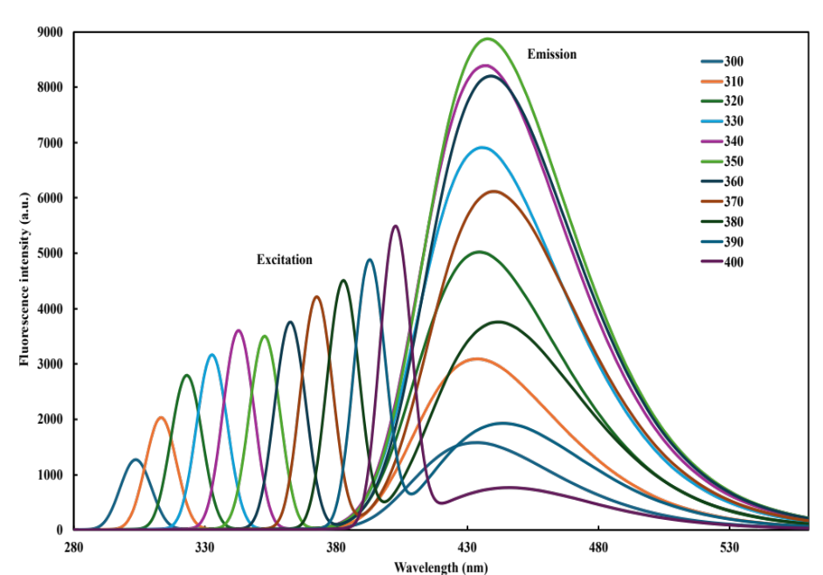
Figure S1: Optical characteristics of the MOF showing excitation and emission behavior.

