Supplementary Material

Unstable Shear Slip Failure and Seismic Potential Investigation Using DEM in Underground Mining
Xu Ma^{1, 2*}, Ping Zhang¹
¹Division of Mining and Geotechnical Engineering, Luleå University of Technology, 97187 Luleå, Sweden.
²State Key Laboratory of Earthquake Dynamics, Institute of Geology, China Earthquake Administration, Beijing, China

Corresponding author*: Xu Ma (xuma@vt.edu) ORCID: 0000-0002-3071-6187

In order to make the logic clearer, we provide a flow chart for better showing the procedures of this study (Figure S1), especially for the numerical modelling part.

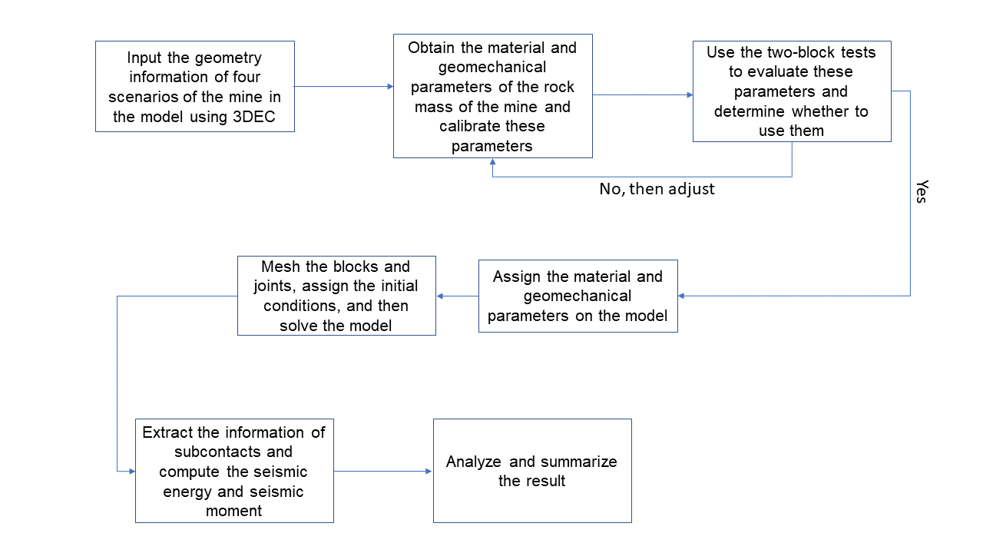
Figure S1 Flow chart of the numerical modelling steps

The process of determining the numerical material parameters is summarized as follows. Figure S2 shows the theoretical performance of MC model and CY model. We applied the two models in the two-block shear test. First, we obtain the result with changing loading normal pressure for both MC model and CY model and the result (Figure S3) agrees well to the theories that are described in Figure S2. We continue to perform the parameters study and then test a series of parameters that are used in the model. The shear stress and the shear displacement for different mechanical system is shown in Figure S3.

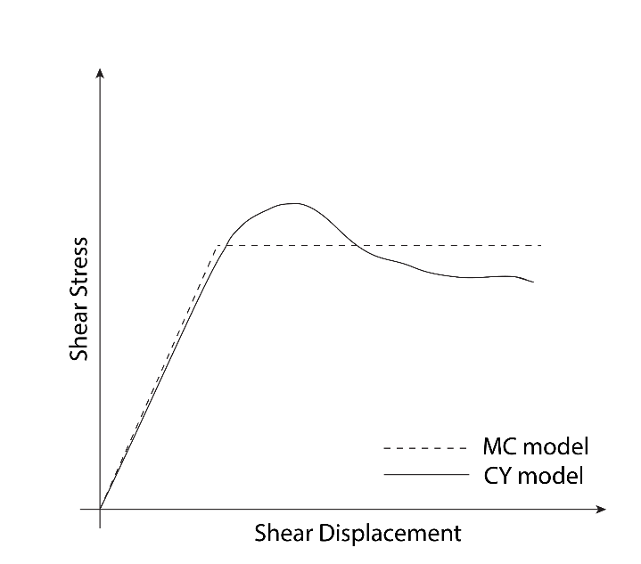
Figure S2 The relationship of shear stress and shear displacement of MC model and CY model

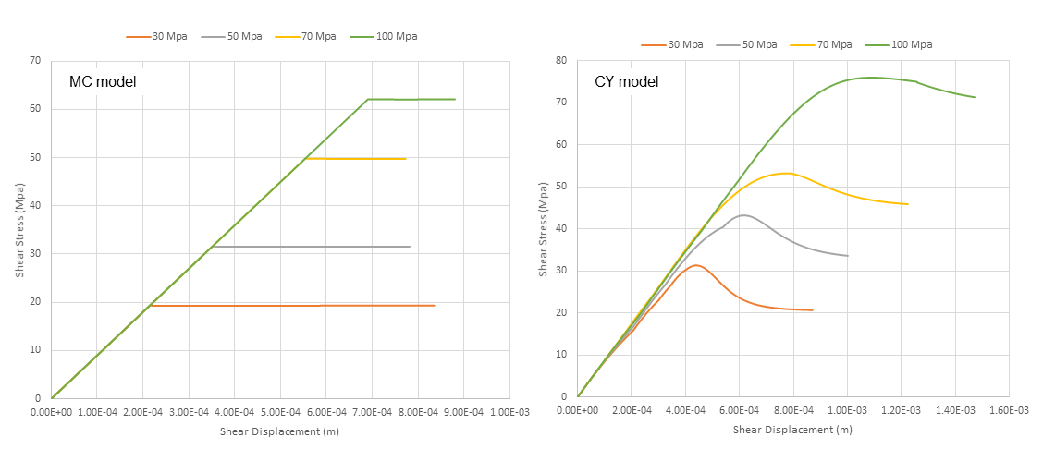
Figure S3 The comparison of MC model and CY model using the two-block shear test

Parameter study
In order to better understand the mechanical system of CY joint model, we tested a series of fundamental parameters of CY Joint Model to observe responses of this model by adjusting these parameters. First, we used parameters listed in Table S1 as a basic set up. Then we changed the objective parameter for testing with keeping all other parameters fixed. Influences of changing the objective parameter can be identified by comparing results with different parameters. The result of basic setup parameter is shown in Figure S4. Followed are results using tested parameters (Figures S4-S9).
Table S1 Parameters for a basic setup
Parameter | Value
Joint initial friction angle | 65°
Joint intrinsic friction angle | 35°
Joint shear stiffness | 110 Gpa/m
Applied normal stress | 30 Mpa

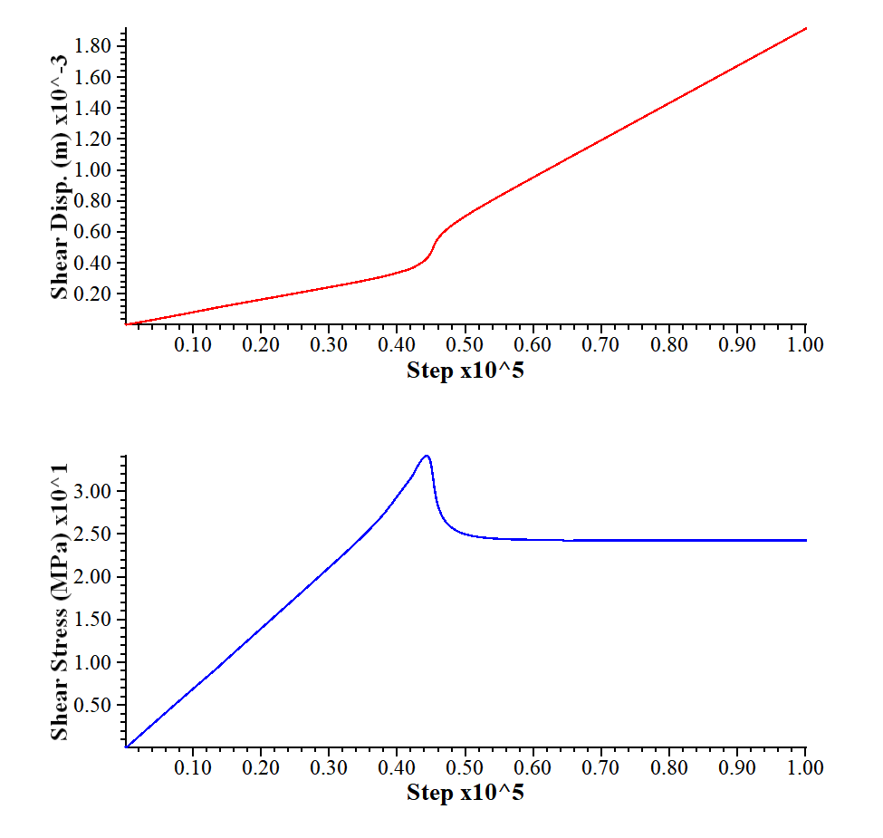
Figure S4 CY joint set model response using the basic setup parameters in Table S1

Joint initial friction angle 35° Joint initial friction angle 85°
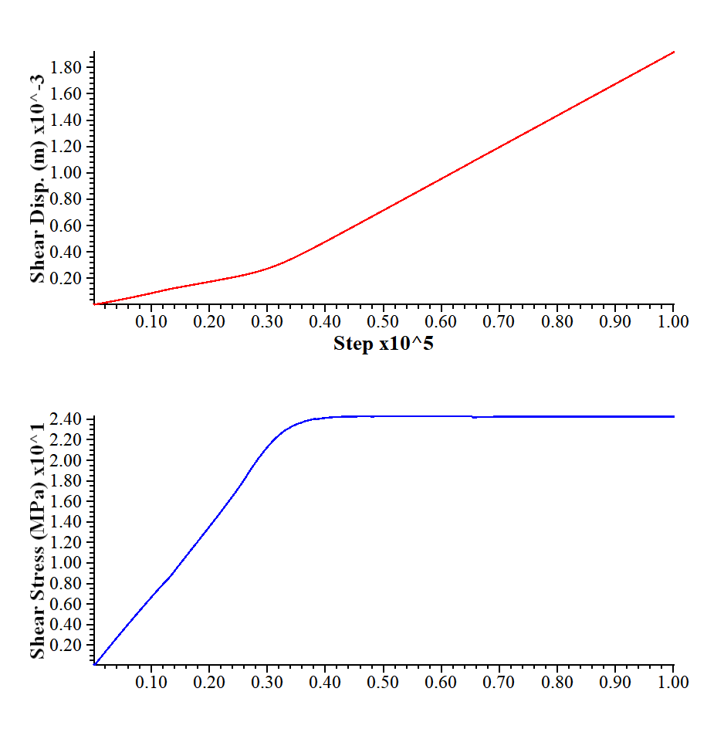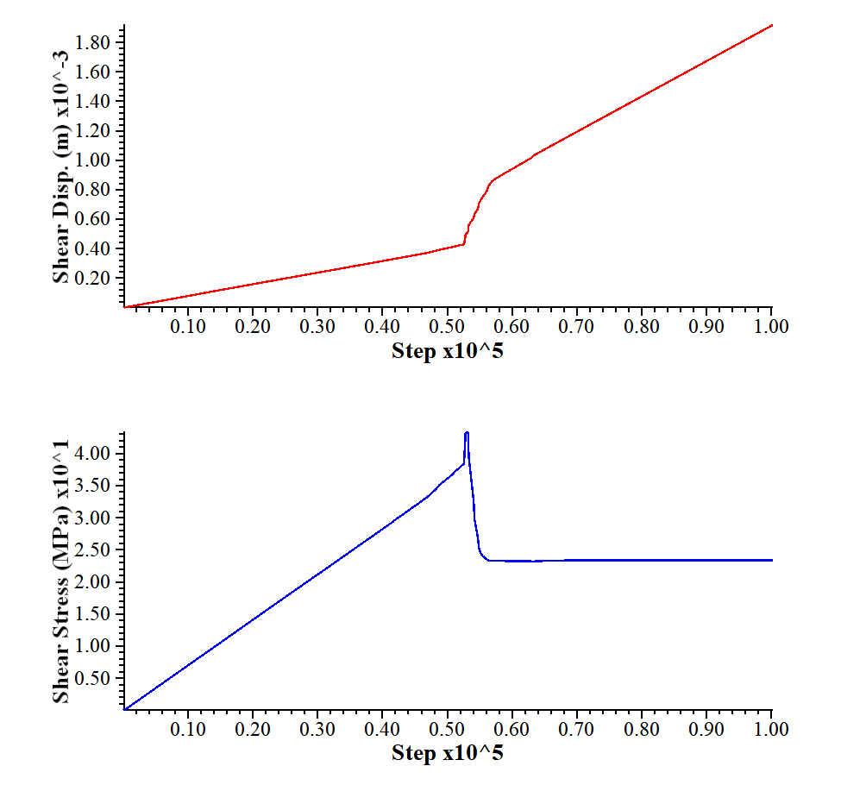
Figure S5 CY joint set model response in comparison of joint initial angle

Joint intrinsic friction angle 25° Joint intrinsic friction angle 65°
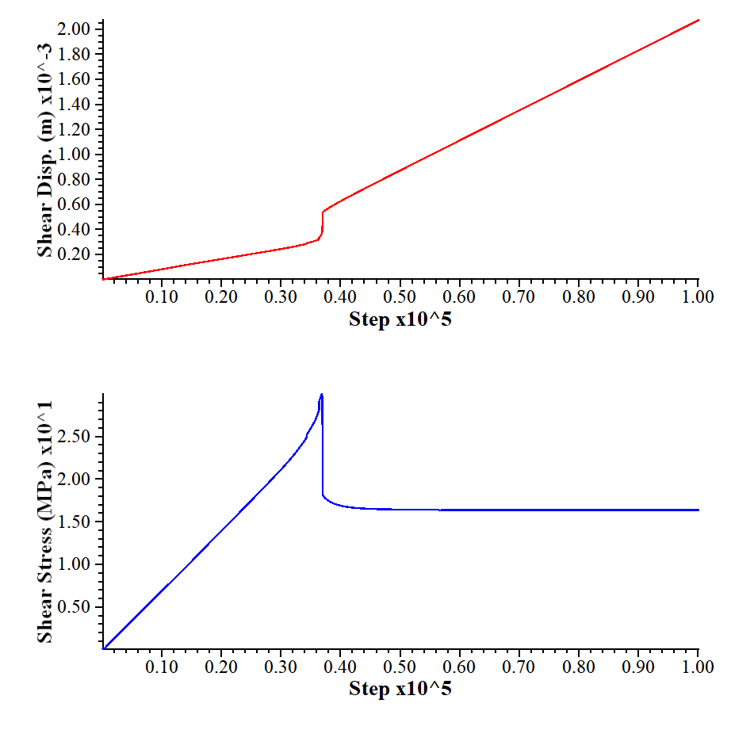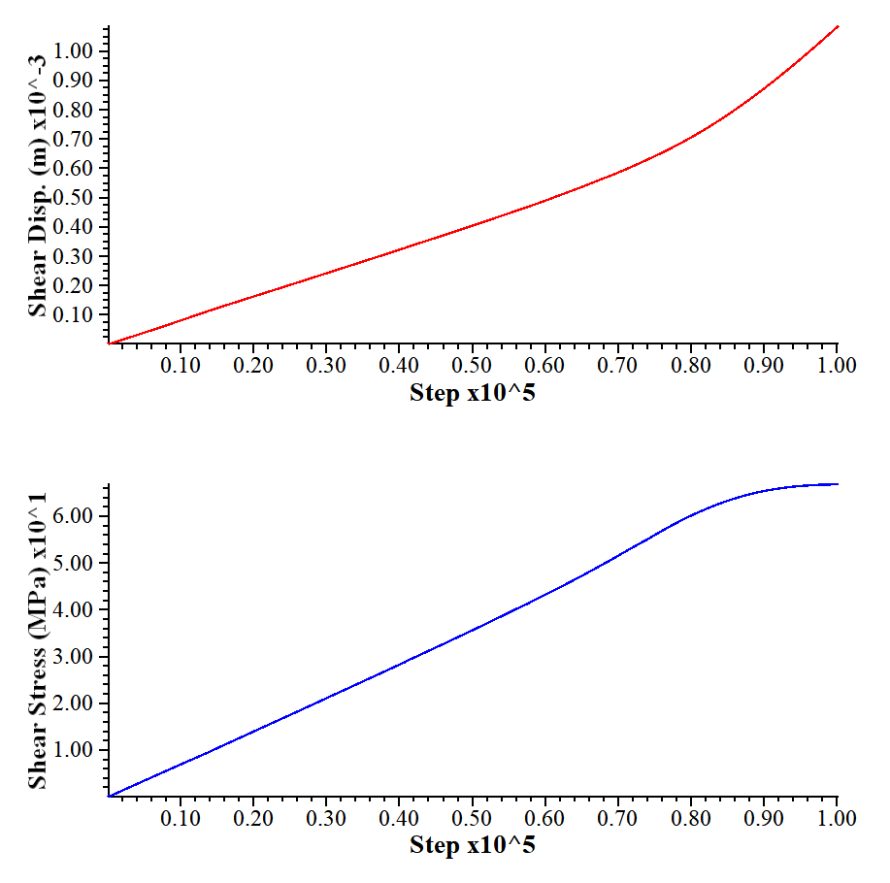
Figure S6 CY joint set model response in comparison of joint intrinsic friction angle

Joint shear stiffness 30 Gpa/m Joint shear stiffness 270 Gpa/m

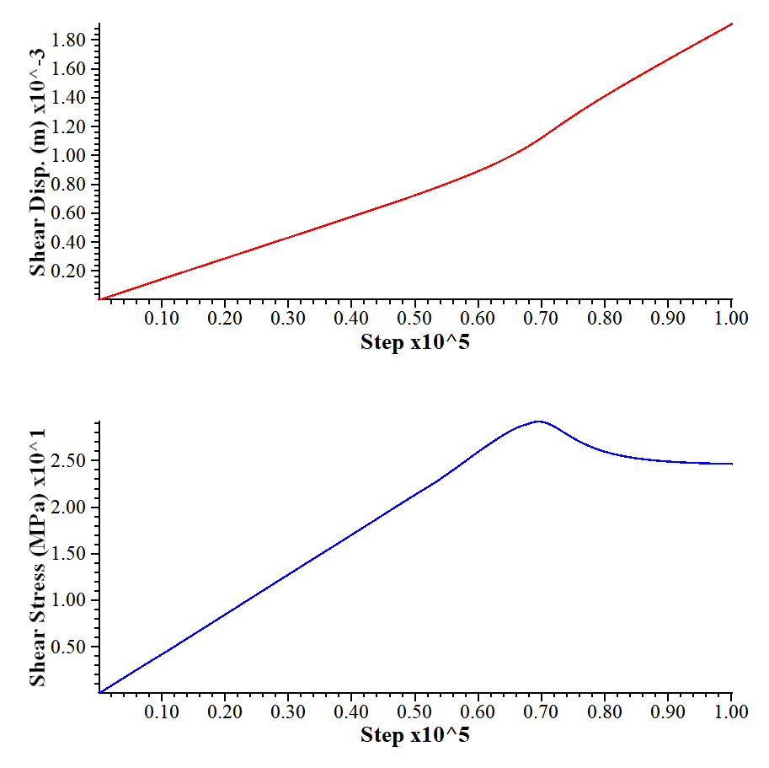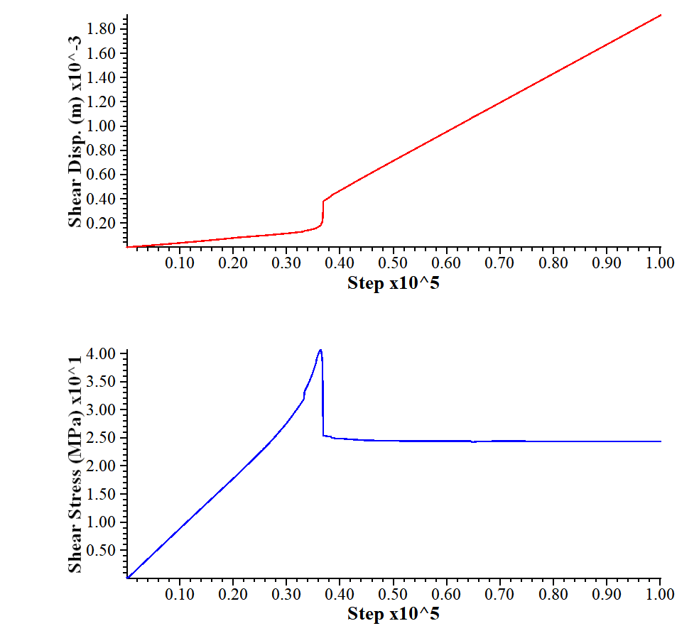

Figure S7 CY joint set model response in comparison of joint shear stiffness

Applied normal stress 5 Mpa Applied normal stress 60 Mpa
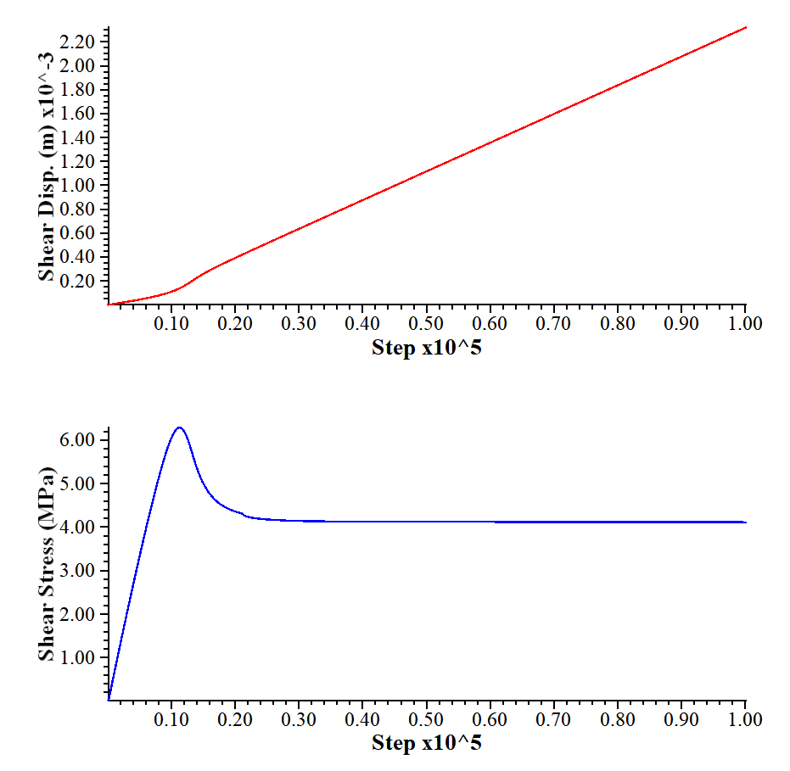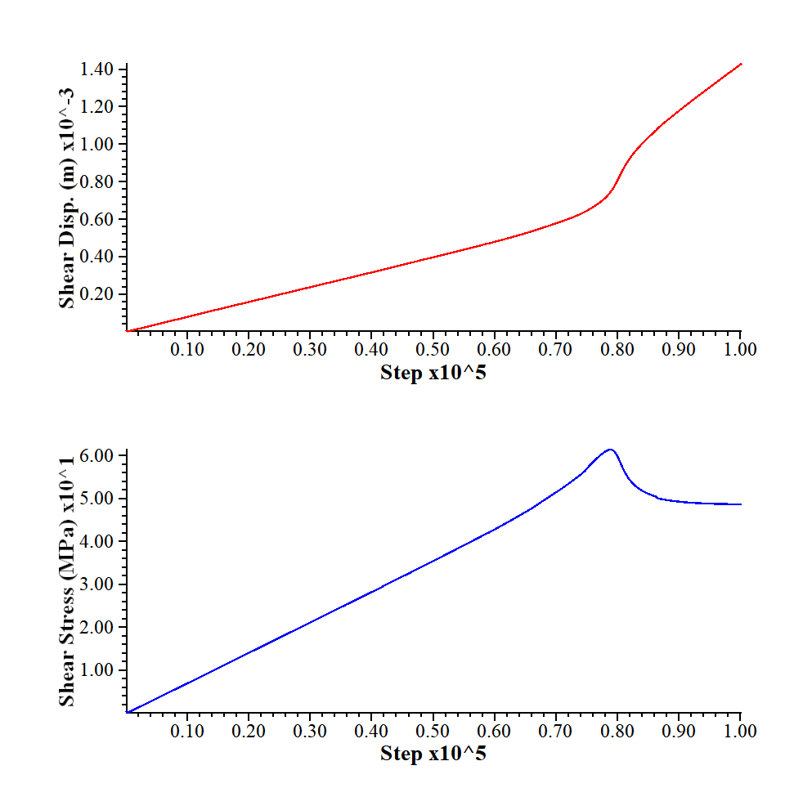

Figure S8 CY joint set model response in comparison of applied normal stress
(a)
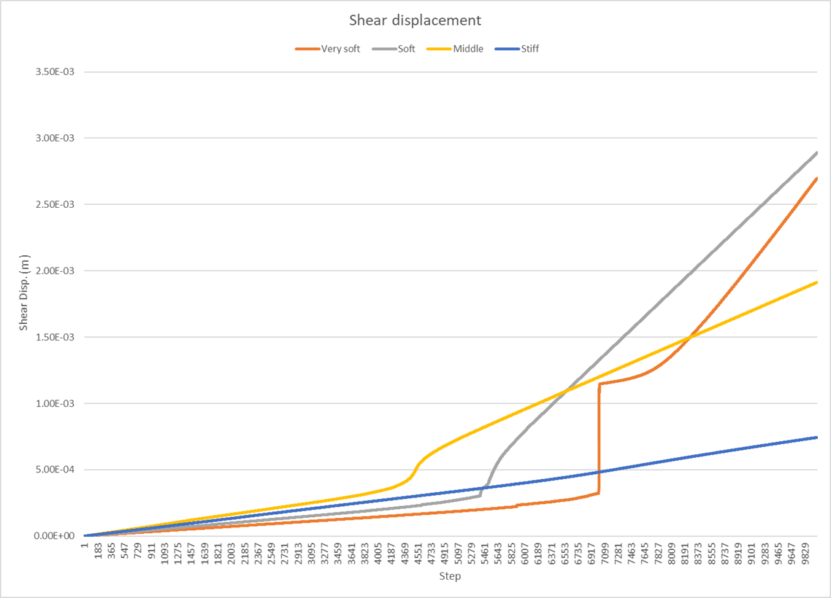

(b)
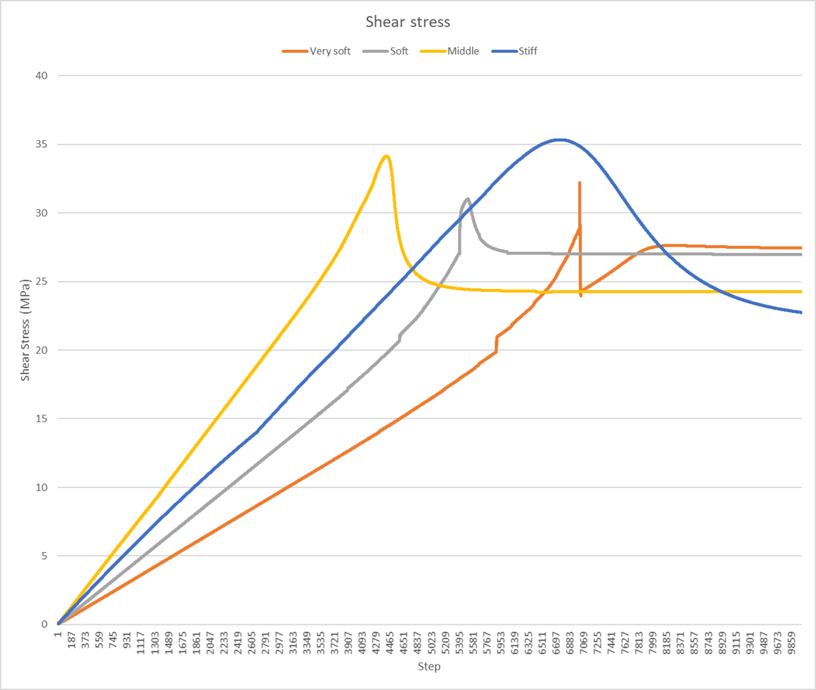
Figure S9 (a) The shear displacement for different loading systems; (b) The shear stress for different loading systems

