Survey Questionnaire

Perceptions of land use impacts on cultural ecosystem services in southwestern Ghana

Name of Respondent:

Institutional affiliation:

Introductory statement

In a workshop held in Takoradi in November 2019, Western region land use planning stakeholders represented by the Ministry of Food and Agriculture (MOFA), Landuse and Spatial Planning Authority (LUSPA), Water Resources Commission (WRC), Regional Coordinating Council (RCC), Ghana Rubber Estates Ltd (GREL), Development Planning Officers (DPOs) and environmental NGOs, identified five important cultural ecosystem services (science/education, spiritual, tourism, recreation and health) supplied by the landscapes of southwestern Ghana.

The purpose of this follow-up survey is to explore how land use planning stakeholders perceive the extent to which the underlisted land use scenarios will influence supply of the cultural ecosystem services under certain planning restrictions such as slope, elevation, soil condition, tidal regime etc.

- Business-as-usual: this scenario reflects current landuse/cover dynamics as depicted by the LULC map.
- Mangrove afforestation: in this scenario, degraded mangrove forests are restored and pristine mangrove ecosystems conserved.
- Market-oriented: in this scenario, future growth is characterized by expansion of infrastructure and plantation agriculture.
- Green network: in this scenario, an “eco-corridor” that connects upland forests, coastal forests and urban green spaces is established by planting native trees.

For orientation, map and pictures of major landuse/cover types of the study landscape as well as definitions of the identified cultural services are provided below.

You have been selected to participate in this survey because of your influence on regional land use decision making and implementation processes in southwestern Ghana. The survey is intended only for academic research purposes hence, your responses will not imply determination of final regional land use strategies. All responses will be handled with strict confidentiality. The survey takes about 45 minutes to complete.

Your time commitment to complete this survey is highly appreciated!

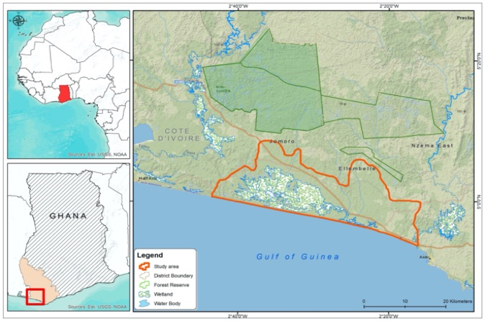
Map of Study Landscape

Landuse/Landcover map
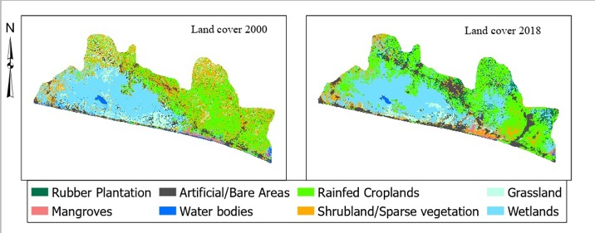

Pictures of major land-use/cover types

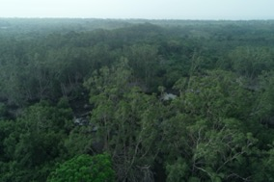  Mangroves | 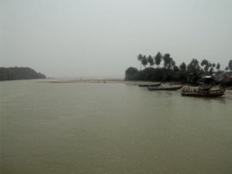  Water bodies
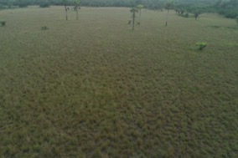  Grassland | 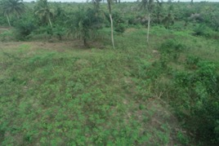  Rainfed croplands
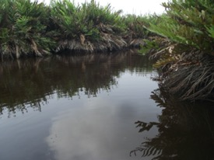  Wetland | 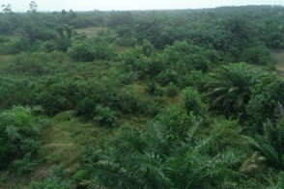  Shrubland/sparse vegetation
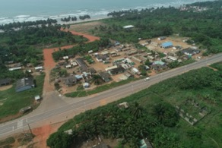  Bare/artificial areas | 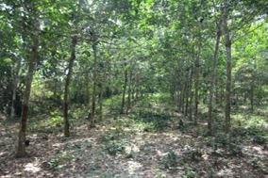  Rubber plantation

Definitions

Categories of cultural ecosystem services | Definitions adapted from Degroot,2010; MA,2005; TESSA,2017
Science/education | Opportunities for outdoor learning where observation, experience and experimentation lead to increased ecological knowledge and enhanced connectedness to nature.
Spiritual | Benefits derived from specific places, features or species within a natural landscape creating sacred, religious or spiritual inspiration, feelings and values. Religious rules and taboos. Links to ancestors, gods or spirit world.
Tourism | Benefits derived from travel to natural ecosystems for tourism, recreational sports and to view rare species. This often involves costs incurred through travelling or fee payments to enjoy the benefits.
Recreation | Benefits derived from playing in open and public places within close proximity. This does not involve costs incurred through travelling or actual fee payments in order to enjoy the benefits.
Health | Places where people can undertake physical activity and interact with nature enabling the restoration, maintenance, and/or development of emotional, mental and physical health and well-being. Viewing or being in an environmental setting that contributes to physical, emotional, mental health and well-being.

Perceptions of land use impacts on supply of cultural ecosystem services under different environmental conditions and scenarios

SECTION A

Business-as-usual scenario (small holder farmlands are expanding in area while more shrubland/sparse vegetation and grassland cover are decreasing in extent; pressures on mangrove forests are increasing and resulting in declining extent of mangrove forest cover)

A1.0 Considering a business-as-usual scenario, indicate the probability of the landuse/landcover conversion under the given environmental conditions. Provide your response on a scale (1- very low; 2- low; 3-medium; 4-high; 5- very high).

Conditions  LULC conversion | Flat slope |  |  |  |  |  | Steep slope
Shrubland/sparse vegetation to Rainfed cropland | 1 | 2 | 3 | 4 | 5 |  | 1 | 2 | 3 | 4 | 5

A1.1 On a scale (1-low; 2- medium; 3-high), indicate the effect of the above landuse/landcover conversion on the extent of change of cultural ecosystem services supply by the landscape.

Conditions  Cultural ecosystem services | Flat slope |  |  |  | Steep slope
Science/education | 1 | 2 | 3 |  | 1 | 2 | 3
Spiritual | 1 | 2 | 3 |  | 1 | 2 | 3
Tourism | 1 | 2 | 3 |  | 1 | 2 | 3
Recreation | 1 | 2 | 3 |  | 1 | 2 | 3
Health | 1 | 2 | 3 |  | 1 | 2 | 3

A2.0 Considering a business-as-usual scenario, indicate the probability of the landuse/landcover conversion under the given environmental conditions. Provide your response on a scale (1- very low; 2- low; 3-medium; 4-high; 5-very high)

Conditions  LULC conversion | Low elevation |  |  |  |  |  | High elevation
Shrubland/sparse vegetation to artificial/bare areas | 1 | 2 | 3 | 4 | 5 |  | 1 | 2 | 3 | 4 | 5

A2.1 On a scale (1-low; 2- medium; 3-high), indicate the effect of the above landuse/landcover conversion on the extent of change of cultural ecosystem services supply by the landscape.

Conditions  Cultural ecosystem services | Low elevation |  |  |  | High elevation
Science/education | 1 | 2 | 3 |  | 1 | 2 | 3
Spiritual | 1 | 2 | 3 |  | 1 | 2 | 3
Tourism | 1 | 2 | 3 |  | 1 | 2 | 3
Recreation | 1 | 2 | 3 |  | 1 | 2 | 3
Health | 1 | 2 | 3 |  | 1 | 2 | 3

A3.0 Considering a business-as-usual scenario, indicate the probability of the landuse/landcover conversion under the given environmental conditions. Provide your response on a scale (1- very low; 2- low; 3-medium; 4-high; 5- very high)

Conditions  LULC conversion | Poorly drained soil |  |  |  |  |  | Well drained soil
Grassland to rainfed cropland | 1 | 2 | 3 | 4 | 5 |  | 1 | 2 | 3 | 4 | 5

A3.1 On a scale (1-low; 2- medium; 3-high), indicate the effect of the above landuse/landcover conversion on the extent of change of cultural ecosystem services supply by the landscape.

Conditions  Cultural ecosystem services | Poorly drained soil |  |  |  | Well drained soil
Science/education | 1 | 2 | 3 |  | 1 | 2 | 3
Spiritual | 1 | 2 | 3 |  | 1 | 2 | 3
Tourism | 1 | 2 | 3 |  | 1 | 2 | 3
Recreation | 1 | 2 | 3 |  | 1 | 2 | 3
Health | 1 | 2 | 3 |  | 1 | 2 | 3

SECTION B

Mangrove afforestation scenario (local communities will respond to global voluntary carbon markets and REDD+ opportunities by restoring degraded mangrove forests and conserving pristine mangrove ecosystems)

B1.0 Considering a mangrove afforestation scenario, indicate the probability of the landuse/landcover conversion under the given environmental conditions. Provide your response on a scale (1- very low; 2- low; 3-medium; 4-high; 5- very high)

Conditions  LULC conversion | Tidal influence |  |  |  |  |  | No tidal influence
Wetlands to mangroves | 1 | 2 | 3 | 4 | 5 |  | 1 | 2 | 3 | 4 | 5

B1.1 On a scale (1-low; 2- medium; 3-high), indicate the effect of the above landuse/landcover conversion on the extent of change of cultural ecosystem services supply by the landscape.

Conditions  Cultural ecosystem services | Tidal influence |  |  |  | No tidal influence
Science/education | 1 | 2 | 3 |  | 1 | 2 | 3
Spiritual | 1 | 2 | 3 |  | 1 | 2 | 3
Tourism | 1 | 2 | 3 |  | 1 | 2 | 3
Recreation | 1 | 2 | 3 |  | 1 | 2 | 3
Health | 1 | 2 | 3 |  | 1 | 2 | 3

B2.0 Considering a mangrove afforestation scenario, indicate the probability of the landuse/landcover conversion under the given environmental conditions. Provide your response on a scale (1- very low; 2- low; 3-medium; 4-high; 5- very high)

Conditions  LULC conversion | Low elevation |  |  |  |  |  | High elevation
Wetlands to mangroves | 1 | 2 | 3 | 4 | 5 |  | 1 | 2 | 3 | 4 | 5

B2.1 On a scale (1-low; 2- medium; 3-high), indicate the effect of the above landuse/landcover conversion on the extent of change of cultural ecosystem services supply by the landscape.

Conditions  Cultural ecosystem services | Low elevation |  |  |  | High elevation
Science/education | 1 | 2 | 3 |  | 1 | 2 | 3
Spiritual | 1 | 2 | 3 |  | 1 | 2 | 3
Tourism | 1 | 2 | 3 |  | 1 | 2 | 3
Recreation | 1 | 2 | 3 |  | 1 | 2 | 3
Health | 1 | 2 | 3 |  | 1 | 2 | 3

SECTION C

Market-oriented scenario (Future growth trajectory driven by infrastructure development and expansion of plantation agriculture in coastal areas)

C1.0 Considering a market-oriented scenario, indicate the probability of the landuse/landcover conversion under the given environmental conditions. Provide your response on a scale (1- very low; 2- low; 3-medium; 4-high; 5- very high)

Conditions  LULC conversion | Poorly drained soil |  |  |  |  |  | Well drained soil
Rainfed cropland to artificial/bare areas | 1 | 2 | 3 | 4 | 5 |  | 1 | 2 | 3 | 4 | 5

C1.1 On a scale (1-low; 2- medium; 3-high), indicate the effect of the above landuse/landcover conversion on the extent of change of cultural ecosystem services supply by the landscape.

Conditions  Cultural ecosystem services | Poorly drained soil |  |  |  | Well drained soil
Science/education | 1 | 2 | 3 |  | 1 | 2 | 3
Spiritual | 1 | 2 | 3 |  | 1 | 2 | 3
Tourism | 1 | 2 | 3 |  | 1 | 2 | 3
Recreation | 1 | 2 | 3 |  | 1 | 2 | 3
Health | 1 | 2 | 3 |  | 1 | 2 | 3

C2.0 Considering a market-oriented scenario, indicate the probability of the landuse/landcover conversion under the given environmental conditions. Provide your response on a scale (1- very low; 2- low; 3-medium; 4-high; 5- very high)

Conditions  LULC conversion | Poorly drained soil |  |  |  |  |  | Well drained soil
Rainfed cropland to rubber plantation | 1 | 2 | 3 | 4 | 5 |  | 1 | 2 | 3 | 4 | 5

C2.1 On a scale (1-low; 2- medium; 3-high), indicate the effect of the above landuse/landcover conversion on the extent of change of cultural ecosystem services supply by the landscape.

Conditions  Cultural ecosystem services | Poorly drained soil |  |  |  | Well drained soil
Science/education | 1 | 2 | 3 |  | 1 | 2 | 3
Spiritual | 1 | 2 | 3 |  | 1 | 2 | 3
Tourism | 1 | 2 | 3 |  | 1 | 2 | 3
Recreation | 1 | 2 | 3 |  | 1 | 2 | 3
Health | 1 | 2 | 3 |  | 1 | 2 | 3

What is your level of confidence of your evaluation above?
1 | 2 | 3 | 4 | 5

Very low very high

SECTION D
Green Network scenario (in this scenario, an unbroken “eco-corridor” that connects coastal to upland forests and urban green spaces to rainfed croplands and wetlands will be created by planting native trees. Areas within the “eco-corridor” that are not earmarked for infrastructure development will be designated as greenbelt usable for agriculture. The “eco-corridor” will also incorporate areas for wildlife and biodiversity protection).

D1.0 Draw on the map below, your vision for a green network scenario in the region (this will take the form of a participatory mapping exercise).

PLACEHOLDER

ORTHOPHOTO/BASEMAP OF STUDY LANDSCAPE

D1.1 Considering a green network scenario, indicate the probability of the landuse/landcover conversion under the given environmental conditions. Provide your response on a scale (1- very low; 2- low; 3-medium; 4-high; very high)

Conditions  LULC conversion | 10% Afforestation |  |  |  |  |  | 30% afforestation
Rainfed cropland to forest | 1 | 2 | 3 | 4 | 5 |  | 1 | 2 | 3 | 4 | 5

D1.2 On a scale (1-low; 2- medium; 3-high), indicate the effect of the above landuse/landcover conversion on the extent of change of cultural ecosystem services supply by the landscape.

Conditions  Cultural ecosystem services | 10% afforestation |  |  |  | 30% afforestation
Science/education | 1 | 2 | 3 |  | 1 | 2 | 3
Spiritual | 1 | 2 | 3 |  | 1 | 2 | 3
Tourism | 1 | 2 | 3 |  | 1 | 2 | 3
Recreation | 1 | 2 | 3 |  | 1 | 2 | 3
Health | 1 | 2 | 3 |  | 1 | 2 | 3

D2.0 Considering a green network scenario, indicate the probability of the landuse/landcover conversion under the given environmental conditions. Provide your response on a scale (1- very low; 2- low; 3-medium; 4-high; 5- very high)

Conditions  LULC conversion | 10% Afforestation |  |  |  |  |  | 30% afforestation
Grassland to forest | 1 | 2 | 3 | 4 | 5 |  | 1 | 2 | 3 | 4 | 5

D2.1 On a scale (1-low; 2- medium; 3-high), indicate the effect of the above landuse/landcover conversion on the extent of change of cultural ecosystem services supply by the landscape.

Conditions  Cultural ecosystem services | 10% afforestation |  |  |  | 30% afforestation
Science/education | 1 | 2 | 3 |  | 1 | 2 | 3
Spiritual | 1 | 2 | 3 |  | 1 | 2 | 3
Tourism | 1 | 2 | 3 |  | 1 | 2 | 3
Recreation | 1 | 2 | 3 |  | 1 | 2 | 3
Health | 1 | 2 | 3 |  | 1 | 2 | 3

D3.0 Considering a green network scenario, indicate the probability of the landuse/landcover conversion under the given environmental conditions. Provide your response on a scale (1- very low; 2- low; 3-medium; 4-high; 5- very high)

Conditions  LULC conversion | 10% Afforestation |  |  |  |  |  | 30% afforestation
Shrubland/sparse vegetation to forest | 1 | 2 | 3 | 4 | 5 |  | 1 | 2 | 3 | 4 | 5

D3.1 On a scale (1-low; 2- medium; 3-high), indicate the effect of the above landuse/landcover conversion on the extent of change of cultural ecosystem services supply by the landscape.

Conditions  Cultural ecosystem services | 10% afforestation |  |  |  | 30% afforestation
Science/education | 1 | 2 | 3 |  | 1 | 2 | 3
Spiritual | 1 | 2 | 3 |  | 1 | 2 | 3
Tourism | 1 | 2 | 3 |  | 1 | 2 | 3
Recreation | 1 | 2 | 3 |  | 1 | 2 | 3
Health | 1 | 2 | 3 |  | 1 | 2 | 3

What is your level of confidence of your evaluation above?
1 | 2 | 3 | 4 | 5

Very low very high

