Disentangling the path of pollinator attraction in temporarily colored flowers

Samuel Boff¹, Jessica Amaral Henrique¹, Anna Friedel², Josué Raizer¹

¹ Faculty of Biology and Environmental Sciences, Federal University of Grande Dourados, Dourados, Brazil
³Institute for Biology, Martin-Luther-University Halle-Wittenberg, Halle (Saale), Germany
Corresponding author: samuel.boff@uni-wuerzburg.de

Supplemental online material

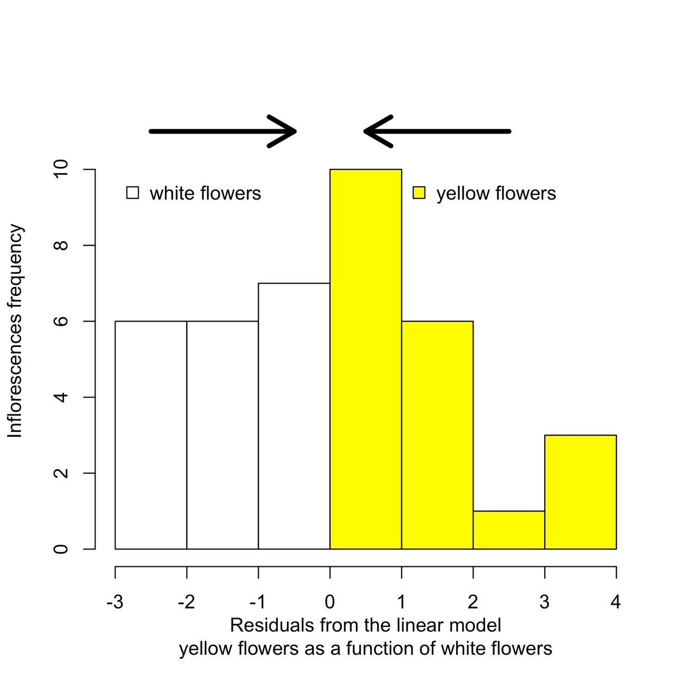
Electronic Supplementary Material 1. Residuals distribution from a linear model of the yellow and white flowers amounts relationship. The largest the residuals, the greater number of yellow flowers. The lower it is the greater number of white flowers. Arrows indicate the increasing of chromatic contrast on flowers of L. canescens.

