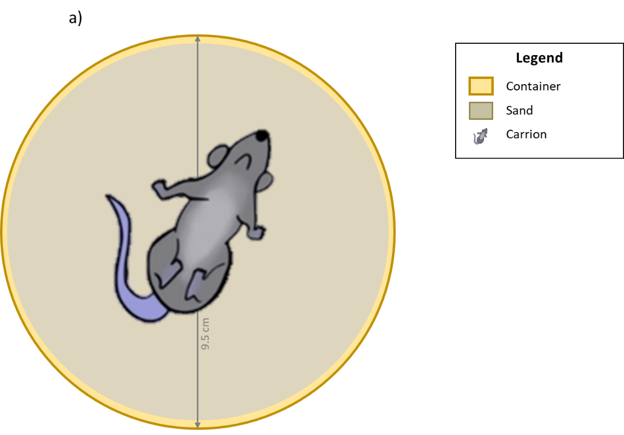

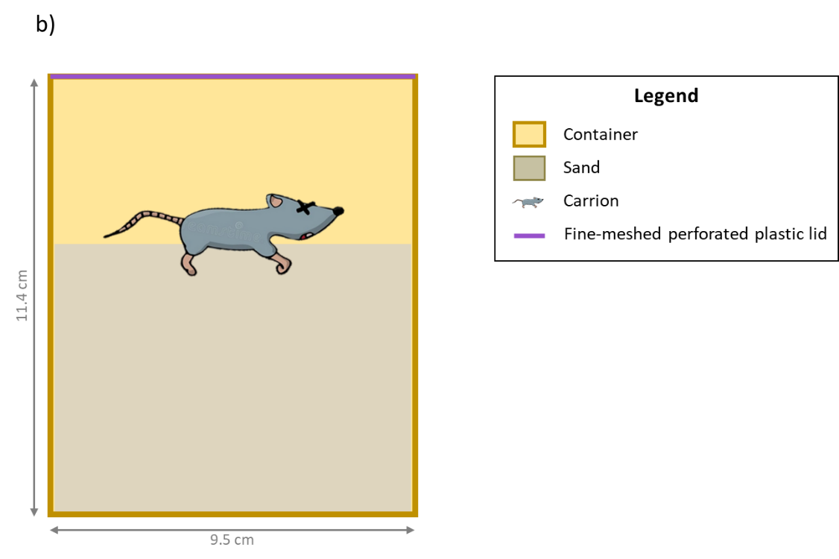
Fig. S1. Design of the experiment assessing the effect of microbes on nutrient fluxes related to carrion decomposition, showing the container top view (a) and front view (b).

