Supplementary Information
Journal: Journal of Soil Science and Plant Nutrition

Title: Fertilizer application method provides an environmental-friendly nitrogen management option for sugarcane

Authors: Sérgio Gustavo Quassi de Castro¹, Vladimir Eliodoro Costa², Saulo Augusto Quassi de Castro^{3,4*}, João Luis Nunes Carvalho¹, Clovis Daniel Borges¹, Rosilaine Araldi de Castro⁵, Oriel Tiago Kölln⁶, Henrique Coutinho Junqueira Franco⁷

Affiliations:
¹ Brazilian Biorenewables National Laboratory, Brazilian Center for Research in Energy and Materials, Giuseppe Máximo Scolfaro Street, 10000, 13083-100, Campinas, SP, Brazil; sergiogqcastro@gmail.com; joao.carvalho@lnbr.cnpem.br; clovisdb@gmail.com.
² Department of Biophysical and Pharmacology, Bioscience Institute, São Paulo State University, Prof. Dr. Antônio Celso Wagner Zanin Street, 250, 18618-689, Botucatu, SP, Brazil; vladimir.costa@unesp.br
³ Department of Soil Science, “Luiz de Queiroz” College of Agriculture, University of São Paulo, Pádua Dias Avenue, 11, 13418-900, Piracicaba, SP, Brazil; saulo.castro@alumni.usp.br
⁴ Department of Plant and Environmental Sciences, Faculty of Sciences, University of Copenhagen, Thorvaldsenvej 40, DK-1871, Frederiksberg C, Denmark; sauloc@plen.ku.dk
⁵ AgroQuatro-S Experimentation and Consultancy Agronomy Applied, Six Avenue, 883, Room 1, 14620-000, Orlândia, SP, Brazil; rosilainearaldi@hotmail.com
⁶ State University of Northern Paraná, Campus Luiz Meneghel, Roadway BR 369, km 54, 86660-000, Bandeirantes, PR, Brazil; oriel.kolln@uenp.edu.br
⁷ Cropman Agriculture Innovation, Adelaide Daniel de Almeida Street, 170, 13080-661, Campinas, SP, Brazil; henrique.junqueira@cropman.com.br

* Corresponding author: sauloc@plen.ku.dk / saulo.castro@alumni.usp.br
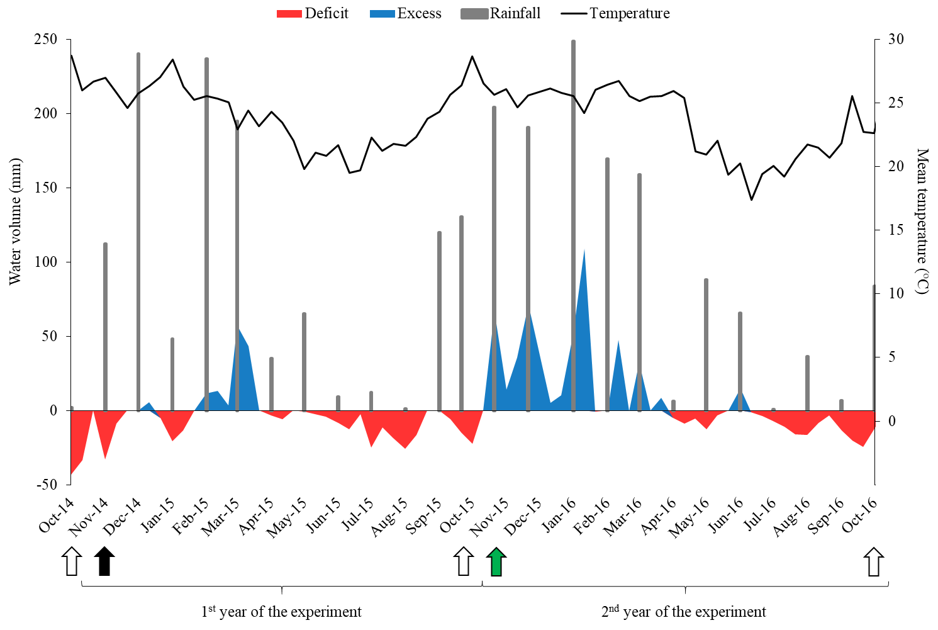
Online Resource 1 Water balance according to the Penman-Monteith method throughout the experimental period (October 2014 to October 2016). Sugarcane harvest is represented by open arrows, while N-fertilization is represented by solid arrows (the green arrow shows ¹⁵N-fertilizer application).

Online Resource 2 Chemical and physical characterization of the soil prior to the installation of the experiment
Soil  attributes | Units | Soil layer (m)
Soil  attributes | Units | 0.0-0.2 | 0.2-0.4 | 0.4-0.6 | 0.6-0.8 | 0.8-1.0
pH | CaCl₂ | 5.3 | 5.7 | 6 | 6.1 | 6.2
SOM | g dm⁻³ | 28 | 25 | 18 | 16 | 15
S | mg dm⁻³ | 11 | 11 | 10 | 9 | 10
P | mg dm⁻³ | 7 | 5 | 8 | 5 | 4
K | mmol_{c} dm⁻³ | 1.8 | 1 | 0.7 | 0.6 | 0.6
Ca | mmol_{c} dm⁻³ | 41 | 31 | 25 | 19 | 18
Mg | mmol_{c} dm⁻³ | 12 | 9 | 7 | 6 | 5
H+Al | mmol_{c} dm⁻³ | 32 | 23 | 20 | 18 | 17
CEC | mmol_{c} dm⁻³ | 87 | 64 | 52 | 43 | 41
V | % | 63 | 64 | 63 | 59 | 58
Bulk density | g cm⁻³ | 1.32 | 1.22 | 1.18 | 1.16 | 1.14
Sand | g kg⁻¹ | 69 | 68 | 66 | 64 | 67
Clay | g kg⁻¹ | 700 | 718 | 733 | 686 | 680
Silt | g kg⁻¹ | 244 | 214 | 201 | 250 | 253
Texture |  | Very  clayey | Very  clayey | Very  clayey | Very  clayey | Very  clayey
SOM – Soil Organic Matter; CEC – Cation Exchange Capacity; V – base saturation.

Online Resource 3 Primers utilized in the amplification of the 16S rRNA bacteria and archaea genes and nifH, AOA and AOB
Target genes | Primers | Sequence (5’- 3’) | Fragment size  (pb) | Reference | Amplification conditions
16S rRNA Bacteria | Eub 338f  Eub 518r | ACTCCTACGGGAGGCAGCAG  ATTACCGCGGCTGCTGG | 180 | Bakke et al. (2011) | 95 ºC – 10 min; 40 cycles, 94 ºC – 15 s, 56 ºC – 30 s e 72 ºC – 45 s.
16S rRNA Archaea | ARC1059r RC787f | ATTAGATACCCSBGTAGTCC  GCCATGCACCWCCTC T) | 273 | Yu et al. (2005) | 95 ºC – 10 min; 40 cycles, 95 ºC – 15 s, 57 ºC – 20 s e 72 ºC – 30 s.
nifH | nifH-f  nifH-r | AAA GGY GGW ATC GGY AAR TCC ACC AC  TTG TTS GCS GCR TAC ATS GCC ATC AT | 457 | Wallenstein and Vilgalys (2005) | 95 ºC – 5 min; 40 cycles, 95 ºC – 30 s, 59 ºC – 30 s e 72 ºC – 1 min e 72 º C – 1 min.
AOA amoA | amoA19F  amoA643R | ATGGTCTGGCTWAGACG  TCCCACTTWGACCARGCGGCCATCCA | 624 | Leininger et al. (2006) | 95 ºC – 10 min; 40 cycles, 95 ºC – 60 s, 55 ºC – 30 s e 72 ºC – 45 s.
AOB amoA | amoA 1F  amoA 2R | GGG GTT TCT ACT GGT GGT  CCC CTC KGS AAA GCC TTC TTC | 491 | Rotthauwe et al. (1997) | 95 ºC – 10 min; 40 cycles, 95 ºC – 45 s, 60 ºC – 45 s e 72 ºC – 45 s.
Bakke I, Schryver P de, Boon N, Vadstein O (2011) PCR-based community structure studies of Bacteria associated with eukaryotic organisms: A simple PCR strategy to avoid co-amplification of eukaryotic DNA. Journal of Microbiological Methods, 84, 349-351. https://doi.org/10.1016/j.mimet.2010.12.015.
Leininger S, Urich T, Schloter M, Schwark L, Qi J, Nicol GW, Prosser JI, Schuster SC, Schleper C (2006) Archaea predominate among ammonia-oxidizing prokaryotes in soils. Nature 442, 806-809. https://doi.org/10.1038/nature04983.
Rotthauwe JH, Witzel KP, Liesack W (1997) The Ammonia Monoozygenase Structural Gene amoA as a Functional Marker: Molecular Fine-Scale Analysis of Natural Ammonia-Oxidizing Populations. Applied and Environmental Microbiology 63, 4704-4712. https://doi.org/10.1128/aem.63.12.4704-4712.1997.
Wallenstein MD, Vilgalys RJ (2005) Quantitative analyses of nitrogen cycling genes in soils. Pedobiologia, 49, 665-672, https://doi.org/10.1016/j.pedobi.2005.05.005.
Yu Y, Lee C, Kim J, Hwang S (2005) Group-specific primer and probe sets to detect methanogenic communities using quantitative real-time polymerase chain reaction. Biotechnol Bioengeneer 89, 670-679. https://doi.org/10.1002/bit.20347.

