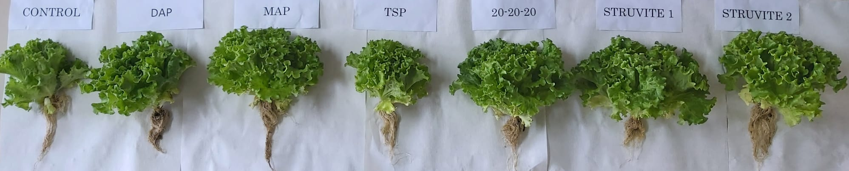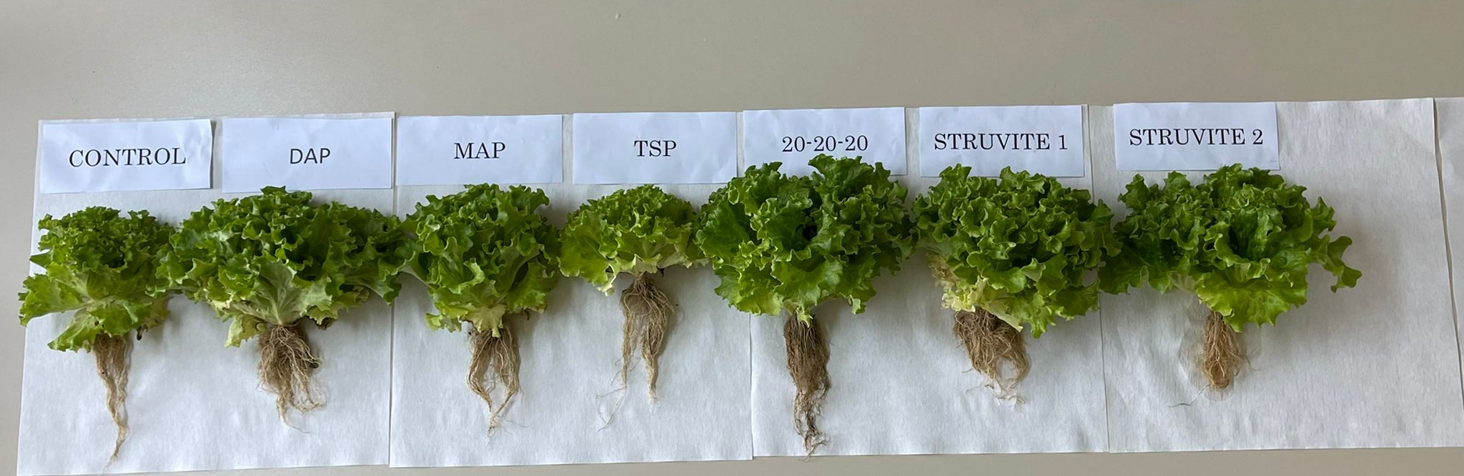
Figure S1. Comparison of the effects of struvites and chemical fertilizers on the growth of lettuce grown in acidic (above) and calcareous (below) soils. DAP di-ammonium phosphate, MAP monoammonium phosphate, TSP triple superphosphate, 20-20-20 NPK fertilizer.

