Impact of erosion-induced topsoil dilution on rapeseed root growth, assimilate C input, and turnover in the soil
Ayten Pehlivan^{1,3}, Julian Ruggaber², Rainer Remus¹, Jürgen Augustin¹, Steffen Kolb^{2,3}
¹ Leibniz Centre for Agricultural Landscape Research (ZALF), Isotope Biogeochemistry & Gas Fluxes, Research Area 1 “Landscape Functioning”, Eberswalder Str. 84, 15374, Müncheberg, Germany;
² Leibniz Centre for Agricultural Landscape Research (ZALF), Microbial Biogeochemistry, Research Area 1 “Landscape Functioning”, Eberswalder Str. 84, 15374, Müncheberg, Germany;
³ Humboldt-Universität zu Berlin, Thaer-Institute of Agricultural and Horticultural Sciences, Invalidenstraße 42, 10099, Berlin, Germany

Correspondence to: Ayten Pehlivan (ayten.pehlivan@zalf.de)

Supplementary Information

Table S1. Physical characteristics of topsoil (Ap) and subsoil (Bt) material of the eroded Nudiargic Luvisol used in the experiment. Depths indicate horizons sampled, with percentages of sand, silt and clay, defining texture and for each horizon.

Soil type | Horizon | Depth  (cm) | Sand (%) | Silt (%) | Clay (%)
eroded  Nudiargic Luvisol | Ap | 0-30 | 61 | 26 | 13
Subsoil | Bt | 30-60 | 54 | 27 | 18

Table S2. Soil chemical characteristics (TN: total nitrogen, TS: total sulfur, TIC: total inorganic carbon, SOC: soil organic carbon, P_{DL}: plant available phosphorous, K_{DL}: plant available potassium, Mg_{CaCl2}: magnesium and pH) of three topsoil dilution levels (0%, 12%, and 24% subsoil (Bt) material addition into the topsoil (Ap) material). Parameters measured in the admixture treatments of bare soil and Bt horizon before the experiment in the ZALF central lab. DL = double lactate extraction. Data are presented as means (n = 3 for 0 %, 12 % and 24 %), (n = 4 for Bt) with standard deviations (SD). Differences between treatments, revealed by one-way ANOVA (p < 0.05), are indicated by letters: treatments sharing the same letter are not significantly different, while different letters indicate significant differences.

Treatment/  Soil horizon | TN  (%) | TS  (%) | TIC  (%) | SOC  (%) | P_{DL}  mg 100 g⁻¹ | K_{DL}  mg 100 g⁻¹ | Mg_{CaCl2}  mg 100 g⁻¹ | pH  (CaCl₂)
Ap (0 %) | 0.08ª ± 0.00 | 0.03ª ± 0.00 | 0.03ª ± 0.01 | 0.80ª ± 0.00 | 8.32ª ± 0.43 | 21.36ª ± 2.55 | 10.54ª ± 2.03 | 6.91ª ± 0.13
12 % Bt | 0.08ª ± 0.00 | 0.03ª ± 0.00 | 0.03^{ab}± 0.00 | 0.72^{b} ± 0.02 | 7.75^{ab} ± 0.05 | 18.73^{ab} ± 1.94 | 9.21ª ± 0.36 | 6.84ª ± 0.11
24 % Bt | 0.07ª ± 0.01 | 0.03ª ± 0.00 | 0.02^{b} ± 0.00 | 0.64^{c} ± 0.02 | 7.22^{b} ± 0.72 | 15.51^{b} ± 0.70 | 9.10ª ± 0.19 | 6.85ª ± 0.08
Bt (100 %) | 0.03^{b} ± 0.00 | 0.01^{b} ± 0.00 | 0.01^{c} ± 0.00 | 0.16^{d} ± 0.00 | 0.63^{c} ± 0.02 | 5.86^{c} ± 0.18 | 5.95^{b} ± 0.07 | 6.52^{b} ± 0.01

Table S3. Soil physiochemical properties: Al_{o} = oxalate soluble aluminium, Al_{d} = dithionite soluble aluminium, Fe_{o}= oxalate soluble iron, Fe_{d} = dithionite soluble iron) of three topsoil dilution levels (0%, 12%, and 24% subsoil (Bt) material addition into the topsoil (Ap) material). Parameters measured in the admixture treatments of bare soil before the experiment in the ZALF central lab. o = ammonium oxalate extraction, d = sodium dithionite extraction. Data are presented as means (n = 5) with standard deviations (SD). Differences between treatments, revealed by one-way ANOVA (p < 0.05), are indicated by letters: treatments sharing the same letter are not significantly different, while different letters indicate significant differences.

Treatment | Al_{o}  mg kg⁻¹ | Al_{d}  mg kg⁻¹ | Fe_{o}  mg kg⁻¹ | Fe_{d}  mg kg⁻¹
0 % Bt | 380.39^{c} ± 8.49 | 790.26^{c} ± 12.18 | 1072.66^{b} ± 23.41 | 5051.82^{c} ± 99.89
12 % Bt | 404.82^{b} ± 15.66 | 855.76^{b} ± 17.12 | 1126.95^{ab} ± 50.94 | 5468.82^{b} ± 162.56
24 % Bt | 422.03ª ± 6.86 | 913.66ª ± 20.05 | 1161.76ª ± 31.83 | 6009.76ª ± 127.38

Table S4. Dry mass [g] of shoot, and root of spring rapeseed, grown on soils with varying topsoil dilution levels (0%, 12%, and 24% subsoil (Bt) material addition into the topsoil (Ap) material), 21 days after labelling. Data are presented as means (n = 5) with standard deviations (SD). Differences between treatments, revealed by one-way ANOVA (p < 0.05), are indicated by letters: treatments sharing the same letter are not significantly different, while different letters indicate significant differences.
Treatment/Plant organ | 0 % Bt | 12 % Bt | 24 % Bt
Shoot | 16.04ª ± 1.40 | 17.79ª ± 2.07 | 15.48ª ± 1.11
Root | 4.26ª ± 0.48 | 4.77ª ± 0.67 | 5.37ª ± 0.85

Table S5. From the total ¹⁴C activity of plant-soil-soil gas system, the relative partitioning of ¹⁴C expressed in percentage [%] was calculated by summing up the activity of each component and calculating the percentage of ¹⁴C in individual components in relation to the total activity (100 %) of the system. Relative partitioning of ¹⁴C [%] in each plant-soil-soil gas system, 21 days after labelling of spring rapeseed, grown on soils with varying topsoil dilution levels (0%, 12%, and 24% subsoil (Bt) material addition into the topsoil (Ap) material). Data are presented as means (n = 5) with standard deviations (SD). Differences between treatments, revealed by one-way ANOVA (p < 0.05), are indicated by letters: treatments sharing the same letter are not significantly different, while different letters indicate significant differences.

Treatment/  Compartment |  | 0 % Bt | 12 % Bt | 24 % Bt
Shoot |  | 67.7ª ± 3.4 | 59.6^{b} ± 2.7 | 51.3^{c} ± 2.9
Belowground respiration |  | 20.2^{c} ± 2.9 | 24.5^{b} ± 3.4 | 31.4ª ± 2.9
Root system |  | 8.5^{b} ± 1.8 | 11.7ª ± 1.9 | 12.4ª ± 2.2
Detectable rhizodeposition |  | 3.7^{b} ± 1.8 | 4.3^{b} ± 0.4 | 4.9ª ± 0.5

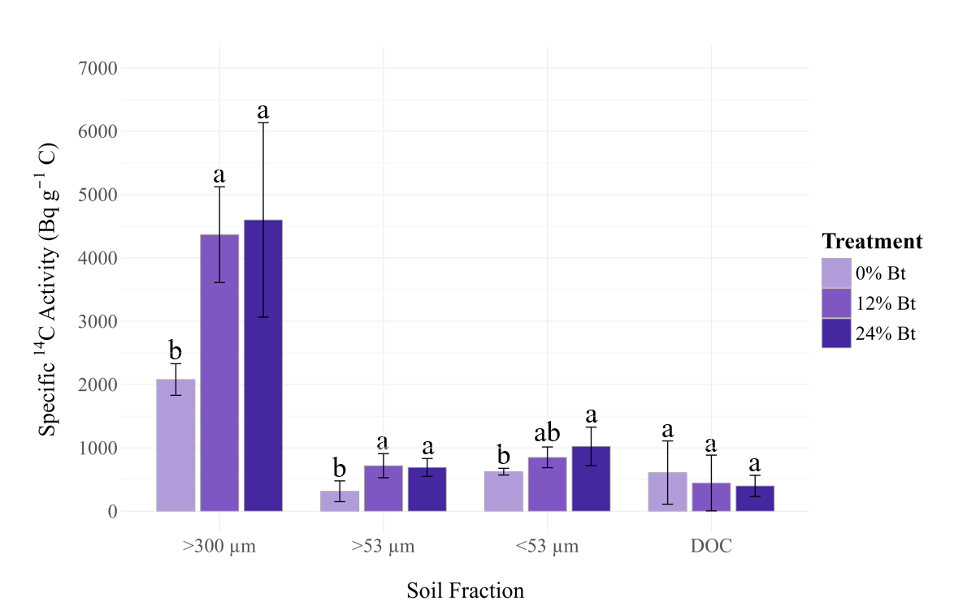
a
a
a
a
ab
b
a
a
b
a
a
b
Figure S1. ¹⁴C incorporation into bulk soil fractions, 21 days after labelling of spring rapeseed, grown on soils with varying topsoil dilution levels (0%, 12%, and 24% subsoil (Bt) material addition into the topsoil (Ap) material), expressed as specific ¹⁴C activity (Bq g⁻¹ C). Data are presented as means (n = 5) with error bars representing standard deviation (SD). Differences between treatments within each soil fraction, revealed by one-way ANOVA followed by Tukey's HSD test (p > 0.05), are indicated by letters: treatments sharing the same letter are not significantly different.

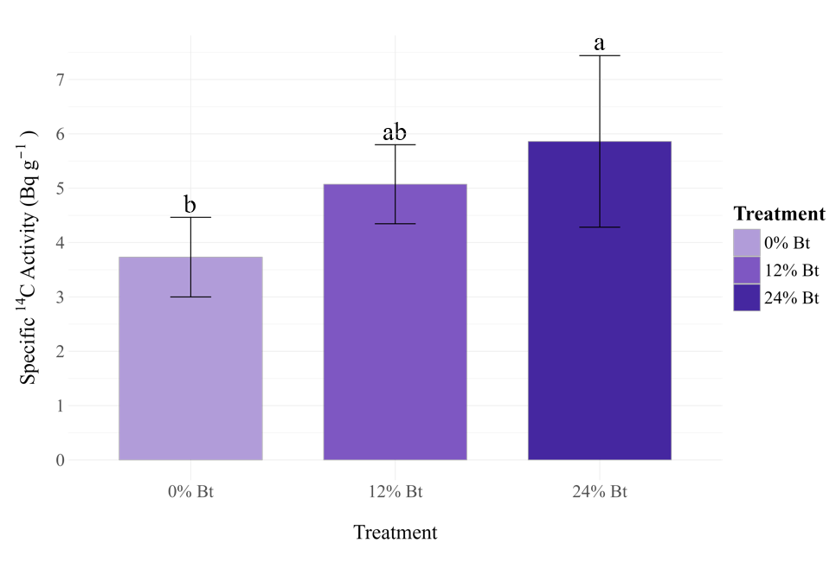Figure S2. Specific ¹⁴C activity of rhizodeposits (< 300 µm) of bulk and rhizosphere soil combined, 21 days after labelling of spring rapeseed, grown on soils with varying topsoil dilution levels (0%, 12%, and 24% subsoil (Bt) material addition into the topsoil (Ap) material), expressed as Bq g⁻¹ soil dry mass. Data are presented as means (n = 5) with error bars representing standard deviation (SD). Differences between treatments, revealed by one-way ANOVA (p > 0.05) followed by Tukey's HSD test, are indicated by letters: treatments sharing the same letter are not significantly different.

