Table S1. Correlation coefficients for nutrient concentrations in plant tissues for the whole data set
 | N root | Na root | K root | Cl leaf | N leaf | Na leaf | K leaf
Cl root | -0.2252 | 0.6307 | 0.2404 | 0.2268 | 0.3407 | 0.0927 | 0.557
N root |  | -0.2327 | -0.0464 | -0.4196 | 0.363 | -0.0334 | -0.1954
Na root |  |  | 0.1603 | 0.4668 | 0.1354 | 0.3673 | 0.5642
K root |  |  |  | 0.1365 | 0.1174 | 0.2273 | 0.0034
Cl leaf |  |  |  |  | -0.4212 | 0.7752 | 0.43
N leaf |  |  |  |  |  | -0.3035 | 0.1552
Na leaf |  |  |  |  |  |  | 0.3459
n=84; italics, bold and underlined, italics and bold, italics, significant at p<0.000, p<0.05 and p<0.1, respectively.

Table S2. Effect of treatments and rootstocks on chlorophyll content in leaf
Factor | Chlorophyll content
Factor | 2 | 15 | 31 | 46
Treatment |  | mmol m⁻²
0 | 622.7 | 717.2a | 720.5a | 750.3a
25 | 646.8 | 712.1ab | 665.8ab | 671.4b
50 | 586.6 | 645.7b | 620.3bc | 570.7c
75 | 633.5 | 665.8ab | 578.5c | 576.6c
Rootstock
US942 | 512.8d | 620.1d | 630.3b | 669.6ab
Cleopatra | 617.9c | 655.4cd | 644.8b | 689.8a
B11R3T27 | 650.2bc | 706.3bc | 625.1b | 592.7bc
B11R5T64 | 620.9bc | 771.3b | 696.4b | 685.8ab
US802 | 714.7b | 769.8b | 677.4b | 666.4ab
B11R5T36 | 809.4a | 875.0a | 795.4a | 739.6a
Carrizo | 437.4d | 421.9e | 462.5c | 463.7c
ANOVA
T | 0.0714 | 0.0046 | 0.0000 | 0.0000
R | 0.0000 | 0.0000 | 0.0000 | 0.0000
T*R | 0.8692 | 0.1412 | 0.4766 | 0.0680
2, 15, 31 y 46; days after the first application of treatments.
Mean followed by different letters in the same column for each treatment within a factor are significantly different according to the test of Tukey.
Significant effects are marked in bold.

Table S3. Effect of the treatments and rootstocks on stomatal conductance in leaf
Factor | Stomatal conductance
Factor | 17 | 30 | 45
Treatment | mmol m⁻² s⁻¹
0 | 187.1a | 145.0a | 155.0a
25 | 158.3ab | 140.1a | 128.3ab
50 | 150.1b | 103.3b | 95.0bc
75 | 133.5b | 88.2b | 73.0c
Rootstock
US942 | 146.7ab | 124.2abc | 128.0ab
Cleopatra | 113.1ab | 93.9bc | 125.8ab
B11R3T27 | 177.9b | 107.6bc | 85.7b
B11R5T64 | 223.4a | 170.4a | 154.0a
US802 | 185.9ab | 119.0bc | 110.4ab
B11R5T36 | 160.5b | 133.3ab | 96.6b
Carrizo | 93.3b | 85.8c | 89.2b
ANOVA
T | 0.0016 | 0.0000 | 0.0000
R | 0.0000 | 0.0000 | 0.0008
T*R | 0.6125 | 0.6953 | 0.0907
17, 30 y 45; days after the first application of treatments.
Mean followed by different letters in the same column for each treatment within a factor are significantly different according to the test of Tukey.
Significant effects are marked in bold.

Table S4. Mean values and standard error for nutrient concentration in roots
Rootstock | Root
Rootstock | Fe | Cu | Mn | Zn | N | P | K | Ca
Rootstock | mg kg |  |  |  | %
Cleopatra | 318.9±14.8 | 13.9±0.8 | 368.9±21.8 | 56.8±3.4 | 2.24±0.03 | 0.28±0.02 | 1.7±0.09 | 1.3±0.04
US942 | 297.4±17.2 | 11.4±2.0 | 328.8±33.4 | 44.8±2.9 | 1.95±0.06 | 0.33±0.02 | 1.54±0.12 | 1.11±0.06
B11R3T27 | 241.3±20.5 | 18.5±6.9 | 174.3±18.7 | 53.6±5.4 | 2.53±0.05 | 0.31±0.02 | 1.19±0.22 | 1.10±0.12
B11R5T64 | 510.9±121.3 | 73.2±22.6 | 215.9±29.7 | 48.7±5.8 | 1.88±0.06 | 0.24±0.02 | 1.91±0.21 | 2.02±0.1
US802 | 341.5±39.2 | 31.1±8.5 | 310.9±60.9 | 60.0±7.2 | 2.30±0.05 | 0.32±0.02 | 2.15±0.15 | 1.61±0.06
B11R5T36 | 302.9±34.2 | 59.1±15.2 | 203.1±29.3 | 40.2±4.5 | 2.14±0.06 | 0.24±0.02 | 1.87±0.1 | 1.73±0.05
Carrizo | 280.2±45.9 | 28.2±9.6 | 204.6±34.7 | 43.6±5.6 | 2.07±0.06 | 0.24±0.02 | 1.81±0.1 | 1.62±0.1
Cleopatra, Cleopatra mandarin; Carrizo, Carrizo citrange.

Table S5. Mean values and standard error for nutrient concentration in leaves

Rootstock | Leaf
Rootstock | Fe | Cu | Mn | Zn | N | P | K | Ca
Rootstock | mg kg |  |  |  | %
Cleopatra | 142.6±16.2 | 83.6±11.2 | 49.5±7.5 | 19.9±1.3 | 3.2±0.07 | 0.2±0.01 | 2.51±0.08 | 1.48±0.11
US942 | 98.4±6.6 | 17.0±1.2 | 32.7±3.3 | 15.7±0.7 | 2.29±0.12 | 0.18±0.01 | 2.08±0.09 | 2.24±0.07
B11R3T27 | 91.2±4.0 | 4.0±0.4 | 52.2±4.2 | 40.7±1.4 | 2.76±0.05 | 0.21±0.01 | 1.58±0.07 | 1.50±0.05
B11R5T64 | 193.0±40.7 | 43.0±12.2 | 89.0±28.1 | 31.4±6.0 | 2.73±0.06 | 0.18±0.02 | 2.15±0.25 | 1.53±0.1
US802 | 175.6±21.3 | 46.8±7.0 | 103.2±34.8 | 27.4±4.8 | 3.32±0.07 | 0.19±0.01 | 2.20±0.16 | 1.39±0.05
B11R5T36 | 197.6±34.1 | 74.4±11.4 | 96.0±35.9 | 30.9±6.2 | 2.69±0.04 | 0.17±0.01 | 2.19±0.1 | 1.77±0.07
Carrizo | 142.8±17.8 | 56.1±11.7 | 80±26.1 | 25.6±5.2 | 2.59±0.07 | 0.16±0.01 | 1.91±0.1 | 1.63±0.07
Cleopatra, Cleopatra mandarin; Carrizo, Carrizo citrange.

Figure S1. Toxicity symptoms in citrus seedlings, US802 (a) and B11R3T27 (b), irrigated with increasing concentrations of NaCl in the nutrient solution (0 mM, 25 mM, 50 mM and 75 mM, from left to right).
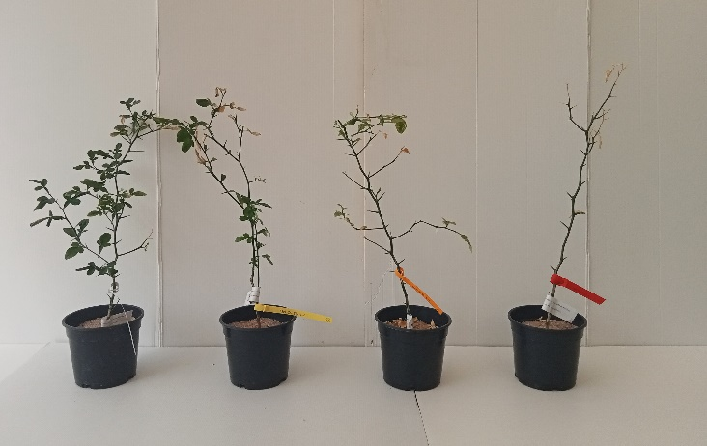
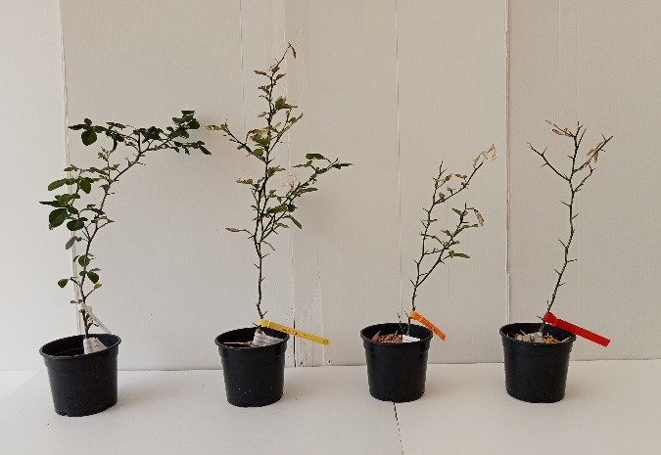
a)
b)

