Impact of Different Organic Amendments on Soil Health and Banana Plant Performance
Correa-Delgado Raquelª, Bodenhausen Natacha^{b}, Romero Ignacio^{b}, Brito-López Patriciaª, Jaizme Vega María Cª, Laich Federicoª*
ª Unidad de Protección Vegetal. Instituto Canario de Investigaciones Agrarias. Valle de Guerra. Santa Cruz de Tenerife. Canary Islands. Spain.
^{b} Department of Soil Sciences, Research Institute of Organic Agriculture (FiBL), Frick, Switzerland.
*Corresponding author at: Unidad de Protección Vegetal. Instituto Canario de Investigaciones Agrarias. Valle de Guerra. Santa Cruz de Tenerife. Canary Islands. Spain. E-mail address: flaich@icia.es

Supplementary Table S1. Initial chemical parameters of the soil used in this experiment
Parameters | Soil | unit
Oxidisable Organic Matter (OOM)¹ | 2.48 | %
Total Organic Matter (TOM) | 10.12 | %
Nitrogen | 0.11 | % (w:w)
Phosphorus | 31.50 | mg kg⁻¹
Calcium | 140.00 | mEq kg⁻¹
Magnesium | 60.90 | mEq kg⁻¹
Sodium | 20.90 | mEq kg⁻¹
Potassium | 13.40 | mEq kg⁻¹
pH water 1:5 | 8.10 | U
Conductivity (EC) | 0.25 | mS cm⁻¹
¹The methodology for the analysis of the samples is described in section 2.5 ‘Soil and amendments analysis’

Supplementary Table S2. Initial chemical parameters of each organic amendment
Parameters¹ | units | Chicken manure | Cow  manure | Compost | Pelletised compost
Total Organic Matter (TOM) | % (w:w) | 72.40 | 70.96 | 56.72 | 49.50
Total Organic Carbon (TOC) | % (w:w) | 40.21 | 39.42 | 31.51 | 27.50
C/N Ratio |  | 11.59 | 19.14 | 24.05 | 21.83
Dry Matter (100C) | % | 63.40 | 27.93 | 71.48 | 78.20
Wet density | kg L⁻¹ | 0.50 | 0.55 | 0.32 | 0.83
Nitrogen | % | 3.47 | 2.06 | 1.31 | 1.26
Phosphorus | mg kg⁻¹ | 979.20 | 935.00 | 292.23 | 41.90
Calcium | mEq kg⁻¹ | 831.00 | 141.00 | 173.17 | 257.00
Magnesium | mEq kg⁻¹ | 200.80 | 135.40 | 137.70 | 137.40
Sodium | mEq kg⁻¹ | 98.70 | 87.40 | 80.70 | 237.10
Potassium | mEq kg⁻¹ | 482.60 | 259.10 | 237.60 | 279.80
pH water 1:5 | U | 7.35 | 7.81 | 8.13 | 8.70
Conductivity (EC) | mS cm⁻¹ | 15.43 | 13.36 | 7.06 | 10.86

¹The methodology used for the analysis of the samples is described in section 2.5 ‘Soil and amendments analysis’

Supplementary Table S3. Characteristics of irrigation water used in this study
Compound | Value | Units
pH | 8.6 | units
EC | 790 | uS cm⁻¹
Calcium | 0.38 | mEq L⁻¹
Magnesium | 1.5 | mEq L⁻¹
Sodium | 7.4 | mEq L⁻¹
Potassium | 0.35 | mEq L⁻¹
Carbonate | 0.4 | mEq L⁻¹
Bicarbonate | 0.2 | mEq L⁻¹
Sulfate | 0.45 | mEq L⁻¹
Chloride | 1.3 | mEq L⁻¹
Phosphate | ND | mEq L⁻¹
Nitrates | ND | mEq L⁻¹
Nitrites | ND | mEq L⁻¹
Fluoride | 0.21 | ppm
Boron | 0.13 | ppm
ND: Not Detectable

Supplementary Table S4. Results of one-way ANOVA testing the effect of different treatments on soil parameters across six sampling times (0 to 20.80 months).
Parameter | Sampling time | F-Value | P-Value | Significance
(p)OOM | t0 (0 months) | 189.8 | 2.20E-09 | ***
OOM | t1 (2.37 months) | 25.67 | 3.06E-05 | ***
OOM | t2 (4.77 months) | 60.15 | 5.87E-07 | ***
OOM | t3 (9.33 months) | 91.97 | 7.61E-08 | ***
OOM | t4 (13.70 months) | 51.12 | 1.27E-06 | ***
OOM | t5 (20.80 months) | 77.83 | 1.71E-07 | ***
MOT | t0 (0 months) | 23.16 | 4.84E-05 | ***
MOT | t1 (2.37 months) | 13.05 | 0.000558 | ***
MOT | t2 (4.77 months) | 18.29 | 0.000136 | ***
MOT | t3 (9.33 months) | 43.59 | 2.69E-06 | ***
MOT | t4 (13.70 months) | 34.42 | 8.05E-06 | ***
MOT | t5 (20.80 months) | 54.81 | 9.14E-07 | ***
Phosphorus (P) | t0 (0 months) | 70.61 | 2.73E-07 | ***
Phosphorus (P) | t1 (2.37 months) | 26.73 | 2.55E-05 | ***
Phosphorus (P) | t2 (4.77 months) | 160.7 | 5.00E-09 | ***
Phosphorus (P) | t3 (9.33 months) | 97.06 | 5.87E-08 | ***
Phosphorus (P) | t4 (13.70 months) | 61.01 | 5.49E-07 | ***
Phosphorus (P) | t5 (20.80 months) | 60.98 | 5.50E-07 | ***
pH | t0 (0 months) | 30.44 | 1.42E-05 | ***
pH | t1 (2.37 months) | 30.66 | 1.37E-05 | ***
pH | t2 (4.77 months) | 45.98 | 2.09E-06 | ***
pH | t3 (9.33 months) | 39.69 | 4.17E-06 | ***
pH | t4 (13.70 months) | 5.91 | 0.0105 | *
pH | t5 (20.80 months) | 34.62 | 7.85E-06 | ***
Conductivity (EC) | t0 (0 months) | 49.02 | 1.55E-06 | ***
Conductivity (EC) | t1 (2.37 months) | 206.3 | 1.46E-09 | ***
Conductivity (EC) | t2 (4.77 months) | 50.01 | 1.41E-06 | ***
Conductivity (EC) | t3 (9.33 months) | 16.27 | 0.000223 | ***
Conductivity (EC) | t4 (13.70 months) | 6.462 | 0.00778 | **
Conductivity (EC) | t5 (20.80 months) | 38.55 | 4.77E-06 | ***
Sodium (Na) | t0 (0 months) | 3.73 | 0.0416 | *
Sodium (Na) | t1 (2.37 months) | 3.131 | 0.0652 | .
Sodium (Na) | t2 (4.77 months) | 8.679 | 0.00273 | **
Sodium (Na) | t3 (9.33 months) | 3.044 | 0.0698 | .
Sodium (Na) | t4 (13.70 months) | 5.416 | 0.0139 | *
Sodium (Na) | t5 (20.80 months) | 1.802 | 0.205
Magnesium (Mg) | t0 (0 months) | 13.05 | 0.000558 | ***
Magnesium (Mg) | t1 (2.37 months) | 4.494 | 0.0246 | *
Magnesium (Mg) | t2 (4.77 months) | 5.324 | 0.0147 | *
Magnesium (Mg) | t3 (9.33 months) | 9.157 | 0.00224 | **
Magnesium (Mg) | t4 (13.70 months) | 26.19 | 2.80E-05 | ***
Magnesium (Mg) | t5 (20.80 months) | 11.74 | 0.000855 | ***
Nitrogen (N) | t0 (0 months) | 43.53 | 2.71E-06 | ***
Nitrogen (N) | t1 (2.37 months) | 43.6 | 2.69E-06 | ***
Nitrogen (N) | t2 (4.77 months) | 22.89 | 5.10E-05 | ***
Nitrogen (N) | t3 (9.33 months) | 33.16 | 9.57E-06 | ***
Nitrogen (N) | t4 (13.70 months) | 16.52 | 0.00021 | ***
Nitrogen (N) | t5 (20.80 months) | 19.96 | 9.31E-05 | ***
The table shows F-values and associated P-values for each parameter and sampling time. Significance levels are indicated as follows: *** p < 0.001, ** p < 0.01, * p < 0.05, and ns for not significant (p ≥ 0.05).

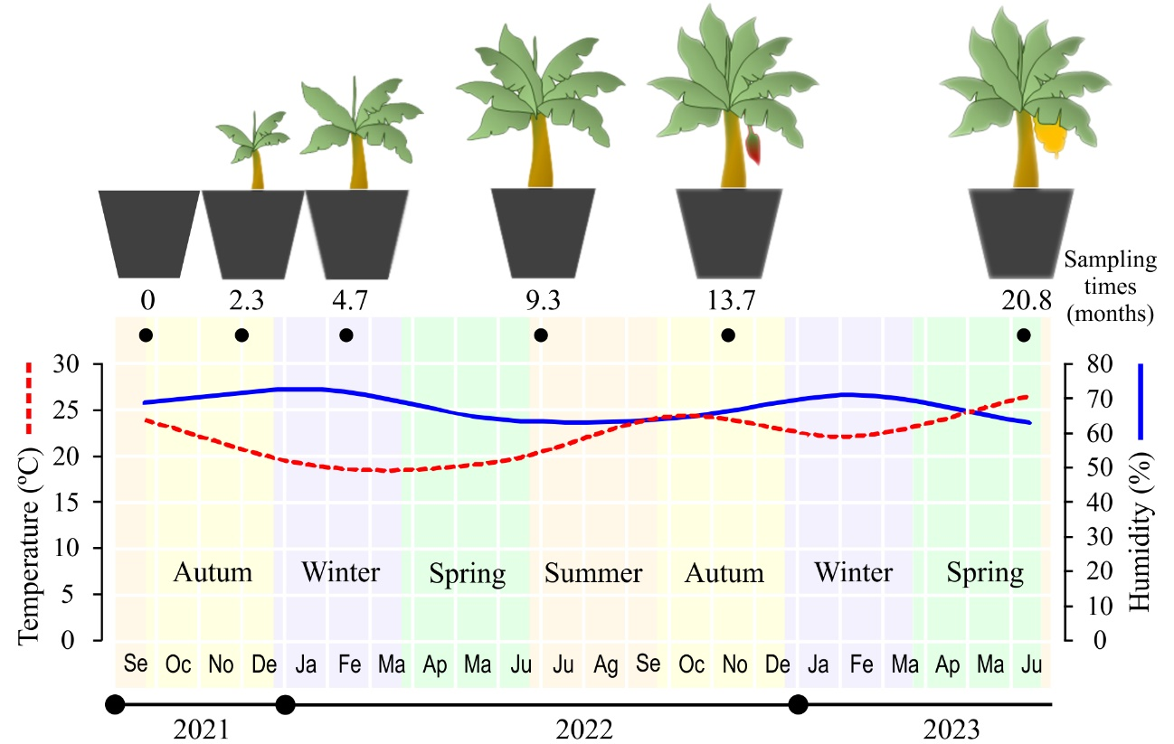
Supplementary Figure S1. Experimental design illustrating the sampling times, temperature (°C), and humidity (%) throughout the experiment. The red dashed line represents the temperature variations across different sampling times, while the blue continuous line represents the evolution of the environmental humidity. Sampling was performed at 0, 2.37, 4.77, 9.33, 13.70, and 20.80 months after planting.

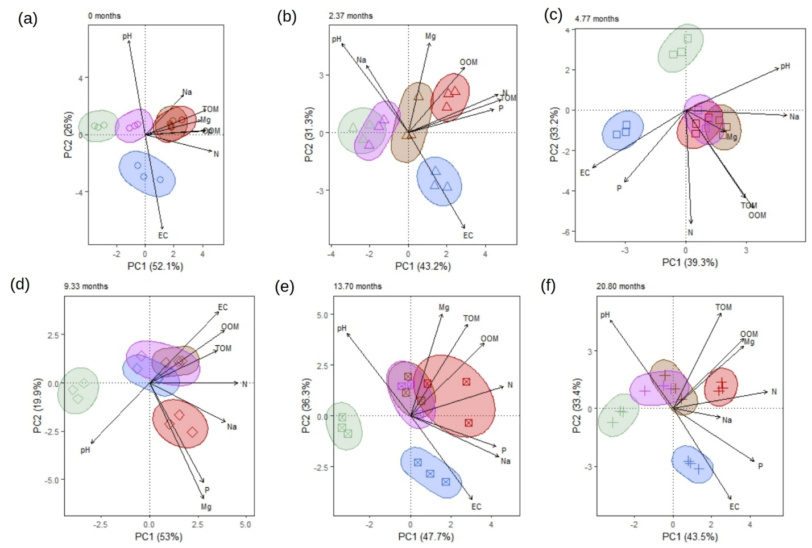

Supplementary Figure S2. Principal Component Analysis of soil chemical properties in the different treatments over time (0 to 20.80 months). (a): 0 months. (b): 2.37 months. (c): 4.77 months. (d): 9.33 months. (e): 13.70 months. (f): 20.80 months. EC: electrical conductivity; TOM: total organic matter; OOM: oxidisable organic matter; N: nitrogen; P: phosphorus; Mg: magnesium; Na: sodium, pH: pH in aqueous extract. Treatments: control (green), compost (brown), chicken manure (blue) cow manure (red), and pelletised compost (purple).

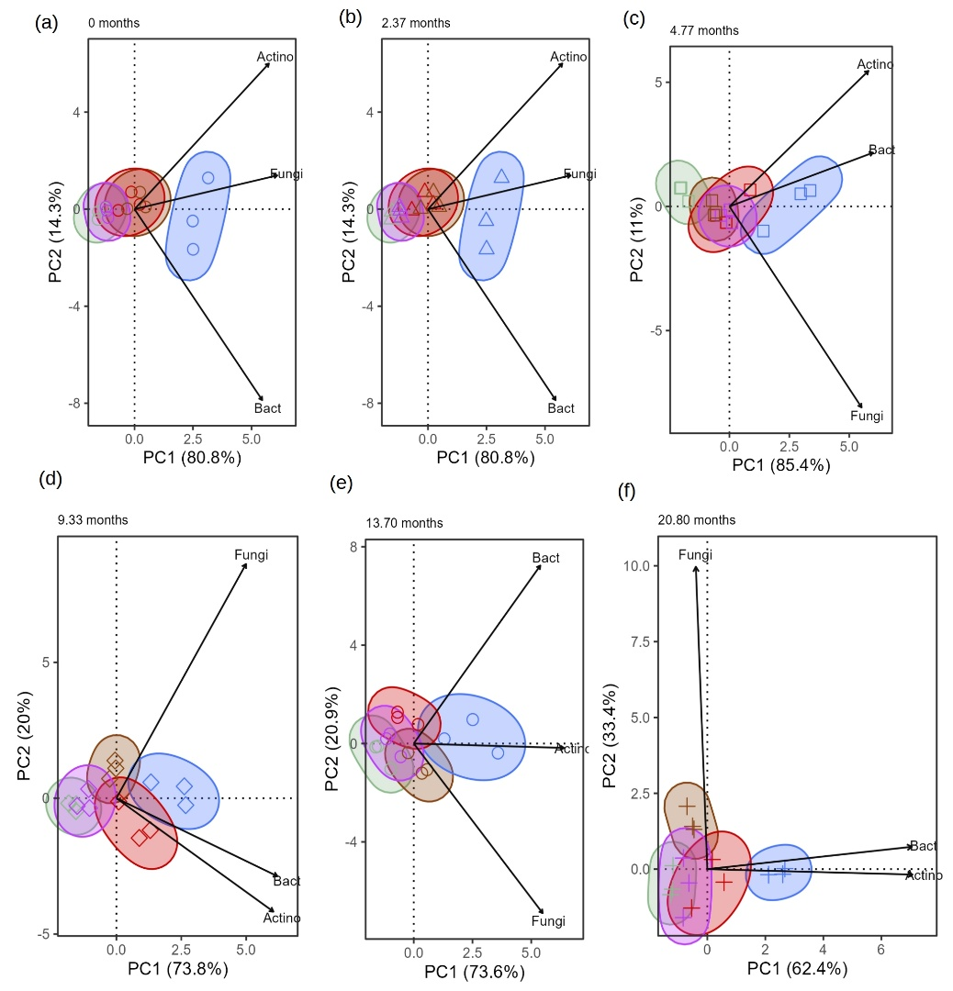
Supplementary Figure S3. Principal Component Analysis of soil microbiological properties in the different treatments over time (0 to 20.80 months). (a): 0 months. (b): 2.37 months. (c): 4.77 months. (d): 9.33 months. (e): 13.70 months. (f): 20.80 months. Actino: Actinobacteria, Bact: Bacteria, Fungi: Filamentous fungi. Treatments: control (green), compost (brown), chicken manure (blue) cow manure (red), and pelletised compost (purple).

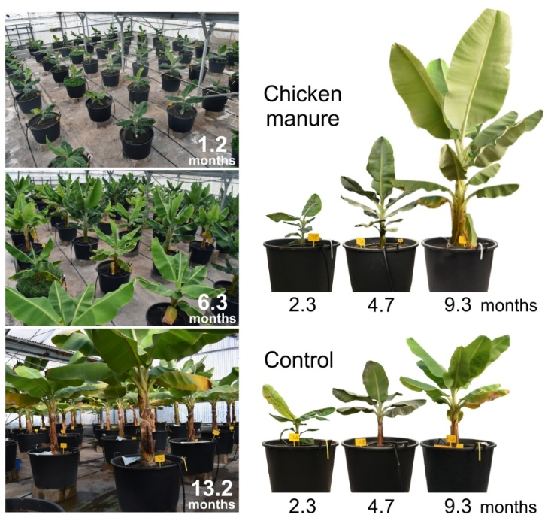

Supplementary Figure S4. Plant development status in the greenhouse over time after planting

