Application of a green compost for improving quality and fertility of a soil co-contaminated by antibiotics and copper
Chiara De Carolis^{1,2}, Anna Barra Caracciolo¹, Lisa Ciadamidaro³, Michel Chalot³, Alessandra Narciso¹, Ludovica Rolando¹, Paola Grenni^{1,4}
¹Water Research Institute, National Research Council (IRSA-CNR), Montelibretti (Rome), Italy
²Department of Environmental Biology, Sapienza University of Rome, Italy
³Université Marie et Louis Pasteur, CNRS, Chrono-environnement (UMR 6249), F-25200 Montbéliard, France
⁴National Biodiversity Future Center (NBFC), Palermo, Italy

Supplementary Information
Microbial DNA extraction and quantification of ARGs
Total DNA was extracted from 0.25 g of soil sample using the DNeasy PowerSoil kit (Qiagen, United States), following the manufacturer’s recommendations. A non-template sample (DNA-free water) was included as a negative control during the whole workflow. Extraction yield and DNA quality were assessed with a spectrophotometer (Multiskan Sky Microplate Spectrophotometer, Thermo Fisher Scientific, United States). All extractions were stored at -20°C until analysis. The extracted DNA was used for both the qPCR and NGS analyses.
Quantitative PCR was used to quantify two SMX-resistance genes (sul1 and sul2), the class 1 integron-integrase gene (intI1), three plasmid-mediated quinolone resistance genes (qnrS, qepA and aac-(6’)-Ib-cr), tetracycline efflux pump gene (tetA) and transposase gene (tnpA). The 16S rRNA gene copy numbers were determined for calculating the relative abundance of the resistance genes targeted in the samples. All qPCR assays were performed with a CFX96 real-time PCR detection system (Bio-Rad, United States), using SYBR green detection.
Each reaction was carried out in a total volume of 20 μL containing 10 μL SsoAdvanced Universal SYBR Green Supermix (Bio-Rad, United States), 0.5 μL of each primer (10 μM), and 1 ng of DNA template. For all genes analysed, the thermal cycling conditions were as follows: 95°C for 3 min, 45 cycles at 95°C for 15 s, annealing temperature (Tm) specific for each gene and primer pair for 30 s, and 72°C for 30 s. The fluorescence signal was read after each elongation step. Amplicon specificity for each gene was verified by performing a melting curve starting at 55°C and increasing by 0.5°C until 95°C. Moreover, preliminary PCR was conducted to test the efficiency and the quality of primers (and amplicons), running gel electrophoresis of amplified DNA, and matching DNA bands with the expected fragment size. Each assay was run in triplicate including the no template controls. Any possible qPCR inhibition was assessed by conducting an inhibition test using samples diluted from 10- to 100-fold, and no inhibition was observed. The quantitative PCR data were expressed as the ratio of ARG or intI1 gene copy number per 16S copy number to evaluate the relative abundance of each target gene in the bacterial community.

Evaluation of microbial community composition by Next-Generation sequencing
Aliquots of the DNA extracted from three replicates for each condition were used for Next Generation Sequencing (NGS). The hypervariable V3–V4 region of 16S rRNA genes were amplified by Miseq Illumina with the Pro341F and Pro805R. These primers were selected to ensure the simultaneous identification of Bacteria and Archaea (Takahashi et al. 2014).
The raw sequences were imported and demultiplexed using QIIME2 Next-Generation microbiome bioinformatics platform v2019.11 (Bolyen et al. 2019) and denoised with the DADA2 plug-in (Callahan et al. 2016). The primers were removed using the “trim-left-f” (forward) and “trim-left-r” (reverse) primer DADA2 functions (Garbini et al. 2023; Mazzurco Miritana et al. 2020). These commands remove the sequences from its beginning to a specific position. The exact length of the primers was 17 nucleotides for the forward and 21 nucleotides for the reverse ones. The amplicon sequencing variants (ASV) obtained were sorted using the Silva 132 database (https://www.arb-silva.de) with a naive Bayes classifier trained on the amplified regions with 80% confidence (Bolyen et al. 2019). The Evenness, Shannon and Chao1 indexes were estimated by QIIME2 in order to evaluate diversity of the prokaryotic community in the different conditions.

Supplementary tables and figures
Table S1. Physicochemical properties of the soil, compost and Soil+compost used in the experiments.
SOIL | Average value
pH | 7.12 ± 0.03
Sand (%) | 56
Silt (%) | 17
Clay (%) | 27
Soil texture | sandy clay loam
Electrical conductivity (mS) | 0.291
Organic carbon (%) | 1.28±0.04
Total nitrogen (%) | 0.18±0.004
Organic matter (%) | 2.3
COMPOST
pH | 8
Ammoniacal nitrogen (N-NH₄ %) | 2.72
Nitric nitrogen (N-NO₃ %) | < 0.01
Uric nitrogen (N %) | <1
Total nitrogen (N %) | 1.42
Organic Matter by Loss on Ignition Organic Carbon (%) | 31.1
Organic carbon (%) | 17.6
Copper (mg/Kg) | 39.6
C:N ratio | 12.4
SOIL+ COMPOST
Organic carbon (%) | 1.42 ± 0.00

Table S2. Bioavailable Cu (mg kg⁻¹) values in the soil at 42 d in the various conditions. Different letters indicate significant differences among the various conditions (p value ≤ 0.05).
S: Soil (Control); SABCu: Soil + Antibiotic mixture + Cu; S_P: Soil + Plant (Control with L. sativa); SAB_P: Soil + AB mixture + Plant; SCu_P: Soil + Cu + Plant; SABCu_P: Soil + AB mixture + Cu + Plant; SCom_P: Soil + Compost + Plant; SABCom_P: Soil + AB mixture + Compost + Plant; SABCuCom_P: Soil + AB mixture + Cu + Compost + Plant.
Adding copper, we have put an additional amount of total Cu (Table 1). However, because the compost itself contained copper (0.396 mg kg⁻¹ adding 1% Compost, Table S1), we cannot exclude that an aliquot of this copper (ca. 0.017 mg kg⁻¹ in SCom_P more than S condition) was bioavailable and this can explain the higher amount found in SCom_P. Additionally, the antibiotics (SABCom_P and SABCuCom_P) made copper less bioavailable (Table S2), as found in other works (Narciso et al. 2023).
 | Available Cu (mg kg⁻¹)
S | 0.014±0.001^{cdef}
SABCu | 0.021±0.004^{bcd}
S_P | 0.015±0.002^{def}
SAB_P | 0.012±0.000^{ef}
SCu_P | 0.028±0.002^{ab}
SABCu_P | 0.024±0.002^{abc}
SCom_P | 0.031±0.005ª
SABCom_P | 0.011±0.004^{f}
SABCuCom_P | 0.020±0.004^{bcde}

Table S3. Primer names and sequences of antibiotic resistance genes, mobile genetic elements and bacterial 16S rRNA gene.
Primer name | Target gene | Primer sequence (5’->3’) | Reference
Sul1 fw | sul1 | CGCACCGGAAACATCGCTGCAC | Vila-Costa et al. (2017)
Sul1 rv | sul1 | TGAAGTTCCGCCGCAAGGCTCG | Vila-Costa et al. (2017)
Sul2 fw | sul2 | GCGCTCAAGGCAGATGGCATT | Kerrn et al. (2002)
Sul2 rv | sul2 | GCGTTTGATACCGGCACCCGT | Kerrn et al. (2002)
IntI1 fw | intI1 | TCGTGCGTCGCCATACA | Byrne-Bailey et al. (2011)
IntI1 rv | intI1 | GCTTGTTCTACGGCCGTTTGA | Byrne-Bailey et al. (2011)
16S fw | 16S rRNA | CGGTGAATACGTTCYCGG | Mckinney et al. (2018)
16S rv | 16S rRNA | TACCTTGTTACGACTT | Mckinney et al. (2018)
qnrS fw | qnrS | GACGTGCTAACTTGCGTGAT | Marti and Balcázar (2013)
qnrS rv | qnrS | TGGCATTGTTGGAAACTT | Marti and Balcázar (2013)
qepA fw | qepA | GCAGGTCCAGCAGCGGGTAG | Yamane et al. (2008)
qepA rv | qepA | CTTCCTGCCCGAGTATCGTG | Yamane et al. (2008)
Aac-(6’)-Ib cr fw | aac-(6’)-Ib-cr | TGCATCACAACTGGGCAAAGGCT | Ruiz et al. (2012)
Aac-(6’)-Ib cr rv | aac-(6’)-Ib-cr | ACACGGCTGGACCATATGGGGT | Ruiz et al. (2012)
tnpA FW | tnpA | CCGATCACGGAAAGCTCAAG | Zhu et al. (2013)
tnpA RV | tnpA | GGCTCGCATGACTTCGAATC | Zhu et al. (2013)

Table S4. Primers used for Next Generation Sequencing.
 | Primer name | Oligonucleotide sequence (5’–3’) | Reference
Prokaryotes | 341F | CCTACGGGAGGCAGCAG | (Baker et al. 2003)
Prokaryotes | 805R | GACTACHVGGGTATCTAATCC | (Baker et al. 2003)

Table S5. Diversity indices (Chao1, Shannon and Evenness) in the different conditions at 42 days. They were estimated on ASV abundances which passed the denoise step. Different letters indicate significant differences among the various conditions (p value ≤ 0.05). S: Soil (Control); SABCu: Soil + Antibiotic mixture + Cu; S_P: Soil + Plant (Control with L. sativa); SAB_P: Soil + AB mixture + Plant; SCu_P: Soil + Cu + Plant; SABCu_P: Soil + AB mixture + Cu + Plant; SCom_P: Soil + Compost + Plant; SABCom_P: Soil + AB mixture + Compost + Plant; SABCuCom_P: Soil + AB mixture + Cu + Compost + Plant
Experimental condition | Shannon | Evenness | Chao 1
S | 8.90 ± 0.05^{b} | 0.87 ± 0.00^{abc} | 1242.26 ± 92.23^{ab}
SABCu | 8.97 ± 0.03ª | 0.88 ± 0.00^{abc} | 1272.64 ± 65.85ª
S_P | 8.93 ± 0.10^{b} | 0.87 ± 0.01^{abc} | 1239.41 ± 33.67^{c}
SAB_P | 8.70 ± 0.06^{c} | 0.87 ± 0.01^{abc} | 1060.14 ± 4.72^{d}
SCu_P | 8.73 ± 0.10^{b} | 0.86 ± 0.00^{b} | 1148.70 ± 54.05^{ab}
SABCu_P | 8.91 ± 0.08^{b} | 0.87 ± 0.01^{abc} | 1292.06 ± 101.19^{c}
SCom_P | 8.78 ± 0.10^{b} | 0.89 ±0.00ª | 1005.75 ± 61.41^{d}
SABCom_P | 8.57 ± 0.44^{b} | 0.85 ± 0.04^{abc} | 1091.96 ± 44.95^{b}
SABCuCom_P | 8.96 ± 0.11^{b} | 0.89 ± 0.01^{ab} | 1154.03 ± 129.91ª

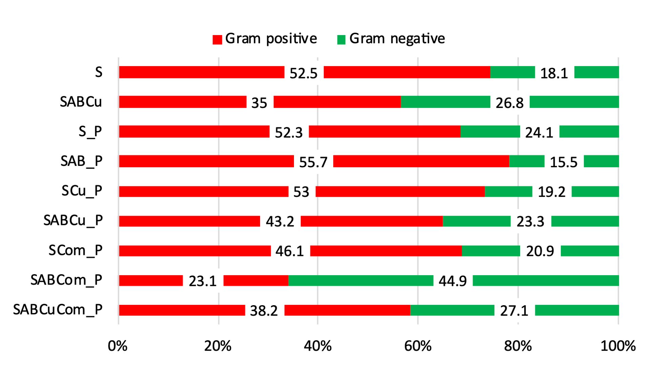
Figure S1. Sum of the relative abundances of Gram positive and Gram negative bacteria (%) in the various experimental conditions. S: Soil (Control); SABCu: Soil + Antibiotic mixture + Cu; S_P: Soil + Plant (Control with L. sativa); SAB_P: Soil + AB mixture + Plant; SCu_P: Soil + Cu + Plant; SABCu_P: Soil + AB mixture + Cu + Plant; SCom_P: Soil + Compost + Plant; SABCom_P: Soil + AB mixture + Compost + Plant; SABCuCom_P: Soil + AB mixture + Cu + Compost + Plant

References

Baker GC, Smith JJ, Cowan DA (2003) Review and re-analysis of domain-specific 16S primers. J Microbiol Methods 55:541–555. https://doi.org/10.1016/j.mimet.2003.08.009
Bolyen E, Rideout JR, Dillon MR, et al (2019) Reproducible, interactive, scalable and extensible microbiome data science using QIIME 2. Nat Biotechnol 37:852–857. https://doi.org/10.1038/s41587-019-0209-9
Byrne-Bailey KG, Gaze WH, Zhang L, Kay P, Boxall A, Hawkey PM, Wellington EMH (2011) Integron prevalence and diversity in manured soil. Appl Environ Microbiol 77:684–687. https://doi.org/10.1128/AEM.01425-10
Callahan BJ, McMurdie PJ, Rosen MJ, Han AW, Johnson AJA, Holmes SP (2016) DADA2: High-resolution sample inference from Illumina amplicon data. Nat Methods 13:581–583. https://doi.org/10.1038/nmeth.3869
Garbini GL, Barra Caracciolo A, Rolando L, Visca A, Borello D, Cosentini C, Gagliardi G, Ieropoulos I, Grenni P (2023) Effects of municipal waste compost on microbial biodiversity and energy production in terrestrial microbial fuel cells. N Biotechnol 78:131–140. https://doi.org/10.1016/j.nbt.2023.10.009
Kerrn MB, Klemmensen T, Espersen F (2002) Susceptibility of Danish Escherichia coli strains isolated from urinary tract infections and bacteraemia , and distribution of sul genes conferring sulphonamide resistance. J Antimicrobial Chemotherapy 50(4)513–516. https://doi.org/10.1093/jac/dkf164
Marti E, Balcázar JL (2013) Real-time PCR assays for quantification of qnr genes in environmental water samples and chicken feces. Appl Environ Microbiol 79:1743–1745. https://doi.org/10.1128/AEM.03409-12
Mazzurco Miritana V, Massini G, Visca A, Grenni P, Patrolecco L, Spataro F, Rauseo J, Garbini GL, Signorini A, Rosa S, Barra Caracciolo A (2020) Effects of Sulfamethoxazole on the Microbial Community Dynamics During the Anaerobic Digestion Process. Front Microbiol 11: 537783. https://doi.org/10.3389/fmicb.2020.537783
Mckinney CW, Dungan RS, Moore A, Leytem AB (2018) Occurrence and abundance of antibiotic resistance genes in agricultural soil receiving dairy manure. FEMS Microbiol Ecol 94(3):fiy010. https://doi.org/10.1093/femsec/fiy010
Narciso A, Barra Caracciolo A, Grenni P, Rauseo J, Patrolecco L, Spataro F, Mariani L (2023) Application of the Aliivibrio fischeri bacterium bioassay for assessing single and mixture effects of antibiotics and copper. FEMS Microbiol Ecol 99: fiad125. https://doi.org/10.1093/femsec/fiad125
Ruiz E, Ocampo-sosa AA, Arlet G, Torres C (2012) Changes in Ciprofloxacin Resistance Levels in Enterobacter aerogenes Isolates Associated with Variable Expression of the aac(6’)-Ib-cr Gene. Antimicrob Agents Chemother 56(2):1097–1100. https://doi.org/10.1128/AAC.05074-11
Takahashi S, Tomita J, Nishioka K, Hisada T, Nishijima M (2014) Development of a Prokaryotic Universal Primer for Simultaneous Analysis of Bacteria and Archaea Using Next-Generation Sequencing. PLoS One 9:e105592. https://doi.org/10.1371/journal.pone.0105592
Vila-Costa M, Gioia R, Aceña J, Pérez S, Casamayor EO, Dachs J (2017) Degradation of sulfonamides as a microbial resistance mechanism. Water Res 115:309–317. https://doi.org/10.1016/j.watres.2017.03.007
Yamane K, Wachino J, Suzuki S, Arakawa Y (2008) Plasmid-Mediated qepA Gene among Escherichia coli Clinical Isolates from Japan. Antimicrob Agents Chemother 52:1564–1566. https://doi.org/10.1128/AAC.01137-07
Zhu YG, Johnson TA, Su JQ, Qiao M, Guo GX, Stedtfeld RD, Hashsham SA, Tiedje JM (2013) Diverse and abundant antibiotic resistance genes in Chinese swine farms. PNAS 110(9):3435–3440. https://doi.org/10.1073/pnas.122274311

