Supplementary figures and tables

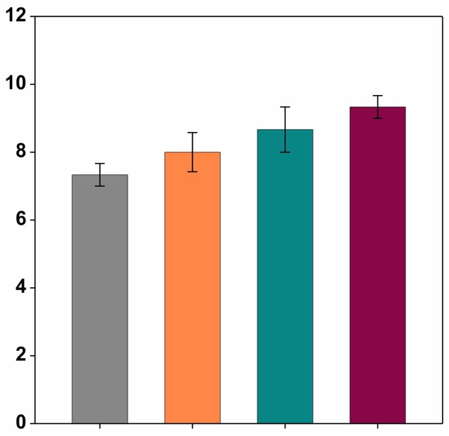
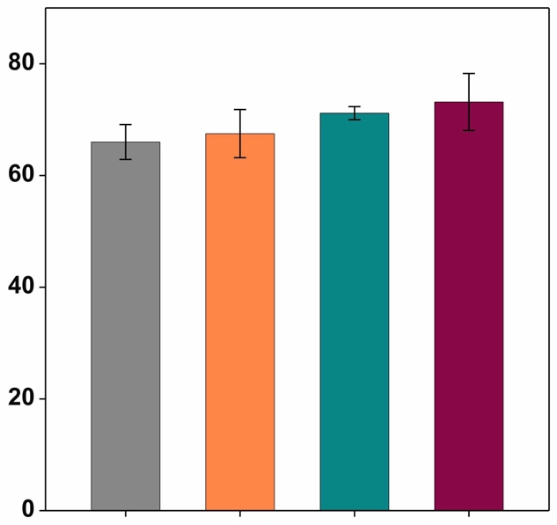
(b)
(a)
a
Plant height (cm)
a
a
a
a
a
Tiller number (plant⁻¹)
a
a

CLG
Control
Control
CLG + NPK
CLG + Compost
CLG + Compost
CLG + NPK
CLG

Legends: |  | Control (no amendment) |  | CLG + NPK (clay + lime + gypsum + N, P, K)
Legends: |  | CLG (clay + lime + gypsum) |  | CLG + Compost (clay + lime + gypsum + compost)
Fig. S1 Effect of soil amendments on wheat plant characteristics: (a) plant height and (b) tiller number at growth stage Z61 (beginning of anthesis), under four soil treatments. Same letters above bars indicate non-significant differences (p > 0.05) among treatments. Error bars are standard deviations (n=3). Four soil treatments: Control (no amendment), CLG (clay + lime + gypsum), CLG + NPK (clay + lime + gypsum + N, P, K fertilisers), and CLG + Compost (clay + lime + gypsum + compost).

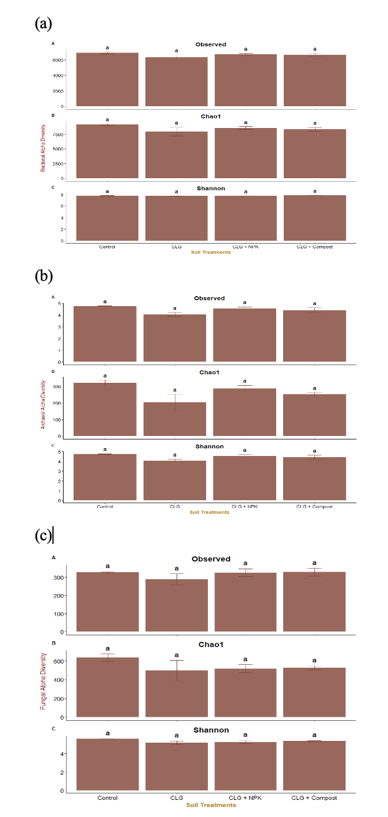

Fig. S2 Alpha diversity metrics of (a) bacteria, (b) archaea, and (c) fungi under four different soil treatments at growth stage Z61(beginning of anthesis). Values represent means ± SE of three replicates. Non-significant differences among the treatments were determined using a generalised least squares model, followed by Tukey’s test (P > 0.05), indicated by same letters.

Table S1 Soil chemical properties before amelioration (baseline) and at growth stage Z61 (beginning of anthesis) under four different treatments.

Stage | Treatments | Soil chemical properties
Stage | Treatments | NH⁺-N  (mg kg^{–1}) | NO₃–-N  (mg kg^{–1}) | Colwell-P  (mg kg^{–1}) | Colwell-K  (mg kg^{–1}) | Sulphur  (mg kg^{–1}) | Organic C  (%) | EC  (dS m^{–1}) | pH  (CaCl₂) | DOC  (mg kg^{–1} C) | MBC  (mg C kg^{–1} soil)
Baseline | Control | 2.0±0.0b | 2.63±0.35a | 15.5±0.20a | 7.47±0.05b | 1.17±0.25c | 0.27±0.10a | 0.02±0.005a | 4.93±0.21a | – | –
Baseline | CLG | 1.67±0.57b | 3.37±0.35a | 13.6±1.02a | 14.9±0.17a | 4.17±0.65b | 0.29±0.04a | 0.03±0.005a | 4.90±0.32a | – | –
Baseline | CLG + NPK | 1.67±0.57b | 4.17±0.15a | 16.7±4.0a | 17.6±2.65a | 5.47±1.75b | 0.31±0.10a | 0.03±0.01a | 5.10±0.20a | – | –
Baseline | CLG + Compost | 3.0±1.0a | 4.16±1.15a | 17.2±5.20a | 19.3±3.59a | 9.70±0.70a | 0.32±0.17a | 0.04±0.01a | 4.87±0.42a | – | –
Baseline | ANOVA | 0.0293* | 0.066^{NS} | 0.649^{NS} | 0.001** | 0.001** | 0.102^{NS} | 0.086^{NS} | 0.438^{NS} | – | –
Z61 | Control | 0.02±0.01b | 0.61±0.02d | 19.67±1.15b | 84.67±3.79c | 6.97±2.67b | 0.33±0.02b | 0.048±0.004b | 5.07±0.13c | 14.69±0.09c | 9.56±2.0c
Z61 | CLG | 0.027±0.01b | 0.86±0.01b | 29.33±3.51b | 104.67±10.4b | 8.3±2.56ab | 0.397±0.02ab | 0.055±0.004b | 6.50±0.16b | 14.50±0.62c | 14.15±1.43b
Z61 | CLG+ NPK | 0.03±0.01ab | 0.82±0.00c | 30.33±6.4ab | 123.67±4.16a | 10.7±2.01ab | 0.427±0.03ab | 0.075±0.001a | 6.25±0.12b | 18.76±0.23b | 16.70±3.17b
Z61 | CLG + Compost | 0.047±0.01a | 0.93±0.01a | 40.67±7.23a | 130.67±5.86a | 15.5±2.72a | 0.52±0.13a | 0.074±0.002a | 6.91±0.07a | 31.24±1.27a | 21.71±3.75a
Z61 | ANOVA | 0.018* | 1.71e⁻⁰⁷*** | 0.003** | 0.0003*** | 0.029* | 0.038* | 0.000314*** | <0.001*** | 1.45e⁻⁰⁷*** | 0.0003***
Control: no amendment; CLG: clay + lime + gypsum; CLG + NPK: clay + lime + gypsum + N, P, K fertilisers; and CLG + Compost: clay + lime + gypsum + compost. Data are means ± standard errors (n = 3); *** p < 0.001, ** p < 0.01, * p < 0.05, NS - not significant. Different letters within a column and stages indicate significant differences (p < 0.05) among treatments.

Table S2 Plant morpho-physiological parameters at growth stage Z23 (main stem and three tillers) and Z61 (beginning of anthesis) under four soil treatments.

Stage | Treatments | Plant morpho-physiological parameters
Stage | Treatments | Plant  height  (cm) | Tiller number (plant^{–1}) | Leaf  area  (cm²) | Chlorophyll  Index  (SPAD reading) | Shoot dry  weight  (g plant^{–1}) | Root dry  weight  (g plant^{–1})
Z23 | Control | 31±1.0c | 3.67±0.58a | 57.89±4.17c | 33.98±2.2b | 1.18±0.095b | 0.517±0.119b
Z23 | CLG | 33.67±0.577b | 4.67±0.58a | 99.11±7.52ab | 38.25±1.44ab | 1.61±0.191ab | 0.603±0.012ab
Z23 | CLG NPK | 32.67±0.577bc | 4.33±0.58a | 89.21±1.3b | 39.91±0.53a | 1.47±0.206ab | 0.64±0.03ab
Z23 | CLG + Compost | 36.33±0.577a | 4.67±0.58a | 118.7±18.25a | 40.69±2.29a | 1.92±0.268a | 0.807±0.09a
Z23 | ANOVA | 0.0007*** | 0.142 ^{NS} | 0.002** | 0.023* | 0.016* | 0.032*
Z61 | Control | 66±5.41a | 7.3±0.058a | 247.11±15.69c | 50.29±1.82b | 3.81±0.19b | 1.33±0.06b
Z61 | CLG | 67.5±7.47a | 8.0±1.0a | 301.87±10.26b | 52.47±1.54ab | 4.30±0.39ab | 1.67±0.08ab
Z61 | CLG+NPK | 71.17±2.02a | 8.67±1.15a | 318.13±3.65ab | 52.52±1.03ab | 4.29±0.14ab | 1.64±0.08ab
Z61 | CLG + Compost | 73.17±8.84a | 9.33±0.58a | 332.43±11.45a | 55.05±1.09a | 4.81±0.08a | 2.02±0.11a
Z61 | ANOVA | 0.416^{NS} | 0.091^{NS} | 0.00015*** | 0.024* | 0.0134* | 0.007**
Control: no amendment; CLG: clay + lime + gypsum; CLG + NPK: clay + lime + gypsum + N, P, K fertilisers; and CLG + Compost: clay + lime + gypsum + compost. Data are means ± standard errors (n = 3); *** p < 0.001, ** p < 0.01, * p < 0.05, NS - not significant. Different letters within a column and stages indicate significant differences (p < 0.05) among treatments.

