Supplement:
Figure 1 and 2 here represents the scatterplots, identical to the correlations presented in the colored table in the manuscript.

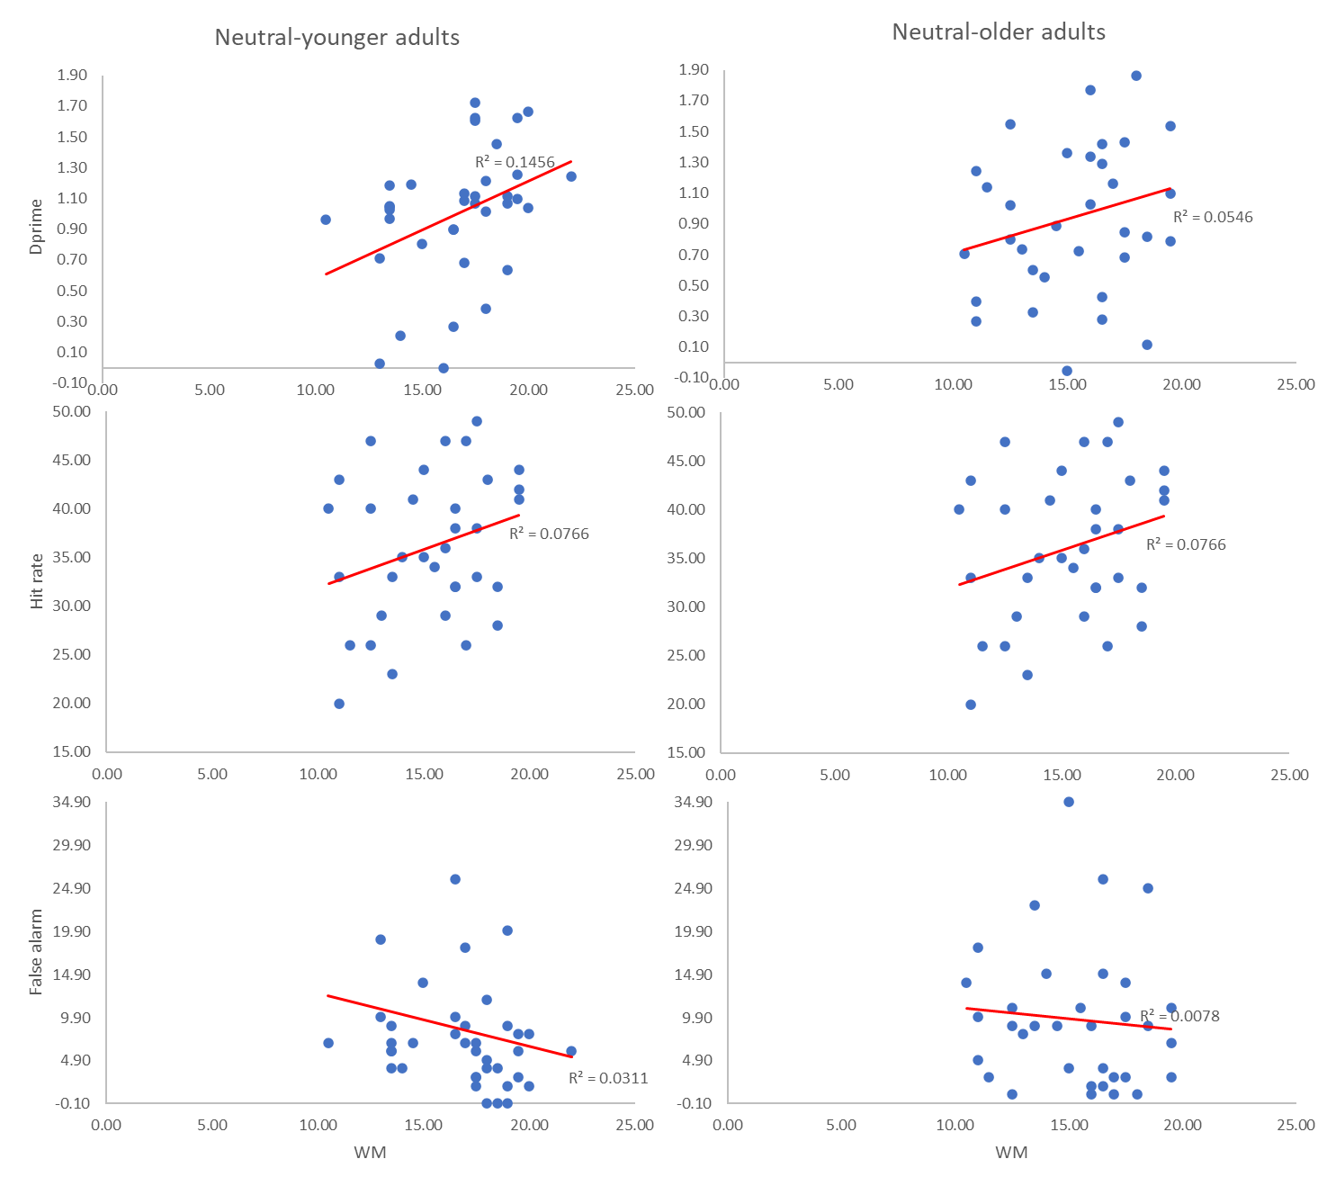
Figure 1: WM and LTM [dprime(first row), hit rate (second row) and false alarm (third row)] associations in Young (left pannels) and Old (right pannels) adults for neutral word types.
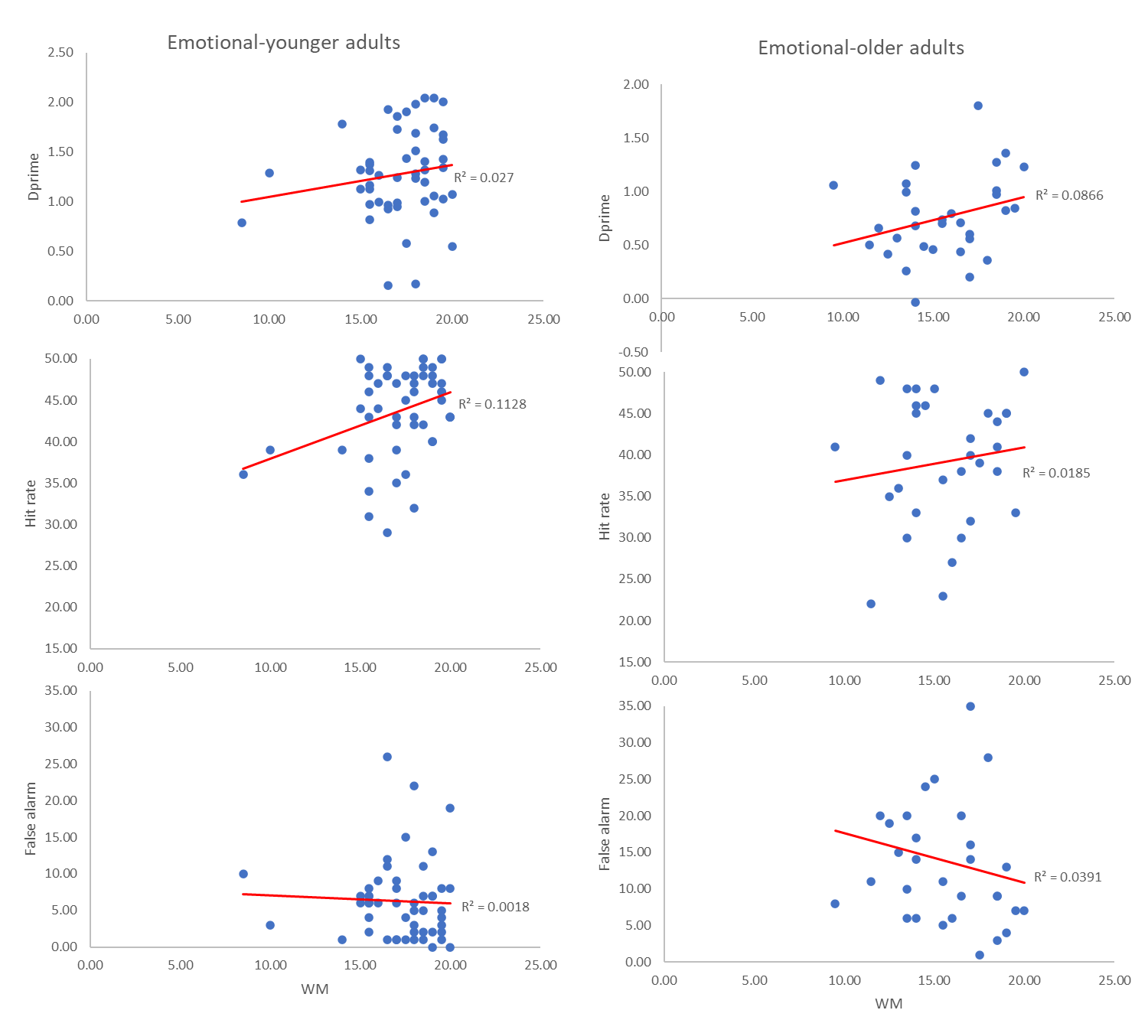
Figure 2: WM and LTM [dprime(first row), hit rate (second row) and false alarm (third row)] associations in Young (left pannels) and Old (right pannels) adults for emotional word types.

