Supporting Information

Boost Up the Mechanical and Electrical Property of CNT Fibers by Governing Lyotropic Liquid Crystalline Mesophases with Aramid Polymers for Robust Lightweight Wiring Applications

Ki-Hyun Ryu,^{a,c} Jeong-Gil Kim,^{a,d} Dongju Lee,^{b} Seo Gyun Kim,^{b} Bon-Cheol Ku,^{b} Jun Yeon Hwang,^{b} Kwang-Un Jeong,^{c,}* Nam Dong Kim,^{a,}* and Dae-Yoon Kim^{a,}*

ª Functional Composite Materials Research Center, Korea Institute of Science and Technology, Wanju 55324, Republic of Korea
^{b} Carbon Composite Materials Research Center, Korea Institute of Science and Technology, Wanju 55324, Republic of Korea
^{c} Department of Polymer-Nano Science and Technology, Department of Nano Convergence Engineering, Jeonbuk National University, Jeonju 54896, Republic of Korea
^{d} Department of Chemical and Biomolecular Engineering, Korea Advanced Institute of Science and Technology, Daejeon 34141, Republic of Korea

Corresponding authors
*E-mail: kujeong@jbnu.ac.kr (K.-U. Jeong); ndkim@kist.re.kr (N. D. Kim); kdaeyoon@kist.re.kr (D.-Y. Kim)

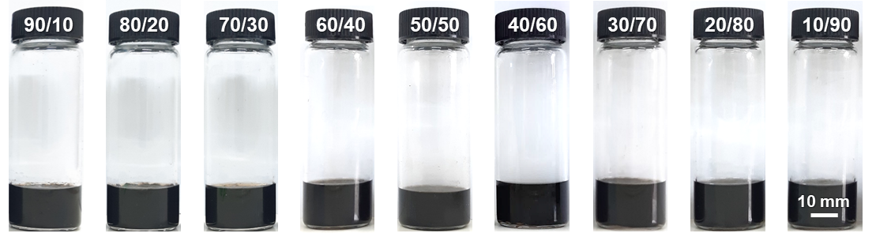
Fig. S1 Macroscopic images of LLC solution of PA/CNT in vials.

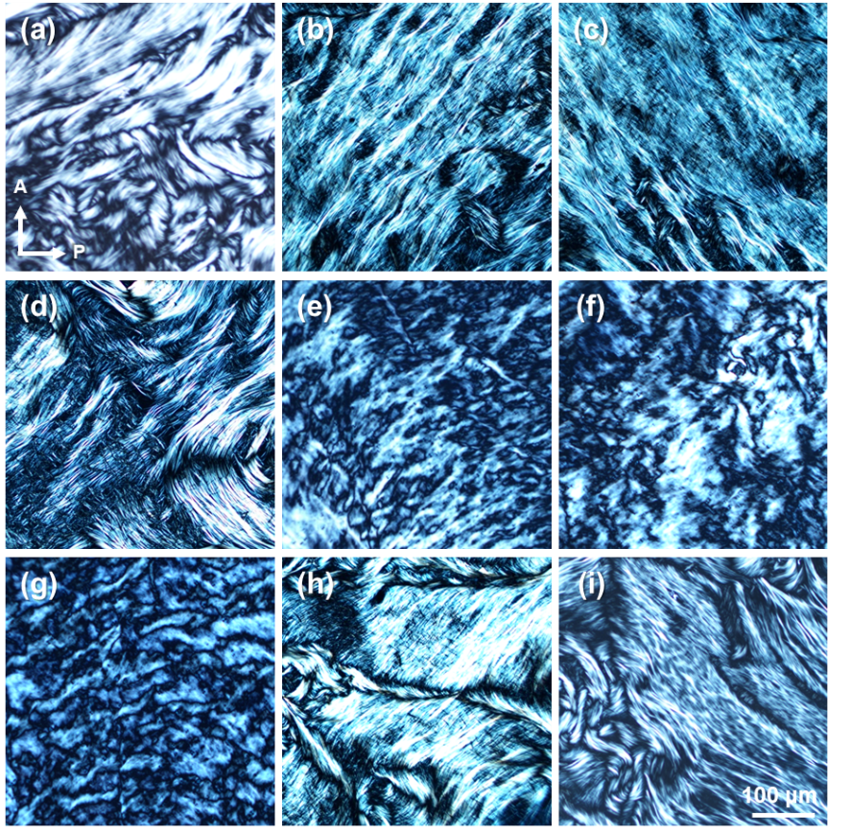
Fig. S2 POM images of the LLC phases of PA/CNT (90/10) (a), PA/CNT (80/20) (b), PA/CNT (70/30) (c), PA/CNT (60/40) (d), PA/CNT (50/50) (e), PA/CNT (40/60) (f), PA/CNT (30/70) (g), PA/CNT (20/80) (h), and PA/CNT (10/90) (i) solutions.

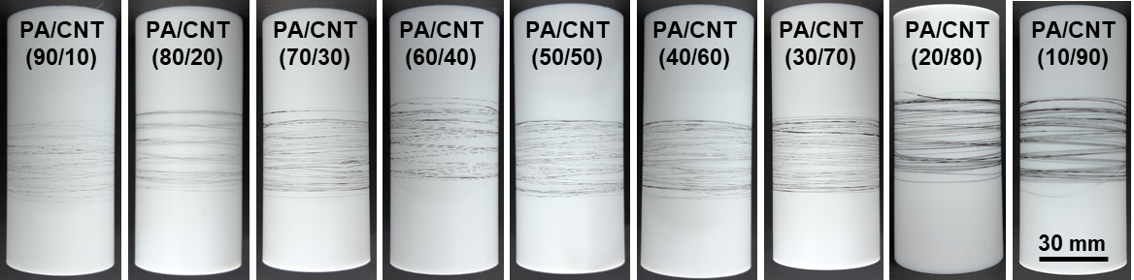
Fig. S3 PA/CNT fibers on the bobbin.

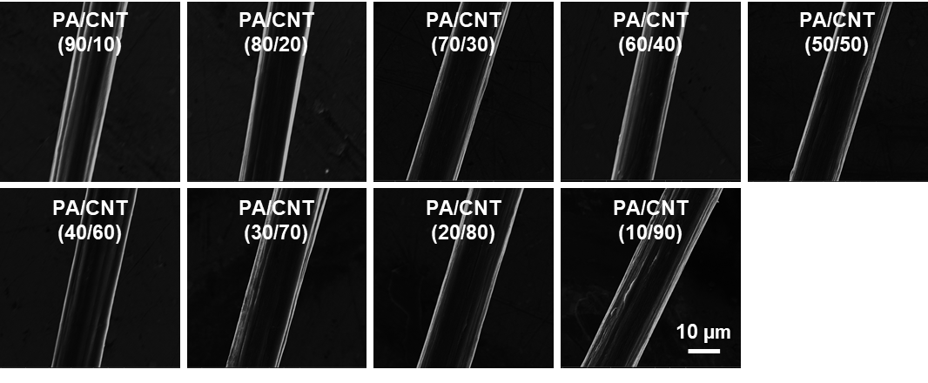
Fig. S4 SEM images of PA/CNT fibers.

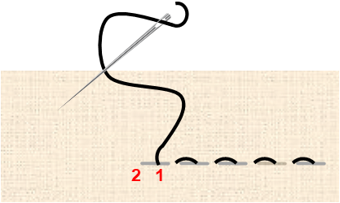
Fig. S5 Schematic illustration of the running stitch by bringing the needle up at point 1 and down at point 2, repeatedly.

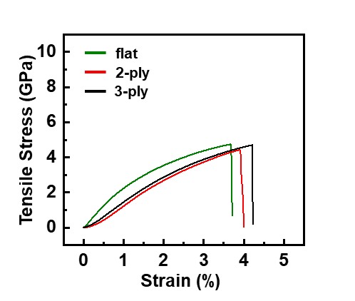
Fig. S6 Stress and strain curve of PA/CNT fibers in different shapes.

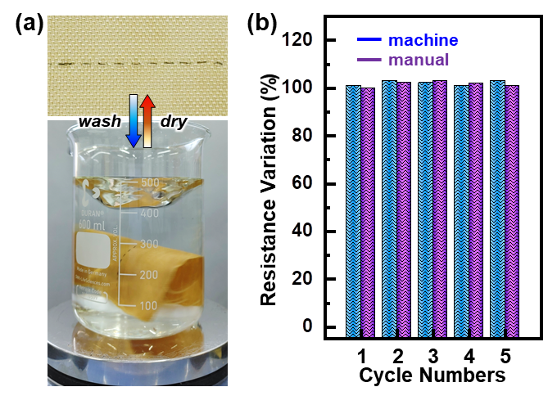
Fig. S7 Simulated washing of the conventional Kevlar fabric weaved with PA/CNT fibers (a). Resistance variation of PA/CNT fibers before and after several times of washing and subsequent drying cycles (b).

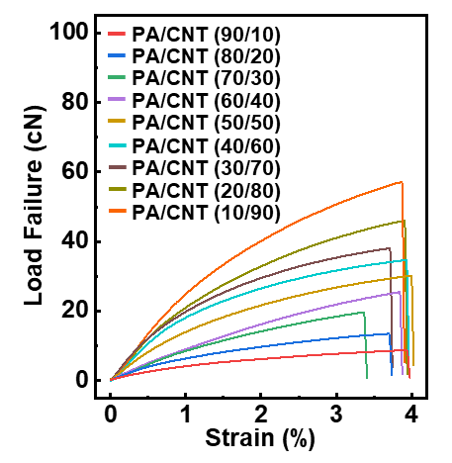
Fig. S8 Load at failure and strain curves of PA/CNT fibers.

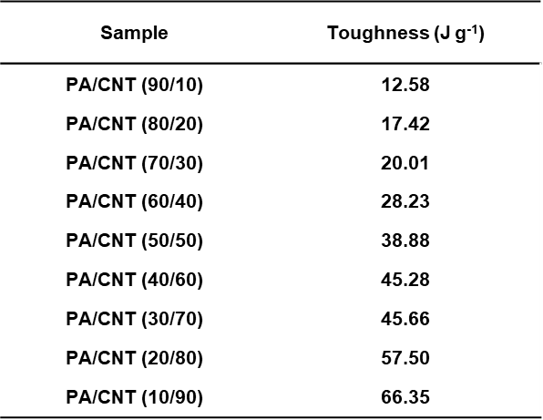
Fig. S9 Toughness of PA/CNT fibers.

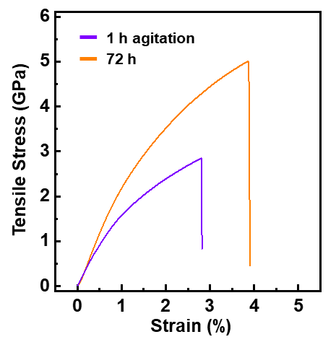
Fig. S10 Stress and strain curve of PA/CNT (10/90) fabricated by wet-spinning the dope prepared by 1 h and 72 h agitation time.

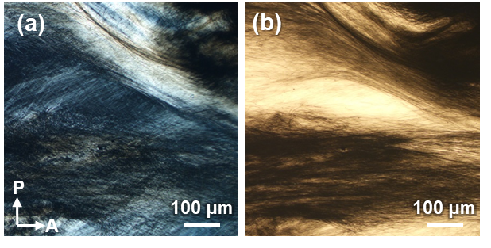
Fig. S11 Optical microscopy images obtained with (a) and without (b) polarizers of the PA/CNT (10/90) spinning dope prepared by 1 h agitation time.

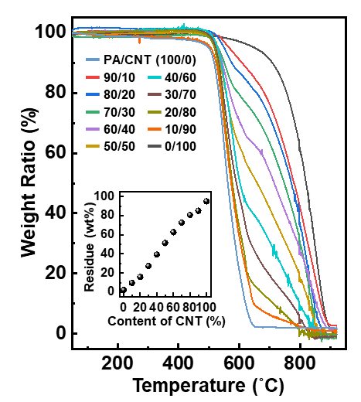
Fig. S12 TGA thermograms of PA/CNT fibers.

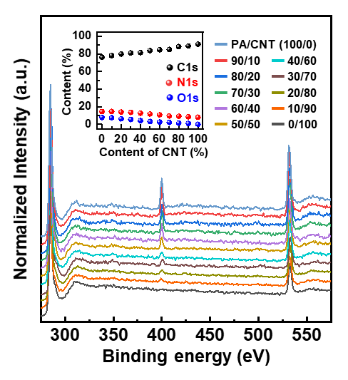
Fig. S13 XPS spectra of PA/CNT fibers.

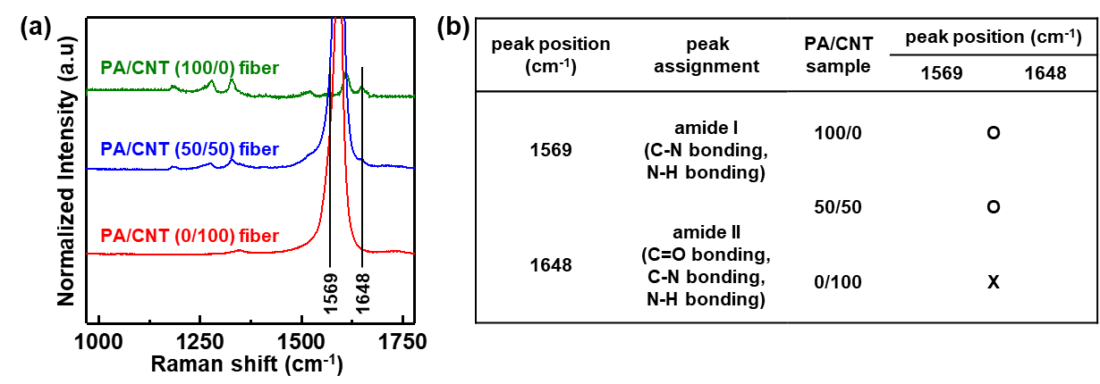
Fig. S14 FT Raman spectra (a) and the appearance of amide peak positions (b) from the PA/CNT fibers.

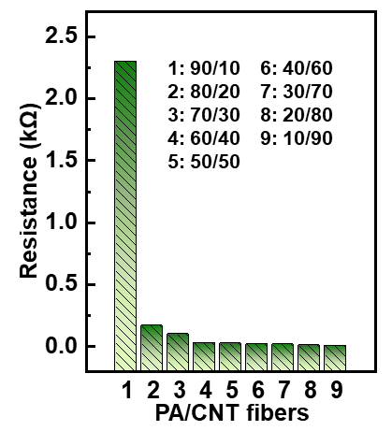
Fig. S15 Resistance of PA/CNT fibers.

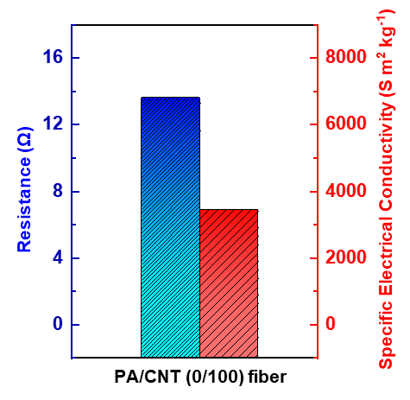
Fig. S16 Electrical properties of the PA/CNT (0/100) fiber.

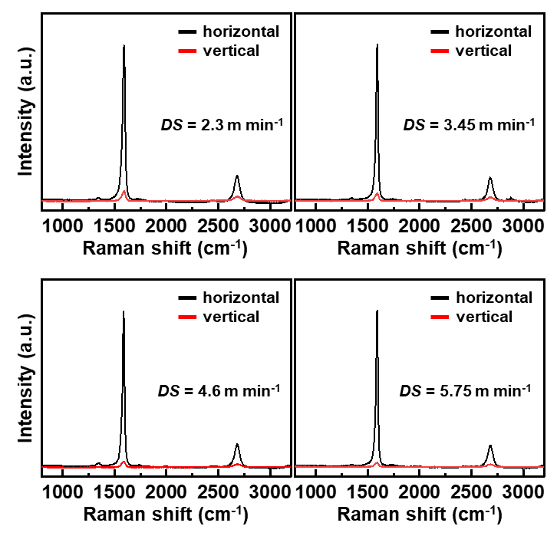
Fig. S17 S of PA/CNT (10/90) fibers depending on the DS.

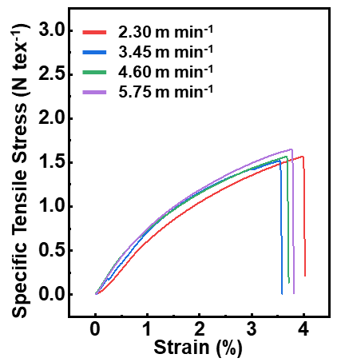
Fig. S18 Changes to the mechanical properties of PA/CNT (0/100) fiber upon increasing DS.

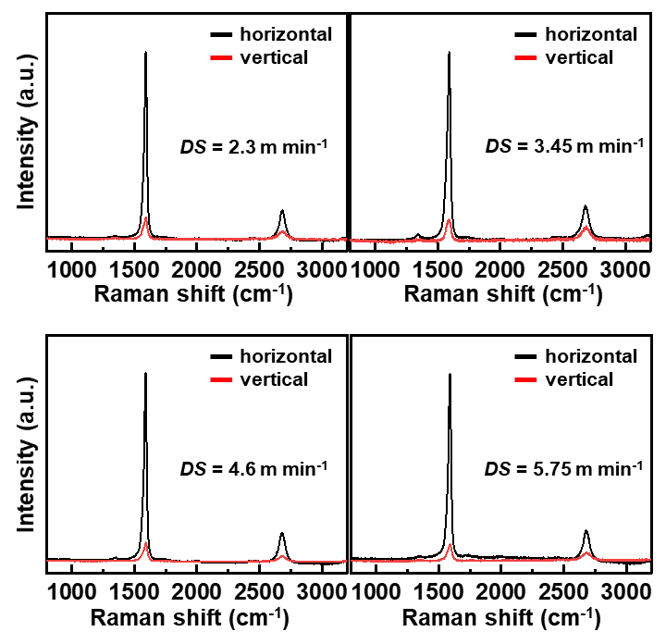
Fig. S19 S of PA/CNT (0/100) fibers depending on the DS.

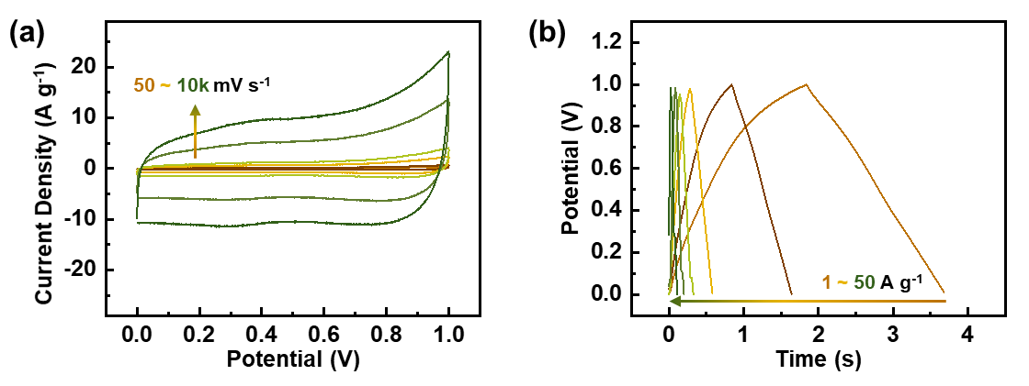
Fig. S20 CV profiles (a) and GCD curves (b) of PA/CNT (0/100) fibers.

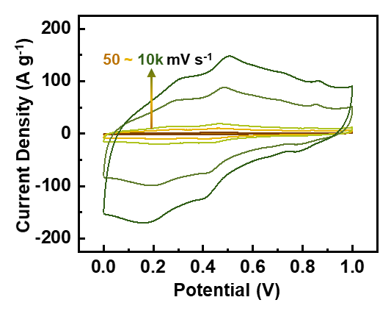
Fig. S21 CV profiles of PA/CNT (10/90) fiber at scan rate from 50 to 10,000 mV s⁻¹.

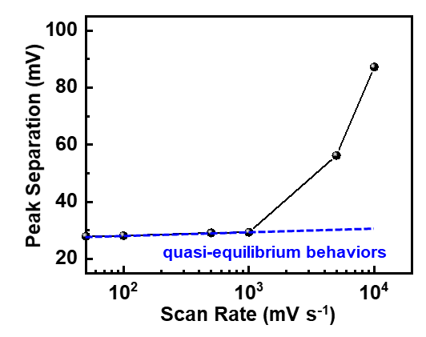
Fig. S22 Peak separation for diverse scan rates as derived from CV profiles of PA/CNT (10/90) fibers.

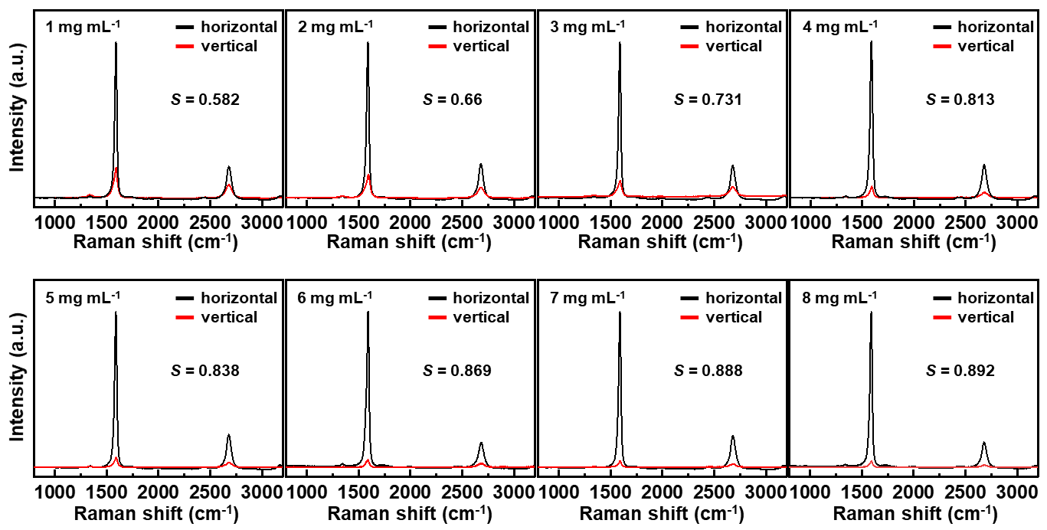
Fig. S23 S of PA/CNT (10/90) fibers depending on the concentration of dope.

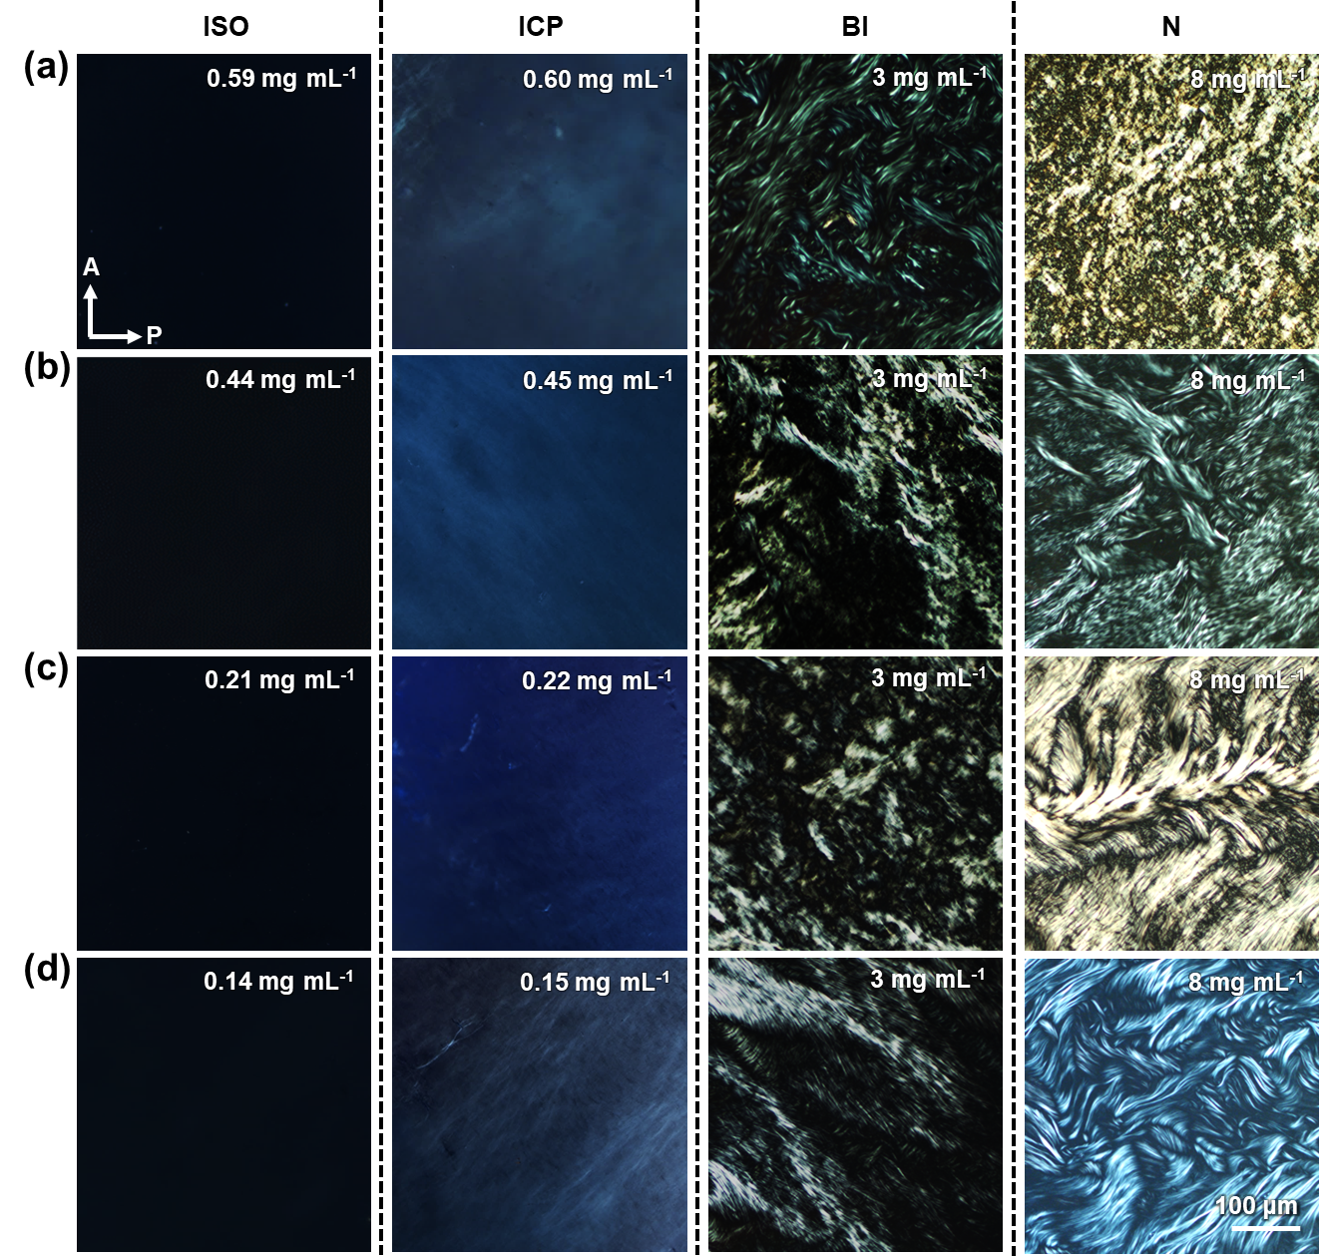
Fig. S24 Phase behaviors of CNT with the AR of 1084 (a), 1747 (b), 2996 (c), and 5817 (d), respectively.

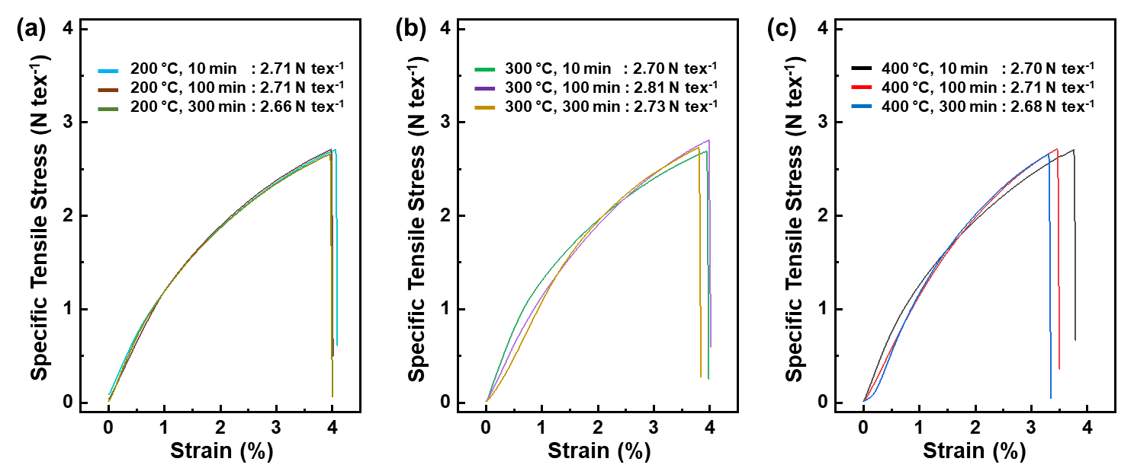
Fig. S25 Mechanical properties of PA/CNT (10/90) fibers after thermal annealing for 200 °C (a), 300 °C (b), and 400 °C (c).

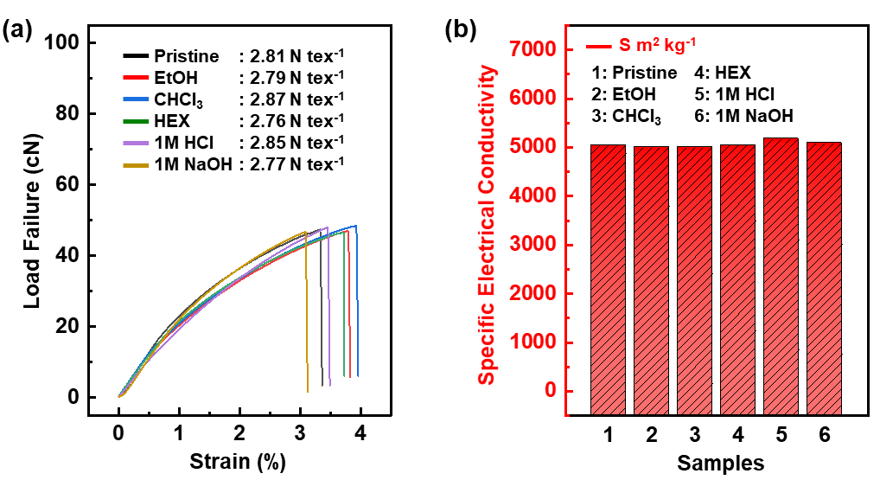
Fig. S26 Mechanical (a) and electrical (b) properties of PA/CNT (10/90) fibers treated with organic and inorganic solvents.

