Electronic Supplementary Information

Self-powered Airflow Sensor Based on Energy Harvesting of Ventilation Air in Buildings
Moon Hyun Chung,^{a,b} Seunghwan Yoo,^{b} Woo-Nam Jung,^{c,d} Hakgeun Jeong,^{b,∗} and Kyung-Hwa Yoo^{a,∗}

ª Department of Physics, Yonsei University, 50 Yonsei-ro, Seodaemun-gu, Seoul 03722, Republic of Korea
^{b} Energy ICT Convergence Research Department, Energy Efficiency Research Division, Korea Institute of Energy Research, 152 Gajeong-ro, Yuseong-gu, Daejeon 34129, Republic of Korea
^{c} Advanced Combustion Power Lab., Energy Efficiency Research Division, Korea Institute of Energy Research, 152, Gajeong-ro, Yuseong-gu, Daejeon, 34129, Republic of Korea
^{d} Department of Mechanical Engineering, Korea Advanced Institute of Science and Technology(KAIST), 291 Daehak-ro, Yuseong, Daejeon, 34141, Republic of Korea

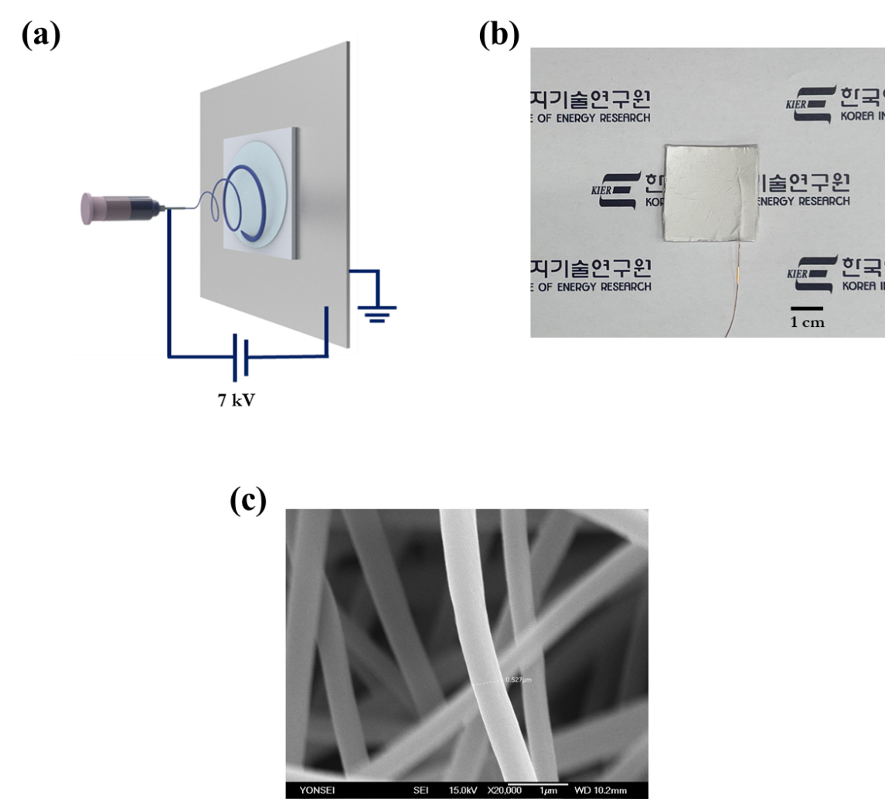

Fig. S1 (a) Schematic of the PVDF-TrFE/PEDOT:PSS fabrication by electrospinning. (b) Photograph of the PVDF-TrFE/PEDOT:PSS fibrous mat. (c) SEM image of the PVDF-TrFE/PEDOT:PSS fibrous mat.
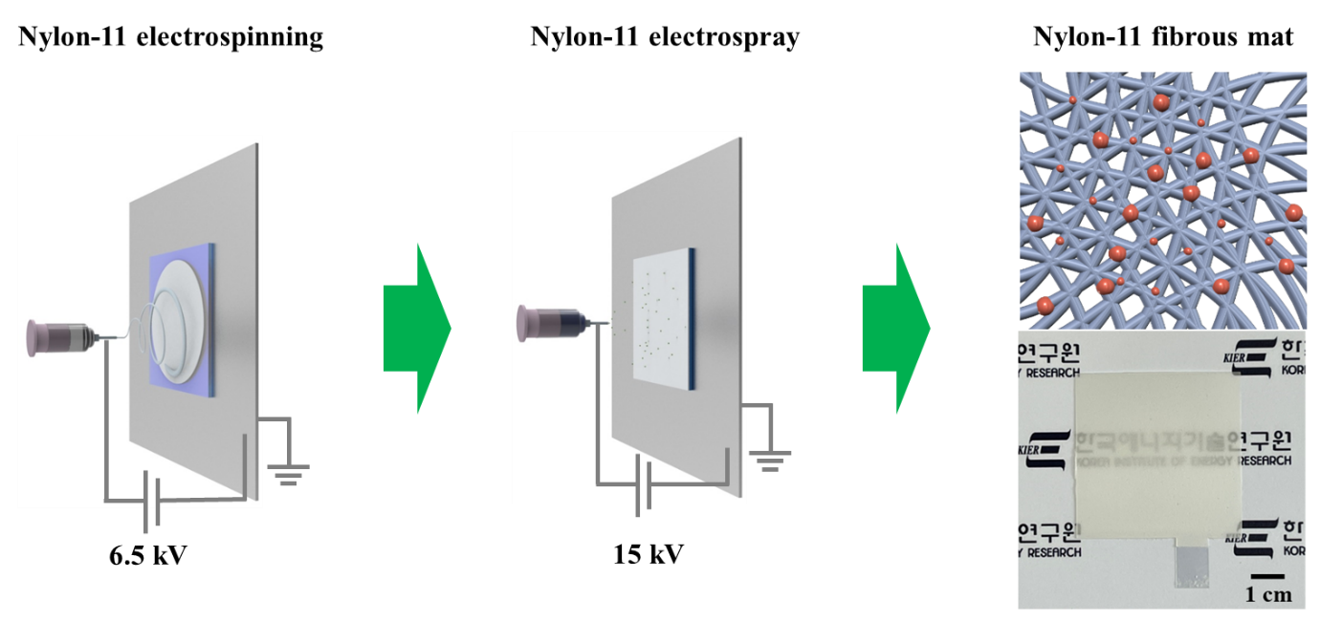
Fig. S2 Fabrication process of nylon-11 fibrous mat.

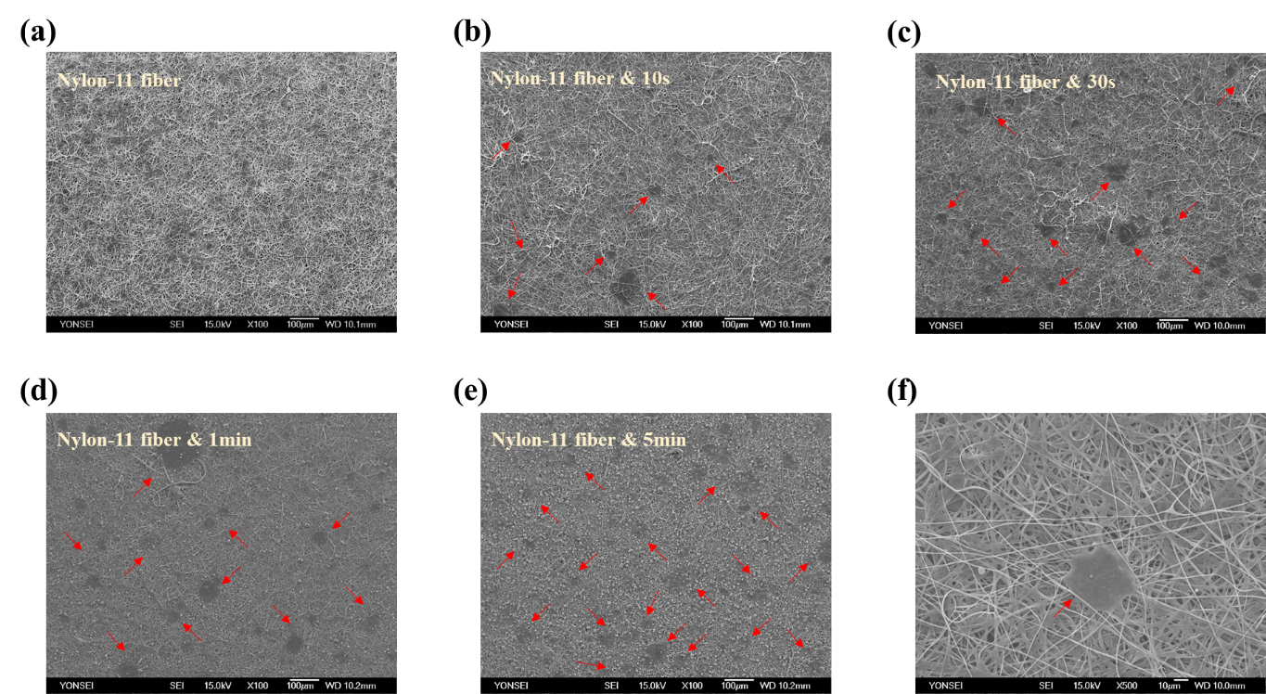
Fig. S3 SEM images of nylon-11 fibrous mats at different electrospraying times: (a) 0 s (no electrospraying), (b) 10 s, (c) 30 s, (d) 1 min, and (e) 5 min. (f) Magnified SEM image of a section indicated by the red arrows (electrosprayed on nylon-11 fibrous mat).
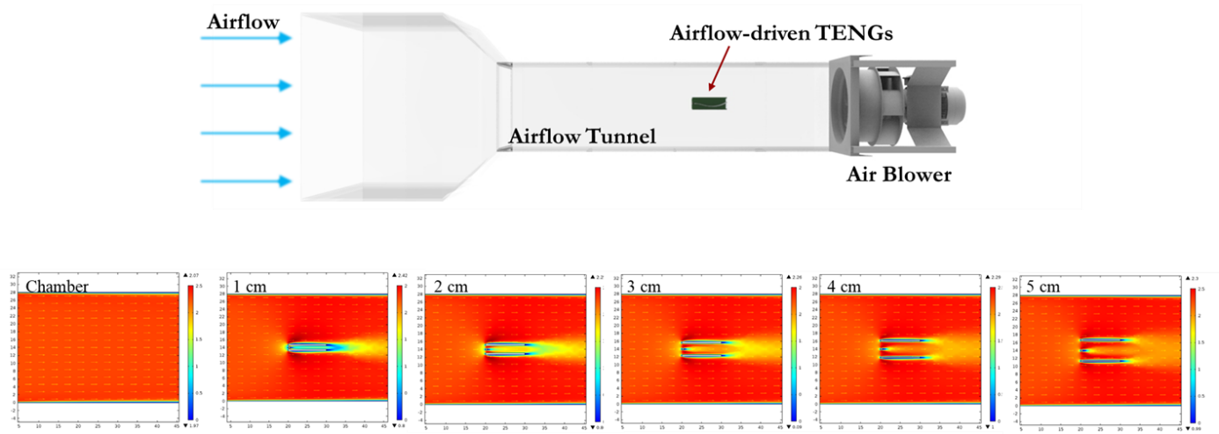
Fig. S4 Flowrate-based simulation results from COMSOL according to variations in the height of the air-driven case.
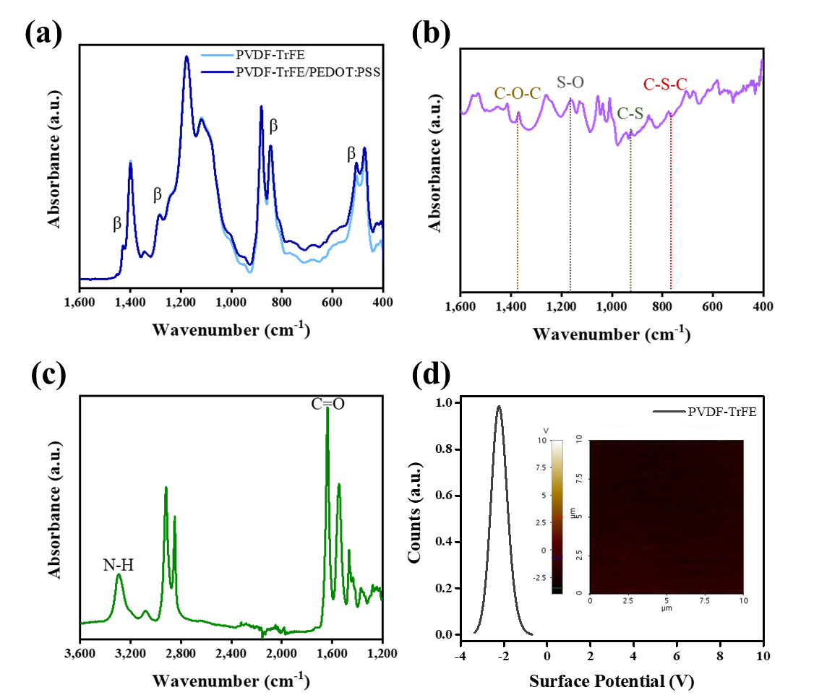
Fig. S5 (a) FT-IR spectra of the PVDF-TrFE/PEDOT:PSS fibrous mat. (b) FT-IR spectra of PEDOT:PSS. (c) FT-IR spectra of nylon-11 fibrous mat. (d) KPFM analysis of PVDF-TrFE.
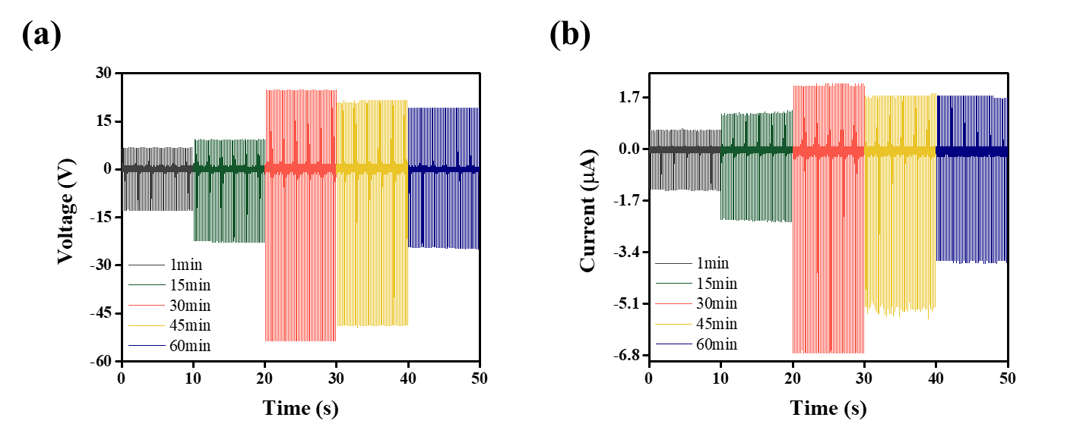
Fig. S6 Time-dependent electrical output performance of Si rubber and nylon-11 fibrous mats based on electrospinning: (a) open-circuit voltage and (b) short-circuit current.
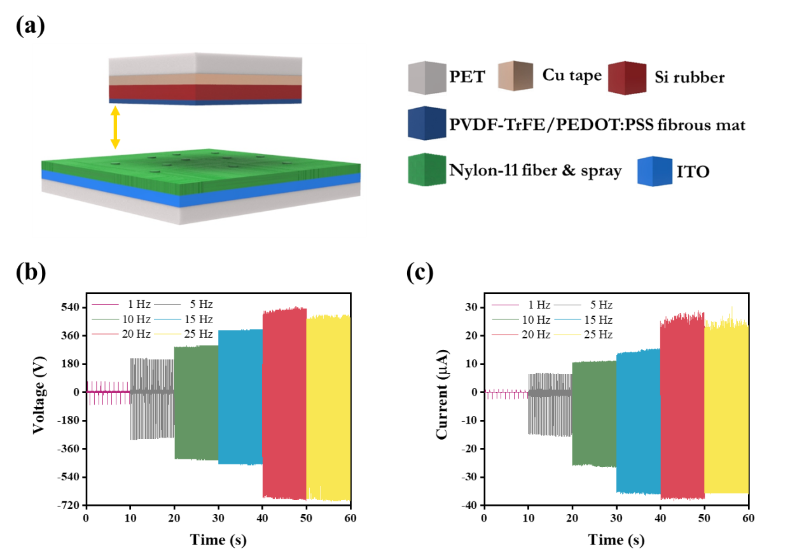
Fig. S7 (a) Schematic of the PVDF-TrFE/PEDOT:PSS fibrous mat on Si rubber and nylon-11 fibrous mat with electrosprayed TENGs. Generated electrical output performances of FM-TENGs with various frequency conditions: (b) open-circuit voltage and (c) short-circuit current.
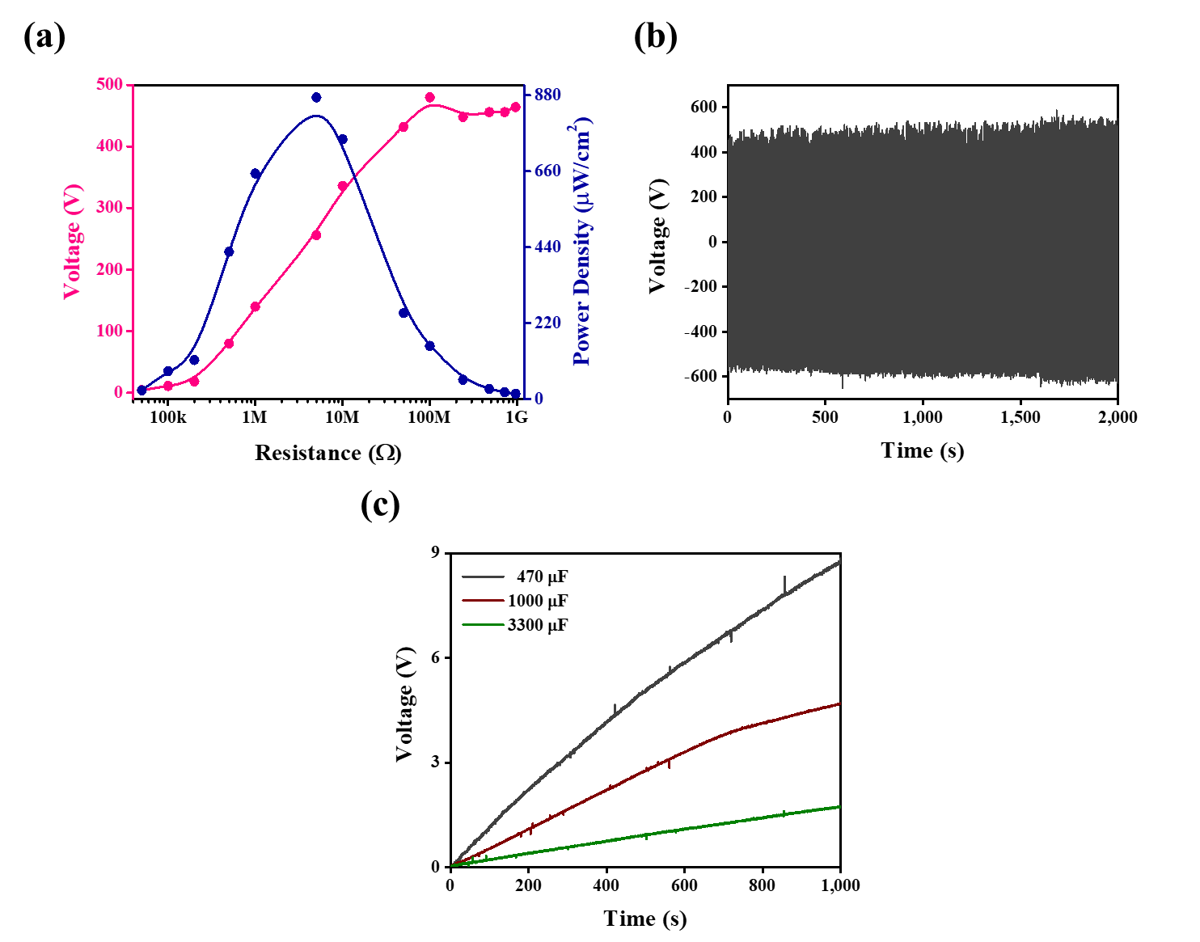
Fig. S8 (a) Output voltage and power density of the FM-TENG calculated with an external load resistance ranging from 50 kΩ to 960 MΩ. (b) Stability test of FM-TENGs over 2,000 s at 20 Hz. (c) The measured voltage of the charging capacitors.

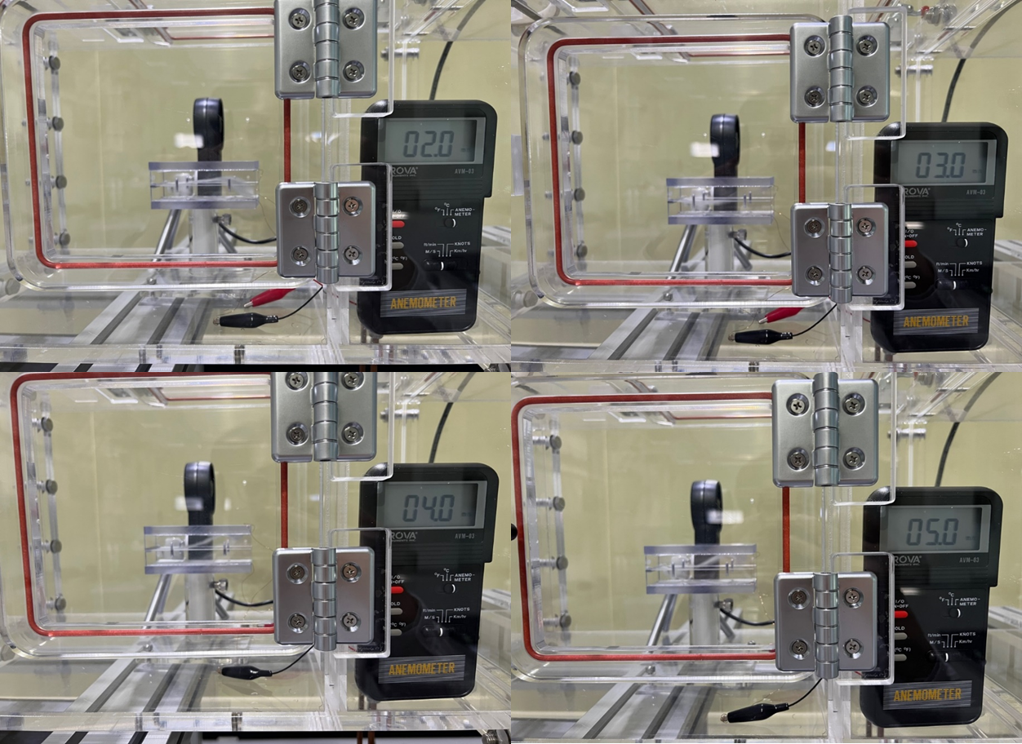

Fig. S9 Photographs of the flutter moving at airflow rates ranging from 2 m/s to 5 m/s.

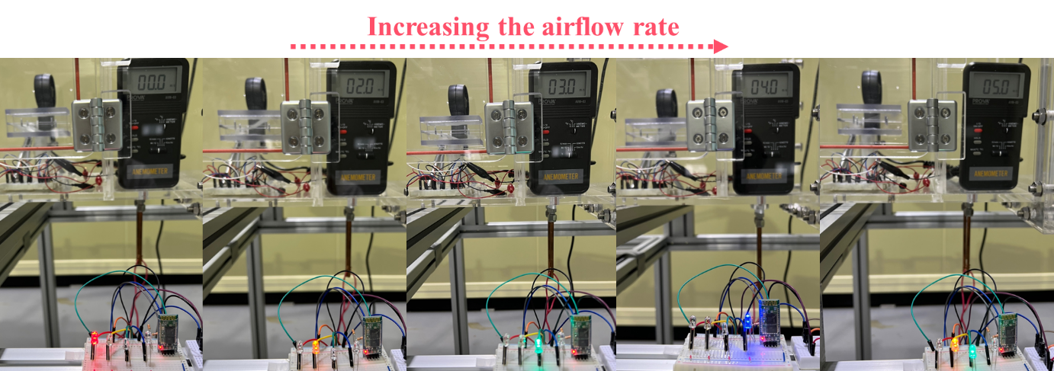
Fig. S10 Photographs of the LEDs illuminating on the airflow-check using FM-ATENGs in airflow rates ranging from 2 to 5 m/s by an Arduino.

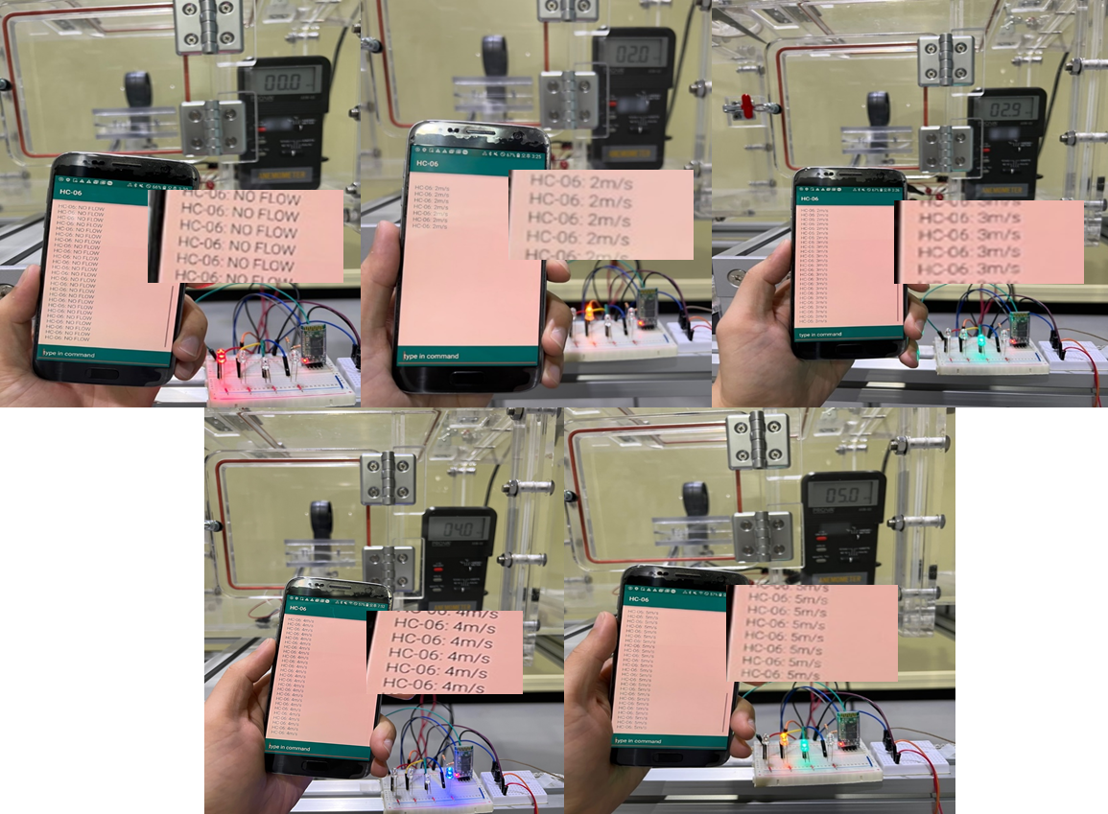
Fig. S11 Photographs of the airflow check data transmitting to a mobile phone using FM-ATENGs and an Arduino. The insets of each photograph show the magnified data.
Table S1. Comparison of the airflow-driven TENG systems in previous reports and this work.
Moving start  airflow rate (m/s) | Flutter material | Opposite material | Output power  (optimal velocity) | Ref.
6.4 | FEP | Aluminum | 160 µW (10 m/s) | [1]
7.5 | Au-coated Textile | PTFE film | 17.5 mW (22 m/s) | [2]
7.6 | Al/Kapton/Al | Film | 2.35 mW (7.6 m/s) | [3]
1 | PVC-nanofiber mat/Al foil | Al plate | 0.33 µW (4 m/s) | [4]
2.75 | Conductive textile | PTFE nanofiber membrane | 1.07 mW (10 m/s) | [5]
2.9 | PTFE | PVA/Ag nanofiber | 2.06 µW (10 m/s) | [6]
1.9 | PVDF-TrFE fibrous mat /Silicone rubber | Nylon-11 fibrous mat  (Surface post-treatment) | 1.76 µW (5 m/s)  0.44 µW (2 m/s) | This work

The airflow-driven TENG performances with one side fixed in the previous literatures are listed in Table S1. The flutters of airflow-driven TENGs start moving at various of airflow rates, likely according to the material properties of the flutters. The post-treated fibrous mat can generate a high output power even in low airflow. Furthermore, we expect that it will be employed as a power supply for a variety of sensors.

Video S1 FM-ATENGs act according to airflow rate of 2 m/s.

Video S2 Twenty-four commercial white light-emitting diodes illuminated by FM-ATENGs.

Video S3 The airflow sensor of the FM-ATENGs checked by charging states of 4.7 μF according to lit on LEDs and the data being sent to a mobile phone via an Arduino.
References
[1] Yang Y, Zhu G, Zhang H, Chen J, Zhong X, Lin ZH, Su Y, Bai P, Wen X, Wang ZL. Triboelectric nanogenerator for harvesting wind energy and as self-powered wind vector sensor system. ACS Nano 2013, 7: 9461.
[2] Bae J, Lee J, Kim S, Ha J, Lee BS, Park Y, Choong C, Kim JB, Wang ZL, Kim HY, Park JJ, Chung UI. Flutter-driven triboelectrification for harvesting wind energy. Nat. Commun. 2014, 5: 1.
[3] Wang S, Mu X, Yang Y, Sun C, Gu AY, Wang ZL, Wang S, Yang Y, Wang ZL, Mu X, Sun C, Gu AY. Flow-Driven Triboelectric Generator for Directly Powering a Wireless Sensor Node. Adv. Mater. 2015, 27: 240.
[4] Phan H, Shin DM, Heon Jeon S, Young Kang T, Han P, Han Kim G, Kook Kim H, Kim K, Hwang YH, Won Hong S. Aerodynamic and aeroelastic flutters driven triboelectric nanogenerators for harvesting broadband airflow energy. Nano Energy 2017, 33: 476.
[5] Zhang Y, Fu S-C, Chan KC, Shin D-M, Chao CYH. Boosting power output of flutter-driven triboelectric nanogenerator by flexible flagpole. Nano Energy 2021, 88: 106284.
[6] Wang D, Zhang D, Guo J, Hu Y, Yang Y, Sun T, Zhang H, Liu X. Multifunctional poly(vinyl alcohol)/Ag nanofibers-based triboelectric nanogenerator for self-powered MXene/tungsten oxide nanohybrid NO2 gas sensor. Nano Energy 2021, 89: 106410.

* Corresponding author. E-mail address: hgjeong@kier.re.kr (H.G. Jeong); khyoo@yonsei.ac.kr (K.-H. Yoo). * Hakgeun Jeong and Kyung-Hwa Yoo are co-corresponding authors.

