Supporting Information
High Thermoelectric Performance and Flexibility in Rationally Treated PEDOT:PSS Fiber Bundles
Ting Wu,^{a,#} Xiao-Lei Shi,^{b,#} Wei-Di Liu,^{c} Meng Li,^{b} Fang Yue,^{d} Pei Huang,ª Qingfeng Liu,^{a,*} Zhi-Gang Chen ^{b,}
ª State Key Laboratory of Materials Oriented Chemistry Engineering, College of Chemistry Engineering, Nanjing Tech University, Nanjing 211800, Jiangsu, China;
^{b} School of Chemistry and Physics, ARC Research Hub in Zero-emission Power Generation for Carbon Neutrality, and Centre for Materials Science, Queensland University of Technology, Brisbane 4000, Queensland, Australia;
^{c} Australian Institute for Bioengineering and Nanotechnology, The University of Queensland, Brisbane 4072, Queensland, Australia;
^{d} Merino & Co Ltd, Osborne Park 6017, Westen Australia, Australia;

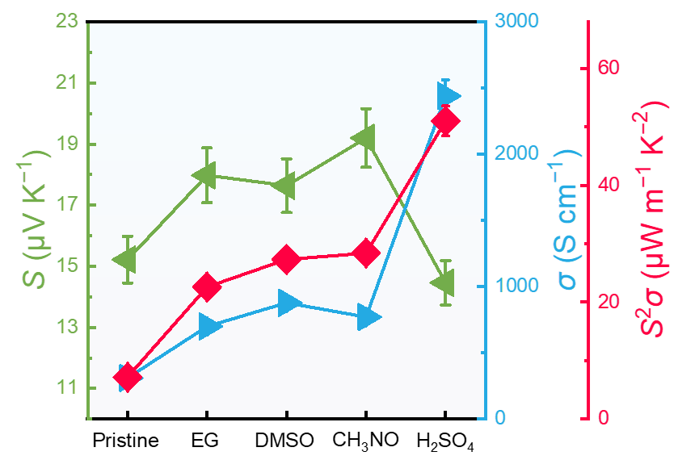
Fig. S1 Room-temperature thermoelectric performance including electrical conductivity σ, Seebeck coefficient S, and power factor S²σ of PEDOT:PSS fibers treated with ethylene glycol (EG), DMSO, CH₃NO, and H₂SO₄ for 120 minutes.

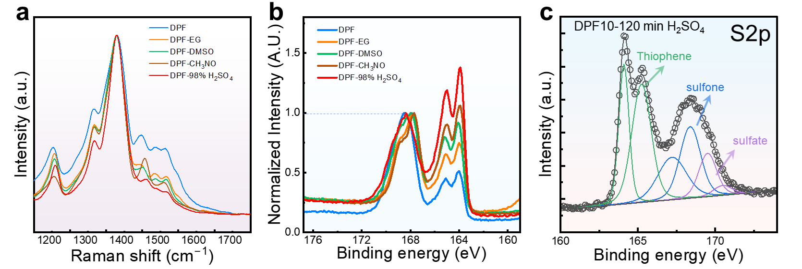
Fig. S2 (a) Raman spectra and (b) high-resolution X-ray photoelectron spectroscopy (XPS) patterns of DPF treated with EG, DMSO, CH₃NO, and H₂SO₄ for 120 minutes for S2p. The H₂SO₄ treatment resulted in the highest PSS phase separation efficiency, making it the most effective method for improving the conductivity. (c) The deconvolution of S2p spectra for DPF treated with H₂SO₄ for 120 minutes.

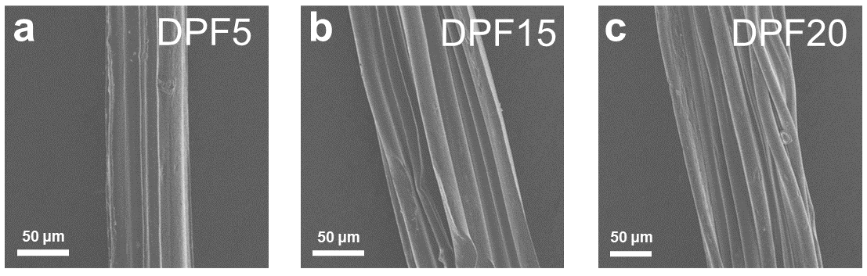
Fig. S3 Scanning electron microscopy (SEM) images of (a) DPF5, (b) DPF15, and (c) DPF20. Here DPF indicates the dimethyl sulfoxide (DMSO)-doped poly(3,4-ethylenedioxythiophene):poly(styrene sulfonate) (PEDOT:PSS) fibers, while the followed numbers indicate the number of fibers in a bundle.

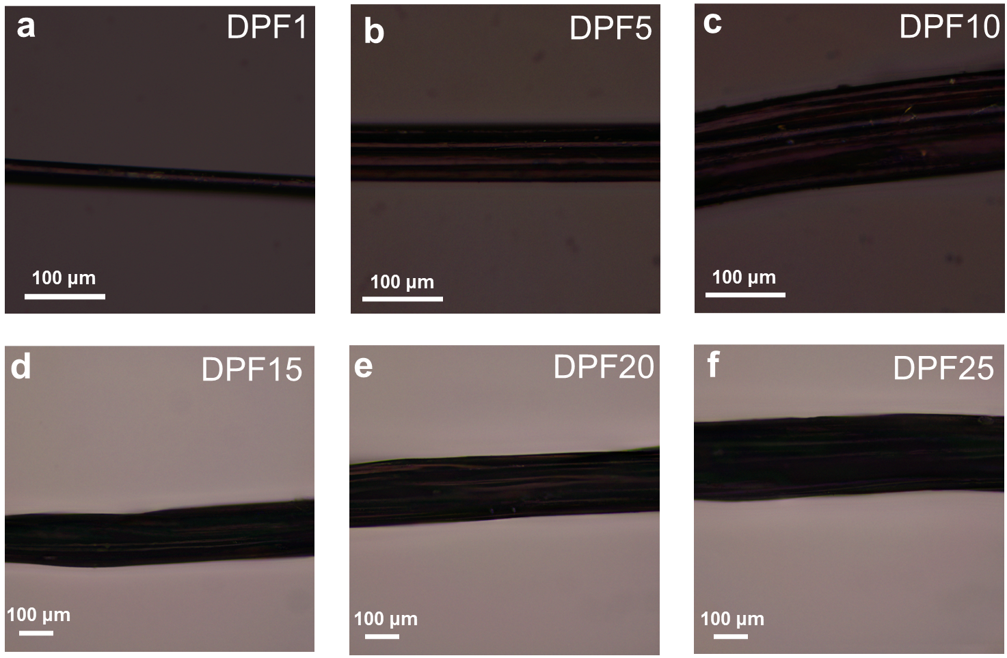
Fig. S4 Metallographic microscope images of (a) DPF1, (b) DPF5, (c) DPF10, (d) DPF15, (e) DPF20, and (f) DPF25 post-treated by 98% H₂SO_{4.}
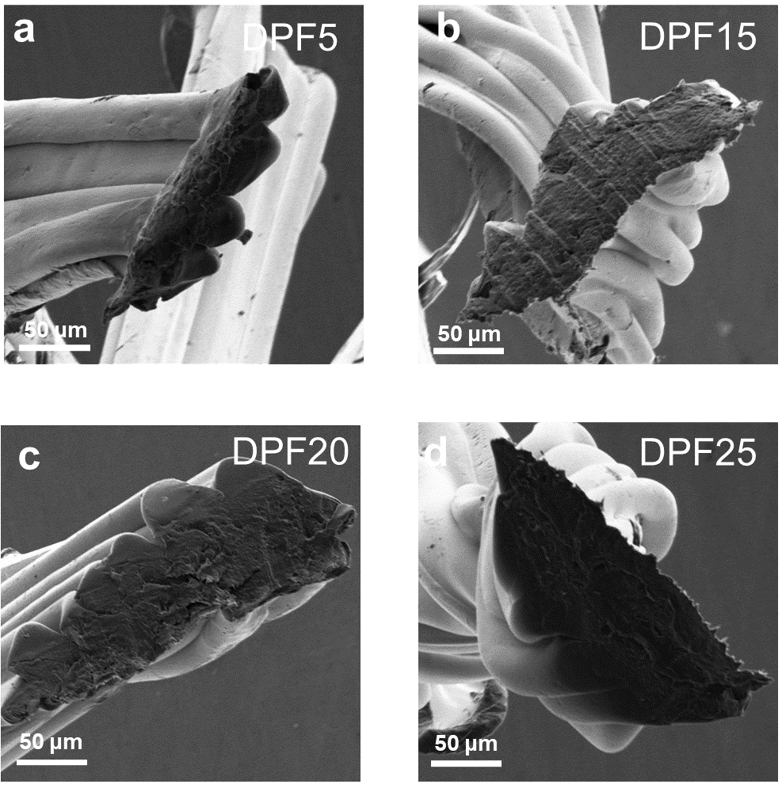
Fig. S5 Cross-sectional SEM images of (a) DPF5, (b) DPF15, (c) DPF20, and (d) DPF25.

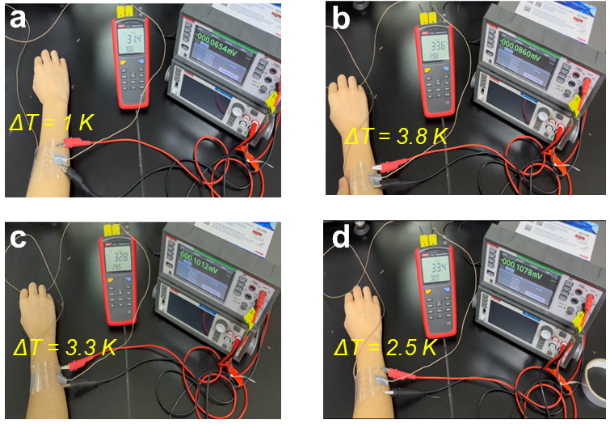
Fig. S6 Photographs of the output evaluation of the wearable device made by (a) DPF5, (b) DPF15, (c) DPF20, and (d) DPF25 under temperature differences ΔTs of 1 K, 3.8 K, 3.3 K, and 2.5 K between environment and human arm.

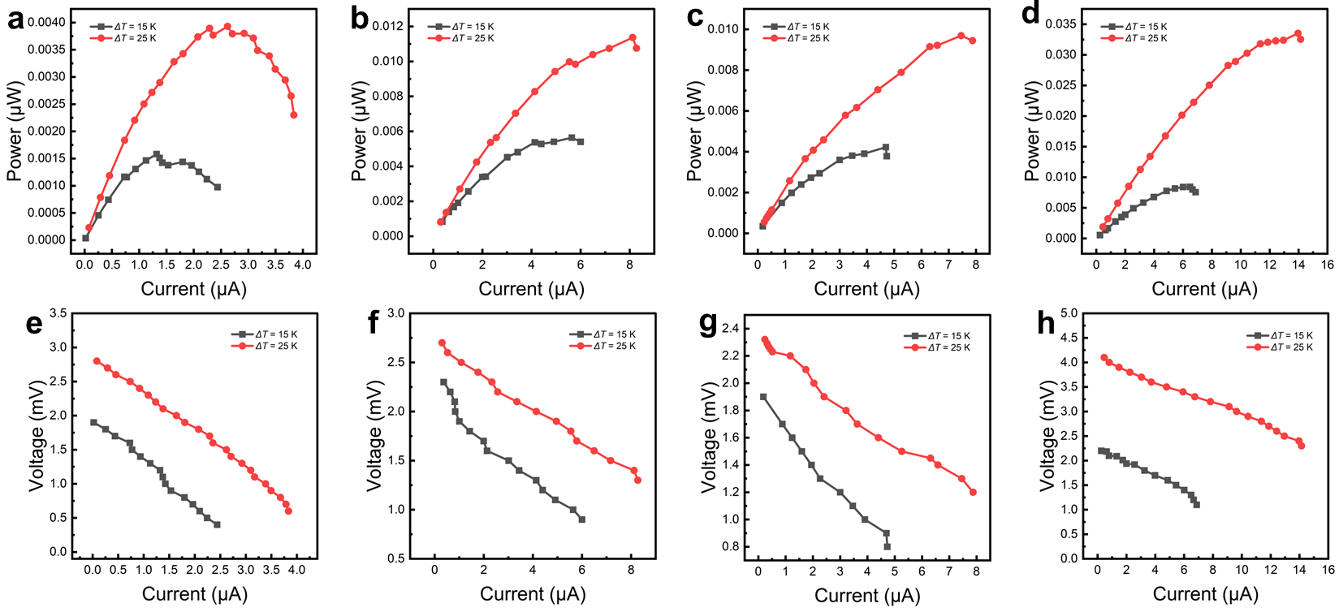
Fig. S7 Measured (a-d) output power P and (e-h) open-circuit V as a function of loading current I_{load} for the device composed of DPF5, DPF15, DPF20, and DPF25 under different ΔTs (10 K and 25 K).

Table S1 A summary of thermoelectric properties of pure PEDOT:PSS-based fibers with different post treatments
Sample | σ  (S cm^{–1}) | S  (μV K^{–1}) | S²σ  (μW m^{–1}K^{–2}) | Treatment  Conditions | Method | Ref.
PEDOT:PSS | 676.59 | 13.13 | 9.42 | EG-H₂SO₄ | Wet-spun fiber | [1]
PEDOT:PSS | 830 | 19 | 30 | H₂SO₄ coagulation and PEI bath | Wet-spun fiber | [2]
PEDOT:PSS | 1433 | 21.3 | 65 | H₂SO₄ coagulation | Wet-spun fiber | [3]
PEDOT:PSS/5 vol% DMSO | 2000 | 16 | 50 | DMSO-drawing | Wet-spun fiber | [4]
PEDOT:PSS/5 vol% DMSO | 172.5 | 18 | 4.77 | EG | Hydrogel fiber | [5]
PEDOT:PSS/3 vol% DMSO | 1013 ± 32 | 19 ± 1 | 34 ± 2 | IPA+DMSO coagulation bath | Wet-spun fiber | [6]
PEDOT:PSS/5 vol% DMSO | 4464.6 | 13.5 | 80.8 | H₂SO₄ | Wet-spun fiber bundle | This Work

Table S2 A summary of thermoelectric properties of PEDOT:PSS-based fibers. Here WPU is abbreviated from waterborne polyurethane, SWCNT is abbreviated from single-walled carbon nanotube, PU is abbreviated from polyurethane, MWCNT is abbreviated from multi-walled carbon nanotube, PVA is abbreviated from poly(vinyl alcohol), PBP is abbreviated from polyethylene-blok-poly(ethylene glycol), PAN is abbreviated from polyacrylonitrile, and PEG is abbreviated from poly(ethylene glycol)
Sample | σ  (S cm^{–1}) | S  (μV K^{–1}) | S²σ  (μW m^{–1}K^{–2}) | Treatment  Conditions | Method | Ref.
PEDOT:PSS | 676.59 | 13.13 | 9.42 | EG-H₂SO₄ bath | Wet-spun fiber | [1]
PEDOT:PSS/WPU | 730 | 18.9 | 26.1 |  | Wet-spun fiber | [7]
PEDOT:PSS/Te | ~700 | ~16 | 17.8 | H₂SO₄ bath | Hydrogel fiber | [8]
PEDOT:PSS/Te | 250 | 56 | 78.1 |  | Wet-spun fiber | [9]
DMSO+PEDOT:PSS | 4029.5 | 19.2 | 147.8 | H₂SO₄ bath | Wet-spun fiber | [10]
PEDOT:PSS/SWCNT | 243.3 | 17.23 | 7.23 | EG bath | Hybrid fiber | [11]
PEDOT:PSS | 830 | 19 | 30 | H₂SO₄ coagulation | Wet-spun fiber | [2]
PEDOT:PSS | 1433 | 21.3 | 65 | H₂SO₄ coagulation | Wet-spun fiber | [3]
PEDOT:PSS | 2000 | 16 | 50 | DMSO-drawing | Wet-spun fiber | [4]
PEDOT:PSS | 172.5 | 18 | 4.77 | EG and DMSO bath | Hydrogel fiber | [5]
PEDOT:PSS | 467 |  |  | EG bath | Wet-spun fiber | [12]
PEDOT:PSS/SWCNT | 450 |  |  |  | Wet-spun fiber | [13]
PEDOT:PSS | 3667+297 |  |  | EG-H₂SO₄ bath | Wet-spun fiber | [14]
PEDOT:PSS | 1013 ± 32 | 19 ± 1 | 34 ± 2 | IPA+DMSO coagulation bath | Wet-spun fiber | [6]
PEDOT:PSS/PU/CNT | ~27 | ~44 | ~5 |  | Electrospinning nanofiber yarn | [15]
PEDOT:PSS | ~42 |  |  | LiCl/CaCl coagulation bath | Wet-spun fiber | [16]
PEDOT:PSS | 4039±215 |  |  | H₂SO₄ bath | Wet-spun fiber | [17]
PEDOT:PSS/MWCNT | ~1394 |  |  | H₂SO₄ bath | Wet-spun fiber | [18]
PEDOT:PSS | 140.7 |  |  |  | Hydrogel fiber | [19]
PEDOT: PSS/EG/PVA | ~3.5 |  |  |  | Wet-spun fiber | [20]
PEDOT:PSS/SWCNT | 2110 | 36.4 | 280 | H₂SO₄ coagulation and NaOH bath | Wet-spun fiber | [21]
PEDOTS:PSS/EG | 3828 |  |  | H₂SO₄ coagulation | Wet-spun fiber | [22]
PEDOT:PSS/PVA | 213 |  |  |  | Wet-spun fiber | [23]
PEDOT:PSS/PBP | 415 |  |  |  | Wet-spun fiber | [24]
PEDOT: PSS | 800 |  |  | DMSO bath | Wet-spun fiber | [25]
PEDOT: PSS | 968.4 |  |  |  | Wet-spun fiber | [26]
PEDOT: PSS/PVA | 20.4 |  |  | EG vapor | Wet-spun fiber | [27]
EG/PEDOT:PSS | 467 |  |  | EG bath | Wet-spun fiber | [28]
DMSO/PEDOT:PSS/ PVA | 21.16 |  |  |  | Wet-spun fiber | [29]
PEDOT:PSS/PAN | 5 |  |  |  | Wet-spun fiber | [30]
PEDOT:PSS/PEG/SWCNT | 400 |  |  | EG bath | Wet-spun fiber | [31]
PEDOT:PSS/PEG | 264 |  |  |  | Wet-spun fiber | [32]
PEDOT:PSS/DMSO | 4464.6 | 13.5 | 80.8 | H₂SO₄ bath | Wet-spun fiber | This work

References
1. Pan Y, Song Y, Jiang Q, Jia Y, Liu P, Song H & Liu G, Solvent treatment of wet-spinning PEDOT:PSS fiber towards wearable thermoelectric energy harvesting. Synthetic Met. 2022;283:116969.
2. Kim Y, Lund A, Noh H, Hofmann A I, Craighero M, Darabi S, Zokaei S, Park J I, Yoon M-H & Müller C, Robust PEDOT:PSS Wet-Spun Fibers for Thermoelectric Textiles. Macromol Mater Eng. 2020;305:1900749.
3. Ge R, Dong X, Sun L, Hu L, Liu T, Zeng W, Luo B, Jiang X, Jiang Y & Zhou Y, Meters-long, sewable, wearable conductive polymer wires for thermoelectric applications. J Mater Chem C. 2020;8:1571-1576.
4. Sarabia-Riquelme R, Shahi M, Brill J W & Weisenberger M C, Effect of Drawing on the Electrical, Thermoelectrical, and Mechanical Properties of Wet-Spun PEDOT:PSS Fibers. ACS Appl Polym Mater. 2019;1:2157-2167.
5. Liu J, Jia Y, Jiang Q, Jiang F, Li C, Wang X, Liu P, Liu P, Hu F, Du Y & Xu J, Highly Conductive Hydrogel Polymer Fibers toward Promising Wearable Thermoelectric Energy Harvesting. ACS Appl Mater Interfaces. 2018;10:44033-44040.
6. Liu L, Chen J, Liang L, Deng L & Chen G, A PEDOT:PSS thermoelectric fiber generator. Nano Energy. 2022;102:107678.
7. Wen N, Fan Z, Yang S, Zhao Y, Li C, Cong T, Huang H, Zhang J, Guan X & Pan L, High-performance stretchable thermoelectric fibers for wearable electronics. Chem Eng J. 2021;426:130816.
8. Liu Y, Liu P, Jiang Q, Jiang F, Liu J, Liu G, Liu C, Du Y & Xu J, Organic/inorganic hybrid for flexible thermoelectric fibers. Chem Eng J. 2021;405:126510.
9. Xu H, Guo Y, Wu B, Hou C, Zhang Q, Li Y & Wang H, Highly Integrable Thermoelectric Fiber. ACS Appl Mater Interfaces. 2020;12:33297-33304.
10. Wen N, Fan Z, Yang S, Zhao Y, Cong T, Xu S, Zhang H, Wang J, Huang H, Li C & Pan L, Highly Conductive, Ultra-Flexible and Continuously Processable PEDOT:PSS Fibers with High Thermoelectric Properties for Wearable Energy Harvesting. Nano Energy. 2020;78:105361.
11. Liu J, Zhu Z, Zhou W, Liu P, Liu P, Liu G, Xu J, Jiang Q & Jiang F, Flexible metal-free hybrid hydrogel thermoelectric fibers. J Mater Sci. 2020;55:8376-8387.
12. Okuzaki H, Harashina Y & Yan H, Highly conductive PEDOT/PSS microfibers fabricated by wet-spinning and dip-treatment in ethylene glycol. Eur Polym J. 2009;45:256-261.
13. Jalili R, Razal J M & Wallace G G, Exploiting high quality PEDOT:PSS–SWNT composite formulations for wet-spinning multifunctional fibers. J Mater Chem. 2012;22:25174-25182.
14. Xu T, Ji W, Wang X, Zhang Y, Zeng H, Mao L & Zhang M, Support-Free PEDOT:PSS Fibers as Multifunctional Microelectrodes for In Vivo Neural Recording and Modulation. Angew Chem Int Ed. 2022;61:e202115074.
15. He X, Gu J, Hao Y, Zheng M, Wang L, Yu J & Qin X, Continuous manufacture of stretchable and integratable thermoelectric nanofiber yarn for human body energy harvesting and self-powered motion detection. Chem Eng J. 2022;450:137937.
16. Feng D, Wang P, Wang M, Zhu C, Gao Q & Shen M, A Facile Route Toward Continuous Wet-spinning of PEDOT: PSS Fibers with Enhanced Strength and Electroconductivity. Fiber Polym. 2021;22:1491-1495.
17. Sarabia-Riquelme R, Andrews R, Anthony J E & Weisenberger M C, Highly conductive wet-spun PEDOT:PSS fibers for applications in electronic textiles. J Mater Chem C. 2020;8:11618-11630.
18. Meng C, Qian Y, He J & Dong X, Wet-spinning fabrication of multi-walled carbon nanotubes reinforced poly(3,4-ethylenedioxythiophene)-poly(styrenesulfonate) hybrid fibers for high-performance fiber-shaped supercapacitor. J Mater Sci-Mater El. 2020;31:19293-19308.
19. Liu G, Jiang F, Liu J, Liu C, Xu J, Jiang Q, Zheng N, Nie G & Liu P, Solvent treatment inducing ultralong cycle stability poly(3,4-ethylenedioxythiophene):poly(styrenesulfonic acid) fibers as binding-free electrodes for supercapacitors. Int J Energ Res. 2020;44:5856-5865.
20. Gao Q, Wang M, Kang X, Zhu C & Ge M, Continuous wet-spinning of flexible and water-stable conductive PEDOT: PSS/PVA composite fibers for wearable sensors. Compos Commun. 2020;17:134-140.
21. Xu C, Yang S, Li P, Wang H, Li H & Liu Z, Wet-spun PEDOT:PSS/CNT composite fibers for wearable thermoelectric energy harvesting. Compos Commun. 2022;32:101179.
22. Zhang J, Seyedin S, Qin S, Lynch P A, Wang Z, Yang W, Wang X & Razal Joselito M, Fast and scalable wet-spinning of highly conductive PEDOT:PSS fibers enables versatile applications. J Mater Chem A. 2019;7:6401-6410.
23. Wang X-y, Feng G-y, Li M-j & Ge M-q, Effect of PEDOT:PSS content on structure and properties of PEDOT:PSS/poly(vinyl alcohol) composite fiber. Polym Bull. 2019;76:2097-2111.
24. Tian G, Zhou J, Xin Y, Tao R, Jin G & Lubineau G, Copolymer-enabled stretchable conductive polymer fibers. Polymer. 2019;177:189-195.
25. Reid D O, Smith R E, Garcia-Torres J, Watts J F & Crean C, Solvent Treatment of Wet-Spun PEDOT: PSS Fibers for Fiber-Based Wearable pH Sensing. Sensors. 2019;19:4213.
26. Kim Y, Lim T, Kim C-H, Yeo C S, Seo K, Kim S-M, Kim J, Park S Y, Ju S & Yoon M-H, Organic electrochemical transistor-based channel dimension-independent single-strand wearable sweat sensors. NPG Asia Mater. 2018;10:1086-1095.
27. Wang X, Feng G-y & Ge M-q, Influence of ethylene glycol vapor annealing on structure and property of wet-spun PVA/PEDOT:PSS blend fiber. J Mater Sci. 2017;52:6917-6927.
28. Zhou J, Li E Q, Li R, Xu X, Ventura I A, Moussawi A, Anjum D H, Hedhili M N, Smilgies D-M, Lubineau G & Thoroddsen S T, Semi-metallic, strong and stretchable wet-spun conjugated polymer microfibers. J Mater Chem C. 2015;3:2528-2538.
29. Wang X, Ge M-q & Feng G-y, The effects of DMSO on structure and properties of PVA/PEDOT:PSS blended fiber. Fiber Polym. 2015;16:2578-2585.
30. Li X, Liu Y, Shi Z, Li C & Chen G, Influence of draw ratio on the structure and properties of PEDOT-PSS/PAN composite conductive fibers. RSC Adv. 2014;4:40385-40389.
31. Jalili R, Razal J M & Wallace G G, Wet-spinning of PEDOT:PSS/Functionalized-SWNTs Composite: a Facile Route Toward Production of Strong and Highly Conducting Multifunctional Fibers. Sci Rep. 2013;3:3438.
32. Jalili R, Razal J M, Innis P C & Wallace G G, One-Step Wet-Spinning Process of Poly(3,4-ethylenedioxythiophene):Poly(styrenesulfonate) Fibers and the Origin of Higher Electrical Conductivity. Adv Funct Mater. 2011;21:3363-3370.

# These authors contributed equally to the work. * Corresponding author. E-mail address: qfliu@njtech.edu.cn (Qingfeng Liu); zhigang.chen@qut.edu.au (Zhi-Gang Chen)

