Supporting Information

High-Energy-Density Fiber Supercapacitors Based on Transition Metal Oxide Nanoribbon Yarns for Comprehensive Wearable Electronics

Junseong Ahn^{1,#}, Suchithra Padmajan Sasikala^{2,3,#}, Yongrok Jeong^{4,5,6,#}, Jin Goo Kim^{2,3}, Ji-Hwan Ha^{4,5}, Soon Hyoung Hwang⁵, Sohee Jeon⁵, Junhyuk Choi⁴, Byung-Ho Kang^{4,5}, Jihyeon Ahn⁴, Jun-Ho Jeong^{5,*}, Sang Ouk Kim^{2,3,*}, Inkyu Park^{4,*}

Supplementary Note 1. Calculation of surface-area-to-volume ratio and porosity of nanoribbon yarn
The porosity of the nanoribbon yarn was determined using the equation:
$$φ_{yarn}=1-\frac{n×A_{nanoribbon}×L_{nanoribbon}}{A_{yarn}×L_{yarn}}$$
where $φ_{yarn}$ represents the porosity of the nanoribbon yarn, $n$ denotes the number of nanoribbons within a single nanoribbon yarn, $A_{yarn}$ signifies the cross-sectional area of the nanoribbon yarn,$L_{nanoribbon}$ represents the total length of a nanoribbon before twisting, $L_{yarn}$ represents the total length of nanoribbon yarn (which is 10% shorter than $L_{nanoribbon}$), and $A_{nanoribbon}$is the cross-sectional area of a nanoribbon.
In this study, the width ($W_{nanoribbon}$) and height ($h_{nanoribbon}$) of the nanoribbon were 800 and 300 nm, respectively, and the radius of the yarn ($R_{yarn}$) was approximately 200 μm. The value of n was computed by dividing the width of the original nanoribbon mold (2 cm) before yarning by the width of a single nanoribbon (800 nm), resulting in 𝑛 = 2.5 × 10⁴. Consequently, the calculated final porosity of the nanoribbon yarn was 94.7%.

Subsequently, the surface-area-to-volume ratio (SA:V) of the nanoribbon yarn was determined using the equation:
$${SA:V}_{yarn}=\frac{{SA}_{yarn}}{V_{yarn}},$$
where $V_{yarn}$ is the entire volume of a single nanoribbon yarn, and ${SA}_{yarn}$ represents the effective surface area of the nanoribbon yarn. Considering excellent alignment and identical dimensions of the constituent nanoribbons within the yarn, the equation can be expressed as:
$${SA:V}_{yarn}=k\frac{{SA}_{yarn}}{V_{yarn}}=k\frac{n×L_{nanoribbon}}{A_{yarn}×L_{yarn}}=k\frac{n×2{(W}_{nanoribbon}+h_{nanoribbon})}{π{R_{yarn}}^{2}}×\frac{L_{nanoribbon}}{L_{yarn}}$$
where k represents the coefficient indicating the reduction in the effective surface area due to established contact between the nanoribbons. (i.e., k = 1 signifies no effective contact area between the nanoribbons; that is, the effective surface area does not decrease in this condition).
Given the high porosity of the nanoribbon yarn, it is reasonable to assume that individual nanoribbons are separated at the nanoscale. Thus, k = 1 was assumed in this study. Nevertheless, the value of k should be rigorously experimentally validated in the future.
Consequently, the calculated final SA:V of the nanoribbon yarn was 4.86 × 10⁵ m⁻¹. Notably, the SA:V for an individual nanoribbon was calculated by dividing the total length of the nanoribbon edges by the cross-sectional area of a nanoribbon and was found to be equal to 1.09 × 10⁷ m⁻¹.
In summary, the developed nanoribbon exhibited a theoretical SA:V of 4.86 × 10⁵ m⁻¹, whereas the nanoribbon yarn exhibited a theoretical SA:V of 1.09 × 10⁷ m⁻¹ with a porosity of 94.7%.

Supplementary Note 2. Energy balance of energy harvesting, storage, and consumption
As shown in Fig. 6b, a single TENG can charge a single 1.5-cm-long aFS up to 1.0 V during one inhalation and exhalation cycle. Assuming a working voltage range of approximately 1.5 V for the developed aFS (see Fig. 4c) and that the voltage and capacitance are proportional, two TENGs should be equipped to fully charge a single aFS with each breathing motion. Furthermore, in our experiments, we found that with four fully charged aFS (each 1.5 cm in length) connected in series, the LED array could operate for approximately 25 s (Fig. S12 and Supplementary Movie S1). Additionally, as shown in Fig. S13, the pressure sensor can be driven for up to 40 s.

Table S1 Comparison of the characteristics of the developed sFSs with those of previously reported high-performing sFSs
Description of the fiber electrode | Volumetric capacitance (F/cm³) | Arial capacitance (F/cm²) | Volumetric energy density (Wh/cm³)  @Power density  (W/cm³) | Arial energy density (mWh/cm²) @Power density  (mW/cm²) | Reference
Co_{x}Ni_{y}O_{z} (CNO) yarn | 493.34 | 7.36 | 13.87@62.4 | 0.20@0.93 | This work
Mn_{x}O_{y}(MO)yarn | 156.6 | 2.32 | 4.40@63.2 | 0.06@0.93 | This work
Ni_{x}O_{y} (INO) yarn | 54.7 | 0.78 | 1.54@68.63 | 0.02@0.97 | This work
Graphene/Carbon nanotube (CNT) fiber | – | 0.004 | – | – | [1]
MnO₂/CNT yarn | 156 | – | 0.011@0.16 | – | [2]
MnO₂/CNT yarn | 25.4 | – | 0.003@0.12 | – | [3]
MnO₂/Carbon fiber | 2.5 | – | 0.0002@0.008 | – | [4]
MnO₂/CNT yarn | – | 0.003 | 0.003@1.08 | – | [5]
PANI/CNT yarn | – | 0.038 | – | – | [6]
MnO₂/rGO fiber | 169 | 0.059 | 0.003 | 0.001 | [7]
CNF paper/CNT fiber | – | 0.086 | – | 0.009 | [8]
MnO₂/rGO/SWCNT fiber | 137 | – | – | – | [9]
PANI@ γ-irradiated CNT yarn | – | 0.043 | – | – | [10]
MnO₂/SWCNT fiber | 74.8 | – | 0.01@5 | – | [11]
Biscrolled MnO2-coated CNT fiber | 155 | 0.89 | 0.005 | 0.035 | [12]
GO/SWCNT fiber | 300 | – | 0.006 | 0.016 | [13]
PEDOT/rGO fiber | 263.1 | 0.83 | 0.007 | 0.017 | [14]
Ordered mesoporous carbon@CNT fiber | – | 0.039 | – | 0.001@0.04 | [15]
Graphene/CNT fiber | 158 | – | 0.003 | 0.003 | [16]
Mxene/CNT yarn | 1083 | 3.18 | 0.008@0.53 |  | [17]
Activated carbon  @carbon fiber | – | 0.23 | – | – | [18]
rGO/Mxene fiber | 23.2 | 0.377 | – | 0.027@2.5 | [19]
Mxene@Ag plated nylon fiber | – | 0.328 | – | 0.007@0.13 | [20]
PEDOT@Mxene fiber | 54.7 | 0.658 | – | – | [20]
Polypyrrole@MnO₂@CNT@cotton thread | – | 1.49 | – | 0.033@0.67 | [21]
PANI@F-MWCNT@silk | 63.7 | 0.095 | – | 1.22x10⁻⁴@0.0127 | [22]

Table S2. Comparison of the characteristics of the developed aFSs with those of previously reported high-performing aFSs
Description of the fiber electrode  Cathode (-)//Anode (+) | Max  Voltage  (V) | Electrolyte | Capacitance | Energy density  @Power density | Reference
Graphene fiber//CNO yarn | 1.6 | Polyvinyl alcohol/potassium hydroxide (PVA/KOH) | 214.9 F/cm³  2.93 F/cm² | 0.076 Wh/cm³@0.53 W/cm³  1.04 mWh/cm²@7.2 mW/cm² | This work
Mxene fiber//CNO yarn | 1.45 | PVA/KOH | 166.3 F/cm³  2.08 F/cm² | 0.048 Wh/cm³@0.57 W/cm³  0.60 mWh/cm²@7.1 mW/cm² | This work
RuO₂/CNT yarn//Mxene/CNT yarn | 1.5 | PVA/H₂SO₄ | 203 F/cm³  0.55 F/cm² | 0.061 Wh/cm³@0.35 W/cm³  0.168 mWh/cm²@0.975 mW/cm² | [17]
rGO@SWCNT fiber//MnO₂@rGO@SWCNT fiber | 1.8 | PVP/  Na₂SO₄ | 11.1 F/cm³ | 0.005 Wh/cm³ | [9]
ZnNiCo₃O₂@Ni(OH)₂ @ CNTF//VN@CNT fiber | 1.6 | PVA/KOH | 94.67 F/cm³  0.57 F/cm³ | 0.033 Wh/cm³@0.39 W/cm³  0.204 mWh/cm² | [23]
Graphene Fiber//NiCo₂S₄@Graphene Fiber | 1.5 | PVA/KOH | 300 F/cm³  0.568 F/cm² | 0.012 Wh/cm³ | [24]
MnO₂-CuO@Cu wire//Fe₂O₃@Carbon fiber | 1.6 | LiCl/PVA | 2.46 F/cm³ | 0.0008 Wh/cm³@0.10 W/cm³ | [25]
rGO@CNT fiber//PPy@CNT@CNT fiber | 1.6 | PVA/H₃PO₄ | 12.8 F/cm³  0.058 F/cm² | 0.012 mWh/cm²@0.4 mWh/cm² | [26]
MoS₂ coated CNT fiber //Na-doped MnO₂@CNT fiber | 2.2 | Na₂SO₄/PVA | 0.265 F/cm² | 0.178 mWh/cm²@1.1 mWh/cm² | [27]
PPy coated carbon fiber//CNT@MnO₂ film | 1.6 | LiCl/PVA | 4.08 F/cm³  0.066 F/cm² | 0.001 Wh/cm³  0.023 mWh/cm² | [28]
MoS₂@CNTF// MnO₂@PEDOT:PSS@OCNTF | 1.8 | LiCl/PVA | 0.278 F/cm² | 0. 125 mWh/cm²@0.540 mW/cm² | [29]
Mxene@rGO fiber// PANI@PEDOT fiber | 1.45 | PVA/  H₂SO₄ | 139 F/cm³ | 0.041 Wh/cm³@ 0.725 W/cm³ | [30]

Fig. S1 Detailed fabrication process for the TMO/metal/TMO trilayer nanoribbon yarn. (a) Polymer nanopatterned mold replication through NIL. (b) E-beam deposition of each layer. (c) Selective O₂ plasma etching of the polymer nanopatterned mold. (d) Twisting of the nanoribbon array to form a nanoribbon yarn.

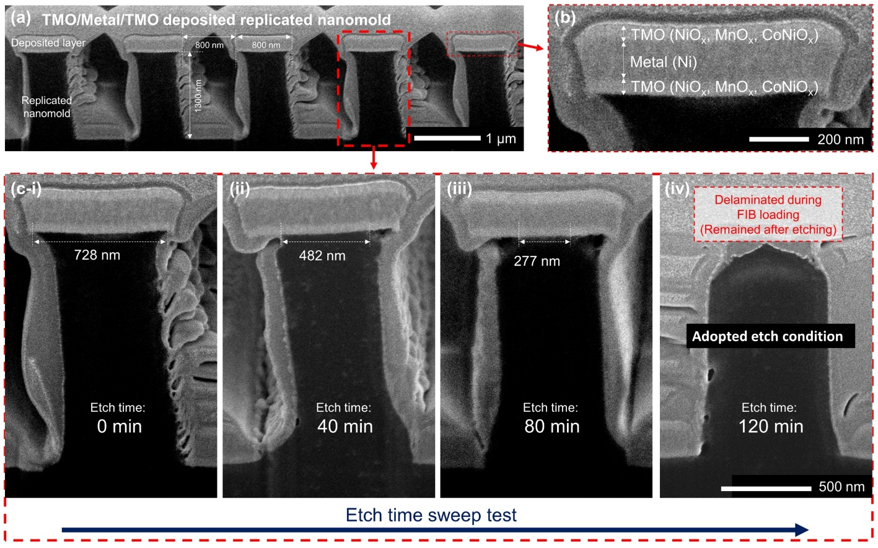
Fig. S2 Experimental results showing the selective etching of the nanopatterned mold based on O₂ plasma treatment. All the images are side-view SEM images. The nanopatterns were cut using a focused ion beam. (a) As-deposited TMO/metal/TMO trilayer on the nanopatterned polymer mold and (b) its enlarged image. (c) Variation of the polymer mold with the deposited trilayer at various O₂ plasma etching times.

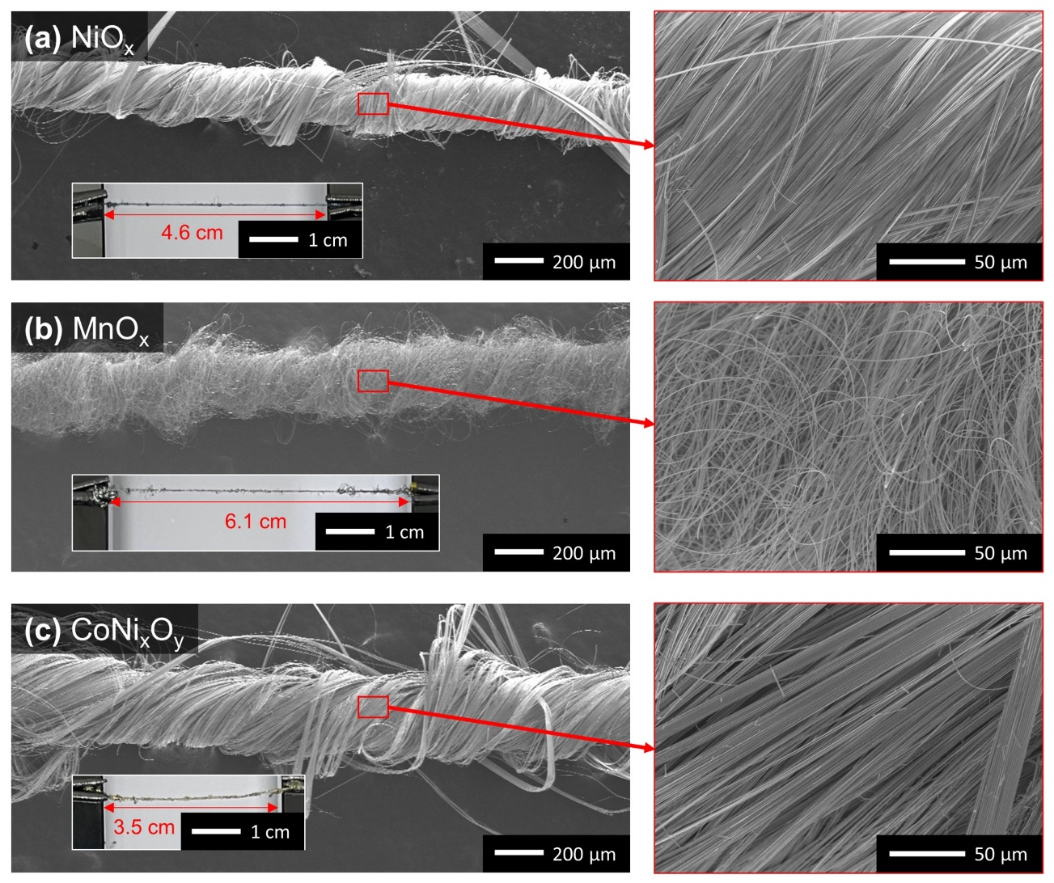
Fig. S3 Low- and high-magnification SEM images of the (a) NO, (b) MO, and (c) CNO nanoribbon yarns.

Fig. S4 Schematic representation of the sFS structure. The sFS comprises an electrode (anode/cathode) composed of the same material-based nanoribbon yarn and a PVA/KOH gel electrolyte.

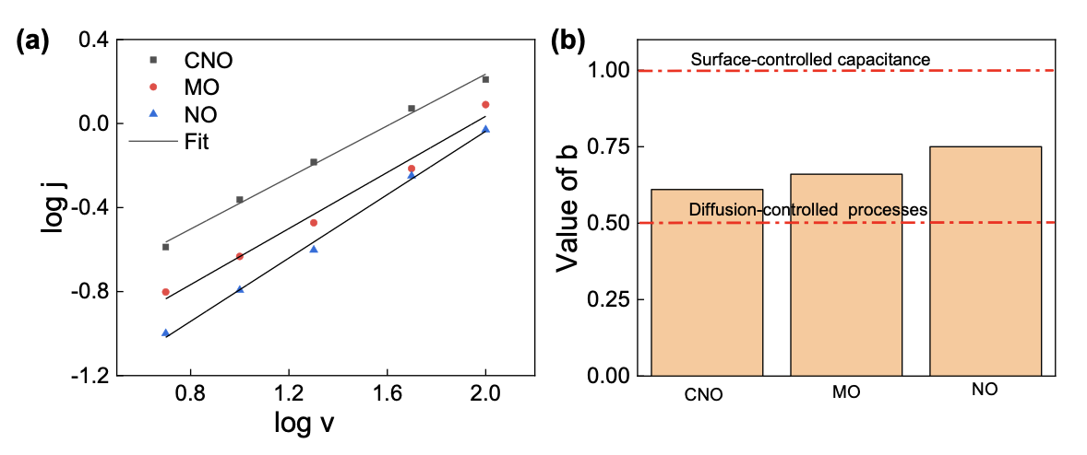
Fig. S5. (a) Log j versus log v plot and (b) associated b-values for CNO, MO, and NO yarn sFS at 0.1 V.

Fig. S6 (a) Nyquist plots of different FSs over a frequency range of 0.01 Hz to 100 kHz. (b) Amplified Nyquist plots in the high-frequency range displaying internal resistance.

Fig. S7 (a) CV curves of the G-CNO aFS at different scan rates, and (b) evolution of the discharge current density at different scan rates.

Fig. S8 GCD curves of the M-CNO aFS at increasing current densities.

Fig. S9 Electrochemical performances of the G-CNO and M-CNO aFSs. (a) Volumetric capacitance and (b) areal capacitance of the device at increasing current densities. Ragone plots displaying variations in the energy and power densities for the G-CNO and M-CNO aFSs.

Fig. S10 Electrochemical capacitance of the CNO sFSs during bending–straightening cycles.

Fig. S11 TENG–mask integration and charging of the developed aFS. (a) Working principle of the TENG. (b) TENG output open circuit voltage under human exhalation conditions. (c) Charging of aFS by the TENG. The red line represents the natural charge of the aFS due to leakage of the electrical measurement equipment. The black line represents the charging of the aFS with the TENG under human exhale conditions. (d) Calibrated charging plot of the aFS to demonstrate interactions between the TENG and aFS.

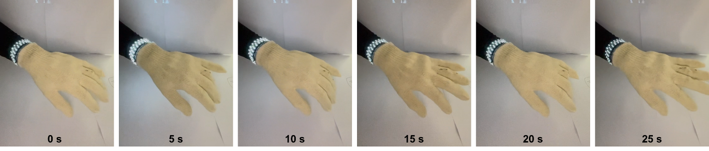
Fig. S12 A snapshot of the LED driven by the developed supercapacitor over time.

Fig. S13 Integration of the pressure sensor with the aFS. (a) The working mechanism and electrical circuit are used to measure the current and voltage of the aFS and to calculate the electrical conductance change of the pressure sensor. (b) Experimental results show the measured current and voltage at the pressure applied by a finger. (c) Electrical conductance of the pressure sensor at various pressures for sensor calibration. I₀ represents the initial electrical conductance of the pressure sensor.

References:

[1] Sun H, You X, Deng J, Chen X, Yang Z, Ren J, Peng H. Novel graphene/carbon nanotube composite fibers for efficient wire-shaped miniature energy devices. Adv Mater. 2014; 26: 2868–2873.
[2] Lu Z, Chao Y, Ge Y, Foroughi J, Zhao Y, Wang C, Long H, Wallace GG. High-performance hybrid carbon nanotube fibers for wearable energy storage. Nanoscale 2017; 9: 5063–5071.
[3] Choi C, Lee JA, Choi AY, Kim YT, Lepró X, Lima MD, Baughman RH, Kim SJ. Flexible supercapacitor made of carbon nanotube yarn with internal pores. Adv Mater. 2014; 26: 2059–2065.
[4] Xiao X, Li T, Yang P, Gao Y, Jin H, Ni W, Zhan W, Zhang X, Cao Y, Zhong J, Gong L, Yen WC, Mai W, Chen J, Huo K, Chueh YL, Wang ZL, Zhou J. Fiber-based all-solid-state flexible supercapacitors for self-powered systems. ACS Nano 2012; 6: 9200–9206.
[5] Ren J, Li L, Chen C, Chen X, Cai Z, Qiu L, Wang Y, Zhu X, Peng H. Twisting carbon nanotube fibers for both wire-shaped micro-supercapacitor and micro-battery. Adv Mater. 2013; 25: 1155–1159.
[6] Wang K, Meng Q, Zhang Y, Wei Z, Miao M. High-performance two-ply yarn supercapacitors based on carbon nanotubes and polyaniline nanowire arrays. Adv Mater. 2013; 25: 1494–1498.
[7] Zheng B, Huang T, Kou L, Zhao X, Gopalsamy K, Gao C. Graphene fiber-based asymmetric micro-supercapacitors. J Mater Chem A 2014; 2: 9736–9743.
[8] Le VT, Kim H, Ghosh A, Kim J, Chang J, Vu QA, Pham DT, Lee JH, Kim SW, Lee YH. Coaxial fiber supercapacitor using all-carbon material electrodes. ACS Nano 2013; 7: 5940–5947.
[9] Yu D, Goh K, Zhang Q, Wei L, Wang H, Jiang W, Chen Y. Controlled functionalization of carbonaceous fibers for asymmetric solid-state micro-supercapacitors with high volumetric energy density. Adv Mater. 2014; 26: 6790–6797.
[10] Su F, Miao M, Niu H, Wei Z. Gamma-irradiated carbon nanotube yarn as substrate for high-performance fiber supercapacitors. ACS Appl Mater Interfaces 2014; 6: 2553–2560.
[11] Li G-X, Hou P, Luan J, Li J, Li X, Wang H, Shi C, Liu C, Cheng H. A MnO₂ nanosheetisingle-wall carbon nanotube hybrid fiber for wearable solid-state supercapacitors. Carbon 2018; 140: 634–643.
[12] Choi C, Kim KM, Kim KJ, Lepró X, Spinks GM, Baughman RH, Kim SJ. Improvement of system capacitance via weavable superelastic biscrolled yarn supercapacitors. Nat Commun. 2016; 7: 13811.
[13] Yu D, Goh K, Wang H, Wei L, Jiang W, Zhang Q, Dai L, Chen Y. Scalable synthesis of hierarchically structured carbon nanotube-graphene fibres for capacitive energy storage. Nat Nanotechnol. 2014; 9: 555–562.
[14] Padmajan Sasikala S, Lee KE, Lim J, Lee HJ, Koo SH, Kim IH, Jung HJ, Kim SO. Interface-confined high crystalline growth of semiconducting polymers at graphene fibers for highperformance wearable supercapacitors. ACS Nano 2017; 11: 9424–9434.
[15] Ren J, Bai W, Guan G, Zhang Y, Peng H. Flexible and weaveable capacitor wire based on a carbon nanocomposite fiber. Adv Mater. 2013; 25: 5965–5970.
[16] Kou L, Huang T, Zheng B, Han Y, Zhao X, Gopalsamy K, Sun H, Gao C. Coaxial wet-spun yarn supercapacitors for high-energy density and safe wearable electronics. Nat Commun. 2014; 5: 3754.
[17] Wang Z, Qin S, Seyedin S, Zhang J, Wang J, Levitt A, Li N, Haines C, Ovalle-Robles R, Lei W, Gogotsi Y, Baughman RH, Razal JM. High-performance biscrolled MXene/carbon nanotube yarn supercapacitors. Small 2018; 14: e1802225.
[18] He N, Song J, Liao J, Zhao F, Gao W. Separator threads in yarn-shaped supercapacitors to avoid short-circuiting upon length. NPJ Flex Electron. 2022; 6: 19.
[19] He N, Liao J, Zhao F, Gao W. Dual-core supercapacitor yarns: An enhanced performance consistency and linear power density. ACS Appl Mater Interfaces 2020; 12: 15211–15219.
[20] Hu M, Li Z, Li G, Hu T, Zhang C, Wang X. All-solid-state flexible fiber-based MXene supercapacitors. Adv Mater Technol. 2017; 2: 1700143.
[21] Liu N, Ma W, Tao J, Zhang X, Su J, Li L, Yang C, Gao Y, Golberg D, Bando Y. Cable-type supercapacitors of three-dimensional cotton thread based multi-grade nanostructures for wearable energy storage. Adv Mater. 2013; 25: 4925–4931.
[22] Song P, Tao J, He X, Sun Y, Shen X, Zhai L, Yuan A, Zhang D, Ji Z, Li B. Chem Eng J. 2020; 386: 124024.
[23] Zhang Q, Xu W, Sun J, Pan Z, Zhao J, Wang X, Zhang J, Man P, Guo J, Zhou Z, He B, Zhang Z, Li Q, Zhang Y, Xu L, Yao Y. Constructing ultrahigh-capacity zinc-nickel-cobalt oxide@Ni(OH). Nano Lett. 2017; 17: 7552–7560.
[24] Cai W, Lai T, Lai J, Xie H, Ouyang L, Ye J, Yu C. Transition metal sulfides grown on graphene fibers for wearable asymmetric supercapacitors with high volumetric capacitance and high energy density. Sci Rep. 2016; 6: 26890.
[25] Yu Z, Moore J, Calderon J, Zhai L, Thomas J. Coil-type asymmetric supercapacitor electrical cables. Small 2015; 11: 5289–5295.
[26] Liu J-h, Xu X, Yu J, Hong J, Liu C, Ouyang X, Lei S, Meng X, Tang J, Chen D. Facile construction of 3D porous carbon nanotubes/polypyrrole and reduced graphene oxide on carbon nanotube fiber for high-performance asymmetric supercapacitors. Electrochim Acta. 2019; 314: 9–19.
[27] Zong Q, Zhang Q, Mei X, Li Q, Zhou Z, Li D, Chen M, Shi F, Sun J, Yao Y, Zhang Z. ACS Appl Mater Interfaces 2018; 10: 37233.
[28] Xu Y, Yan Y, Lu W, Yarlagadda S, Xu G. High-Performance flexible asymmetric fiber-shaped supercapacitor based on CF/PPy and CNT/MnO₂ composite electrodes. ACS Appl Energy Mater. 2021; 4: 10639–10645.
[29] Zhang Q, Sun J, Pan Z, Zhang J, Zhao J, Wang X, Zhang C, Yao Y, Lu W, Li Q, Zhang Y, Zhang Z. Stretchable fiber-shaped asymmetric supercapacitors with ultrahigh energy density. Nano Energy 2017; 39: 219–228.
[30] Li Y, Yan X, Zheng X, Si H, Li M, Liu Y, Sun Y, Jiang Y, Zhang Y. Fiber-shaped asymmetric supercapacitors with ultrahigh energy density for flexible/wearable energy storage. J Mater Chem A 2016; 4: 17704–17710.

