Lidocaine-Loaded Iontophoresis-Driven Fiber-Based Microneedle Patch for Controllable and Long-Lasting Transdermal Local Analgesia
Ting Wang,^{1,#} Xiaoyu Shi,^{2,#}, Yue Wang,^{1,#} Hengda Sun,² Yu Sun,^{1,*} Gang Wang,^{2,*} and Hong Jiang^{1,*}

Fig. S1 SEM image of MN patch. (a-d) PVA-based dissolving MN SEM image. (e-h) Fiber-based dissolving MN SEM image.

Fig. S2 MN solubility testing

Fig. S3 Stability of drug-loaded fiber-based MNs under conditions of (40±2) °C and (75±5) % relative humidity (Mean±SDs, n=3).

Fig. S4 Optical photographs of PVA hydrogels and PVA-PEDOT: PSS hydrogels prepared from one freeze–thaw cycle (FT-1), two freeze–thaw cycles (FT-2), and three freeze–thaw cycles (FT-3).

Fig. S5 Hydrogel electrical performance tests for various freeze–thaw cycle conditions. (a) EIS results for PVA-FT-1 and PVA-PEDOT: PSS-FT-1 hydrogels. (b) EIS results for PVA-FT-2 and PVA-PEDOT: PSS-FT-2 hydrogels. (c) EIS results for PVA-FT-3 and PVA-PEDOT: PSS-FT-3 hydrogels. (d) Conductivity statistics of each PVA and PVAPEDOT: PSS hydrogel at FT-1, FT-2, and FT-3. e-f) PVA-FT-3 and PVA-PEDOT: PSS-FT-3 hydrogel conductivity difference photos.

Fig. S6 Hydrogel mechanical property test under freeze-thaw cycle conditions. (a) compressive stress–strain curves of PVA-PEDOT: PSS-FT hydrogels. (b) Statistical chart of compression modulus of each PVA hydrogel and PVA-PEDOT: PSS hydrogel at FT-1, FT-2, and FT-3.

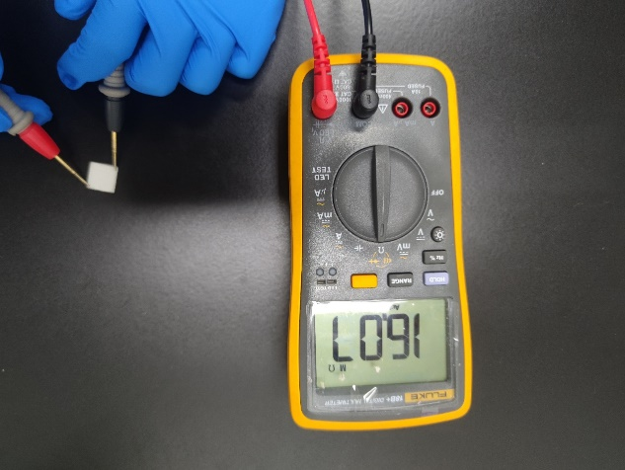
Fig. S7 Fiber-based dissolving MNs possessed no electrical conductivity.

Fig. S8 Changes in resistance during transdermal patch application.

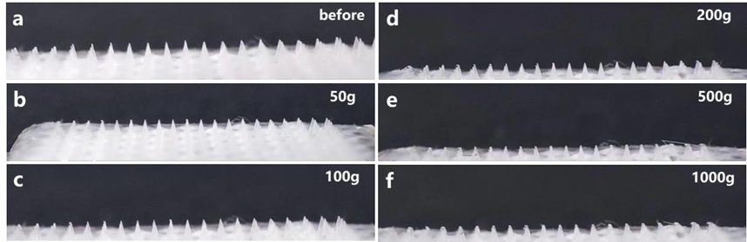
Fig. S9 Deformation after applying 0-1000g weight to LIDO-loaded fiber-based MNs

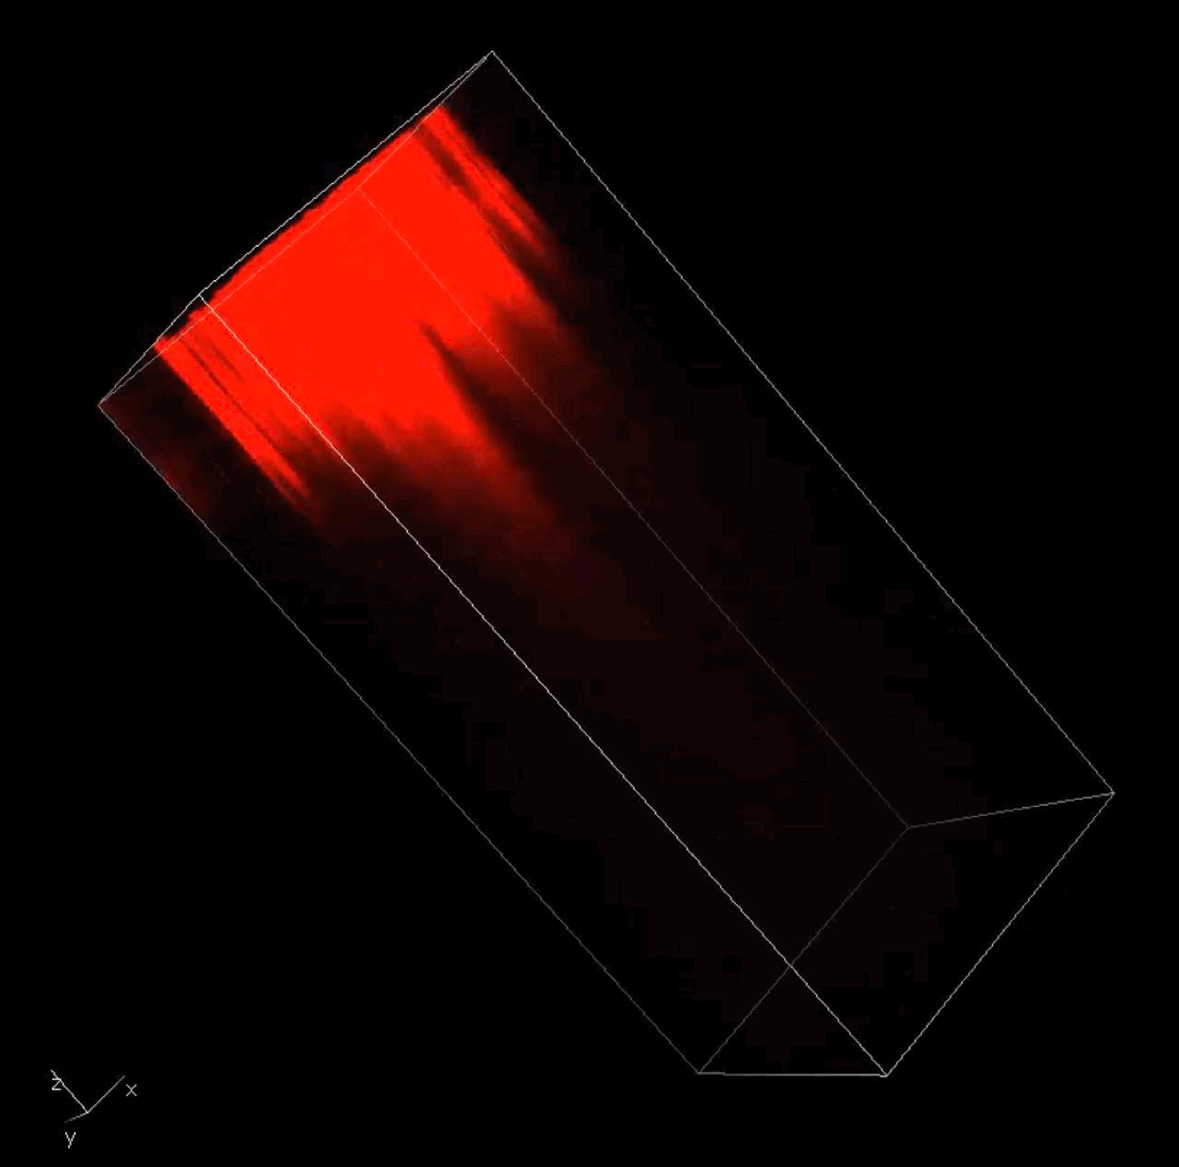
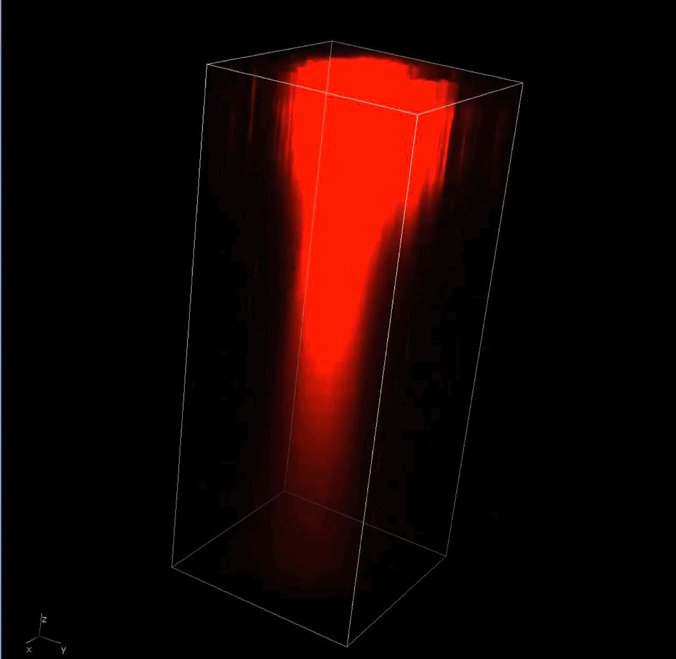
Fig. S10 Dynamic images of 3D confocal microscopy of R6G/MN and R6G/MN/1 mA ITP applied to rat skin.
Fig. S11 Adhesion tests of the fiber-based MN patch. (a) MN-treated rat dorsal skin; (b) Photograph of LIDO-loaded fiber-based MN patch (scale bar=0.5 cm).

Fig. S12 Drug release profile surface fitting.

Fig. S13 Relative cell viability of L929 incubated with extracts from Control, LIDO/MN, LIDO/hydrogel, and LIDO/MN/hydrogel groups.

Fig. S14 H&E staining of the main organs (heart, liver, spleen, lung, and kidney) of the rats in the different groups (scale bar=100 μm).

Fig. S15 Anesthetic effects of LIDO-loaded IFMP in back-acupuncture test. (a) Schematic illustration of the acupuncture method on the back of rats. (b) Inhibition of CTMR reflected by nociceptive blockade score. Data are presented as mean ± SD, n = 6. *p<0.05, **p<0.01, ***p<0.001, ****p<0.0001.
Fig. S16 Trajectory statistical chart of open field test. (a-d) Open field testing results for the total and central distances traveled (cm) and mean speed (cm/s) over a 30 min duration in different groups. Data are presented as mean ± SD, n = 6. * p < 0.05, ** p < 0.01, *** p < 0.001, **** p < 0.0001 for the Incision, LIDO/cream, Blank/MN and LIDO/MN groups vs. the LIDO/MN/1 mA ITP group.
.

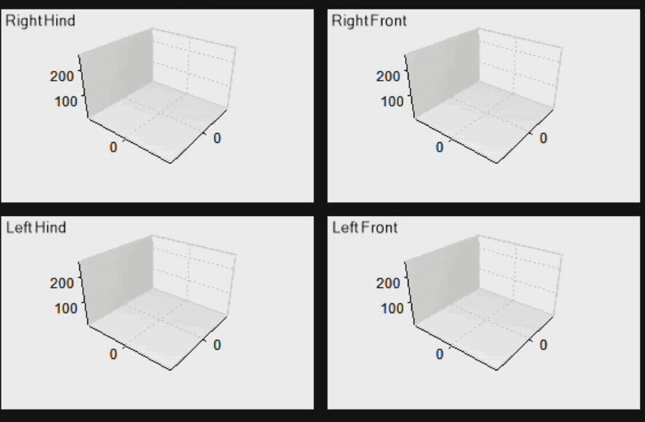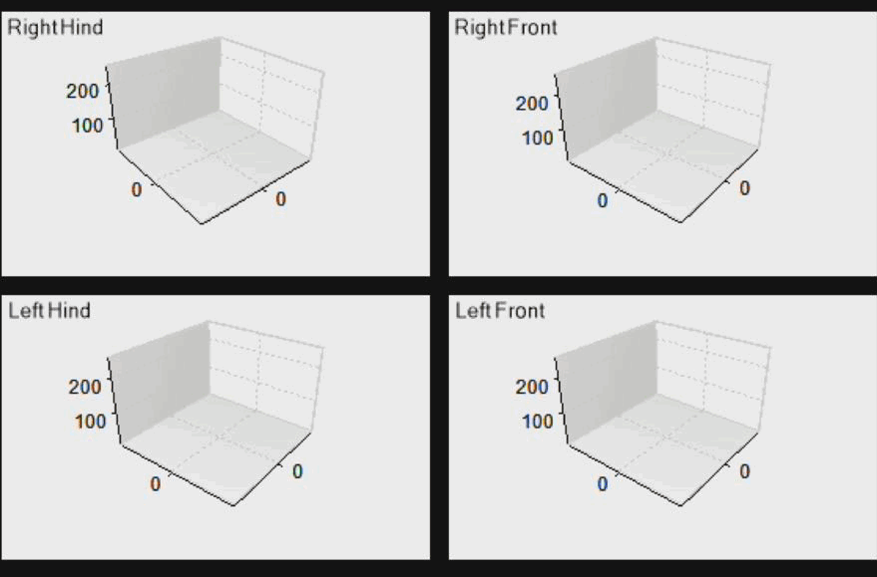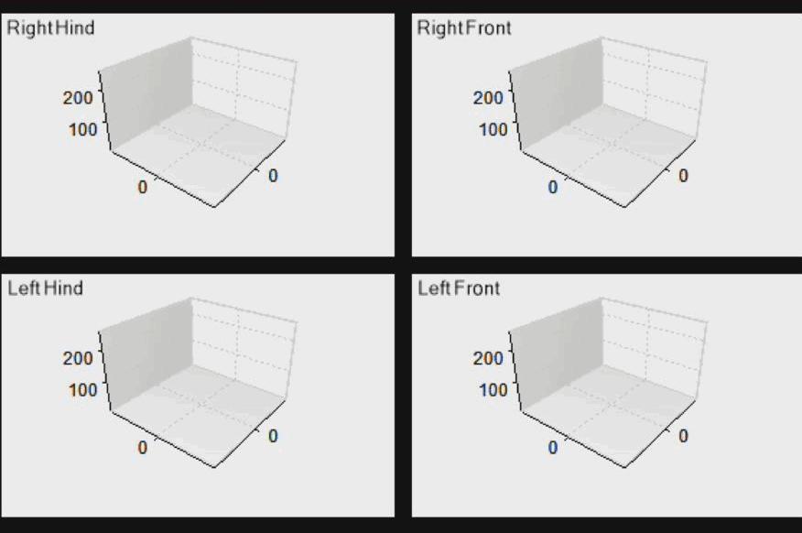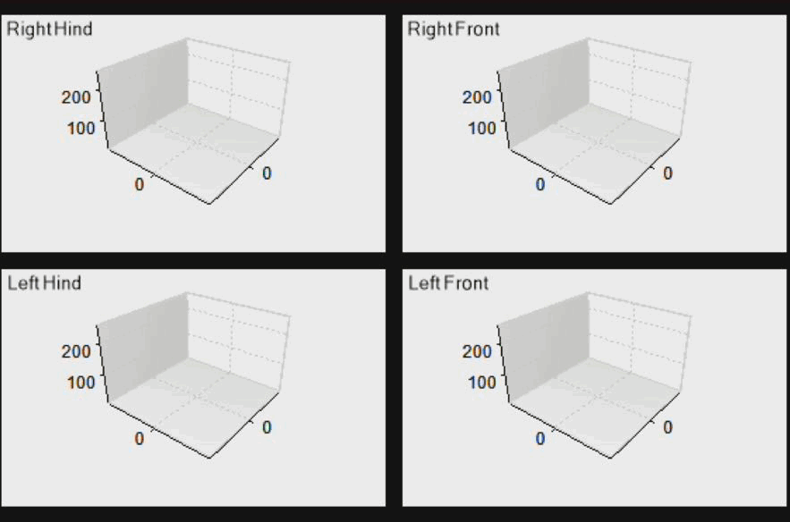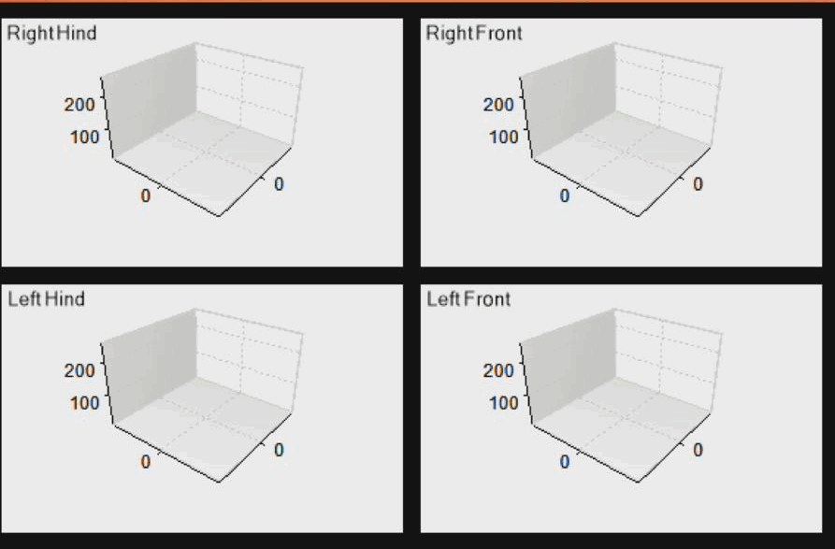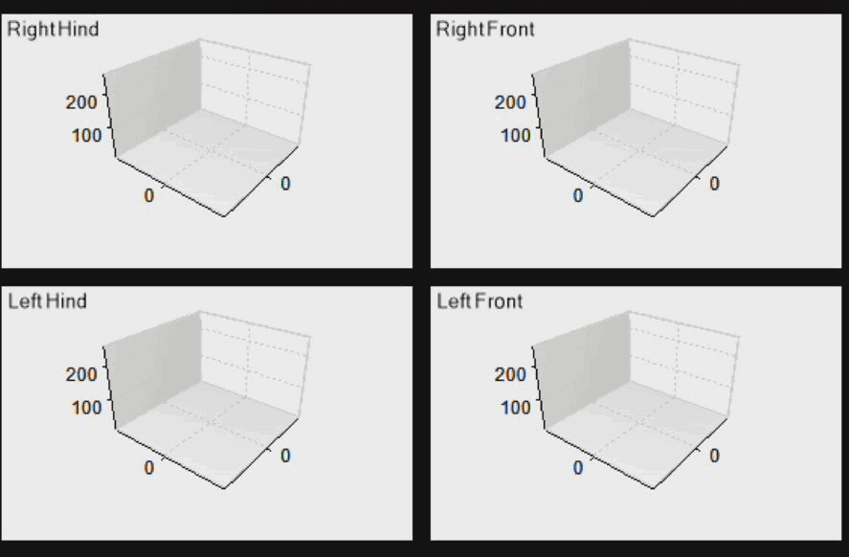
Fig. S17 Representative gait analysis associated with LIDO-loaded IFMP. (a) For gait recording, the different group rats were put into the pressure sensing track. Individually recording the left front paw (LF), left hind paw (LH), right front paw (RF), and right hind paw (RH), the CW system captured three-dimensional (3D) representations and gait pressure of all four paws in rats passing at normal speed. (b) 3D footprint intensities of the RH and LH paws of the rats in Naïve, Incision, LIDO/cream, Blank/MN, LIDO/MN, and LIDO/MN/1 mA ITP group, respectively. (c-f) Mean paw print intensity, stance duration, stride phase, and swing duration of LH/RH of the rats in Naïve, Incision, LIDO/cream, Blank/MN, LIDO/MN, LIDO/MN/1 mA ITP group, respectively. Data are presented as mean ± SD, n = 6. * p < 0.05, ** p < 0.01, *** p < 0.001, **** p < 0.0001 for the Incision, LIDO/cream, Blank/MN and LIDO/MN groups vs. the LIDO/MN/1 mA ITP group.

Fig. S18 Immunofluorescence of c-Fos /NeuN at 12 h after plantar incision surgery. (a) Representative immunofluorescence results for c-Fos and NeuN in the spinal cord dorsal horn neurons of the SG area 12 h after plantar incision surgery. Green: c-Fos, Red: NeuN, Blue: DAPI, Yellow: c-Fos/NeuN. (b) Statistical analysis of the proportion of co‐expression of c‐Fos and NeuN in NeuN⁺ neurons in different groups. Data are presented as mean ± SD, n = 6. * p < 0.05, ** p < 0.01, *** p < 0.001, **** p < 0.0001 for the Naïve and LIDO/MN/1 mA ITP groups vs. the Incision group. All scale bars=100 μm.

Fig. S19 Immunofluorescence of Iba-1 in spinal cord dorsal horn at 12 h after plantar incision surgery. (a) Immunofluorescence results for Iba-1 in the spinal cord dorsal horn. Red: Iba-1, Blue: DAPI. (b) Statistical analysis of mean fluorescence intensity of Iba-1 in SG area of spinal cord dorsal horn neurons in different groups. Data are presented as mean ± SD, n = 6. * p < 0.05, ** p < 0.01, *** p < 0.001, **** p < 0.0001 for the Naïve and LIDO/MN/1 mA ITP groups vs. the Incision group. All scale bars=100 μm.

Data availability statement
The data that support the findings of this study are available from the corresponding authors upon reasonable request.

#Ting Wang, Xiaoyu Shi and Yue Wang have contributed equally to this work. * Corresponding author. Yu Sun¹: dr_sunyu@163.com, Gang Wang²: gwf8707@dhu.edu.cn and Hong Jiang¹: dr_jianghong@163.com. 1 Department of Anesthesiology, Shanghai Ninth People’s Hospital, Shanghai Jiao Tong University School of Medicine, No. 639 Zhizaoju Rd Shanghai 200011, P.R. China. 2 State Key Laboratory for Modification of Chemical Fibers and Polymer Materials, College of Materials Science & Engineering, Donghua University, No. 2999 Renmin Rd, Shanghai 201620, P.R. China

