Supporting Information of
Eco-friendly free-standing conductive PEDOT-based nonwovens for wearable and flexible touch sensors
Emanuele Alberto Slejko^{1,*}, Vivek Manish², Roberta Miroglio³, Alessandro Talone¹, Giovanni Carraro¹, Letizia Savio¹, Ola Alayan^{4,1}, Gianangelo Bracco^{4,1}, Luca Vattuone^{4,1}, Alessio Montarsolo³, Dario Cavallo⁵, Roberto Spotorno^{5,1}, Chiara Gambardella³, Marco Faimali³, Veronica Piazza³, Maria F, Pantano^{2,*}, Marco Smerieri^{1,*}

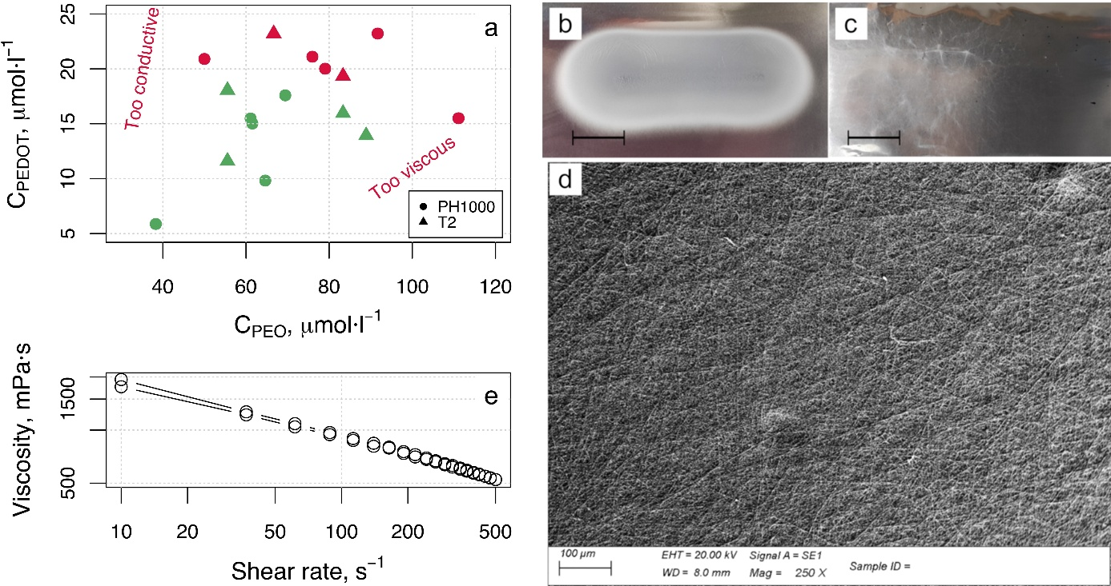
Fig. S1 a Composition of each tested solution. Colored spots indicate successful (green) or failed (red) spinning, with optical macrographs of representative successful and unsuccessful samples in b and c, respectively (scale bars are 2 cm). d SEM image of the obtained nanofibers, indicating the large area uniformity. e Example of rheological properties of PEDOT:PSS-PEO water-dispersion for the fabrication of nonwovens.

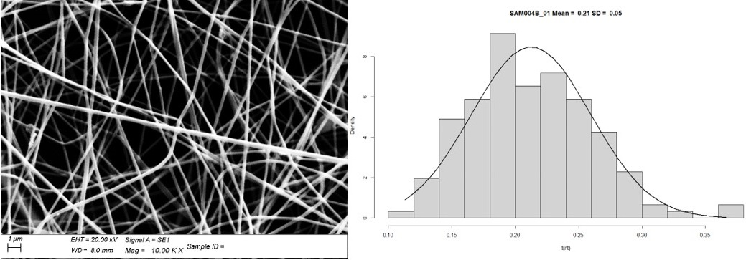
Fig. S2 Size analysis of nanofibers from SEM images. Values in the histogram are expressed in µm.

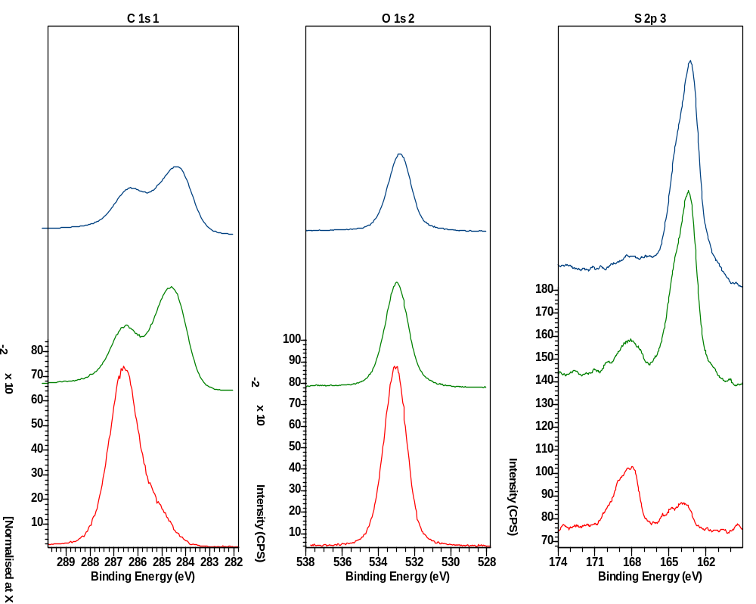
Thermally
treated
Sputtered 8 min
Sputtered 60 min
Fig. S3 Depth profiling of the thermally treated sample. C 1s, O 1s and S 2p photoemission lines. After sputtering the thermally treated sample with 1kV Ar+ ions we observe significative changes in C 1s and S 2p and a reduction in O 1s. The C 1s peak main C-O-C feature at 286.5 eV reduces, in agreement with the reduction of the O content of the sample. At the same time we observe a reduction in the PSS related S 2p components around 167.9 eV which is probably due to preferential sputtering, and a sharp increase in the PEDOT related component at 163.5 eV.

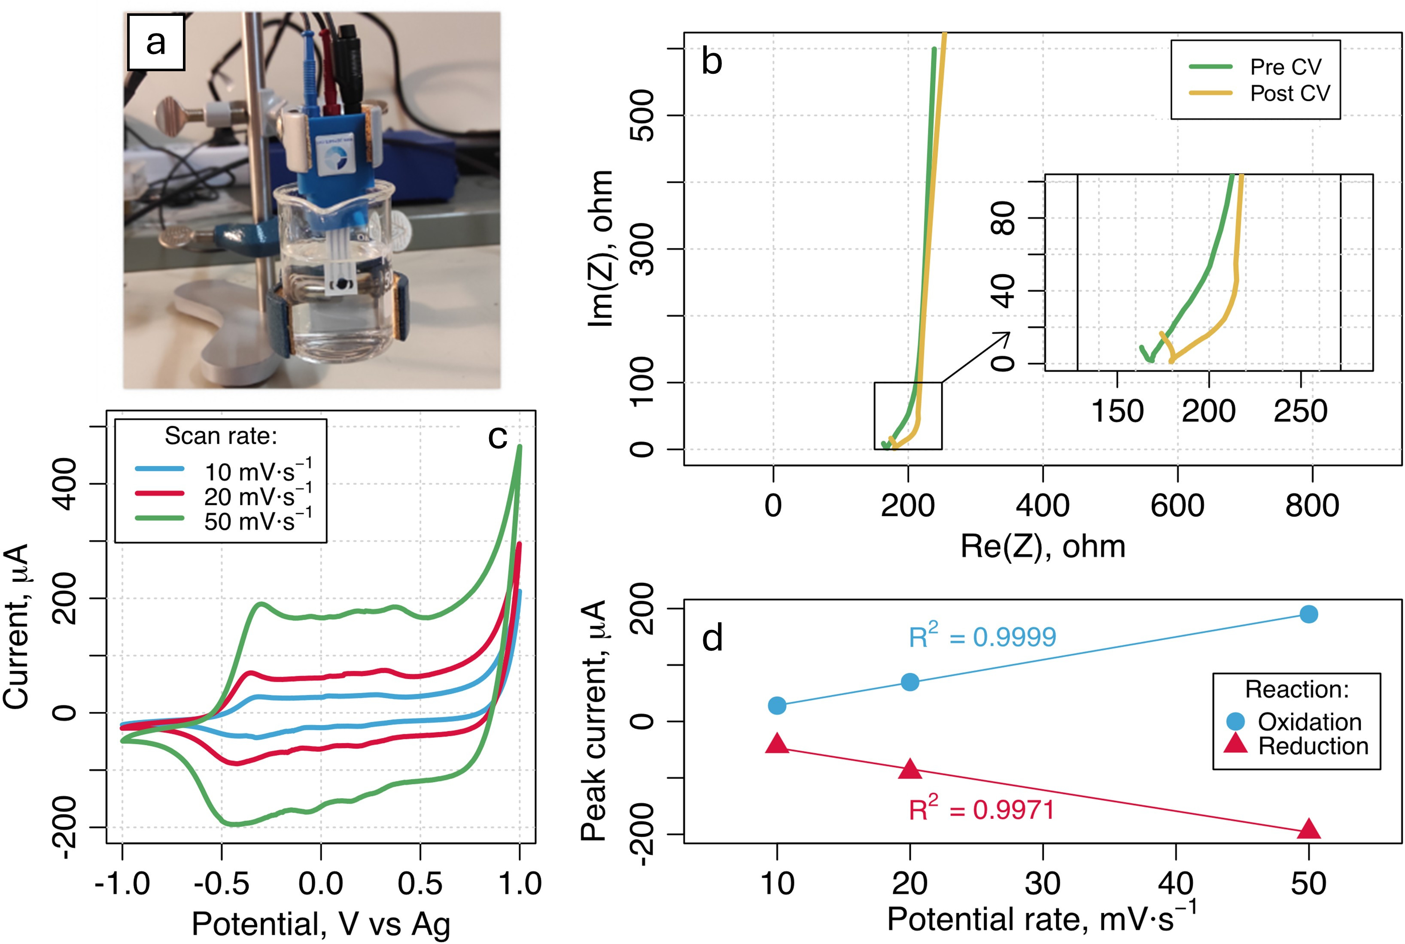
Fig. S4 Electrochemical characterization of the thermally treated material. a Measurement setup; b EIS; c CV at different scan rates. d Linear dependence of peak current with scan rate for the main reactions.

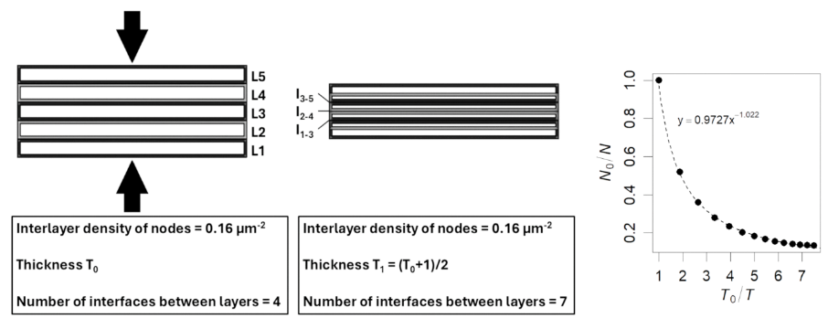
Fig. S5 Side view of the nonwoven sample, schematized as a series of finite boxes, each ideally representing a single layer of nanofibers. Upon compression, these layers begin to interpenetrate, leading to the formation of new interfaces between layers that were initially non-adjacent (e.g., a new interface may form between layers 1 and 3 upon compression). Each interface is characterized by a constant number of nanofiber contacts. Therefore, as compression increases the number of interfaces, the total number of fiber–fiber contacts within the material also increases. If we plot the total number of interfaces N on the thickness T of the material, the data can be fitted by a power law.

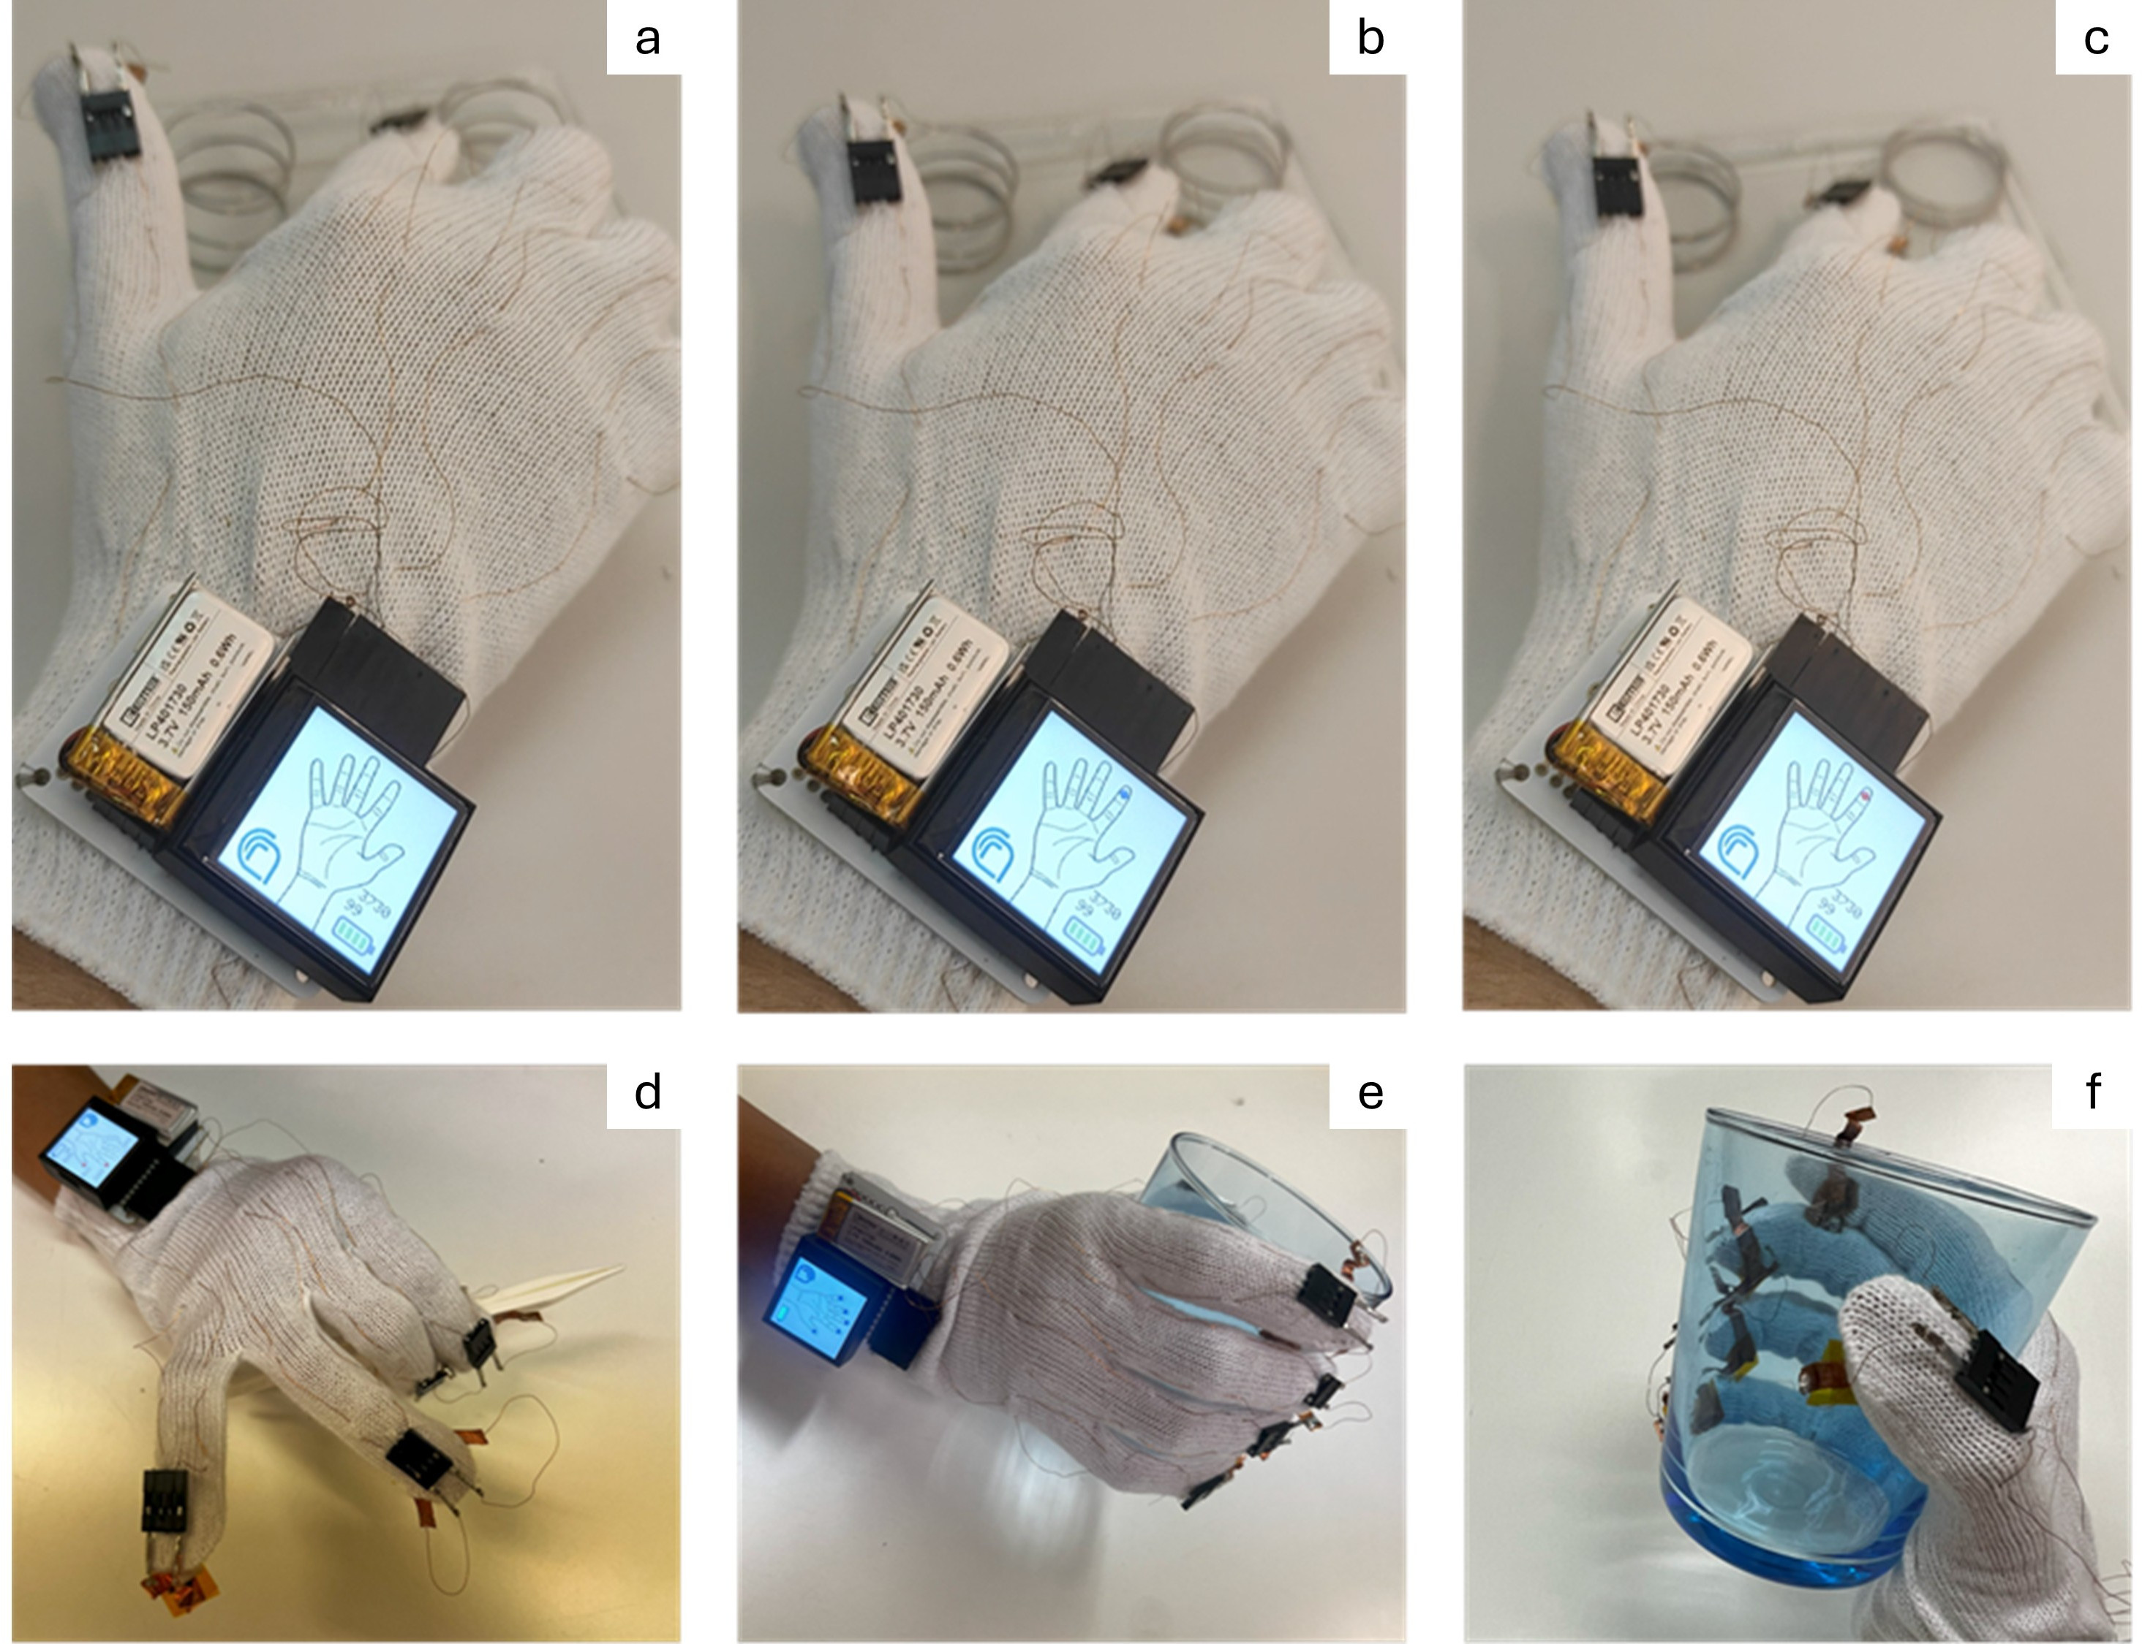
Fig. S6 Example of use case for the pressure monitoring glove. a,b,c Single finger test on a damping plate with increasing pressure levels on the index finger. Test of two main biomechanical hand grips used in daily activities: precision pitch grip using a laboratory tweezer d and force cylindrical grip with a glass e,f.

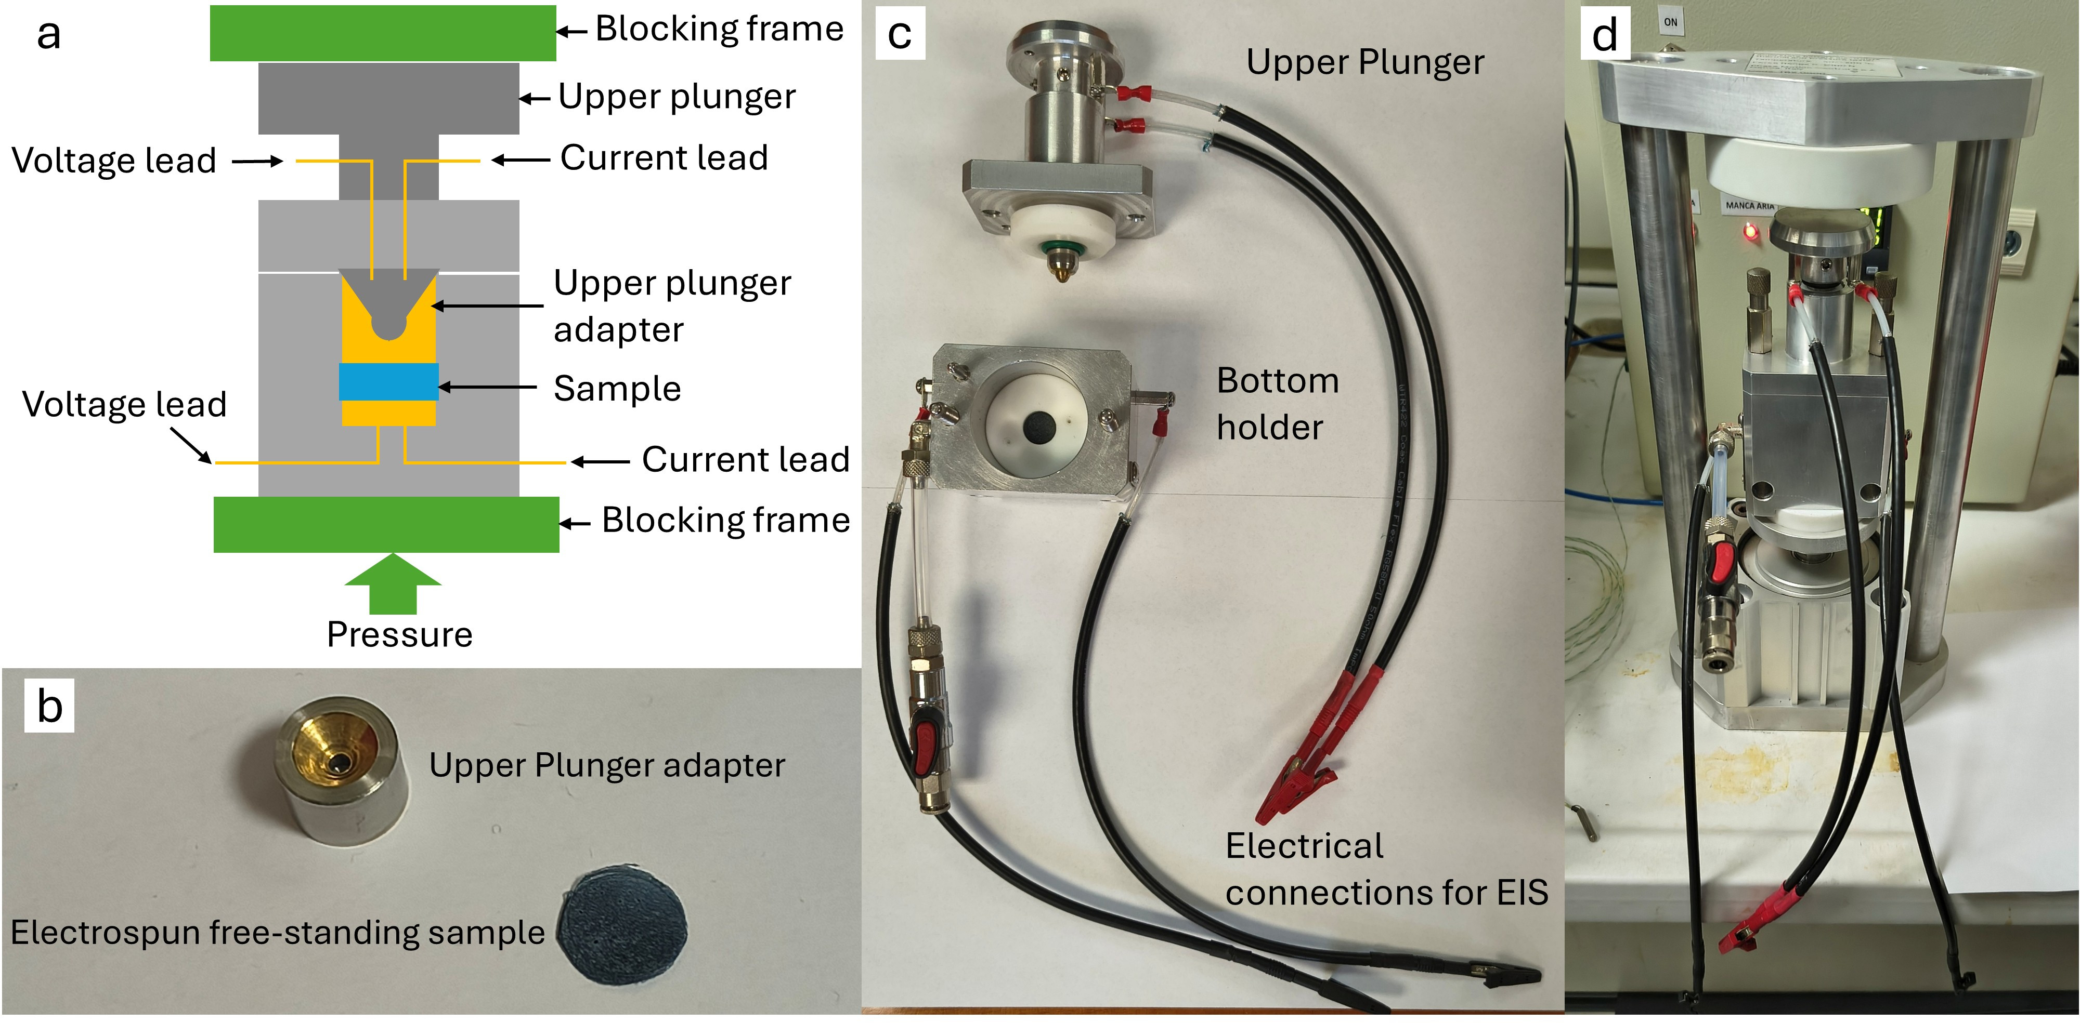
Fig. S7 Equipment for the electro-mechanical response. a Scheme of the instrument and photos of the b upper plunger adapter and free-standing sample. c Upper plunger and bottom holder; d equipment ready for testing.

Table S1. Raw measurement data (e.g.. luminescence units. cell counts. number of immobile organisms) of each ecotoxicological test performed with the different aquatic species for both control and treated groups

Bioluminescence-30 min
 |  | A.fischeri
Relative Light Units (RLU) |  | Control | PEDOT-PEO | HT-PEDOT-PEO
Replicate | a | 246 | 212 | 224
 | b | 250 | 207 | 232
 | c | 243 | 216 | 221
mean (M) |  | 246.33 | 211.67 | 225.67
st.dev (sd) |  | 3.51 | 4.51 | 5.69
st.error (se) |  | 2.03 | 2.60 | 3.28

Algal growth-72h
 |  | P.tricornutum |  |  | R.subcapitata
n cell/mL |  | Control | PEDOT-PEO | HT-PEDOT-PEO | Control | PEDOT-PEO | HT-PEDOT-PEO
Replicate | a | 319424 | 284704 | 298592 | 180544 | 180544 | 180544
 | b | 333312 | 288176 | 312480 | 211792 | 197904 | 201376
 | c | 361088 | 340256 | 336784 | 229152 | 229152 | 215264
mean (M) |  | 337941.33 | 304378.67 | 315952 | 207162.7 | 202533.33 | 199061.33
st.dev (sd) |  | 21214.27 | 31119.14 | 19331.28 | 24632.45 | 24632.45 | 17475.35
st.error (se) |  | 12248.06 | 17966.64 | 11160.92 | 14221.55 | 14221.55 | 10089.39

Immobility-48h of marine crustacean
 |  | A.franciscana
n immobile/tot |  | Control | PEDOT-PEO | HT-PEDOT-PEO
Replicate | a | 0/20 | 0/17 | 1/17
 | b | 0/19 | 0/15 | 2/19
 | c | 1/18 | 0/20 | 2/20

Swimming behaviour-48h of marine crustacean
 |  | A.franciscana
mm/s |  | Control | PEDOT-PEO | HT-PEDOT-PEO
Replicate | a | 2.63 | 2.45 | 2.42
 | b | 2.64 | 2.47 | 2.45
 | c | 3.3 | 2.89 | 2.5
mean (M) |  | 2.86 | 2.60 | 2.46
st.dev (sd) |  | 0.38 | 0.25 | 0.04
st.error (se) |  | 0.22 | 0.14 | 0.02

Immobility-48h
 |  | D.magna
n immobile/tot |  | Control | PEDOT-PEO | HT-PEDOT-PEO
Replicate | a | 0/5 | 1/5 | 1/5
 | b | 0/5 | 0/5 | 1/5
 | c | 1/5 | 0/5 | 1/5
 | d | 0/5 | 0/5 | 1/5

* Corresponding author. Emanuele Alberto Slejko emanuelealberto.slejko@cnr.it; Maria F. Pantano maria.pantano@unitn.it; Marco Smerieri marco.smerieri@cnr.it 1 Institute of Materials for Electronics and Magnetism (IMEM), National Research Council (CNR), Via Dodecaneso 33, 16146 Genova, Italy 2 Department of Civil, Environmental and Mechanical Engineering (DICAM), University of Trento, Via Mesiano 77, 38123 Trento, Italy 3 Institute for the Study of Anthropic Impact and Sustainability in the Marine Environment (IAS), National Research Council (CNR), Via De Marini 6, 16149 Genova, Italy 4 Department of Physics, University of Genoa (DIFI), Via Dodecaneso 33, 16146 Genova, Italy 5 Department of Chemistry and Industrial Chemistry (DCCI), University of Genoa, Via Dodecaneso 31, 16146 Genova, Italy

