Supplementary materials
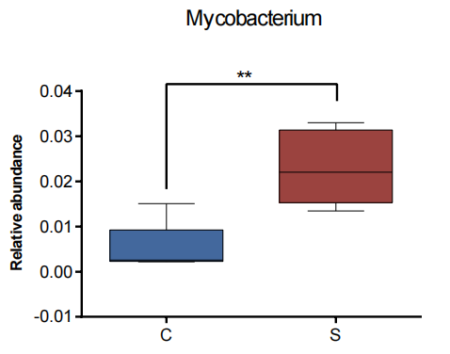
Fig. S1 The relative abundances of Mycobacterium
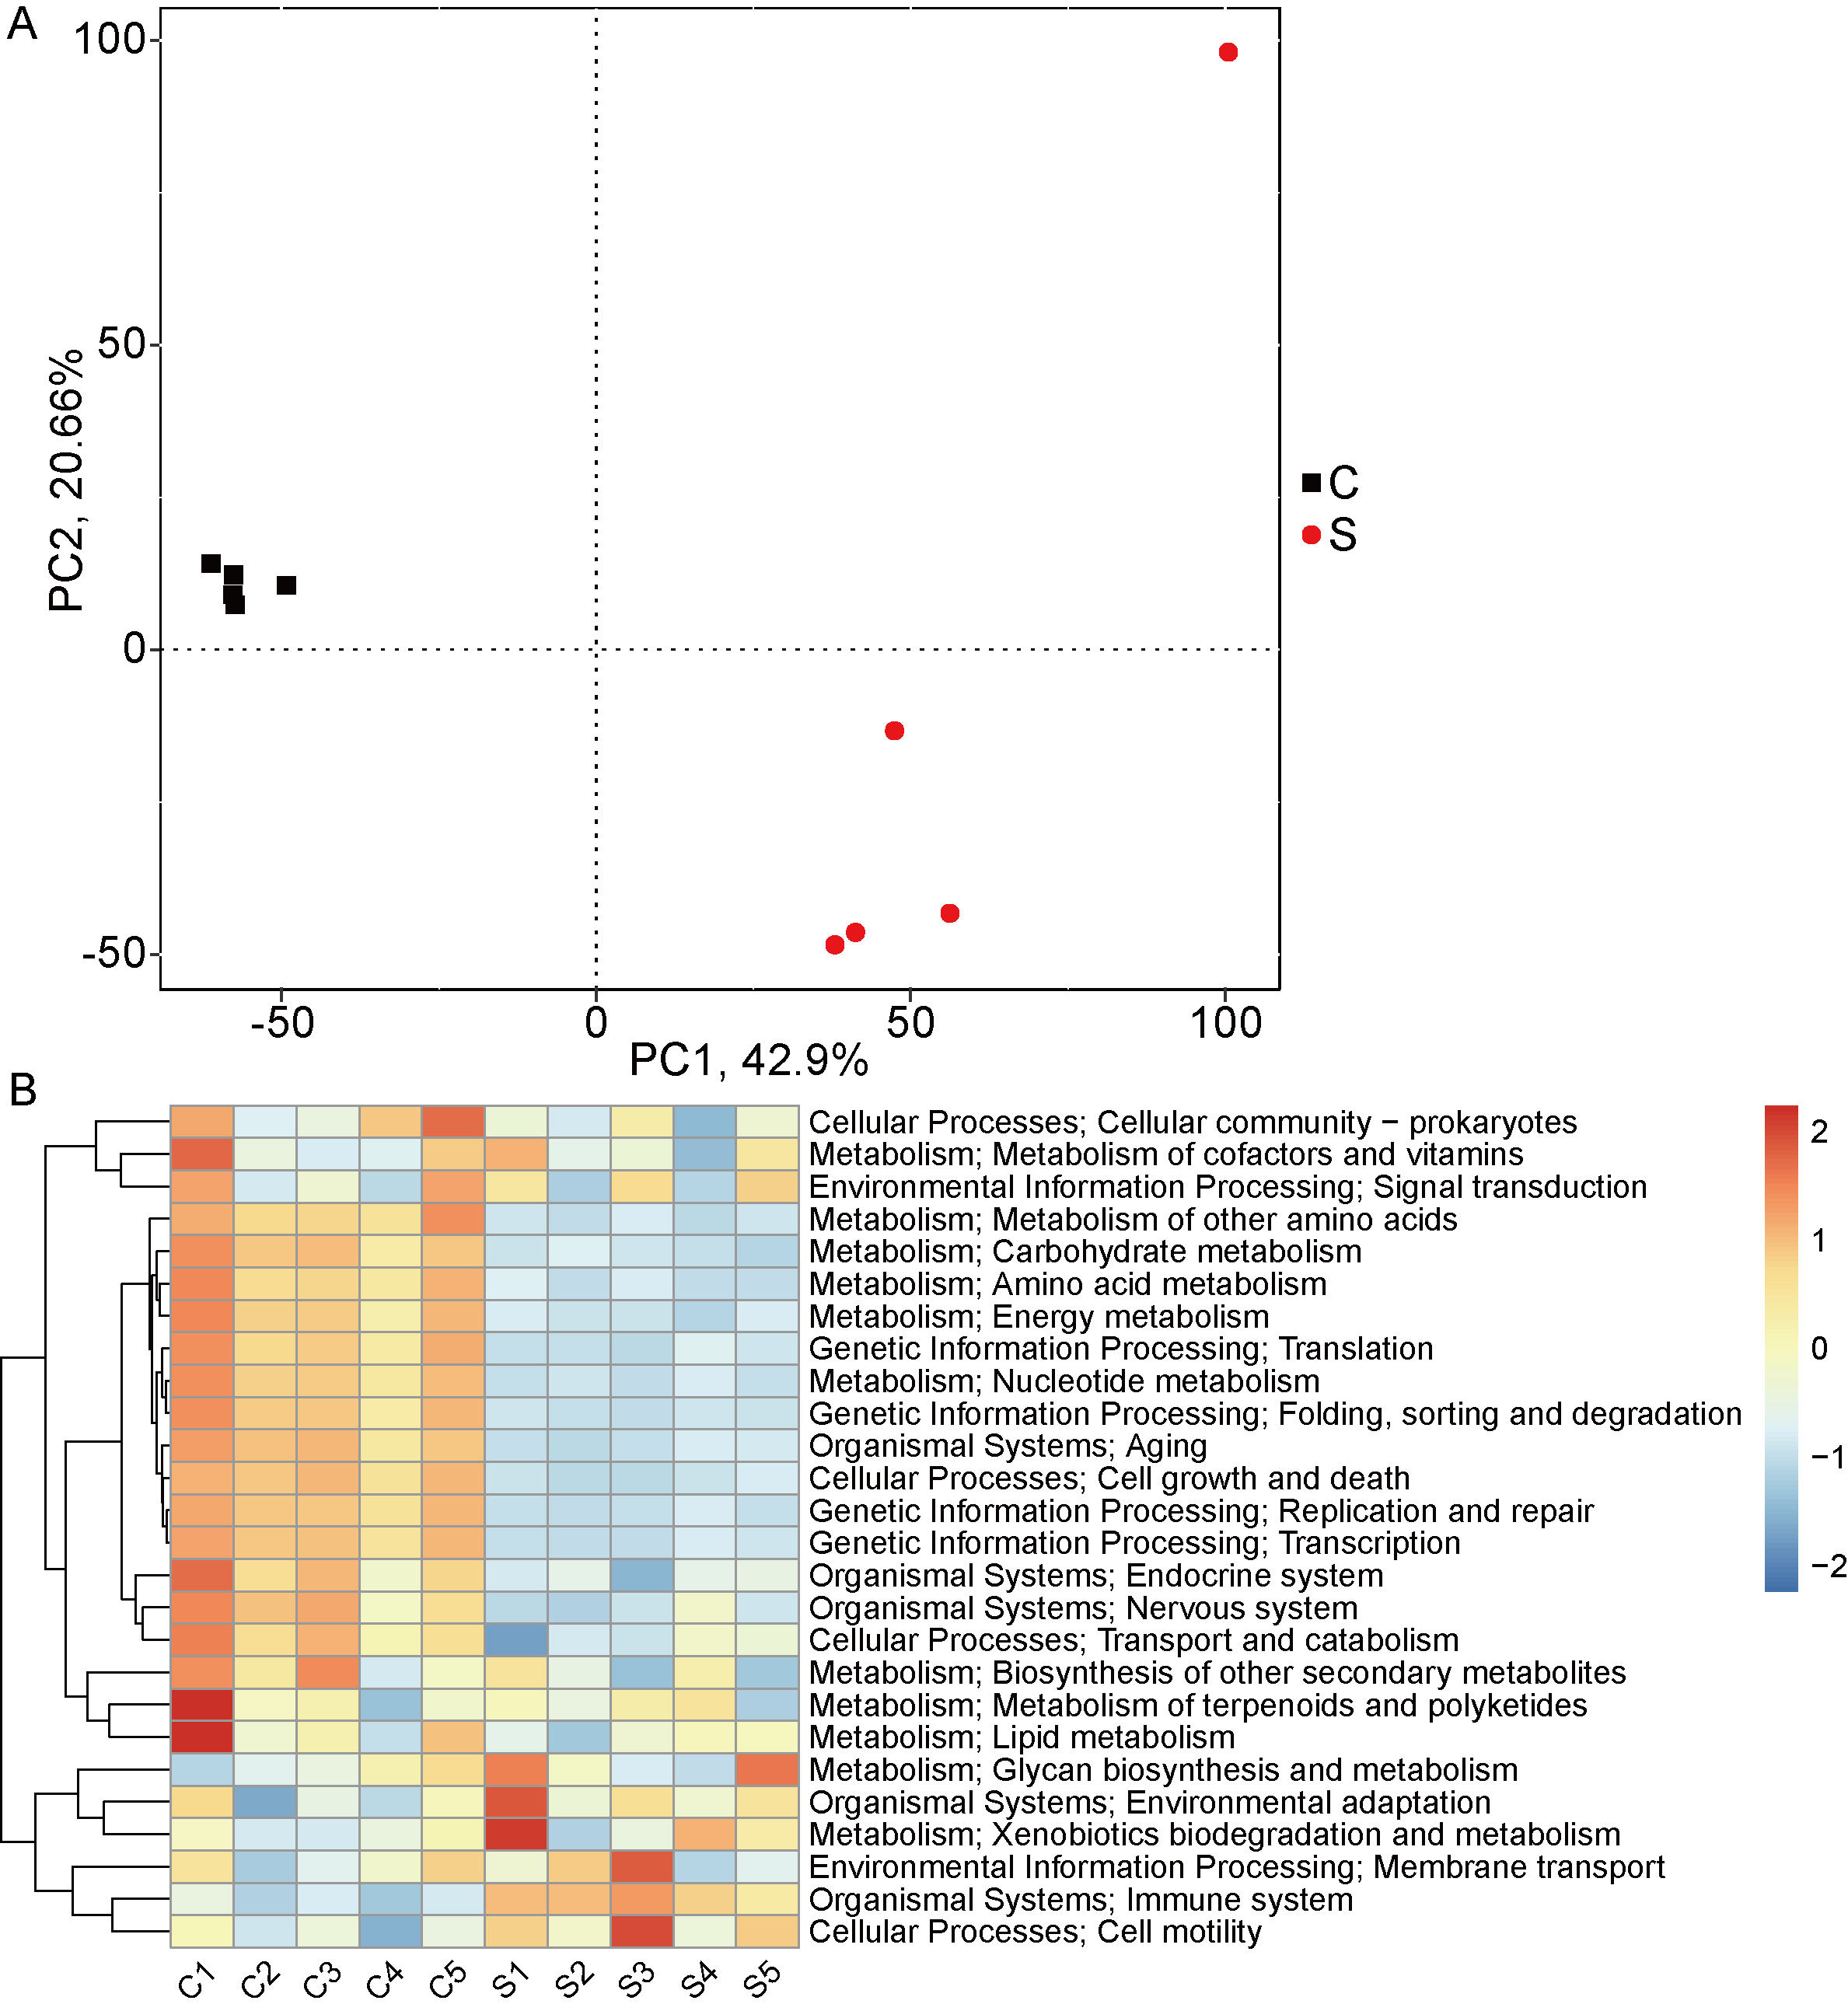
Fig. S2 Functional gene annotation and metabolic pathway analysis
A PCA analysis results displayed based on KEGG function abundance; B Clustering analysis based on level 2 of KEGG database.

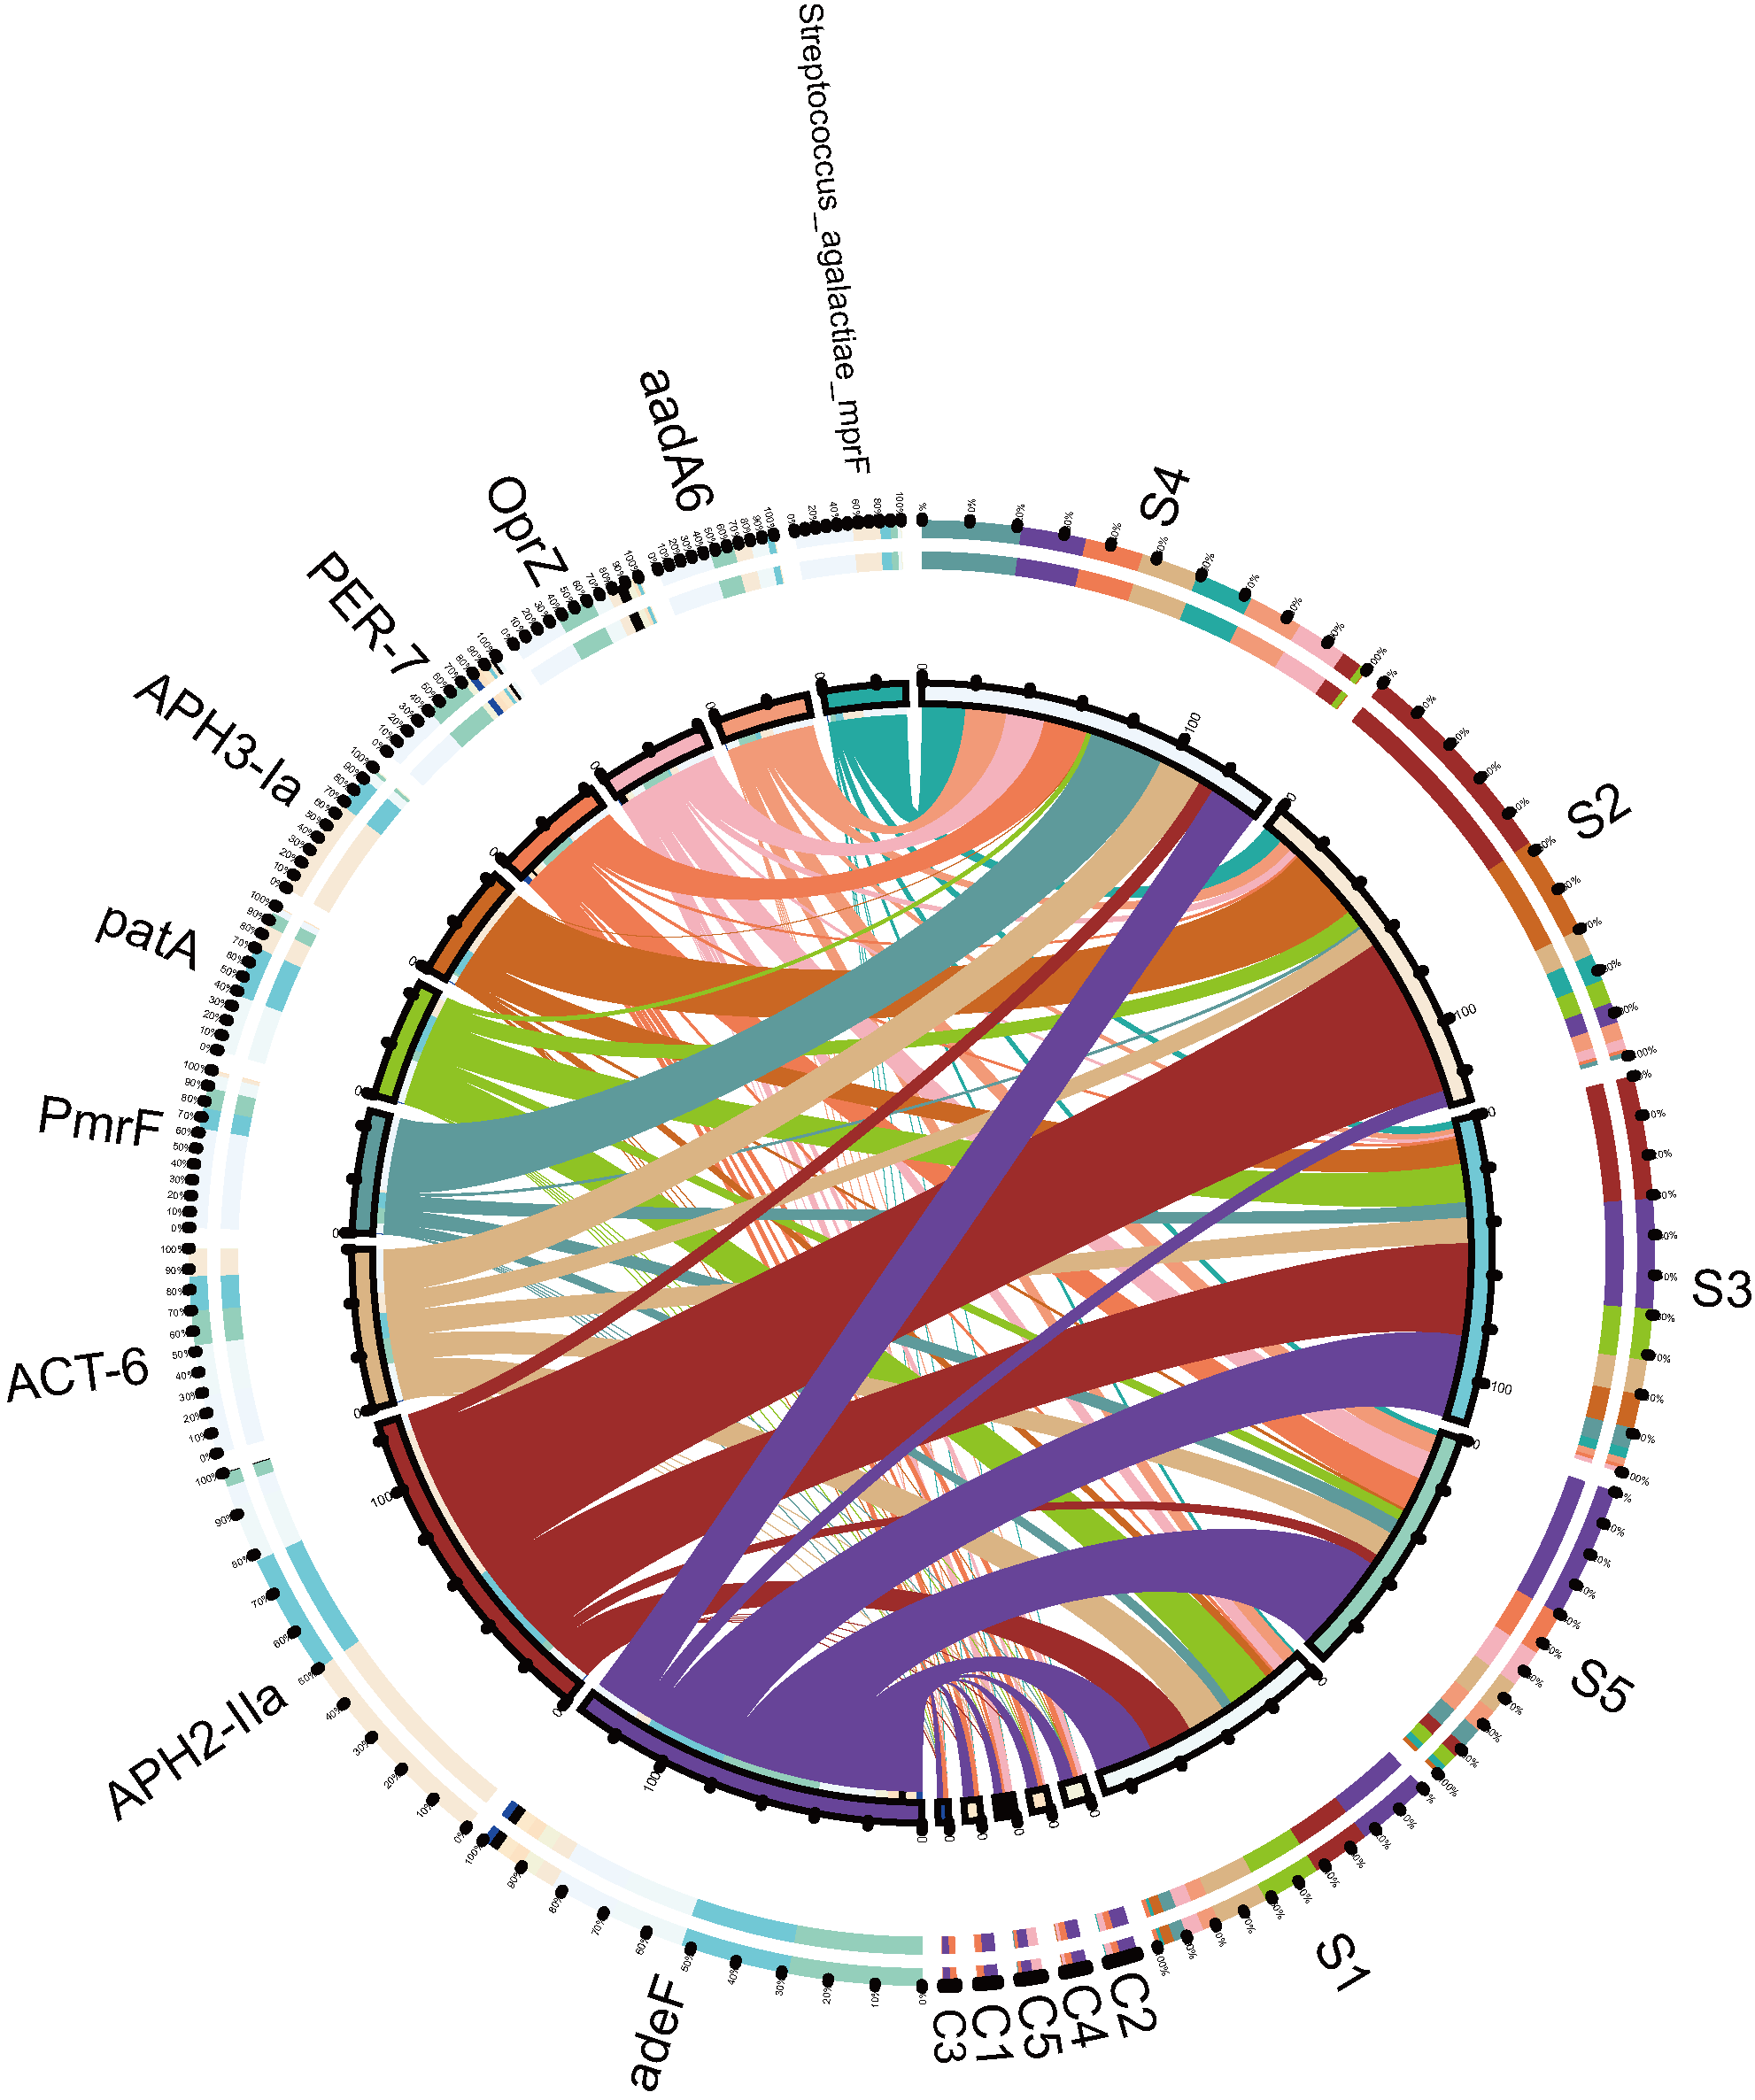
Fig. S3 Overview of the distribution ratio of resistance gene types in groups S and C. Different colors in the inner circle indicate different samples and resistance genes. The left side is the sum of the relative abundance of resistance genes of all samples, while the right side is the relative abundance of resistance genes in one sample.

