Rapid identification of Sporothrix brasiliensis by MALDI-TOF MS directly from clinical cultures in an Amazonian epidemic setting
Brazilian Journal of Microbiology
Daniel dos Santos Caldas^{1*}, Gabriel Silas Marinho de Sousa¹, Pedro Henrique Oliveira Favacho¹, Rodrigo Santos de Oliveira², Elaine Patrícia Tavares do Espírito Santo² e Silvia Helena Marques da Silva^{1,2}
¹ Programa de Pós-Graduação em Biologia de Agentes Infecciosos e Parasitários, Instituto de Ciências Biológicas, Universidade Federal do Pará, Belém 66075-110, Pará, Brazil
² Laboratório de Micoses Superficiais e Sistêmicas, Seção de Bacteriologia e Micologia, Instituto Evandro Chagas, Ananindeua 67030-000, Pará, Brazil
*Corresponding author email: dancaldas@yahoo.com

SUPPLEMENTARY MATERIAL

Table S1 Data regarding the isolates used for validation of the in-house library
Isolate | Source | Organism | Geography | Genbank | MALDI TOF MS Score
 |  |  |  |  | Filamentous | Yeast-like
IEC7321 | Human | Sporothrix brasiliensis | Pará, Brazil | PZ028649 | 2.01 | 2.39
IEC7322 | Human | Sporothrix brasiliensis | Pará, Brazil | PZ028650 | 2.12 | 2.31
IEC7325 | Human | Sporothrix brasiliensis | Pará, Brazil | PZ028651 | 2.08 | 2.33
IEC7332 | Human | Sporothrix brasiliensis | Pará, Brazil | PZ028652 | 2.12 | 2.46
IEC7334 | Human | Sporothrix brasiliensis | Pará, Brazil | PZ028653 | 2.10 | 2.42
IEC7345 | Human | Sporothrix brasiliensis | Pará, Brazil | PZ028654 | 2.11 | 2.39
IEC7346 | Human | Sporothrix brasiliensis | Pará, Brazil | PZ028655 | 2.02 | 2.46
IEC7347 | Human | Sporothrix brasiliensis | Pará, Brazil | PZ028656 | 2.10 | 2.43
IEC7348 | Human | Sporothrix brasiliensis | Pará, Brazil | PZ028657 | 2.10 | 2.36
IEC7350 | Human | Sporothrix brasiliensis | Pará, Brazil | PZ028658 | 2.18 | 2.37
IEC7363 | Human | Sporothrix brasiliensis | Pará, Brazil | PZ028660 | 2.06 | 2.35
IEC7392 | Human | Sporothrix brasiliensis | Pará, Brazil | PZ028673 | 2.04 | 2.41
IEC7397 | Human | Sporothrix brasiliensis | Pará, Brazil | PZ028676 | 2.01 | 2.18
IEC7399 | Human | Sporothrix brasiliensis | Pará, Brazil | PZ028677 | 2.16 | 2.20
IEC7417 | Human | Sporothrix brasiliensis | Pará, Brazil | PZ028683 | 2.05 | 2.17
IEC7425 | Human | Sporothrix brasiliensis | Pará, Brazil | PZ028686 | 2.18 | 2.55
IEC7428 | Human | Sporothrix brasiliensis | Pará, Brazil | PZ028687 | 2.14 | 2.37
IEC7430 | Human | Sporothrix brasiliensis | Pará, Brazil | PZ028688 | 2.06 | 2.32
IEC7433 | Human | Sporothrix brasiliensis | Pará, Brazil | PZ028689 | 2.21 | 2.52
IEC7437 | Human | Sporothrix brasiliensis | Pará, Brazil | PZ028690 | 2.13 | 2.38
IEC7439 | Human | Sporothrix brasiliensis | Pará, Brazil | PZ028691 | 2.18 | 2.43
IEC7441 | Human | Sporothrix brasiliensis | Pará, Brazil | PZ028692 | 2.13 | 2.38
IEC7442 | Human | Sporothrix brasiliensis | Pará, Brazil | PZ028693 | 2.11 | 2.34
IEC7534 | Human | Sporothrix brasiliensis | Pará, Brazil | PZ028694 | 2.06 | 2.43
IEC7535 | Human | Sporothrix brasiliensis | Pará, Brazil | PZ028695 | 2.02 | 2.37
IEC7552 | Human | Sporothrix brasiliensis | Pará, Brazil | PZ028702 | 2.18 | 2.46
IEC7553 | Human | Sporothrix brasiliensis | Pará, Brazil | PZ028703 | 2.15 | 2.45
UFRA10 | Feline | Sporothrix brasiliensis | Pará, Brazil | PZ067666 | 2.22 | 2.36
UFRA11.1 | Feline | Sporothrix brasiliensis | Pará, Brazil | PZ067667 | 2.01 | 2.46
UFRA11.2 | Feline | Sporothrix brasiliensis | Pará, Brazil | PZ067668 | 2.11 | 2.49
UFRA14 | Feline | Sporothrix brasiliensis | Pará, Brazil | PZ067673 | 2.06 | 2.41
UFRA15.2 | Feline | Sporothrix brasiliensis | Pará, Brazil | PZ067675 | 2.11 | 2.32
UFRA16.1 | Feline | Sporothrix brasiliensis | Pará, Brazil | PZ067678 | 2.12 | 2.43
UFRA16.2 | Feline | Sporothrix brasiliensis | Pará, Brazil | PZ067679 | 2.2 | 2.38
UFRA18 | Feline | Sporothrix brasiliensis | Pará, Brazil | PZ067681 | 2.02 | 2.49
UFRA19.2 | Feline | Sporothrix brasiliensis | Pará, Brazil | PZ067683 | 2.09 | 2.46
UFRA21.1 | Feline | Sporothrix brasiliensis | Pará, Brazil | PZ067685 | 2.05 | 2.53
UFRA22.1 | Feline | Sporothrix brasiliensis | Pará, Brazil | PZ067687 | 2.05 | 2.42
UFRA22.2 | Feline | Sporothrix brasiliensis | Pará, Brazil | PZ067688 | 2.09 | 2.37
UFRA22.3 | Feline | Sporothrix brasiliensis | Pará, Brazil | PZ067689 | 2.18 | 2.30
UFRA23.1 | Feline | Sporothrix brasiliensis | Pará, Brazil | PZ067690 | 2.1 | 2.51
UFRA23.2 | Feline | Sporothrix brasiliensis | Pará, Brazil | PZ067691 | 2.08 | 2.45
UFRA24.1 | Feline | Sporothrix brasiliensis | Pará, Brazil | PZ067692 | 2.04 | 2.34
UFRA24.2 | Feline | Sporothrix brasiliensis | Pará, Brazil | PZ067693 | 2.18 | 2.40
UFRA25 | Feline | Sporothrix brasiliensis | Pará, Brazil | PZ067694 | 2.13 | 2.42
UFRA26.2 | Feline | Sporothrix brasiliensis | Pará, Brazil | PZ067695 | 2.02 | 2.36

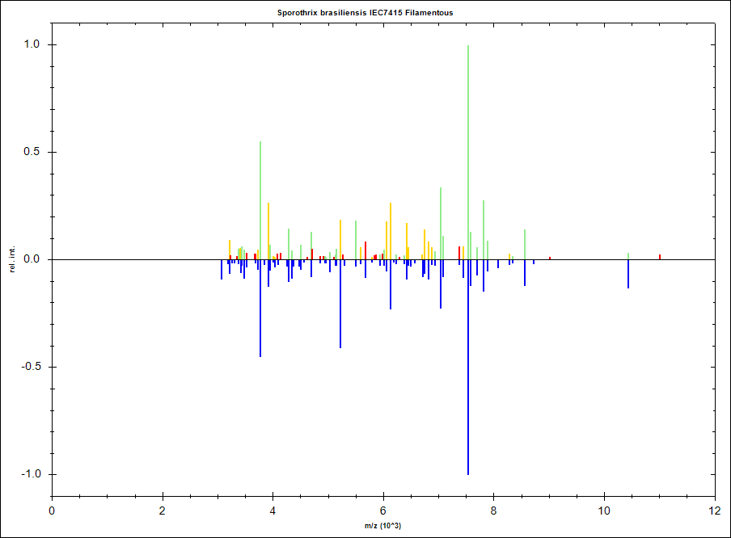
Fig. S1 Comparison of two Main Spectra Profiles (MSPs). The upper spectrum represents IEC7415 yeast-like MSP and the lower, inverted spectrum represents IEC7415 filamentous MSP
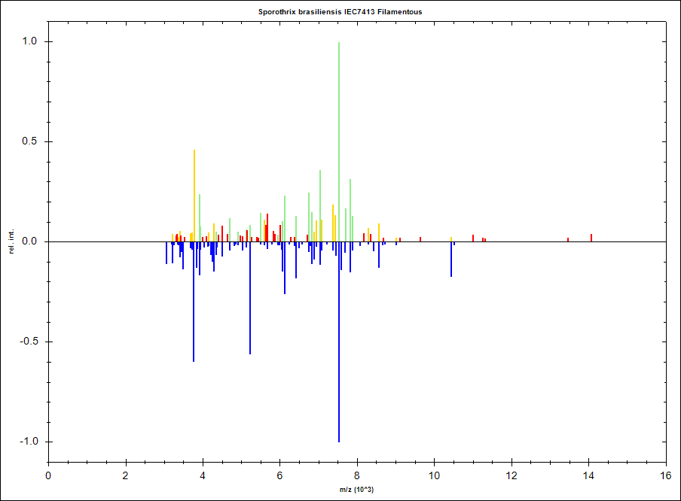
Fig. S2 Comparison of two Main Spectra Profiles (MSPs). The upper spectrum represents IEC7413 yeast-like MSP and the lower, inverted spectrum represents IEC7413 filamentous MSP
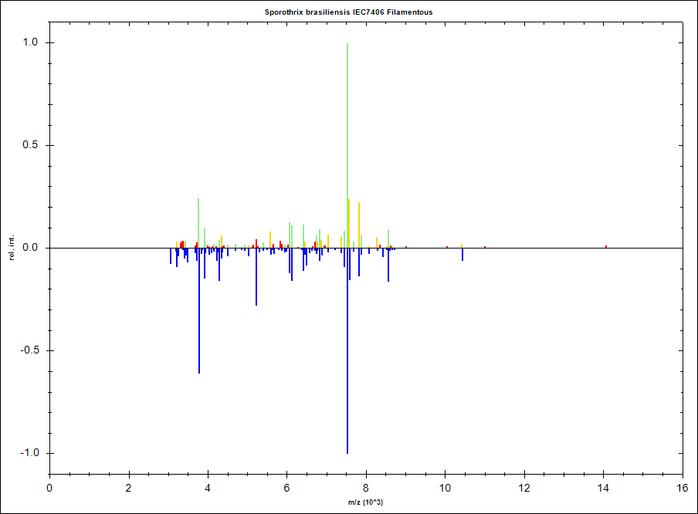
Fig. S3 Comparison of two Main Spectra Profiles (MSPs). The upper spectrum represents IEC7406 yeast-like MSP and the lower, inverted spectrum represents IEC7406 filamentous MSP
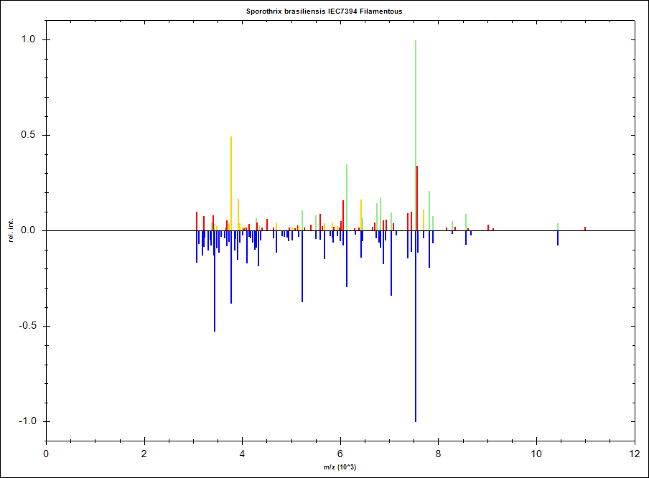
Fig. S4 Comparison of two Main Spectra Profiles (MSPs). The upper spectrum represents IEC7394 yeast-like MSP and the lower, inverted spectrum represents IEC7394 filamentous MSP
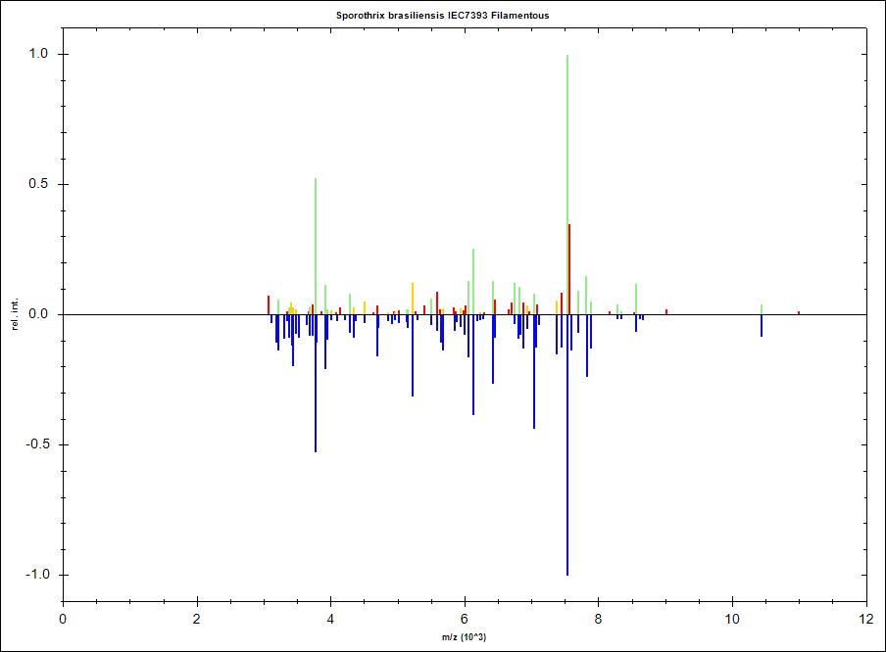
Fig. S5 Comparison of two Main Spectra Profiles (MSPs). The upper spectrum represents IEC7393 yeast-like MSP and the lower, inverted spectrum represents IEC7393 filamentous MSP
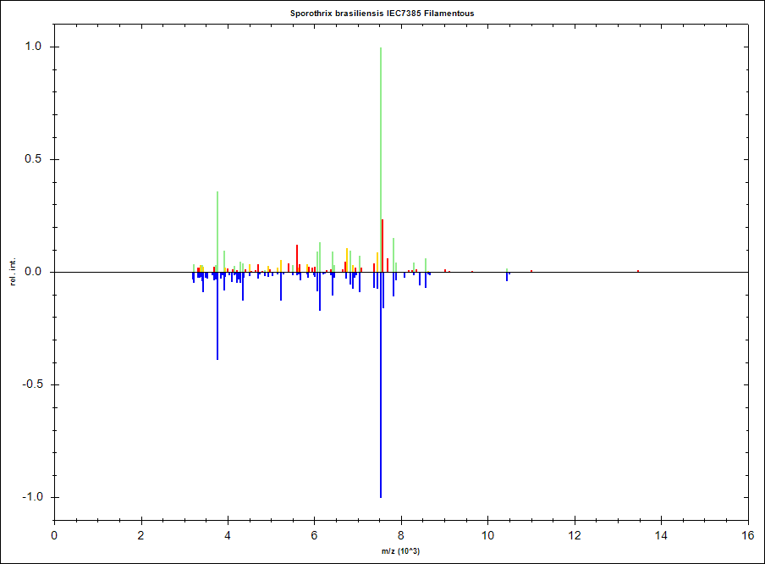
Fig. S6 Comparison of two Main Spectra Profiles (MSPs). The upper spectrum represents IEC7385 yeast-like MSP and the lower, inverted spectrum represents IEC7385 filamentous MSP
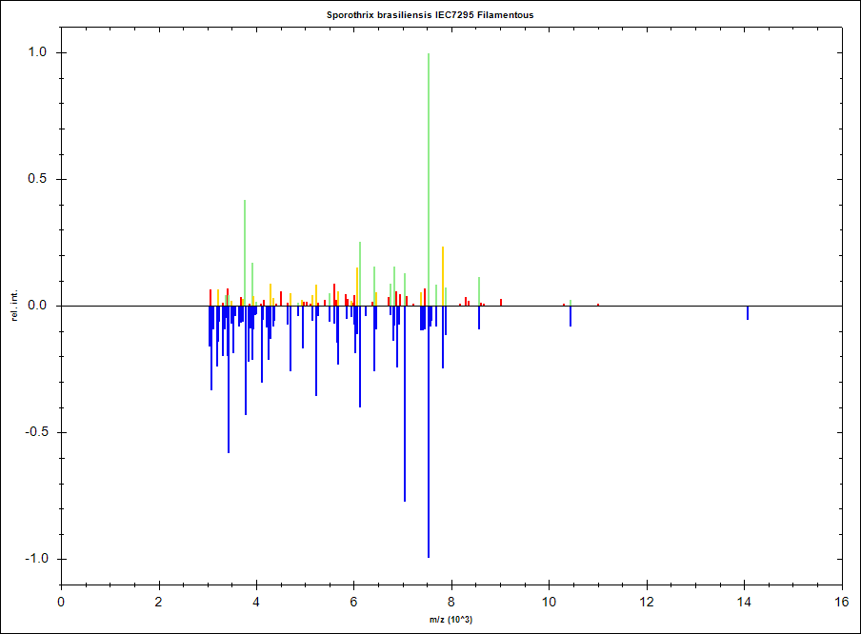
Fig. S7 Comparison of two Main Spectra Profiles (MSPs). The upper spectrum represents IEC7295 yeast-like MSP and the lower, inverted spectrum represents IEC7295 filamentous MSP
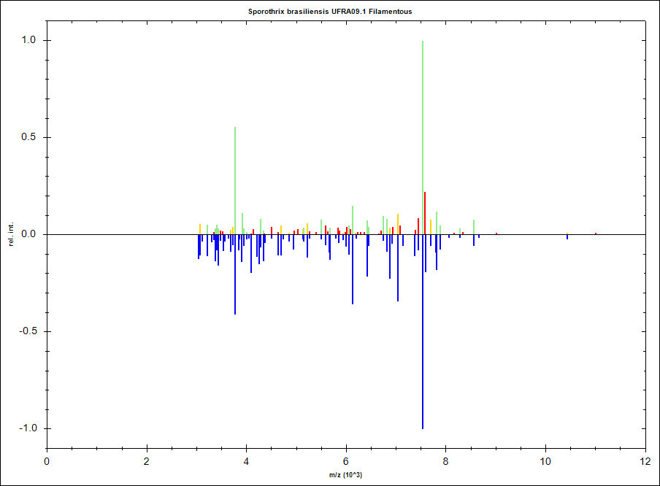
Fig. S8 Comparison of two Main Spectra Profiles (MSPs). The upper spectrum represents UFRA09.1 yeast-like MSP and the lower, inverted spectrum represents UFRA09.1 filamentous MSP
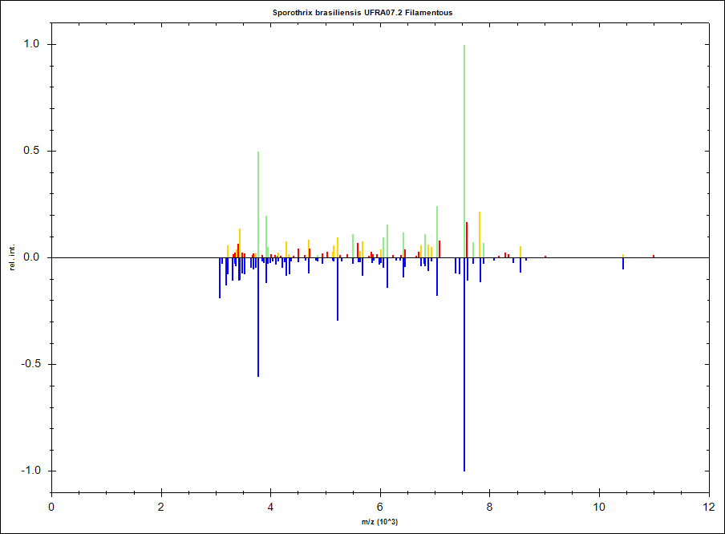
Fig. S9 Comparison of two Main Spectra Profiles (MSPs). The upper spectrum represents UFRA07.2 yeast-like MSP and the lower, inverted spectrum represents UFRA07.2 filamentous MSP
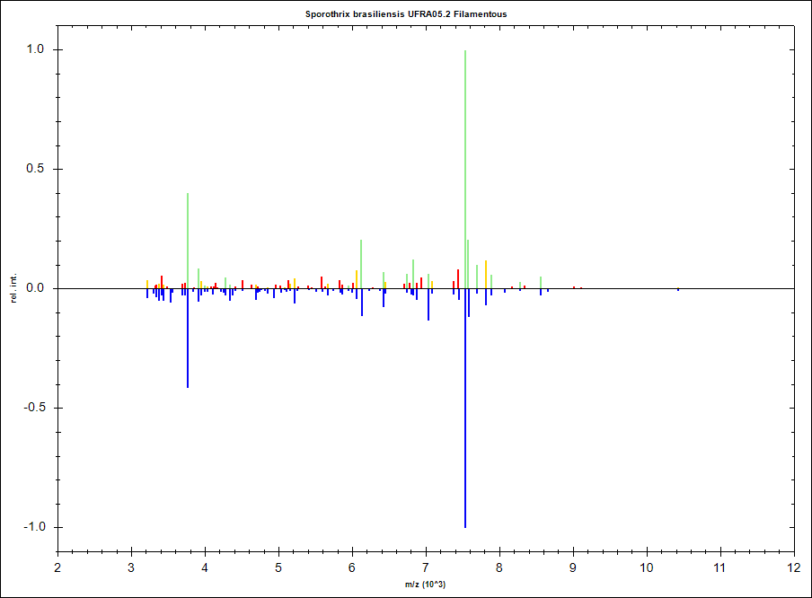
Fig. S10 Comparison of two Main Spectra Profiles (MSPs). The upper spectrum represents UFRA05.2 yeast-like MSP and the lower, inverted spectrum represents UFRA05.2 filamentous MSP
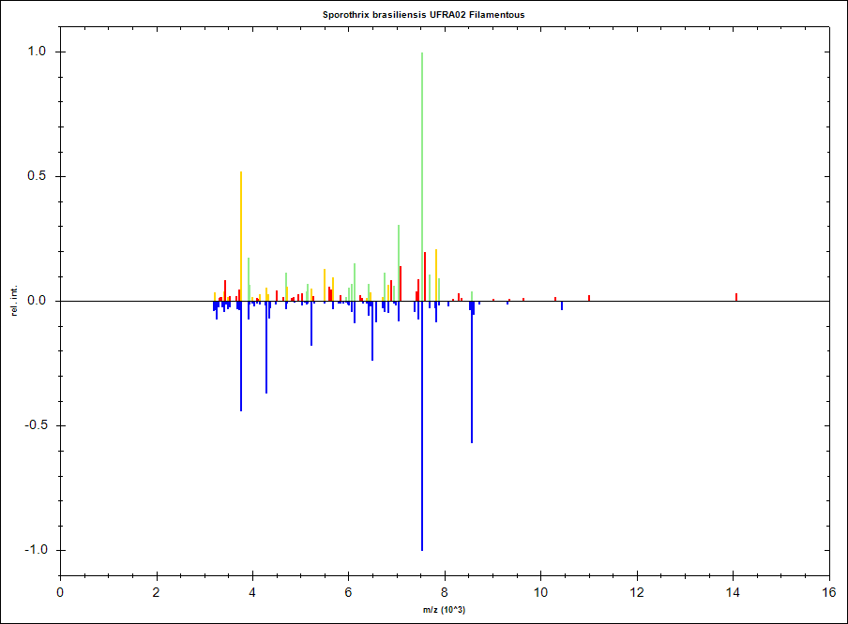
Fig. S11 Comparison of two Main Spectra Profiles (MSPs). The upper spectrum represents UFRA02 yeast-like MSP and the lower, inverted spectrum represents UFRA02 filamentous MSP
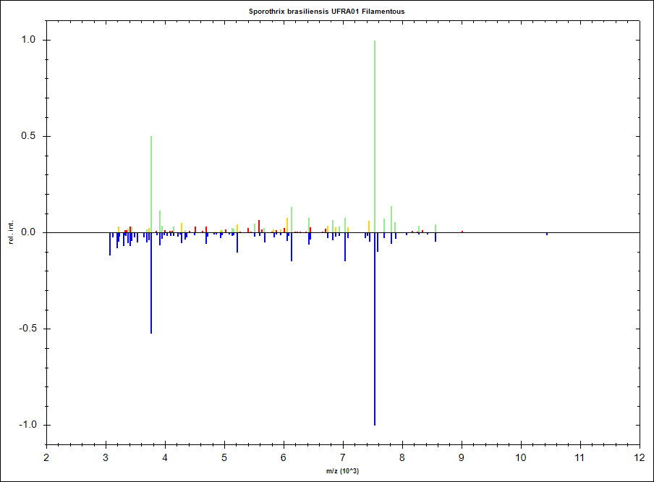
Fig. S12 Comparison of two Main Spectra Profiles (MSPs). The upper spectrum represents UFRA01 yeast-like MSP and the lower, inverted spectrum represents UFRA01 filamentous MSP

