Whole-grain pet biscuits made with millet flour (Pennisetum glaucum) and probiotic lactic acid bacteria

Supplementary material 1

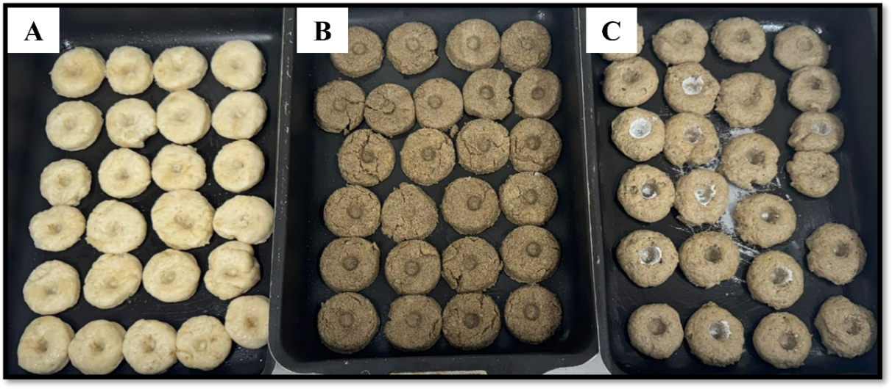
Supplementary material 1 1. Dog biscuits made with wheat flour - WF (A), millet flour - MF (B), and both wheat and millet flour – WMF (C)

