Supplementary Tables & Figures:
Fig. S1. Collection site of Tri-State Mine soil (A), back hoe collection method (B), and redoxy-morphic features of soil (C).
Table S1. Chemical properties of Tri-State mine soil.
Table S2. Chemical and physical properties of compost and biochars.
Table S3. Treatments used in Switchgrass greenhouse experiment.

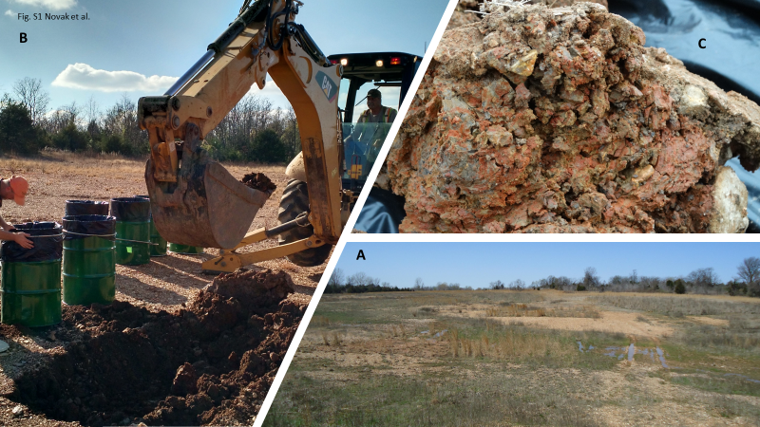

Fig. S1 Novak et al.

Table S1. Chemical properties of Tri-State Mine soil (means of n = 3; standard deviation in parentheses; ND = not determined; 0 value = below detection)
 |  | Extractable metal (mg/kg)
Element | Total metal (mg/kg)† | H₂O | 0.01 M CaCl₂
Al | ND | 4.40 (3.87) | 11.36 (1.56)
Cl | ND | ND | ND
Cd | 72.2 (2.7) | 5.73 (0.98) | 50.45 (0.40)
Cr | ND | 0 | 0.12 (0.01)
Cu | 66.5 (2.5) | 0.22 (0.07) | 2.17 (0.02)
Fe | ND | 10.57 (2.11) | 12.65 (1.45)
K | 711 (25) | 26.18 (3.47) | 59.48 (3.35)
Mg | 355 (45) | 4.53 (1.38) | 36.49 (0.97)
Mn | 72 (5.7) | 2.48 (0.72) | 21 (0.9)
Na | ND | 22.25 (4.01) | 25.58 (4.24)
Ni | 7.6 (0.3) | 0.18 (0.01) | 0.45 (0.01)
P | 168 (4) | 3.89 (0.06) | 1.43 (1.30)
Pb | 23.5 (0.7) | 0 | 0
SO₄ | ND | 152.6 (19.4) | 112.8 (17.4)
Zn | 2225 (12) | 141.0 (25.7) | 782 (13)
†samples digested using 4M HNO₃

Table S2. Chemical and physical properties of compost and biochars (dry-basis)
- Ultimate and proximate analysis
 | Beef cattle manure |  | Lodgepole pine | Poultry litter
Measurement (%) | Compost | biochar | biochar | biochar
C | 17.5 | 13.8 | 90.5 | 37.4
H | 1.9 | 0.7 | 2.4 | 2.8
O | 10.5 | 1.4 | 3.2 | 13.0
N | 1.6 | 1.0 | 0.7 | 4.2
S | 0.09 | 0.02 | < 0.001 | 0.07
Ash | 68.4 | 83.1 | 3.2 | 42.5
Fixed C | 6.1 | 9.4 | 82.5 | 21.2
Volatile matter | 25.5 | 7.5 | 14.3 | 36.3
pH | 6.8 | 9.5 | 9.7 | 9.1
O/C | 0.46 | 0.07 | 0.03 | 0.26
H/C | 1.29 | 0.60 | 0.32 | 0.89
- Elemental analysis of ash (%, ash wt basis)
Al | 3.0 | 2.9 | 0.9 | 0.9
As | < 0.005 | < 0.005 | 0.1 | < 0.005
Ca | 3.0 | 2.8 | 11.8 | 11.6
Cd | < 0.005 | < 0.005 | < 0.005 | < 0.005
Cl | < 0.01 | < 0.01 | 0.6 | 5.6
Cr | < 0.005 | < 0.005 | 0.15 | 0.01
Cu | 0.005 | 0.005 | 0.26 | 0.4
Fe | 1.43 | 1.41 | 1.13 | 1.11
K | 2.2 | 2.13 | 3.9 | 18.0
Mg | 0.93 | 0.90 | 2.6 | 3.9
Mn | 0.09 | 0.10 | 0.35 | 0.28
Na | 0.31 | 0.30 | 1.1 | 4.5
Ni | 0.005 | 0.006 | 0.03 | 0.016
P | 0.67 | 0.68 | 0.4 | 8.6
Pb | < 0.005 | < 0.005 | 0.09 | < 0.005
S | 0.25 | 0.22 | 0.58 | 4.9
Si | 77.6 | 77.2 | 18.2 | 8.4
Zn | 0.03 | 0.03 | 0.09 | 0.23

Table S3. Treatments used in Switchgrass greenhouse experiment.
% application rate (w/w)
Biochar | Compost
0 | 0
0 | 2.5
0 | 5
2.5 | 0
2.5 | 2.5
2.5 | 5
5 | 0
5 | 2.5
5 | 5

