List of Appendix

- Experimental setup of the one–dimensional soil columns during the wetting
- Experimental setup of the one–dimensional soil columns during the drying

- Experimental setup of the one–dimensional soil columns during the wetting

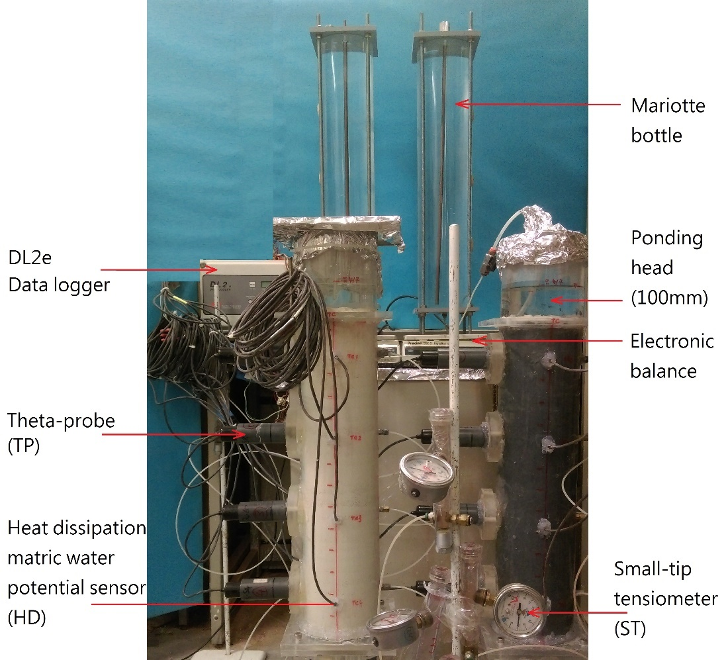

- Experimental setup of the one–dimensional soil columns during the drying

