Supplementary Information

Magnetic Fe₂O₃/biochar composite prepared in a molten salt medium for antibiotic removal in Water
Huagen Liang^{1,3}, Chenxi Zhu^{1,3}, Shan Ji^{2*}, Palanisamy Kannan², Fu Chen,^{1,4**}
¹ Jiangsu Key Laboratory of Coal-based Greenhouse Gas Control and Utilization, China University of Mining and Technology, Low Carbon Energy Institute, China University of Mining and Technology, Xuzhou, 221008, China
² College of Biological, Chemical Science and Engineering, Jiaxing University, Jiaxing, 314001, China
³ School of Materials Science and Engineering, China University of Mining and Technology, Xuzhou, 221008, China
⁴ School of Environment Science and Spatial Informatics, China University of Mining and Technology, Xuzhou, 221008, China

Corresponding authors:
Shan Ji (*): jishan@zjxu.edu.cn, Tel./fax: +86 (0)573 83643264
Fu Chen (**): chenfu@cumt.edu.cn, Tel./fax: +86(0)516 83883501

Table S1 Physical and chemical properties of CPW-700 and PWC-700.
Samples | Yield | pH | BET surface area  (m² g⁻¹) | Average pore size  (nm) | Pore volume  (cm³ g⁻¹) | saturation magnetization  (emu g⁻¹)
CPW-700 | 51.3% | 6.72 | 431.59 | 2.12 | 0.23 | 47.0
PWC-700 | 34.1% | 7.18 | 422.06 | 3.17 | 0.33 | 0

Fig. S1 High-resolution XPS spectrum of C 1s (a) and O 1s (b) of CPW-700 and PWC-700.

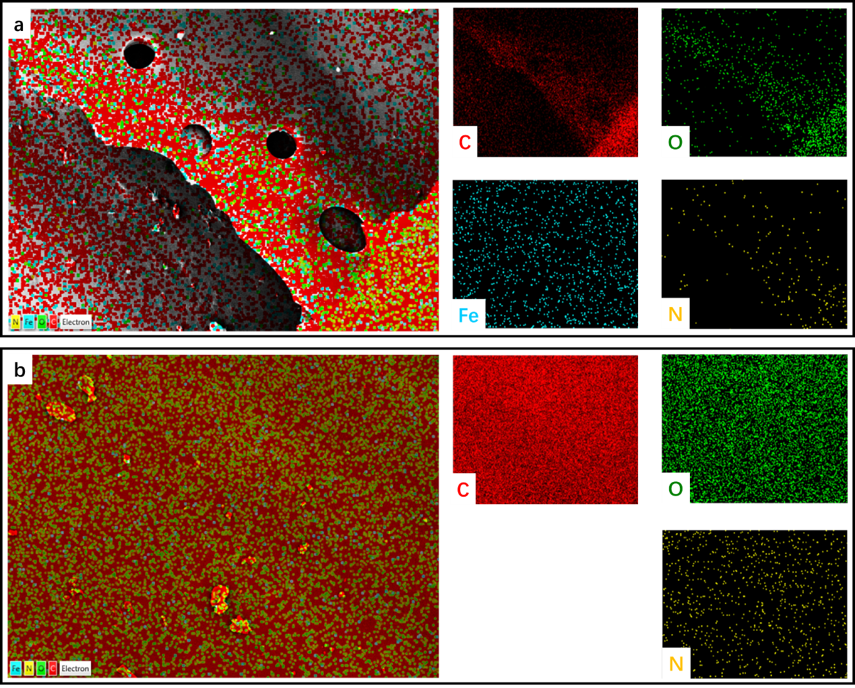
Fig. S2 The elemental mapping results of CPW-700 (a) and PWC-700 (b).

Samples | Pseudo-first-order |  | Pseudo-second-order |  |  | Intra-particle diffusion model
 | k₁(×10²)  （min⁻¹） | R² | k₂  （g/mg.min） | q_{e}  （mg/g） | R² | k_{i}  （mg/g.min^{1/2}） | R²
CPW-700 | 0.004 | 0.9936 | 0.015 | 80.97 | 0.9991 | 0.39 | 0.6136
PWC-700 | 0.002 | 0.9041 | 0.012 | 33.28 | 0.9977 | 0.37 | 0.5863
Table S2. Kinetic parameters for NOR adsorption on CPW-700 and PWC-700

Table S3. Parameters of Langmuir and Freundlich models for NOR adsorption.
Samples | Freundlich isotherm model |  |  | Langmuir isotherm model
Samples | 1/n | K_{f}  （mg^{(n+1)}/g/L^{n}） | R² | Q_{m}  （mg/g） | K_{L}  (mg/L) | R²
CPW-700 | 0.67 | 4.86 | 0.9953 | 379.85 | 0.005 | 0.9997
PWC-700 | 0.88 | 1.73 | 0.9804 | 275.69 | 0.002 | 0.9858

Table S4. Adsorption thermodynamic parameters of CPW-700 and PWC-700.
Samples | ΔH  (kJ/mol) | ΔS  (kJ/mol/K) | ΔG(kJ/mol)
Samples | ΔH  (kJ/mol) | ΔS  (kJ/mol/K) | 288.15 K | 298.15 K | 308.15 K
CPW-700 | 8.0001 | 0.0567 | -8.2521 | -9.0619 | -9.3859
PWC-700 | 5.1192 | 0.0198 | -0.6983 | -0.7131 | -1.0246

Fig. S3 FTIR spectra of CPW-700 and PWC-700 before and after adsorption.

Fig. S4 N₂ adsorption/desorption isotherms and corresponding pore size distribution (inset) of CPW-700 and PWC-700 after adsorption.

Table S5 Physical and chemical properties of CPW-700 and PWC-700.
Samples | BET surface area  (m² g⁻¹) | Average pore size  (nm) | Pore volume  (cm³ g⁻¹)
CPW-700 | 431.59 | 2.12 | 0.23
PWC-700 | 422.06 | 3.17 | 0.33
CPW-700+NOR | 327.28 | 1.56 | 0.13
PWC-700+NOR | 375.22 | 2.15 | 0.20

