Supporting Information (SI)

p-Arsanilic acid decontamination over a wide pH range using biochar-supported manganese ferrite material as an effective persulfate catalyst: Performances and mechanisms
Bin Yaoª, Xia Chenª, Kun Zhouª, Zirui Luoª, Peipei Liª, Zihui Yang^{b}, Yaoyu Zhouª*
ª Hunan International Scientific and Technological Cooperation Base of Agricultural Typical Pollution Remediation and Wetland Protection, College of Resources and Environment, Hunan Agricultural University, Changsha 410128, China
^{b} College of Veterinary Medicine, Hunan Agricultural University, Changsha 410128, China
The number of pages: 6
The number of tables: 1
The number of figures: 2

List of Supporting Information
Table:
Table S1. Porosity characteristic of BC and MFB. (Page S4).

Figures:
Fig. S1. Proposed degradation pathway of p-ASA in the MFB/PS system. (Page S5).
Fig. S2. Inorganic arsenic concentrations variations in the MFB/PS system. Reaction conditions: MFB = 1.0 g/L, PS = 2.1 mM, pH = 7.0, T = 298 K. (Page S6).
Table S1. Porosity characteristic of BC and MFB.
Materials | BC | MFB
SSA_{BET} (m²/g) | 9.82 | 97.83
Total pore volume (cm³/g) | 0.016 | 0.16
Average pore diameter (nm) | 7.72 | 8.53
BET: Brunauer-Emmett-Teller

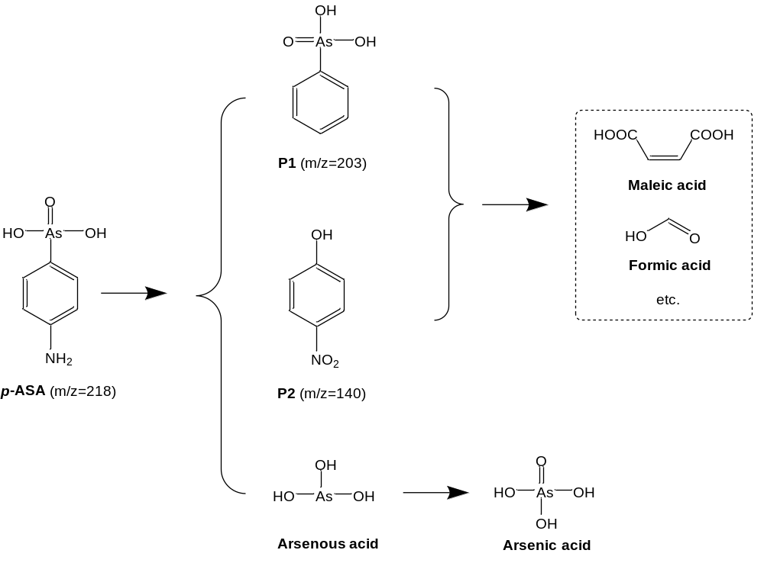
Fig. S1. Proposed degradation pathway of p-ASA in the MFB/PS system.
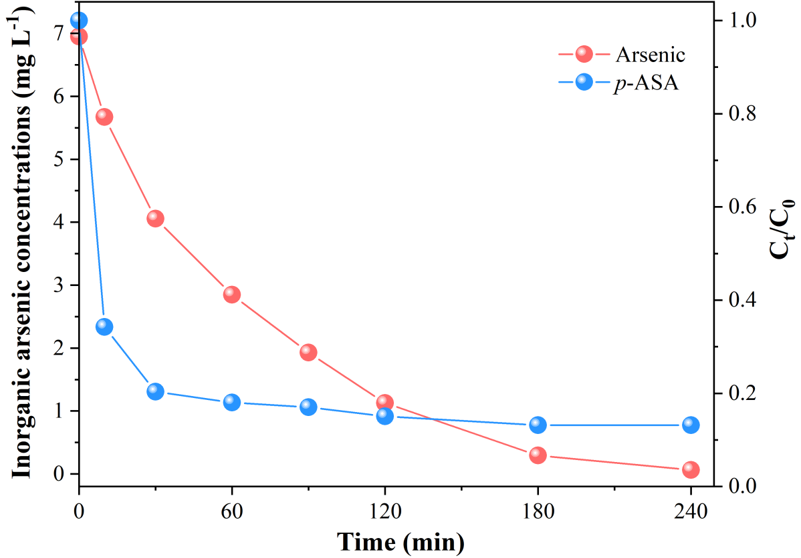
Fig. S2. Inorganic arsenic concentrations variations in the MFB/PS system. Reaction conditions: MFB = 1.0 g/L, PS = 2.1 mM, pH = 7.0, T = 298 K.

* Corresponding author: zhouyy@hunau.edu.cn, (Y. Zhou)

