A Nanoscale Observation to Explain the Discrepancy of Electron Exchange Capacities Between Biochar Containing Comparable Surface Redox Active Moieties
Supplementary Materials

Shasha Li^{1,3}, Liming Shao³, Hua Zhang^{1,2}, Xuemin Lu^{1,3}, Fan Lü^{1,2}*, Pinjing He^{3,4}*
1 State Key Laboratory of Pollution Control and Resource Reuse, Tongji University, Shanghai 200092, People’s Republic of China
2 Shanghai Institute of Pollution Control and Ecological Security, Shanghai 200092, People’s Republic of China
3 Institute of Waste Treatment and Reclamation, Tongji University, Shanghai 200092, People’s Republic of China
4 Shanghai Multi-source Solid Waste Collaborative Treatment and Energy Engineering Technology Research Center, Shanghai, People’s Republic of China
*Corresponding author: lvfan.rhodea@tongji.edu.cn (Fan Lü); solidwaste@tongji.edu.cn (Pinjing He)

Table of Contents (SI)
Text S1 Mediated electrochemical measurement 1
Text S2 Operations of Py-GC/MS 2
Text S3 XPS data processing 2
Reference 17
Tables and Figures (SI)
Figure S1 Thermogravimetry (TG) and derivative thermogravimetry (DTG) curves of polymer feedstocks a) starch, b) indigo, c) lignin 2
Figure S2 The size histogram of fine particles on the surface of bulk chars a) st700 b) ind400 3
Figure S3 Amount of exfoliated biochar under ultrasonic intensity gradient a) st700 b) ind400 4
Figure S4 Current-time (I-t) curves of raw biochar in mediated electrochemical oxidation measurement 5
Figure S5 Current-time (I-t) curves of raw biochar in mediated electrochemical reduction measurement 6
Figure S6 Current-time (I-t) curves of residue biochar in mediated electrochemical measurement a)st700 b)ind400 7
Figure S7 SEM images of a) st300, b) st700, c) ind400, d) ind700, e) lig300, f) lig700 8
Figure S8 Dry effect on the EDC of ind400 and st700 9
Figure S9 Molecular information of exfoliated and residue char fractions from st700 and ind400 by Py-GC/MS. 10
Figure S10 Current-Voltage (I-V) curves of spots on st700 a) conductivity dominated spot, b) redox property dominated spot 11
Figure S11 Topography of st700 before a) and after b) 5V potential scan 12
Table S1 Pyrolysis products of st700 analyzed by Py-GC/MS 13
Table S2 Pyrolysis products of ind400 analyzed by Py-GC/MS 15
Table S3 The assignments of deconvolved peaks from Raman spectra and fitted parameters^{[6-7]} 17
Table S4 The area ratios of peaks to G band (G_{G}) 18

Text S1 Mediated electrochemical measurement
A three-electrode electrochemical system comprised a 9-mL glassy carbon cylinder (Sigradur G, HTW, Germany) working as both working electrode (WE) and reaction vessel, an Ag/AgCl reference electrode (ida Co, Ltd., China) and a coiled platinum wire separated from the WE chamber by a porous glass frit. 5 mL buffer (0.1 M KCl, 0.1 M phosphate, pH 7) was used as the electrolyte. Redox potential (E_{h}= – 0.69 V for MER, E_{h}= +0.41 V for MEO vs. Ag/AgCl electrode) was applied. 120 μL ABTs (2,2′-azinobis(3-ethylbenzthiazoline-6-sulfonic-acid) diammonium salt, purchased from Sigma-Aldrich) and DQ (diquat dibromide monohydrate, purchased from Sigma-Aldrich) solution (10 mM) were added to the cell as mediators for MEO and MER, respectively. When the equilibrium was attained, 100 μL-200uL sample suspension (2 g/L) was spiked into the cell, then the EDC and EAC were calculated by integrating the subsequently caused current peak through the equation below:
EDC or EAC$=\frac{\int{Idt}}{FM_{a}}$ (S1)
Where I is the baseline-corrected currents, F is the Faraday constant, M_{a} is the mass of added samples, and the EDC or EAC unit is mmol e⁻/g.
All solutions were purged with N₂ for 45 min to remove oxygen and then transferred into an anaerobic glovebox (AW400SG/TG, Electrotek, Britain) for subsequent use. Magnetic stirring was on over the measurement for mixing. All the implementations during the measurement were conducted in the glovebox (AW400SG/TG, Electrotek, Britain).

Text S2 Operations of Py-GC/MS
Py-GC/MS analysis was conducted by a combined instrument (QP-2010Ultra, Shimadzu, Japan). Briefly, samples were placed in a Pt boat and subsequently fell freely into a pre-heated tube (900 °C) for pyrolysis, of which the pyrolyzed products were separated by the conjoint gas chromatography equipped with a DB-5 column (30 m × 0.25 mm × 0.25 μm) with helium as the carrier gas of 0.80 mL/min (split ratio 100:1), and analyzed by a mass spectrometry at an electron ionization energy of 70 eV in a scan range of 15–400 m/z, and identified based on the NIST library. The temperature of the column oven was held at 40 °C for 3 min before ramped to 280 °C at 15 °C min⁻¹ and then held for 10 min.

Text S3 XPS data processing
The spectra were calibrated according to the C 1s peak (284.8 eV), smoothed and peak fitted by XPSPEAK software. The C 1s peaks were fitted with sp2 (284.6 eV), sp3 (285.2 eV), C‒O (286.8 eV), C=O (288.9 eV), and π-π* (291.0 eV) features ^{[1]}. The O 1s peaks were fitted with quinone (531.2 eV), C=O (532.5 eV), C‒OH (533.7 eV) ^{[2-3]}, and ‒COOH (534.3−535.4 eV) features ^{[4]}. The N 1s peaks were fitted with pyridinic-N (398.5 ± 0.3 eV), protein-N (399.8 ± 0.3 eV), pyrrolic-N (400.5 ± 0.3 eV), quaternary-N (401.2 ± 0.3 eV) ^{[4]}, and N-oxide (402 eV) features ^{[5]}. The proportion of each element bonding category was calculated by multiplying element contents and area percentage of deconvoluted peak in the corresponding element.

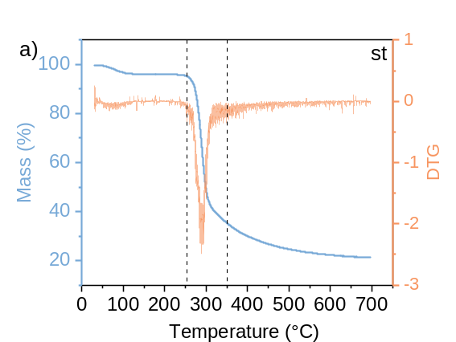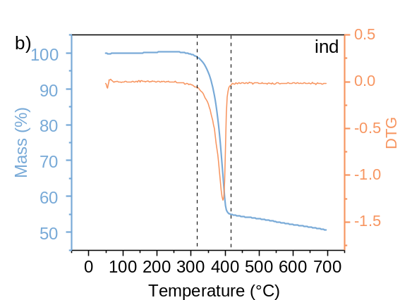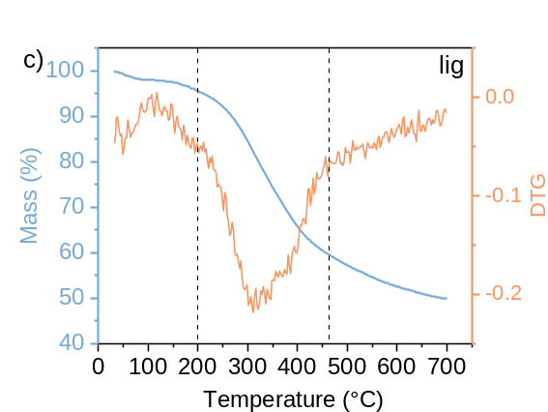
Figure S1 Thermogravimetry (TG) and derivative thermogravimetry (DTG) curves of polymer feedstocks a) starch, b) indigo, c) lignin

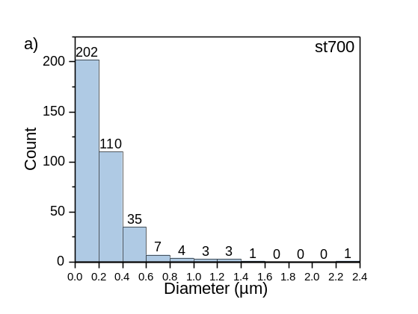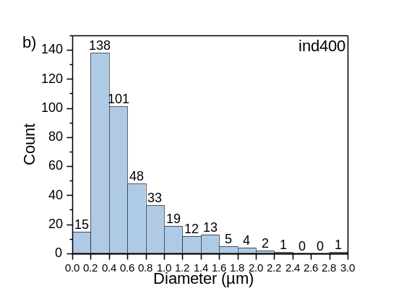
Figure S2 The size histogram of fine particles on the surface of bulk chars a) st700 b) ind400
“st” and “ind” represent chars derived from starch and indigo dye, respectively. The suffix number represents pyrolysis temperature.

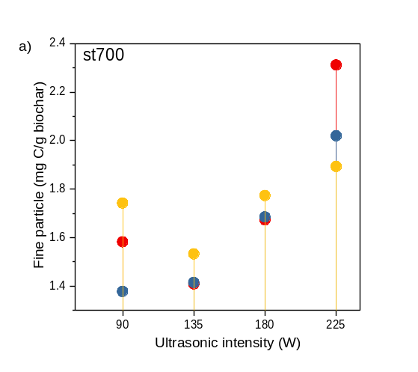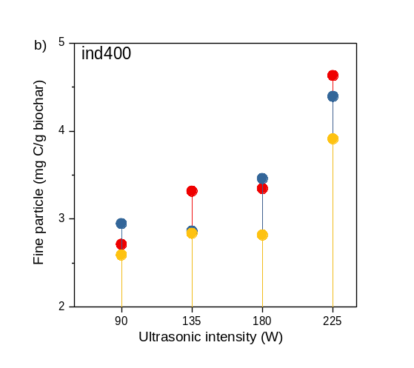
Figure S3 Amount of exfoliated biochar under ultrasonic intensity gradient a) st700 b) ind400
Exfoliation was performed in triplicate, as represented in color yellow, red and blue, separately. “st” and “ind” represent biochar derived from starch and indigo dye, respectively. The suffix number represents pyrolysis temperature.

Figure S4 Current-time (I-t) curves of raw biochar in mediated electrochemical oxidation measurement

Figure S5 Current-time (I-t) curves of raw biochar in mediated electrochemical reduction measurement

Figure S6 Current-time (I-t) curves of residue biochar in mediated electrochemical measurement a)st700 b)ind400

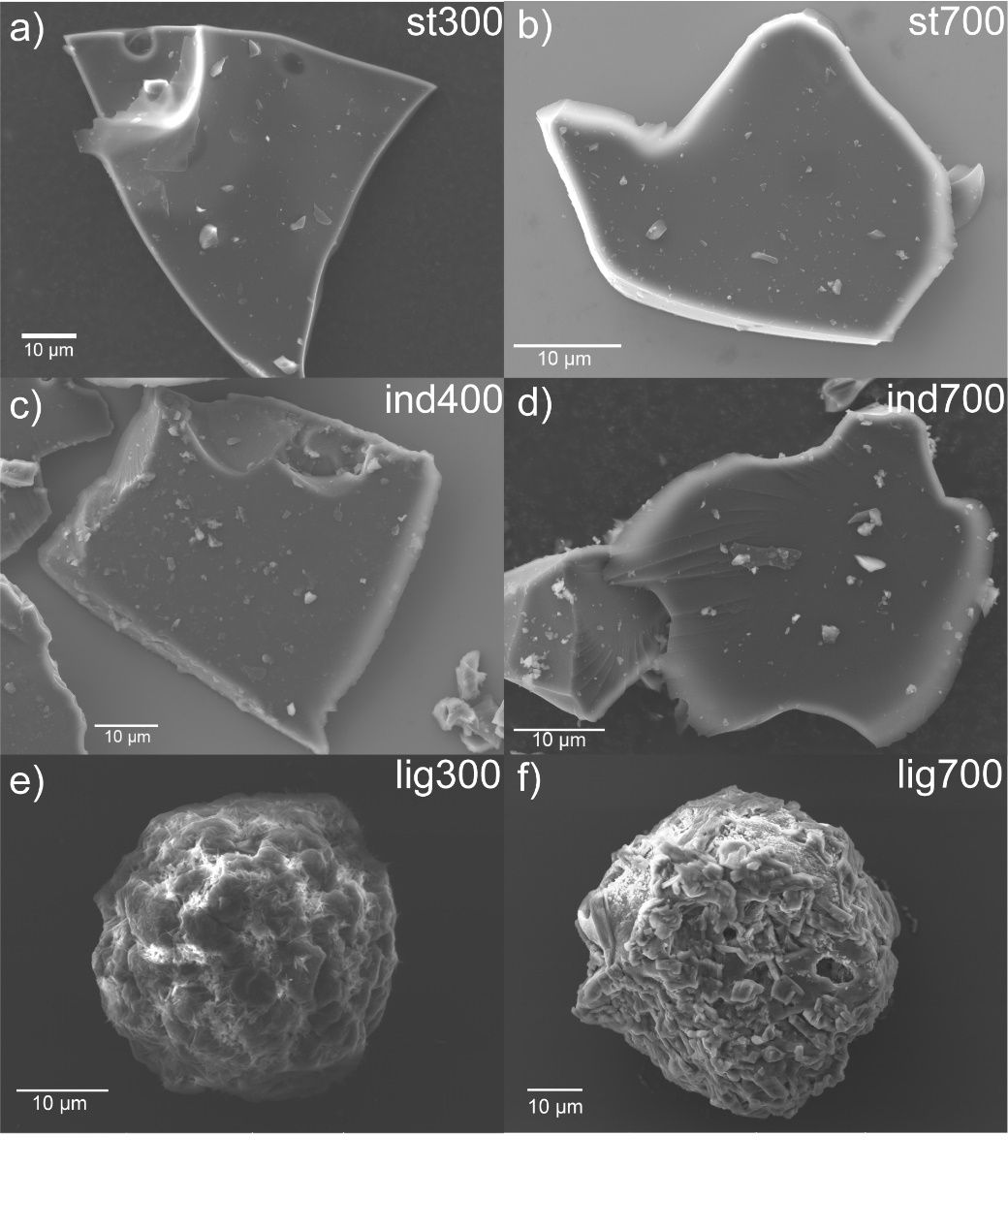
Figure S7 SEM images of a) st300, b) st700, c) ind400, d) ind700, e) lig300, f) lig700
“st”, “ind”, and “lig” represent the chars derived from starch, indigo dye, and lignin, respectively. The suffix number represents pyrolysis temperature.

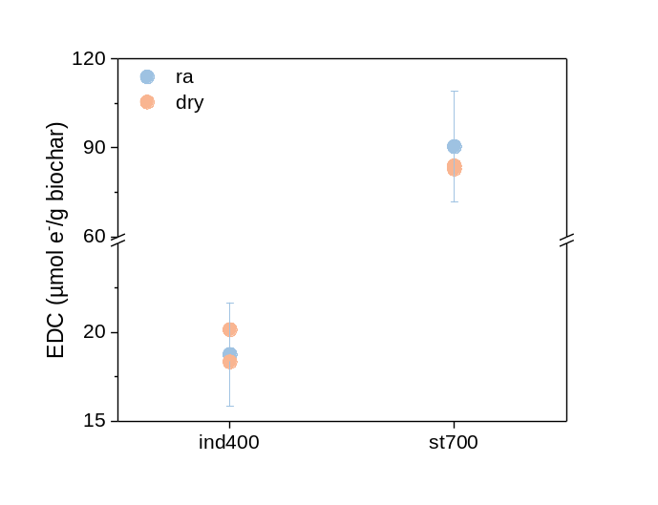
Figure S8 Dry effect on the EDC of ind400 and st700
“st” and “ind” represent biochar derived from starch and indigo dye, respectively. The suffix number represents pyrolysis temperature. “ra” and “dry” represent raw biochar and dried biochar, respectively.

Figure S9 Molecular information of exfoliated and residue char fractions from st700 and ind400 by Py-GC/MS.
Comparison between different fractions based on compound type and relative contents of shared compounds was illustrated by a) and b) for st700, c) and d) for ind400. “DBE” in a) and c) is short for Double Bond Equivalent“st” and “ind” represent biochar derived from starch and indigo dye, respectively. The suffix number represents pyrolysis temperature. “ra” and “dry” represent raw biochar and dried biochar, respectively.

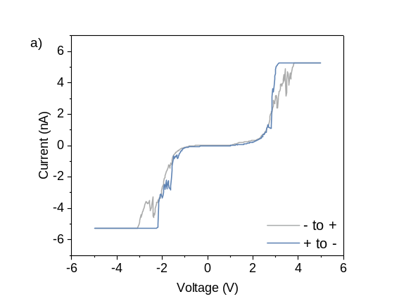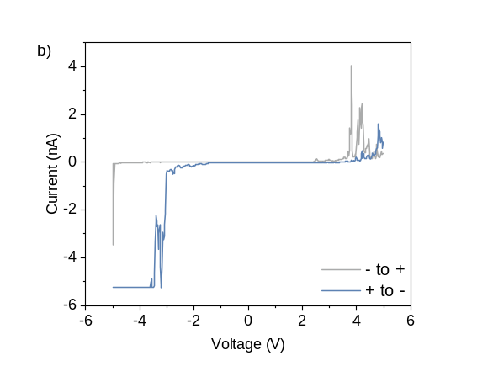
Figure S10 Current-Voltage (I-V) curves of spots on st700 a) conductivity dominated spot, b) redox property dominated spot
- to + (grey curve) scan was conducted before + to – scan (blue curve).

Figure S11 Topography of st700 before a) and after b) 5V potential scan
Cross sections of the topography images taken along the dash lines shown in the images were displayed in the line plots below.

Table S1 Pyrolysis products of st700 analyzed by Py-GC/MS
 | Compound | m/z | Category
1 | Benzene | 78 | MAH
2 | Methylbenzene | 91 | MAH
3 | Benzonitrile | 50, 76, 103 | CHN
4 | p-xylene | 91, 106 | MAH
5 | Benzene, 1-ethyl-x-methyl- | 39, 63, 90, 117 | CHN
6 | Ethylbenzene | 91, 106 | MAH
7 | Benzene, 1,x-dimethyl- | 91, 105, 106 | MAH
8 | Phenylethyne | 76, 102 | MAH
9 | Styrene | 51, 78, 104 | MAH
10 | Indane | 105, 120 | MAH
11 | Benzene, 1-propynyl- | 105, 120 | MAH
12 | Benzene, 1-ethenyl-x,x-dimethyl- | 91, 118 | PAH
13 | Benzene, 1,x-diethenyl- | 63, 89, 115 | MAH
14 | Benzene, (1-methylethyl)- | 77, 105, 120 | MAH
15 | Benzene, x-propenyl- | 91, 117, 118 | MAH
16 | Benzene, 1-ethenyl-x-methyl- | 91, 117, 118 | MAH
17 | Benzene, x-ethenyl-1,x-dimethyl- | 91, 117, 132 | MAH
18 | 1,4-Dihydronaphthalene | 51, 77, 115, 130 | MAH
19 | Benzocycloheptatriene | 51, 91, 117, 132 | MAH
20 | Naphthalene-x-carbonitrile | 51, 115, 130 | PAH
21 | Azulene | 102, 128 | PAH
22 | Naphthalene | 102, 128 | PAH
23 | Acenaphthene | 115, 141 | PAH
24 | Dibenzofuran | 126, 153 | CHN
25 | Naphthalene, x-methyl- | 115, 142 | PAH
26 | Biphenyl | 115, 142 | PAH
27 | Naphthalene, 1-(x-propenyl)- | 76, 153,154 | PAH
28 | 1,1'-Biphenyl, x-methyl- | 139, 168 | CHO
29 | Naphthalene, x,x-dimethyl- | 76, 153, 154 | PAH
30 | Biphenylene | 141, 156 | PAH
31 | 9H-Fluoren-9-one | 76, 153, 154 | PAH
32 | Phenanthrene | 76, 152 | PAH
33 | Naphthalene, x-methylethenyl | 115, 141, 153, 167 | PAH
34 | Fluorene | 152, 167, 168 | PAH
35 | 1,1'-Biphenyl, x-ethenyl- | 153, 167, 168 | PAH
36 | Anthracene | 82, 165, 166 | PAH
37 | Benzonitrile, x-methyl- | 76, 152, 180 | CHO
38 | Naphthalene, x-methyl- | 76, 89, 178 | PAH
39 | 9H-Fluorene, 9-methylene | 76, 165, 180 | PAH
40 | Anthracene, x-ethenyl- | 76, 89, 152, 178 | PAH
41 | Naphthalene, x-phenyl- | 76, 89, 152, 178 | PAH
42 | Benzene, 1,x,x-trimethyl- | 76, 89, 178 | PAH
43 | Biphenyl | 119, 213, 238 | CHO
44 | Pyrene | 88, 101, 203 | PAH
45 | Fluoranthene | 89, 101, 204 | PAH
46 | p-xylene | 88, 101, 202 | PAH
47 | Bisphenol A | 88, 101, 203 | PAH
MAH, monocyclic aromatic hydrocarbons; PAH, polycyclic aromatic hydrocarbons; CHO, O-containing benzene series; CHN, N-containing benzene series

Table S2 Pyrolysis products of ind400 analyzed by Py-GC/MS
 | Compound | m/z | Category
1 | Acetonitrile | 41 | CHN
2 | 2-Propenenitrile | 26, 53 | CHN
3 | 1,3-Cyclopentadiene | 39, 66 | Cycloalkene
4 | Benzene | 78 | MAH
5 | Aniline | 39, 66, 93 | CHN
6 | Benzimidazole | 63, 91, 118 | CHN
7 | Methylbenzene | 91 | MAH
8 | Benzene, isocyanato- | 64, 91, 119 | CHNO
9 | Benzaldehyde | 51, 77, 105 | CHO
10 | Benzonitrile | 50, 76, 103 | CHN
11 | Benzenamine, x-methyl- | 77, 106, 107 | CHN
12 | Benzonitrile, x-amino- | 64, 91, 118 | CHN
13 | Benzyl nitrile | 51, 90, 117 | CHN
14 | Styrene | 51, 78, 104 | MAH
15 | Benzonitrile, x-methyl- | 39, 63, 90, 117 | CHN
16 | Indole | 90, 117 | CHN
17 | 1,x-Dicyanobenzene | 50, 101, 128 | CHN
18 | x-Hydroxyquinazoline | 90, 118, 146 | CHNO
19 | Ethylbenzene | 91, 106 | MAH
20 | Benzene, 1,x-dimethyl- | 91, 106 | MAH
21 | Phenylethyne | 50, 76, 102 | CHN
22 | Benzene, 1,x-dimethyl- | 91, 105, 106 | MAH
23 | Benzofuran | 63, 89, 118 | CHO
24 | 3-Indolecarbonitrile | 115, 142 | CHN
25 | x-Benzazine | 51, 102, 129 | CHN
26 | x-Cyanoindole | 88, 115, 142 | CHN
27 | Benzene, 1-propynyl- | 63, 89, 115 | MAH
28 | Naphthalene | 128 | PAH
29 | [1,1'-Biphenyl]-x-amine | 115, 167, 169 | CHN
30 | [1,1'-Biphenyl]-x-amine | 115, 167, 169 | CHN
31 | Biphenyl | 76, 153, 154 | PAH
32 | Dibenzofuran | 139, 168 | CHO
33 | x-Azafluorene | 83, 139, 167 | CHN
34 | Phenanthridone | 139, 167, 195 | CHNO
35 | Fluorene | 82, 165, 166 | PAH
36 | Acridine | 89, 179 | CHN
37 | 3-Phenylindole | 165, 193 | CHN
38 | Anthracene | 76, 89, 152, 178 | PAH
39 | Indole, x-phenyl- | 89, 165, 193 | CHN
40 | 5(4H)-Thebenidinone | 190, 219 | CHNO
41 | Benzo(b)naphtho(2,3-d)furan | 109, 190, 218 | CHO
42 | Benzo[kl]xanthene | 109, 190, 219 | CHO
43 | Benzonaphthofuran | 109, 189, 218 | CHO
44 | Quinoline, 2-(2-methylphenyl)- | 109, 218 | CHN
45 | Triphenylene, x-methyl- | 121, 242 | PAH
46 | 14H-Benzo[4,5]isoquino[2,1-a]perimidin-14-one | 320 | CHN
MAH, monocyclic aromatic hydrocarbons; PAH, polycyclic aromatic hydrocarbons; CHO, O-containing benzene series; CHN, N-containing benzene series; CHNO, N and O-containing benzene series

Table S3 The assignments of deconvolved peaks from Raman spectra and fitted parameters^{[6-7]}
Peak center (cm⁻¹) | Peak | Assignment
1210±28 | S | Breathing modes for rings with 7⁺ carbons or benzene ring breathing modes adjacent to heteroatom defects.
1239±1 | D_{S} | Assorted breathing modes for most PAHs
1349±12 | D | Combined breathing for PAHs with larger more symmetric systems
1467±22 | A₁ | Breathing mode for 5-membered rings
1516±6 | A₂ | Mixed breathing and asymmetric stretch vibrational modes for sp² carbons
1594±3 | G_{G} | Distributed asymmetric vibrations for distribution of small PAHs
1699±3 | C | Carbonyl stretching mode (weak)

Table S4 The area ratios of peaks to G band (G_{G})
Peak | st700re | st700ex | ind400re | ind400ex
I(S)/I(G) | 0.91 | 0.97 | 0.92 | 0.45
I(D_{S})/I(G) | / | / | / | 0.13
I(D)/I(G) | 1.19 | 1.51 | 1.29 | 1.36
I(A₁)/I(G) | / | / | 0.42 | 1.32
I(A₂)/I(G) | 1.31 | 1.11 | 0.35 | 0.18
I(C)/I(G) | / | 0.06 | / | 0.07

Reference
[1] Varga, M.; Izak, T.; Vretenar, V., et al., Diamond/carbon nanotube composites: Raman, FTIR and XPS spectroscopic studies. Carbon 2017, 111, 54-61.
[2] Wang, J.-G.; Liu, H.; Sun, H., et al., One-pot synthesis of nitrogen-doped ordered mesoporous carbon spheres for high-rate and long-cycle life supercapacitors. Carbon 2018, 127, 85-92.
[3] Arrigo, R.; Hävecker, M.; Wrabetz, S., et al., Tuning the Acid/Base Properties of Nanocarbons by Functionalization via Amination. Journal of the American Chemical Society 2010, 132 (28), 9616-9630.
[4] Chen, W.; Yang, H.; Chen, Y., et al., Influence of biochar addition on nitrogen transformation during copyrolysis of algae and lignocellulosic biomass. Environmental Science & Technology 2018, 52 (16), 9514-9521.
[5] Li, B.; Dai, F.; Xiao, Q., et al., Nitrogen-doped activated carbon for a high energy hybrid supercapacitor. Energy & Environmental Science 2016, 9 (1), 102-106.
[6] Smith, M. W.; Dallmeyer, I.; Johnson, T. J., et al., Structural analysis of char by Raman spectroscopy: Improving band assignments through computational calculations from first principles. Carbon 2016, 100, 678-692.
[7] Martin, J. W.; Nyadong, L.; Ducati, C., et al., Nanostructure of gasification charcoal (biochar). Environmental Science & Technology 2019, 53 (7), 3538-3546.

