Additional file 1
Biochar mitigates the biotoxicity of heavy metals in livestock manure during composting
Xiaomeng Chenª, Zhuang Duª, Dan Liuª, Liqin Wangª, Chaonan Panª, Zimin Wei ^{a,} *, Liming Jia^{b}, Ran Zhao^{b}
ª College of Life Science, Northeast Agricultural University, Harbin 150030, China
^{b} Heilongjiang Province Environmental Monitoring Center, Harbin 150056, China

*Corresponding author Address: Northeast Agricultural University, Harbin 150030, China. Tel./Fax: +86 451 55190413. E-mail address: weizimin@neau.edu.cn

This Additional file contains 7-page document including 1 table and 5 figures.

Table S1 Initial carbon and nitrogen content of chicken manure and corn straw.
 | Chicken manure | Corn straw
Total organic carbon content (%) | 16.8±0.872 | 40.2 ± 4.33
Total nitrogen content (%) | 2.63±0.199 | 0.832 ± 0.0327
C/N ratio | 6.39 | 48.4

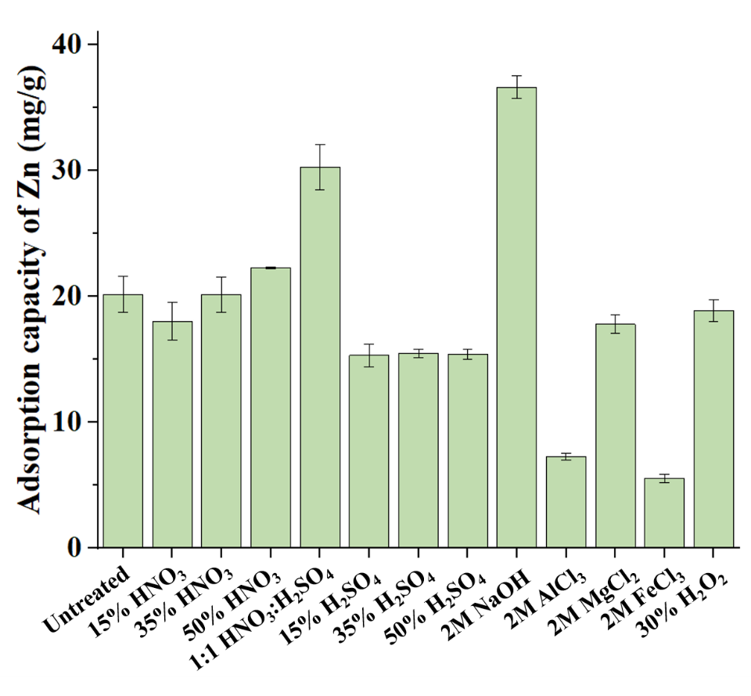
Fig. S1 Adsorption capacity of Zn on biochar treated by different modification methods.

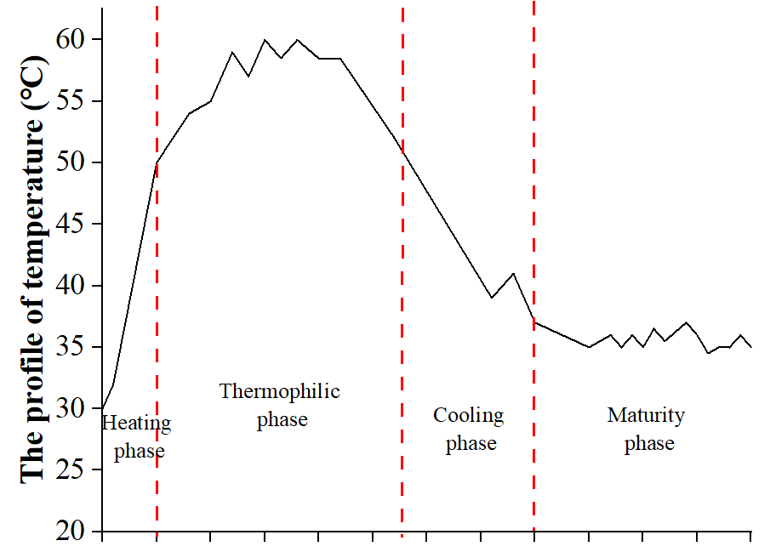
Fig. S2 The profile of temperature during composting.

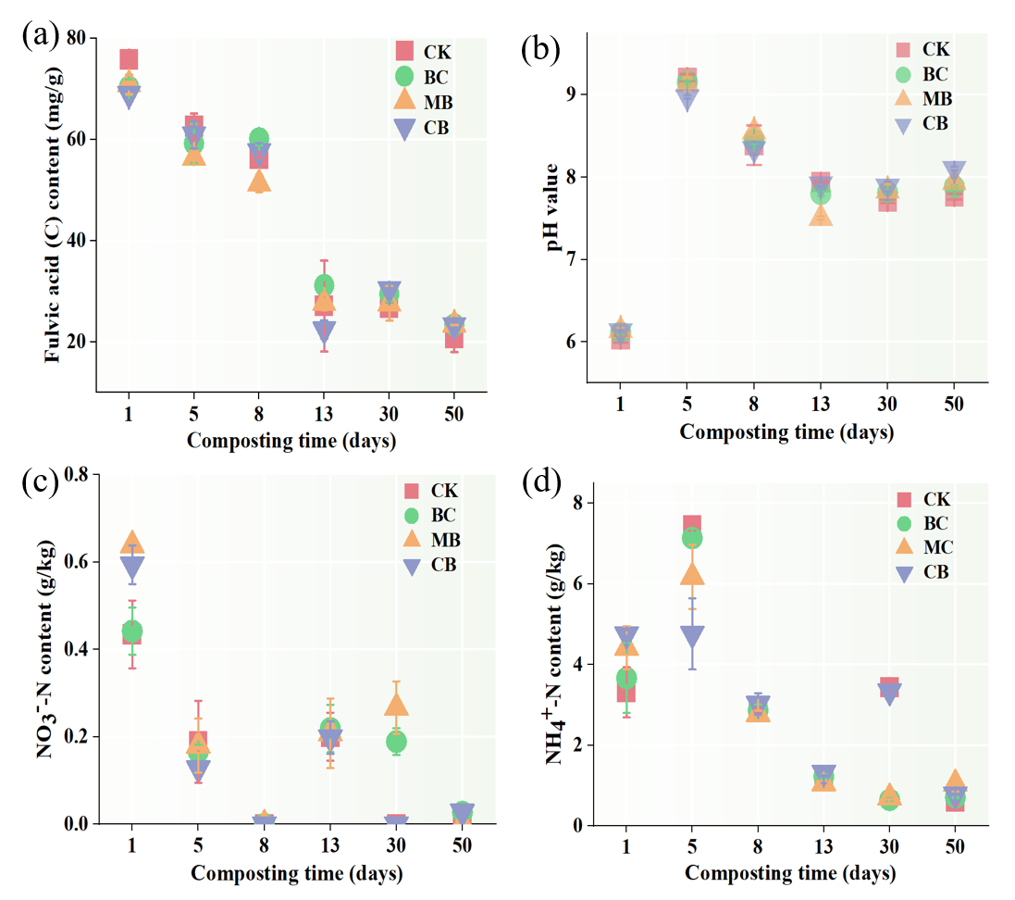
Fig. S3 Changes in the physicochemical indexes during composting.

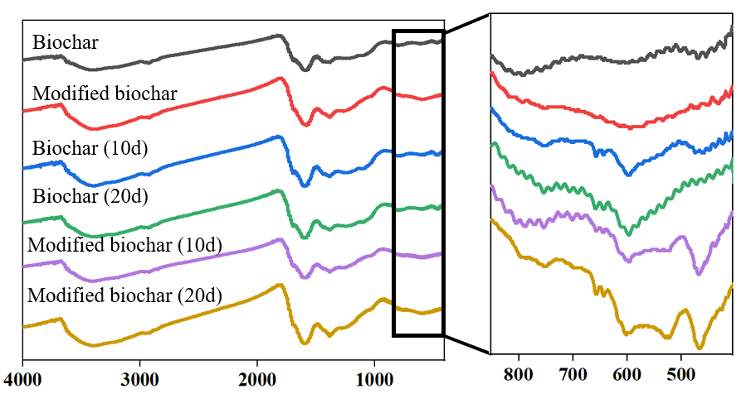
Fig. S4 FTIR spectral characterization of biochar and modified biochar that taken out from composting.

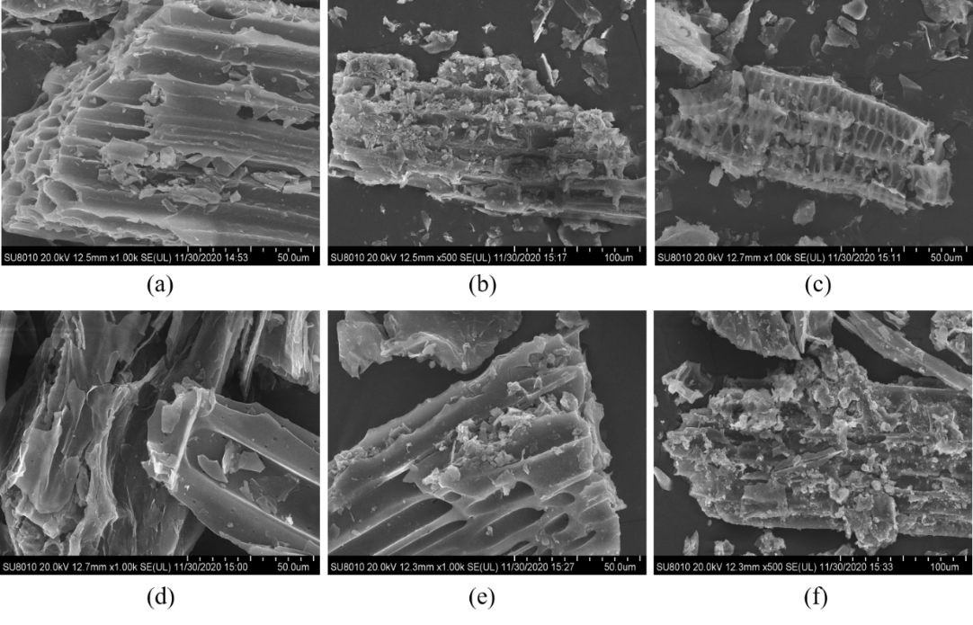
Fig. S5 Electron microscopy of biochar and modified biochar. (a) biochar; (b) biochar that taken out from the 10th day of composting; (c) biochar that taken out from the 20th day of composting; (d) modified biochar; (e) modified biochar that taken out from the 10th day of composting; (f) modified biochar that taken out from the 10th day of composting.

