Supplementary Information

Formable porous biochar loaded with La-Fe (hydr)oxides/montmorillonite for efficient removal of phosphorus in wastewater: Process and mechanisms
Enhui Sun^{a,b*}, Yanyang Zhang^{c}, Qingbo Xiaoª, Huayong Li^{d}, Ping Quª, Cheng Yongª, Bingyu Wang^{e}, Yanfang Feng^{a*}, Hongying Huangª, Linzhang Yang^{a,b}, Charles Hunter^{b}

ª Key Laboratory of Saline-Alkali Soil Improvement and Utilization (Coastal Saline-Alkali Lands), Ministry of Agriculture and Rural Affairs; Jiangsu Collaborative Innovation Center for Solid Organic Waste Resource Utilization; Institute of Agricultural Resources and Environment, Jiangsu Academy of Agricultural Sciences, Nanjing 210014, China.
^{b} School of Life Sciences, College of Agriculture, Engineering and Science, University of KwaZulu-Natal (Pietermaritzburg Campus), Private Bag X01, Scottsville 3209, Republic of South Africa.
^{c} State Key Laboratory of Pollution Control and Resource Reuse, School of the Environment, Nanjing University, Nanjing 210023, China
^{d} Institute of Germplasm Resources and Biotechnology, Jiangsu Academy of Agricultural Sciences, Nanjing 210014, China.
^{e} Jiangsu Key Laboratory of Chemical Pollution Control and Resources Reuse, School of Environmental and Biological Engineering, Nanjing University of Science and Technology, Nanjing 210094, China

*Corresponding Author
*Enhui Sun: enhsun@126.com
*Yanfang Feng: jaasfengyanfang@163.com Tel: (86)-15050525155
This file contains 16 pages, including Text S1-S5, Figure S1-S6, and Table S1-S3.

Summary
Text S1. Mathematical equations and corresponding curve fitting model formulas of adsorption kinetics.
Text S2. Langmuir and Freundlich isotherm models of adsorption isotherms.
Text S3. Adsorption site energy distribution.
Text S4. Basic parameters of the pond water, as well as the specific sampling point and time.
Text S5. Leaching experiment of Fe and La from La_{0.3}Fe_{0.1}/MB in actual water.

Fig. S1. Phosphate adsorption capacities of different adsorbents in a solution with an initial concentration of 100 mg P L⁻¹.
Fig. S2. Scanning electron microscopy (SEM) images of (a) B, (b) MB, (c) Fe_{0.4}/MB, (d) La_{0.4}/MB.
Fig. S3. Energy-dispersive spectra (EDS) of B, MB, M, Fe_{0.4}/MB, La_{0.3}Fe_{0.1}/MB, and La_{0.4}/MB.
Fig. S4. Phosphate adsorption fitted data of La_{0.3}Fe_{0.1}/MB conducted by intra-particle diffusion model results.
Fig. S5. Langmuir model based-site energy on phosphate solid-phase sorption (a), Langmuir model based-site energy distribution of phosphate sorption on La_{0.3}Fe_{0.1}/MB (b).
Fig. S6. XRD patterns of La_{0.3}Fe_{0.1}/MB after phosphate adsorption.

Table S1. Preparation conditions used to obtain the different formable porous granulated LaFe/MB adsorbents.
Table S2. Surface elemental composition (wt.%) of adsorbents.
Table S3. Leaching concentration of Fe and La from La_{0.3}Fe_{0.1}/MB in actual water.

Note: biochar (B), montmorillonite (M), biochar/montmorillonite (MB), respectively.

Text S1. Mathematical equations and corresponding curve fitting model formulas of adsorption kinetics.
To better understand the mechanism that controls the adsorption kinetics and the phosphate adsorption process on adsorbent, a pseudo-first-order model, pseudo-second-order model, and intra-particle diffusion models were employed to fit the sorption kinetic data (Tang et al., 2018). The mathematical equations for these models are given in Eqs. (1) to (3).
Pseudo-first-order equation [1]:
ln (q_{e}-q_{t}) = ln q_{e} - k₁t
Pseudo-second-order equation [2]:
t/q_{t} =1/k₂q²_{e} + t/q_{e}
Intra-particle diffusion equation [3]:
q_{t} = k_{di}t^{1/2} + C_{i}
where q_{t} and q_{e} (mg P g⁻¹) are the amounts adsorbed at time t and at equilibrium, respectively; t (min) is the sorption time; and k₁ (min) and k₂ (g/(mg·min)) are the rate constants for the pseudo-first-order model and the pseudo-second-order model, respectively, which can be determined from the experimental data by regression analysis; k_{di} [g/(mg·min^{0.5})] is the adsorption rate constant of the intra-particle diffusion models, and C_{i} (mg g⁻¹) is a constant of the intra-particle diffusion model, which is related to the thickness of the boundary layer.

Text S2. Langmuir and Freundlich isotherm models of adsorption isotherms.
And their equations were presented using the following equations, respectively.
Langmuir model [4]:
q_{e}= k_{L} q_{m}C_{e}/ (1+ k_{L}C_{e})
Freundlich model [5]:
q_{e}= k_{F} C_{e}^{1/n}
Where k_{L} (L·mg⁻¹) and k_{F} (mg·g⁻¹) are constants related to the Langmuir adsorption and Freundlich affinity, respectively. q_{m} represents the Langmuir maximum capacity (mg P g⁻¹), n is the Freundlich empirical constant and C_{e} is the solution concentration at equilibrium (mg P L⁻¹).

Text S3. Adsorption site energy distribution.
The site energy distribution of LaFe/MB can be deduced from the Langmuir model based on an assumption of the distribution of site energies, expressed as Eq. (6).
${\text{Q}}_{\text{e}}\left({\text{C}}_{\text{e}}\right) \text{=}\int_{\text{0}}^{\text{+∞}}{{\text{Q}}_{\text{h}}}\text{(}\text{E}\text{, }{\text{C}}_{\text{e}}\text{)}\text{F}\text{(}\text{E}\text{)d}\text{E}$ (6)
where C_{e} is the equilibrium aqueous-phase concentration (mg L⁻¹), Q_{e} (C_{e}) is the total sorbed solid-phase concentration (mg g⁻¹), Q_{h} (E, C_{e}) is energetically homogeneous isotherm with sorption energy E (mg g⁻¹), and F(E) is the site energy frequency function of homogeneous sorption site energies (mol-mg/J-g). The range of the energies is assumed to be from 0 to infinity (∞) since the value of negative infinity (-∞) will not have any physical meaning (Reguyal and Sarmah, 2018).
Based on the condensation approximation or asymptotically correct approximation proposed by Wang (Wang et al., 2022), the equilibrium aqueous-phase concentration (C_{e}) of P is related to the sorption site energy (E) given by Eq. (7).
${\text{C}}_{\text{e}}\text{=}{\text{C}}_{\text{s}}\text{exp}\left(\text{-}\frac{\text{E}\text{-}{\text{E}}_{\text{s}}}{\text{RT}}\right)\text{=}{ \text{C}}_{\text{s}}\text{exp}\left(\text{-}\frac{{\text{E}}^{\text{*}}}{\text{RT}}\right)$ (7)
where C_{s} is the maximum solubility of phosphate solution (KH₂PO₄) at 28°C (mg L⁻¹), E_{s} is the lowest physically realizable sorption energy when C_{e} = C_{s}, (J mol⁻¹), R is the universal gas constant (J/mol-K), T is the absolute temperature (K), and calculated E* is the divergence of sorption energies between the sorbent surface in the solvent and the sorbate (J mol⁻¹), determined by substituting the C_{e} and C_{s} into Eq. (7).
Incorporating Eq. (7) into the Langmuir model, Q_{e} (E*) was expressed by Eq. (8).
${\text{Q}}_{\text{e}}\text{= }{\text{Q}}_{\text{max}}\frac{{\text{K}}_{\text{L}}{\text{C}}_{\text{s}}\text{exp}\left(\text{-}\frac{{\text{E}}^{\text{*}}}{\text{RT}}\right)}{{\text{K}}_{\text{L}}{\text{C}}_{\text{s}}\text{exp}\left(\text{-}\frac{{\text{E}}^{\text{*}}}{\text{RT}}\right)\text{+1}}$ (8)
where K_{L} is the Langmuir affinity coefficient (L kg⁻¹), Q_{max} is the maximum sorption capacity (mg g⁻¹), and C_{e} is the equilibrium aqueous-phase concentration (mg L⁻¹).
The approximate site energy distribution F(E*) can be obtained by differentiating the isotherm Q_{e} (E*) with respect to E* as shown by Eq. (9) (Wang et al., 2022).
$\text{F}\text{(}\text{E}\text{*}\text{)} \text{=}{\text{Q}}_{\text{max}}\frac{{\text{K}}_{\text{L}}{\text{C}}_{\text{s}}\text{exp}\left(\text{-}\frac{{\text{E}}^{\text{*}}}{\text{RT}}\right)}{\text{RT}{\text{(}{\text{K}}_{\text{L}}{\text{C}}_{\text{s}}\text{exp}\left(\text{-}\frac{{\text{E}}^{\text{*}}}{\text{RT}}\right)\text{+1)}}^{\text{2}}}$ (9)

Text S4. Basic parameters of the pond water, as well as the specific sampling point and time.
The pond water of Jiangsu Academy of Agricultural Sciences was taken as the test sample to evaluate the actual application potential of the adsorbent, the basic parameters of the pond water, with total nitrogen content (4.94±0.24) mg L⁻¹ and total phosphorus content (0.58±0.04) mg L⁻¹. The sampling time was September 2021, and the sampling site was pond water 10 cm above the surface.

Text S5. Leaching experiment of Fe and La from La_{0.3}Fe_{0.1}/MB in actual water.
To determine the leach ability of Fe and La from La_{0.3}Fe_{0.1}/MB. The leaching test was adapted according to Shen (Shen et al., 2022). Briefly, approximately 2 g of La_{0.3}Fe_{0.1}/MB was mixed with 1000 mL of the ditch water (pH, 8.21; EC, 301 us cm⁻¹; TOC, 8.07mg L⁻¹; TN, 2.65 mg L⁻¹; TP, 0.376 mg L⁻¹.) in a 2000-mL polyethylene vessel. The mixture was tumbled at a speed of 30 rpm for 7 days at 25 °C. Supernatants were taken on days 0, 1, 3, 5, and 7 d and filtered through 0.45-μm membrane filters, then the concentration of Fe and La were measured by inductively coupled plasma mass spectrometry (ICP-MS, Thermo Fisher Scientific, USA). Among them, the day 0 represents the sample on the sampling day and just after the corresponding materials were added. And ditch water +La_{0.3}Fe_{0.1}/MB was marked as trial group, while the ditch water was control group, respectively.

Fig. S1. Phosphate adsorption capacities of different adsorbents in a solution with an initial concentration of 100 mg P L⁻¹.

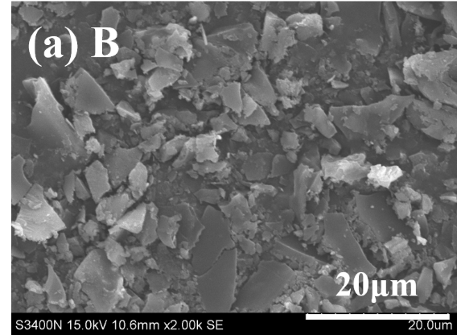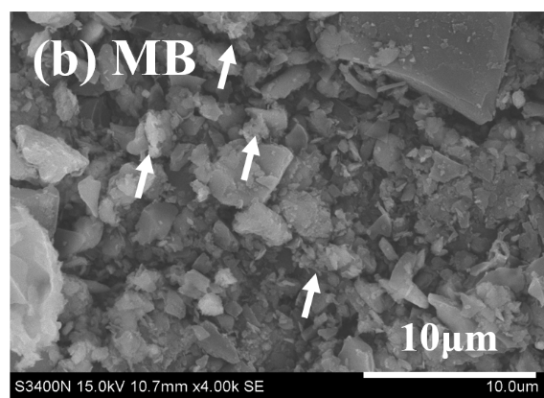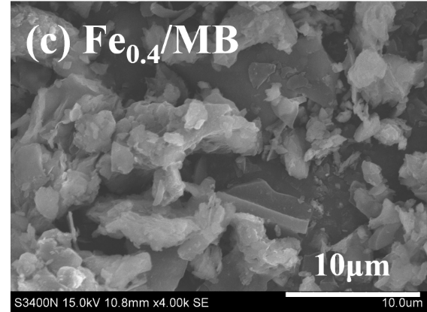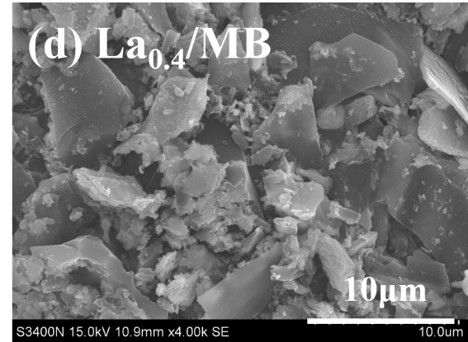
Fig. S2. Scanning electron microscopy (SEM) images of (a) B, (b) MB, (c) Fe_{0.4}/MB, (d) La_{0.4}/MB.

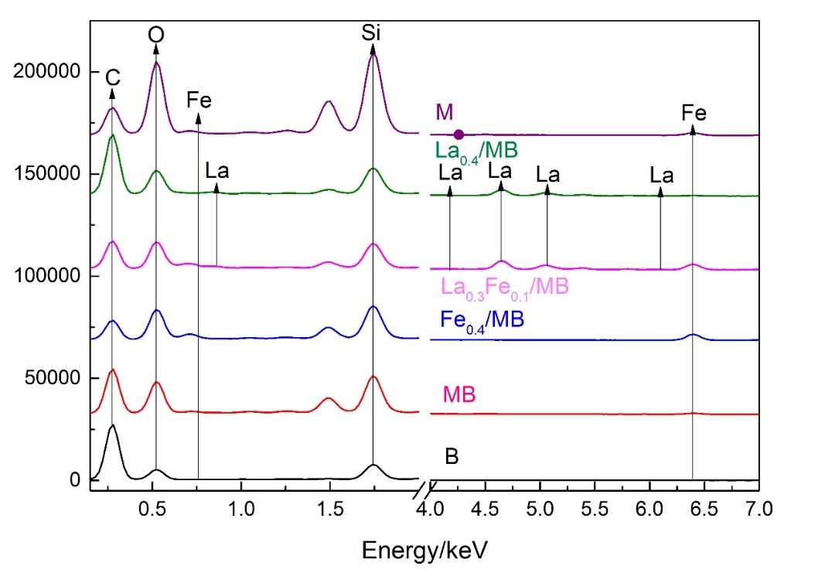
Fig. S3. Energy-dispersive spectra (EDS) of B, MB, M, Fe_{0.4}/MB, La_{0.3}Fe_{0.1}/MB, and La_{0.4}/MB.

Fig. S4. Phosphate adsorption fitted data of La_{0.3}Fe_{0.1}/MB conducted by intra-particle diffusion model results.

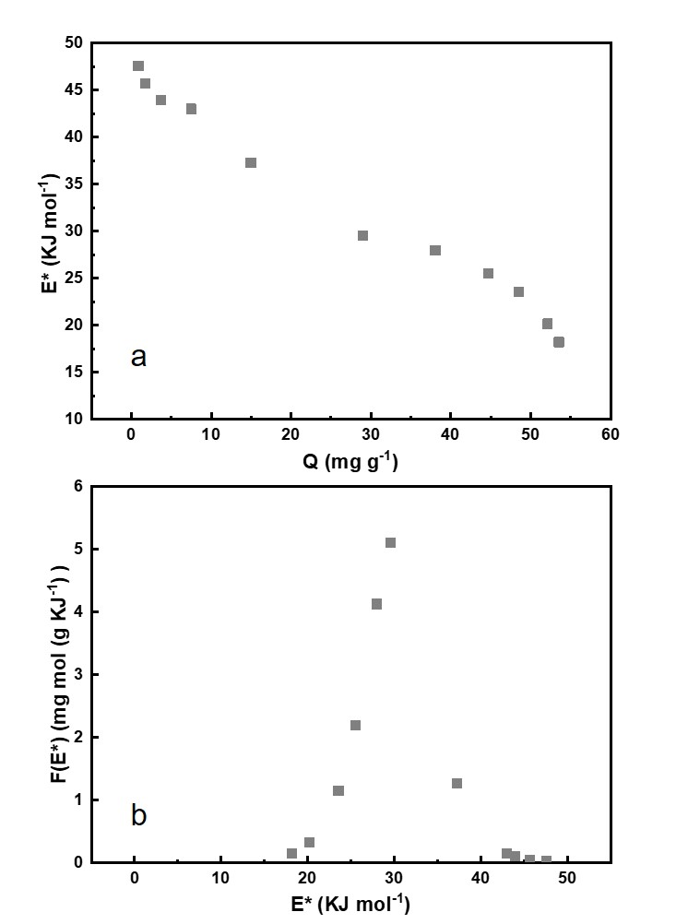
Fig. S5. Langmuir model based-site energy on phosphate solid-phase sorption (a), Langmuir model based-site energy distribution of phosphate sorption on La_{0.3}Fe_{0.1}/MB (b).

Fig. S6. XRD patterns of La_{0.3}Fe_{0.1}/MB after phosphate adsorption. The marks of LaPO₄ (JCPDS 04-0635) were referenced from the reported earlier (Shi et al., 2019).

Table S1
Preparation conditions used to obtain the different formable porous granulated LaFe/MB adsorbents
Abbreviation | B (g) | M (g) | n Fe³⁺ (mol) | n La³⁺ (mol)
B | 100 | - | - | -
MB | 100 | 50 | - | -
Fe_{0.4}/MB | 100 | 50 | 0.4 | -
La_{0.1}Fe_{0.3}/MB | 100 | 50 | 0.3 | 0.1
La_{0.2}Fe_{0.2}/MB | 100 | 50 | 0.2 | 0.2
La_{0.3}Fe_{0.1}/MB | 100 | 50 | 0.1 | 0.3
La_{0.4}/MB | 100 | 50 | - | 0.4

Table S2
Surface elemental composition (wt.%) of adsorbents
Adsorbents | Elements wt.% (calculated based on EDS spectrum)
Adsorbents | C | O | Mg | Al | Si | Ca | Fe | La
B | 67.06 | 24.55 | 0.12 | 0.24 | 7.22 | 0.30 | 0.52 | BDL
MB | 46.17 | 35.88 | 0.42 | 3.77 | 10.69 | 0.98 | 2.09 | BDL
Fe_{0.4}/MB | 31.29 | 34.81 | 0.48 | 3.87 | 12.68 | 0.85 | 14.01 | BDL
La_{0.3}Fe_{0.1}/MB | 30.22 | 23.12 | 0.26 | 1.96 | 8.54 | 0.40 | 8.02 | 19.49
La_{0.4}/MB | 49.05 | 24.58 | 0.12 | 1.14 | 7.76 | 0.52 | 1.03 | 15.80
M | BDL | 53.93 | 0.90 | 9.73 | 28.74 | 0.88 | 5.81 | BDL
Note: B, M and BDL means straw biochar, montmorillonite particles, and below detection limit, respectively.

Table S3
Leaching concentration of Fe and La of La_{0.3}Fe_{0.1}/MB in actual water
d | Control group |  | Trial group |  | Δ_{Fe}  (mg L⁻¹)
d | La (mg L⁻¹) | Fe (mg L⁻¹) | La (mg L⁻¹) | Fe (mg L⁻¹) | Δ_{Fe}  (mg L⁻¹)
0 | BDL | 0.094 | BDL | 0.0613 | -0.0327
1 | BDL | 0.076 | 0.004 | 0.0807 | 0.0047
3 | BDL | 0.053 | 0.005 | 0.0565 | 0.0035
5 | BDL | 0.0457 | 0.005 | 0.0463 | 0.0006
7 | BDL | 0.0417 | 0.006 | 0.0440 | 0.0023
Note: BDL means below detection limit; Δ_{Fe} means the difference between trial and control groups.

Reference
Reguyal F, Sarmah A K, (2018) Site energy distribution analysis and influence of Fe3O4 nanoparticles on sulfamethoxazole sorption in aqueous solution by magnetic pine sawdust biochar. Environ Pollut 233: 510-519. http://dx.doi.org/10.1016/j.envpol.2017.09.076
Shen X, Meng H, Shen Y et al (2022) A comprehensive assessment on bioavailability, leaching characteristics and potential risk of polycyclic aromatic hydrocarbons in biochars produced by a continuous pyrolysis system. Chemosphere 287: 132116. http://dx.doi.org/10.1016/j.chemosphere.2021.132116
Shi W M, Fu Y W, Jiang W et al (2019) Enhanced phosphate removal by zeolite loaded with Mg-Al-La ternary (hydr)oxides from aqueous solutions: Performance and mechanism. Chemical Engineering Journal 357: 33-44. http://dx.doi.org/10.1016/j.cej.2018.08.003
Tang N, Niu C G, Li X T et al (2018) Efficient removal of Cd2+ and Pb2+ from aqueous solution with aminoand thiol-functionalized activated carbon: Isotherm and kinetics modeling. Science of the Total Environment 635: 1331-1344. http://dx.doi.org/10.1016/j.scitotenv.2018.04.236
Wang B, Shang C, Xie H et al (2022) Unraveling natural aging-induced properties change of sludge-derived hydrochar and enhanced cadmium sorption site heterogeneity. Biochar 4: 34. https://doi.org/10.1007/s42773-022-00159-w

