Additional file 1
Machine learning predicting and engineering the yield, N content, and specific surface area of biochar derived from pyrolysis of biomass
Lijian Leng ª, Lihong Yang ª, Xinni Lei ª, Weijin Zhang ª, Zejian Ai ª, Zequn Yang ª, Hao Zhan ª, Jianping Yang ª, Xingzhong Yuan ^{b}, Haoyi Peng ^{a, *}, Hailong Li ^{a, *}

ª School of Energy Science and Engineering, Central South University, Changsha, Hunan 410083, People’s Republic of China
^{b} College of Environmental Science and Engineering, Hunan University, Changsha, Hunan 410082, PR China
* Corresponding author
Lijian Leng, E-mail: lljchs@126.com
Haoyi Peng, E-mail: penghaoyicsu@126.com
Hailong Li, E-mail: hailongli18@gmail.com

Table S1 The optimal solution and corresponding predicted and experimental outputs from ML models
No. | Biomass | C, H, N, O, % ª | VM, Ash, FC, % ^{b} | T, °C | RT, min | HR, °C min^{–1}
Run 1 | Rice husk | 48.00, 6.82, 0.38, 44.53 | 70.10, 13.46, 16.44 | 600 | 90 | 6
Run 2 | Rice husk | 48.00, 6.82, 0.38, 44.53 | 70.10, 13.46, 16.44 | 800 | 30 | 8
Run 3 | Sawdust | 48.22, 6.13, 0.30, 45.35 | 82.80, 1.00, 16.20 | 800 | 30 | 6
Run 4 | Corn stalk | 48.26, 7.02, 1.24, 42.92 | 71.85, 14.83, 13.32 | 800 | 30 | 4
ª O=100-C-H-N-O, on dry ash-free basis
^{b} Ash=100-VM-FC, on dry basis
Table S2 Detailed parameter distribution and parameter scale in the seven datasets
Items |  | Dataset #1 | Dataset #2 | Dataset #3 | Dataset #4 | Dataset #5 | Dataset #6 | Dataset #7
Elemental composition ª | C (%) | 39.78-87.62 | 33.77-87.62 | 33.77-87.62 | 39.78-87.62 | 39.78-87.62 | 33.77-87.62 | 39.78-87.62
Elemental composition ª | H (%) | 3.42-10.76 | 3.42-13.67 | 3.42-13.67 | 3.42-10.76 | 3.42-10.76 | 3.42-13.67 | 3.42-10.76
Elemental composition ª | N (%) | 0.05-9.78 | 0.05-8.21 | 0.05-8.21 | 0.05-8.21 | 0.05-8.21 | 0.05-8.21 | 0.05-8.21
Elemental composition ª | O (%) | 0.87-52.86 | 0.87-52.86 | 0.87-52.86 | 0.87-52.86 | 0.87-52.86 | 0.87-52.86 | 0.87-52.86
Proximate composition ^{b} | VM (%) | 29.86-94.16 | 49.36-94.16 | 49.36-94.16 | 49.36-94.16 | 49.36-94.16 | 49.36-94.16 | 49.36-94.16
Proximate composition ^{b} | Ash (%) | 0.30-45.54 | 0.30-42.02 | 0.30-42.02 | 0.30-42.02 | 0.30-42.02 | 0.30-42.02 | 0.30-42.02
Proximate composition ^{b} | FC (%) | 3.37-37.77 | 3.37-32.03 | 3.37-37.77 | 3.37-32.03 | 3.37-37.77 | 3.37-32.03 | 3.37-32.03
Biochemical composition | Cel (%) | 11.87-66.26 | 11.87-66.26 | 11.87-66.26 | 11.87-66.26 | 11.87-66.26 | 11.87-66.26 | 11.87-66.26
Biochemical composition | Hem (%) | 10.21-55.42 | 10.21-55.42 | 10.21-55.42 | 10.21-55.42 | 10.21-55.42 | 10.21-55.42 | 10.21-55.42
Biochemical composition | Lig (%) | 2.11-54.23 | 2.11-31.20 | 2.96-40.61 | 2.96-31.20 | 2.96-31.20 | 2.96-31.20 | 2.96-31.20
Biochemical composition | Ext (%) | 2.43-72.12 | 2.43-72.12 | 2.19-72.12 | 2.43-72.12 | 2.43-72.12 | 2.43-72.12 | 2.43-72.12
Pyrolysis conditions | T (°C) | 150-800 | 200-800 | 150-800 | 200-800 | 200-800 | 200-800 | 200-800
Pyrolysis conditions | RT (min) | 6-480 | 6-240 | 10-480 | 6-240 | 10-480 | 10-240 | 10-240
Pyrolysis conditions | HR (°C min^{–1}) | 1-300 | 1-300 | 1-300 | 1-300 | 1-300 | 1-300 | 1-300
Properties of biochar | Yield-char (%) | 9.60-93.50 | - ^{c} | - | 13.50-88.50 | 9.60-81.66 | - | 15.38-81.66
Properties of biochar | N-char (%) | - | 0.09-9.20 | - | 0.09-9.13 | - | 0.09-9.20 | 0.09-9.13
Properties of biochar | SSA-char (m² g^{–1}) | - | - | 0.02-525.86 | - | 0.02-525.86 | 0.56-525.86 | 0.73-525.86
ª On dry ash-free basis
^{b} On dry basis
^{c} Not available

Table S3 Single-task prediction for biochar yield, N content and specific surface area of biochar based on RF and GBR
Datasets | Sub-datasets | Inputs | Target  (outputs) | Data points | Model | Optimal (n_estimators, max_depth) | Model score | Train R² | Train RMSE | Test R² | Test RMSE
#1 | #1_1 | CHON, T, RT, HR | Yield-char | 282 | RF | 128,16 | 0.83 | 0.97 | 2.31 | 0.83 | 6.68
 |  |  |  |  | GBR | 150,2 | 0.89 | 1.00 | 0.70 | 0.89 | 5.49
#1 | #1_2 | Ash, FC, VM, T, RT, HR | Yield-char | 206 | RF | 128,32 | 0.90 | 0.98 | 1.91 | 0.90 | 4.07
 |  |  |  |  | GBR | 150,2 | 0.92 | 0.98 | 2.24 | 0.92 | 3.57
#1 | #1_3 | CHLE, T, RT, HR | Yield-char | 133 | RF | 16,16 | 0.93 | 0.97 | 2.28 | 0.93 | 3.73
 |  |  |  |  | GBR | 150,4 | 0.92 | 1.00 | 0.33 | 0.92 | 3.84
#1 | #1_4 | CHON, Ash, T, RT, HR | Yield-char | 282 | RF | 150,16 | 0.84 | 0.97 | 2.25 | 0.84 | 6.48
 |  |  |  |  | GBR | 150,2 | 0.84 | 0.96 | 2.85 | 0.84 | 6.48
#1 | #1_5 | CHON, Ash, FC, VM, T, RT, HR | Yield-char | 196 | RF | 64,16 | 0.85 | 0.99 | 1.30 | 0.85 | 5.69
 |  |  |  |  | GBR | 150,4 | 0.90 | 1.00 | 0.39 | 0.90 | 4.66
#1 | #1_6 | CHON, Ash, FC, VM, CHLE, T, RT, HR | Yield-char | 118 | RF | 32,16 | 0.97 | 0.99 | 1.40 | 0.97 | 2.32
 |  |  |  |  | GBR | 150,2 | 0.94 | 1.00 | 0.94 | 0.94 | 3.56
#2 | #2_1 | CHON, T, RT, HR | N-char | 251 | RF | 150,32 | 0.81 | 0.98 | 0.33 | 0.81 | 0.96
 |  |  |  |  | GBR | 64,4 | 0.87 | 1.00 | 0.13 | 0.87 | 0.79
#2 | #2_2 | Ash, FC, VM, T, RT, HR | N-char | 170 | RF | 150,16 | 0.84 | 0.98 | 0.28 | 0.84 | 0.80
 |  |  |  |  | GBR | 150,4 | 0.86 | 1.00 | 0.10 | 0.86 | 0.75
#2 | #2_3 | CHLE, T, RT, HR | N-char | 75 | RF | 128,16 | 0.88 | 0.91 | 0.36 | 0.88 | 0.44
 |  |  |  |  | GBR | 16,2 | 0.61 | 0.99 | 0.11 | 0.61 | 0.80
#2 | #2_4 | CHON, Ash, T, RT, HR | N-char | 236 | RF | 8,8 | 0.82 | 0.96 | 0.46 | 0.82 | 0.93
 |  |  |  |  | GBR | 128,4 | 0.92 | 1.00 | 0.12 | 0.92 | 0.64
#2 | #2_5 | CHON, Ash, FC, VM, T, RT, HR | N-char | 161 | RF | 128,8 | 0.90 | 0.97 | 0.33 | 0.90 | 0.63
 |  |  |  |  | GBR | 150,2 | 0.92 | 0.97 | 0.30 | 0.92 | 0.56
#2 | #2_6 | CHON, Ash, FC, VM, CHLE, T, RT, HR | N-char | 67 | RF | 64,2 | 0.77 | 0.82 | 0.51 | 0.77 | 0.64
 |  |  |  |  | GBR | 16,2 | 0.65 | 0.90 | 0.38 | 0.65 | 0.79
#3 | #3_1 | CHON, T, RT, HR | SSA-char | 259 | RF | 150,32 | 0.60 | 0.94 | 25.29 | 0.60 | 81.13
 |  |  |  |  | GBR | 150,4 | 0.70 | 0.99 | 9.55 | 0.70 | 70.06
#3 | #3_2 | Ash, FC, VM, T, RT, HR | SSA-char | 183 | RF | 16,16 | 0.88 | 0.95 | 23.69 | 0.88 | 38.22
 |  |  |  |  | GBR | 150,4 | 0.84 | 1.00 | 5.98 | 0.84 | 45.42
#3 | #3_3 | CHLE, T, RT, HR | SSA-char | 75 | RF | 64,64 | 0.76 | 0.99 | 14.90 | 0.76 | 68.78
 |  |  |  |  | GBR | 64,4 | 0.86 | 1.00 | 4.20 | 0.86 | 53.17
#3 | #3_4 | CHON, Ash, T, RT, HR | SSA-char | 253 | RF | 150,32 | 0.83 | 0.95 | 26.38 | 0.83 | 33.84
 |  |  |  |  | GBR | 150,4 | 0.90 | 0.99 | 9.78 | 0.90 | 26.03
#3 | #3_5 | CHON, Ash, FC, VM, T, RT, HR | SSA-char | 183 | RF | 32,8 | 0.86 | 0.97 | 20.75 | 0.86 | 41.62
 |  |  |  |  | GBR | 150,4 | 0.93 | 1.00 | 4.49 | 0.93 | 29.89
#3 | #3_6 | CHON, Ash, FC, VM, CHLE, T, RT, HR | SSA-char | 68 | RF | 16,8 | 0.85 | 0.99 | 14.90 | 0.85 | 51.85
 |  |  |  |  | GBR | 8,4 | 0.91 | 1.00 | 1.69 | 0.91 | 39.65
Note: Elemental Composition (C: carbon; H: hydrogen; O: oxygen; N: nitrogen); Proximate Composition (Ash: ash content, FC: fixed carbon, VM: volatile matter); Biochemical composition (CHLE: cellulose, hemicellulose, lignin, extractive); Pyrolysis Conditions (T: temperature, RT: residence time, HR: heating rate); Yield-char: biochar yield; N-char: nitrogen content in biochar; SSA-char: specific surface area of biochar
Table S4 Multi-task prediction for biochar yield and N content of biochar, N content and specific surface area, biochar yield and specific surface area based on RF and GBR
Dataset | Sub-datasets | Inputs | Target  (outputs) | Data points | Model | Optimal (n_estimators, max_depth) | Model score (average of test R²) | Train R² | Train RMSE | Test R² | Test RMSE
#4 | #4_1 | CHON, T, RT, HR | Yield-char  N-char | 209 | RF | 16, 16 | 0.77 | 0.95 | 0.21 | 0.75 | 0.53
 |  |  |  |  |  |  |  | 0.95 | 0.22 | 0.79 | 0.54
 |  |  |  |  | GBR | 150, 4 | 0.89 | 1.00 | 0.04 | 0.84 | 0.42
 |  |  |  |  |  |  |  | 1.00 | 0.06 | 0.93 | 0.30
#4 | #4_2 | Ash, FC, VM, T, RT, HR | Yield-char  N-char | 142 | RF | 150, 16 | 0.77 | 0.98 | 0.15 | 0.88 | 0.34
 |  |  |  |  |  |  |  | 0.96 | 0.20 | 0.65 | 0.50
 |  |  |  |  | GBR | 150, 4 | 0.90 | 1.00 | 0.04 | 0.96 | 0.19
 |  |  |  |  |  |  |  | 1.00 | 0.06 | 0.83 | 0.35
#4 | #4_3 | CHLE, T, RT, HR | Yield-char  N-char | 72 | RF | 128, 8 | 0.92 | 0.98 | 0.14 | 0.97 | 0.17
 |  |  |  |  |  |  |  | 0.94 | 0.26 | 0.87 | 0.21
 |  |  |  |  | GBR | 64, 2 | 0.93 | 0.98 | 0.14 | 0.97 | 0.17
 |  |  |  |  |  |  |  | 0.96 | 0.21 | 0.89 | 0.20
#4 | #4_4 | CHON, Ash, T, RT, HR | Yield-char  N-char | 209 | RF | 150, 32 | 0.84 | 0.96 | 0.18 | 0.82 | 0.45
 |  |  |  |  |  |  |  | 0.97 | 0.17 | 0.86 | 0.34
 |  |  |  |  | GBR | 128, 4 | 0.91 | 1.00 | 0.05 | 0.88 | 0.36
 |  |  |  |  |  |  |  | 1.00 | 0.05 | 0.93 | 0.23
#4 | #4_5 | CHON, Ash, FC, VM, T, RT, HR | Yield-char  N-char | 136 | RF | 150, 16 | 0.88 | 0.97 | 0.16 | 0.94 | 0.22
 |  |  |  |  |  |  |  | 0.97 | 0.16 | 0.81 | 0.43
 |  |  |  |  | GBR | 150, 2 | 0.91 | 0.98 | 0.15 | 0.93 | 0.26
 |  |  |  |  |  |  |  | 0.98 | 0.15 | 0.90 | 0.31
#4 | #4_6 | CHON, Ash, FC, VM, CHLE, T, RT, HR | Yield-char  N-char | 64 | RF | 64, 4 | 0.95 | 0.96 | 0.19 | 0.95 | 0.24
 |  |  |  |  |  |  |  | 0.93 | 0.28 | 0.94 | 0.15
 |  |  |  |  | GBR | 32, 2 | 0.96 | 0.98 | 0.14 | 0.97 | 0.21
 |  |  |  |  |  |  |  | 0.95 | 0.24 | 0.95 | 0.14
#5 | #5_1 | CHON, T, RT, HR | Yield-char  SSA-char | 193 | RF | 64, 64 | 0.76 | 0.96 | 0.19 | 0.86 | 0.34
 |  |  |  |  |  |  |  | 0.94 | 0.25 | 0.66 | 0.37
 |  |  |  |  | GBR | 150, 4 | 0.82 | 1.00 | 0.05 | 0.88 | 0.31
 |  |  |  |  |  |  |  | 1.00 | 0.07 | 0.76 | 0.31
#5 | #5_2 | Ash, FC, VM, T, RT, HR | Yield-char  SSA-char | 138 | RF | 128, 8 | 0.85 | 0.97 | 0.16 | 0.76 | 0.55
 |  |  |  |  |  |  |  | 0.96 | 0.20 | 0.93 | 0.27
 |  |  |  |  | GBR | 64, 4 | 0.86 | 0.99 | 0.08 | 0.79 | 0.51
 |  |  |  |  |  |  |  | 0.99 | 0.12 | 0.92 | 0.28
#5 | #5_3 | CHLE, T, RT, HR | Yield-char  SSA-char | 78 | RF | 32, 8 | 0.95 | 0.99 | 0.11 | 0.94 | 0.27
 |  |  |  |  |  |  |  | 0.98 | 0.13 | 0.97 | 0.19
 |  |  |  |  | GBR | 150, 4 | 0.93 | 1.00 | 0.01 | 0.96 | 0.20
 |  |  |  |  |  |  |  | 1.00 | 0.01 | 0.90 | 0.36
#5 | #5_4 | CHON, Ash, T, RT, HR | Yield-char  SSA-char | 193 | RF | 150, 32 | 0.79 | 0.97 | 0.18 | 0.87 | 0.30
 |  |  |  |  |  |  |  | 0.97 | 0.19 | 0.72 | 0.46
 |  |  |  |  | GBR | 150, 4 | 0.72 | 1.00 | 0.04 | 0.91 | 0.25
 |  |  |  |  |  |  |  | 1.00 | 0.06 | 0.53 | 0.59
#5 | #5_5 | CHON, Ash, FC, VM, T, RT, HR | Yield-char  SSA-char | 131 | RF | 8, 32 | 0.91 | 0.96 | 0.20 | 0.86 | 0.36
 |  |  |  |  |  |  |  | 0.95 | 0.21 | 0.96 | 0.24
 |  |  |  |  | GBR | 150, 4 | 0.95 | 1.00 | 0.02 | 0.93 | 0.25
 |  |  |  |  |  |  |  | 1.00 | 0.02 | 0.96 | 0.23
#5 | #5_6 | CHON, Ash, FC, VM, CHLE, T, RT, HR | Yield-char  SSA-char | 68 | RF | 150, 16 | 0.92 | 0.98 | 0.13 | 0.98 | 0.17
 |  |  |  |  |  |  |  | 0.98 | 0.12 | 0.86 | 0.36
 |  |  |  |  | GBR | 150, 2 | 0.98 | 0.99 | 0.08 | 0.98 | 0.19
 |  |  |  |  |  |  |  | 1.00 | 0.06 | 0.98 | 0.15
#6 | #6_1 | CHON, T, RT, HR | N-char  SSA-char | 189 | RF | 128, 16 | 0.86 | 0.98 | 0.15 | 0.89 | 0.36
 |  |  |  |  |  |  |  | 0.95 | 0.23 | 0.83 | 0.28
 |  |  |  |  | GBR | 32, 4 | 0.87 | 0.98 | 0.13 | 0.90 | 0.34
 |  |  |  |  |  |  |  | 0.96 | 0.20 | 0.85 | 0.27
#6 | #6_2 | Ash, FC, VM, T, RT, HR | N-char  SSA-char | 143 | RF | 32, 8 | 0.74 | 0.97 | 0.18 | 0.70 | 0.52
 |  |  |  |  |  |  |  | 0.94 | 0.26 | 0.78 | 0.40
 |  |  |  |  | GBR | 64, 4 | 0.82 | 1.00 | 0.06 | 0.80 | 0.43
 |  |  |  |  |  |  |  | 0.99 | 0.12 | 0.85 | 0.32
#6 | #6_3 | CHLE, T, RT, HR | N-char  SSA-char | 69 | RF | 150, 16 | 0.75 | 0.94 | 0.20 | 0.59 | 0.96
 |  |  |  |  |  |  |  | 0.98 | 0.14 | 0.90 | 0.27
 |  |  |  |  | GBR | 64, 2 | 0.80 | 0.94 | 0.19 | 0.74 | 0.76
 |  |  |  |  |  |  |  | 0.97 | 0.18 | 0.86 | 0.32
#6 | #6_4 | CHON, Ash, T, RT, HR | N-char  SSA-char | 186 | RF | 64, 64 | 0.85 | 0.97 | 0.17 | 0.90 | 0.25
 |  |  |  |  |  |  |  | 0.95 | 0.23 | 0.80 | 0.44
 |  |  |  |  | GBR | 16, 4 | 0.80 | 0.93 | 0.28 | 0.88 | 0.27
 |  |  |  |  |  |  |  | 0.86 | 0.38 | 0.72 | 0.53
#6 | #6_5 | CHON, Ash, FC, VM, T, RT, HR | N-char  SSA-char | 134 | RF | 64, 16 | 0.83 | 0.98 | 0.15 | 0.89 | 0.25
 |  |  |  |  |  |  |  | 0.95 | 0.21 | 0.76 | 0.53
 |  |  |  |  | GBR | 150, 4 | 0.84 | 1.00 | 0.02 | 0.89 | 0.25
 |  |  |  |  |  |  |  | 1.00 | 0.02 | 0.79 | 0.51
#6 | #6_6 | CHON, Ash, FC, VM, CHLE, T, RT, HR | N-char  SSA-char | 63 | RF | 16, 8 | 0.83 | 0.92 | 0.27 | 0.69 | 0.58
 |  |  |  |  |  |  |  | 0.99 | 0.11 | 0.97 | 0.17
 |  |  |  |  | GBR | 32, 4 | 0.82 | 0.99 | 0.09 | 0.67 | 0.60
 |  |  |  |  |  |  |  | 1.00 | 0.06 | 0.98 | 0.14
Note: Elemental Composition (C: carbon; H: hydrogen; O: oxygen; N: nitrogen); Proximate Composition (Ash: ash content, FC: fixed carbon, VM: volatile matter); Biochemical composition (CHLE: cellulose, hemicellulose, lignin, extractive); Pyrolysis Conditions (T: temperature, RT: residence time, HR: heating rate); Yield-char: biochar yield; N-char: nitrogen content in biochar; SSA-char: specific surface area of biochar

Table S5 Multi-task prediction for biochar yield, N content in biochar and specific surface area of biochar based on RF and GBR
Dataset | Sub-datasets | Inputs | Target  (outputs) | Data points | Model | Optimal (n_estimators, max_depth) | Model score (average of test R²) | Train R² | Train RMSE | Test R² | Test RMSE
#7 | #7_1 | CHON, T, RT, HR | Yield-char  N-char  SSA-char | 170 | RF | 150, 16 | 0.75 | 0.96 | 0.19 | 0.82 | 0.44
 |  |  |  |  |  |  |  | 0.96 | 0.19 | 0.78 | 0.53
 |  |  |  |  |  |  |  | 0.96 | 0.20 | 0.66 | 0.50
 |  |  |  |  | GBR | 128, 2 | 0.84 | 0.94 | 0.24 | 0.87 | 0.36
 |  |  |  |  |  |  |  | 0.97 | 0.16 | 0.96 | 0.22
 |  |  |  |  |  |  |  | 0.90 | 0.32 | 0.69 | 0.48
#7 | #7_2 | Ash, FC, VM, T, RT, HR | Yield-char  N-char  SSA-char | 126 | RF | 64, 16 | 0.78 | 0.95 | 0.22 | 0.86 | 0.34
 |  |  |  |  |  |  |  | 0.95 | 0.23 | 0.85 | 0.40
 |  |  |  |  |  |  |  | 0.97 | 0.18 | 0.64 | 0.47
 |  |  |  |  | GBR | 150, 2 | 0.83 | 0.97 | 0.17 | 0.92 | 0.25
 |  |  |  |  |  |  |  | 0.96 | 0.19 | 0.89 | 0.35
 |  |  |  |  |  |  |  | 0.96 | 0.21 | 0.66 | 0.46
#7 | #7_3 | CHLE, T, RT, HR | Yield-char  N-char  SSA-char | 69 | RF | 128, 16 | 0.85 | 0.98 | 0.15 | 0.98 | 0.13
 |  |  |  |  |  |  |  | 0.95 | 0.23 | 0.65 | 0.37
 |  |  |  |  |  |  |  | 0.99 | 0.10 | 0.92 | 0.32
 |  |  |  |  | GBR | 150, 2 | 0.84 | 0.99 | 0.07 | 0.96 | 0.20
 |  |  |  |  |  |  |  | 0.99 | 0.10 | 0.66 | 0.37
 |  |  |  |  |  |  |  | 0.99 | 0.11 | 0.90 | 0.35
#7 | #7_4 | CHON, Ash, T, RT, HR | Yield-char  N-char  SSA-char | 170 | RF | 128, 16 | 0.80 | 0.97 | 0.19 | 0.70 | 0.55
 |  |  |  |  |  |  |  | 0.96 | 0.19 | 0.86 | 0.40
 |  |  |  |  |  |  |  | 0.95 | 0.23 | 0.85 | 0.35
 |  |  |  |  | GBR | 150, 2 | 0.85 | 0.96 | 0.2 | 0.76 | 0.49
 |  |  |  |  |  |  |  | 0.98 | 0.13 | 0.89 | 0.36
 |  |  |  |  |  |  |  | 0.9 | 0.32 | 0.90 | 0.28
#7 | #7_5 | CHON, Ash, FC, VM, T, RT, HR | Yield-char  N-char  SSA-char | 120 | RF | 64, 16 | 0.81 | 0.96 | 0.19 | 0.67 | 0.60
 |  |  |  |  |  |  |  | 0.97 | 0.19 | 0.84 | 0.29
 |  |  |  |  |  |  |  | 0.96 | 0.20 | 0.91 | 0.31
 |  |  |  |  | GBR | 150, 2 | 0.81 | 0.98 | 0.14 | 0.73 | 0.55
 |  |  |  |  |  |  |  | 0.98 | 0.15 | 0.81 | 0.32
 |  |  |  |  |  |  |  | 0.98 | 0.16 | 0.89 | 0.34
#7 | #7_6 | CHON, Ash, FC, VM, CHLE, T, RT, HR | Yield-char  N-char  SSA-char | 64 | RF | 128, 16 | 0.82 | 0.98 | 0.12 | 0.96 | 0.19
 |  |  |  |  |  |  |  | 0.96 | 0.21 | 0.55 | 0.48
 |  |  |  |  |  |  |  | 0.99 | 0.08 | 0.94 | 0.28
 |  |  |  |  | GBR | 128, 2 | 0.88 | 1.00 | 0.06 | 0.97 | 0.17
 |  |  |  |  |  |  |  | 0.99 | 0.12 | 0.70 | 0.39
 |  |  |  |  |  |  |  | 1.00 | 0.06 | 0.97 | 0.19
Note: Elemental Composition (C: carbon; H: hydrogen; O: oxygen; N: nitrogen); Proximate Composition (Ash: ash content, FC: fixed carbon, VM: volatile matter); Biochemical composition (CHLE: cellulose, hemicellulose, lignin, extractive); Pyrolysis Conditions (T: temperature, RT: residence time, HR: heating rate); Yield-char: biochar yield; N-char: nitrogen content in biochar; SSA-char: specific surface area of biochar
Table S6 Detailed parameter distribution and parameter scale in the seven sub-datasets
Item |  | Dataset #1_6 | Dataset #2_6 | Dataset #3_6 | Dataset #4_6 | Dataset #5_6 | Dataset #6_6 | Dataset #7_6
Elemental composition ª | C (%) | 44.48-60.46 | 44.48-60.46 | 47.60-60.46 | 44.48-60.46 | 44.48-60.46 | 44.48-60.46 | 44.48-60.46
Elemental composition ª | H (%) | 4.00-9.08 | 4.00-9.08 | 4.00-9.08 | 4.00-9.08 | 4.00-9.08 | 4.00-9.08 | 4.00-9.08
Elemental composition ª | N (%) | 0.49-8.21 | 0.49-8.21 | 0.53-3.10 | 0.53-8.21 | 0.53-8.21 | 0.53-8.21 | 0.53-8.21
Elemental composition ª | O (%) | 27.36-46.96 | 27.36-46.96 | 27.36-46.10 | 27.36-44.44 | 27.36-46.1 | 27.36-44.44 | 27.36-44.44
Proximate composition ^{b} | VM (%) | 60.84-85.68 | 60.84-85.68 | 60.84-85.68 | 60.84-85.68 | 67.47-85.68 | 60.84-85.68 | 60.84-85.68
Proximate composition ^{b} | Ash (%) | 1.13-22.55 | 1.13-22.55 | 1.13-22.55 | 1.13-22.55 | 1.13-14.57 | 1.13-22.55 | 1.13-22.55
Proximate composition ^{b} | FC (%) | 11.83-25.51 | 11.83-25.51 | 11.83-20.61 | 11.83-20.61 | 11.83-20.61 | 11.83-20.61 | 11.83-20.61
Biochemical composition | Cel (%) | 22.29-49.87 | 22.29-49.87 | 25.19-49.87 | 22.78-49.87 | 22.78-49.87 | 22.78-49.87 | 22.78-49.87
Biochemical composition | Hem (%) | 14.30-55.42 | 14.30-55.42 | 14.30-40.39 | 14.30-55.42 | 14.30-55.42 | 14.30-55.42 | 14.30-55.42
Biochemical composition | Lig (%) | 2.11-31.20 | 2.11-31.20 | 3.71-31.20 | 2.96-31.20 | 2.96-31.20 | 2.96-31.20 | 2.96-31.20
Biochemical composition | Ext (%) | 2.43-30.83 | 2.43-30.83 | 2.43-30.83 | 2.43-30.83 | 2.43-30.83 | 2.43-30.83 | 2.43-30.83
Pyrolysis conditions | T (°C) | 250-800 | 250-800 | 250-700 | 250-800 | 250-800 | 250-800 | 250-800
Pyrolysis conditions | RT (min) | 10-180 | 10-180 | 10-180 | 10-180 | 10-180 | 10-180 | 10-180
Pyrolysis conditions | HR (°C min^{–1}) | 1-300 | 1-300 | 1-300 | 1-300 | 1-300 | 1-300 | 1-300
Properties of biochar (outputs) | Yield-char (%) | 15.38-61.55 | - | - | 15.38-61.55 | 15.38-61.55 | - | 15.38-61.55
Properties of biochar (outputs) | N-char (%) | - ^{c} | 0.37-8.48 | - | 0.54-8.48 | - | 0.54-5.51 | 0.54-8.48
Properties of biochar (outputs) | SSA-char (m² g^{–1}) | - | - | 0.49-418.73 | - | 0.49-418.73 | 0.73-418.73 | 0.73-418.73
Data size | Number of data points | 118 | 67 | 68 | 64 | 68 | 63 | 64
Hyper-parameter | N_estimators, max_depth | 150, 2 | 16, 2 | 8, 4 | 32, 2 | 150, 2 | 32, 4 | 128, 2
Predictive performance | Train R² (Test R²) | 1.00 (0.94) | 0.90 (0.65) | 1.00 (0.91) | 0.97 (0.96) | 1.00 (0.98) | 1.00 (0.82) | (0.88)
Predictive performance | Train RMSE (Test RMSE) | 0.94 (3.56) | 0.38 (0.79) | 1.69 (39.65) | 0.19 (0.18) | 0.07 (0.17) | 0.08 (0.37) | (0.25)
ª On dry ash-free basis
^{b} On dry basis
^{c} Not available
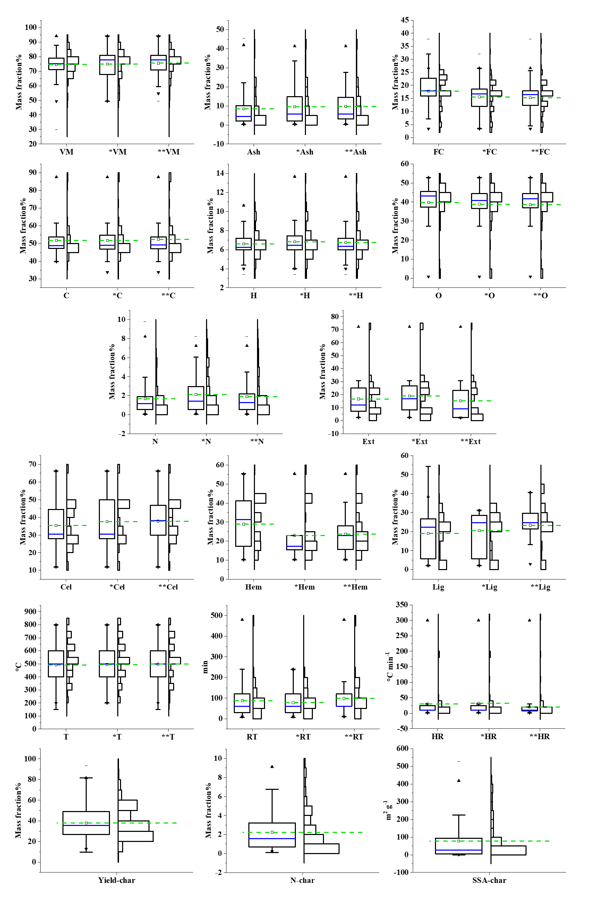
Fig. S1 The data distribution of biomass properties and biochar properties from 400 samples (Yield-char dataset without *, N-char dataset with *, SSA-char dataset with **)

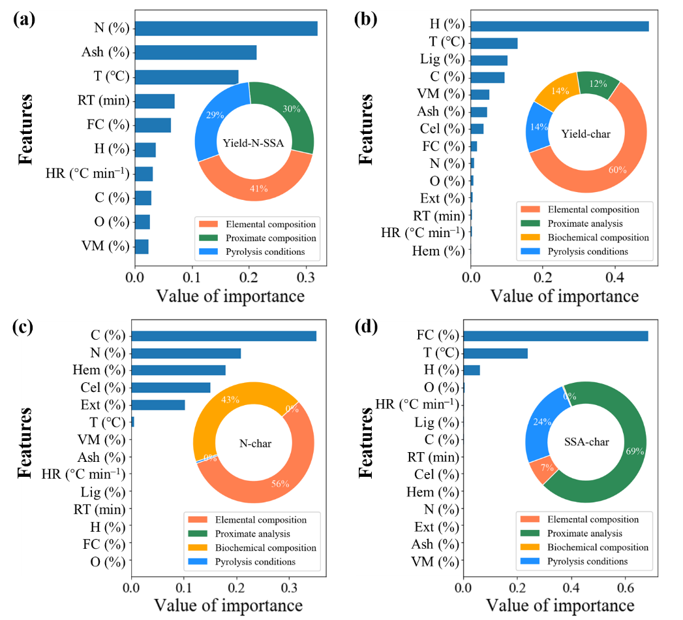
Fig. S2 The relative contribution of each feature for (a) Yield-char, N-char and SSA-char with all inputs except biochemical composition (b) Yield-char with all inputs (c) N-char with all inputs, (d) SSA-char with all inputs based on GBR model
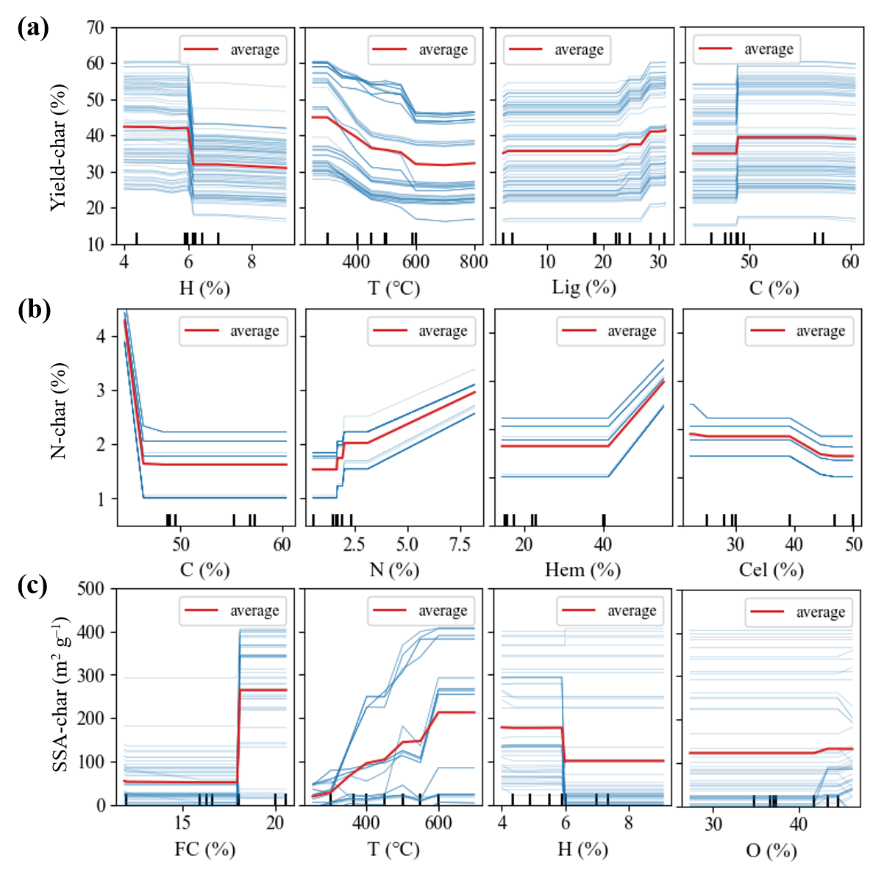
Fig. S3 Partial dependence plots of the top-four inputs to the prediction of (a) Yield-char (from dataset #1_6), (b) N-char (from dataset #2_6) and (c) SSA-char (from dataset #3_6) based on improved GBR model developed
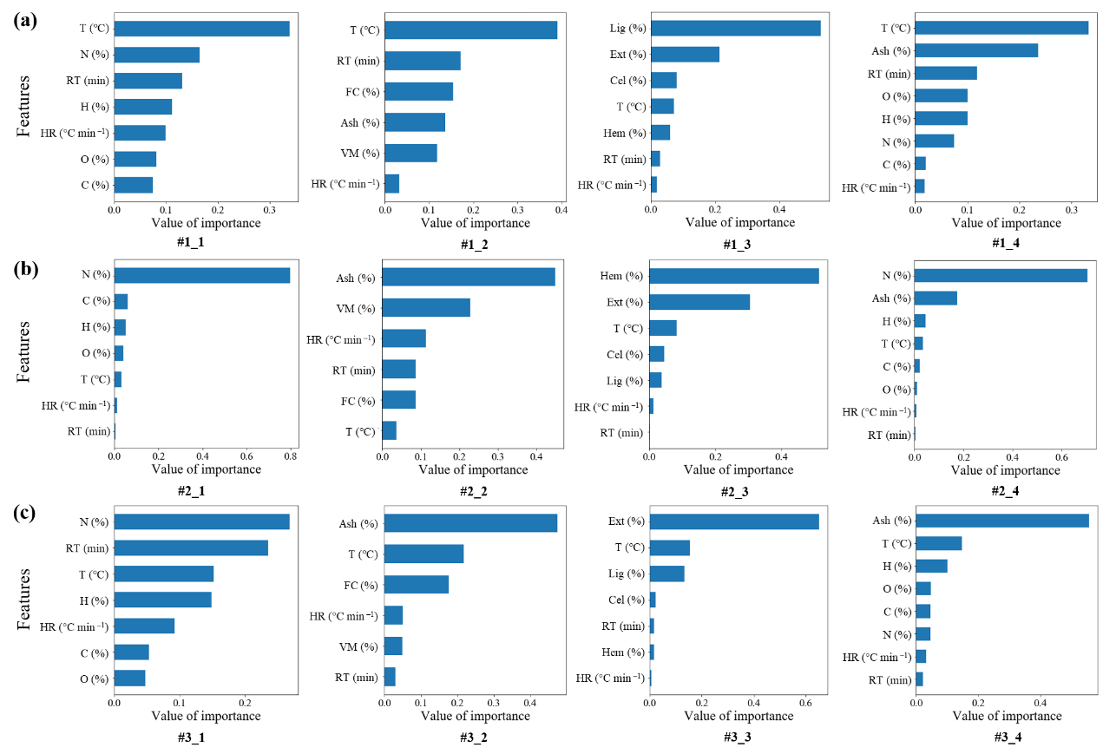
Fig. S4 The relative contribution of each feature for (a) Yield-char (b) N-char, (c) SSA-char based on GBR model
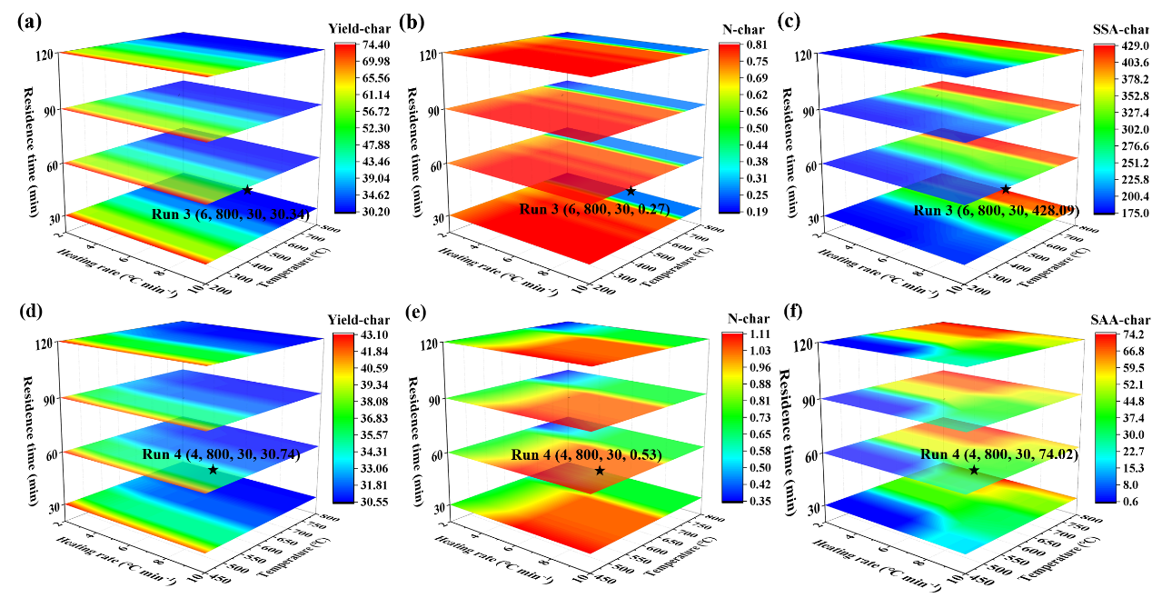
Fig. S5 The optimal schemes of three target parameters derived from (a-c) sawdust and (d-f) corn stalk

References used for data collection:
[1][2][3][4][5][6][7][8][9][10][11][12][13][14][15][16][17][18][19][20][21][22][23][24][25][26][27][28][29][30][31][32][33][34][35][36][37][38][39][40][41][42][43][44][45][46][47][48][49][50].
Bibliography
[1] Z.Z. Chowdhury, M. Ziaul Karim, M.A. Ashraf, K. Khalid, Influence of carbonization temperature on physicochemical properties of biochar derived from slow pyrolysis of durian wood (Durio zibethinus) sawdust, BioResources. 11 (2016) 3356–3372. https://doi.org/10.15376/biores.11.2.3356-3372.
[2] K.W. Jung, T.U. Jeong, H.J. Kang, K.H. Ahn, Characteristics of biochar derived from marine macroalgae and fabrication of granular biochar by entrapment in calcium-alginate beads for phosphate removal from aqueous solution, Bioresour. Technol. 211 (2016) 108–116. https://doi.org/10.1016/j.biortech.2016.03.066.
[3] S. Yavari, A. Malakahmad, N.B. Sapari, S. Yavari, Sorption properties optimization of agricultural wastes-derived biochars using response surface methodology, Process Saf. Environ. Prot. 109 (2017) 509–519. https://doi.org/10.1016/j.psep.2017.05.002.
[4] X. Xing, F. Fan, W. Jiang, Characteristics of biochar pellets from corn straw under different pyrolysis temperatures, R. Soc. Open Sci. 5 (2018). https://doi.org/10.1098/rsos.172346.
[5] P. Boakye, H.N. Tran, D.S. Lee, S.H. Woo, Effect of water washing pretreatment on property and adsorption capacity of macroalgae-derived biochar, J. Environ. Manage. 233 (2019) 165–174. https://doi.org/10.1016/j.jenvman.2018.12.031.
[6] J. Zhang, J. Jin, M. Wang, R. Naidu, Y. Liu, Y.B. Man, X. Liang, M.H. Wong, P. Christie, Y. Zhang, C. Song, S. Shan, Co-pyrolysis of sewage sludge and rice husk/ bamboo sawdust for biochar with high aromaticity and low metal mobility, Environ. Res. 191 (2020) 110034. https://doi.org/10.1016/j.envres.2020.110034.
[7] L. Zhao, W. Zheng, X. Cao, Distribution and evolution of organic matter phases during biochar formation and their importance in carbon loss and pore structure, Chem. Eng. J. 250 (2014) 240–247. https://doi.org/10.1016/j.cej.2014.04.053.
[8] L. Luo, C. Xu, Z. Chen, S. Zhang, Properties of biomass-derived biochars: Combined effects of operating conditions and biomass types, Bioresour. Technol. 192 (2015) 83–89. https://doi.org/10.1016/j.biortech.2015.05.054.
[9] Q. Xu, S. Tang, J. Wang, J.H. Ko, Pyrolysis kinetics of sewage sludge and its biochar characteristics, Process Saf. Environ. Prot. 115 (2018) 49–56. https://doi.org/10.1016/j.psep.2017.10.014.
[10] T. Tay, S. Ucar, S. Karagöz, Preparation and characterization of activated carbon from waste biomass, J. Hazard. Mater. 165 (2009) 481–485. https://doi.org/10.1016/j.jhazmat.2008.10.011.
[11] S. Li, V. Barreto, R. Li, G. Chen, Y.P. Hsieh, Nitrogen retention of biochar derived from different feedstocks at variable pyrolysis temperatures, J. Anal. Appl. Pyrolysis. 133 (2018) 136–146. https://doi.org/10.1016/j.jaap.2018.04.010.
[12] N. Touray, W.T. Tsai, H.R. Chen, S.C. Liu, Thermochemical and pore properties of goat-manure-derived biochars prepared from different pyrolysis temperatures, J. Anal. Appl. Pyrolysis. 109 (2014) 116–122. https://doi.org/10.1016/j.jaap.2014.07.004.
[13] J. Jin, Y. Li, J. Zhang, S. Wu, Y. Cao, P. Liang, J. Zhang, M.H. Wong, M. Wang, S. Shan, P. Christie, Influence of pyrolysis temperature on properties and environmental safety of heavy metals in biochars derived from municipal sewage sludge, J. Hazard. Mater. 320 (2016) 417–426. https://doi.org/10.1016/j.jhazmat.2016.08.050.
[14] J. Zhang, B. Huang, L. Chen, Y. Li, W. Li, Z. Luo, Characteristics of biochar produced from yak manure at different pyrolysis temperatures and its effects on the yield and growth of highland barley, Chem. Speciat. Bioavailab. 30 (2018) 57–67. https://doi.org/10.1080/09542299.2018.1487774.
[15] S. Gupta, G.K. Gupta, M.K. Mondal, Slow pyrolysis of chemically treated walnut shell for valuable products: Effect of process parameters and in-depth product analysis, Energy. 181 (2019) 665–676. https://doi.org/10.1016/j.energy.2019.05.214.
[16] S. Li, G. Chen, Thermogravimetric, thermochemical, and infrared spectral characterization of feedstocks and biochar derived at different pyrolysis temperatures, Waste Manag. 78 (2018) 198–207. https://doi.org/10.1016/j.wasman.2018.05.048.
[17] K. Intani, S. Latif, A.K.M.R. Kabir, J. Müller, Effect of self-purging pyrolysis on yield of biochar from maize cobs, husks and leaves, Bioresour. Technol. 218 (2016) 541–551. https://doi.org/10.1016/j.biortech.2016.06.114.
[18] F. Li, X. Wu, W. Ji, X. Gui, Y. Chen, J. Zhao, C. Zhou, T. Ren, Effects of pyrolysis temperature on properties of swine manure biochar and its environmental risks of heavy metals, J. Anal. Appl. Pyrolysis. 152 (2020) 104945. https://doi.org/10.1016/j.jaap.2020.104945.
[19] P. Wang, J. Zhang, Q. Shao, G. Wang, Physicochemical properties evolution of chars from palm kernel shell pyrolysis, J. Therm. Anal. Calorim. 133 (2018) 1271–1280. https://doi.org/10.1007/s10973-018-7185-z.
[20] Y.J. Zhang, Z.J. Xing, Z.K. Duan, M. Li, Y. Wang, Effects of steam activation on the pore structure and surface chemistry of activated carbon derived from bamboo waste, Appl. Surf. Sci. 315 (2014) 279–286. https://doi.org/10.1016/j.apsusc.2014.07.126.
[21] W.K. Kim, T. Shim, Y.S. Kim, S. Hyun, C. Ryu, Y.K. Park, J. Jung, Characterization of cadmium removal from aqueous solution by biochar produced from a giant Miscanthus at different pyrolytic temperatures, Bioresour. Technol. 138 (2013) 266–270. https://doi.org/10.1016/j.biortech.2013.03.186.
[22] W.T. Tsai, S.C. Liu, H.R. Chen, Y.M. Chang, Y.L. Tsai, Textural and chemical properties of swine-manure-derived biochar pertinent to its potential use as a soil amendment, Chemosphere. 89 (2012) 198–203. https://doi.org/10.1016/j.chemosphere.2012.05.085.
[23] Y. Lee, P.R.B. Eum, C. Ryu, Y.K. Park, J.H. Jung, S. Hyun, Characteristics of biochar produced from slow pyrolysis of Geodae-Uksae 1, Bioresour. Technol. 130 (2013) 345–350. https://doi.org/10.1016/j.biortech.2012.12.012.
[24] J. Liu, S. Huang, K. Chen, T. Wang, M. Mei, J. Li, Preparation of biochar from food waste digestate: Pyrolysis behavior and product properties, Bioresour. Technol. 302 (2020) 122841. https://doi.org/10.1016/j.biortech.2020.122841.
[25] J. Park, Y. Lee, C. Ryu, Y.-K. Park, Slow pyrolysis of rice straw: Analysis of products properties, carbon and energy yields, Bioresour. Technol. 155 (2014) 63–70. https://doi.org/10.1016/j.biortech.2013.12.084.
[26] Y. Lee, J. Park, C. Ryu, K.S. Gang, W. Yang, Y.K. Park, J. Jung, S. Hyun, Comparison of biochar properties from biomass residues produced by slow pyrolysis at 500°C, Bioresour. Technol. 148 (2013) 196–201. https://doi.org/10.1016/j.biortech.2013.08.135.
[27] K.B. Cantrell, P.G. Hunt, M. Uchimiya, J.M. Novak, K.S. Ro, Impact of pyrolysis temperature and manure source on physicochemical characteristics of biochar, Bioresour. Technol. 107 (2012) 419–428. https://doi.org/10.1016/j.biortech.2011.11.084.
[28] R. Liu, G. Liu, B. Yousaf, Q. Abbas, Operating conditions-induced changes in product yield and characteristics during thermal-conversion of peanut shell to biochar in relation to economic analysis, J. Clean. Prod. 193 (2018) 479–490. https://doi.org/10.1016/j.jclepro.2018.05.034.
[29] D. Chen, Y. Li, K. Cen, M. Luo, H. Li, B. Lu, Pyrolysis polygeneration of poplar wood: Effect of heating rate and pyrolysis temperature, Bioresour. Technol. 218 (2016) 780–788. https://doi.org/10.1016/j.biortech.2016.07.049.
[30] Z. Liu, F. Zhang, H. Liu, F. Ba, S. Yan, J. Hu, Pyrolysis/gasification of pine sawdust biomass briquettes under carbon dioxide atmosphere: Study on carbon dioxide reduction (utilization) and biochar briquettes physicochemical properties, Bioresour. Technol. 249 (2018) 983–991. https://doi.org/10.1016/j.biortech.2017.11.012.
[31] P. Fu, S. Hu, L. Sun, J. Xiang, T. Yang, A. Zhang, J. Zhang, Structural evolution of maize stalk/char particles during pyrolysis, Bioresour. Technol. 100 (2009) 4877–4883. https://doi.org/10.1016/j.biortech.2009.05.009.
[32] N. Phusunti, W. Phetwarotai, C. Tirapanampai, S. Tekasakul, Subcritical Water Hydrolysis of Microalgal Biomass for Protein and Pyrolytic Bio-oil Recovery, Bioenergy Res. 10 (2017) 1005–1017. https://doi.org/10.1007/s12155-017-9859-y.
[33] Q. Abbas, G. Liu, B. Yousaf, M.U. Ali, H. Ullah, M.A.M. Munir, R. Liu, Contrasting effects of operating conditions and biomass particle size on bulk characteristics and surface chemistry of rice husk derived-biochars, J. Anal. Appl. Pyrolysis. 134 (2018) 281–292. https://doi.org/10.1016/j.jaap.2018.06.018.
[34] Z. Wang, K. Liu, L. Xie, H. Zhu, S. Ji, X. Shu, Effects of residence time on characteristics of biochars prepared via co-pyrolysis of sewage sludge and cotton stalks, J. Anal. Appl. Pyrolysis. 142 (2019) 104659. https://doi.org/10.1016/j.jaap.2019.104659.
[35] K. Zeng, D.P. Minh, D. Gauthier, E. Weiss-Hortala, A. Nzihou, G. Flamant, The effect of temperature and heating rate on char properties obtained from solar pyrolysis of beech wood, Bioresour. Technol. 182 (2015) 114–119. https://doi.org/10.1016/j.biortech.2015.01.112.
[36] W. Suliman, J.B. Harsh, N.I. Abu-Lail, A.M. Fortuna, I. Dallmeyer, M. Garcia-Perez, Influence of feedstock source and pyrolysis temperature on biochar bulk and surface properties, Biomass and Bioenergy. 84 (2016) 37–48. https://doi.org/10.1016/j.biombioe.2015.11.010.
[37] P. Zhang, X. Zhang, Y. Li, L. Han, Influence of pyrolysis temperature on chemical speciation, leaching ability, and environmental risk of heavy metals in biochar derived from cow manure, Bioresour. Technol. 302 (2020) 122850. https://doi.org/10.1016/j.biortech.2020.122850.
[38] L. Riva, A. Cardarelli, G.J. Andersen, T.V. Buø, M. Barbanera, P. Bartocci, F. Fantozzi, H.K. Nielsen, On the self-heating behavior of upgraded biochar pellets blended with pyrolysis oil: Effects of process parameters, Fuel. 278 (2020) 118395. https://doi.org/10.1016/j.fuel.2020.118395.
[39] A. Borgohain, K. Konwar, D. Buragohain, S. Varghese, A. Kumar Dutta, R.K. Paul, P. Khare, T. Karak, Temperature effect on biochar produced from tea (Camellia sinensis L.) pruning litters: A comprehensive treatise on physico-chemical and statistical approaches, Bioresour. Technol. 318 (2020) 124023. https://doi.org/10.1016/j.biortech.2020.124023.
[40] O. Onay, Influence of pyrolysis temperature and heating rate on the production of bio-oil and char from safflower seed by pyrolysis, using a well-swept fixed-bed reactor, Fuel Process. Technol. 88 (2007) 523–531. https://doi.org/10.1016/j.fuproc.2007.01.001.
[41] M. Ahmad, S.S. Lee, A.U. Rajapaksha, M. Vithanage, M. Zhang, J.S. Cho, S.E. Lee, Y.S. Ok, Trichloroethylene adsorption by pine needle biochars produced at various pyrolysis temperatures, Bioresour. Technol. 143 (2013) 615–622. https://doi.org/10.1016/j.biortech.2013.06.033.
[42] F. Lian, F. Huang, W. Chen, B. Xing, L. Zhu, Sorption of apolar and polar organic contaminants by waste tire rubber and its chars in single- and bi-solute systems, Environ. Pollut. 159 (2011) 850–857. https://doi.org/10.1016/j.envpol.2011.01.002.
[43] E.L.K. Mui, W.H. Cheung, G. McKay, Tyre char preparation from waste tyre rubber for dye removal from effluents, J. Hazard. Mater. 175 (2010) 151–158. https://doi.org/10.1016/j.jhazmat.2009.09.142.
[44] X.J. Lee, L.Y. Lee, S. Gan, S. Thangalazhy-Gopakumar, H.K. Ng, Biochar potential evaluation of palm oil wastes through slow pyrolysis: Thermochemical characterization and pyrolytic kinetic studies, Bioresour. Technol. 236 (2017) 155–163. https://doi.org/10.1016/j.biortech.2017.03.105.
[45] H. Yuan, T. Lu, Y. Wang, H. Huang, Y. Chen, Influence of pyrolysis temperature and holding time on properties of biochar derived from medicinal herb (radix isatidis) residue and its effect on soil CO2 emission, J. Anal. Appl. Pyrolysis. 110 (2014) 277–284. https://doi.org/10.1016/j.jaap.2014.09.016.
[46] B. Zhao, D. O’Connor, J. Zhang, T. Peng, Z. Shen, D.C.W. Tsang, D. Hou, Effect of pyrolysis temperature, heating rate, and residence time on rapeseed stem derived biochar, J. Clean. Prod. 174 (2018) 977–987. https://doi.org/10.1016/j.jclepro.2017.11.013.
[47] A. Selvarajoo, D. Oochit, Effect of pyrolysis temperature on product yields of palm fibre and its biochar characteristics, Mater. Sci. Energy Technol. 3 (2020) 575–583. https://doi.org/10.1016/j.mset.2020.06.003.
[48] L. Qin, Y. Wu, Z. Hou, E. Jiang, Influence of biomass components, temperature and pressure on the pyrolysis behavior and biochar properties of pine nut shells, Bioresour. Technol. 313 (2020) 123682. https://doi.org/10.1016/j.biortech.2020.123682.
[49] A. Shaaban, S.M. Se, N.M.M. Mitan, M.F. Dimin, Characterization of biochar derived from rubber wood sawdust through slow pyrolysis on surface porosities and functional groups, Procedia Eng. 68 (2013) 365–371. https://doi.org/10.1016/j.proeng.2013.12.193.
[50] Y. Liu, S. Yao, Y. Wang, H. Lu, S.K. Brar, S. Yang, Bio- and hydrochars from rice straw and pig manure: Inter-comparison, Bioresour. Technol. 235 (2017) 332–337. https://doi.org/10.1016/j.biortech.2017.03.103.

