Carbon-negative cement-bonded biochar particleboards
Liang Chen¹, Yuying Zhang¹, Claudia Labianca¹, Lei Wang ^{2, *}‬, Shaoqin Ruan³, Chi Sun Poon^{1,4}, Yong Sik Ok⁵, Daniel C.W. Tsang^{1,4,#} ‬

¹ Department of Civil and Environmental Engineering, The Hong Kong Polytechnic University, Hung Hom, Kowloon, Hong Kong, China
² State Key Laboratory of Clean Energy Utilization, Institute for Thermal Power Engineering, Zhejiang University, Hangzhou, 310027, China.
³ College of Civil Engineering and Architecture, Zhejiang University, Hangzhou 310058, China
⁴ Research Centre for Resources Engineering towards Carbon Neutrality, The Hong Kong Polytechnic University, Hung Hom, Kowloon, Hong Kong, China
⁵ Korea Biochar Research Center, APRU Sustainable Waste Management Program & Division of Environmental Science and Ecological Engineering, Korea University, Seoul 02841, South Korea

* Corresponding author: wanglei.leo@zju.edu.cn
# Corresponding author: dan.tsang@polyu.edu.hk
F1 Supplementary Information
Figure S1 Particle size distribution of raw materials.
Figure S2 Probability distributions of CO₂ emission related to the production of 70BC-FA particleboard.
Figure S3 Water absorption of the MOSC biochar particleboards.
Figure S4 Cost-benefit analysis of biochar particleboards based on the carbon prices in different countries.
Table S1 Basic information of biochar.
Table S2 Chemical compositions of raw materials (wt.%).
Table S3 Example of the cost-benefit analysis for biochar particleboards.

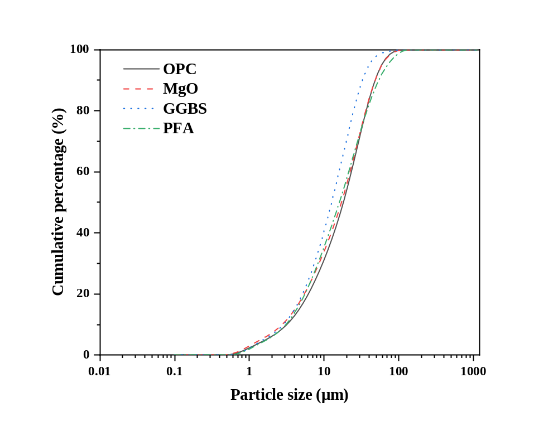
Fig. S1 Particle size distribution of raw materials.

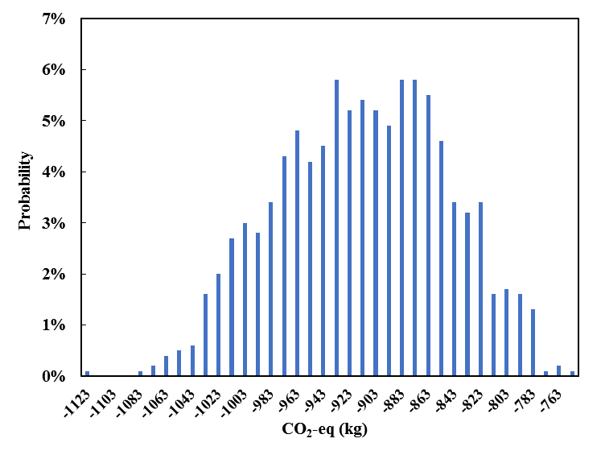
Fig. S2 Probability distributions of CO₂ emission related to the production of 70BC-FA particleboard.

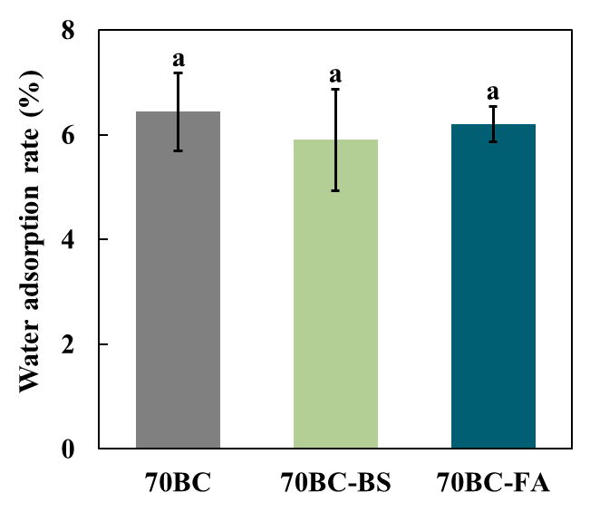
Fig. S3 Water absorption of the MOSC biochar particleboards.

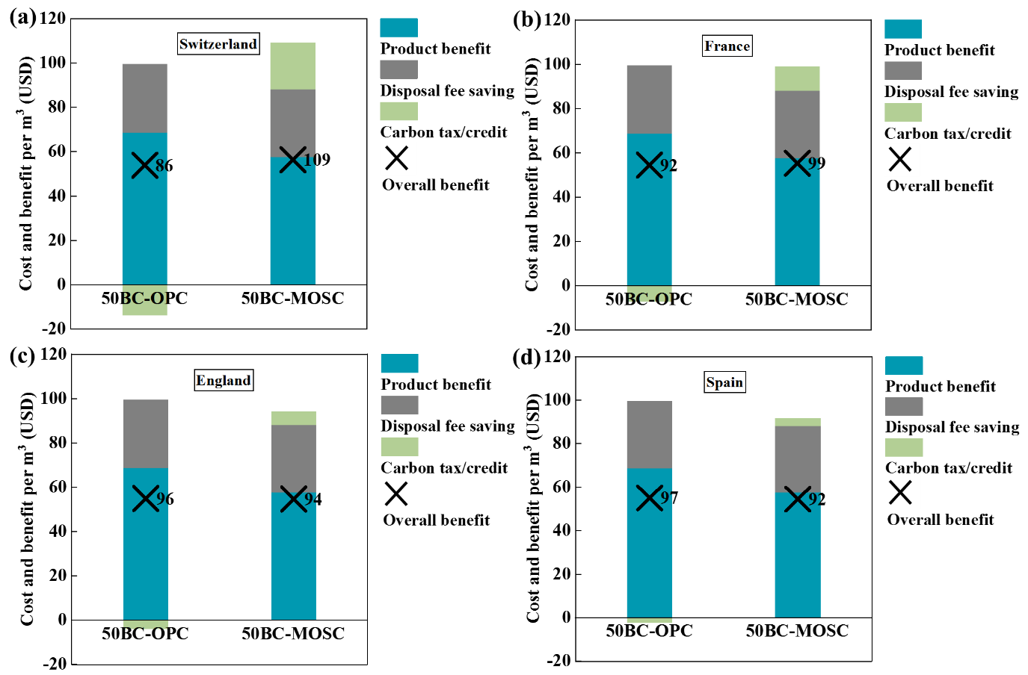
Fig. S4 Cost benefit analysis of biochar particleboards based on the carbon taxes in different countries: (a) 101.5 USD tonne⁻¹ in Switzerland, (b) 52.4 USD tonne⁻¹ in France, (c) 28.4 USD tonne⁻¹ in England, and (d) 17.6 USD tonne⁻¹ in Spain.

Table S1 Basic information of biochar.
 | Biochar
Surface Area (m² g⁻¹) | 142
Total Pore Volume (m³ g⁻¹) | 0.08
Average Pore Diameter (nm) | 2.01
Water Adsorption Capacity (%) | 83.6
Table S2 Chemical compositions of raw materials (wt.%).
 | Na₂O | MgO | Al₂O₃ | SiO₂ | P₂O₅ | SO₃ | K₂O | CaO | Fe₂O₃
OPC | 0.19 | 1.55 | 4.52 | 19.12 | 0.09 | 4.12 | 0.56 | 66.08 | 3.56
MgO cement | 0 | 89.45 | 0.46 | 5.86 | 0.12 | 0.07 | 0.14 | 2.89 | 0.75
GGBS | 0 | 6.55 | 15.78 | 35.82 | 0 | 2.31 | 0.82 | 38.14 | 0.24
PFA | 1.06 | 2.86 | 25.58 | 51.15 | 0.69 | 0.76 | 1.56 | 7.75 | 8.53
Biochar | 0 | 6.77 | 0.86 | 14.98 | 2.15 | 14.4 | 6.84 | 52.54 | 1.42
OPC: ordinary Portland cement; GGBS: ground granulated blast furnace slag; PFA: pulverized fly ash;

Table S3 Example of the cost-benefit analysis for biochar particleboards (50BC-MOSC particleboard).
Assuming the production capacity of factory is 112 m³ per day and unit price is 119 USD per m³.
Capital costs (USD) | Unit Price (USD) | Price per m³ (USD) | Note
Land cost | 769 m⁻² | 0.63 | Sub-urban land for non-living activities (1000 m²)
Building cost | 923,077 | 0.75 | 30-year service life
Production equipment | 3,077 | 2.51 | 30-year service life
Strength test equipment | 7,692 | 0.013 | 3-year service life
Total |  | 3.9
Operational costs | Unit Price | Price per m³
Materials cost |  | 55.59 | Including transportation fee
Energy cost | 0.15 kW·h⁻¹ | 0.0275 | Including electricity, fuel
Maintenance cost | 15,384 y⁻¹ | 0.38 | Machine maintenance
Labour cost | 30.8 d⁻¹ | 1.37 | Five workers
Curing cost | 0 | 0 | Air curing, the curing room was included in land cost
Total |  | 57.37
Comparative costs (Benefits) | Unit Price | Price per m³
Landfill disposal fee saving (wood) | 25.6 t⁻¹ | 30.40 | Wood waste
Total |  | 30.40
Carbon tax/credit | 137.2 t⁻¹ | 28.28 | Carbon price of Sweden
Product benefit per m³ = Price - Capital cost - Operational cost |  |  | 57.73
Landfill disposal fee saving per m³ |  |  | 30.40
Carbon tax/credit per m³ |  |  | 28.28
Over benefit per m³ = Product benefit + Landfill disposal fee saving + Carbon tax/credit |  |  | 117.67

