Bibliometric analysis of biochar research in 2021: A critical review for development, hotspots and trend directions
Ping Wu ¹, Bhupinder Pal Singh ², Hailong Wang ^{3,7}, Zhifen Jia ^{1,4} Yujun Wang ^{5,4*}, Wenfu Chen ^{6*}
¹ Center for Agricultural Resources Research, Institute of Genetics and Developmental Biology, Chinese Academy of Sciences, Shijiazhuang 050021, China
² School of Environmental and Rural Science, University of New England, Armidale, NSW, 2351, Australia
³ School of Environmental and Chemical Engineering, Foshan University, Foshan, Guangdong 528000, China
⁴ University of Chinese Academy of Sciences, Beijing 100049, China
⁵ Key Laboratory of Soil Environment and Pollution Remediation, Institute of Soil Science, Chinese Academy of Sciences, Nanjing, Jiangsu 210008, China
⁶ Biochar Engineering and Technology Research Center of Liaoning Province, Rice Research Institute, Agronomy College, Shenyang Agricultural University, Shenyang 110866, Liaoning, China
⁷ Institute of Eco-Environmental and Soil Sciences, Guangdong Academy of Sciences, Guangzhou 510650, China

* Corresponding authors. E-mail address: yjwang@issas.ac.cn (Yujun Wang); wfchen5512@126.com (Wenfu Chen)

Table S1 The top 10 most productive countries in biochar area in 2021
Rank | Country | Frequency | The percentage of total (%)
1 | P. R. China | 2435 | 43.99
2 | USA | 504 | 9.11
3 | India | 376 | 6.79
4 | PAKISTAN | 238 | 4.30
5 | SOUTH KOREA | 238 | 4.30
6 | AUSTRALIA | 229 | 4.14
7 | CANADA | 175 | 3.16
8 | BRAZIL | 159 | 2.87
9 | SAUDI ARABIA | 155 | 2.80
10 | GERMANY | 147 | 2.66

Table S2 The top 10 institutions in the field of biochar research in 2021
Rank | Institution | Frequency | The percentage of total (%)
1 | Chinese Academy of Sciences | 267 | 4.82
2 | University of Chinese Academy of Sciences | 103 | 1.86
3 | Zhejiang University | 101 | 1.82
4 | Northwest Agriculture & Forestry University | 93 | 1.68
5 | Chinese Academy of Agricultural Sciences | 71 | 1.28
6 | Harbin Institute of Technology | 68 | 1.23
7 | China Agricultural University | 64 | 1.16
8 | King Saud University | 63 | 1.14
9 | Nanjing Forestry University | 61 | 1.10
10 | Korea University | 59 | 1.07

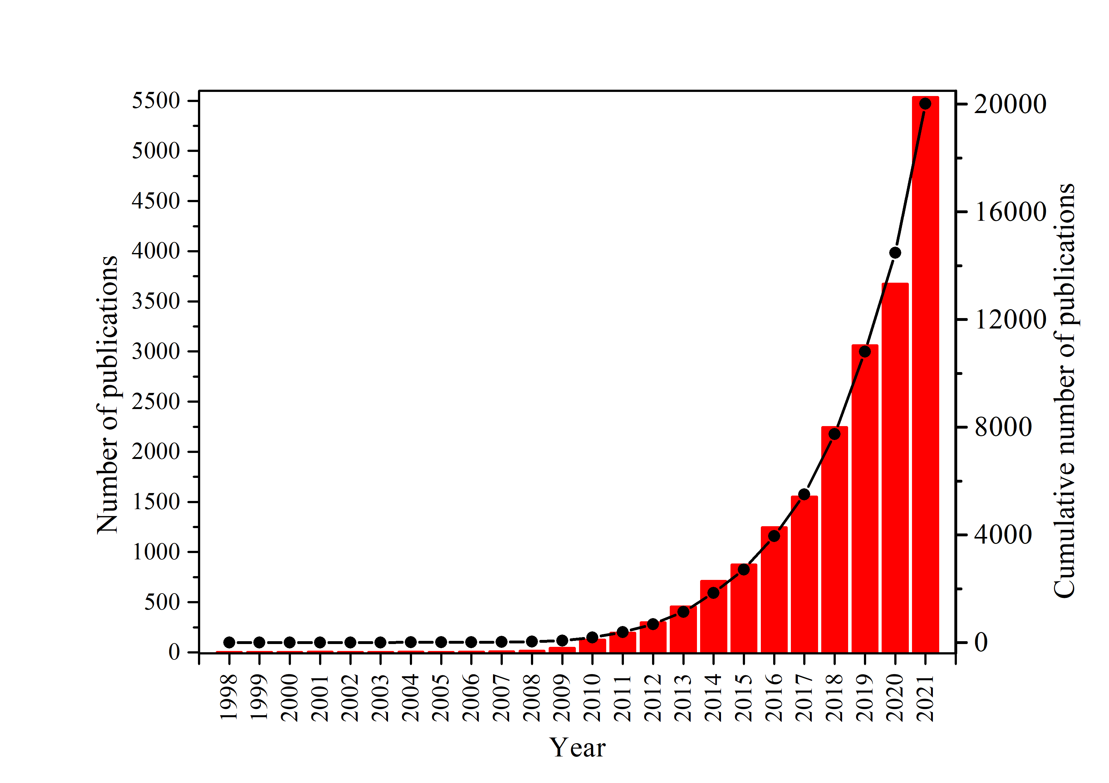
Fig. S1 The number of published documents on biochar research.

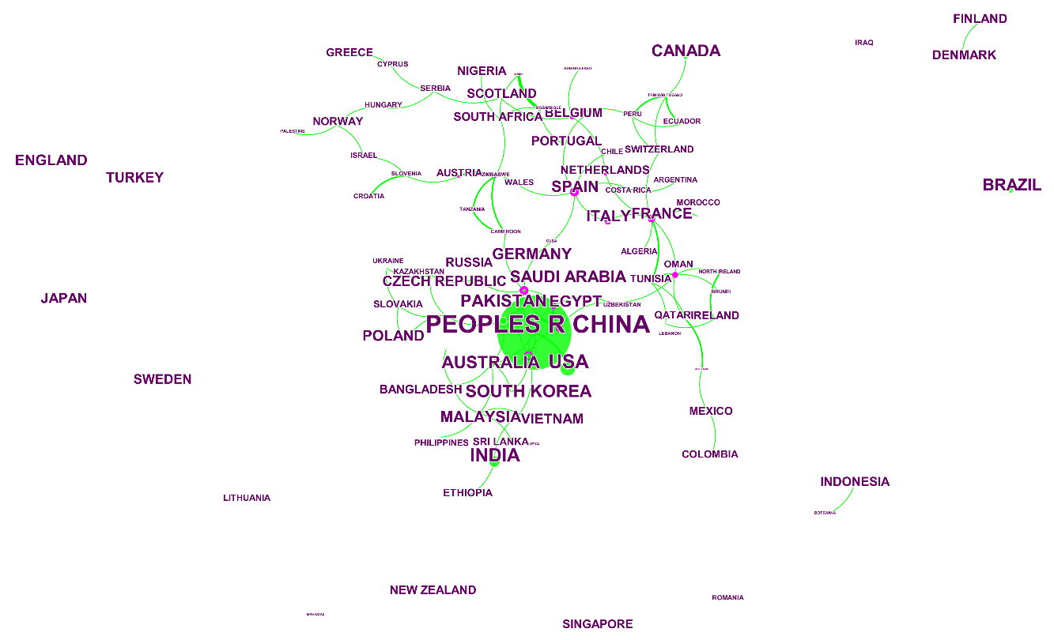
Fig. S2 Countries performing biochar research in 2021.

