Additional file1

Biochar-derived dissolved organic matters influencing bacterium characteristics during biodegradation of sulfamethoxazole and chloramphenicol under alternation of visible and avoiding light
Fang Yang^{a,b}, Yanan Xueª, Yue Gaoª, Qing Zhuª, Cuiping Wang^{a,*}, Hongwen Sunª
ªKey Laboratory of Pollution Processes and Environmental Criteria, Ministry of Education, Tianjin Key Laboratory of Environmental Remediation and Pollution Control, College of Environmental Science and Engineering, Nankai University, Tianjin 300071, PR China
^{b}College of Natural Resources and Environment, Northwest A&F University, Yangling 712100, PR China

*Corresponding author.
Prof. Cuiping Wang.
Phone: +86-22-23504362; Fax: +86-22-23509241.
E-mail: wangcp@nankai.edu.cn

Text S1. Microbial culture conditions
Liquid nutrient agar medium (NA) (g·L⁻ ¹): 5.0 g of beef paste, 10 g of peptone, and 5.0 g of NaCl, and 15 g of agar were boiled in 1 L of DI; then, 100 mM HCl and NaOH were used to adjust the liquid medium pH to approximately 7.0, and the medium was passed through 0.22 µm filtration membrane. Then, the medium was sterilized by autoclaving at 121 °C (1.05 MPa) for 30 min. The bacteria used for subsequent experimental inoculation was collected from the end of the logarithmic phase after continuous two batches of culture.
Liquid nutrient medium (NM) (g·L⁻ ¹) for strain culture: 5.0 g of beef paste, 10 g of peptone, and 5.0 g of NaCl were boiled in 1 L of DI; then, 100 mM HCl and NaOH were used to adjust the liquid medium pH to approximately 7.0, and the medium was passed through 0.22 µm filtration membrane. The liquid medium was sterilized by autoclaving at 121 °C (1.05 MPa) for 30 min.
Mineral liquid medium (MM) (g·L⁻¹) contained KH₂PO₄ (1.5 g), K₂HPO₄·3H₂O (5.0 g), NaCl (1.0 g), MgSO₄·7H₂O (0.4 g), and 1 mL trace elements. The trace elements (g·L⁻¹) contained ZnSO₄·2H₂O (0.2 g), NaHCO₃ (2.0 g), CuSO₄·12H₂O (0.1 g), MnSO₄·3H₂O (0.3 g), (NH₄)₆Mo₇O₂·4H₂O (0.02 g), CaCL₂·2H₂O (0.05 g), CoCl₂·5H₂O (0.5 g), FeSO₄·5H₂O (0. 5 g). The medium was adjusted pH to 7.0 using 100 mM HCl and NaOH, respectively. And the liquid MM was filtrated using 0.22 µm membrane and sterilized by autoclaving at 121 °C for 30 min.

Text S2. Biochar preparation
Rice straw was collected from a farm field in Rizhao City, Shandong Province, China, and was used to produce biochar. The methods of biochar production are described as below. First, the rice straw was washed, dried, and ground to pass through a 60-mesh sieve. Then, the ground straw was placed in a 50 mL quartz tube in a tube furnace from Tianjin Central Electric Furnace Limited by Share LTD (model no. SK-G08123K, Tianjin, China) and pyrolyzed under pure N₂ gas (1.5 L min⁻¹) according to the following temperature program: first, the temperature was controlled at 100 °C for 1 h to dry the sample, and then it was pyrolyzed for 4 h at 350, 500, and 700 °C at a rate of approximately 10 °C/min. Finally, biochar was obtained when the temperature of the reactor inside the furnace was below 40 °C. The samples were named BC350, BC500, and BC700, respectively; they were stored in sealed plastic bags and placed in the dark until further use.

Text S3. Acid-modified biochar
Briefly, 50 g biochar mixed with 400 mL DI water on a shaker plate operating at 180 rpm for 3 days (the time selected according to the equilibrium experiment of the DOM released from biochar) to remove easily dissolved organic matter, and got biochar. Next, mixture solutions containing 200 mL of 1 M HCl and 200 mL of 1 M HF to biochar on a shaker plate operating at 180 rpm for 3 days was used to remove ash and refractory organic matter, then gather biochar, repeating four times. Finally, it was washed biochar with DI water until reaching a neutral pH, then freeze-dried biochar used freeze dryer from Titan Scientific LAB (model no. FD-1B-50, Shanghai, China), which main remove water of biochar in a vacuum at about -30 °C, named MBC350, MBC500, and MBC700, respectively, and stored in sealed plastic bags and placed in the dark until further use.

Text S4. BDOMs extraction
Briefly, 50 g biochar (BC350-B700) was mixed with 400 mL DI (pH 9.0) in a glass bottle and then shaken at 25 ± 1 °C, 180 rpm/min for 7 days. The samples were allowed to stand until they were stratified and then collected the liquid supernatant. Next, 0.1 M HCl and NaOH were used to adjust the solution pH to 7.0, and the solutions were named BDOM350, BDOM500, BDOM700, respectively. A total organic carbon analyzer (model no. Multi N/C 3100, Germany) was used to measure the contents of BDOMs (the content of DOC represented the BDOM’s content). The BDOM samples were stored at 4 °C for a short time until further use.

Text S5. Bacterial suspension preparation
P. stutzeri and S. putrefaciens were inoculated from solid NA slants into sterilized test tubes filled with approximately 10 mL of fresh liquid NM medium with rubber caps. Then, the tubes were shaken at 180 rpm at 30 ± 1 °C for 24 h to fully activate the strains. 5 mL of the above activated suspension was added into 250 mL conical flasks containing 45 mL of liquid NM medium and incubated for 24 h under the same conditions. Then, the cultures were centrifuged at 4000 rpm/min for 10 min and the supernatant was poured off. The residue was washed twice with sterile normal saline before resuspension in 50 mL of sterile normal saline. Sterile normal saline was taken as the control, and the concentration of the bacteria in suspension was measured using ultraviolet spectrophotometry (model no. TU-1810; Beijing Purkinje General Instrument Co., Ltd., China) to analyze the optical density (OD) at 660 nm, after which the bacterial suspension was diluted to an absorbance of approximately 0.65. Generally, OD660 = 0.65 represented a bacteria concentration in culture of approximately 5.2 x 10⁸ CFU/mL.

Text S6. Fatty acid extraction
The extraction and analysis of fatty acids from microbes during biodegradation of SMX and CAP in MM culture solution were performed and modified according to the method described by Microbial IDentification Inc. (MIDI) methods (Fernandes et al., 2013; Law et al., 2018). Briefly, 5 mL of solution was taken from the biodegradation system and centrifuged at 8000 rpm/min at 4 °C and for 10 min and placed in a clean 15×100 culture tube with Teflon-lined caps. Then, added 1 mL of Reagent 1 (45 g of sodium hydroxide, 150 mL of methanol, and 150 mL of DI) into the tubes to saponify in a boiling water bath for 30 min. The first saponification was finished and followed by methylation using 2 mL of Reagent 2 (325 mL of certified 6 N HCl, 275 mL of methyl alcohol and 65 mL of DI) and heated for 10 min at 80° ± 1 °C water. Finally, the above saponified solution was extracted using 1.25 mL of Reagent 3 (200 mL of hexane and 200 mL of methyl tertbutyl ether) at on a clinical rotator with gentle tumbling for 10 min. The saponified solution was divided into two layers, specifically, the lower aqueous and the upper organic phase. The upper organic phase was transferred into the tubes and washed using approximately 3 mL of Reagent 4 (10.8 g of sodium hydroxide dissolved in 900 mL of DI). The tubes were recapped and tumbled for 5 min, and the saponified fatty acids were transferred into GC-MS vial for analysis.

Text S7. The copy number of genes by using quantitative real-time PCR (qPCR)
Bacterial DNA extraction: The FAST DNA Spin Kit was chosen (FAST DNA spin kit for soil) to extract DNA from bacteria under biochar and antibiotics culture in this experiment.
Primer design: Use Primer Express software version 3.0 (Applied Biosystems, Foster City, CA) was used to design PCR primers and TaqMan probes for the P. stutzeri and S. putrefaciens strains as shown in Table S2.
The reaction conditions of qPCR experiment: Each PCR mix contained 10 µL of ChamQ SYBR Color qPCR Master Mix (2×), 0.4 µL (5 µM) each of forward and reverse primer, 7.2 µL of ddH₂O, and 1 µL genomic DNA for a final volume of 20 µL. The cycling conditions used for each gene were as follows (Table S2): 95 °C for 3 min, 35 cycles of 95 °C for 30 s, 56 °C for 30 s, and 72 °C for 40 s, followed by a final extension at 72 °C for 10 min in fluorescence quantitative PCR instrument (LineGene 9600 Plus, Bioer Co., Ltd., Hangzhou, China). Plasmids were extracted using the plasmid extraction kit, and PCR and agarose gel electrophoresis were verified with cloned fragments. Then, the copy number of plasmids was obtained by spectrophotometry using a NanoDrop ND-5000 spectrophotometer (Bio Teke Co., Ltd., Beijing, China), and the copy number of gene was calculated according to the molar mass derived from amplicon sequences and the plasmid. Dilutions of plasmid DNA to four-six samples were used to generate standard curves in quantities ranging from 10⁻³ to 10⁻⁸, and all qPCRs were measured three times.
Data analysis: Absolute transcript copy numbers of each gene and replicate were calculated, and data was exported with the LineGene 9600 Plus software for further statistical analysis.

Text S8. The experiments and analysis of bacterial transcriptomic
The data generated from Illumina platform were used for bioinformatics analysis. All of the analyses were performed using the free online platform of Majorbio Cloud Platform (www.majorbio.com) from Shanghai Majorbio Bio-pharm Technology Limited Company. The major software and parameters are as follows.
Mapping reads to reference genome: High quality reads in each sample were mapped to the reference genome provided by the customer. Analysis tool: Bowtie2 (http://bowtie-bio.sourceforge.net/bowtie2/index.shtml)
rRNA contamination assessment: In this step, randomly selected 10000 raw reads in each sample are aligned to Rfam database (http://rfam.xfam.org/) with blast method. Based on the annotation results, percentage of rRNA in each sample is calculated, which is estimated as rRNA contamination. Analysis tool：Blast
Expression analysis: Quantify gene and isoform abundances from single-end or paired-end RNA-Seq data using RSEM，RSEM computes maximum likelihood abundance estimates using the Expectation Maximization (EM) algorithm for its statistical model, including the modeling of paired-end (PE) and variable-length reads, fragment length distributions, and quality scores, to determine which transcripts are isoforms of the same gene. In addition to the default RSEM, customers can also use Kallisto and Salmon. FPKM and TPM method is used to calculated expression level, FPKM represents fragments per kilpbase of exon model per million mapped reads, TPM represents transcript per million mapped reads. The FPKM and TPM are able to eliminate the influence of different gene length and sequencing discrepancy on the calculation of gene expression. Therefore, the calculated gene expression can be directly used for comparing the difference of gene expression among samples. Analysis tools: RSEM（http://deweylab.github.io/RSEM/）, Kallisto（https://pachterlab.github.io/kallisto/）, Salmon (https://combine-lab.github.io/salmon/)
Differential expression analysis: For each data set, and for each alignment and quantification protocol, we identified differentially expressed genes by using the edgeR , DESeq2, or DESeq packages. Analysis tools: edgeR (http://www.bioconductor.org/packages/2.12/bioc/html/edgeR.html), DESeq2 (http://bioconductor.org/packages/release/bioc/html/DESeq2.html), DESeq (http://www.bioconductor.org/packages/release/bioc/html/DESeq.html)
DEGs GO enrichment analysis: The Gene Ontology (http://www.geneontology.org/) project provides an ontology of defined terms representing gene properties, which covers three domains: Cellular Component, Molecular Function and Biological Process. GO enrichment analysis will find GO terms which DEGs are enriched in. And it helps to illustrate the difference between two particular samples on functional levels. Goatools (https://github.com/tanghaibao/GOatools) is used to identify statistically significantly enriched GO term using Fisher’s exact test. The purpose of performing FDR correction is to reduce the Type-1 error by bonferroni, Holm, BY, BH (multiple hypothesis test method). After multiple testing correction, GO terms with adjusted P-value ≤ 0.05 are significantly enriched in DEGs.
DEGs KEGG enrichment analysis: Different expressed genes (DEGs) usually interact with each other in vivo to play roles in certain biological functions. Comparing with the whole genome background, KEGG enrichment analysis could identify the most important biological metabolic pathways and signal transduction pathways that DEGs involved in. KOBAS 2.0 (http://kobas.cbi.pku.edu.cn/home.do) is used to identify statistically significantly enriched pathway using Fisher’s exact test. The purpose of performing FDR correction is to reduce the Type-1 error by bonferroni, Holm, BY, BH (multiple hypothesis test method). The calculating formula of P-value and corrected P-value is similar with that in GO analysis. After multiple testing correction, we choose pathways with P-value ≤ 0.05 which are significantly enriched in DEGs.

Text S9. Antibiotics analysis and fatty acid analysis

Analysis of antibiotics: The methods for measuring the residual amount of SMX and CAP were the same as that described in our previous study (Yang et al., 2020a). The detailed steps are shown in the supporting information. According to the antibiotic residues in the culture medium, the degradation rates of each treatment can be calculated. The calculation formula was: degradation rate (%) = ((initial content - residual)/initial content) ×100%.
Analysis of fatty acid: Fatty acids were analyzed using GC-MS (Agilent Technologies 5977B MSD) equipped with a splitless injector, used the scan model, and electron impact (EI) spectra derived from scanning ranging from 40 to 450 m/z were obtained at 70 eV. The setting detector and injector temperatures were at 250 and 280 °C, respectively. The column temperature was initially 80 °C for 5 min, then gradually increased to 250 °C with 3 °C/min, and maintained thereafter at 5 min. In this case, 1.0 µL of the sample was injected manually into a DB-5MS (30 m×30m×60 m) capillary column. Fatty acids were identified by comparing their retention times with those of authentic materials containing saturated and unsaturated fatty acids from a mix of 37 component fatty acids mix (AccuStandard, Inc, New Harven, CT, USA). To measure the composition of fatty acid, each peak area was calculated based on the height of the peak and retention time (RT). Triplicate determinations were made for each isolate.

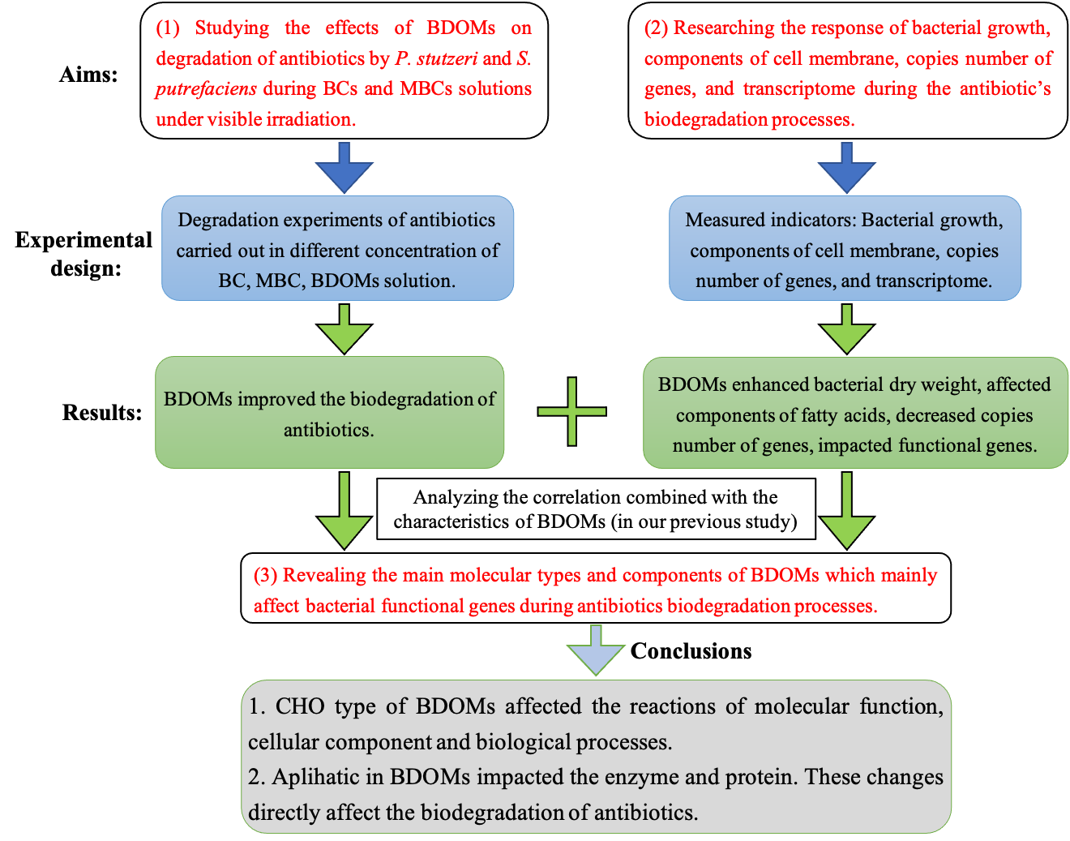
Fig. S1. The whole scheme of mechanisms and experimental design for this study.

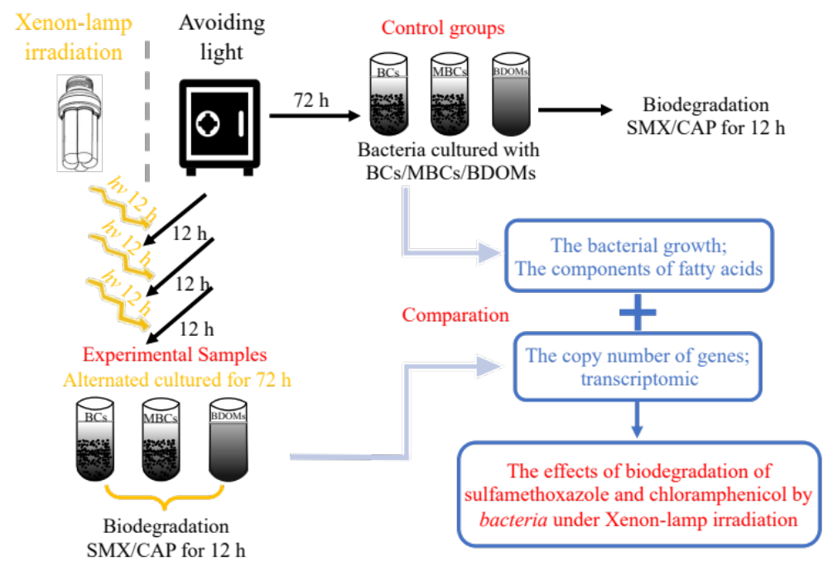
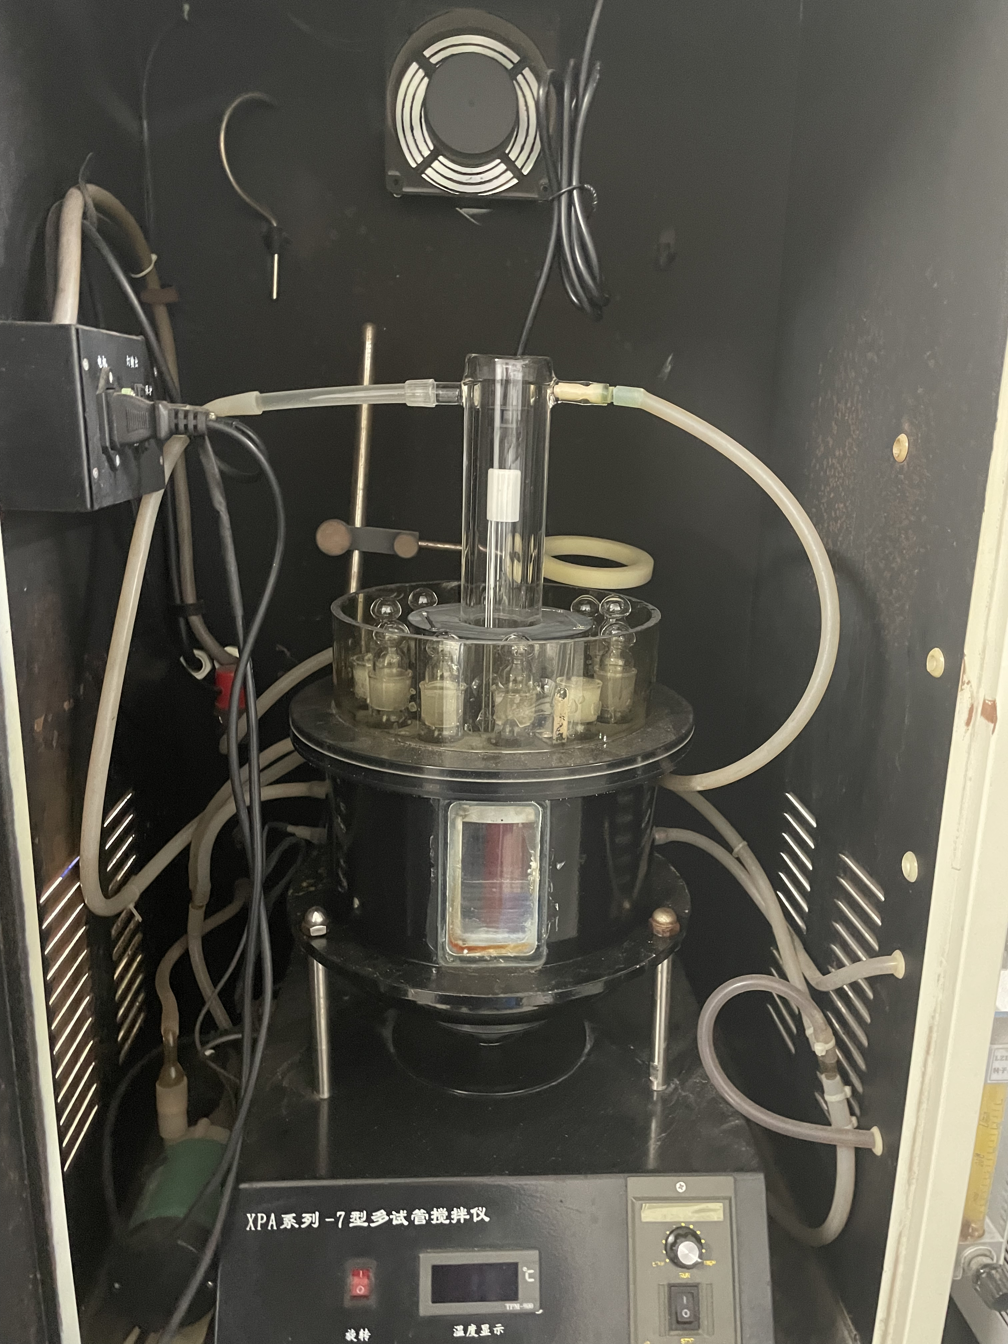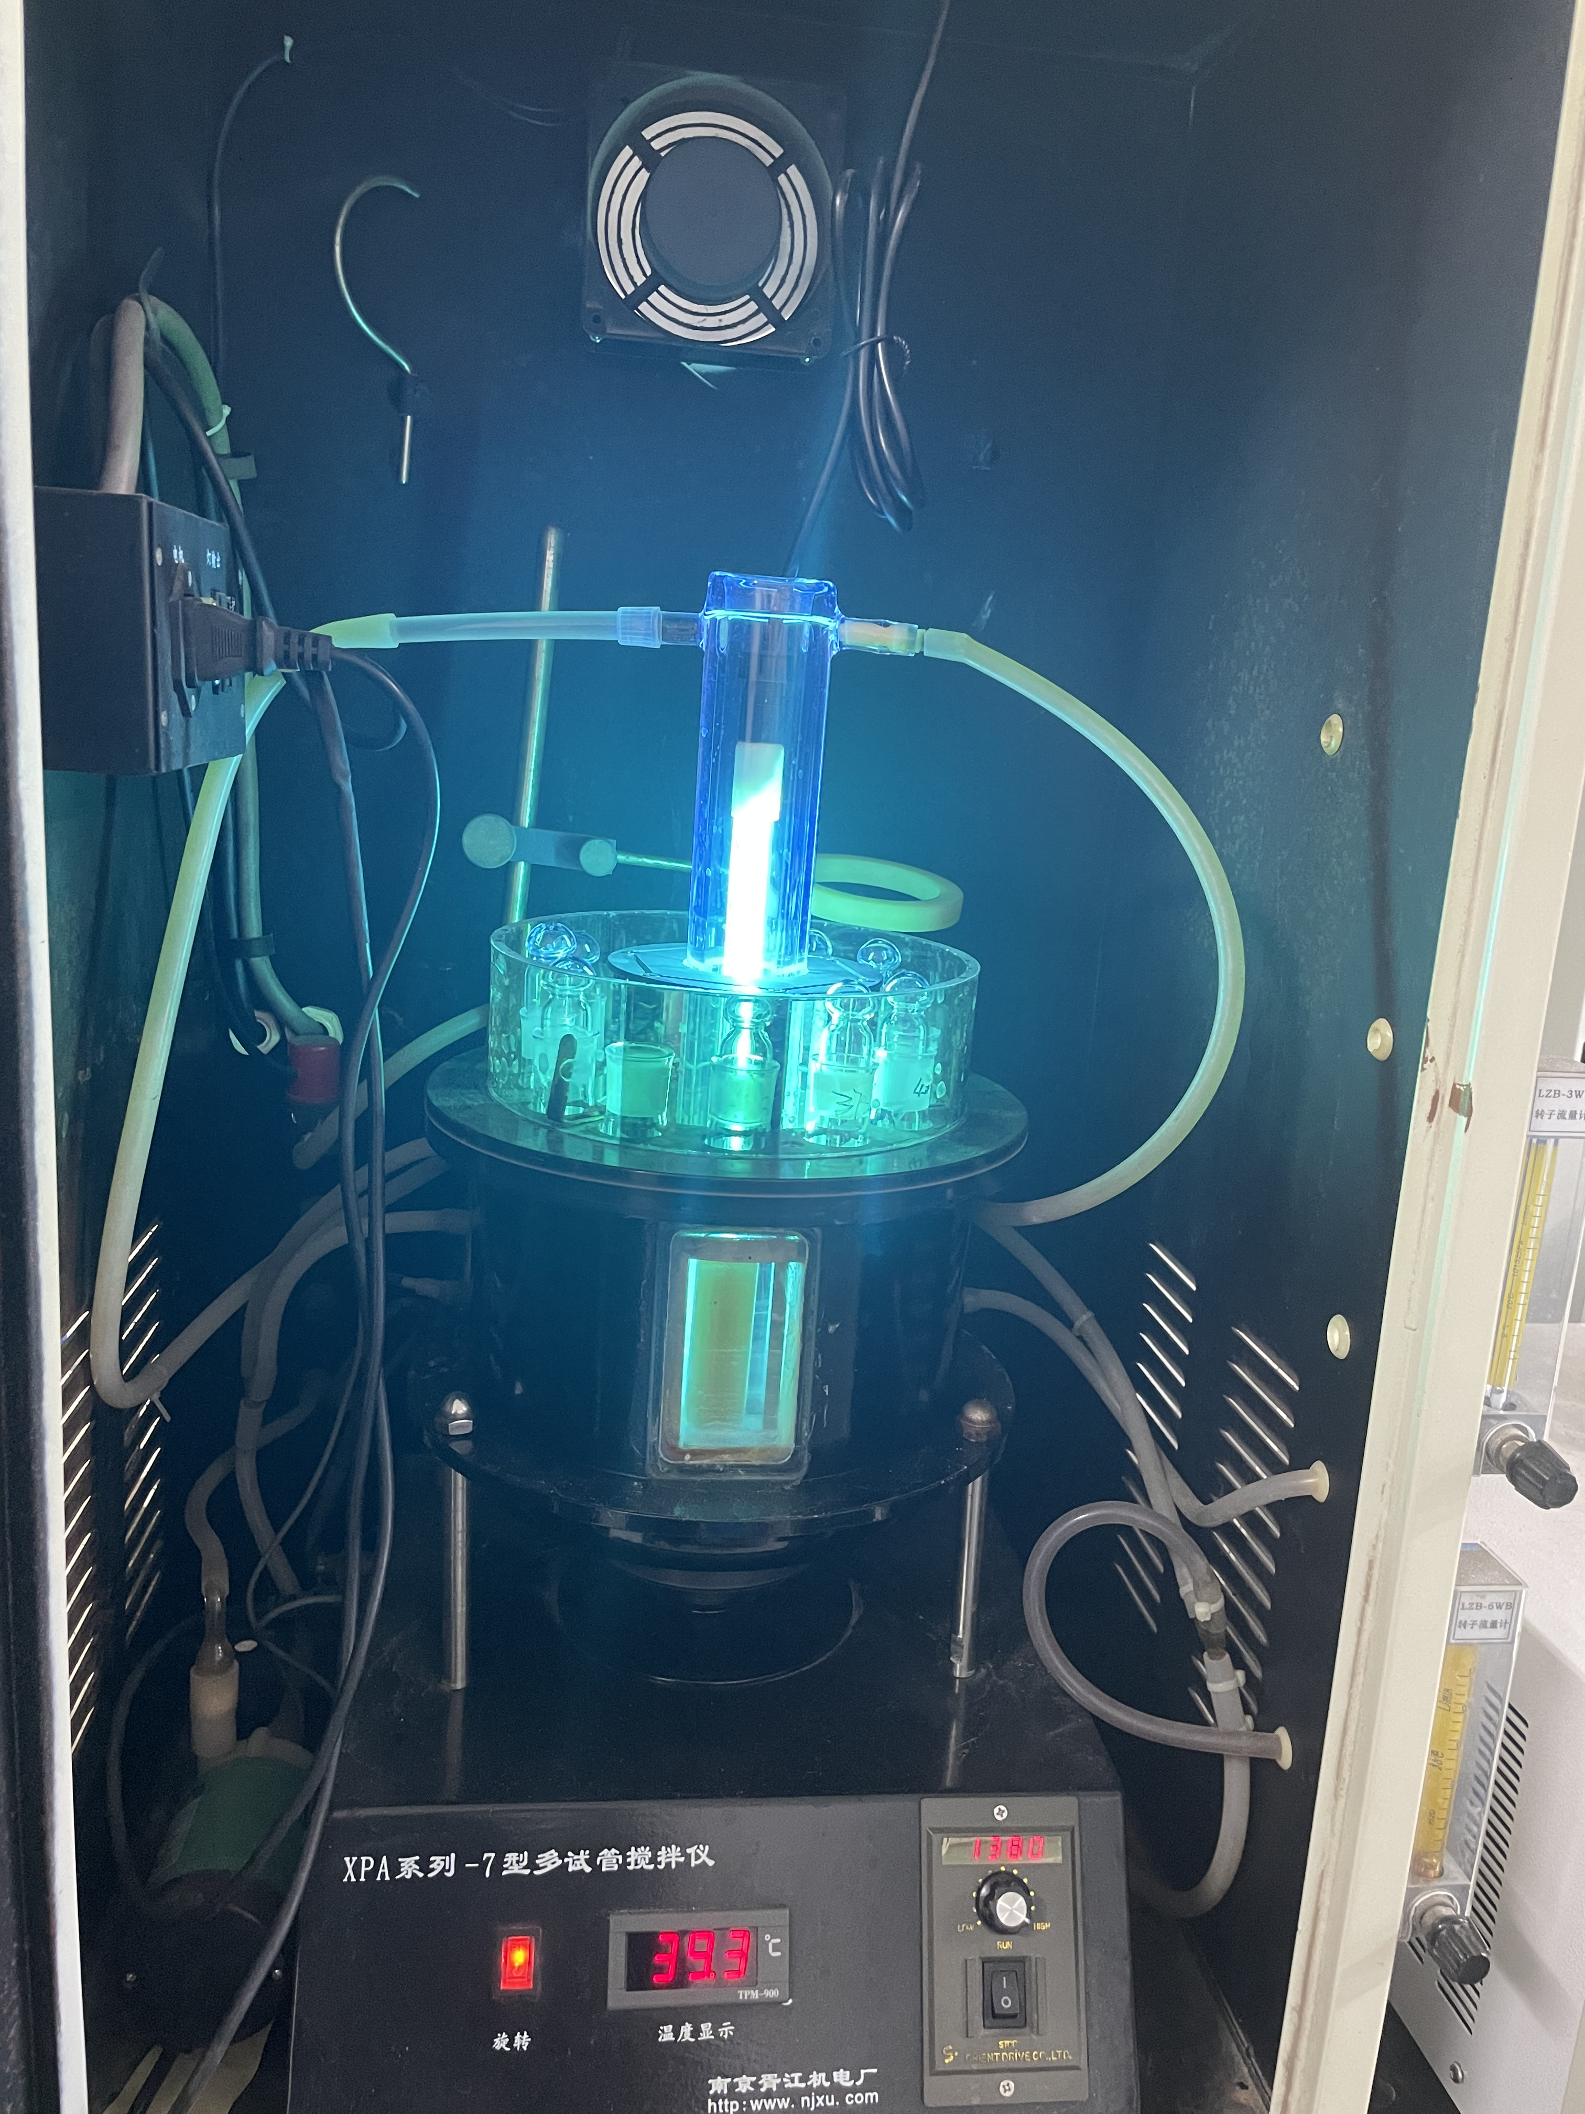
Fig. S2. The scheme and the photoreactor of experiments of biodegradation of SMX and CAP by bacteria cultured with BC, MBCs, and BDOMs under xenon-lamp irradiation and avoiding-light alternated.

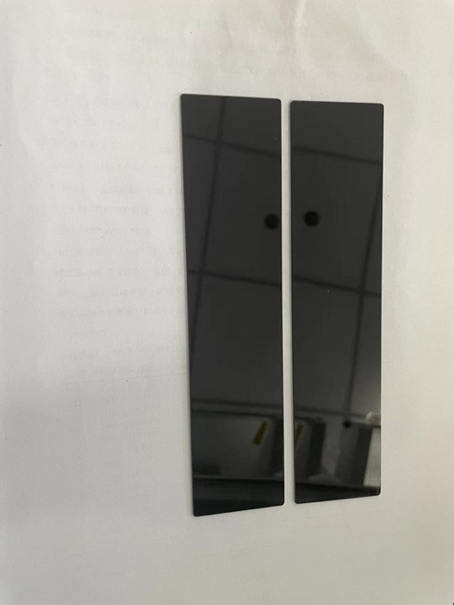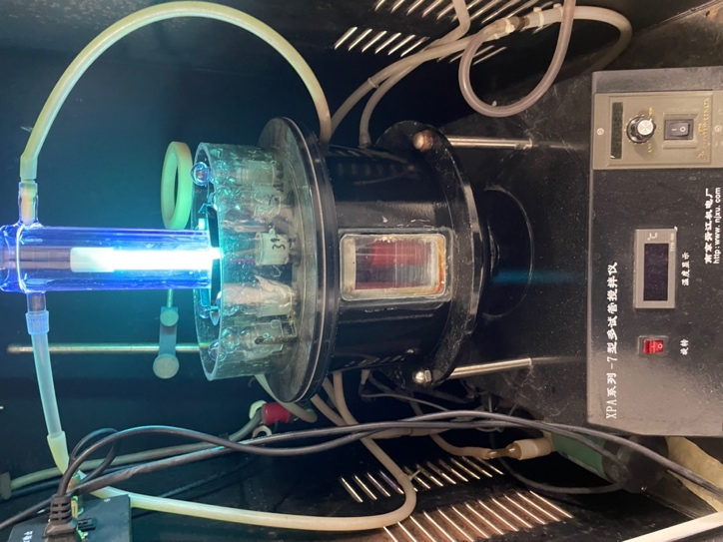
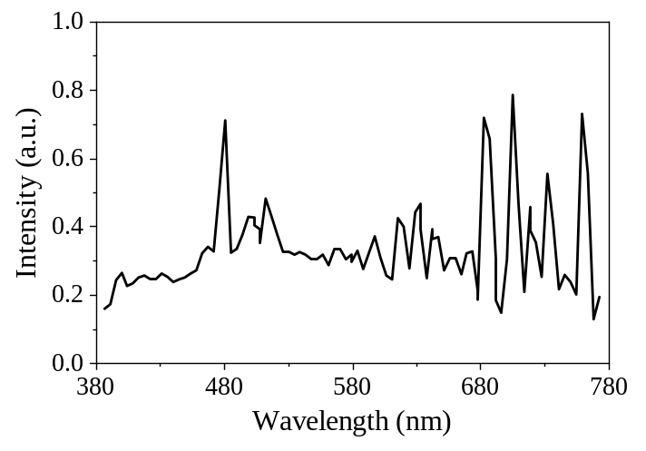
Fig. S3. The photoreactor inserted with ultra violet filter and the variation of wavelength (nm) of the irradiation, which came from Xujiang electromechanical plant, Nanjing, China.

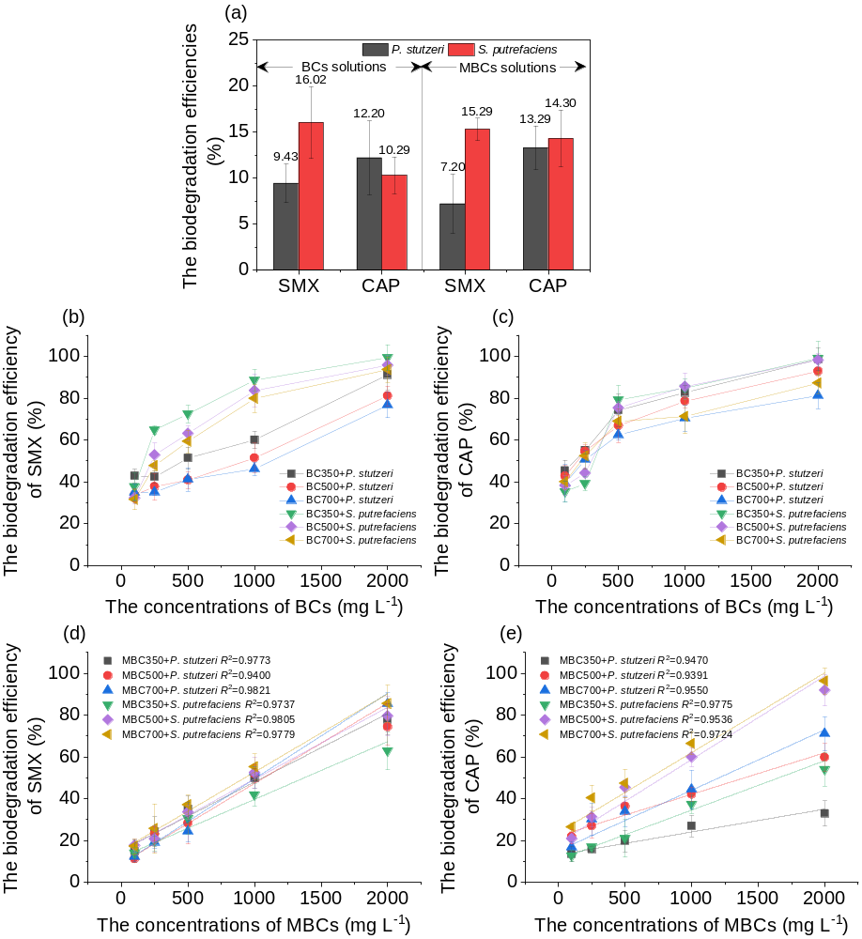
Fig. S4. The biodegradation efficiencies of SMX and CAP by P. stutzeri and S. putrefaciens (a) and cultured with BCs (b-c) and MBCs (d-e) solutions under the alteration of xenon-lamp irradiation (12 h × 3) and avoiding-light (12 h × 3). A was the control groups, which the biodegradation efficiencies of SMX and CAP by P. stutzeri and S. putrefaciens cultured with BCs (350-700) and MBCs (350-700) solutions under avoiding-light condition.

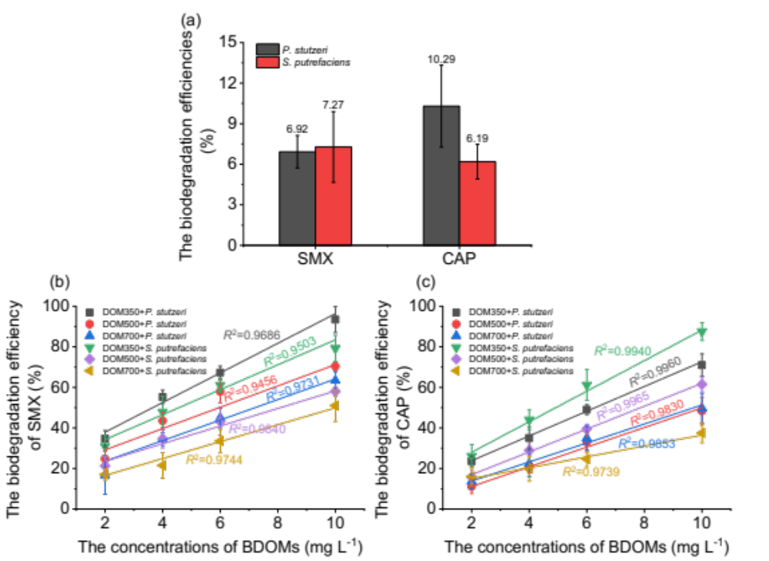
Fig. S5. The biodegradation efficiencies of SMX and CAP by P. stutzeri and S. putrefaciens cultured with different concentrations of BDOMs under avoiding-light condition as control.

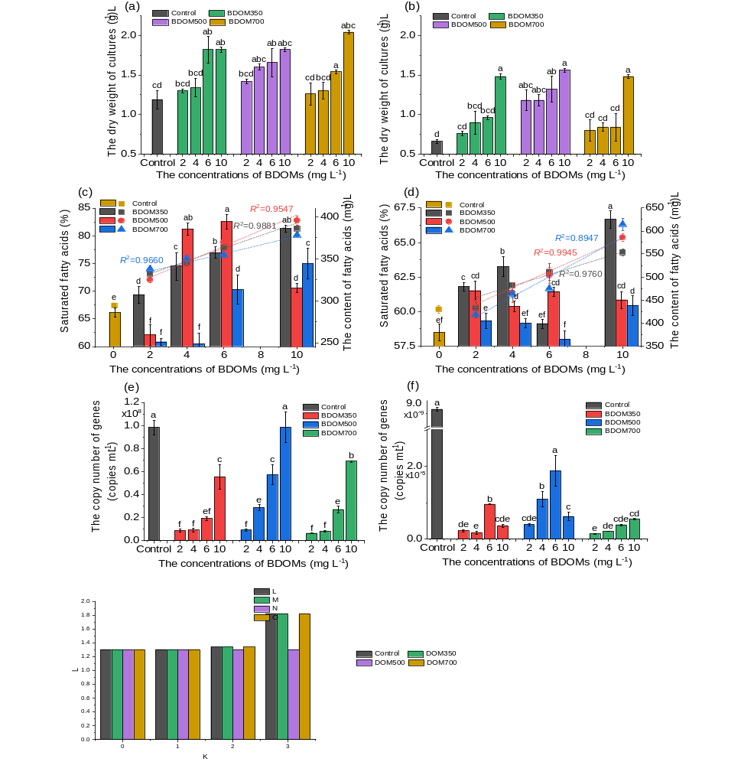
Fig. S6. The bacterial growth (a), saturated fatty acid (b) and the copy number of genes (c) for P. stutzeri and S. putrefaciens cultured with different concentrations of BDOMs under xenon-lamp irradiation and avoiding-light alternated condition. The control groups were the samples from the condition of BDOMs (10 mg L⁻¹) under avoiding-light. Different letters in each panel represent significant differences among all the treatments (p ≤ 0.05, LSD's test).

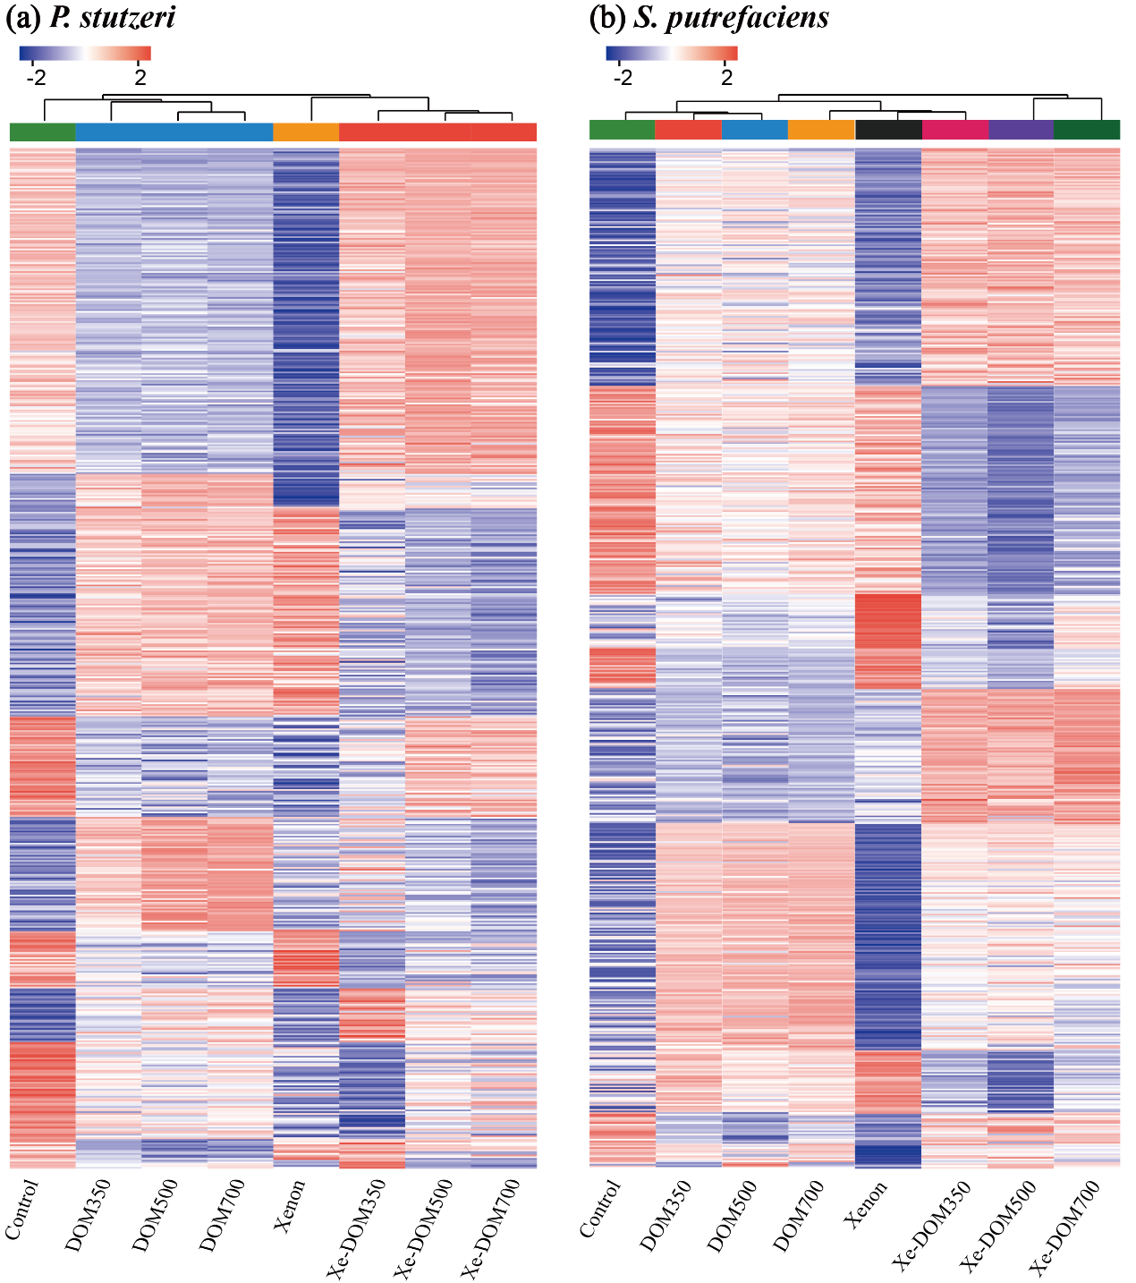
Fig. S7. Hierarchical clustering of the expression genes from P. stutzeri (a) and S. putrefaciens (b) whether exposed to the xenon-lamp irradiation. Each column represents a sample (DBT-, BT-treatment and control, respectively). Each row represents a gene. The color in the figure indicates the amount of expression of the gene in the sample (the amount was calculated as the [log₁₀(TPM + 1)] of the gene abundance).

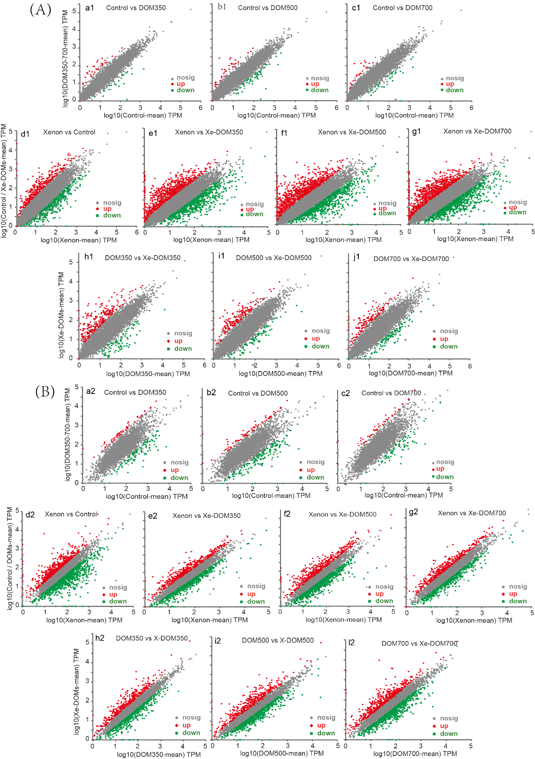
(b)
(a)
Fig. S8. Differential expression levels between samples. Samples of P. stutzeri (A) and S. putrefaciens (B) were treated with BDOMs whether exposed to xenon-lamp irradiation.

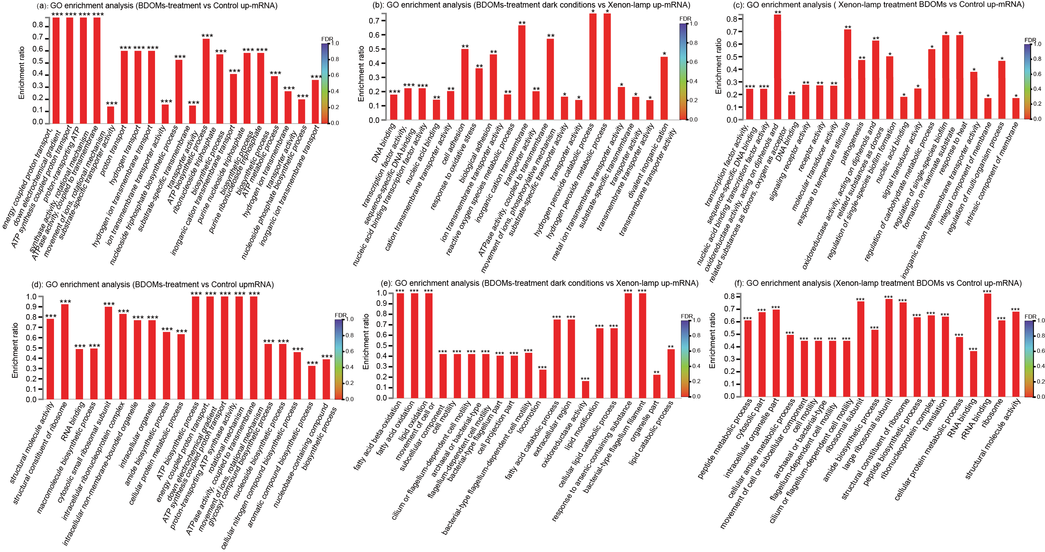
(d)
(c)
(e)
(f)
(b)
(a)
Fig. S9. Functional enrichment analysis of DEGs of P. stutzeri (a-c) and S. putrefaciens (d-e) were treated with BDOMs whether exposed to xenon-lamp irradiation.

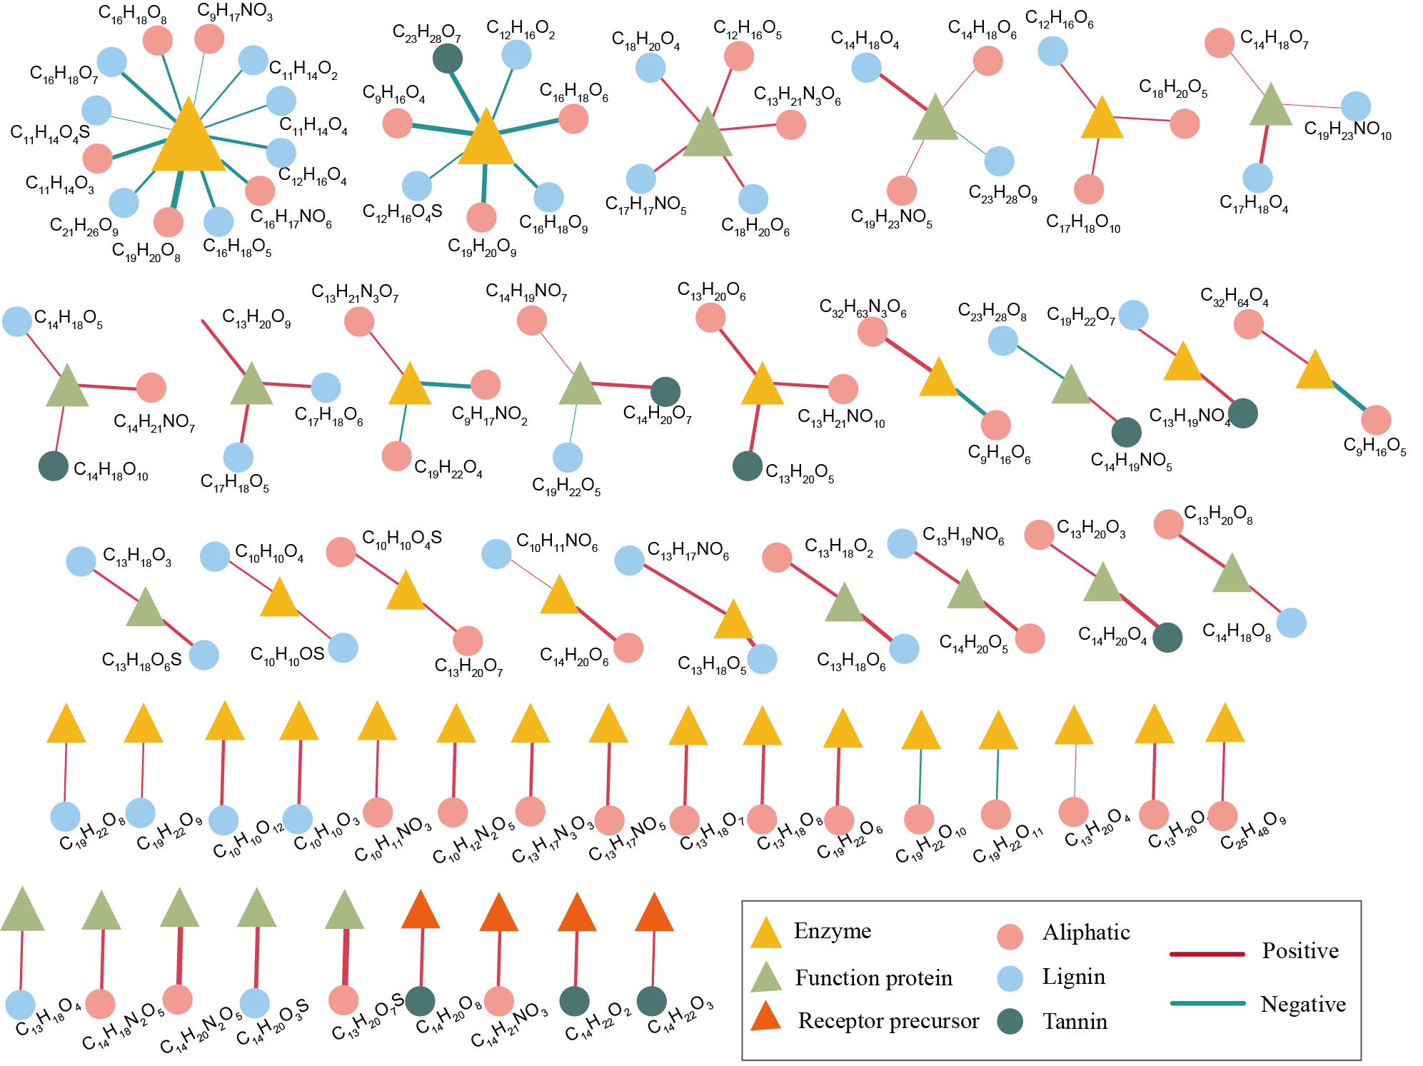
Fig. S10. The interaction network analysis between components of BDOMs and the top 100 functional genes of P. stutzeri and S. putrefaciens. The thicker the line, the bigger value of “r” in the above figure.
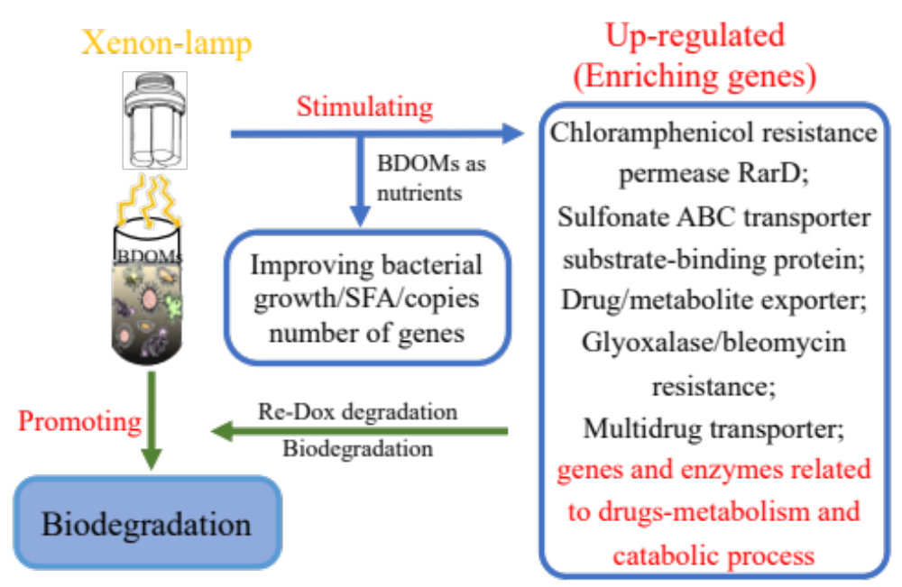
Fig. S11. The proposed biodegradation metabolisms of SMX and CAP by bacteria cultured with BDOMs under the condition of xenon-lamp and avoiding-light alternated.

Table S1.
The structures of sulfamethoxazole and chloramphenicol
Chemicals | Structure | pK_{a} | Molecule Weight
Sulfamethoxazole  (SMX) | 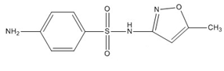 | pK_{a1} = 1.7;  pK_{a2} = 5.8 | 254
Chloramphenicol (CAP) | 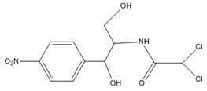 | pK_{a} = 5.5 | 356
Note: SMX structure contained para-aminobenzene sulfonamide structures, and CAP structure contained paranitrophenyl and propylene glycol and dichloroacetamide groups.

Table S2.
Primers and probes used in this study.
Gene | Primer name | Sequence（5’-3’） | Length of amplicon  (bp) | Thermal profile
S. putrefaciens | Forward: U968-GC | CGCCCGGGGCGCGCCCCGGGCGGGGCGG  GGGCACGGGGGGAACGCGAAGAACCTTAC | 475 | 95 °C for 3 min × 1 cycle;  95 °C for 30 s, 56 °C for 30 s,  72 °C for 40 s×35 cycles;
S. putrefaciens | Reverse: L1401-r | CGGTGTGTACAAGACCC | 475
P. stutzeri | Forward: P. stutzeri-f | GGTCTGAGAGGATGATCAGT | 989
P. stutzeri | Reverse: P. stutzeri-r | TTAGCTCCACCTCGCGGC | 989

Table S3.
The content of BDOMs (DOC represented the content of BDOMs) released from different concentrations of BCs and MBCs.
BCs | Concentrations  (mg L⁻¹) | DOC  (mg C L⁻¹) | MBCs | Concentrations  (mg L⁻¹) | TOC  (mg C L⁻¹)
BC350 | 100 | 2.33 | MBC350 | 100 | -
BC350 | 250 | 2.96 | MBC350 | 250 | -
BC350 | 500 | 3.79 | MBC350 | 500 | -
BC350 | 1000 | 4.59 | MBC350 | 1000 | -
BC350 | 2000 | 7.23 | MBC350 | 2000 | -
BC500 | 100 | 2.17 | MBC500 | 100 | -
BC500 | 250 | 2.34 | MBC500 | 250 | -
BC500 | 500 | 2.94 | MBC500 | 500 | -
BC500 | 1000 | 4.02 | MBC500 | 1000 | -
BC500 | 2000 | 5.77 | MBC500 | 2000 | -
BC700 | 100 | 1.77 | MBC700 | 100 | -
BC700 | 250 | 2.01 | MBC700 | 250 | -
BC700 | 500 | 2.80 | MBC700 | 500 | -
BC700 | 1000 | 3.64 | MBC700 | 1000 | -
BC700 | 2000 | 5.01 | MBC700 | 2000 | -
“-”: no detection.

Table S4.
Cell membrane fatty acids profiles of P. stutzeri grown with BDOM350-700 (2, 4, 6, and 10 mg L⁻¹) under xenon-lamp irradiation (12 h) and avoiding-light (12 h) alternated.
Fatty acids | Control | BDOM350 (mg L⁻¹) |  |  |  | BDOM500 (mg L⁻¹) |  |  |  | BDOM700 (mg L⁻¹)
Fatty acids | Control | 2 | 4 | 6 | 10 | 2 | 4 | 6 | 10 | 2 | 4 | 6 | 10
C_{12:0} | 9.92 | 12.05 | 12.50 | 11.95 | 11.01 | 9.54 | 11.16 | 12.62 | 8.54 | 13.35 | 7.86 | 11.39 | 13.03
C_{14:0} | 6.03 | 8.77 | 7.72 | 7.34 | 7.83 | 8.86 | 7.17 | 7.16 | 6.90 | 6.77 | 5.13 | 6.57 | 10.04
C_{14:1,cis-9} | 5.67 | 6.68 | 6.90 | 6.99 | 7.43 | 6.95 | 21.45 | 7.33 | 6.91 | 6.61 | 6.02 | 6.43 | 6.94
C_{15:1,cis-10} | 21.21 | 19.57 | 16.76 | 17.48 | 16.37 | 17.84 | 18.06 | 24.84 | 12.38 | 16.76 | 14.24 | 18.13 | 18.11
C_{16:0} | 148.28 | 165.26 | 182.45 | 201.31 | 221.96 | 135.99 | 212.00 | 226.79 | 185.98 | 128.31 | 134.45 | 179.62 | 200.73
C_{17:1,cis-10} | 32.38 | 30.76 | 33.59 | 32.27 | 21.17 | 23.31 | 30.59 | 30.59 | 9.62 | 20.67 | 16.48 | 31.37 | 23.60
C_{18:0} | 27.93 | 37.77 | 53.29 | 63.02 | 72.88 | 31.40 | 61.28 | 71.26 | 59.29 | 33.28 | 28.96 | 41.01 | 47.32
C_{20:1,cis-11} | 6.38 | 3.63 | 3.66 | 3.68 | 3.74 | 3.72 | 3.67 | 3.76 | 3.70 | 3.32 | 4.01 | 3.92 | 4.49
C_{20:2,cis-11,14} | 27.39 | 21.57 | 23.62 | 19.73 | 23.63 | 20.41 | 19.50 | 18.81 | 21.82 | 20.88 | 20.46 | 18.50 | 19.77
SFA (%) | 67.38 | 73.14 | 75.17 | 77.96 | 81.26 | 72.01 | 75.77 | 78.84 | 82.73 | 74.02 | 75.93 | 76.52 | 80.11

Table S5.
Cell membrane fatty acids profiles of S. putrefaciens grown with BDOM350-700 (2, 4, 6, and 10 mg L⁻¹) under xenon-lamp irradiation (12 h) and avoiding-light (12 h) alternated.
Fatty acids | Control | BDOM350 (mg L⁻¹) |  |  |  | BDOM500 (mg L⁻¹) |  |  |  | BDOM700 (mg L⁻¹)
Fatty acids | Control | 2 | 4 | 6 | 10 | 2 | 4 | 6 | 10 | 2 | 4 | 6 | 10
C_{10:0} | ND | 16.72 | 18.00 | 14.89 | 26.66 | 14.29 | 13.92 | 11.36 | 18.06 | 10.30 | 14.65 | 14.79 | 7.04
C_{11:0} | ND | 1.38 | 1.27 | 1.19 | 2.29 | 1.43 | 1.53 | 1.17 | 1.53 | 1.22 | 1.30 | 1.28 | 1.33
C_{12:0} | 12.28 | 18.77 | 20.11 | 17.31 | 26.93 | 14.58 | 16.53 | 18.32 | 13.11 | 14.29 | 16.83 | 13.98 | 15.46
C_{13:0} | 11.31 | 9.13 | 8.40 | 6.80 | 12.39 | 8.88 | 8.40 | 7.54 | 8.87 | 7.80 | 8.19 | 6.49 | 7.49
C_{14:0} | 9.29 | 10.68 | 11.91 | 9.46 | 15.32 | 9.21 | 10.54 | 9.85 | 8.05 | 8.90 | 8.95 | 8.57 | 9.05
C_{14:1,cis-9} | ND | 9.59 | 9.43 | 7.81 | 10.91 | 8.39 | 9.06 | 8.87 | 8.22 | 9.26 | 7.51 | 7.55 | 8.03
C_{15:0} | 14.29 | 25.71 | 20.82 | 15.88 | 27.76 | 24.10 | 19.35 | 20.21 | 20.55 | 22.09 | 13.50 | 13.57 | 17.64
C_{15:1,cis-10} | 70.02 | 104.29 | 111.14 | 93.14 | 139.93 | 100.10 | 98.48 | 104.27 | 83.80 | 91.22 | 83.75 | 81.71 | 86.46
C_{16:0} | 138.93 | 159.10 | 186.99 | 146.71 | 237.30 | 166.67 | 157.78 | 174.30 | 174.18 | 136.91 | 141.30 | 124.27 | 180.77
C_{16:1,cis-9} | 45.31 | 57.38 | 45.77 | 33.05 | 58.31 | 59.79 | 45.10 | 44.44 | 49.44 | 46.91 | 29.32 | 28.50 | 36.88
C_{17:0} | 9.19 | 8.08 | 7.27 | 6.04 | 7.53 | 8.93 | 6.73 | 7.45 | 8.10 | 7.58 | 5.81 | 5.45 | 6.83
C_{17:1,cis-10} | 9.92 | 8.69 | 9.50 | 6.24 | 9.83 | 7.79 | 6.99 | 8.69 | 6.72 | 7.73 | 7.86 | 5.75 | 7.80
C_{18:0} | 30.17 | 38.91 | 48.29 | 32.10 | 51.93 | 36.59 | 32.76 | 42.71 | 41.72 | 32.81 | 34.28 | 23.96 | 45.02
C_{18:1,cis-9} | 12.09 | ND | ND | ND | ND | ND | ND | ND | ND | ND | ND | ND | ND
C_{20:1,cis-11} | 5.81 | 4.03 | 3.60 | 3.91 | 4.01 | 3.91 | 3.76 | 3.81 | 3.95 | 3.71 | 3.94 | 4.09 | 3.84
C_{20:2,cis-11,14} | 10.29 | 5.97 | 19.43 | 3.68 | 3.80 | 5.11 | 4.94 | 4.77 | 3.81 | 3.98 | 22.38 | 4.37 | 4.68
SFA (%) | 59.50 | 60.30 | 61.90 | 62.88 | 64.28 | 60.60 | 61.38 | 62.62 | 65.35 | 59.77 | 61.27 | 61.67 | 66.30
ND: Not detected.

Table S6.
Filtered data quality statistics.
Bacteria | Sample | Clean Reads | Clean Bases (bp) | Q20 (%) | Q30 (%)
P. stutzeri | Control | 19376176 | 2697250550 | 98.62 | 95.75
P. stutzeri | BDOM350 | 20942814 | 2900560298 | 98.50 | 95.38
P. stutzeri | BDOM500 | 24952458 | 3437137114 | 98.51 | 95.34
P. stutzeri | BDOM700 | 18345204 | 2550685254 | 98.46 | 95.23
P. stutzeri | Xe | 15810654 | 2088963921 | 98.50 | 95.32
P. stutzeri | Xe-BDOM350 | 17670092 | 2465692952 | 98.40 | 95.09
P. stutzeri | Xe-BDOM500 | 18594222 | 2569462365 | 98.39 | 95.04
P. stutzeri | Xe-BDOM700 | 19539572 | 2722063336 | 98.44 | 95.16
S. putrefaciens | Control | 17506292 | 2435783171 | 98.24 | 94.49
S. putrefaciens | BDOM350 | 17321788 | 2454921337 | 98.29 | 94.69
S. putrefaciens | BDOM500 | 16334132 | 2316612849 | 98.30 | 94.68
S. putrefaciens | BDOM700 | 17103504 | 2430273929 | 98.39 | 94.90
S. putrefaciens | Xe | 17554982 | 2443872224 | 98.84 | 96.06
S. putrefaciens | Xe-BDOM350 | 16785874 | 2361299768 | 98.38 | 94.94
S. putrefaciens | Xe-BDOM500 | 16036512 | 2201870147 | 98.41 | 95.01
S. putrefaciens | Xe-BDOM700 | 17169200 | 2387709246 | 98.78 | 95.85
Samples of BDOM350-700 were represented the bacteria treatment cultured with BDOM350, BDOM500, and BDOM700 under the condition of avoiding-light. And the samples of Xe-BDOM350-700 were represented the bacteria treatment cultured with BDOM350, BDOM500, and BDOM700 under the condition of xenon-lamp irradiation (12 h) and avoiding-light (12 h) alternated.

Table S6.
The category of differentially expressed (DEGs) in P. stutzeri and S. putrefaciens (BDOMs-, culture condition of xenon-lamp irradiation and avoiding-light alternated - treatment and control, respectively).
Category | P. stutzeri  (unigenes) | S. putrefaciens  (unigenes)
Cellular process and signaling | 142 | 305
Information storage and processing | 116 | 260
Metabolism | 243 | 446
Poorly characterized | 309 | 567

Table S7.
Differentially expressed (DEGs) in samples of P. stutzeri (BDOMs-, culture condition-treatment and control, respectively).
Gene ID | Gene name | Gene description | TPM value of DEGs (The expression of functional genes in each sample)
Gene ID | Gene name | Gene description | Control | Xenon | BDOM350 | Xe-BDOM350 | BDOM500 | Xe-BDOM500 | BDOM700 | Xe-BDOM700
gene0135 | - | beta-alanine degradation protein BauB | 37.64 | 115.40 | 34.29 | 37.83 | 41.13 | 52.10 | 34.70 | 39.52
gene0350 | - | multidrug transporter | 274.37 | 597.64 | 441.97 | 669.34 | 480.73 | 541.56 | 486.04 | 516.04
gene0421 | acrA | RND multidrug efflux membrane fusion protein MexA precursor | 48.41 | 63.54 | 134.56 | 228.76 | 141.49 | 200.91 | 144.06 | 214.96
gene0422 | acrB | multidrug efflux RND transporter permease subunit | 31.62 | 61.50 | 79.56 | 110.05 | 94.59 | 124.46 | 83.94 | 100.68
gene0423 | oprM | adeC/adeK/oprM family multidrug efflux complex outer membrane factor | 29.10 | 86.16 | 69.00 | 69.48 | 84.65 | 85.51 | 50.22 | 97.30
gene0483 | rarD | chloramphenical resistance permease RarD | 6.59 | 25.19 | 13.37 | 15.71 | 12.60 | 21.55 | 24.61 | 15.10
gene0743 | - | multidrug ABC transporter permease | 0.16 | 0.23 | 0.22 | 0.31 | 0.46 | 12.91 | 0.26 | 0.45
gene0757 | mexI | acriflavine resistance protein B | 0.67 | 1.20 | 1.50 | 12.78 | 1.88 | 3.31 | 2.33 | 8.36
gene0758 | mexH | MexH family multidrug efflux RND transporter periplasmic adaptor subunit | 1.23 | 0.94 | 1.82 | 38.48 | 1.99 | 8.51 | 2.71 | 22.85
gene0995 | - | phenylacetic acid degradation protein PaaI | 14.97 | 51.20 | 8.08 | 10.73 | 3.78 | 22.08 | 6.39 | 31.34
gene1059 | - | DNA degradation protein EddB | 1.07 | 1.18 | 1.58 | 2.62 | 2.02 | 2.39 | 1.52 | 2.44
gene1070 | - | fusaric acid resistance protein | 1.22 | 1.72 | 2.04 | 7.52 | 2.82 | 25.59 | 2.85 | 4.57
gene1085 | - | multidrug transporter | 20.46 | 24.68 | 26.12 | 39.06 | 30.45 | 26.22 | 33.78 | 38.45
gene1305 | cpbD | multidrug transporter | 1.25 | 1.67 | 2.22 | 2.50 | 2.97 | 2.80 | 2.02 | 3.25
gene1346 | mexK | multidrug transporter AcrB | 11.51 | 12.95 | 18.58 | 21.43 | 18.78 | 50.54 | 16.96 | 24.73
gene1453 | bcr | Bcr/CflA family drug resistance efflux transporter | 7.50 | 14.62 | 22.23 | 27.02 | 27.49 | 27.54 | 28.17 | 29.62
gene1505 | gesA | MexE family multidrug efflux RND transporter periplasmic adaptor subunit | 9.49 | 45.51 | 18.74 | 2.68 | 2.69 | 9.51 | 2.99 | 19.04
gene1506 | gesB | multidrug efflux RND transporter permease subunit | 8.08 | 13.36 | 3.08 | 6.58 | 4.86 | 2.05 | 3.20 | 7.67
gene1692 | - | fusaric acid resistance protein | 10.89 | 14.88 | 14.96 | 28.03 | 13.61 | 17.93 | 17.35 | 34.39
gene1731 | sugE | multidrug transporter | 8.42 | 11.74 | 19.66 | 29.35 | 19.64 | 32.59 | 27.15 | 26.13
gene1773 | vcaM | multidrug ABC transporter ATP-binding protein | 24.65 | 87.84 | 26.20 | 36.10 | 31.18 | 36.42 | 26.12 | 39.95
gene1877 | - | bleomycin resistance protein | 6.53 | 16.60 | 7.24 | 11.11 | 8.06 | 10.71 | 9.99 | 13.49
gene1987 | - | multidrug transporter | 0.23 | 0.48 | 0.11 | 0.48 | 0.06 | 0.50 | 0.12 | 0.58
gene2046 | lolC_E | multidrug ABC transporter substrate-binding protein | 20.39 | 38.97 | 49.61 | 98.65 | 78.27 | 84.52 | 64.78 | 91.63
gene2048 | lolC_E | multidrug ABC transporter substrate-binding protein | 11.54 | 30.23 | 21.75 | 23.26 | 23.00 | 28.68 | 17.81 | 30.68
gene2182 | - | organic hydroperoxide resistance protein | 25.60 | 52.92 | 16.56 | 26.53 | 27.14 | 91.82 | 9.32 | 27.83
gene2646 | - | multidrug DMT transporter permease | 1.81 | 3.33 | 4.39 | 7.82 | 4.33 | 4.93 | 5.90 | 5.61
gene2720 | mdtB | multidrug transporter | 6.07 | 6.60 | 11.38 | 14.61 | 8.15 | 9.85 | 13.26 | 16.22
gene2721 | mdtC | multidrug transporter | 3.43 | 7.56 | 8.11 | 8.75 | 5.85 | 6.79 | 7.90 | 12.09
gene2755 | mexF | multidrug efflux RND transporter permease subunit | 0.88 | 2.05 | 2.80 | 3.44 | 2.32 | 3.61 | 3.23 | 4.52
gene2756 | mexE | MexE family multidrug efflux RND transporter periplasmic adaptor subunit | 1.07 | 1.60 | 3.08 | 5.83 | 3.54 | 4.84 | 3.85 | 6.59
gene2774 | - | phenol degradation protein | 0.21 | 0.72 | 0.16 | 0.64 | 0.19 | 0.28 | 0.09 | 0.32
gene2915 | arsH | arsenical resistance protein ArsH | 8.82 | 30.44 | 29.37 | 62.16 | 121.11 | 60.20 | 18.80 | 68.03
gene3149 | pcoB | copper resistance protein B | 0.27 | 1.15 | 0.71 | 2.25 | 0.99 | 1.30 | 0.75 | 0.83
gene3187 | mexX | MexX/AmrA family multidrug efflux RND transporter periplasmic adaptor subunit | 0.64 | 1.22 | 1.39 | 1.70 | 0.95 | 4.41 | 2.07 | 2.17
gene3188 | mexY | multidrug efflux RND transporter permease | 0.79 | 2.42 | 1.81 | 2.72 | 2.50 | 3.84 | 1.88 | 2.66
gene3189 | oprM | multidrug transporter | 0.33 | 0.79 | 0.91 | 0.86 | 1.81 | 1.94 | 0.66 | 1.68
gene3469 | - | aromatic hydrocarbon degradation protein | 2.33 | 3.68 | 3.49 | 4.84 | 2.46 | 3.61 | 3.42 | 3.72
gene3771 | mexN | acriflavine resistance protein B | 0.73 | 1.47 | 1.00 | 2.38 | 1.24 | 1.49 | 1.94 | 2.47
gene3873 | - | multidrug DMT transporter permease | 1.17 | 1.91 | 1.11 | 3.68 | 1.42 | 1.91 | 2.90 | 4.08
gene4007 | - | fusaric acid resistance protein | 1.24 | 4.49 | 3.01 | 3.19 | 6.16 | 7.46 | 3.55 | 5.88
gene4048 | - | aminoglycoside resistance protein | 4.29 | 6.86 | 3.07 | 7.89 | 2.25 | 8.49 | 3.60 | 9.92
gene4553 | - | fusaric acid resistance protein conserved region | 0.75 | 0.84 | 0.61 | 1.08 | 1.25 | 1.31 | 0.91 | 1.12
gene4697 | vanW | vancomycin resistance protein | 8.34 | 16.16 | 14.97 | 18.19 | 15.21 | 17.36 | 14.96 | 18.98
gene4860 | acrB | acriflavine resistance protein B | 2.53 | 16.07 | 4.37 | 6.40 | 3.70 | 6.17 | 3.52 | 7.58
gene5007 | - | glyoxalase/bleomycin resistance protein/dioxygenase | 1.64 | 1.80 | 2.96 | 3.47 | 0.83 | 4.03 | 3.06 | 4.95
gene5108 | oprJ | multidrug transporter | 0.63 | 0.76 | 1.35 | 2.57 | 1.48 | 2.33 | 1.69 | 2.72
gene5109 | mexD | multidrug efflux RND transporter permease subunit | 1.63 | 2.49 | 2.65 | 5.88 | 2.38 | 6.65 | 4.25 | 6.96
gene5326 | - | drug/metabolite exporter YedA | 3.30 | 17.84 | 8.21 | 8.34 | 4.22 | 11.01 | 5.14 | 14.99
gene5643 | - | sulfonate ABC transporter substrate-binding protein | 21.95 | 90.30 | 5.15 | 16.81 | 6.88 | 14.07 | 3.90 | 16.89
gene5713 | - | multidrug RND transporter | 2.56 | 3.45 | 2.65 | 6.77 | 2.08 | 2.46 | 1.83 | 3.82

Table S8.
Differentially expressed (DEGs) in samples of S. putrefaciens (BDOMs-, culture condition-treatment and control, respectively).
Gene ID | Gene name | Gene description | TPM value of DEGs (The expression of functional genes in each sample)
Gene ID | Gene name | Gene description | Control | Xenon | BDOM350 | Xe-BDOM350 | BDOM500 | Xe-BDOM500 | BDOM700 | Xe-BDOM700
gene0098 | acrA | multidrug transporter | 333.00 | 404.99 | 599.46 | 676.03 | 580.48 | 686.05 | 596.11 | 814.59
gene0099 | acrB | multidrug efflux RND transporter permease subunit | 118.40 | 146.61 | 246.55 | 267.86 | 200.59 | 312.46 | 222.26 | 279.28
gene0111 | - | acriflavin resistance protein | 3.83 | 6.59 | 3.75 | 3.75 | 5.02 | 4.26 | 3.57 | 5.05
gene0261 | - | copper-resistance protein, CopA family | 41.63 | 224.57 | 106.17 | 153.41 | 103.51 | 136.03 | 108.36 | 217.82
gene0262 | pcoB | copper resistance protein B | 45.19 | 148.73 | 125.72 | 140.79 | 89.69 | 123.58 | 108.62 | 155.70
gene0263 | copC | copper resistance protein CopC | 109.43 | 361.03 | 368.62 | 377.89 | 252.35 | 368.92 | 296.14 | 384.33
gene0264 | pcoD | copper resistance protein CopD | 26.23 | 55.26 | 45.43 | 77.71 | 48.64 | 51.30 | 54.79 | 74.53
gene0279 | - | copper resistance protein | 73.87 | 149.52 | 89.75 | 114.52 | 67.15 | 90.89 | 72.14 | 135.48
gene0335 | bcr | Bcr/CflA family drug resistance efflux transporter | 64.85 | 120.43 | 100.78 | 285.38 | 83.55 | 285.46 | 113.36 | 241.71
gene0335 | bcr | Bcr/CflA family drug resistance efflux transporter | 64.85 | 120.43 | 100.78 | 285.38 | 83.55 | 285.46 | 113.36 | 241.71
gene0496 | fadL | membrane protein involved in aromatic hydrocarbon degradation | 33.84 | 71.83 | 35.58 | 65.31 | 38.01 | 64.94 | 38.45 | 114.26
gene0742 | - | multidrug transporter AcrB | 45.21 | 65.51 | 140.00 | 170.32 | 94.82 | 182.09 | 92.13 | 134.13
gene0869 | - | teicoplanin resistance protein VanZ | 51.55 | 77.93 | 76.14 | 89.39 | 47.44 | 90.17 | 74.36 | 89.72
gene0941 | - | acriflavin resistance protein | 14.98 | 36.76 | 15.79 | 46.20 | 11.30 | 38.22 | 13.06 | 43.79
gene0989 | - | multidrug DMT transporter | 12.87 | 14.20 | 13.31 | 33.65 | 16.37 | 28.02 | 14.21 | 37.89
gene1133 | murJ | multidrug transporter MurJ | 65.48 | 94.78 | 34.22 | 57.46 | 34.02 | 63.11 | 43.90 | 59.69
gene1350 | - | multidrug transporter MatE | 17.27 | 21.85 | 18.50 | 24.73 | 24.05 | 29.36 | 28.08 | 29.11
gene1557 | - | multidrug ABC transporter ATP-binding protein | 11.70 | 19.90 | 15.86 | 26.10 | 9.99 | 24.71 | 18.00 | 20.22
gene1845 | acrA | MexH family multidrug efflux RND transporter periplasmic adaptor subunit | 21.44 | 38.87 | 25.22 | 31.03 | 31.39 | 32.06 | 20.26 | 29.92
gene1846 | acrB | multidrug transporter | 13.05 | 14.49 | 13.96 | 21.80 | 15.36 | 22.98 | 11.85 | 22.79
gene1863 | sugE | multidrug transporter | 29.46 | 84.79 | 24.26 | 38.83 | 19.90 | 28.14 | 41.22 | 42.52
gene2143 | - | arsenic resistance protein | 9.23 | 82.79 | 10.25 | 17.24 | 10.00 | 16.02 | 8.95 | 24.91
gene2160 | - | arsenic resistance protein | 85.81 | 90.19 | 15.51 | 35.20 | 11.70 | 34.82 | 14.84 | 33.96
gene2177 | - | Bcr/CflA family drug resistance efflux transporter | 4.74 | 22.17 | 6.39 | 22.42 | 6.16 | 13.98 | 6.16 | 26.02
gene2325 | bcr | Bcr/CflA family drug resistance efflux transporter | 51.68 | 123.54 | 75.11 | 140.07 | 74.90 | 175.31 | 65.46 | 189.63
gene2473 | - | acriflavin resistance protein | 49.29 | 262.16 | 29.16 | 37.10 | 38.00 | 57.88 | 22.24 | 31.18
gene2474 | - | acriflavin resistance protein | 20.71 | 36.65 | 13.84 | 21.03 | 18.22 | 19.70 | 13.56 | 16.84
gene2688 | fadL | membrane protein involved in aromatic hydrocarbon degradation | 53.62 | 63.37 | 42.94 | 237.76 | 39.62 | 339.41 | 40.61 | 298.79
gene2693 | - | multidrug transporter AcrB | 16.98 | 17.69 | 11.38 | 15.71 | 9.16 | 12.52 | 11.98 | 13.82
gene2718 | vcaM | multidrug ABC transporter ATP-binding protein | 23.85 | 47.25 | 25.47 | 52.70 | 23.33 | 47.05 | 23.78 | 49.15
gene2773 | - | copper resistance protein | 67.68 | 105.32 | 124.85 | 206.16 | 155.33 | 221.79 | 140.40 | 239.18
gene2887 | - | acriflavin resistance protein | 11.06 | 39.94 | 9.62 | 19.90 | 7.51 | 14.86 | 10.33 | 19.23
gene3060 | - | MexH family multidrug efflux RND transporter periplasmic adaptor subunit | 39.96 | 74.32 | 41.62 | 62.01 | 36.56 | 70.47 | 38.68 | 75.32
gene3061 | - | multidrug transporter AcrB | 17.51 | 27.20 | 17.45 | 40.46 | 14.36 | 35.28 | 14.62 | 39.69
gene3062 | - | Bcr/CflA family drug resistance efflux transporter | 6.23 | 10.76 | 3.64 | 9.48 | 5.33 | 7.49 | 3.82 | 10.43
gene3065 | mexF | multidrug efflux RND transporter permease subunit | 25.58 | 238.31 | 32.08 | 53.79 | 25.59 | 161.49 | 26.52 | 76.11
gene3066 | mexE | MexE family multidrug efflux RND transporter periplasmic adaptor subunit | 49.86 | 1239.93 | 65.96 | 193.77 | 76.37 | 515.02 | 59.26 | 271.29
gene3586 | - | acriflavin resistance protein | 10.18 | 28.23 | 22.18 | 28.40 | 29.91 | 31.62 | 31.04 | 36.45
gene3587 | - | MexH family multidrug efflux RND transporter periplasmic adaptor subunit | 11.35 | 54.61 | 25.56 | 52.94 | 47.95 | 58.12 | 45.72 | 74.49
gene3713 | - | mitomycin resistance protein | 46.12 | 78.23 | 46.14 | 49.43 | 56.56 | 56.88 | 31.65 | 57.69
gene3988 | - | multidrug MFS transporter | 6.72 | 11.92 | 2.14 | 7.59 | 1.48 | 5.16 | 2.20 | 7.45
gene4209 | - | arsenic resistance operon repressor | 21.63 | 48.38 | 26.99 | 225.60 | 40.46 | 368.95 | 21.15 | 230.77
gene4213 | - | acriflavin resistance protein | 11.14 | 12.11 | 13.28 | 18.41 | 19.42 | 22.41 | 14.87 | 16.96
gene4361 | adeB | multidrug efflux RND transporter permease subunit | 4.46 | 8.62 | 3.99 | 6.04 | 5.40 | 5.85 | 5.92 | 12.51
gene4362 | adeB | multidrug efflux RND transporter permease subunit | 5.40 | 6.17 | 9.77 | 10.53 | 9.80 | 9.96 | 13.87 | 18.13
gene4363 | adeA | MexC family multidrug efflux RND transporter periplasmic adaptor subunit | 4.96 | 6.28 | 8.87 | 9.40 | 7.41 | 7.53 | 12.30 | 15.23

