Additional file 1

Figures:
Figure S1: Soil properties in 2020 of different treatments at a mature stage. CK represents control treatment. RS represents the annual rice straw treatment. AL represents biochar collected from annual low biochar strategy treatment and HS represents biochar collected from high single biochar strategy.
Figure S2: Soil TC, TOC, IOC, and DOC content at a mature stage in 2020. CK represents control treatment. RS represents the annual rice straw treatment. AL represents biochar collected from annual low biochar strategy treatment and HS represents biochar collected from high single biochar strategy.
Figure S3: Soil active carbon, slow carbon, and recalcitrant carbon content at a mature stage in 2020. CK represents control treatment. RS represents the annual rice straw treatment. AL represents biochar collected from annual low biochar strategy treatment and HS represents biochar collected from high single biochar strategy.
Figure S4: PCA analysis for rice yield and soil properties. PCA analysis was conducted by the data in 2015 ~ 2020.
Figure S5: Soil total carbon (TC) content at the mature stage during 2015 ~ 2020. CK represents control treatment. RS represents the annual rice straw treatment. AL represents biochar collected from annual low biochar strategy treatment and HS represents biochar collected from high single biochar strategy.

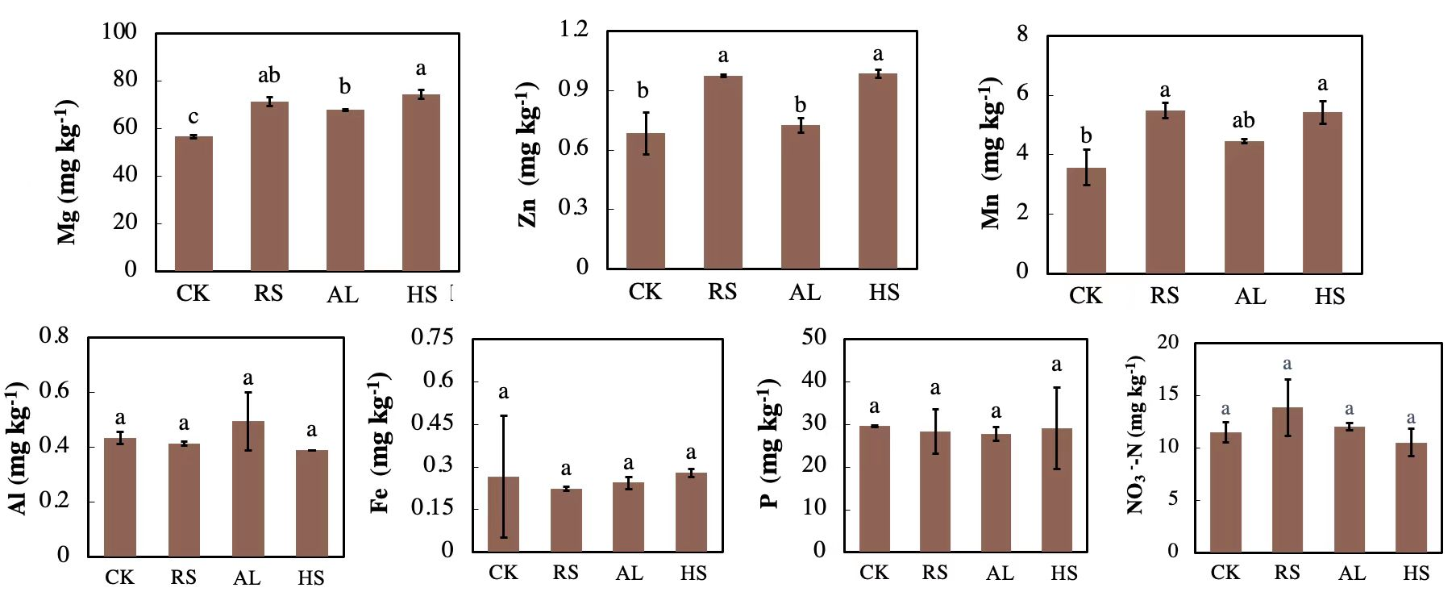
Figure S1: Soil properties in 2020 of different treatments at a mature stage. CK represents control treatment. RS represents the annual rice straw treatment. AL represents biochar collected from annual low biochar strategy treatment and HS represents biochar collected from high single biochar strategy.

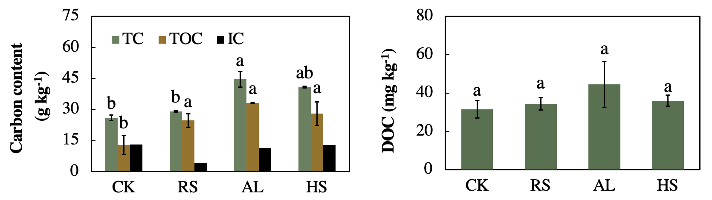
Figure S2: Soil TC, TOC, IOC, and DOC content at a mature stage in 2020. CK represents control treatment. RS represents the annual rice straw treatment. AL represents biochar collected from annual low biochar strategy treatment and HS represents biochar collected from high single biochar strategy.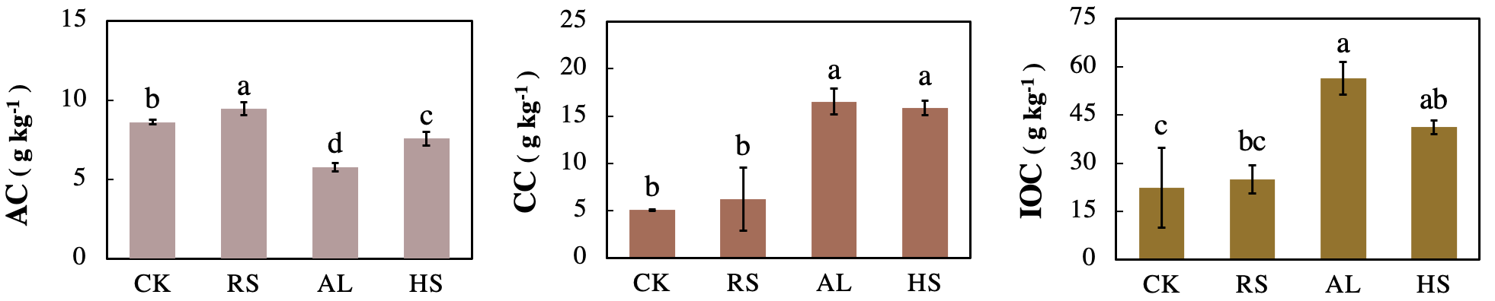
Figure S3: Soil active carbon, slow carbon, and recalcitrant carbon content at a mature stage in 2020. CK represents control treatment. RS represents the annual rice straw treatment. AL represents biochar collected from annual low biochar strategy treatment and HS represents biochar collected from high single biochar strategy.
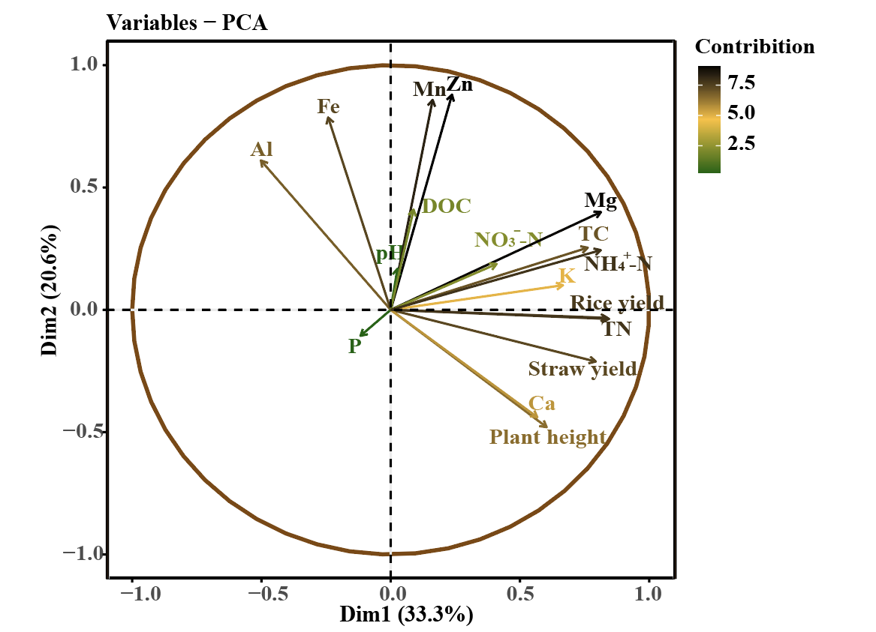
Figure S4: PCA analysis for rice yield and soil properties. PCA analysis was conducted by the data in 2015 ~ 2020.
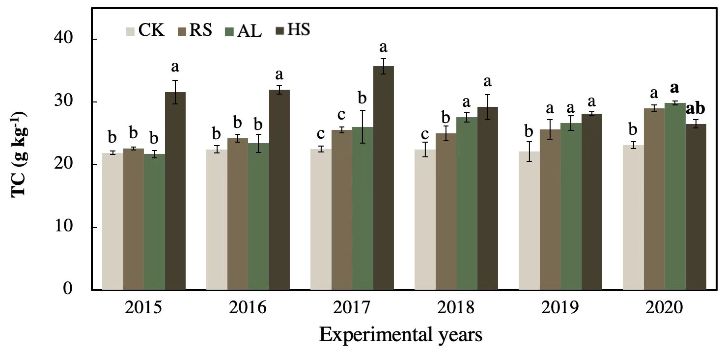
Figure S5: Soil total carbon (TC) content at the mature stage during 2015 ~ 2020. CK represents control treatment. RS represents the annual rice straw treatment. AL represents biochar collected from annual low biochar strategy treatment and HS represents biochar collected from high single biochar strategy.

Tables：
Table S1: Properties of experimental field soil and rice straw and rice straw biochar
Table S2: Relative abundance of functional groups obtained from XPS result

Table S1: Properties of experimental field soil and rice straw and rice straw biochar
 | Total C  (g kg⁻¹) | Total N  (g kg⁻¹) | C/N | pH | NH₄⁺-N  (g kg⁻¹) | NO₃⁻ -N  (g kg⁻¹) | Specific surface area (m² g⁻¹) | bore diameter (nm)
Experiment soil | 49.3 | 2.8 | 17.6 | 5.39 | 1.50×10⁻³ | 1.13×10⁻³ | / | /
Rice straw | 425.4 | 12.3 | 34.6 | / | / | / | / | /
Rice straw biochar | 472.1 | 10.8 | 42.7 | 10.58 | / | / | 111.5 | 538.2
Noted： pH was determined by 1:2.5 of soil and water rate for soil and 1:10 of biochar and water rate or biochar.

Table S2: Relative abundance of functional groups obtained from XPS result
 | F | AL | HS
C-C/C-H | 0.69 | 0.47±0.0048 | 0.33±0.037
C-O | 0.15 | 0.29±0.011 | 0.43±0.037
C=O | 0.14 | 0.15±0.0039 | 0.15±0.0019
COOR | 0.016 | 0.079±0.0023 | 0.091±0.00032

Materials and Method:

1 Biochar production and soil properties determination:
The feedstock was collected after rice was harvested and after collection and was air-dried to remove the moisture. The feedstock was cut into 2 ~ 5 mm after drying. biochar was produced under 500 ℃ in oxygen-deficient conditions for 2 hours in a self-made auto-carbonizing furnace. After production at the designated temperature, the biochar was left inside the furnace to cool down to room temperature.
The climate is a typical subtropical monsoon climate with an annual average temperature of 17.2°C and rainfall of 1490 mm. The soil’s total C and N contents were 2.13% and 0.28%, respectively. The soil pH was 5.1 and the CEC was 8.91 cmol kg⁻¹. The soil had available nutrients including 7.3 mg P kg⁻¹ and 77.6 mg K kg⁻¹. The soil-specific surface area was 35.0 m² g⁻¹.
Total C and N in soil were measured by use of an Elemental Analyzer (Vario Max, Germany). The pH was determined at the soil-to-water ratio of 1:2.5 (w/v). Available nutrients were extracted using Mehlich III solution with horizontal shaking for 5 min. Available P was determined by the ascorbic acid-ammonium molybdate method, and the available K, Fe, Al, Ca, Mg, Zn, and Mn were determined using inductively coupled plasma-mass spectroscopy (ICP-MS; G3271A, Shimadzu, Japan). Soil ammonia (NH₄⁺-N) and nitrate nitrogen were determined by UV spectrophotometry.

2 Soil carbon fractions determination
2.1 DOC detection
The dissolved organic carbon (DOC) was extracted from moist soil (5.0 g) with a 1:5 ratio of soil to 1 M KCl solution at 25 °C, and shaken for 30 minutes at the speed of 250 rpm. The samples were subsequently centrifuged for 10 min at 5000 rpm, after which the supernatant was filtered using a 0.45 μm membrane filter. The filtrate was measured by dichromate oxidation.
2.2 MBC detection
Microbial biomass carbon (MBC) was estimated following the fumigation extraction method: two portions of moist soil (20 g oven-dry soil) were weighed, and the first one (not fumigated) was immediately extracted with 80 ml of 0.5 M K₂SO₄ for 30 min by oscillating shaking at 200 rpm and filtered; the second one was fumigated for 24 h at 25°C with ethanol-free CHCl₃ and then extracted as described above. Organic C in the extracts was determined after oxidation with 0.4 N K₂Cr₂O₇ at 100°C for 30 min. Microbial biomass was calculated as follows: biomass C = E_{C}: k_{EC} where E_{C} is the difference between organic C extracted from fumigated soils and organic C extracted from non-fumigated soils and k_{EC} = 0.38.
2.3 LFOC and HFOC detection
The LFOC was separated by flotation in a NaI solution (1.7 g cm⁻³) before and after an aggregate disruption. In brief, 100 g of sample was placed in a 1 L beaker with 500 ml of NaI solution, gently shaken by hand, and left standing at room temperature for about 1 h. The supernatant was aspirated with a vacuum pump, centrifuged (15 min, 3500 rpm), and filtered through a membrane filter (Whatman GF/A) into a millipore vacuum unit. The fraction recovered on the filter was washed with 100 ml of 0.01 M CaCl₂ followed by 200 ml of distilled water. The sediment in the centrifuge tubes was placed back in the 1 L beakers, resuspended in NaI (the solution previously filtered), and gently shaken by hand. The same procedure was repeated three times in total. The three sub-fractions were combined, oven-dried at 50 °C, and stored for analysis. The sediment was resuspended and ultrasonicated at 800 J ml⁻¹, with a Vibracell VCX 600 probe-type model. The centrifugation and filtration procedure were repeated three times as described above and the fraction recovered from the supernatant was referred to as LFOC. The HFOC (sediment) was washed once with 0.01 M CaCl₂ and about 10 times with distilled water until the clay fraction remained in suspension after 24 h, freeze-dried, and stored for analysis.
2.4 POC and MOC detection
Twenty grams of soil was
dispersed by shaking for 15 h on an end-over-end shaker in
100 ml of 5 g l
±1
sodium hexametaphosphate solution. The
the dispersed soil suspension was passed through a 53
mm sieve
and after rinsing several times with distilled water, the
material retained on the sieve was dried at 105 °C. The soil
suspension that had passed through the sieve was made up
to 250 ml in a 500 ml measuring cylinder. The suspension
was thoroughly mixed by end-over-end shaking and a 25 ml
sample centrifuged at 12 100g for 1 h. Carbon was measured
in the supernatant using a Shimadzu
R
Dissolved Carbon
Analyzer. The residue after centrifuging was returned to the
<53
mm suspension which was then evaporated to dryness at
105 °C, weighed, ground with a mortar and pestle (to
<0.5 mm) and analyzed for C and N using a LECO CNS
Analyser (Nelson & Sommers 1982).
Twenty grams of soil was
dispersed by shaking for 15 h on an end-over-end shaker in
100 ml of 5 g l
±1
sodium hexametaphosphate solution. The
the dispersed soil suspension was passed through a 53
mm sieve
and after rinsing several times with distilled water, the
material retained on the sieve was dried at 105 °C. The soil
suspension that had passed through the sieve was made up
to 250 ml in a 500 ml measuring cylinder. The suspension
was thoroughly mixed by end-over-end shaking and a 25 ml
sample centrifuged at 12 100g for 1 h. Carbon was measured
in the supernatant using a Shimadzu
R
Dissolved Carbon
Analyzer. The residue after centrifuging was returned to the
<53
mm suspension which was then evaporated to dryness at
105 °C, weighed, ground with a mortar and pestle (to
<0.5 mm) and analyzed for C and N using a LECO CNS
Analyser (Nelson & Sommers 1982).
Twenty grams of soil was
dispersed by shaking for 15 h on an end-over-end shaker in
100 ml of 5 g l
±1
sodium hexametaphosphate solution. The
the dispersed soil suspension was passed through a 53
mm sieve
and after rinsing several times with distilled water, the
material retained on the sieve was dried at 105 °C. The soil
suspension that had passed through the sieve was made up
to 250 ml in a 500 ml measuring cylinder. The suspension
was thoroughly mixed by end-over-end shaking and a 25 ml
sample centrifuged at 12 100g for 1 h. Carbon was measured
in the supernatant using a Shimadzu
R
Dissolved Carbon
Analyzer. The residue after centrifuging was returned to the
<53
mm suspension which was then evaporated to dryness at
105 °C, weighed, ground with a mortar and pestle (to
<0.5 mm) and analyzed for C and N using a LECO CNS
Analyser (Nelson & Sommers 1982).
Twenty grams of soil was dispersed by shaking for 15 h on an end-over-end shaker in 100 ml of 5g1⁻¹ sodium hexametaphosphate solution. The dispersed soil suspension was passed through a 53 μm sieve and after rinsing several times with distilled water, the material retained on the sieve was dried at 105℃. The soil suspension that had passed through the sieve was made up to 250 ml in a 500 ml measuring cylinder. The suspension was thoroughly mixed by end-over-end shaking and a 25 ml sample was centrifuged at 12100 g for 1 h. Carbon was measured in the supernatant using a Shimadzu Dissolved Carbon Analyzer. The residue after centrifuging was returned to the < 53 um suspension which was then evaporated to dryness at105℃, weighed, with a mortar and pestle (to < 0.5 mm), and analyzed for C and N using a LECO CNS Analyzer (Nelson & Sommers 1982). The total C contents present in the <53 um fraction were calculated after correcting the soil weight for the amount of sodium hexametaphosphate present in the extractant. POC was calculated as the difference in C passing the 53 μm sieve and that obtained from the corresponding whole soil sample expressed on an oven-dried whole soil basis.
The organic matter content associated with soil mineral fraction is considered the stable fraction of organic carbon. This mineral-associated organic (MOC) fraction was separated from the total organic matter by dispersing 10 g of the 2 mm sieved fraction in 30 mL of sodium hexametaphosphate (5 g L⁻¹) and further shaking for 15 h. Then, the dispersed soils were wet-sieved at 50 μm mesh size and the different fractions were oven-dried at 50 °C. TOC and MOC were determined by (Walkley and Black's, 1934) method. Soil organic carbon of the particulate organic matter (POC) was obtained as the difference between SOC and MOC.

3 Quantification of Sample/Bacteria name by qPCR
The microbial community composition was also assessed by the ratios of gram-negative bacteria/gram-positive bacteria (G⁻/G⁺), thus to better analyze the biochar degradation potential. The specific sequences of primers (5-AGAGTTTGATCCTGGCTCAG-3) and (5-ACGGCTACCTTGTTACGACTT-3) were used for G⁺. Primers of (5-CCAGCAGCCGCGGTAATAC-3) and (5-TAACCCAACATYTCACRACACGAG-3) were used for G⁺. Tenfold serial dilutions of the genomic DNA of xxx from 10-1 to 10-6 were subjected to qPCR to generate a standard curve. The qPCR assay of standards, samples, and no-template control was performed in triplicate on an Applied Biosystems 7500 Real-Time PCR System (Thermo Fisher Scientific, USA) with a 96-well format by Allwegene Technology (Allwegene Technology Co., Ltd. Beijing, China).
The 20 μL reaction mixture contained 10 μL of SYBR Premix Ex Taq (Tli RNase H Plus; 2× concentration) from TaKaRa (Shiga, Japan); 0.5 μL of each 10μmol/L primer; 7 μL of sterile DNase-free water; and 2μL of DNA. The PCR was performed under the following conditions: 95 °C for 30 s, followed by 40 cycles of 5 s at 95°C, 40 s at 60°C, and 20 s at 72°C. The fluorescence signal was acquired following the 72 °C extension phase of each cycle. Melting curve analysis was performed to check the specificity of the products followed by a cooling step performed at 95°C for 10 s, 60°C for 60, and 95°C for 15 s (ramp rate of 0.05 °C/s). PCR products that had been resolved on a 3% agarose gel were checked after ethidium bromide staining to confirm the specificity of the amplification. Data were analyzed with ABI 7500 Real-Time PCR software version 2.0.5 using the second derivate maximum method, which calculates PCR efficiency by Pfaffl (2001).
The standard curve was constructed using crossing point (Cp) values plotted against the log10 of the initial amount of G⁺/G⁻ genomic DNA. Sample DNA concentration was calculated by comparing the sample Cp value to the standard curve.
Correlations between DNA yield and organic matter content were calculated using PASW Statistics 18 software (SPSS, Chicago, Illinois, USA). Correlations between the amounts of G⁺/G⁻ genomic DNA and the soil depth or horizontal distance were calculated in the same way. A P-value of <0.05 was considered statistically significant.
References
Pfaffl, M.W. 2001. A new mathematical model for relative quantification in real-time RT-PCR. Nucleic Acids Res. 29(9): e45. doi:10.1093/nar/29.9.e45. PMID:11328886.

