Supplementary Information

Application of Magnesium and Biosurfactant Functionalized Biochar Composite in Treating Cyanobacteria in Phosphorus and Crude Oil Contaminated Water

Zhuo Wei^{1, 2}, Yaxi Xu¹, Yi Wei¹, Yang Liu¹, Shuai Niu¹, Jim J. Wang^{2*}
¹ Faculty of Environmental Science & Engineering, Kunming University of Science & Technology, Kunming, 650500, Yunnan, China
² School of Plant, Environment and Soil Sciences, Louisiana State University AgCenter, Baton Rouge, LA 70803, USA

*Corresponding author:
- mail addresses: jjwang@agcenter.lsu.edu (Jim J. Wang)

Contents: 1 table and 5 figures

Table S1. Parameters of Freundlich and Langmuir adsorption isotherms models. (a) PO₄³⁻ and (b) total petroleum hydrocarbons (TPH).
(a)
PO₄³⁻ adsorption | Freundlich model |  |  |  | Langmuir model
 | K_{F} | n | R² |  | Q_{max} | K_{L} | R²
 | (mg g⁻¹) / (mg L⁻¹)^{n}) |  |  |  | (mg g⁻¹) | (L mg⁻¹)
Biochar | 0.25 | 0.614 | 0.987 |  | 12.87 | 0.021 | 0.982
Mg-biochar | 12.59 | 0.414 | 0.976 |  | 118.31 | 0.035 | 0.960
RL-biochar | __ | __ | __ |  | __ | __ | __
Mg-RL-biochar | 10.83 | 0.437 | 0.979 |  | 112.12 | 0.031 | 0.979

(b)
TPH adsorption | Freundlich model |  |  |  | Langmuir model
 | K_{F} | n | R² |  | Q_{max} | K_{L} | R²
 | (mg g⁻¹) / (mg L⁻¹)^{n}) |  |  |  | (mg g⁻¹) | (L mg⁻¹)
Biochar | 0.03 | 0.733 | 0.994 |  | 2.34 | 0.022 | 0.968
Mg-biochar | __ | __ | __ |  | __ | __ | __
RL-biochar | 0.23 | 0.903 | 0.986 |  | 44.42 | 0.011 | 0.977
Mg-RL-biochar | 0.15 | 0.956 | 0.985 |  | 40.21 | 0.007 | 0.983

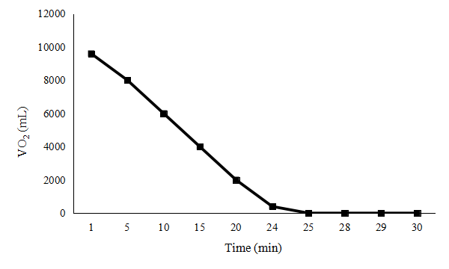
Fig. S1. Oxygen volume change curve in 30 mins.(The space of furnace:10 L, the flow rate of N₂: 400 mL min⁻¹, time: 30 min. $VO_{2}=V_{0}−v_{N_{2}}∙t$)

Fig. S2. Phosphorous adsorption by biochar modified with different level of magnesium.
Fig. S3. Percentage total petroleum hydrocarbon (TPH) adsorbed by MgO-biochar composite modified with different levels of rhamnolipids (RL).

(a) (b)
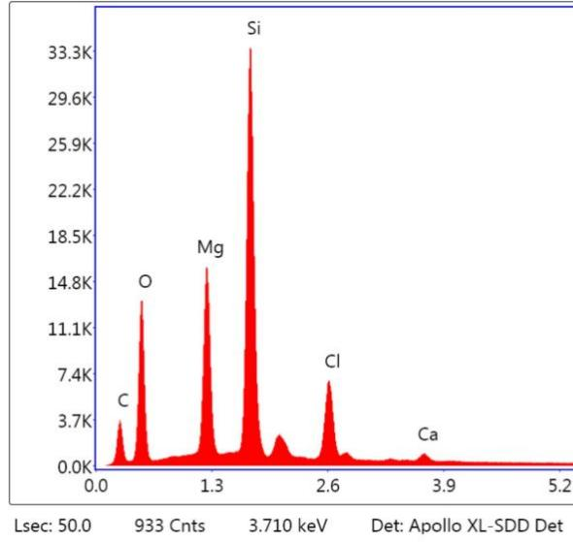
(c) (d)
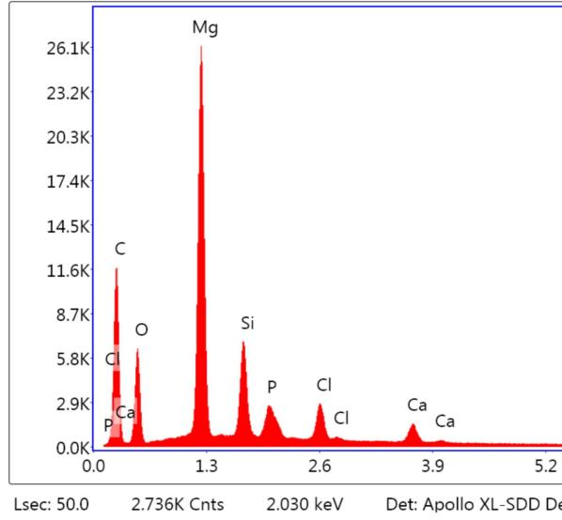
Fig. S4. Scanning electron microscopy (SEM) images and the corresponding energy dispersive X-ray spectroscope (EDX) of Mg-biochar before (a), (b) and after (c), (d) phosphorous adsorption.

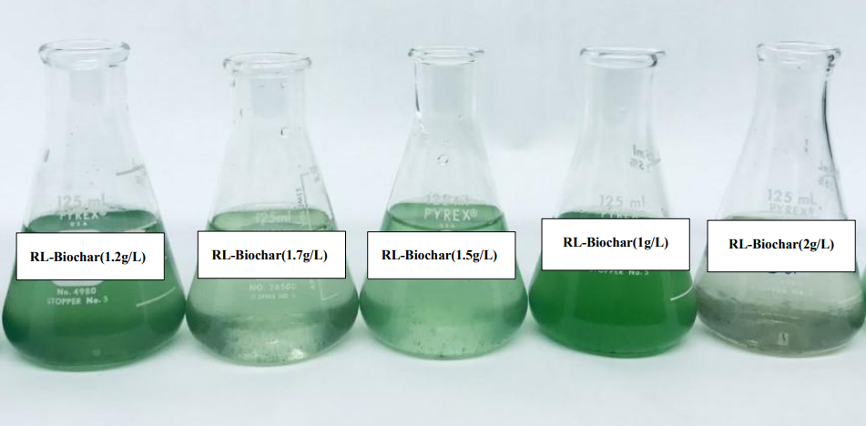
2 weeks

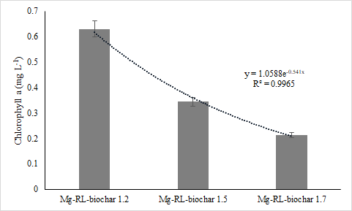
Fig. S5. The effect of RL-Biochar with a series of levels on growth of algae (The cultivation time of algae was two weeks).

