Additional Information
Biochar reduces colloidal phosphorus in leachate by regulating phoD- and phoC-harboring microbial communities during drying/rewetting cycles
Xiaochun Wang ª, Hongnuo Ge ^{b}, Yunying Fang ^{c}, Chunlong Liu ^{d}, Kamel Mohamed Eltohamy ª, Zekai Wang ª, Xinqiang Liang ^{a,d, *}
ª Key Laboratory of Watershed Non-point Source Pollution Control and Water Eco-security of Ministry of Water Resources, College of Environmental and Resource Sciences, Zhejiang University, Hangzhou 310058, China
^{b} College of Agriculture & Biotechnology, Zhejiang University, Hangzhou 310058, China
^{c} Australian Rivers Institute and School of Environment and Science, Griffith University, Nathan Campus, 4111, Queensland, Australia
^{d} Key Laboratory of Mollisols Agroecology, Northeast Institute of Geography and Agroecology, Chinese Academy of Sciences, Harbin 150081, China

* Corresponding authors: Xinqiang Liang, E-mail: liang410@zju.edu.cn

Tables:
Table S1 The Basic Physicochemical Properties of Soil and Biochar
 | Soil A | Soil B | Straw biochar (SB) | Manure biochar (MB)
pH | 7.7 | 6.2 | 8.7 | 9.1
Total C (g kg⁻¹) | 14.2 | 12.7 | 58.6 | 46.2
Total N (g kg⁻¹) | 1.5 | 1.1 | 2.1 | 3.6
Total P (mg kg⁻¹) | 835.2 | 618.7 | 3152.1 | 4243.2
Cation exchange capacity (cmol kg⁻¹) | 24.8 | 164.8 | 63.4 | 41.7
Sand (%) | 18.6 | 38.7 | / | /
Silt (%) | 66.1 | 30.1 | / | /
Clay (%) | 15.3 | 31.2 | / | /

Table S2 Topological Properties of the Co-occurrence Network for the Microbial Communities
 | CK | SBL | SBH | MBL | MBH |  | CK | SBL | SBH | MBL | MBH
phoD gene group: |  |  |  |  |  | phoC gene group:
Nodes | 429 | 452 | 443 | 463 | 433 | Nodes | 241 | 311 | 308 | 317 | 315
Edges | 1175 | 1574 | 1496 | 1597 | 1228 | Edges | 219 | 889 | 913 | 855 | 891
Average degree | 5.478 | 6.965 | 6.754 | 6.898 | 5.672 | Average degree | 2.047 | 5.717 | 5.929 | 5.394 | 5.657
Graph density | 0.013 | 0.015 | 0.015 | 0.015 | 0.013 | Graph density | 0.01 | 0.018 | 0.019 | 0.017 | 0.018
Clustering coefficient | 0.016 | 0.017 | 0.019 | 0.015 | 0.014 | Clustering coefficient | 0.01 | 0.039 | 0.032 | 0.02 | 0.024
Modularity | 0.385 | 0.395 | 0.352 | 0.399 | 0.392 | Modularity | 0.775 | 0.385 | 0.365 | 0.398 | 0.381
Abbreviations: CK, no biochar addition; SBL, 0.5% straw biochar addition; SBH, 1% straw biochar addition; MBL, 0.5% manure biochar addition; MBH, 1% manure biochar addition
Figure:
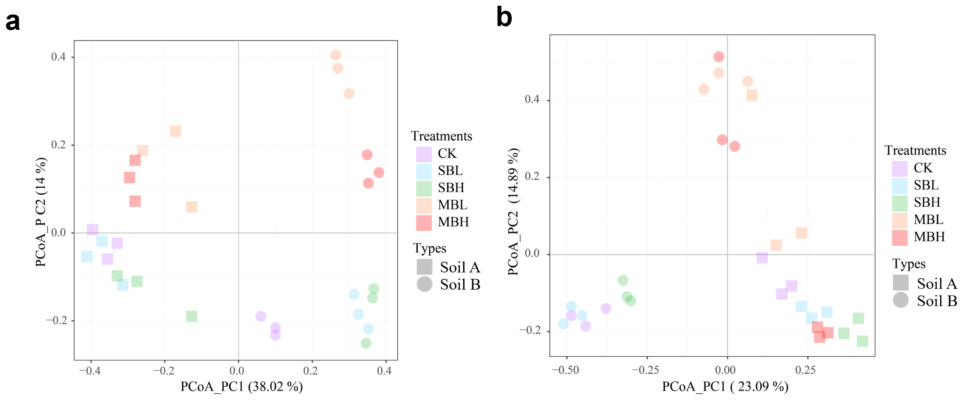
Fig S1 Principal Coordinate Analysis (PCoA) shows how different biochar treatments affect phoD- (a) and phoC-harboring (b) microbial communities. Different biochar additions are shown in different colors, while soils A and B are represented by different symbols. Abbreviations: CK, no biochar addition; SBL, 0.5% straw biochar addition; SBH, 1% straw biochar addition; MBL, 0.5% manure biochar addition; MBH, 1% manure biochar addition

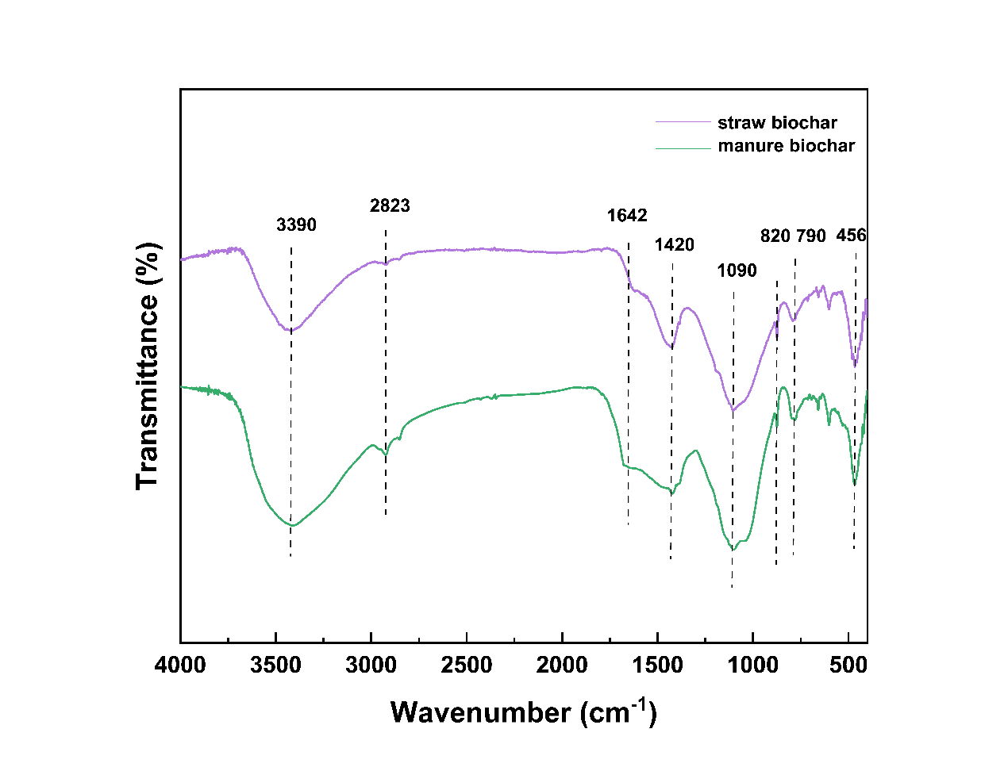
Fig S2 FTIR spectrum of straw biochar and manure biochar

