Additional Information
Standardization and Micromechanistic Study of Tetracycline Adsorption by Biochar
Xiaotong Zhangª, Jinju Hou^{b}, Shudong Zhangª, Tong Caiª, Shujia Liu^{c}, Wenjin Huª, Qiuzhuo Zhang^{a,d,e *}
ª Shanghai Key Lab for Urban Ecological Processes and Eco-Restoration, Shanghai Engineering Research Center of Biotransformation of Organic Solid Waste, School of Ecological and Environmental Sciences, East China Normal University, 200241 Shanghai, China
^{b} School of Chemical and Environmental Engineering, Shanghai Institute of Technology, Shanghai 201418, China
^{c} Shanghai SUS Environment Co., LTD, Shanghai 201703, China
^{d} Institute of Eco-Chongming (IEC), 3663 N. Zhongshan Rd., Shanghai 200062, China
^{e} Technology Innovation Center for Land Spatial Eco-restoration in Metropolitan Area, Ministry of Natural Resources, 3663 N. Zhongshan Road, Shanghai 200062, China
*Corresponding author: telephone number: 86-021-54341141, email address: qzhzhang@des.ecnu.edu.cn

Name of the journal: Biochar
Date of the document prepared: July 27, 2023
Pages: 23
Figures: 13
Tables: 7
Text S1 Chemicals and Reagents. Tetracycline (C₂₂H₂₄N₂O₈, purity>99.0%) was purchased from Sinopharm Chemical Reagents Co., Ltd. (Shanghai, China) and stored in a freezer. Na₂C₂O₄·2H₂O, HCl, and NaOH were of analytical grade and purchased from Sinopharm Chemical Reagents Co., Ltd. (Shanghai, China). Methanol, acetonitrile, and isopropanol were of HPLC grade and were purchased from Sinopharm Chemical Reagents Co., Ltd. (Shanghai, China). Rice straw was collected from Jining of Shandong Province, P.R. China. Ultrapure water (18.2 MΩ cm) was used throughout the experiments.
Text S2 Titration of functional groups. Titration of acidic functional groups: 0.05 mol/L of potassium hydrogen phthalate standard solution was prepared. Then, 0.05 mol/L NaOH, 0.05 mol/L HCl, 0.025 mol/L Na₂CO₃, 0.05 mol/L NaHCO₃, and 0.05 mol/L C₂H₅ONa were prepared and calibrated. The concentrations were labeled as C₁, C₂, C₃, C₄, and C₅, respectively. Na₂CO₃ and NaHCO₃ are treated with nitrogen gas for 2 hours during calibration to remove carbon dioxide from the water. For each type of biochar, weigh 0.2 g of the sample and place it in a conical flask. Then, add 10 mL of C₂H₅ONa solution, NaOH solution, Na₂CO₃ solution, NaHCO₃ solution, and distilled water (as a blank experiment) into the flask respectively. Use phenolphthalein as an indicator, seal the flask with cling film, shake it for one hour, and let it stand for 24 hours at room temperature. Filter the mixture, wash the biochar, add 10 mL of the aforementioned known concentration of HCl solution to each filtrate, and titrate it with NaOH until the endpoint is reached. The calculation formula is as follows:
$$n_{NaHCO_{3}}=\left(C_{4}×10+C_{1}×V_{NaOH-1}-C_{2}×10+Δn_{blank}\right)∕m_{1}$$
$$n_{Na_{2}CO_{3}}=\left(C_{3}×10+\frac{1}{2}C_{1}×V_{NaOH-2}-\frac{1}{2}C_{2}×10+Δn_{blank}\right)∕m_{2}$$
$$n_{NaOH}=\left(C_{1}×10+C_{1}×V_{NaOH-3}-C_{2}×10+Δn_{blank}\right)∕m_{3}$$
$$n_{C_{2}H_{5}ONa}=\left(C_{5}×10+C_{1}×V_{NaOH-4}-C_{2}×10+Δn_{blank}\right)∕m_{4}$$
$n_{alkali}$——the content of acidic functional groups in the reaction, mmol/g
$m_{n}$——the mass of biochar, g
The content of oxygen-containing functional groups can be calculated accordingly:
$$n_{RCOOH}=n_{NaHCO_{3}}$$
$$n_{RCOOR^{'}}=n_{Na_{2}CO_{3}}-n_{NaHCO_{3}}$$
$$n_{ROR^{'}}=n_{CH_{3}CH_{2}ONa}-n_{NaOH}$$
Titration of alkaline functional groups: 0.2 g sample of each biochar is taken and 10 mL of the pre-standardized HCl solution is added to a conical flask. Phenolphthalein is used as an indicator. The flask is then sealed with cling film and shaken for one hour, followed by 24 hours of settling at room temperature. The biochar is filtered and washed. The remaining HCl solution in the filtrate is titrated with a known concentration of NaOH solution (C₁). The endpoint of titration is indicated by the change in color of the filtrate from colorless to red. The consumption of HCl per unit mass of activated carbon is calculated, which corresponds to the content of alkaline functional groups in the biochar.
Text S3 Competitive adsorption experiments. Benz[b]anthracene was selected as the competitive adsorbent of tetracycline on biochar. Benz[b]anthracene is a compound consisting of four connected benzene rings, and the main interaction between it and biochar is intermolecular interaction. Firstly, a tetracycline solution with a concentration of 0.01 mmol/L was prepared under neutral conditions, and adsorbed on biochar for 72 hours to reach equilibrium. Then, different concentrations of benz[b]anthracene (0.01-0.2 mmol/L) were added to determine the optimal concentration for competitive adsorption. Throughout the process, toluene was used as a co-solvent carrier for competitor, with a final concentration of less than 0.5% (v/v). A control experiment was conducted using 0.5% v/v toluene for TTC adsorption, and the results showed that the effect of the co-solvent can be negligible. According to the results shown in Figure S8, the optimal concentration was determined to be 0.09 mmol/L benz[b]anthracene, and the ratio of its adsorption to that of tetracycline was considered as the final relative contribution.
Detection methods of tetracycline. The tetracycline concentration was measured and calculated by HPLC (Agilent, 1260 Infinity II, USA) using a C18 reverse phase column (5 μm, 4.6 mm × 250 mm) and a UV/Vis detector (G7115A, Agilent, USA). The mobile phase consisted of methanol (CH3OH, HPLC grade, %), acetonitrile (C2H3N, HPLC grade, %) and 0.01 M oxalic acid (C2H2O4, AR, %), the column temperature was 30 °C, the flow rate was 1mL/min, the injection volume was 20 μL, and the retention time was 5.8 min. All samples are filter through 0.22 μm filter membrane (Tianjin Jinteng, China) and stored in 4 °C freezer. The detected solute was quantified using an external standard method, and the curve-fitting coefficient was greater than 0.99.
Text S4 Model equations of pseudo-first-order (PFO), pseudo-second-order (PSO), Elovich, intraparticle diffusion (IPD), and liquid film diffusion (LFD) models.
Pseudo-first-order (PFO): $Q_{t}=Q_{e}(1-e^{(-K_{1}t)})$ (1)
Pseudo-second-order (PSO): $Q_{t}=\frac{K_{2}Q_{e}t}{1+K_{2}Q_{e}t}$ (2)
Elovich: $Q_{t}=\left(\frac{1}{b}\right)lnab+\left(\frac{1}{b}\right)lnt, t_{0}=\frac{1}{ab}$ (3)
Liquid film diffusion (LFD): $\ln\left(1-F\right)=-K_{fd}t, F=\frac{Q_{t}}{Q_{e}}$ (4)
Intraparticle diffusion (IPD): $Q_{t}=K_{i}\sqrt{t}+C_{i}$ (5)
where Q_{e} is the adsorption capacity (mg·g⁻¹) at equilibrium time; Q_{t} is the adsorption capacity (mg·g⁻¹) at time t (min); K₁ represents the pseudo-first-order rate constant; K₂ denotes the pseudo-second-order rate constant; a is the rate constant of adsorption (mg·g⁻¹·min⁻¹); b is the rate constant of desorption (g·mg⁻¹); K_{i} is the intraparticle diffusion rate constant (mg·min^{0.5}·g⁻¹); C_{i} is a constant (mg·g⁻¹); and K_{fd} is the adsorption rate constant.
Text S5 Model equations of Dubinin-Ashtahkov model.
Dubinin-Ashtahkov: $lnq_{e}=lnQ^{0}-{\left(\frac{ε}{E_{DA}}\right)}^{b}, ε= RT ln (Cs/Ce)$ (6)
where C_{e} (mg·L⁻¹) is the equilibrium aqueous concentration; q_{e} (mg·g⁻¹) is the equilibrium adsorbed concentration; Q⁰ (mg·g⁻¹) is the sorption capacity; ε (kJ·mol⁻¹) is the effective adsorption potential; $C_{W}^{sat}$(L) (mg·L⁻¹) is the liquid or subcooled liquid water solubility at 298 K (Table S1); R is the gas constant; T is temperature (K); b is a site heterogeneity parameter, typically between 1 and 3 depending on the compound and adsorbent; and E_{DA} (kJ·mol⁻¹) is the characteristic adsorption energy. The sum of squared error (SSE) was determined according to Eq. (7)
SSE=$\sqrt{\frac{{\sum{(Q_{e}-Q_{c})}}^{2}}{N}}$ (7)
where Q_{e} and Q_{c} are the observed and calculated value of adsorption capacity (mg/g), respectively, and N is the number of measurements.
Text S6 MWSE calculation.⁶ To compare the goodness of data fitting by various models and screen out a model that can well fit the sorption/removal data of antibiotics by biochars, the mean weighted square error (MWSE) was used. The method for calculating MWSE values takes the form as below.
$$MWSE=\frac{1}{ν}\sum_{i=1}^{N}{\left[\frac{{\left(Q_{experiment-i}-Q_{calculate-i}\right)}^{2}}{Q_{experiment-i}^{2}}\right]}$$
where ν is the free degree of the Langmuir-, Freundlich-, Tempkin- and Dubinin-Radushkevich models, ν = N – 2; for other models, ν = N – 3; N is the number of experimental data; i is the serial number of data corresponding to a given initial sorbate concentration; Q_{experiment-i} and Q_{calculate-i} are experimentally-measured and model-fitted equilibrium concentrations of the sorbate for the number i sample, respectively.

Table S1. pH values before and after adsorption at 7, pH_{pzc} of biochars.
 | Before adsorption | After adsorption | pH_{pzc}
BC300 | 7.01 | 7.40 | 7.50
BC400 | 7.00 | 8.59 | 9.38
BC500 | 7.01 | 8.60 | 9.80
BC600 | 7.02 | 8.64 | 9.70
BC700 | 7.00 | 9.50 | 10.69

Table S2. The tetracycline adsorption capacity of BC for comparison with this study.
Feedstock | Pyrolysis temperature (℃) | Initial concentration (mg/L) | Adsorption capacity (mg/g) | Source
Auricularia auricula | 300 | 10 | 2.02 | 1
Auricularia auricula | 500 | 10 | 3.27 | 1
Auricularia auricula | 700 | 10 | 4.13 | 1
Maple leaves | 350 | 100 | 40.30 | 3
Maple leaves | 750 | 100 | 361.00 | 3
Poplar saw dust | 300 | 100 | 6.22 | 2
Poplar saw dust | 500 | 100 | 14.00 | 2
Poplar saw dust | 700 | 100 | 22.21 | 2
Rice straw | 400 | 100 | 7.00 | 4
Rice straw | 600 | 100 | 9.90 | 4
Swine manure | 400 | 100 | 4.93 | 4
Swine manure | 600 | 100 | 6.08 | 4
Cow manure | 300 | 50 | 5.49 | 5
Cow manure | 500 | 50 | 7.44 | 5
Cow manure | 700 | 50 | 11.79 | 5
Rice straw | 300 | 40 | 12.43 | this study
Rice straw | 300 | 80 | 16.08 | this study
Rice straw | 400 | 40 | 37.77 | this study
Rice straw | 400 | 80 | 69.49 | this study
Rice straw | 500 | 40 | 43.68 | this study
Rice straw | 500 | 80 | 78.75 | this study
Rice straw | 600 | 40 | 50.21 | this study
Rice straw | 600 | 80 | 90.33 | this study
Rice straw | 700 | 40 | 54.51 | this study
Rice straw | 700 | 80 | 98.35 | this study

Table S3. Ash content, elemental compositions and pore properties of biochar.
Absorbent | Ash (%) | Elemental composition (%) |  |  |  |  | SSA  (m²·g⁻¹) | Pore volume (cm³·g⁻¹) |  |  | ^{d}A (nm)
Absorbent | Ash (%) | C | H | N | S | O | SSA  (m²·g⁻¹) | ªV_{Total} | ^{b}V_{Micro} | ^{b}V_{Meso} | ^{d}A (nm)
BC300 | 8.17 | 56.94 | 4.27 | 1.63 | 2.35 | 28.63 | 2.35 | 0.0078 | 0.001 | 0.003 | 5.697
BC400 | 10.12 | 57.75 | 3.47 | 1.15 | 6.98 | 27.14 | 6.98 | 0.0302 | 0.002 | 0.016 | 5.218
BC500 | 13.92 | 59.25 | 2.91 | 1.30 | 8.17 | 22.40 | 8.17 | 0.0319 | 0.005 | 0.020 | 5.275
BC600 | 15.38 | 62.25 | 1.85 | 0.90 | 13.92 | 19.31 | 13.92 | 0.0490 | 0.007 | 0.040 | 5.638
BC700 | 17.08 | 67.81 | 1.93 | 1.48 | 17.08 | 11.48 | 17.08 | 0.0582 | 0.006 | 0.051 | 4.391
a: volume of total pores.
b: volume of micropores
c: volume of mesoporous
d: average pore width (nm)

Table S4. FTIR bands and functional groups of biochar
Wavenumber (cm⁻¹) | Vibrations | Functionality
3200-3700 | O-H stretching | -OH group
3200-3700 | N-H stretching | Primary amine
3030 | C-H stretching | Substituted aromatics
3010 | C-H stretching | Alkene
2500-3000 | O-H stretching | Carboxyl, Aliphatic -CH_{x},
1730 | C=O stretching | Carboxyl, aryl esters
1710 | C=O stretching | Ketones, aldehydes
1670 | C=O stretching | Conjugated ketones and quinones
1670 | C=C stretching | Aromatics
1580-1650 | N-H bending | Primary amine
1538 | C=C ring stretching | Phenols
1365 | C-H bending | -CH_{x}
1340 | C-O stretching | Phenol
1307 | C-O-C stretching | Ester group
1106 | C-O stretching | Secondary alcohol
990 | C-H bending | Alkene
960 | O-H bending | Carboxyl
856 | N-H bending | Carboxyl
770 | C-H bending | Alkene
688 | N-H bending | Primary amine

Table S5. Kinetic parameters of tetracycline adsorption on biochar.
 |  | BC300 |  | BC400 |  | BC500 |  | BC600 |  | BC700
 |  | 40 | 80 | 40 | 80 | 40 | 80 | 40 | 80 | 40 | 80
 | Q_{exp} | 12.43 | 16.08 | 37.77 | 69.49 | 43.68 | 78.75 | 50.21 | 90.33 | 54.51 | 98.35
Pseudo first-order | Q_{e} | 11.54 | 14.14 | 31.73 | 71.27 | 36.52 | 81.00 | 44.52 | 88.76 | 42.10 | 103.58
Pseudo first-order | K₁ | 5.07E-03 | 9.97E-01 | 4.63E-03 | 1.00E+00 | 5.04E-03 | 1.00E+00 | 2.28E-03 | 9.99E-01 | 7.29E-03 | 9.99E-01
Pseudo first-order | SSE | 1.76 | 1.96 | 19.41 | 41.39 | 41.58 | 42.22 | 23.79 | 66.33 | 68.30 | 67.10
Pseudo first-order | R² | 0.89 | 0.93 | 0.81 | 0.91 | 0.74 | 0.94 | 0.89 | 0.92 | 0.67 | 0.93
Pseudo second-order | Q_{e} | 12.47 | 16.80 | 34.88 | 70.19 | 38.74 | 80.86 | 49.69 | 89.33 | 46.06 | 100.90
Pseudo second-order | K₂ | 6.13E-04 | 3.97E-03 | 1.79E-04 | 4.80E-04 | 2.22E-04 | 5.09E-04 | 6.58E-05 | 7.50E-04 | 2.67E-04 | 6.68E-04
Pseudo second-order | SSE | 0.90 | 1.17 | 9.63 | 39.99 | 26.68 | 37.39 | 10.58 | 52.50 | 39.97 | 56.68
Pseudo second-order | R² | 0.94 | 0.96 | 0.90 | 0.92 | 0.84 | 0.94 | 0.95 | 0.94 | 0.81 | 0.94
Elovich | a | 0.47 | 0.26 | 1.04 | 0.34 | 1.76 | 0.40 | 0.79 | 0.42 | 2.74 | 0.61
Elovich | b | 0.53 | 0.36 | 0.19 | 0.09 | 0.19 | 0.07 | 0.12 | 0.06 | 0.15 | 0.06
Elovich | 1/b | 1.87 | 2.78 | 5.38 | 11.15 | 5.23 | 13.62 | 8.54 | 16.97 | 6.54 | 17.09
Elovich | t₀ | 4.00 | 10.70 | 5.17 | 32.96 | 2.97 | 34.37 | 10.87 | 40.77 | 2.38 | 28.08
Elovich | SSE | 0.54 | 1.16 | 2.37 | 87.97 | 6.68 | 156.99 | 3.35 | 93.26 | 9.31 | 147.94
Elovich | R² | 0.97 | 0.96 | 0.98 | 0.82 | 0.98 | 0.76 | 0.98 | 0.89 | 0.99 | 0.85
Liquid film diffusion | Kfd | 1.60E-03 | 1.04E-03 | 1.57E-04 | 9.81E-04 | 7.99E-04 | 8.36E-04 | 1.05E-03 | 1.05E-03 | 1.00E-03 | 8.12E-04
Liquid film diffusion | SSE | 3.50 | 1.80 | 0.98 | 3.10 | 0.24 | 3.81 | 7.21 | 11.84 | 0.62 | 4.30
Liquid film diffusion | R² | 0.95 | 0.90 | 0.93 | 0.84 | 0.97 | 0.78 | 0.72 | 0.69 | 0.95 | 0.79
Intra-particle diffusion | Ki | 0.14 | 0.21 | 0.38 | 1.05 | 0.39 | 1.15 | 0.58 | 1.26 | 0.54 | 1.33
Intra-particle diffusion | K_{i1} | 0.19 | 0.28 | 0.67 | 0.60 | 0.68 | 0.47 | 0.90 | 0.12 | 0.68 | 1.14
Intra-particle diffusion | K_{i2} | 0.26 | 0.34 | 0.29 | 1.14 | 0.35 | 1.25 | 0.23 | 1.31 | 0.46 | 1.37
Intra-particle diffusion | K_{i3} | 0.02 | 0.05 | 0.07 | 0.19 | 0.15 | 0.38 | 0.03 | 0.05 | 0.26 | 0.38
Intra-particle diffusion | C_{i} | 4.77 | 4.18 | 14.26 | 0.30 | 15.21 | 2.14 | 14.33 | 7.04 | 19.05 | 10.15
Intra-particle diffusion | SSE | 17.61 | 21.29 | 23.75 | 326.63 | 37.66 | 182.80 | 96.92 | 276.03 | 15.76 | 93.54
Intra-particle diffusion | R² | 0.82 | 0.90 | 0.96 | 0.93 | 0.95 | 0.97 | 0.94 | 0.96 | 0.98 | 0.96

Table S6. The Frontier Orbital (HOMO and LUMO) Energy of BC700 and Functionalized Biochars, Their Energy Gaps with Tetracycline Orbitals, and the Corresponding π-Electron Donors.
Matrix | HOMO (eV) | LUMO (eV) | Eg1 (eV) | Eg2 (eV) | electron donor
BC700 | -4.790711 | -2.664872 | -2.970539 | -3.750786 | BC700
BC-OH | -4.724707 | -2.629721 | -2.904535 | -3.785937 | BC-OH
BC-COOH | -4.868149 | -2.787214 | -3.047977 | -3.628444 | BC-COOH
BC-GN | -3.901099 | -2.568876 | -2.080927 | -3.846782 | BC-GN
BC-PDN | -4.641395 | -2.643589 | -2.821223 | -3.772069 | BC-PDN
BC-PLN | -4.901754 | -2.784041 | -3.081582 | -3.631617 | BC-PLN

Table S7. Comparative study of tetracycline adsorption by biochar.
Feedstock | Hitting temperature （°C） | SSA (m²/g) | Modification methods | Key structural changes | Q_{e} (mg/g) | Main mechanism | Ref.
Orange peels | 700 °C, 2h | 2888.33 | La-activated | More functional groups | 143.2 | pore filling, surface complexation, π-π interaction, and other interfacial interactions | (Chen et al., 2023)
fungi-microalgae | 750 °C, 2h | 338.6 | Hydrochloric acid-modified | More functional groups for conductive adsorption | 103.518 | pore filling, H-bonds, π-π interaction, hydrophobic affinity, and van der Waals forces | (Nie et al., 2023)
walnut shell | 900 °C, 1h | 1713.87 ± 37.05 | alkali-activated | Generated more meso- porous structures | 607.00 ± 31.87 | pore filling, hydrogen bonding, π–π stacking, and electrostatic interaction | (Shi et al., 2023)
rice waste | 800 °C, 1.5h | 747.76 | coupling hydrothermal carbonization and pyrolysis activation | Iron-zinc grafting, graphite structure and surface functional groups are increased. | 94.63 | pore filling, electrostatic attraction, π-π interactions, and complexation reactions of surface functional groups | (Zhang, F. et al., 2023)
sunflower seed husk | 700 °C, 2h | 1578.3 | ZnCl₂-activated and hydrothermal carbonization | Increased the graphitization degree and aromaticity of biochar. | 673 | combination of chemical and electrostatic interaction | (Nguyen et al., 2023)
corn straw | 500 °C, 4h | 203.14 | bimetallic nickel/copper-loaded | Doped with Ni/Cu, increased graphite carbon content, and elevated functional groups. | 445.75 ± 25.59 | π-π interaction and complexation | (Zhang, Y. et al., 2023)
chlorella | 800 °C, 1h | 491.16 | N-doped | Enhanced microporous structure, oxygen functional groups, and graphitization degree. | 381.584 | electrostatic repulsion, hydrogen bonding and π-π interaction. | (Wang et al., 2023)
sugarcane bagasse | 600 °C, 2h | 91.357 | Fe-Al bimetallic oxides functionalized, ball milling | Larger disordered surface and more porous structure, abundant graphene nanosheets, and the addition of Fe and Al-doped functional groups. | 116 | π-π conjugation, H-bonding, complexation as well as pore filling | (Tang et al., 2023)
banana fruit | 350 °C, 2h+200 °C, 5h | 207.8 | Mn-Zn ferrite modification | Doped with iron and Mn, the degree of aromaticity gets higher. | 142.4 | hydrogen bonding and π-π stacking, Mn promotes degradation. | (Hu et al., 2022)
sludge | 600 °C, 2h | 75.34 | Fe₃O₄ nanoparticle | The introduction of Fe₃O₄ nanoparticles incorporates more functional groups and smaller micro-pores | 184.5 | Functional groups on smaller-sized Fe₃O₄ nanoparticles. | (Luo et al., 2022)
sludge | 700 °C, 2h | 243 | magnetic N-doped | Higher degree of graphitization, and nitrogen doping. | 197.3 | Lewis acid-base, π-π conjugation, electrostatic interactions and pore filling | (Ma et al., 2022)
sludge | 600 °C, 2h | 160.5 | MoS₂ modified | Enriched with oxygen-containing functional groups. | 229.2 | π-π conjugation, H-bonding, electrostatic interaction and pore filling | (Zhu et al., 2022)
suaeda | 800 °C, 2h | 248.8 | iron modified | Mainly doped with iron | 1494 | pore filling, ion exchange, metal ion complexation, hydrogen bonds and cation-π interaction | (Jiang et al., 2023)
Eichhornia crassipes | 500 ℃, 2h | 362.537 | iron and aminoacetic acid sequentially modified | Iron doping, micro-pore structure enhancement, and an increase in functional groups. | 457.85 | pore filling, surface complexation, H-bond and π–π interaction | (Li et al., 2022)
swine manure | 450 °C, 4h | 66.27 | KMnO₄ modified | The increase oxygen-containing functional groups has altered the structure of the biochar, affecting the C-H bonds, amide bonds, and aromatic rings. | 105.9 | pore-filling, surface complexation, π-π interactions and H-bonding | (Fu et al., 2022)

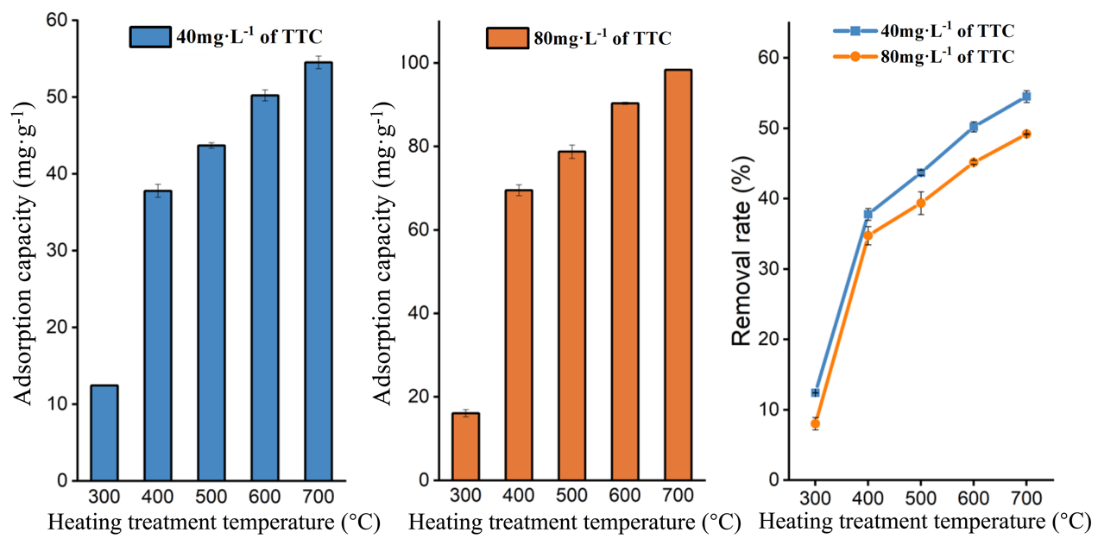
Figure S1. Adsorption capacity of tetracycline by biochar under different hitting treatment temperatures and concentrations.

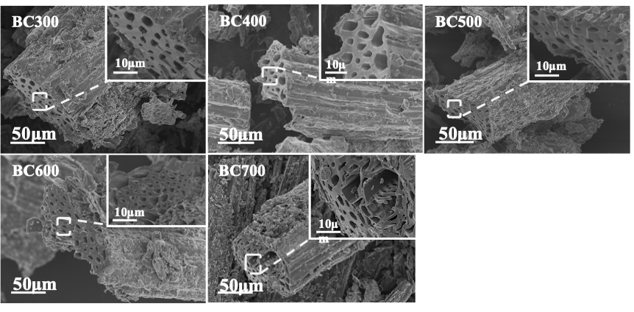
Figure S2. SEM images of biochar.

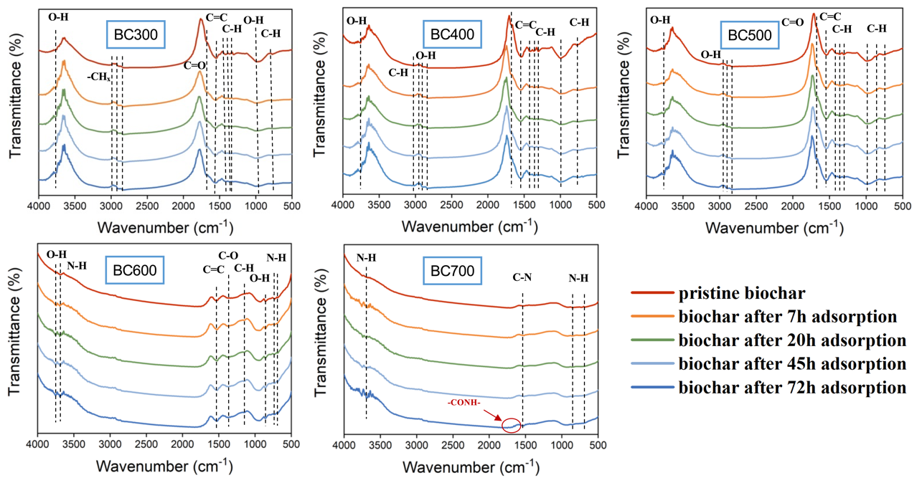
Figure S3. FTIR spectra of before- and after- TTC adsorption at different time.

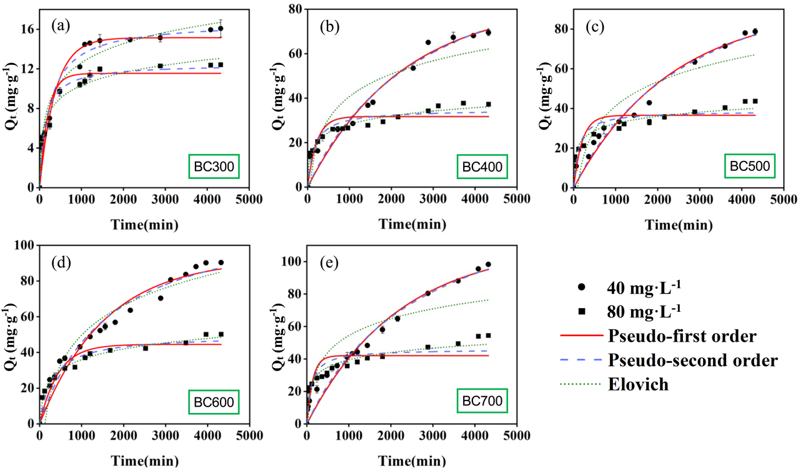
Figure S4. Adsorption kinetics of TTC on BC300 (a), BC400 (b), BC500 (c), BC600 (d) and BC700 (e) by fitting the model of pseudo-first order (PFO), pseudo-second order (PSO), and Elovich.
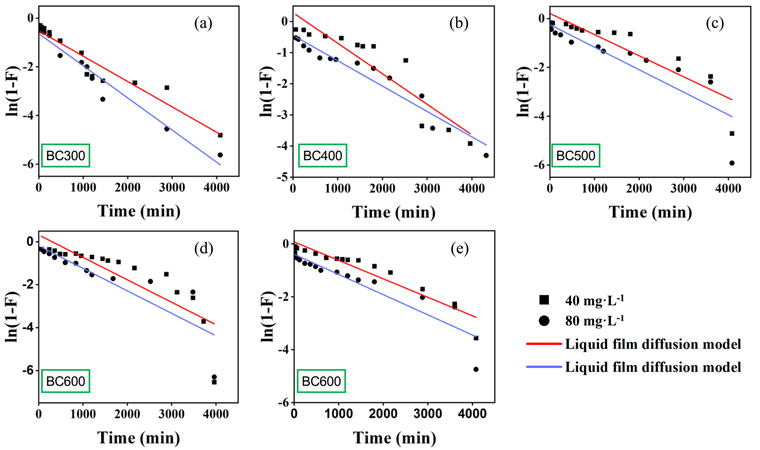
Figure S5. Adsorption kinetics of TTC on BC300 (a), BC400 (b), BC500 (c), BC600 (d) and BC700 (e) by fitting the model of Liquid film diffusion under initial concentrations of 40 mg·L⁻¹ and 80 mg·L⁻¹.
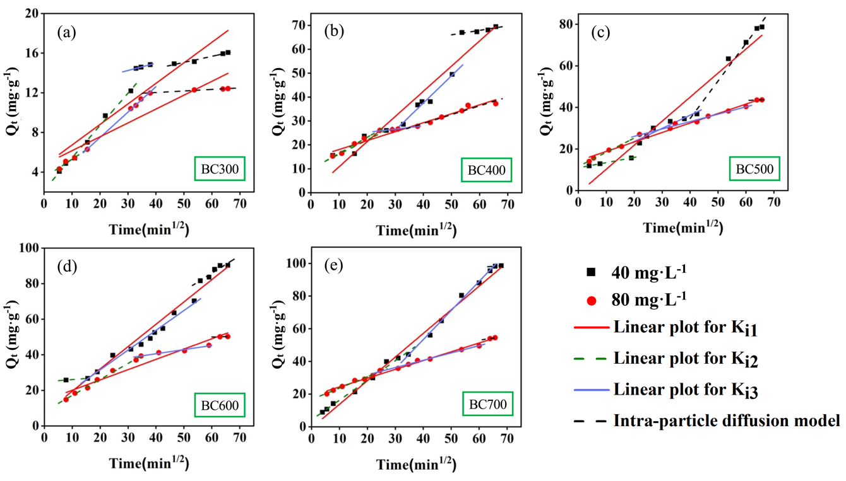
Figure S6. Adsorption kinetics of TTC on BC300 (a), BC400 (b), BC500 (c), BC600 (d) and BC700 (e) by fitting the model of Intra-particle diffusion under initial concentrations of 40 mg·L⁻¹ and 80 mg·L⁻¹.
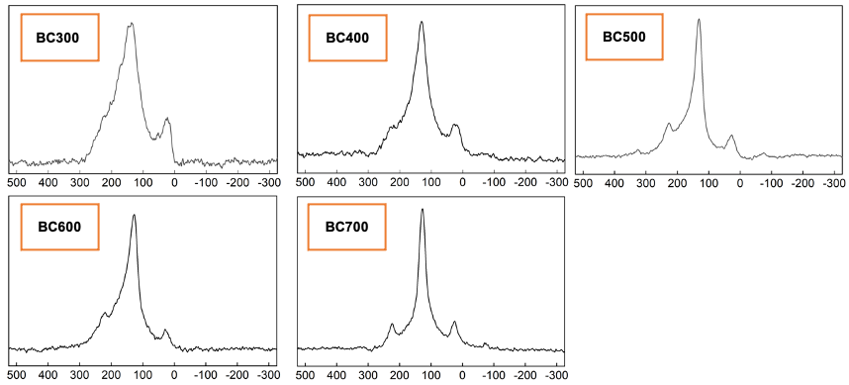
Figure S7. ¹³C NMR spectra of biochar.

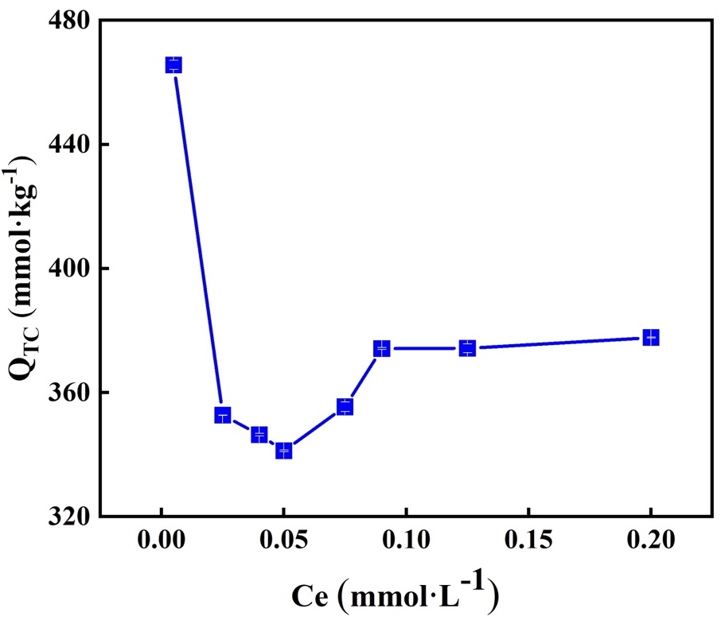
TTC: 0.01mmol/L
Benz[b]anthracene
Figure S8. Bisolute competitive experiments at different TTC initial concentration. Error bar represents standard error of at least three replicates.
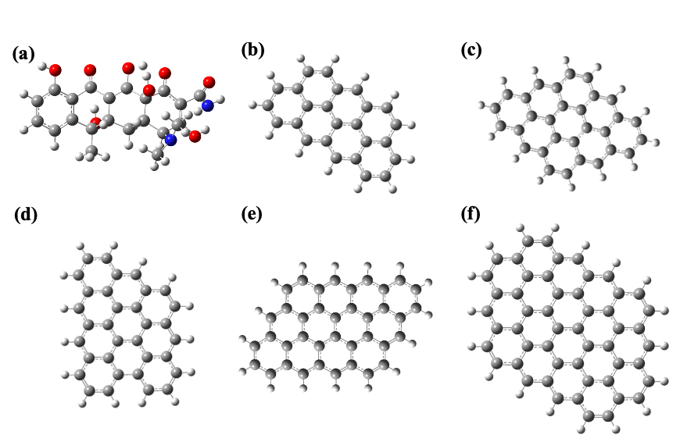
Figure S9. Dft simulated models of tetracycline and Biochars. (a) tetracycline; (b) BC300; (c) BC400; (d) BC500; (e) BC600; (f) BC700.

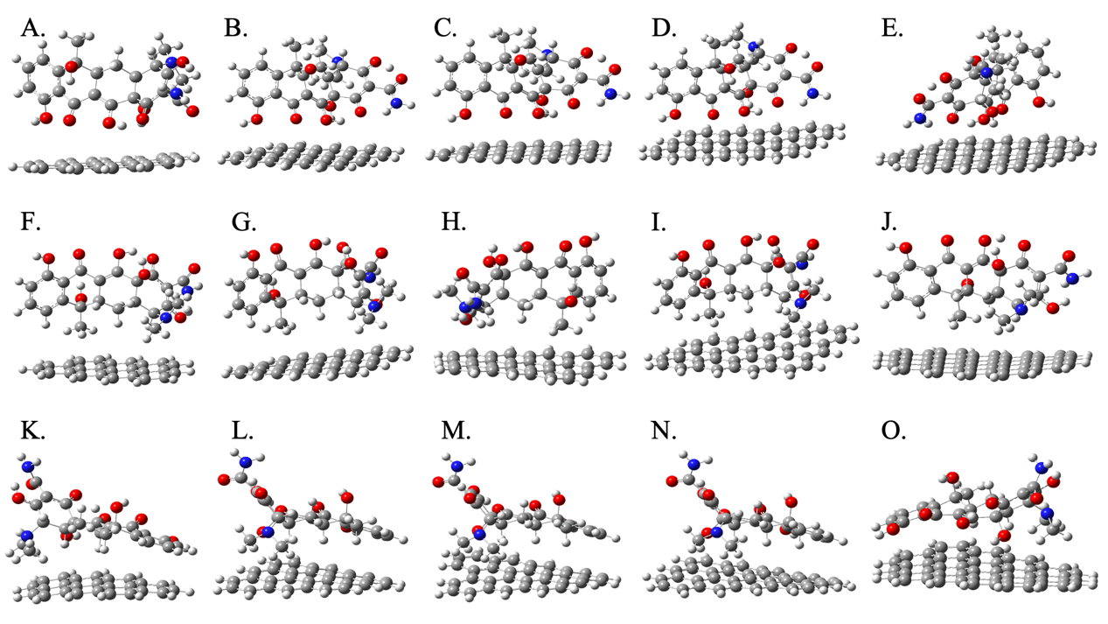

Figure S10. Adsorption configuration of tetracycline adsorbed on Biochars. (A, F, K: BC300; B, G, L: BC400; C, H, M: BC500; D, I, N: BC600; E, J, O: BC700; position 1: A, B, C, D, E; position 2: F, G, H, I, J; position 3: K, L, M, N, O).
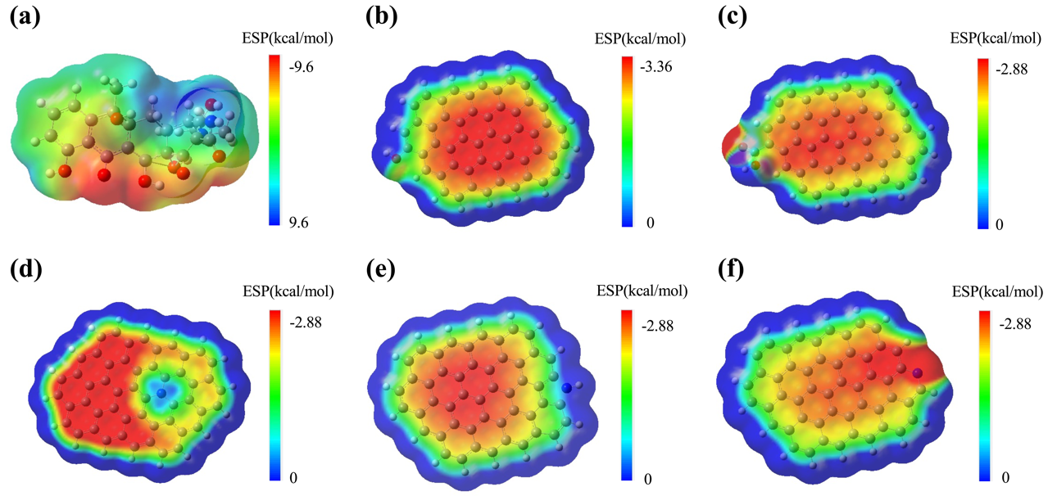
Figure S11. Electrostatic potential (ESP) distribution of TTC and functionalized Biochars. (a) TTC; (b) BC-OH; (c) BC-COOH; (d) BC-GN; (e) BC-PDN; (f) BC-PLN.

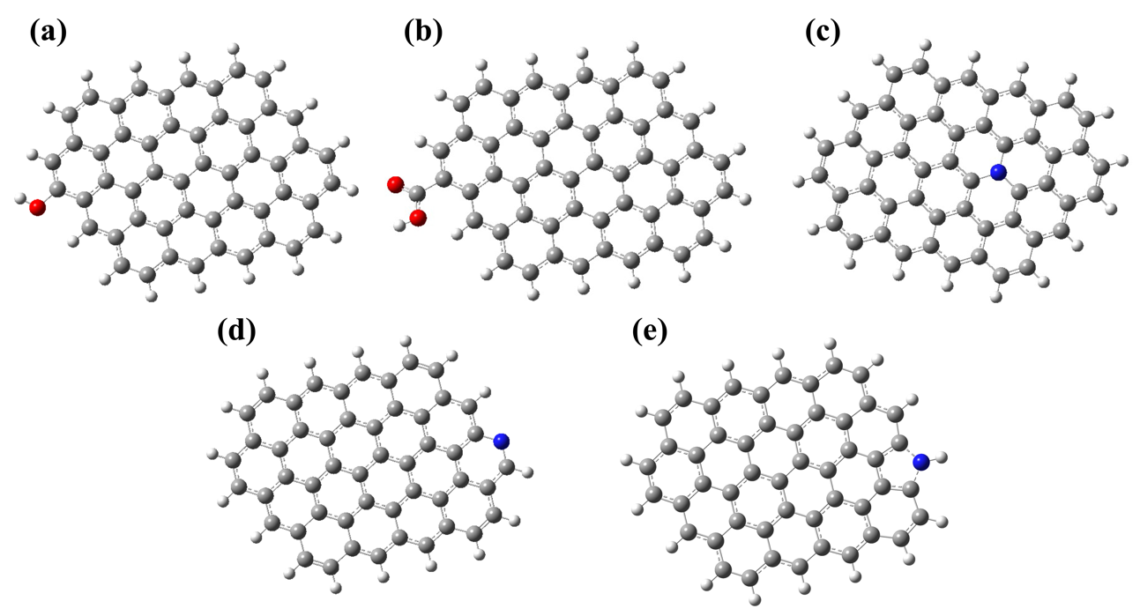
Figure S12. Dft simulated models of functionalized Biochars. (a) BC-OH; (b) BC-COOH; (c) BC-GN; (d) BC-PDN; (e) BC-PLN.

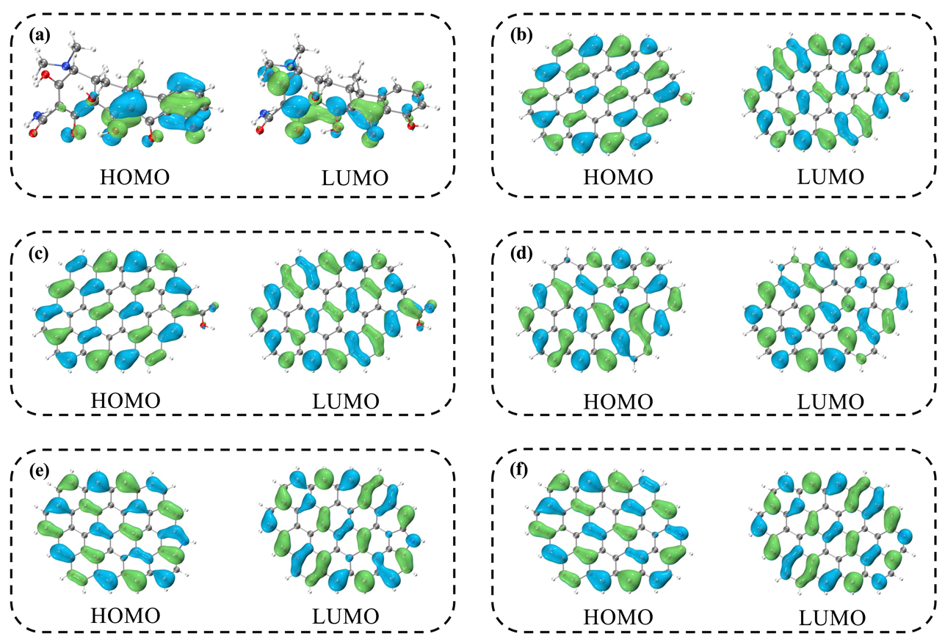
Figure S13. The frontier orbitals (HOMO and LUMO) of TTC and functionalized Biochars. (a) TTC; (b) BC-OH; (c) BC-COOH; (d) BC-GN; (e) BC-PDN; (f) BC-PLN.

Reference
Chen, Z., Lin, B., Huang, Y., Liu, Y., Wu, Y., Qu, R., Tang, C., 2023. Pyrolysis temperature affects the physiochemical characteristics of lanthanum-modified biochar derived from orange peels: Insights into the mechanisms of tetracycline adsorption by spectroscopic analysis and theoretical calculations. Sci Total Environ 862, 160860. https://doi.org/10.1016/j.scitotenv.2022.160860.
Fu, Z., Chen, Y., Lu, Y., Wang, Y., Chen, J., Zhao, Y., Yang, M., Tian, X., 2022. KMnO4 modified biochar derived from swine manure for tetracycline removal. Water Practice and Technology 17(11), 2422-2434. https://doi.org/10.2166/wpt.2022.129.
Hu, Z.T., Wang, X.F., Xiang, S., Ding, Y., Zhao, D.Y., Hu, M., Pan, Z., Varjani, S., Wong, J.W., Zhao, J., 2022. Self-cleaning MnZn ferrite/biochar adsorbents for effective removal of tetracycline. Sci Total Environ 844, 157202. https://doi.org/10.1016/j.scitotenv.2022.157202.
Jiang, W., Cai, Y., Liu, D., Shi, Q., Wang, Q., 2023. Adsorption properties and mechanism of suaeda biochar and modified materials for tetracycline. Environ Res 235, 116549. https://doi.org/10.1016/j.envres.2023.116549.
Li, X., Xu, J., Shi, J., Luo, X., 2022. Rapid and efficient adsorption of tetracycline from aqueous solution in a wide pH range by using iron and aminoacetic acid sequentially modified hierarchical porous biochar. Bioresour Technol 346, 126672. https://doi.org/10.1016/j.biortech.2022.126672.
Luo, S., Qin, J., Wu, Y., Feng, F., 2022. Tetracycline adsorption on magnetic sludge biochar: size effect of the Fe(3)O(4) nanoparticles. R Soc Open Sci 9(1), 210805. https://doi.org/10.1098/rsos.210805.
Ma, Y., Lu, T., Tang, J., Li, P., Mašek, O., Yang, L., Wu, L., He, L., Ding, Y., Gao, F., Qi, X., Zhang, Z., 2022. One-pot hydrothermal synthesis of magnetic N-doped sludge biochar for efficient removal of tetracycline from various environmental waters. Separation and Purification Technology 297. https://doi.org/10.1016/j.seppur.2022.121426.
Nguyen, T.B., Nguyen, T.K., Chen, W.H., Chen, C.W., Bui, X.T., Patel, A.K., Dong, C.D., 2023. Hydrothermal and pyrolytic conversion of sunflower seed husk into novel porous biochar for efficient adsorption of tetracycline. Bioresour Technol 373, 128711. https://doi.org/10.1016/j.biortech.2023.128711.
Nie, Y., Zhao, C., Zhou, Z., Kong, Y., Ma, J., 2023. Hydrochloric acid-modified fungi-microalgae biochar for adsorption of tetracycline hydrochloride: Performance and mechanism. Bioresour Technol 383, 129224. https://doi.org/10.1016/j.biortech.2023.129224.
Shi, Q., Wang, W., Zhang, H., Bai, H., Liu, K., Zhang, J., Li, Z., Zhu, W., 2023. Porous biochar derived from walnut shell as an efficient adsorbent for tetracycline removal. Bioresour Technol 383, 129213. https://doi.org/10.1016/j.biortech.2023.129213.
Tang, J., Ma, Y., Zeng, C., Yang, L., Cui, S., Zhi, S., Yang, F., Ding, Y., Zhang, K., Zhang, Z., 2023. Fe-Al bimetallic oxides functionalized-biochar via ball milling for enhanced adsorption of tetracycline in water. Bioresour Technol 369, 128385. https://doi.org/10.1016/j.biortech.2022.128385.
Wang, S., Yuan, C., Zafar, F.F., Wei, M., Marrakchi, F., Cao, B., Fu, Y., 2023. Facile synthesis of chlorella-derived autogenous N-doped porous biochar for adsorption on tetracycline. Environ Pollut 330, 121717. https://doi.org/10.1016/j.envpol.2023.121717.
Zhang, F., Wang, J., Tian, Y., Liu, C., Zhang, S., Cao, L., Zhou, Y., Zhang, S., 2023. Effective removal of tetracycline antibiotics from water by magnetic functionalized biochar derived from rice waste. Environ Pollut 330, 121681. https://doi.org/10.1016/j.envpol.2023.121681.
Zhang, Y., Ouyang, Z., Dong, Y., Zhao, J., Zhang, H., Li, X., Zhang, C., Tang, X., Guo, X., Zhu, L., 2023. Efficient removal of tetracycline by a novel bimetallic nickel/copper-loaded biochar: The crucial roles of π-π interaction and complexation. Applied Surface Science 640. https://doi.org/10.1016/j.apsusc.2023.158372.
Zhu, J., Ma, Y., Chen, X., Tang, J., Yang, L., Zhang, Z., 2022. One-pot hydrothermal synthesis of MoS2 modified sludge biochar for efficient removal of tetracycline from water. Journal of Water Process Engineering 49. https://doi.org/10.1016/j.jwpe.2022.103089.

