The dissolved organic matter from the co-decomposition of Chinese milk vetch and rice straw induces strengthening the Cd remediation by iron-modified biochar
Method S1 The specific extraction and determination methods
Fresh rice roots were collected, carefully rinsed with deionized water, and then extracted using a dithionite-citrate-bicarbonate (DCB) solution to gain iron-plaque (IP). Following extraction, the Cd concentrations were measured using the inductively coupled plasma mass spectrometry (ICP-MS) with model Optima 8300 (PerkinElmer, USA), while the Fe concentrations in iron plaque were measured via the inductively coupled plasma optical emission spectroscopy (ICP-OES) (Optima 5300 DV, PerkinElmer, USA). DCB-Fe and DCB-Cd meant Fe and Cd in IP, respectively.
Method S2 Preparation of soil inoculum suspensions
The soil inoculum suspensions were prepared according to the method of Frostegard and Baath (1996). The soil used for the preparation of the soil inoculum suspensions was same as that of the pot experiment. 10 g of fresh soil was placed in an incubator bottle and left at 298K for 24 hours to activate the microorganisms. Above soil was shaken and homogenized in 100 mL deionized water, and then the soil suspension was centrifuged at 278K. The supernatant was pumped through a Brinell funnel fitted with quantitative filter paper. The soil pellet redissolved in 100 mL deionized water, and homogenization/centrifugation/pumping operation was repeated once. Finally, we combined the above supernatants and diluted until the water-soluble organic carbon is less than 1 mg L⁻¹.
Method S3 Characterization of samples
The scanning electron microscopy (SEM) (ZEISS Gemini 300, Germany) was used to observe the morphological structure of FB and DMRFB. The surface functional groups were measured using Bruker Vertex 70 Fourier transform infrared spectroscopy (FTIR). The energy dispersive X-ray spectroscopy (EDS) analysis was done for biochar samples to record the distribution of key elements (C, O, Fe, Ca, and Cd). Elemental analysis of biochar was performed using a Elemantar element analyzer (Vario EL cube, Germany). Zeta potentials of biochar were measured by Zeta-sizer Nano ZS90 (Malvern, Worcestershire, UK). Boehm's titration method was used to measure the concentrations of acidic functional groups of biochar (Boehm, 1994). The specific surface areas (S_{BET}) and pore-size distributions of biochar were tested via a surface area analyzer (Quantachrome Nova 4000e, US). The X-ray photoelectron spectroscopy (XPS) spectra for O, C, Fe, and Ca for biochar was recorded by using K-Alpha (Thermo Electron Corporation, USA) in Shiyanjia Lab (www.shiyanjia.com). Rigaku Ultima IV X-ray diffraction was used to analyze the crystal structure of biochar (XRD) (Tokyo, Japan).
Method S4 Statistical analysis
The removal efficiencies and adsorption capacities of Cd(II) by the FB and DMRFB were calculated by Eqs. (1) and (2).
Q_{e} = ((C₀−C_{e})×V)/m (1)
η(%) = (C₀−C_{e})/C₀×100 (2)
where Q_{e} (mg g⁻¹) is the equilibrium adsorption capacity of FB and DMRFB for Cd(II), C₀ (mg L⁻¹) is the initial Cd(II) concentration, C_{e} (mg L⁻¹), V (L), and m (g) are the concentration of Cd(II) in the solution at equilibrium, the solution volume, and the mass of biochar, respectively. η is the removal efficiency of Cd(II) by the biochar.
The isotherms of Cd(II) sorption were fitted using Freundlich (Eq. (3)) and Langmuir models (Eq. (4)). The two equations are as follows:
Q_{e} = K_{F}×C_{e}^(1/n) (3)
Q_{e} = (Q_{m}×K_{L}×C_{e})/(1+K_{L}×C_{e}) (4)
where Q_{m} (mg g⁻¹) is the theoretical maximum Langmuir adsorption capacity, Q_{e} (mg g⁻¹) and C_{e} (mg L⁻¹) are the equilibrium Cd(II) adsorption capacity and concentration, K_{l} (L mg⁻¹) is the sorption equilibrium constant of Langmuir model, K_{f} (mg^{1-n} L^{n} g⁻¹) is the adsorption coefficient of Freundlich model. n is the Freundlich adsorption affinity parameters correlated to the adsorption strength.
The sorption kinetics data is fitted by pseudo-first-order model (Eq. (5)) and pseudo-second-order model (Eq. (6)). The two formulas are as follows:
Qe = Qt×(1−exp(−K₁×t)) (5)
Q_{t} = (K₂×t×Q_{e}^2)/(1+K₂×Q_{e}×t) (6)
where Q_{e} (mg g⁻¹) is as described above, t (h) and Q_{t} (mg L⁻¹) are the adsorption time of Cd(II) and the adsorption capacity of Cd(II) at time t, respectively. The adsorption rate constants of two models are K₁ (1/h) and K₂ (g mg⁻¹ h⁻¹), respectively.
The thermodynamic parameters are calculating by using the Gibbs-Helmholtz equation. The Gibbs free energy ΔG (kJ moL⁻¹) can measure the spontaneity of the reaction, the enthalpy change ΔH (kJ moL⁻¹) is used to measure the heat change in the reaction, and the entropy change ΔS (J (moL K)⁻¹) is used to measure the disorder of the reaction system, Ea (kJ moL⁻¹) is activation energy of a reaction.
ln Kd =−ΔH/RT+ΔS/R (7)
ΔG =−RT ln Kd (8)
ΔG=ΔH−TΔS (9)
ln Kd =lnA−Ea/RT (10)
Where R is the universal gas constant (8.314 J mol⁻¹), T (K) represents the absolute temperature, Kd (Q_{e}/C_{e}) is the equilibrium constant. A is indicative factor.
The testing conditions for the ultra-high-resolution Fourier transform ion cyclotron resonance mass spectrometer (FT-ICR MS) referenced from relevant literature (Liu et al., 2023).
The modified aromaticity index (AI_{mod}) increases as the aromaticity of DOM increases. The AI mod was estimated by Eq. (11):
AI_{mod} =(1+C−0.5O−S−0.5(H+N+P))/(C−0.5O−S−N−P) (11)
where C, H, N, O, P, and S are the stoichiometric numbers of the elements.
The NOSC value represents the ratio of the number of electrons transferred during half of the oxidation reaction to the total number of carbon atoms in the substance. It serves as an indicator of the extent of carbon oxidation in the DOM. (LaRowe and Van Cappellen, 2011; Li et al., 2023). The equation for calculating NOSC is as follows (Eq. 12):
NOSC =4−[(−Z+4C+H−3N−2O+5P−2S)/C] (12)
where Z is the net charge (-0.1). C, H, N, O, P, and S are the atoms numbers of elements in samples.
The double bond equivalent (DBE) was calculated using the following Eq. as:
DBE =C−H/2+N/2+P/2+1 (13)
where C, H, N, and P represent the stoichiometric numbers of the corresponding elements.
Result S1 FT-IR analysis
Our present study confirmed that the mixture of FB and the DMR showed more functional groups (-OH, -CO₃²⁻, C=O, C-O-C, -CH) compared with FB, which might be as an additional binding site for Cd(II) and influence the interaction mechanism between FB and Cd (Fig. S1).
Note S1 Partial least squares path model (PLS–PM)
The goodness of fit (GOF) statistic evaluated the model, and the GOF value of PLS–PM is 0.796. R² represents the proportion of variance explained. The latent variables (IP) represent DCB-Fe and DCB-Cd, and the loading scores of DCB-Fe and DCB-Cd are 0.963 and 0.953, respectively. The normalized path factors are distributed near the arrows. The dashed and solid lines indicate two effects (non-significant and significant, respectively). Blue and red represent negative and positive relationships, respectively (Fig.4).
Fig. S1 Adsorption capacity of different biochar.
Note: RB, rice straw biochar; WB, wheat straw biochar; MB, maize straw biochar; PB, peanut shells biochar; HB, hemp straw biochar; TB, tianjing biochar; FB, iron-modified biochar; BC, the original biochar of FB (wood biochar).
Fig. S2 Effect of Cd(II) equilibrium concentrations under different treatments.
Result S2 Soil physicochemical properties and their relationship with Cd bioavailability
The correlation graph illustrated that pH and DOM was extremely negatively correlated with Avail-Cd (P＜0.001). The Avail-Cd was positively correlated with root Cd (P＜0.01), shoot Cd (P＜0.001), and brown rice Cd (P＜0.001). Furthermore, soil Fe²⁺ and DCB-Cd were greatly positively related to DCB-Fe (P＜0.001). Among various forms of Cd, Aci-Cd was highly positively related to brown rice Cd (P＜0.01), root Cd (P＜0.01), and shoot Cd (P＜0.001), and negatively correlated with Res-Cd (P＜0.01). Also, DCB-Cd, DCB-Fe, and Fe²⁺ were remarkably negatively correlated with shoot Cd and brown rice Cd (P＜0.001).
Fig. S3 Correlation heat map of Cd bioavailability and soil properties. (Blue and red represent negative and positive correlations, respectively. Darker colors represent higher correlations. *, P<0.05, **, P<0.01, ***, P<0.001).
Fig. S4 Fe²⁺ concentrations in soil (LSD Test, P < 0.05).
Fig. S5 Biomass of rice different tissues (LSD Test, P < 0.05).
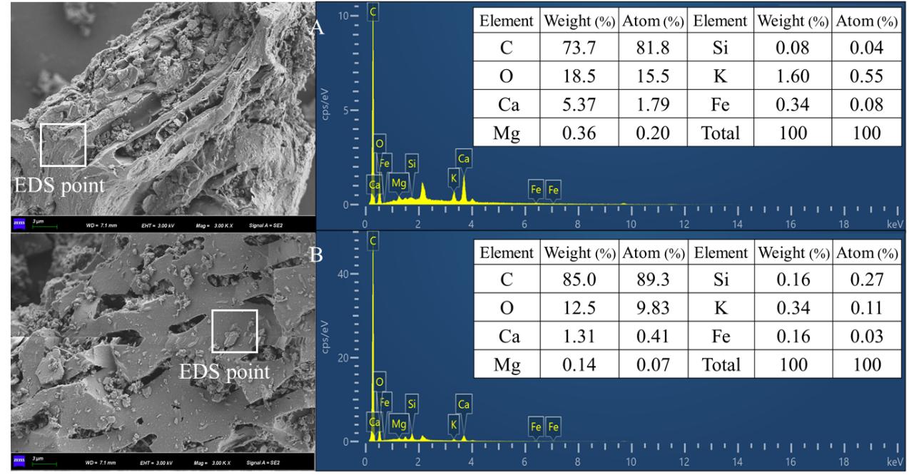
Fig. S6 SEM-EDS mapping images of FB and DMRFB before Cd(II) adsorption (A, FB; B, DMRFB).
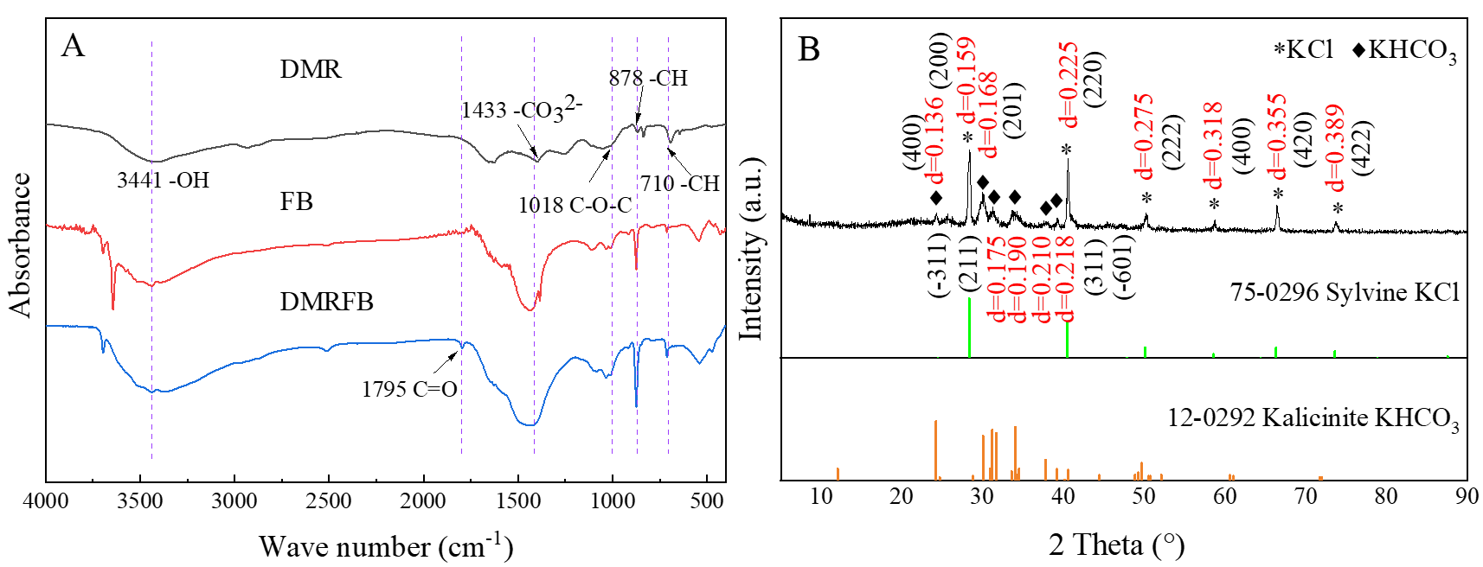
Fig. S7 FT-IR spectrum (A: DMR, FB, and DMRFB) and XRD profile of DMR (B: DMR).
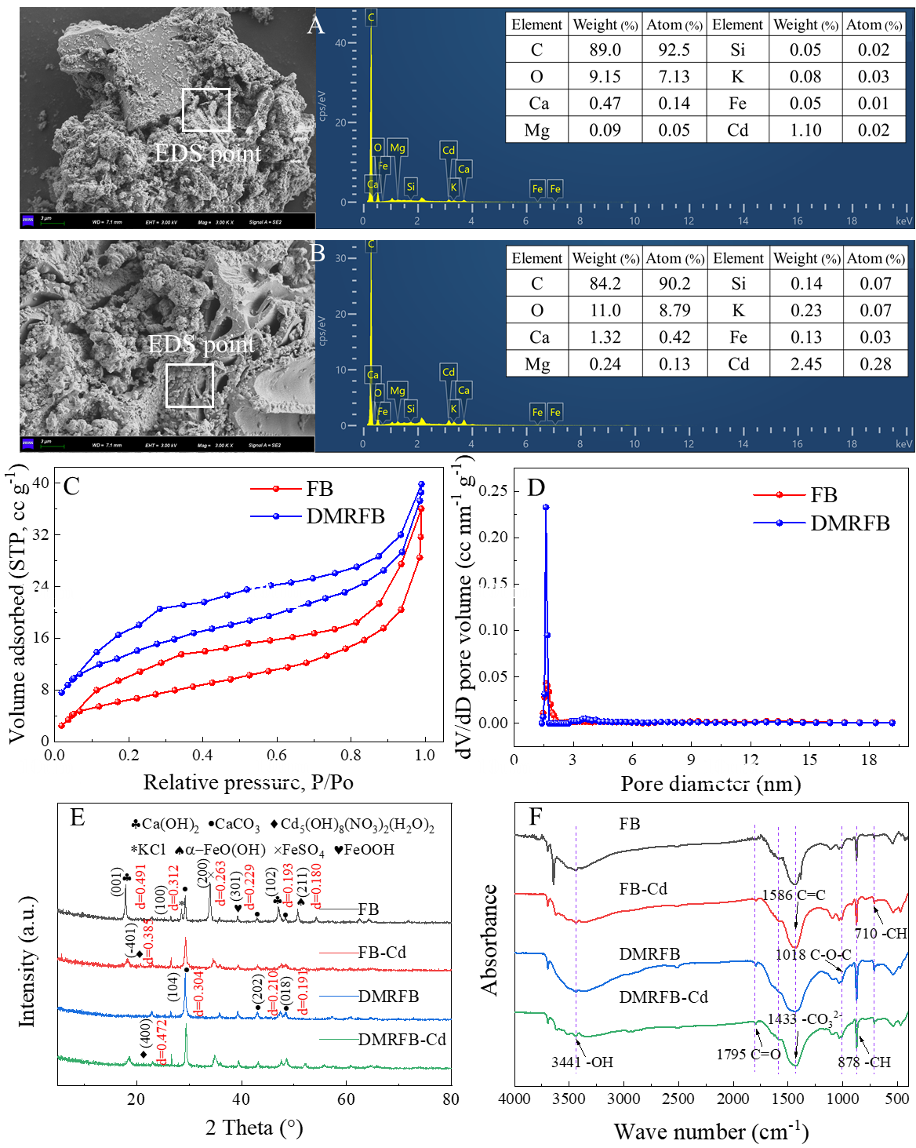
Fig. S8 EDS-mapping images (A: FB-Cd and B: DMRFB-Cd), N₂ adsorption-desorption isothermal curve and pore-size distributions (C and D), and XRD and FT-IR profiles of FB and DMRFB (E and F).
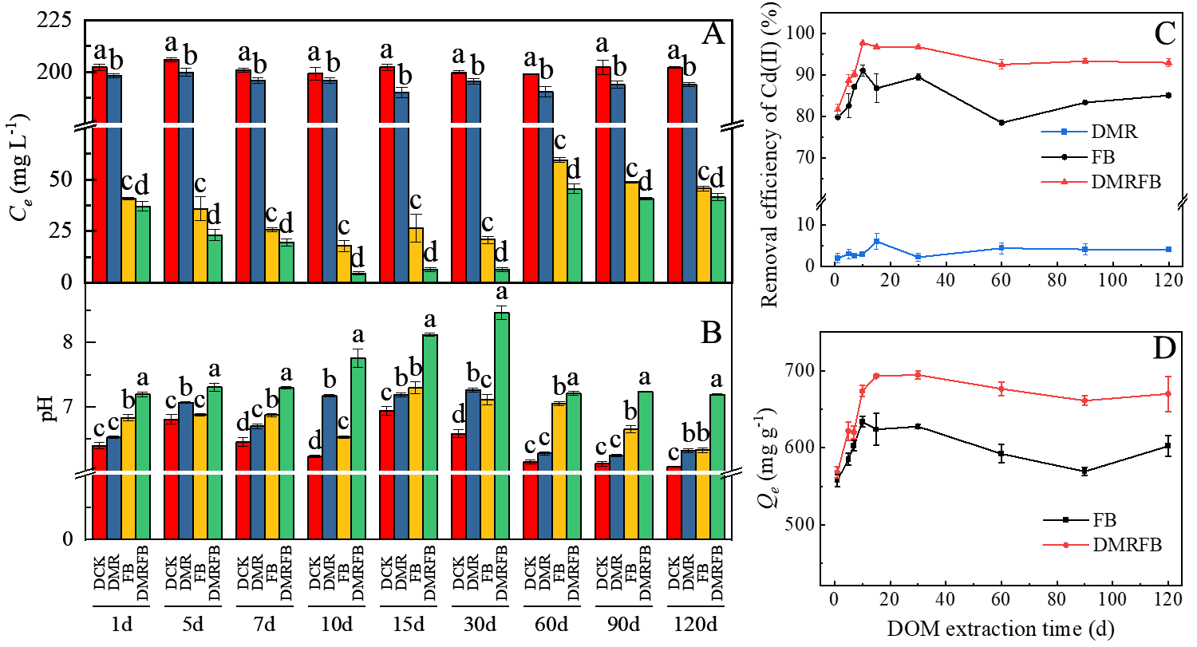
Fig. S9 Effect of Cd(II) adsorption at different decomposition time.
Fig. S10 The linear correlation between pH and Cd(II) equilibrium concentrations.
Fig. S11 Desorption efficiency at different initial Cd(II) concentrations.
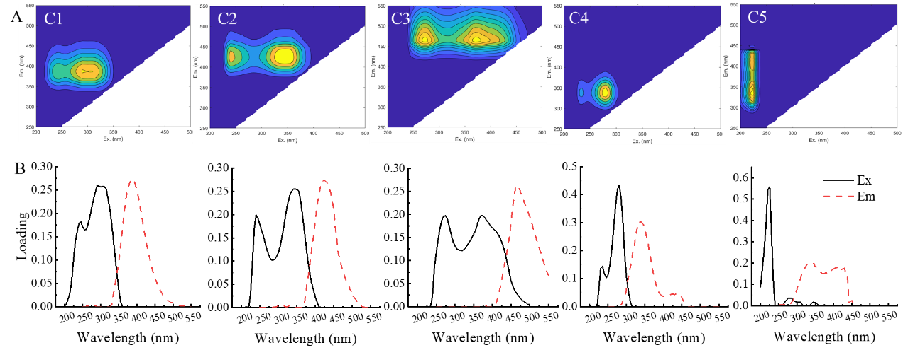
Fig. S12 Five fluorescent components in DOM identified by EEM-PARAFAC analysis. A, Spectral characteristics of five identified components (The contour lines and colors represent the relative intensity of emission (yellow and navy blue corresponded to most and least intense, respectively). B, Excitation and emission loadings of five components from DOM.
Fig. S13 Numbers and intensities of the identified DOM formulae by elemental groups (A, number; B, intensity) and biochemical classes (C, number; D, intensity) in the samples of DMR, FB, and DMRFB.
Fig. S14 Van Krevelen diagram of the carboxylic-rich alicyclic molecules (CRAM) (A, DMR; B, FB; C, DMRFB).

Table S1 The experimental design for pot trial.
Treatments | Chinese milk vetch (g kg⁻¹ soil) | Rice straw (g kg⁻¹ soil) | Fe-modified biochar (g kg⁻¹ soil)
CK-S | 0 | 0 | 0
MV-S | 20 | 0 | 0
RS-S | 0 | 5.33 | 0
MR-S | 20 | 5.33 | 0
FB-S | 0 | 0 | 2.67
MRFB-S | 20 | 5.33 | 2.67
Note: Chinese milk vetch and rice straw were calculated and applied to the soil using fresh and dry weights, respectively.

Table S2 The basic physicochemical properties of studied soil.
SOC | pH | TN | Cd | As | Hg | Pb | Cr | CEC | AK | AP | Avail-Cd
g kg⁻¹ | / | g kg⁻¹ | mg kg⁻¹ | mg kg⁻¹ | mg kg⁻¹ | mg kg⁻¹ | mg kg⁻¹ | mg kg⁻¹ | mg kg⁻¹ | mg kg⁻¹ | mg kg⁻¹
22.4 | 6.09 | 2.10 | 0.67 | 18.4 | 0.324 | 39.2 | 112 | 10.9 | 161 | 8.63 | 0.12

Table S3 Compound class and boundaries of regions in van Krevelen diagrams.\
Compound class | H/C | O/C
Lipids | 1.5-2.0 | 0-0.3
Protein/amino sugar | 1.5-2.2 | 0.3-0.67
lignins | 0.7-1.5 | 0.1-0.67
Carbohydrates | 1.5-2.4 | 0.67-1.2
Condensed aromatics | 0.2-0.7 | 0-0.67
Tannins | 0.5-1.5 | 0.67-1.0
Unsatured hydrocarbons | 0.7-1.5 | 0-0.1
Others

Table S4 Molecular properties of DOM in different samples.
Sample | ªDBE | DBE/C | ^{b}AI_{mod} | ^{c}NOSC | ^{d}MW
DMR | 7.97 | 0.120 | 0.214 | -0.381 | 454
FB | 4.91 | 0.330 | 0.189 | -0.646 | 308
DMRFB | 8.16 | 0.396 | 0.232 | -0.342 | 446
ªDBE: Double bond equivalent.
^{b}AI_{mod}: Modified aromaticity index.
^{c}NOSC: Nominal oxidation state of carbon
^{d}MW: Molecular weight.

Table S5 The resulting information of Shapiro-Wilk analysis.
Index | Statistics | P | Decision at 0.05 level | Statistical test
pH | 0.827 | 8.56×10⁻⁴ | non-normally distributed | Friedman Test, Mann-Whitney U test
SOC | 0.960 | 0.441 | normally distributed | ANOVA
TN | 0.955 | 0.341 | normally distributed | ANOVA
NH₄⁺-N | 0.877 | 0.007 | non-normally distributed | Friedman Test, Mann-Whitney U test
NO₃⁻-N | 0.944 | 0.199 | normally distributed | ANOVA
AP | 0.919 | 0.055 | normally distributed | ANOVA
AK | 0.884 | 0.010 | non-normally distributed | Friedman Test, Mann-Whitney U test
DOM | 0.962 | 0.486 | normally distributed | ANOVA
Fe²⁺ | 0.923 | 0.068 | normally distributed | ANOVA
Avail-Cd | 0.848 | 0.002 | non-normally distributed | Friedman Test, Mann-Whitney U test
DCB-Cd | 0.956 | 0.355 | normally distributed | ANOVA
DCB-Fe | 0.969 | 0.651 | normally distributed | ANOVA
Aci-Cd | 0.814 | 4.94×10⁻⁴ | non-normally distributed | Friedman Test, Mann-Whitney U test
Red-Cd | 0.947 | 0.234 | normally distributed | ANOVA
Org-Cd | 0.889 | 0.012 | non-normally distributed | Friedman Test, Mann-Whitney U test
Res-Cd | 0.975 | 0.783 | normally distributed | ANOVA
Root-Cd | 0.975 | 0.056 | normally distributed | ANOVA
Shoot-Cd | 0.913 | 0.041 | non-normally distributed | Friedman Test, Mann-Whitney U test
Rice-Cd | 0.930 | 0.096 | normally distributed | ANOVA

Table S6 Effects of different treatments on soil chemical properties in pot experiment.
Treatments | SOC  g kg⁻¹ | TN  g kg⁻¹ | NH₄⁺-N  mg kg⁻¹ | NO₃⁻-N  mg kg⁻¹ | AP  mg kg⁻¹ | AK  mg kg⁻¹ | DOM  mg kg⁻¹
CK-S | 21.7±0.25b | 1.98±0.02a | 9.56±0.56a | 1.13±0.13a | 5.45±0.12d | 77.5±5.92b | 204±10.6bc
MV-S | 22.2±0.41ab | 1.98±0.02a | 11.2±0.45a | 0.97±0.18ab | 5.65±0.17cd | 62.5±0.29b | 215±5.96b
RS-S | 22.5±0.11ab | 1.99±0.01a | 9.70±0.43a | 0.84±0.20ab | 6.01±0.14bc | 159±17.88a | 199±5.96c
MR-S | 22.5±0.27a | 1.98±0.03a | 9.87±0.68a | 0.85±0.28ab | 6.20±0.17b | 160±17.24a | 216±4.92b
FB-S | 22.5±0.29ab | 1.97±0.01a | 12.9±1.06a | 0.47±0.09b | 7.08±0.19a | 81.3±4.77b | 238±5.31a
MRFB-S | 22.4±0.25ab | 1.91±0.02b | 12.3±1.83a | 0.65±0.18ab | 7.30±0.09a | 198±21.19a | 249±12.0a
Note: The error indicates the standard deviation. (P < 0.05).

Table S7 The adsorption isothermal model parameters on FB and DMRFB for Cd(II).
Materials | Langmuir model |  |  | Freundlich model
 | Q_{m} (mg g⁻¹) | K_{L} (L mg⁻¹) | R² | K_{F} (mg^{1-n} L^{n} g⁻¹) | 1/n | R²
FB | 487±20.3 | 42.9±9.71 | 0.973 | 239±39.62 | 0.13±0.03 | 0.843
DMRFB | 634±41.8 | 0.23±0.07 | 0.942 | 149±40.48 | 0.24±0.05 | 0.869

Table S8 Summary of for modified biochar adsorption capacity on Cd(II).
Adsorbents | Cd(II) concentration  (mg L⁻¹) | pH | Q_{m} (mg g⁻¹) | References
DMRFB | 5-500 | initial pH | 634 | This study
FB | 5-500 | initial pH | 487 | This study
Goethite modified wheat biochar | 5-500 | 4.0 | 31.9 | (Zhu et al., 2020)
Fe-Mn binary oxide-biochar | 50-200 | 5.0 | 95.2 | (Yin et al., 2020)
Chitosan modified kiwi branch biochar | 0.5-100 | 6.0 | 127 | (Tan et al., 2022)
Sulphur-modified wheat straw biochar | 0-100 | initial pH | 41.4 | (Chen et al., 2020)
Ball-milled P-loaded biochar materials | 5-40 | 3.0-6.0 | 18.7 | (Zhang et al., 2022)
Mg/Fe bimetallic oxide-modified biochar | 200-400 | initial pH | 196 | (Cheng et al., 2023)
Mg/Fe bimetallic oxide‑loaded sludge‑derived biochar | 40-500 | 5.0 | 270 | (Lin et al., 2023)
Note: Q_{m}, Maximum adsorption capacity.

Table S9 The kinetic model parameters of adsorption.
Materials | Pseudo-first-order model |  |  | Pseudo-second-order model
 | Q_{m} (mg g⁻¹) | K₁ (1/h) | R² | Q_{e} (mg g⁻¹) | K₂ (g mg⁻¹ h⁻¹) ×10⁸ | R²
FB | 426±12.2 | 3.99±0.57 | 0.922 | 442±13.44 | 5.56±0.91 | 0.923
DMRFB | 468±15.8 | 3.45±0.57 | 0.891 | 486±13.83 | 6.43±0.96 | 0.932

Table S10 Thermodynamic parameters for Cd(II) adsorption by FB and DMRFB.
Materials | ΔG (kJ moL⁻¹) |  |  |  | ΔH (kJ moL⁻¹) | ΔS (J (moL K)⁻¹)
Materials | 288K | 298K | 308K | 318K | ΔH (kJ moL⁻¹) | ΔS (J (moL K)⁻¹)
FB | -4.25 | -6.28 | -9.15 | -9.81 | 66.3 | 245
DMRFB | -7.96 | -9.39 | -14.1 | -17.7 | 80.3 | 307

Table S11 The activation energy of FB and DMRFB.
Materials | E_{a} (kJ moL⁻¹)
Materials | 288K | 298K | 308K | 318K
FB | 52.5 | 50.7 | 48.2 | 42.5
DMRFB | 89.1 | 88.0 | 83.9 | 81.0

Table 12 The concentrations of acidic functional groups.
Materials | Carboxylic | Lactone | Phenolic | Total
 | mmol g⁻¹ | mmol g⁻¹ | mmol g⁻¹ | mmol g⁻¹
FB | 0.414 | 0.124 | 0.164 | 0.702
DMRFB | 0.445 | 0.156 | 0.197 | 0.798

Table S13 The percentages of atomic in XPS.
Atomic (%) | C 1s | O 1s | Ca 2p | Fe 2p | Cd 3d
FB | 44.1 | 43.6 | 11.8 | 0.49 | /
DMRFB | 56.4 | 36.4 | 6.66 | 0.49 | /
FB-Cd | 61.0 | 32.9 | 3.94 | 0.44 | 1.69
DMRFB-Cd | 49.1 | 41.9 | 5.99 | 0.62 | 2.37

Table S14 Identities and related references for similar components using the OpenFluor database.
Component | Similarity score | ƛex/ ƛem | DOM category | References
C1 | 0.98 | 280&245/386 | Microbial humic-like | Zhou et al., 2022
C2 | 0.96 | 250&340/434 | Terrestrial humic-like I | Peleato et al., 2017
C3 | 0.98 | 250&370/480 | Terrestrial humic-like II | Peleato et al., 2017
C4 | 0.99 | 280&235/334 | Protein-like I | Yamashita et al., 2010
C5 | 0.91 | 220/344&430 | Protein-like II | Derrien et al., 2020

Refrernce
Boehm, H.P (1994) Some aspects of the surface chemistry of carbon blacks and other carbons. Carbon 32(5):759-769. https://doi.org/https://doi.org/10.1016/0008-6223(94)90031-0
Chen D, Wang X, Wang X, Feng K, Su J, Dong J (2020) The mechanism of cadmium sorption by sulphur-modified wheat straw biochar and its application cadmium-contaminated soil. Sci Total Environ 714:136550. https://doi.org/10.1016/j.scitotenv.2020.136550
Cheng S, Meng W, Xing B, Shi C, Wang Q, Xia D, Nie Y, Yi G, Zhang C, Xia H (2023) Efficient removal of heavy metals from aqueous solutions by Mg/Fe bimetallic oxide-modified biochar: Experiments and DFT investigations. Journal of Cleaner Production 403:136821. https://doi.org/10.1016/j.jclepro.2023.136821
Derrien M, Lee M-H, Choi K, Lee K-S, Hur J (2020) Tracking the evolution of particulate organic matter sources during summer storm events via end-member mixing analysis based on spectroscopic proxies. Chemosphere 252:126445. https://doi.org/10.1016/j.chemosphere.2020.126445
Frostegard A , Baath E (1996) The use of phospholipid fatty acid analysis to estimate bacterial and fungal biomass in soil[J]. Biology and fertility of soils 22:59-65. https://doi.org/10.1007/BF00384433
LaRowe D E, Van Cappellen P (2011) Degradation of natural organic matter: A thermodynamic analysis. Geochimica et Cosmochimica Acta 75(8):2030-2042. https://doi.org/10.1016/j.gca.2011.01.020
Li T, Li P, Qin W, Wu M, Saleem M, Kuang L, Zhao S, Tian C, Li Z, Jiang J, Chen K, Wang B (2023) Fertilization Weakens the Ecological Succession of Dissolved Organic Matter in Paddy Rice Rhizosphere Soil at the Molecular Level. Environ. Sci. Technol. 57(48):19782-19792. https://doi.org/10.1021/acs.est.3c05939
Lin W, Zhou J, Sun S (2023) Cadmium and lead removal by Mg/Fe bimetallic oxide-loaded sludge-derived biochar: batch adsorption, kinetics, and mechanism. Environ. Sci. Pollut. Res. 30(37):86866-86878. https://doi.org/10.1007/s11356-023-28574-x
Liu L, Du L, Lu S, Yang B, Zhao X, Wu D, Fei X, He H, Wang D (2023) Molecular insight into DOM fate using EEM-PARAFAC and FT-ICR MS and concomitant heavy metal behaviors in biologically treated landfill leachate during coagulation: Al speciation dependence. Journal of Hazardous Materials 460:132374. https://doi.org/10.1016/j.jhazmat.2023.132374
Liu L, Fan S (2018) Removal of cadmium in aqueous solution using wheat straw biochar: effect of minerals and mechanism. Environ. Sci. Pollut. Res. 25(9):8688-8700. https://doi.org/10.1007/s11356-017-1189-2
Peleato N M, Sidhu B S, Legge R L, Andrews R C (2017) Investigation of ozone and peroxone impacts on natural organic matter character and biofiltration performance using fluorescence spectroscopy. Chemosphere 172:225-233. https://doi.org/10.1016/j.chemosphere.2016.12.118
Tan Y, Wan X, Ni X, Wang L, Zhou T, Sun H, Wang N, Yin X (2022) Efficient removal of Cd (II) from aqueous solution by chitosan modified kiwi branch biochar. Chemosphere 289:133251. https://doi.org/10.1016/j.chemosphere.2021.133251
Yamashita Y, Panton A, Mahaffey C, Jaffé R (2010) Assessing the spatial and temporal variability of dissolved organic matter in Liverpool Bay using excitation–emission matrix fluorescence and parallel factor analysis. Ocean Dynamics 61(5):569-579. https://doi.org/10.1007/s10236-010-0365-4
Yin G, Song X, Tao L, Sarkar B, Sarmah A.K, Zhang W, Lin Q, Xiao R, Liu Q, Wang H (2020) Novel Fe-Mn binary oxide-biochar as an adsorbent for removing Cd(II) from aqueous solutions. Chemical Engineering Journal 389:124465. https://doi.org/10.1016/j.cej.2020.124465
Zhang P, Xue B, Jiao L, Meng X, Zhang L, Li B, Sun H (2022) Preparation of ball-milled phosphorus-loaded biochar and its highly effective remediation for Cd- and Pb-contaminated alkaline soil. Sci Total Environ 813:152648. https://doi.org/10.1016/j.scitotenv.2021.152648
Zhou Z, Liu Y G, Liu S B, Liu H Y, Zeng G M, Tan X F, Yang C P, Ding Y, Yan Z L, Cai X X (2017) Sorption performance and mechanisms of arsenic(V) removal by magnetic gelatin-modified biochar. Chemical Engineering Journal 314:223-231. https://doi.org/10.1016/j.cej.2016.12.113
Zhu S, Zhao J, Zhao N, Yang X, Chen C, Shang J (2020) Goethite modified biochar as a multifunctional amendment for cationic Cd(II), anionic As(III), roxarsone, and phosphorus in soil and water. Journal of Cleaner Production 247:119579. https://doi.org/10.1016/j.jclepro.2019.119579

