Additional file for
Effect mechanism of phosphorous-containing additives on carbon structure evolution and biochar stability enhancement

Haiping Yangª, Yamian Yuª, Han Zhang^{a,}*,Wanwan Wangª, Jinjiao Zhu^{b}, Yingquan Chenª, Shihong Zhangª, Hanping Chenª
ª State Key Laboratory of Coal Combustion, School of Energy and Power Engineering, Huazhong University of Science and Technology, Wuhan 430074, China
^{b} School of Automotive Engineering, Yancheng Institute of Technology, Hope Avenue Middle-road No. 1, Yancheng, Jiangsu 224051, China
*Corresponding information: Han Zhang; E-mail address: hungerzhang@hust.edu.cn..

Text

Text S1. 2D-PCIS analysis
The two-dimensional correlation infrared spectrum (2D-PCIS) was created by processing the collected FT-IR data with a 2D-shige program (Morita team, Kansai University of Japan) utilizing the 2D correlation technique suggested by Noda et al. [1, 2]. Our prior paper [3] contained the fundamental concepts and mathematical explanations of two-dimensional correlation infrared spectroscopy. The 2D-PCIS correlation infrared spectra are characterized as synchronous Φ(v₁, v₂) and asynchronous ψ(v₁, v₂), where v₁ and v₂ are the FT-IR wavenumbers corresponding to associated functional groups. As the mixing ratio increases, the synchronous 2D correlation intensity reveals the overall resemblance (in-phase or coincidental) of the intensity fluctuations in v₁ and v₂. The dissimilarity (out-of-phase or sequential) of the spectral intensity variations in v₁ and v₂ with mixing ratio is shown by the asynchronous 2D correlation intensity. Combining synchronous and asynchronous spectrum analysis yielded the relative change priority of v₁, v₂, and the detailed determination technique is based on Noda's rule (see Table S1).

Text S2. Methods for calculating crystal size.
The SE method [4, 5] is derived from the Scherrer equation for computing the average grain size of crystals. It expresses the quantitative connection between the average grain size of the sample and the width of the diffraction peak when the half-maximum width is employed to represent the degree of diffraction peak widening. That is, the relevant crystal characteristics are determined based on the numerical value of the XRD diffraction peak's half-peak width B, and the specific calculating formulae are shown as follows:
$L_{a}=\frac{1.84λ}{B_{a}\cos{(}θ_{a})}$ (1)
$L_{c}=\frac{0.89λ}{B_{c}\cos{(}θ_{c})}$ (2)
Where λ is the incident wavelength, for the Cu target X-ray instrument, the value is 1.5425 (Å); B_{a} and B_{c} are the half-peak width of d₁₀₀ and d₀₀₂ peaks, respectively; θ_{a} and θ_{c} are scattering angles of d₁₀₀ and d₀₀₂ peaks, respectively. The units of B and θ are both radians. L_{a} is the plane size of graphite crystallites, and L_{c} is the thickness of graphite crystallites.

Tables
Table S1. Noda’s rule
$$\text{ψ(}v_{1}\text{,}v_{2}\text{)}$$ | $$\text{ϕ}\left(v_{1}\text{,}v_{2}\right)$$ | Description
None | + | Peaks located at v₁ and v₂ have the same trend of intensity change, such as increasing or decreasing simultaneously
None | - | Peaks located at v₁ and v₂ have the opposite trend of intensity change
+ | + | Peak located at v₁ changes before that at v₂
- | + | Peak located at v₁ changes after that at v₂
- | - | Peak located at $\text{v}\text{1}$changes before that at v₂
+ | - | Peak located at $\text{v}\text{1}$changes after that at v₂

Table S2. Ultimate analysis results of samples.
Samples | Cª | Hª | Nª | Sª | O^{b} | H/C | O/C | Yield (%)
Corncub | 51.51 | 6.13 | 0.21 | 0.1 | 42.06 | 1.43 | 0.61 | -
BC350 | 74.22 | 3.51 | 0.25 | 0.14 | 21.87 | 0.57 | 0.22 | 49.36
BC550 | 91.26 | 2.50 | 0.60 | 0.13 | 5.50 | 0.33 | 0.05 | 42.96
BC750 | 96.44 | 0.95 | 0.72 | 0.19 | 1.70 | 0.12 | 0.01 | 40.32
BC950 | 96.91 | 0.51 | 0.9 | 0.21 | 1.46 | 0.06 | 0.01 | 35.23
KPBC350 | 73.32 | 2.98 | 0.2 | 0.27 | 19.23 | 0.49 | 0.20 | 64.26
KPBC550 | 73.39 | 1.07 | 0.14 | 0.39 | 21.00 | 0.17 | 0.21 | 61.19
KPBC750 | 67.46 | 0.44 | 0.19 | 0.3 | 26.06 | 0.08 | 0.29 | 59.37
KPBC950 | 71.48 | 0.23 | 0.3 | 0.46 | 19.61 | 0.04 | 0.21 | 56.10
ª Dry ash-free base
^{b} The O content was obtained by subtraction

Table S3. The FTIR functional groups in studied biochars.
Wavenumber(cm⁻¹) | Type of organic functional groups
3850-3580 | free O-H
3560-3200 | intermolecular bonded O-H
3330-2700 | C-H in alkene/alkyne/aldehyde
1820-1650 | C=O in ketone/aldehyde
1680-1580 | C=C in alkene
1450-1350 | C-H in alkane
1310-1060 | C-O in aliphatic ether/alcohol
1050-1040 | C-O-C in glycosides
995-665 | C=C in alkene
900-680 | C-H in aromatic compounds
520-470 | C=O in lactones

Table S4. The Raman functional groups in studied biochars.
Peak name | Position (cm⁻¹) | Description | Bond type
G_{l} | 1700 | Carbonyl group C=O | sp²
G | 1590 | Graphite E²_{2g}; aromatic ring quadrant breathing; alkene C=C | sp²
G_{r} | 1540 | Aromatics with 3~5 rings; amorphous carbon structures | sp²
V_{l} | 1465 | Methylene or methyl; semicircle breathing of aromatic rings; amorphous carbon structures | sp², sp³
V_{r} | 1380 | Methyl group; semicircle breathing of aromatic rings; amorphous carbon structures | sp², sp³
D | 1300 | D band on highly ordered carbonaceous materials; C-C between aromatic rings and aromatics with not less than 6 rings | sp²
S_{l} | 1230 | Aryl-alkyl ether; para-aromatics | sp², sp³
S | 1185 | C_{aromatic}-C_{alkyl}; aromatic (aliphatic) ethers; C-C on hydroaromatic rings; hexagonal diamond carbon sp³; C-H on aromatic rings | sp², sp³
S_{r} | 1060 | C-H on aromatic rings; benzene (ortho-di-substituted) ring | sp²
R | 960-800 | C-C on alkanes and cyclic alkanes; C-H on aromatic rings | sp², sp³

Table S5. Correlation coefficient and probability values of among the physic-chemical properties of biochar.
 | A | B | C | D | E | F | G | H | I | J | K | L | M | N | O | P | Q | R | S
A | 1.00 | -0.33 | -0.77 | -0.84 | -0.50 | 0.99 | 0.96 | 1.00 | 0.98 | 0.95 | 0.95 | 0.98 | 0.99 | -0.91 | -0.83 | 0.66 | -0.73 | 0.83 | 0.80
B | 0.67 | 1.00 | -0.35 | 0.26 | 0.80 | -0.28 | -0.16 | -0.24 | -0.16 | -0.07 | -0.09 | -0.28 | -0.31 | 0.59 | -0.17 | 0.33 | -0.21 | -0.70 | -0.69
C | 0.23 | 0.65 | 1.00 | 0.70 | 0.01 | -0.80 | -0.86 | -0.82 | -0.87 | -0.91 | -0.89 | -0.80 | -0.78 | 0.52 | 0.96 | -0.92 | 0.91 | -0.38 | -0.36
D | 0.16 | 0.74 | 0.30 | 1.00 | 0.71 | -0.89 | -0.94 | -0.84 | -0.82 | -0.89 | -0.92 | -0.93 | -0.90 | 0.91 | 0.87 | -0.83 | 0.89 | -0.87 | -0.87
E | 0.50 | 0.20 | 0.99 | 0.29 | 1.00 | -0.52 | -0.50 | -0.44 | -0.37 | -0.39 | -0.44 | -0.58 | -0.56 | 0.82 | 0.27 | -0.21 | 0.31 | -0.90 | -0.92
F | 0.02 | 0.72 | 0.20 | 0.11 | 0.48 | 1.00 | 0.98 | 0.99 | 0.99 | 0.97 | 0.97 | 0.99 | 1.00 | -0.91 | -0.88 | 0.73 | -0.80 | 0.83 | 0.81
G | 0.01 | 0.84 | 0.14 | 0.07 | 0.50 | 0.01 | 1.00 | 0.97 | 0.97 | 0.99 | 1.00 | 0.99 | 0.98 | -0.88 | -0.94 | 0.84 | -0.89 | 0.80 | 0.79
H | 0.03 | 0.76 | 0.18 | 0.16 | 0.56 | 0.02 | 0.02 | 1.00 | 1.00 | 0.97 | 0.97 | 0.98 | 0.99 | -0.87 | -0.87 | 0.71 | -0.77 | 0.78 | 0.75
I | 0.04 | 0.84 | 0.13 | 0.18 | 0.63 | 0.01 | 0.01 | 0.01 | 1.00 | 0.98 | 0.97 | 0.97 | 0.98 | -0.83 | -0.90 | 0.75 | -0.80 | 0.73 | 0.70
J | 0.02 | 0.93 | 0.09 | 0.11 | 0.61 | 0.03 | 0.01 | 0.02 | 0.02 | 1.00 | 1.00 | 0.98 | 0.97 | -0.83 | -0.96 | 0.86 | -0.90 | 0.73 | 0.71
K | 0.05 | 0.91 | 0.11 | 0.08 | 0.56 | 0.01 | 0.02 | 0.03 | 0.01 | 0.01 | 1.00 | 0.98 | 0.97 | -0.85 | -0.96 | 0.87 | -0.91 | 0.75 | 0.74
L | 0.01 | 0.72 | 0.20 | 0.07 | 0.42 | 0.02 | 0.03 | 0.01 | 0.01 | 0.01 | 0.01 | 1.00 | 1.00 | -0.93 | -0.90 | 0.77 | -0.84 | 0.86 | 0.84
M | 0.02 | 0.69 | 0.22 | 0.10 | 0.44 | 0.02 | 0.04 | 0.02 | 0.01 | 0.02 | 0.01 | 0.01 | 1.00 | -0.93 | -0.87 | 0.73 | -0.80 | 0.86 | 0.84
N | 0.10 | 0.41 | 0.48 | 0.09 | 0.18 | 0.09 | 0.12 | 0.13 | 0.17 | 0.17 | 0.15 | 0.07 | 0.07 | 1.00 | 0.69 | -0.55 | 0.65 | -0.99 | -0.98
O | 0.17 | 0.83 | 0.01 | 0.13 | 0.73 | 0.12 | 0.06 | 0.13 | 0.10 | 0.02 | 0.02 | 0.10 | 0.13 | 0.31 | 1.00 | -0.96 | 0.98 | -0.58 | -0.57
P | 0.34 | 0.67 | 0.09 | 0.17 | 0.79 | 0.27 | 0.16 | 0.29 | 0.25 | 0.14 | 0.13 | 0.23 | 0.27 | 0.45 | 0.01 | 1.00 | -0.99 | 0.45 | 0.45
Q | 0.27 | 0.79 | 0.09 | 0.11 | 0.69 | 0.20 | 0.11 | 0.23 | 0.20 | 0.10 | 0.09 | 0.16 | 0.20 | 0.35 | 0.01 | 0.02 | 1.00 | -0.55 | -0.55
R | 0.17 | 0.30 | 0.62 | 0.13 | 0.10 | 0.17 | 0.20 | 0.22 | 0.27 | 0.27 | 0.25 | 0.14 | 0.14 | 0.01 | 0.42 | 0.55 | 0.45 | 1.00 | 1.00
S | 0.20 | 0.31 | 0.64 | 0.13 | 0.08 | 0.19 | 0.21 | 0.25 | 0.30 | 0.29 | 0.26 | 0.16 | 0.16 | 0.01 | 0.43 | 0.55 | 0.45 | 0.01 | 1.00
The correlation coefficient is shown in black in the table, and the probability values are shown in red.
The A to S corresponding to volatile (A), ash (B), fixed C (C), surface area (D), O/C ratio (E), H/C ratio (F), -OH content (G), -C=O content (H), -C-O (I), P=O (J), P-O (K), I_{G}/I_{D} (L), I_{(Gr+Vi+Vr)}/I_{D} (M), I _{(Sr+Si+S+R)}/I_{D} (N), R₅₀ (O), Recal C (P), Refra C (Q), C loss by H₂O₂ (R), C loss by Cr (S), respectively.

Figures
Fig. S1. FTIR spectrum of samples prepared at various temperatures.
Fig. S2. 2D-PCIS spectrum of BCs prepared at various temperatures.

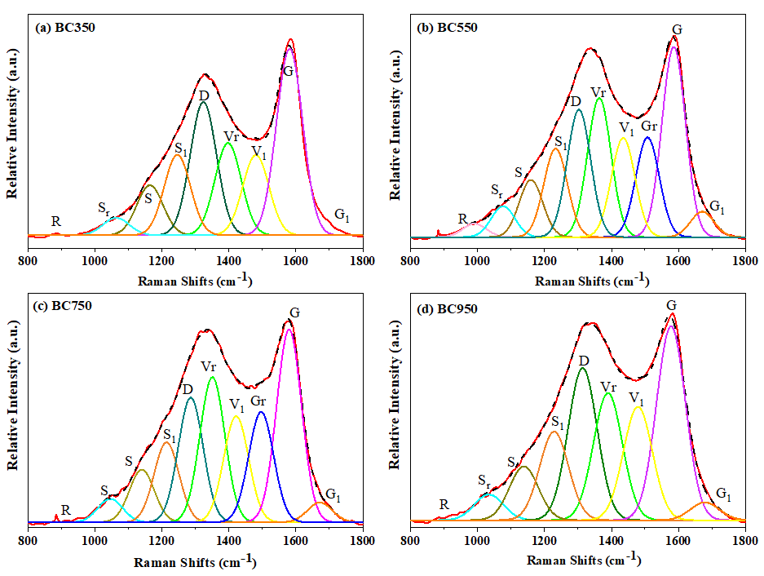
Fig. S3. Peak splitting results for BCs prepared at different temperatures.

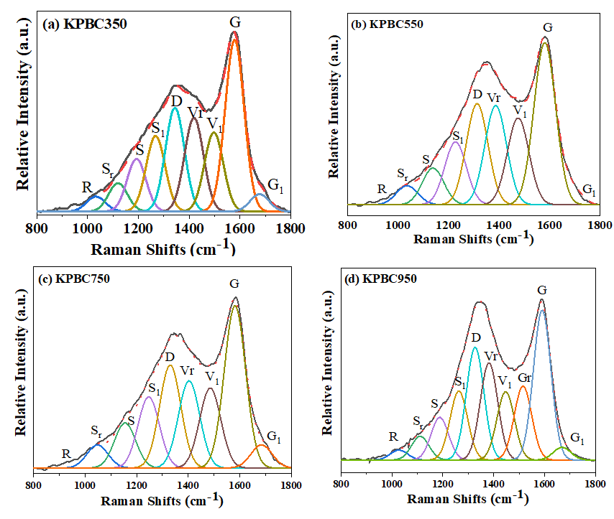
Fig. S4. Peak splitting results for KPBCs prepared at different temperatures.

References
[1] Noda I. Generalized two-dimensional correlation method applicable to infrared, raman, and other types of spectroscopy. Applied Spectroscopy. 1993;47(9):1329-36.
[2] Noda I, Ozaki Y. Two-Dimensional Correlation Spectroscopy: Applications in Vibrational and Optical Spectroscopy. Chichester, West Sussex: John Wiley & Sons Inc, 2004.
[3] Zhang H, Liu M, Yang H, Jiang H, Chen Y, Zhang S, et al. Impact of biomass constituent interactions on the evolution of char’s chemical structure: An organic functional group perspective. 2022;319:123772.
[4] Feng B, Bhatia SK, Barry JC. Structural ordering of coal char during heat treatment and its impact on reactivity. Carbon. 2002;40(4):481-96.
[5] Feng B, Bhatia SK, Barry JC. Variation of the crystalline structure of coal char during gasification. Energy Fuels. 2003;17(3):744-54.

