Supplementary Information
Roles of iron and manganese in bimetallic biochar composites for efficient persulfate activation and atrazine removal

Yuan Liang^{1,}*, Ran Tao ¹, Ben Zhao¹, Zeda Meng², Yuan Yuan Cheng¹, Fan Yang³, Huihui Lei¹, Lingzhao Kong^{*1}

¹ School of Environmental Science and Engineering, Suzhou University of Science and Technology, Suzhou, 215000, China
² School of Chemistry and Life sciences, Suzhou University of Science and Technology, Suzhou, 215000, China
³ School of Environment and Architecture, University of Shanghai for Science and Technology, Shanghai 200093, China

Corresponding author
Yuan Liang, E-mail: liangyuan@usts.edu.cn,
Lingzhao Kong, E-mail: konglz@sari.ac.cn,
Yuan Liang and Lingzhao Kong will handle correspondence at all stages of refereeing and publication, also post-publication.

S.1 The calculation of the total removal amount (QT), the adsorption amount (Qs), and the degradation amount (Qd) of atrazine.

In the atrazine removal experiments, after the 120-min reaction, the total removal amount of atrazine was Q_{T} (mg·kg-1), calculated using the formula:
(S1)
where C₀ is the initial atrazine concentration in mg·L⁻¹, C_{e} is the atrazine concentration in the solution at 120 min in mg·L⁻¹, V is the mixture solution volume in L, and m is the mass of biochar or Fe/Mn loaded biochar in kg.
Both adsorption and degradation played roles in the removal of atrazine from the mixture solution. The filtered complex, after a 120-min reaction, was freeze-dried and extracted with 40 ml of methanol through 6 h of shaking. This process aimed to detect any residual atrazine on the surface of biochar or Fe/Mn loaded biochar, representing the amount of atrazine adsorption on biochar (Q_{s} mg·kg-1). The value of Q_{s} (mg·kg-1) is as follows:
(S2)
where C_{s} represents the atrazine concentration (mg·L-1) after 6 h of methanol desorption, V denotes the volume (L) of the mixture solution, and m stands for the mass (kg) of biochar or Fe/Mn loaded biochar.
The amount of atrazine degraded, Q_{d} (mg·kg-1), is calculated using the formula:
(S3)
The total efficiency of Fe and Mn for atrazine degradation is determined by the following formula：
(S4)
where, the atrazine degradation amount is the degradation amount by biochar or modified biochar after a 120 min reaction in mol, and Fe+Mn added represents the total amount of Fe and Mn in biochar or Fe/Mn loaded biochar in mol.

S.2 The calculation of k_{obs}
C/C₀ was used to describe the removal efficiency of atrazine, and the quasi-first-order kinetic model was applied to evaluate the degradation process (Hu et al., 2021). The formula is as follows:
（S5）
where C₀ is the atrazine concentration (mg·L-1) in the initial solution, C_{t} is the atrazine concentration (mg·L-1) in solution at time T, k_{obs} is the quasi-first order kinetic rate constant (min-1), and t is the reaction time (min).

Table S1 the metal loaded biochar and its degradation of pollutants
Loaded metals | Metals amount loaded on biochar | pH | Pollutant removal effect | Reference
Fe  Fe-Zn | Fe ration in Fe@BC was 10%, 20%, 30%, 40%  Fe and Zn ration in Fe-Zn@BC was 20% and 20% | pH = 3, 5, 7, 9, 11 | Fe-Zn@BC degrade tetracycline with a removal efficiency of 90% in 120 min | (Pan et al. 2022)
Fe | Fe ration in ferric-activated SBA was 0%，6.5%, 9.3%, 12.4%, 14% | pH = 6 | Ferric-activated biochar degrade tetracycline with a removal efficiency of 81.6% in 120 min | (Yang et al. 2016)
Cu²⁺ | Cu²⁺ ration in CuO/rGO was 22.4% | pH = 6, 9, 11 | The removal of chloraniline in CuO/ PS system could reach 71.5% within 5 hours | (Du et al. 2019)
Mn | Mn ration in MBC was 8%, 10%, 14%, 25% | pH = 3, 5, 7, 9, 11 | The removal efficiency of oxytetracycline reached 75% in Mn-modified biochar system | (Fang et al. 2022)
Fe-S  Mn-S  Fe-Mn-S | Fe and Mn ration in Fe-Mn-S @HCS were 5.35% and 1% , respectively. | pH = 2-7 | The adsorption capacity of Fe-Mn-S@HCS and Mn-S@HCS composites for Pb was comparable (181.5-184.5 mg g⁻¹) | (Yang et al. 2019)
Fe  Mn  Fe-Mn | Fe ration in Fe biochar was 2%, Mn ration in Mn biochar was 0.5%-8%, Fe and Mn ration in Fe-Mn biochar was both 4%. | pH =6.5 | Approximately 74.3 − 86.2% of Cr(VI) was removed by the Fe-Mn biochar after the 24h reaction. | (Xu et al. 2023)
Fe -Mn | The concentration of Fe accounts for 75% of the total concentration, while the concentration of Mn accounts for 25% | pH = 2, 3, 5, 7, 9, 11, 12 | FeMn -BC degrade tetracycline with a removal efficiency of 70% | (Zhang et al. 2021)
Fe  Mn  Fe-Mn | Fe and Mn ration in Fe/Mn -SBC were 23.5%~26.5% and 6.5% , respectively. | pH = 3-11 | Fe/Mn-SBC degrade thiacloprid with a removal efficiency of 94.1% in PS activation after 90 min reaction | (He et al. 2022)
Fe  Mn  Fe-Mn | Fe and Mn ration in s F/M-SDBC was both 6%. | pH = 3, 5, 7, 9, 11 | The degradation efficiency of Orange G by PS activated with Fe-Mn bimetallic biochar (75.2%) was also higher than monometallic Fe-loaded biochar (45.6%) and Mn-loaded biochar (32.8%) | (Hao et al. 2020)

Table S2 Abbreviations &Symbols
Abbreviations &Symbols
Fe-MBC | The Fe monometallic biochar
Fe-BBC | The Fe rich biochar, the bimetallic biochar with more Fe and less Mn
Mn-MBC | The Mn monometallic biochar
Mn-BBC | The Mn rich biochar, the bimetallic biochar with more Mn and less Fe
·OH | hydroxyl radical
SO₄^{·−} | sulfate radical
¹O₂ | singlet oxygen
TAB | tert-Butanol
MeOH | Ethanol
FFA | furfuryl alcohol
NaF | sodium fluoride
DFT | Density functional theory
HOMO | The highest occupied molecular orbital
LOMO | the lowest unoccupied molecular orbital
SCRF | the self-consistent reactive field

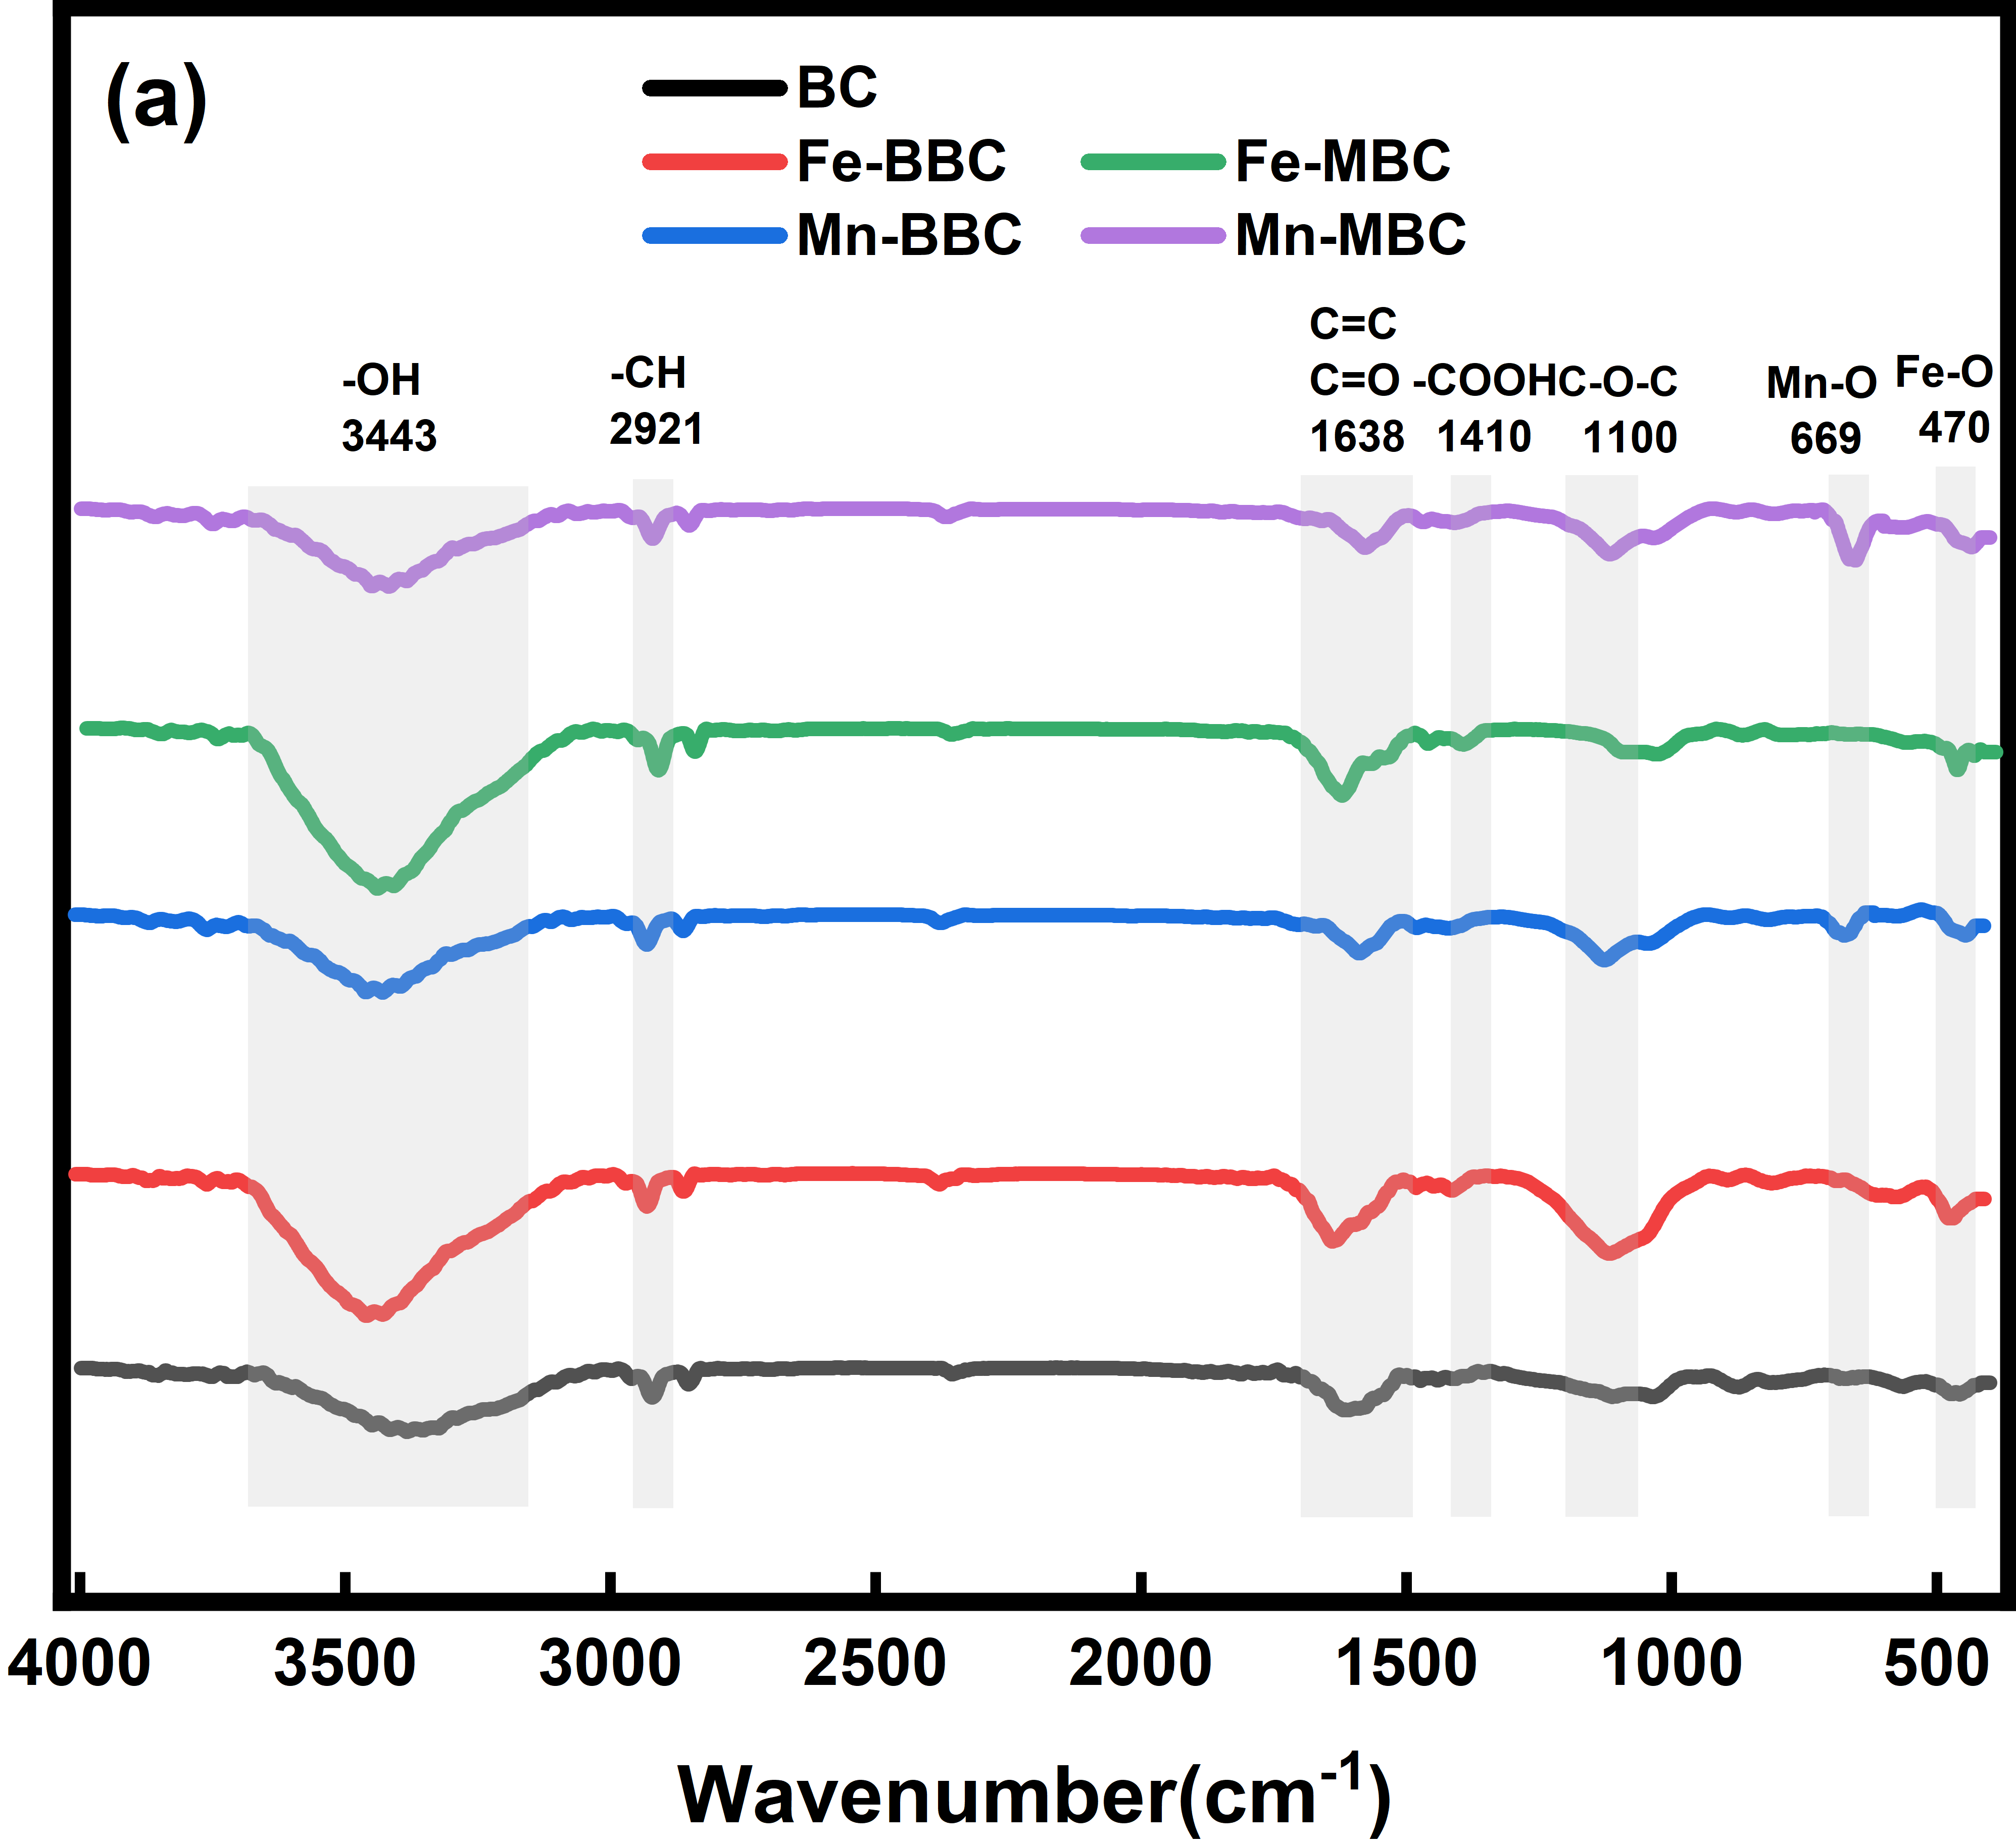
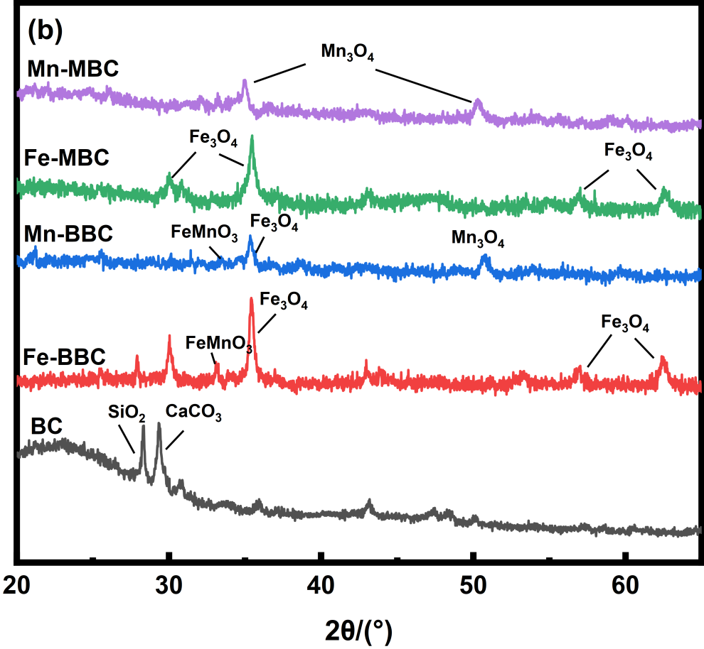
Fig.S1 FTIR patterns (a) and XRD patterns (b) of pristine biochar (BC), monometallic (Fe-MBC, Mn-MBC) and bimetallic biochar (Fe-BBC, Mn-BBC)
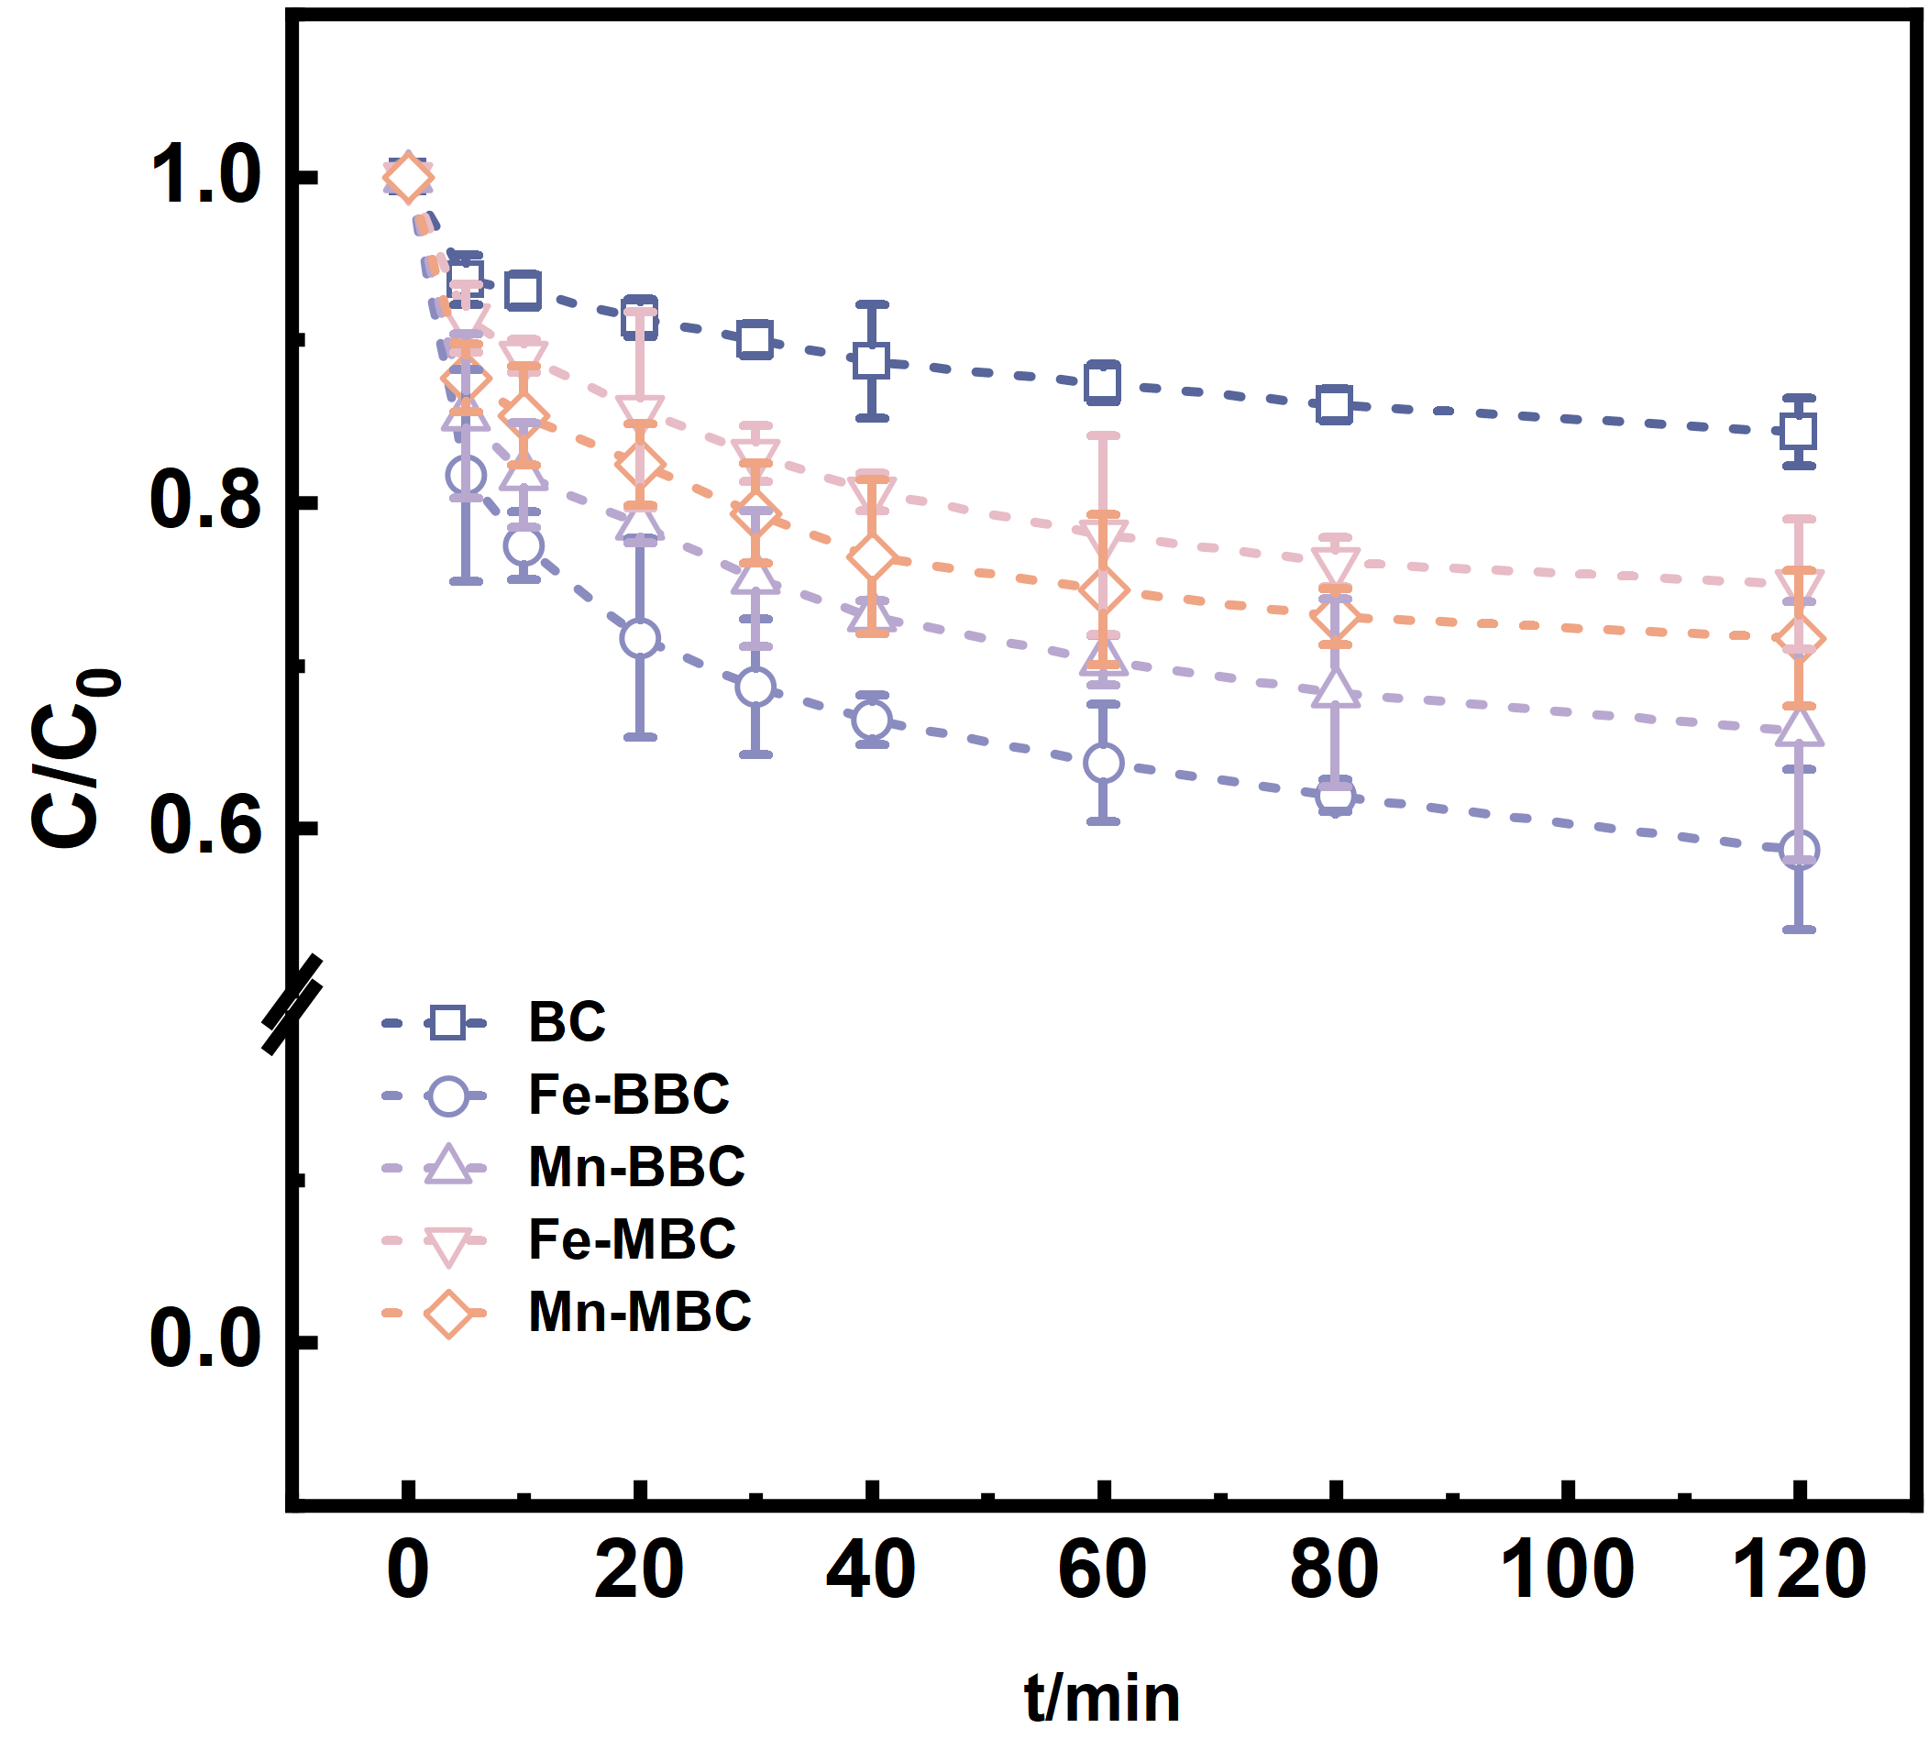
Fig.S2 The atrazine concentration in the solution in BC, Fe-BBC, Mn-BBC, Fe-MBC, and Mn-MBC.

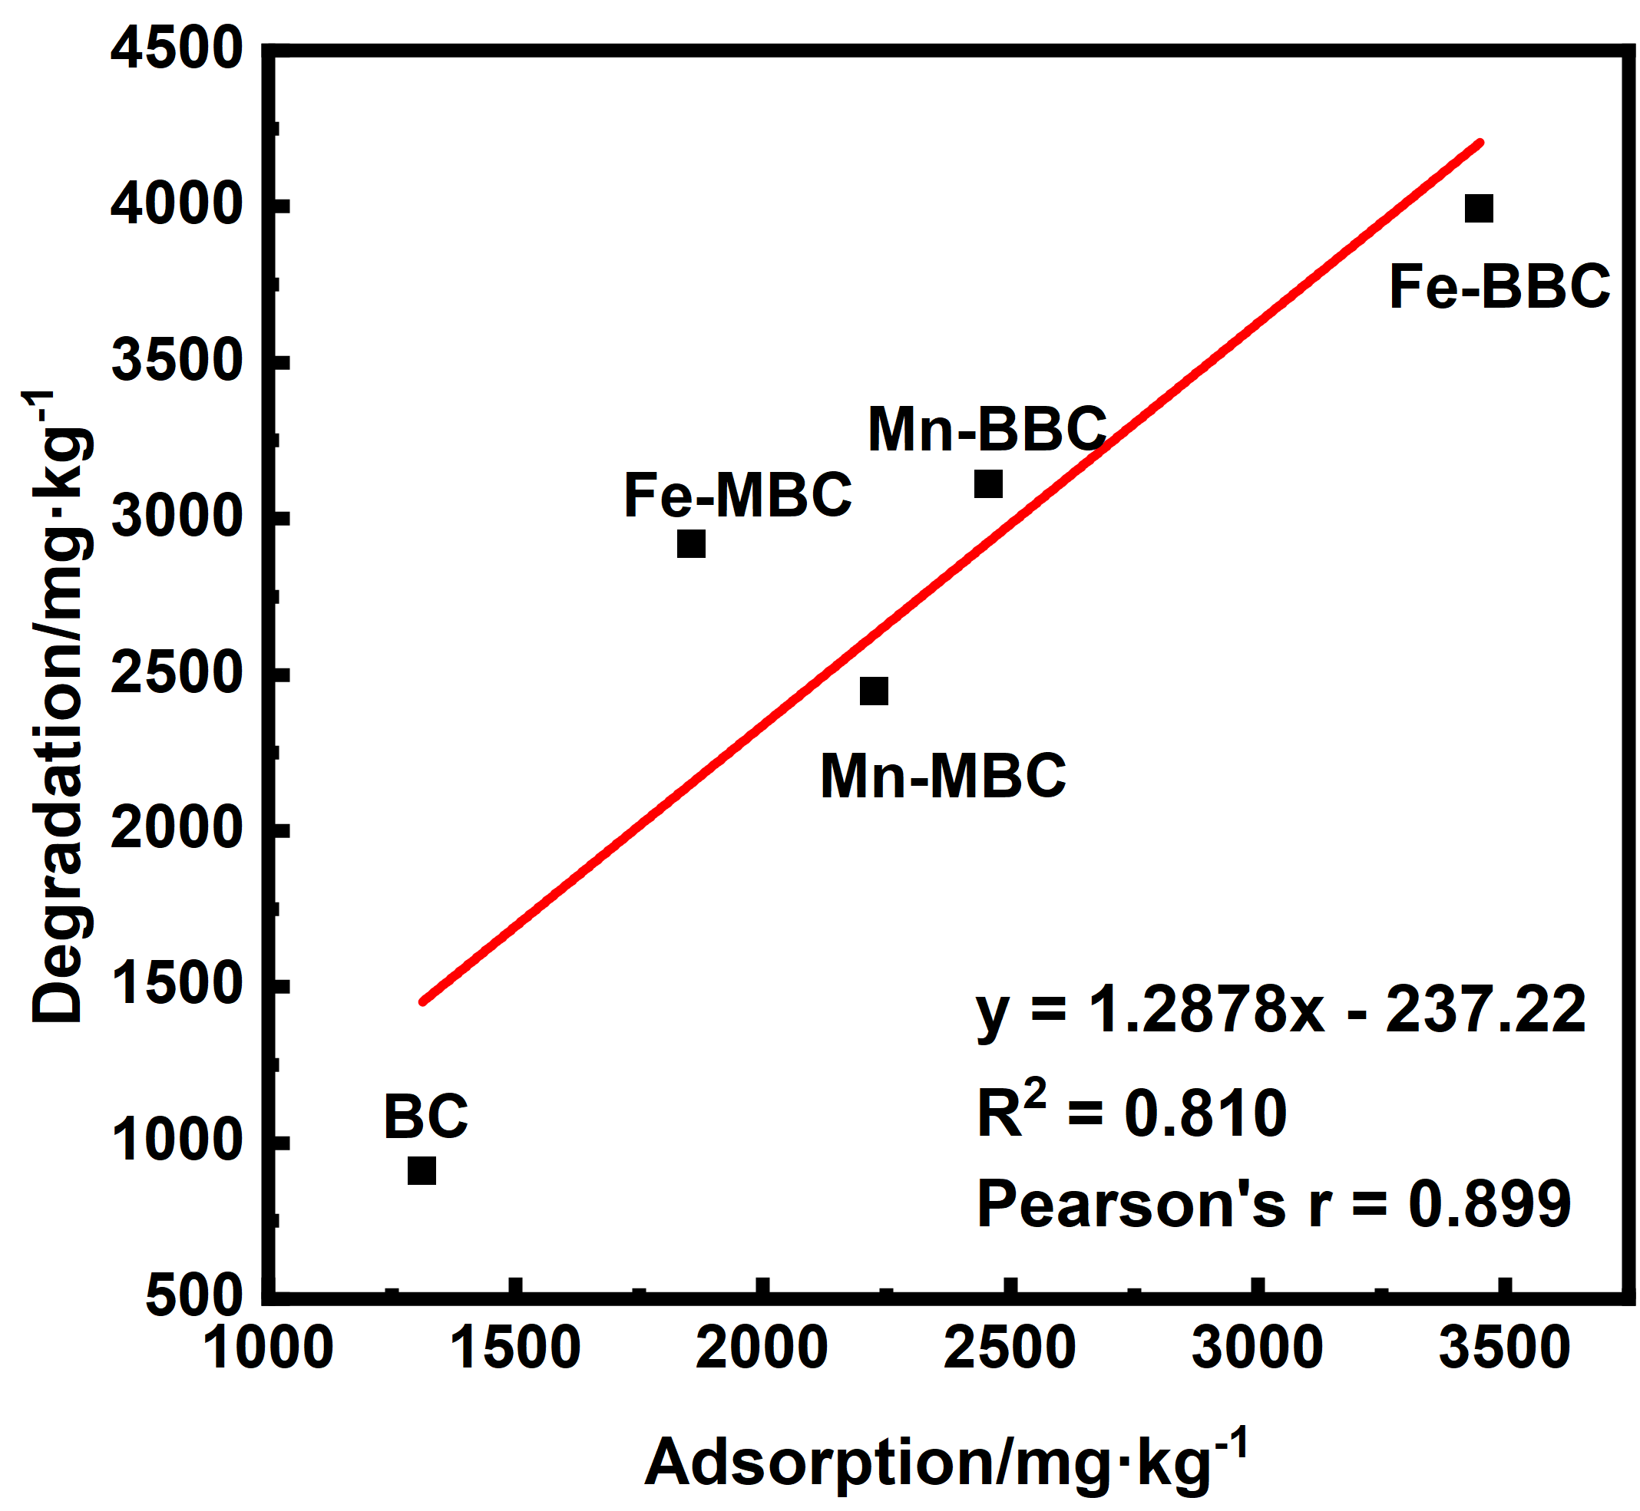
Fig.S3 The correlation between the adsorption of atrazine in biochar alone and the degradation of atrazine in biochar+PS system
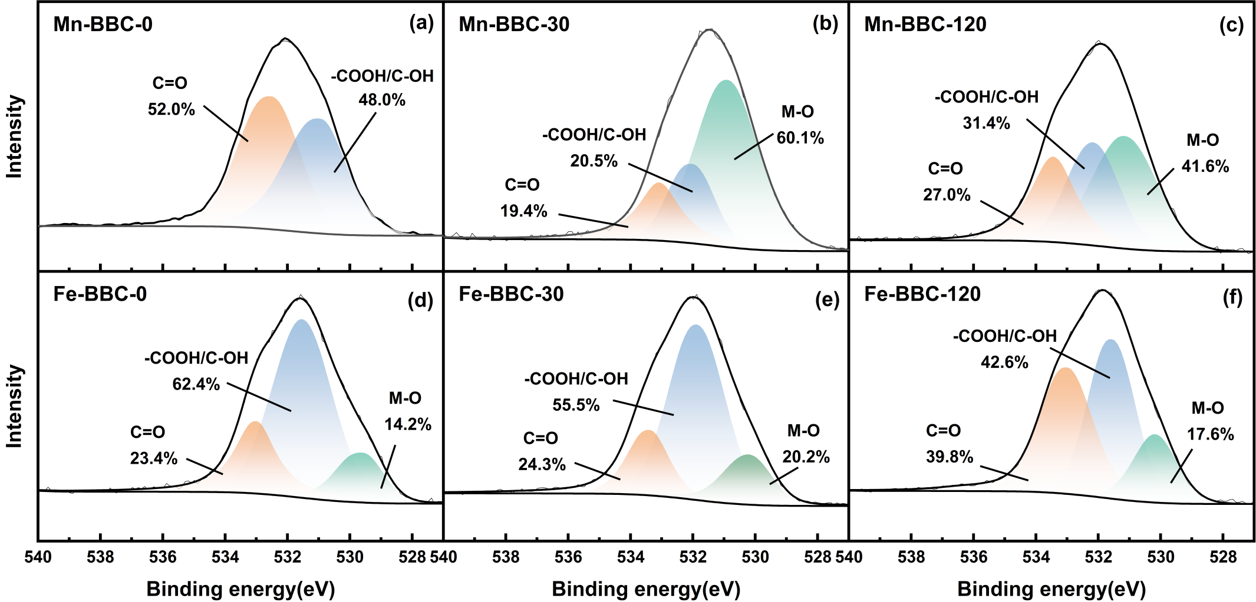
Fig.S4 The fine XPS O1s spectra of Mn-BBC (a, b, c) and Fe-BBC (d, e, f) at 0, 30, and 120 min

